Knock detecting Lock

**Introduction:**

Security is a major concern in our day-to-day life, and digital locks have become an important part of these security systems. There are many types of security systems available to secure our place. Some examples are [PIR based Security System](https://circuitdigest.com/microcontroller-projects/pir-sensor-and-gsm-based-security-system), [RFID based Security System](https://circuitdigest.com/microcontroller-projects/rfid-based-security-system), [Digital Lock System](https://circuitdigest.com/microcontroller-projects/digital-code-lock-using-arduino), bio-matrix systems, Electronics Code lock. So, let us build a **Secret Knock Detecting Door Lock using Arduino Uno** which can detect the pattern of your knocks at the door and will only open the lock if the knocking pattern matches with the correct pattern.

**Description:**

We made a device that will detect a specific "Knocking" sequence and utilizes the sequence to unlock the door automatically. This system is faster than traditional key, or mobile phone Bluetooth unlocking system. Since it is an automated system, it can be used in Smart Home setup architecture. In this project we will use an **ATmega328** microcontroller and **C** programming. Note that there is a limitation in this system. If the battery runs out, then the system will not work properly.

**Hardware Requirements:**

|  |  |  |
| --- | --- | --- |
| **Item No** | **Item Name** | **Price(TK)** |
| 1 | Arduino Uno R3 (ATmega328) | 430 |
| 2 | Gear Motor | 95 |
| 3 | Piezo Sensor | 260 |
| 4 | Single push button (Red) | 30 |
| 5 | RED LED, GREEN LED | 10 |
| 6 | 1K ohm Resistor | 10 |
| 7 | NPN transistor | 2 |
| 8 | Voltage Divider(5volt) | 5 |
| 9 | Jumper wire | 70 |
| 10 | Breadboard | 75 |
| 11 | 9V battery | 25 |
| 12 | Metal Door Lock | 50 |
|  | Total expense | 1062 |

**Working Process:**

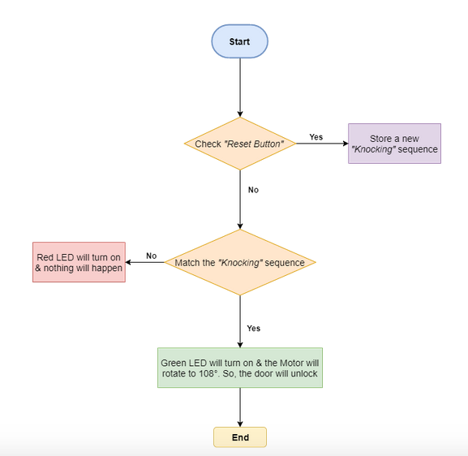

**Circuit Diagram**

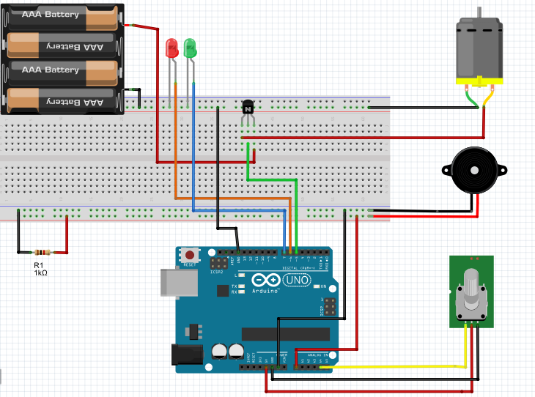

**CSE331**

**Microprocessor Interfacing and Embedded System**



**Project proposal**

**Submitted to**

**Sheikh Faisal**

**Project Members**

|  |  |
| --- | --- |
| **Name** | **ID** |
| Nafis Iftekhar Mahin | 1310496642 |
| M. Alif Ur Rahman | 1410120042 |
| Md. Abu Ashraf | 1410499042 |