Bookify: Online Bookstore Application

Internship Project Report

Submitted as Partial Fulfilment of
Master of Computer Application
Semester-IV

Developed by
Khan Abubakar (202400719010097)

Under Guidance of
Dr. Darshita Kalyani, FCAIT

Faculty of Computer Applications & Information Technology

GLS University
Ahmedabad-380 006

College Certificate

Acknowledgement

We would like to express our sincere gratitude to all those who have contributed to the successful completion of the Bookify – Full Stack Online Bookstore Application project.

First and foremost, we extend our heartfelt thanks to our project guide, Dr. Darshita Kalyani, for her invaluable support, guidance, and continuous encouragement throughout the development of this project. Her expertise, constructive feedback, and insightful suggestions were instrumental in shaping the direction and successful outcome of our work.

We are also deeply thankful to GLS University for providing the necessary resources, technical infrastructure, and a conducive learning environment that enabled us to undertake and successfully complete this project.

A special note of appreciation goes to everyone who contributed ideas, feedback, and technical support during the design and development of this application. Their insights and encouragement played an important role in building a secure, scalable, and feature-rich online bookstore platform.

Lastly, we would like to thank our family and friends for their constant support, motivation, and encouragement throughout this journey.

This project has been an enriching learning experience, allowing us to strengthen our knowledge in React.js, Spring Boot, database design, authentication, payment integration, and full stack application development. We are proud to present Bookify as a modern online bookstore platform that aims to provide seamless book discovery, secure purchasing, and a user-friendly shopping experience.

Index

Sr No | Title | Page No
1 | Title Page | 1
2 | College Certificate | 2
3 | Acknowledgement | 3
4 | Index | 4
5 | Introduction | 5
6 | Project Profile | 6 to 7
7 | Project Definition | 8
8 | Tools and Technology | 9
9 | Feasibility Study | 10 to 11
10 | Modules of the System | 12 to13
11 | Features of the System | 14 to 15
12 | Users of the system | 16
13 | Architecture Diagram | 17
14 | UML Diagrams: ER Diagram, Use Case Diagram, Sequence Diagram, Activity Diagram. | 18 to 24
15 | Database Design (Data Dictionary) | 25 to 27
16 | GUI Design (Mock Screens) | 28
17 | MIS Report | 29-30
18 | Conclusion | 31
19 | Future Enhancement | 32
20 | References | 33-34

Introduction

In today’s digital era, online shopping platforms have become an essential medium for purchasing products conveniently and efficiently. E-commerce applications have transformed the way users browse, select, and buy products by providing seamless digital experiences. Inspired by such platforms, this project presents Bookify – a Full Stack Online Bookstore Web Application developed using modern industry technologies including React.js for the frontend, Spring Boot with Hibernate (JPA) for the backend, and MySQL for database management.

The system is designed using a secure and scalable client–server architecture where users can register, log in using JWT-based authentication, browse books, add items to their cart or wishlist, place orders, write reviews, and manage their profiles. The application also supports secure payment integration, order tracking, and return or replacement requests, ensuring a smooth and reliable purchasing experience for users.

This project demonstrates the practical implementation of RESTful APIs, secure authentication and authorization using Spring Security, proper relational database design with JPA mappings, and responsive user interface development using modern frontend tools and frameworks. Overall, the system reflects an industry-level full stack e-commerce application that emphasizes security, scalability, performance, and modern web development practices.

Project Profile

Project Title: | Bookify: A Full Stack Online Bookstore application
Description: | Bookify is a modern online bookstore web application designed to enable users to browse, purchase, and manage books in a secure and efficient digital environment. The platform provides features such as book browsing, Wishlist management, shopping cart functionality, order placement, payment integration, reviews and ratings, and return or replacement requests.
Aim: | The primary aim of the Bookify – Full Stack Online Bookstore Application is to design and develop a secure, scalable, and user-friendly e-commerce platform that allows users to discover books, manage their purchases, and experience seamless online book shopping.
Category: | Web Application / Database / Internet / Client–Server System
Developed at: | GLS University, Ahmedabad
Tools Used / Required: | Development side  - Hardware: Laptop  - Software:  - Operating System: Windows 11  - Front End: React, HTML, CSS, JS.  - Back End: Spring Boot  - ORM: Hibernate  - Database: MySQL  - Security: Spring Security, JWT  - Payment Integration: Razorpay  - Report Generation Tool: Admin Dashboard  - Build Tool: Maven  - Api Testing tool: Postman  - Architecture: Client – Server Architecture.  Deployment side  - Hardware: Laptop  - Software: Vs Code
Developed for: | To provide a secure and scalable online bookstore platform that enables users to browse books, place orders, manage purchases, and interact with the system through a simple and user-friendly interface.
Developed By: | Abubakar Khan
Guided By: | Internal at Institute  Name Dr Darshita Kalyani  Designation Assistant Professor

Project Definition

Bookify – Full Stack Online Bookstore Application is a web-based platform designed to enable users to browse, purchase, and manage books in a secure and scalable digital environment. The system allows users to register, authenticate securely using JWT-based authentication, explore a wide range of books, add books to their cart or Wishlist, place orders, provide ratings and reviews, and manage their purchase history. It also supports order tracking, invoice generation, and return or replacement requests to enhance the overall shopping experience.

The application is developed using a modern full stack architecture with a React frontend, Spring Boot backend, and MySQL database. The system ensures role-based access control for both normal users and administrators, where administrators can manage books, authors, orders, and monitor overall system activities through an administrative dashboard.

The primary objective of the project is to design and implement a scalable, secure, and industry-standard e-commerce bookstore system that demonstrates the practical implementation of REST APIs, database relationships, authentication mechanisms, and secure transaction workflows. The system emphasizes performance, security, maintainability, and user experience, making it suitable for real-world deployment and future expansion.

Tools And Technology

The development of Bookify involves modern web technologies to ensure scalability, security, and high performance. The following tools and technologies are used in the implementation of the system:

- Programming Language: Java (Backend), JavaScript (Frontend)
- Frontend Technologies: HTML, CSS, JavaScript, React.js, Boostrap
- Backend Framework: Spring Boot
- ORM Framework: Hibernate (JPA)
- Security: Spring Security with JWT Authentication
- Database: MySQL
- Payment Integration: Razorpay
- Build Tool: Maven
- API Testing Tool: Postman
- IDE: VS code

Feasibility Study

The feasibility study evaluates the practicality and viability of developing and implementing the Bookify – Full Stack Online Bookstore Application. The analysis ensures that the system is technically possible, economically viable, and operationally practical.

1. Technical Feasibility
The project is technically feasible as it is developed using widely adopted and industry-standard technologies such as React for frontend development, Spring Boot for backend services, and MySQL for database management. These technologies are stable, well-documented, and supported by strong developer communities.

Development tools such as IntelliJ IDEA and Postman further simplify API development and testing. Since the system follows a modular architecture with REST APIs and proper database design, it can be easily maintained and scaled in the future. Additional technologies such as Spring Security, JWT authentication, and payment integration further enhance the system’s reliability and security.

2. Economic Feasibility
The system is economically feasible because it uses open-source technologies that do not require expensive licensing costs. Development tools like IntelliJ IDEA (Community Edition), MySQL, Spring Boot, and React are freely available.

Deployment can initially be done on low-cost cloud platforms or local servers, making the overall development and implementation cost minimal. Therefore, the project can be developed and maintained within a reasonable budget.

3. Operational Feasibility
The application is user-friendly and designed with an intuitive interface, making it easy for users to interact with the system. Features such as secure authentication, role-based access control, book browsing, cart and Wishlist management, order placement, and review systems enhance usability and user engagement.

Administrators can efficiently manage books, authors, users, and orders through the admin dashboard, ensuring smooth system operations and effective platform management.
4. Schedule Feasibility
The project is feasible within the given academic timeline. The development process is divided into phases including requirement analysis, system design, backend development, frontend development, integration, testing, and deployment. With proper planning and milestone tracking, the system can be completed within the allocated timeframe.

Overall, the feasibility analysis confirms that the Bookify application is technically achievable, financially practical, operationally efficient, and executable within the defined project schedule.

Modules of the System

- Authentication Module
• Register
• Login
• JWT Token generation
• Password encryption (BCrypt)
• Role-based access (USER / ADMIN)
• Forgot password / Reset password via email

- User Module
• View profile
• Edit profile
• Upload profile image
• Manage personal details (address, phone, gender)
• Select favourite book and author
• Account management

- Book Module
• View book catalog
• View book details (author, price, description)
• Search books
• Pagination for book listing
• Add / update / delete books (Admin)
• Manage book inventory

- Author Module
• Add author (Admin)
• Update author details
• Delete author
• View author list
• Associate books with authors

- Cart Module
• Add book to cart
• Update quantity
• Remove item from cart
• View cart items
• Calculate subtotal and total price

- Wishlist Module
• Add book to wishlist
• Remove book from wishlist
• View wishlist items
• Move item from wishlist to cart

- Order Module
• Place order
• View order history
• Order status tracking
• Cancel order
• Remove individual product from order
• Edit delivery details before dispatch

- Payment Module
• Online payment integration
• Payment verification
• Cash on Delivery (COD) option
• Payment status tracking
• Transaction details management

- Review & Rating Module
• Add rating to purchased book
• Write review
• View book reviews
• Display average rating

- Return & Replacement Module
• Request return or replacement
• Upload image evidence
• Enter reason for return
• Schedule return date
• Refund processing
- Invoice Module
• Generate order invoice
• Calculate GST and total amount
• Print invoice for delivered orders
• Invoice number generation

- Admin Module
• Manage books and authors
• View and manage all orders
• Monitor return/replacement requests
• View users, carts, and Wishlist
• Admin dashboard for system monitoring

Feature of the System

- Secure Authentication (JWT)
Provides secure login and session management using JSON Web Tokens to maintain stateless authentication between client and server.

- User Registration and Login
Allows new users to create accounts and existing users to securely log in to the system.

- Password Encryption (BCrypt)
Ensures user passwords are securely stored in the database using strong encryption.

- Role-Based Access Control
Restricts system features based on roles such as ADMIN and USER.

- User Profile Management
Allows users to view and update their personal profile details including name, contact information, and profile image.

- Book Catalog Browsing
Enables users to browse all available books with details such as title, author, price, and description.

- Search and Filtering System
Allows users to search books by title or author and filter results for easier discovery.

- Book Inventory Management (Admin)
Allows administrators to add, update, delete, and manage book details and stock availability.

- Author Management System
Enables administrators to manage author information and link authors to their books.

- Shopping Cart Management
Allows users to add books to the cart, update quantities, remove items, and view cart totals before checkout.

- Wishlist Functionality
Allows users to save books in a Wishlist for future purchases.

- Order Placement System
Enables users to place orders for selected books and complete the checkout process.

- Order Tracking
Allows users to track the status of their placed orders.

- Order History Management
Enables users to view previously placed orders and purchase details.

- Online Payment Integration
Supports secure payment processing for book purchases.

- Return and Replacement Requests
Allows users to request product return or replacement with reason and supporting image upload.

- Refund Processing System
Handles refund operations for returned or cancelled orders.

- Invoice Generation
Automatically generates invoices containing order details and payment information.

- Book Review and Rating System
Allows users to rate books and write reviews to help other customers.

- Admin Dashboard
Provides administrators with a centralized interface to monitor users, books, orders, and system activities.

USERS OF THE SYSTEM

- Normal User
  - Register – Create a new account in the system.
  - Login – Authenticate using valid credentials.
  - Browse Books – View available books along with details such as title, author, price, and description.
  - Search Books – Find books by title, author, or keywords.
  - Add to Cart – Add selected books to the shopping cart for purchase.
  - Manage Cart – Update quantity or remove books from the cart.
  - Add to Wishlist – Save books for future reference or purchase.
  - Place Order – Purchase selected books through the checkout process.
  - Track Orders – View the status and progress of placed orders.
  - Request Return/Replacement – Submit return or replacement requests for delivered products.
  - Write Review & Rating – Provide feedback and ratings for purchased books.
  - Edit Profile – Update personal information such as address, phone number, and profile details.
  - Logout – Securely exit the system.

2. Admin User
- Login – Authenticate as administrator.
- Manage Books – Add, update, delete, and maintain book information.
- Manage Authors – Create and manage author details associated with books.
- Manage Orders – View and monitor all orders placed by users.
- Handle Return Requests – Approve or reject return and replacement requests.
- Monitor Users – View and manage registered users of the system.
- View System Dashboard – Monitor platform activities, orders, and overall system statistics.

Architecture Diagram

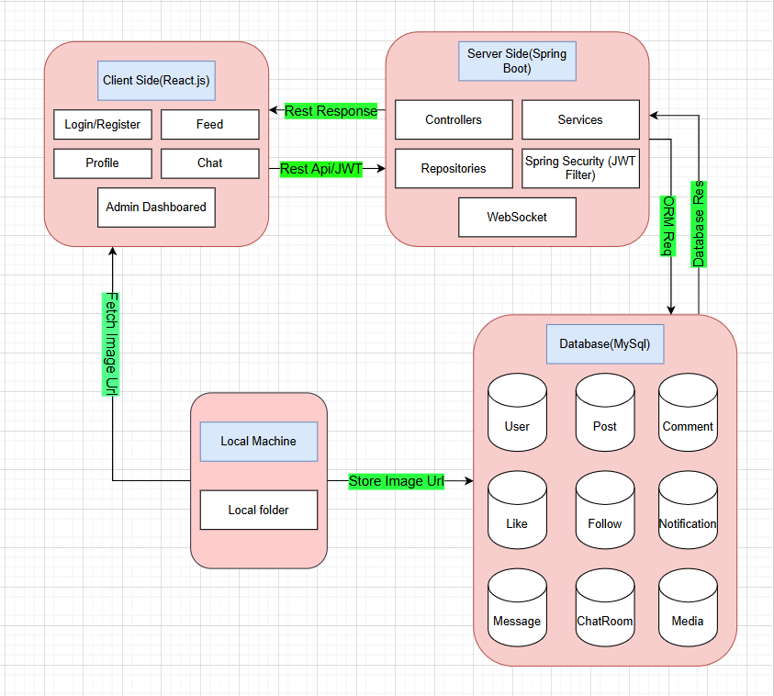

Entity Relationship Diagram

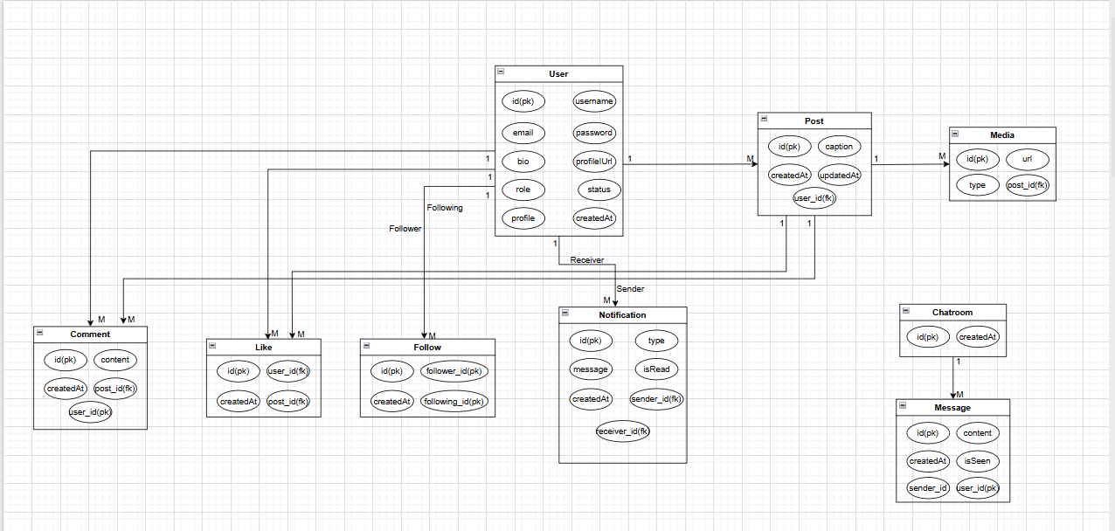

Use Case Diagram

Use Case Diagram Admin

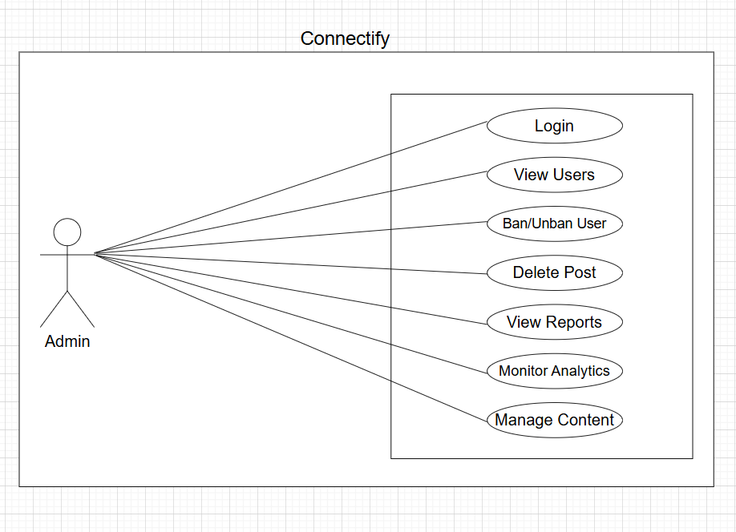

Use Case Diagram User

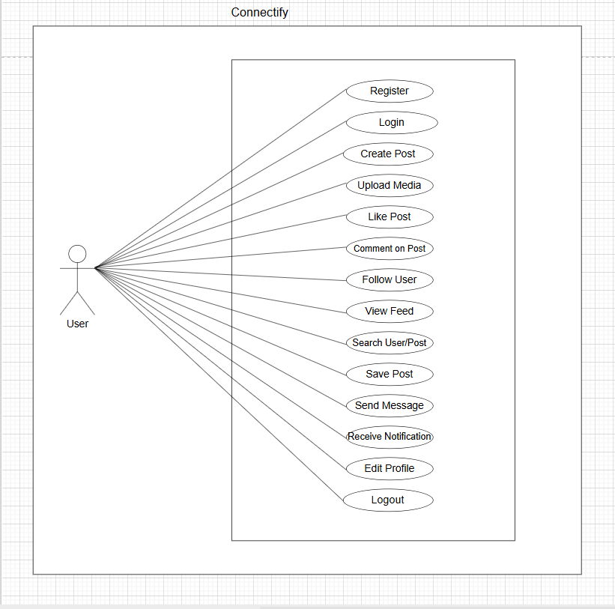

Sequence Diagram

Sequence Diagram Admin

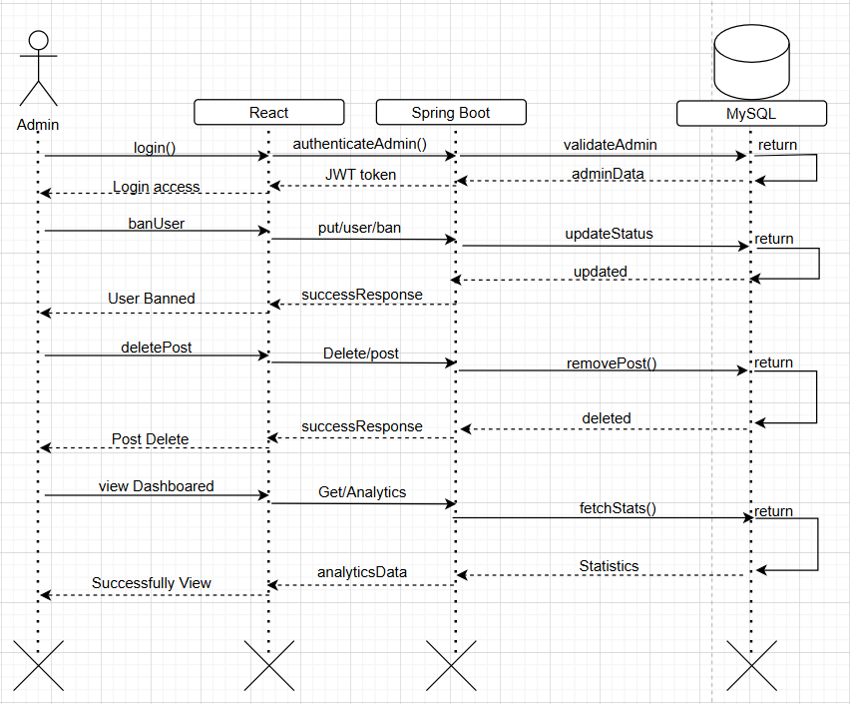

Sequence Diagram User

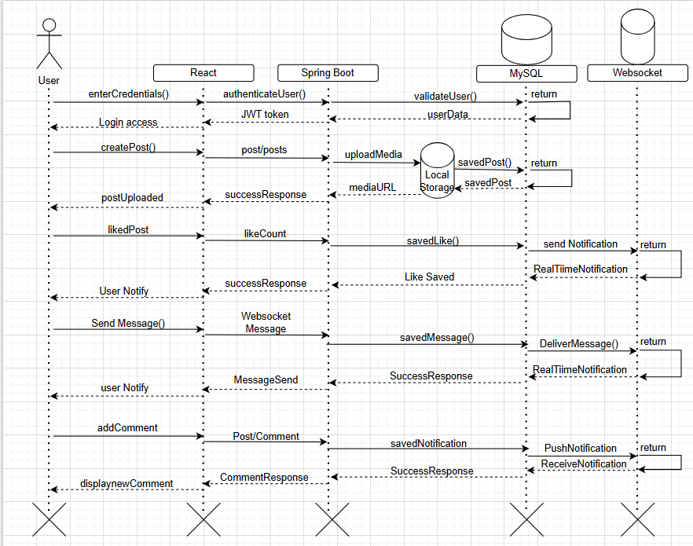

Activity Diagram

Activity Diagram Admin

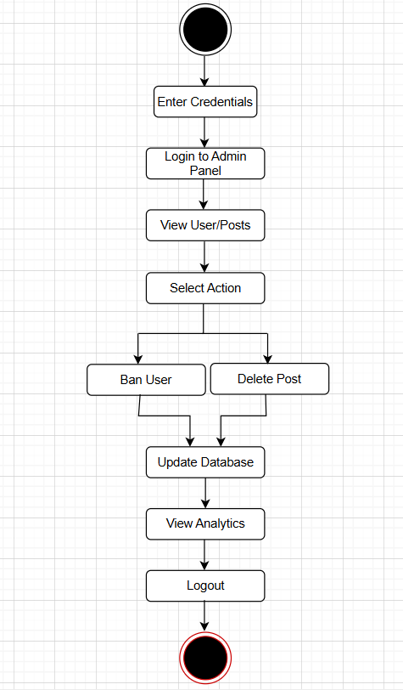
Activity Diagram User

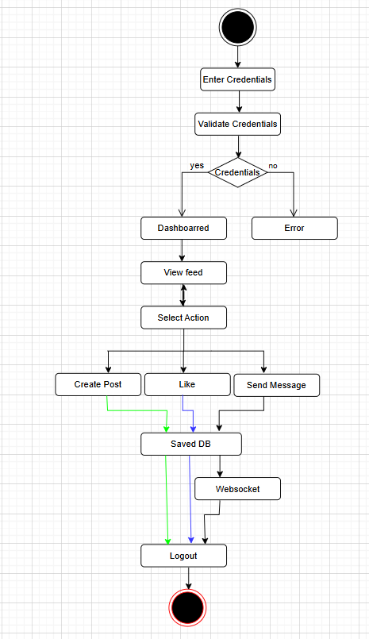

Data Dictionary

- User table:
Field | Type | Description
id | Long | Primary key that uniquely identifies each user
username | String | Unique username used for user identification and login
email | String | Unique email address associated with the user account
password | String | Encrypted password stored securely in the database
bio | String | Short personal description provided by the user
profileImageUrl | String | Stores the path or URL of the user’s profile image
role | Enum | Specifies the role of the user (USER or ADMIN)
status | Boolean | Indicates the permanent account status (active or banned)
profile | Boolean | Indicates whether the user profile is currently active or inactive
createdAt | Timestamp | Date and time when the user account was created

- Post table:
Field | Type | Description
id | Long | Primary key that uniquely identifies each post
caption | String | Text description written by the user for the post
createdAt | Timestamp | Date and time when the post was created
updatedAt | Timestamp | Date and time when the post was last updated
user_id | FK (User) | Foreign key referencing the user who created the post

- Media table:
Field | Type | Description
id | Long | Primary key that uniquely identifies each media record
url | String | Stores the path or cloud URL of the image/video
type | Enum (image/video) | Date and time when the post was created
updatedAt | Timestamp | Date and time when the post was last updated

- Comment table:
Field | Type | Description
id | Long | Primary key that uniquely identifies each comment
content | String | Text content of the comment
createdAt | Timestamp | Date and time when the comment was posted
user_id | FK (User) | Foreign key referencing the user who made the comment
post_id | FK (User) | Foreign key referencing the post on which the comment is made

- Like table:
Field | Type | Description
id | Long | Primary key that uniquely identifies each like record
user_id | FK (User) | Foreign key referencing the user who liked the post
post_id | FK (Post) | Foreign key referencing the liked post
createdAt | Timestamp | Date and time when the post was liked

- Follow table:
Field | Type | Description
id | Long | Primary key that uniquely identifies each follow relationship
follower_id | FK (User) | Foreign key referencing the user who follows another user
following_id | FK (User) | Foreign key referencing the user being followed
createdAt | Timestamp | Date and time when the follow action occurred

- Notification table:
Field | Type | Description
id | Long | Primary key that uniquely identifies each notification
type | Enum | Specifies notification type (LIKE, COMMENT, FOLLOW, MESSAGE)
message | String | Notification message displayed to the user
isRead | Boolean | Indicates whether the notification has been read
receiver_id | FK (User) | Foreign key referencing the user who receives the notification
sender_id | FK (User) | Foreign key referencing the user who triggered the notification

- Chatroom table:
Field | Type | Description
id | Long | Primary key that uniquely identifies each follow relationship
follower_id | FK (User) | Foreign key referencing the user who follows another user

- Message table:
Field | Type | Description
id | Long | Primary key that uniquely identifies each message
content | String | Text content of the message
createdAt | Timestamp | Date and time when the message was sent
isSeen | Boolean | Indicates whether the message has been seen by the receiver
sender_id | FK (User) | Foreign key referencing the user who sent the message
chatroom_id | FK (ChatRoom) | Foreign key referencing the chat room to which the message belongs

Mock Screen

MIS Report

The Management Information System (MIS) Report in the Connectify application is designed to provide administrators with analytical insights and statistical data to support effective decision-making and system monitoring. The MIS module helps in tracking platform performance, user engagement, and overall system activity.

The MIS report is integrated within the Admin Dashboard and presents summarized data in the form of counts, statistics, and visual representations such as charts and graphs.

- Key MIS Reports in Connectify
- User Analytics Report
- Total number of registered users
- Active vs inactive users
- Number of newly registered users
- Banned or suspended accounts
This report helps the admin understand user growth and engagement trends.

- Post Activity Report
- Total number of posts created
- Posts created per day/week/month
- Most liked or most commented posts
- Posts pending approval
This enables monitoring of content activity on the platform.

- Engagement Report
- Total likes and comments
- Most active users
- Follow relationship statistics
- Message activity count
This report measures user interaction and engagement levels.

- System Monitoring Report
- Notification count
- Active sessions
- Database usage overview
- Error logs (if implemented)
This ensures smooth system performance and maintenance.

- Purpose of MIS in the Project
The MIS functionality helps administrators:
- Make data-driven decisions
- Monitor platform growth
- Detect unusual activities
- Improve system performance
- Maintain platform security and integrity

- Conclusion of MIS Module
The MIS Report module enhances the administrative capabilities of Connectify by providing structured, analytical, and real-time data insights. It transforms raw system data into meaningful information, thereby improving operational efficiency and strategic planning.

Conclusion

The Connectify – Full Stack Social Media Application successfully demonstrates the development of a complete industry-level full stack system using modern web technologies. The project integrates secure JWT-based authentication, structured entity relationships using JPA, efficient media handling through local or cloud storage, real-time communication using WebSockets, and a scalable backend architecture built with Spring Boot. The responsive React frontend combined with a robust Java backend ensures performance, security, and maintainability of the application.

Overall, this project reflects a strong understanding of Java backend development, the Spring Boot ecosystem, database design principles, RESTful API development, React frontend architecture, and security implementation. It showcases the ability to design and build a scalable, secure, and production-ready full stack application following industry standards.

Future Enhancement

Although the system is fully functional, it can be further enhanced with advanced features and architectural improvements. An AI-based recommendation engine can be implemented to provide personalized content feeds based on user behaviour and interests. Machine learning models can also be integrated for automated content moderation to detect spam, inappropriate content, or fake accounts.

Additionally, the application can be migrated to a microservices architecture to improve scalability, maintainability, and independent service deployment. The platform can also be extended into a mobile application using React Native to provide cross-platform accessibility and enhance user engagement. These enhancements would further strengthen the system’s scalability and real-world applicability.

References

- Spring Boot – Official Documentation
Spring Boot provides a comprehensive framework for building production-ready Java applications with minimal configuration. It supports REST APIs, dependency injection, embedded servers, and enterprise-level backend development features.
Available at: https://spring.io/projects/spring-boot

- React – Official Documentation
React is a JavaScript library used for building interactive and component-based user interfaces. It enables efficient UI updates through a virtual DOM and supports modern frontend architecture practices.
Available at: https://react.dev

- MySQL 8.0 – Reference Manual
MySQL is a widely used relational database management system that supports structured data storage, SQL queries, indexing, and transaction management for scalable applications.
Available at: https://dev.mysql.com/doc/

- Hibernate ORM – Documentation
Hibernate is an Object Relational Mapping (ORM) framework that simplifies database operations in Java applications. It provides JPA support, entity mapping, and efficient query handling.
Available at: https://hibernate.org/orm/documentation/

- Postman – Learning Centre
Postman is an API development and testing tool used to design, test, and document RESTful services. It simplifies request handling, authentication testing, and API debugging.
Available at: https://learning.postman.com/

- IntelliJ IDEA – Documentation
IntelliJ IDEA is a powerful integrated development environment (IDE) for Java and web development. It provides advanced code assistance, debugging tools, and seamless Spring Boot integration.
Available at: https://www.jetbrains.com/idea/documentation/

- JSON Web Token (JWT) – Introduction
JSON Web Token (JWT) is a compact and secure method for transmitting authentication information between parties. It is widely used for implementing secure login and authorization mechanisms in web applications.
Available at: https://jwt.io/introduction

