Connectify: Social Media Application

Major Project Report

Submitted as Partial Fulfilment of
Master of Computer Application
Semester-IV

Developed by
Khan Abubakar (202400719010097)

Under Guidance of
Dr. Darshita Kalyani, FCAIT

Faculty of Computer Applications & Information Technology

GLS University
Ahmedabad-380 006

Acknowledgement

We would like to express our sincere gratitude to all those who have contributed to the successful completion of the Connectify – FullStack Social Media Application project.

First and foremost, we extend our heartfelt thanks to our project guide, Dr. Darshita Kalyani, for her invaluable support, guidance, and continuous encouragement throughout the development of this project. Her expertise, constructive feedback, and insightful suggestions were instrumental in shaping the direction and successful outcome of our work.

We are also deeply thankful to GLS University for providing the necessary resources, technical infrastructure, and a conducive learning environment that enabled us to undertake and successfully complete this project.

A special note of appreciation goes to our team members for their dedication, collaboration, and consistent effort in designing and developing this full stack application. Each member’s contribution played a vital role in building a secure, scalable, and feature-rich social media platform.

Lastly, we would like to thank our family and friends for their constant support, motivation, and encouragement throughout this journey.

This project has been an enriching learning experience, allowing us to strengthen our knowledge in React.js, Spring Boot, database design, authentication, and real-time systems. We are proud to present Connectify as a modern social networking platform that aims to provide seamless communication, content sharing, and real-time interaction in a secure and user-friendly environment.

Index

Sr No | Title | Page No
1 | Title Page | 1
2 | Acknowledgement | 3
3 | Index | 4
4 | Introduction | 5
5 | Project Profile | 7 to 8
6 | Tools and Technology | 9
7 | Modules of the System | 11
8 | Features of the System | 12
9 | Users of the system | 13
10 | Architecture Diagram | 14
11 | UML Diagrams: ER Diagram, Use case Diagram | 15 to 24
12 | Database Design (Data Dictionary) | 25 to 27
13 | GUI Design (Mock Screens) | 28 to 34
14 | Conclusion | 36

Introduction

In today’s digital era, social media platforms have become an essential medium for communication, content sharing, and community building. Applications like Instagram have transformed the way users interact by enabling real-time sharing of photos, videos, stories, and messages. Inspired by such platforms, this project presents a Full Stack Social Media Web Application developed using modern industry technologies including React.js for the frontend, Spring Boot with Hibernate (JPA) for the backend, and MySQL for database management.

The system is designed using a secure and scalable client–server architecture where users can register, log in using JWT-based authentication, create and manage posts with images or videos, follow other users, like and comment on posts, receive real-time notifications, and engage in direct messaging. The application also integrates local storage solutions for efficient media handling and uses WebSockets to enable real-time features like chat and live notifications.

This project demonstrates practical implementation of RESTful APIs, secure authentication and authorization using Spring Security, proper relational database design with JPA mappings, and responsive user interface development using Tailwind CSS. Overall, the system reflects an industry-level full stack application that emphasizes security, scalability, performance, and modern web development practices.

Project Profile

Project Title: | Connectify: A Full Stack Social Media Application
Description: | Connectify is a modern social networking web application designed to enable users to connect, share, and interact in a secure and dynamic digital environment.
Aim: | The primary aim of the Connectify – Full Stack Social Media Application is to design and develop a secure, scalable, and user-friendly social networking platform that enables seamless digital interaction and content sharing.
Category: | Web Application / Database / Internet / Client–Server System
Developed at: | GLS University, Ahmedabad
Tools Used / Required: | Development side  - Hardware: Laptop  - Software:  - Operating System: Windows 11  - Front End: React, HTML, CSS, JS.  - Back End: Spring Boot  - ORM: Hibernate  - Database: MySQL  - Security: Spring Security, JWT  - Real Time Communication: WebSocket  - Report Generation Tool: Admin Dashboard  - Build Tool: Maven  - Api Testing tool: Postman  - Architecture: Client – Server Architecture.  Deployment side  - Hardware: Laptop  - Software: Vs Code  - Deployment Platforms:  - Backend: Render/Railway  - Frontend: Vercel/Netlify
Developed for: | To provide a secure and scalable social networking platform that enables seamless digital interaction and content sharing.
Developed By: | Abubakar Khan
Guided By: | Internal at Institute  Name: Dr Darshita Kalyani  Designation: Assistant Professor

Tools And Technology

The development of Connectify involves modern web technologies to ensure scalability, security, and high performance. The following tools and technologies are used in the implementation of the system:

- Programming Language: Java (Backend), JavaScript (Frontend)
- Frontend Technologies: HTML, CSS, JavaScript, React.js, Tailwind CSS
- Backend Framework: Spring Boot
- ORM Framework: Hibernate (JPA)
- Security: Spring Security with JWT Authentication
- Database: MySQL
- Real-Time Communication: WebSocket
- Build Tool: Maven
- API Testing Tool: Postman
- IDE: IntelliJ IDEA

Modules of the System

1. Authentication Module
- Register
- Login
- JWT Token generation
- Password encryption (BCrypt)
- Role-based access (USER / ADMIN)
- Refresh token management

2. User Module
- View profile
- Edit profile
- Upload profile image
- Follow / Unfollow users
- View followers & following
- Account status (Active / Disabled / Banned)

3. Post Module
- Create post (Image/Video)
- Add caption
- Delete post
- Update post
- Like post
- Comment on post
- Save post

4. Media Module
- Upload multiple media per post
- Image / Video support
- Store media URL
- Cloud storage integration

5. Feed Module
- View posts from followed users
- Pagination
- Trending posts (based on likes/comments)
- Explore page

6. Comment & Like Module
- Add comment
- Delete comment
- Like / Unlike post
- Like counter
- Real-time update

7. Notification Module
- Like notification
- Comment notification
- Follow notification
- Message notification
- Real-time updates using WebSocket

8. Chat Module
- One-to-one messaging
- Real-time chat
- Seen status
- Chat room management

9. Admin Module
- View all users
- Ban/Unban users
- Delete inappropriate posts
- View analytics dashboard
- Monitor system statistics

Feature of the System

- Secure Authentication (JWT): Ensures secure user login and session management using JSON Web Tokens for stateless authentication.

- Role-based access control: Restricts system access and features based on user roles such as USER and ADMIN.

- Loal media storage: Stores uploaded images and videos on the local folder and saves their file paths in the database.

- Real-time notifications: Instantly alerts users when they receive likes, comments, follows, or messages using WebSockets.

- Direct messaging: Enables private one-to-one communication between users with real-time message delivery and seen status.

- Smart feed algorithm: Generates a personalized feed based on followed users, post popularity, and recency.

- Hashtag support: Allows users to tag posts with hashtags and enables filtering posts by specific tags.

- Search functionality: Provides the ability to search users by username and posts by caption or hashtag.

- Saved posts: Lets users bookmark posts for future reference and easy access.

- Optimistic UI updates: Instantly updates the user interface (e.g., likes) before receiving server confirmation for better user experience.

- Admin dashboard: Provides administrative control to manage users, monitor activity, and view system analytics.

USERS OF THE SYSTEM

1. Normal User
- Register / Login
- Create post
- Like, comment
- Follow users
- Send messages
- Save posts

2. Admin User
- Manage users
- Delete posts
- Ban accounts
- View analytics

Architecture Diagram

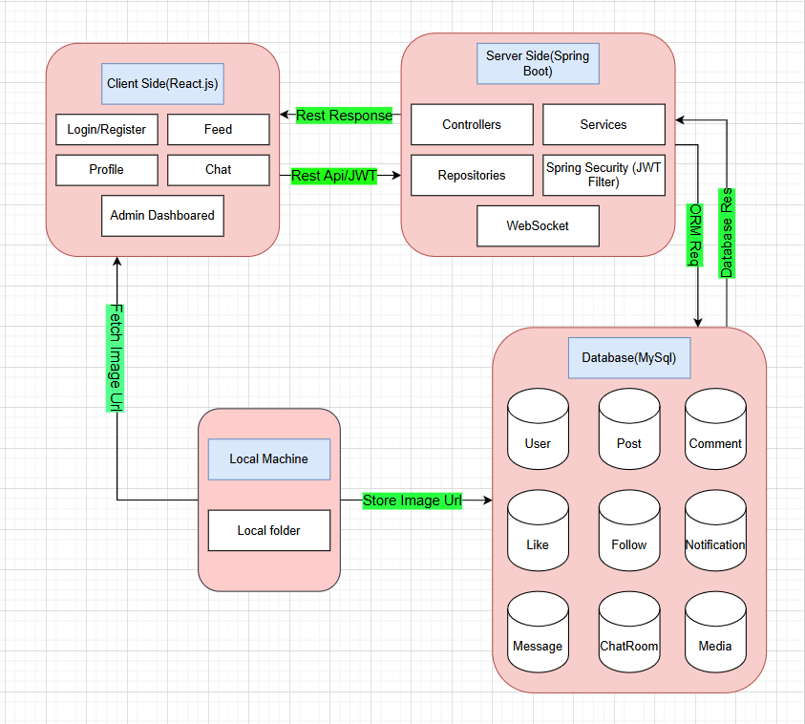

Entity Relationship Diagram

Data Dictionary

- User table:
Field | Type | Description
id | Long | Primary key that uniquely identifies each user
username | String | Unique username used for user identification and login
email | String | Unique email address associated with the user account
password | String | Encrypted password stored securely in the database
bio | String | Short personal description provided by the user
profileImageUrl | String | Stores the path or URL of the user’s profile image
role | Enum | Specifies the role of the user (USER or ADMIN)
status | Boolean | Indicates the permanent account status (active or banned)
profile | Boolean | Indicates whether the user profile is currently active or inactive
createdAt | Timestamp | Date and time when the user account was created

- Post table:
Field | Type | Description
id | Long | Primary key that uniquely identifies each post
caption | String | Text description written by the user for the post
createdAt | Timestamp | Date and time when the post was created
updatedAt | Timestamp | Date and time when the post was last updated
user_id | FK (User) | Foreign key referencing the user who created the post

- Media table:
Field | Type | Description
id | Long | Primary key that uniquely identifies each media record
url | String | Stores the path or cloud URL of the image/video
type | Enum (image/video) | Date and time when the post was created
updatedAt | Timestamp | Date and time when the post was last updated

- Comment table:
Field | Type | Description
id | Long | Primary key that uniquely identifies each comment
content | String | Text content of the comment
createdAt | Timestamp | Date and time when the comment was posted
user_id | FK (User) | Foreign key referencing the user who made the comment
post_id | FK (User) | Foreign key referencing the post on which the comment is made

- Like table:
Field | Type | Description
id | Long | Primary key that uniquely identifies each like record
user_id | FK (User) | Foreign key referencing the user who liked the post
post_id | FK (Post) | Foreign key referencing the liked post
createdAt | Timestamp | Date and time when the post was liked

- Follow table:
Field | Type | Description
id | Long | Primary key that uniquely identifies each follow relationship
follower_id | FK (User) | Foreign key referencing the user who follows another user
following_id | FK (User) | Foreign key referencing the user being followed
createdAt | Timestamp | Date and time when the follow action occurred

- Notification table:
Field | Type | Description
id | Long | Primary key that uniquely identifies each notification
type | Enum | Specifies notification type (LIKE, COMMENT, FOLLOW, MESSAGE)
message | String | Notification message displayed to the user
isRead | Boolean | Indicates whether the notification has been read
receiver_id | FK (User) | Foreign key referencing the user who receives the notification
sender_id | FK (User) | Foreign key referencing the user who triggered the notification
post_id | FK (Post) | References the related post

- Chatroom table:
Field | Type | Description
id | Long | Primary key that uniquely identifies each follow relationship
follower_id | FK (User) | Foreign key referencing the user who follows another user

- Message table:
Field | Type | Description
id | Long | Primary key that uniquely identifies each message
content | String | Text content of the message
createdAt | Timestamp | Date and time when the message was sent
isSeen | Boolean | Indicates whether the message has been seen by the receiver
sender_id | FK (User) | Foreign key referencing the user who sent the message
chatroom_id | FK (ChatRoom) | Foreign key referencing the chat room to which the message belongs

