The Evolution of AI Agents and Modern AI Engineering
Abubakar Adeel
Artificial intelligence has moved rapidly from systems that simply recognise patterns to systems that can read, write, reason, and act. At the centre of this shift are Large Language Models (LLMs). This report traces how plain LLM applications have evolved into autonomous AI agents, explains the core building blocks that make agents possible, namely tool calling, memory, and planning, then introduces multi-agent systems and closes with where AI engineering is heading.

1. LLM Applications
An LLM is a model trained on vast amounts of text to predict the next token, which gives it a broad ability to generate and understand language. An LLM application wraps this model in software so that ordinary users can benefit from it. The earliest and simplest form is the chatbot: the user types a question and the model replies. Building on this, AI assistants add structure and context, while AI copilots embed the model inside another tool to help in real time.
Real-world examples are now familiar. ChatGPT (OpenAI) and Claude (Anthropic) are conversational assistants; GitHub Copilot is a coding copilot that suggests code as a developer types. A particularly important pattern is Retrieval-Augmented Generation (RAG), where the application first retrieves relevant documents from a private knowledge base and feeds them to the LLM, so answers are grounded in the organisation’s own data rather than only the model’s training. The request and response flow of a basic LLM application is shown in Figure 1.
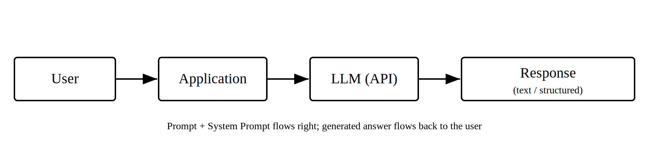

2. AI Agents
A plain LLM application answers a single prompt and stops. An AI agent goes further: given a goal, it decides what steps to take, uses tools to act in the world, observes the results, and repeats this loop until the task is complete. In short, a chatbot responds, but an agent acts. This distinction also separates an agent from a fixed workflow. A workflow follows pre-defined steps that the developer hardcodes, whereas an agent chooses its own steps dynamically based on the situation. Workflows are predictable and easy to control; agents are flexible and better suited to open-ended tasks. Figure 2 shows the internal loop of a typical single agent and how its components connect.
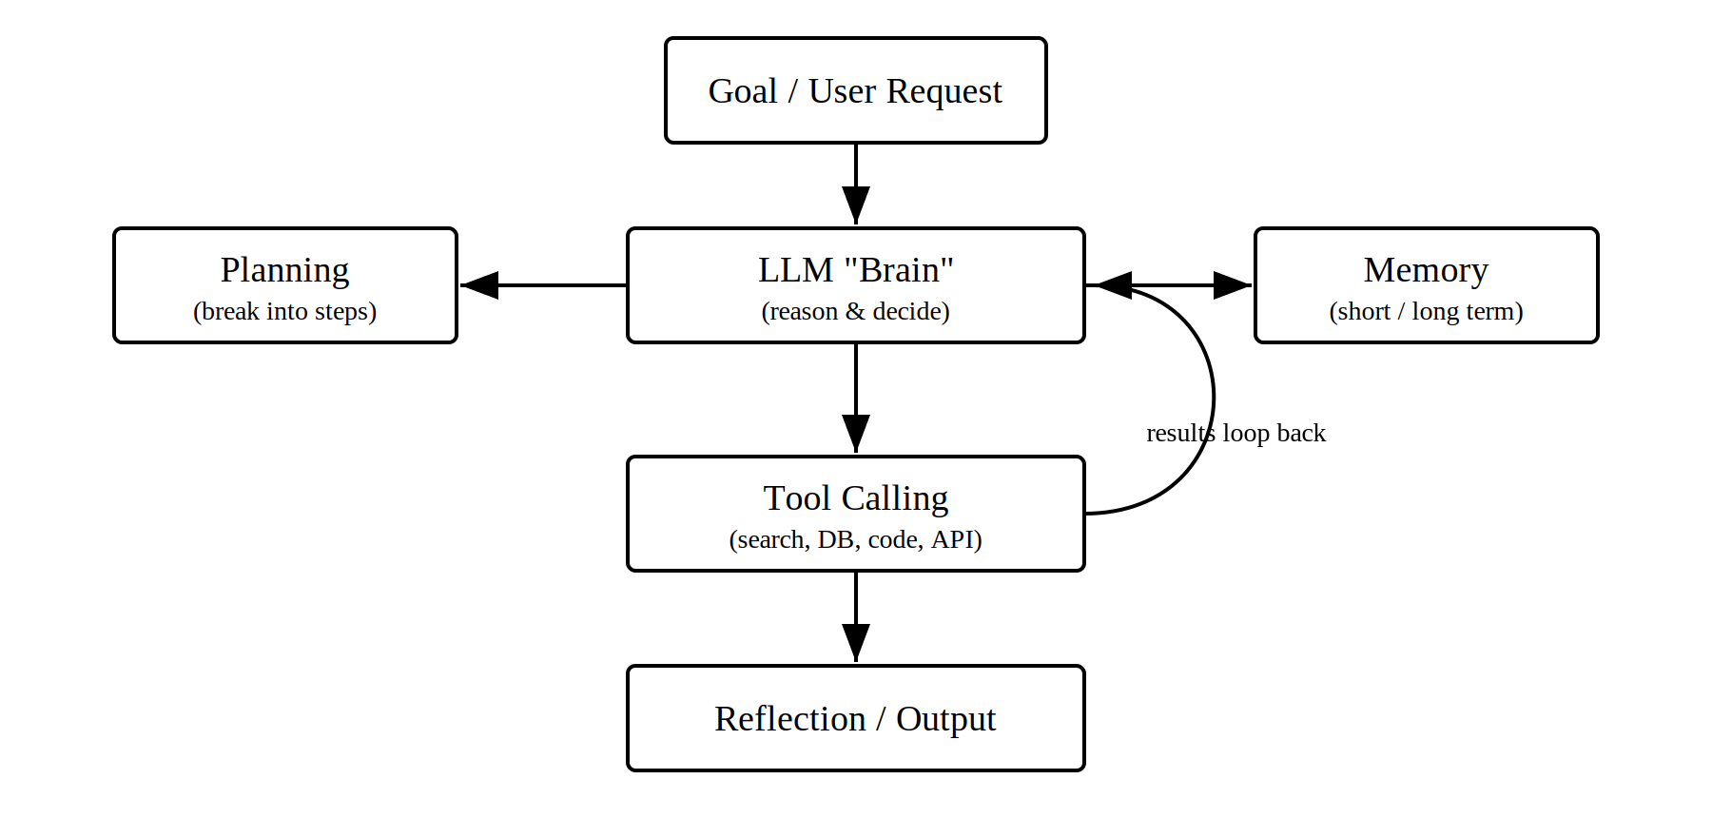

3. Tool Calling
Tool calling (also called function calling) is the mechanism that lets an agent do more than talk. The developer describes a set of tools, for example a web search, a database query, a calculator, or a code runner, and the model can decide when to call one and with what inputs. The tool runs as ordinary software, returns its result, and the model incorporates that result into its next step. This turns a language model into a system that can fetch live data, perform calculations reliably, and trigger real actions. For instance, an internal-audit agent could call a function that queries financial records and then reason over the values returned, instead of guessing them.

4. Memory
Because an LLM only “sees” what fits inside its context window, memory is what allows an agent to retain information across a longer task. Short-term memory holds the current conversation or working state. Long-term memory stores information outside the model, often in a database, so the agent can recall facts, past decisions, or earlier findings in future sessions. A common modern approach is a vector database, which stores text by meaning so the agent can retrieve the most relevant past information when needed. Memory is what makes an agent feel consistent and aware of history rather than starting fresh every time.

5. Planning
Planning is the agent’s ability to break a large goal into an ordered sequence of smaller steps before acting. Rather than attempting everything at once, the agent reasons about what must happen first, what depends on what, and in which order to use its tools. A closely related capability is reflection, where the agent reviews its own output, identifies mistakes, and corrects itself. Techniques such as chain-of-thought prompting encourage the model to think step by step, which improves the quality of both planning and reasoning.

6. Multi-Agent Systems
A single agent can struggle with complex tasks that span many different skills. A multi-agent system addresses this by using several specialised agents that collaborate, usually coordinated by an orchestrator or manager agent. For example, a research agent might gather information, an analysis agent might check and compute over it, and a writer agent might produce the final report. This mirrors how a human team divides work: each member focuses on what they do best, and a coordinator combines the results. Multi-agent systems are more powerful for large problems but require careful coordination.

7. The Future of AI Engineering
AI engineering is consolidating into a discipline of its own. Several trends stand out. Models are becoming more capable while small language models make local, low-cost, and private deployment practical. Tool use and standard protocols are maturing, making it easier to connect agents to real systems safely. Reliability, evaluation, and guardrails are growing in importance as agents take on higher-stakes work, so testing and oversight are becoming core engineering tasks rather than afterthoughts. The likely direction is dependable, domain-specific agents in finance, audit, healthcare, and operations that work alongside professionals, automating routine analysis while leaving judgement to humans.

Conclusion
The path from a simple LLM chatbot to autonomous, collaborating agents has been driven by a few key ideas: giving models tools to act, memory to remember, and the ability to plan and reflect. As these capabilities mature and reliability improves, AI engineering is moving toward practical, trustworthy agents that extend human expertise in specialised domains.

References
- Anthropic. “Building Effective Agents.” Anthropic Engineering Blog, 2024.
- OpenAI. “Function Calling and Tool Use.” OpenAI API Documentation, 2024.
- Wei, J. et al. “Chain-of-Thought Prompting Elicits Reasoning in Large Language Models.” 2022.
- Lewis, P. et al. “Retrieval-Augmented Generation for Knowledge-Intensive NLP Tasks.” 2020.
- Yao, S. et al. “ReAct: Synergizing Reasoning and Acting in Language Models.” 2023.

