
PRODUCTION SCREEN SPECIFICATION
v1.0 • Developer & Product Design Handoff
Mobile app + workplace web experience
Purpose Translate the approved Hearteli UX architecture and wireframes into build-level screen behaviour, states, permissions, analytics and acceptance criteria.

Core loop: CHECK IN → CHOOSE → NUDGE → UNDERSTAND → BE THERE

01 Locked Product Decisions
Hearteli is a consent-based emotional support platform. The MVP is successful when a member can privately check in, choose who may know, send or approve an Empathy Nudge™, and receive real human support without ambiguity about what was shared.
Decision | Locked requirement
Master brand | Hearteli — “Know when to be there.” Approved logo must not be altered.
Core mechanism | Empathy Nudge™ is the proprietary handoff from an authorised emotional signal to a useful human response.
Default privacy | Private by default. Sharing must be explicit, legible, revocable and relationship-specific.
Workplace boundary | Organisation payment never grants managers access to individual mood/check-in history.
Clinical boundary | Hearteli does not diagnose, continuously monitor, guarantee response, or present ordinary emotion as pathology.
AI boundary | AI may help phrase or suggest support; it must not impersonate a therapist or make diagnostic claims.

North-star test Does this screen help one human be there for another — without weakening privacy or consent?

02 Platform Structure & Navigation
The consumer mobile app remains intentionally simple. Workplace and therapist functions appear only when the user has those contexts.
Surface | Primary navigation | Notes
Mobile — Personal | Home • Circle • Check-In • Insights • More | Check-In remains the central action. Nudge entry points can appear contextually.
Mobile — Work context | Home • Circle • Check-In • Work • More | Personal check-in remains private; workspace data is visibly separated.
Recipient deep link | Nudge detail • Suggested action • Acknowledge / respond | A trusted recipient can act without navigating the full app.
Workplace web | Overview • Members/Roles • Resources • Aggregate Insights • Settings | No individual mood search or manager risk dashboard.
Therapist | Appointments • Clients authorised context • Availability • Settings | Only user-authorised context is visible.

Global mobile shell
- Persistent navigation: Home, Circle, Check-In, Insights, More.
- Check-In receives the strongest visual emphasis but must not feel urgent or coercive.
- Profile/avatar opens context switcher: Personal ↔ Workspace(s).
- Every shared-data screen surfaces “Who can see this?” near the action, not only in Settings.
- No hidden background sharing. Pending sends show delivery state: queued, sent, delivered where available, failed.

03 Shared Components & Design Behaviour
Component | Requirement
Primary button | Full-width on mobile when it is the main next action. Coral #F2645A. Disabled state must remain readable.
Secondary button | Ink text on white/cream with 1px neutral border. Never compete visually with consent-sensitive primary actions.
Mood choice | Label + icon/face + selected state. Colour is supportive only; never the sole meaning.
Privacy preview | Compact card: recipient(s), exact information shared, timing, edit link.
Person row | Avatar/initials, relationship, permission summary, status (active/pending/paused).
Nudge card | Sender, bounded state text, support preference, 1–3 suggested actions, acknowledgement actions.
Toast/banner | Calm status language. Avoid alarm-red except explicit urgent-safety flow.
Empty state | No guilt. Explain next useful action with one primary CTA.
Loading | Skeletons for lists; buttons show inline progress and are idempotent.
Sensitive lock-screen notification | Default to minimal detail; user can choose richer preview in notification settings.

04 Screen Inventory & IDs
ID | Screen | Primary user | Release
ONB-01 | Welcome / Splash | All | MVP
ONB-02 | How Hearteli works | Member | MVP
ONB-03 | Create account / Sign in | Member | MVP
ONB-04 | About you / use context | Member | MVP
ONB-05 | Privacy promise | Member | MVP
ONB-06 | Invite first Circle person | Member | MVP
HOME-01 | Personal home | Member | MVP
CHK-01 | Feeling | Member | MVP
CHK-02 | Optional context | Member | MVP
CHK-03 | What would help | Member | MVP
CHK-04 | Who can know | Member | MVP
CHK-05 | Share preview / confirmation | Member | MVP
CIR-01 | Circle list | Member | MVP
CIR-02 | Add / invite person | Member | MVP
CIR-03 | Relationship permissions | Member | MVP
CIR-04 | Invite acceptance | Trusted person | MVP
CIR-05 | Person detail / revoke | Member | MVP
NUD-01 | Nudge suggestion | Member | MVP
NUD-02 | Compose / edit nudge | Member | MVP
NUD-03 | Recipient preview | Member | MVP
NUD-04 | Recipient notification / detail | Trusted person | MVP
NUD-05 | Suggested action | Trusted person | MVP
NUD-06 | Acknowledgement / cannot help | Trusted person | MVP
SUP-01 | Support conversation handoff | Both | MVP
SUP-02 | Support outcome prompt | Member | MVP
INS-01 | Insights overview | Member | MVP
INS-02 | Check-in history | Member | MVP
INS-03 | Support history | Member | MVP
WRK-01 | Work home / consent status | Employee | MVP
WRK-02 | Work support contacts | Employee | MVP
WRK-03 | Manager recipient view | Manager | MVP
WRK-04 | Workspace admin overview | Owner/HR | MVP
WRK-05 | Members & roles | Owner/HR | MVP
WRK-06 | Aggregate insights | Owner/HR | MVP
THR-01 | Therapist directory | Member | MVP
THR-02 | Therapist profile | Member | MVP
THR-03 | Booking | Member | MVP
THR-04 | Share context | Member | MVP
SET-01 | Settings | Member | MVP
SET-02 | Privacy & consent | Member | MVP
SET-03 | Notifications & quiet hours | Member | MVP
SET-04 | Data export / delete | Member | MVP
SAFE-01 | Immediate support / crisis resources | Member | MVP

05 Onboarding Screens
ONB-01 Welcome / Splash
Establish Hearteli as a warm human-support product before asking for data or permissions.
Specification | Build requirement
Entry / trigger | App launch; logged-out user.
Primary UI | Approved Hearteli logo, tagline “Know when to be there.”, one-sentence proposition, Get Started, Sign In.
Primary actions | Get Started → ONB-02; Sign In → auth.
Rules / validation | No notification/contact permission prompt on this screen. Preserve safe-area spacing; logo is approved asset only.
Required states | Loading; offline with retry; signed-in redirect.
Analytics | onboarding_viewed, get_started_tapped

ONB-02 How Hearteli Works
Explain the closed loop in plain language.
Specification | Build requirement
Entry / trigger | From Welcome.
Primary UI | 3–4 cards: Check in privately → choose who may know → gentle nudge → human support.
Primary actions | Continue; Skip explanation.
Rules / validation | Avoid diagnostic claims. Keep to one screen or short swipe sequence; progress indicator optional.
Required states | First visit; returning after interrupted onboarding.
Analytics | how_it_works_viewed, onboarding_continue

ONB-03 Create Account / Sign In
Create one Hearteli identity that can later hold multiple roles/contexts.
Specification | Build requirement
Entry / trigger | Continue from ONB-02 or direct sign-in.
Primary UI | Email/phone/social sign-in as supported; password/passkey; terms links.
Primary actions | Create account; Sign in; Forgot password.
Rules / validation | Validate identity fields; rate-limit auth; do not ask workplace/therapy questions yet.
Required states | Invalid credentials; existing account; network error; verification pending.
Analytics | signup_started, signup_completed, login_completed

ONB-04 About You / Use Context
Personalise onboarding without locking user into a single role.
Specification | Build requirement
Entry / trigger | Post-auth first run.
Primary UI | Name, optional avatar, “I’m here for: myself / partner / family / my team / clients / other”.
Primary actions | Select one or multiple; Continue.
Rules / validation | Choices tailor copy only; they do not grant data access.
Required states | No selection; multi-selection; edit later.
Analytics | use_context_selected

ONB-05 Privacy Promise
Build trust before contact/notification permissions.
Specification | Build requirement
Entry / trigger | After profile.
Primary UI | Plain-language cards: Private by default; you choose who knows; you can revoke; workplaces cannot see private moods by default.
Primary actions | I understand; View privacy details.
Rules / validation | Must be readable without legal copy. Link to policy but do not make policy acceptance substitute for explicit sharing consent.
Required states | Policy unavailable offline; accessibility enlarged text.
Analytics | privacy_promise_viewed, privacy_promise_acknowledged

ONB-06 Invite First Circle Person
Invite support without making activation depend on contacts permission.
Specification | Build requirement
Entry / trigger | After privacy promise.
Primary UI | Name/contact method, relationship, permission summary, Skip for now.
Primary actions | Invite; Choose from contacts; Skip.
Rules / validation | Contacts permission requested only after user chooses “from contacts”. No private data sent before invite acceptance.
Privacy / consent | Invitee receives no check-in data until they accept and the member configures permissions.
Required states | Invite pending; contact already in Circle; invalid contact; skipped.
Analytics | circle_invite_started, circle_invite_sent, onboarding_skipped_circle

06 Circle & Relationship Permissions
CIR-01 Hearteli Circle
Show trusted relationships and their permission status at a glance.
Specification | Build requirement
Entry / trigger | Bottom nav Circle.
Primary UI | People list; relationship label; status; permission summary; Add someone.
Primary actions | Open person; Add person; filter active/pending/paused.
Rules / validation | Never expose private content in list rows. Pending invite is visually distinct.
Required states | Empty; one person; many people; invite pending; paused.
Analytics | circle_viewed, circle_person_opened

CIR-02 Add / Invite Person
Create a relationship record and invitation.
Specification | Build requirement
Entry / trigger | Add someone.
Primary UI | Name, relationship type, contact method, optional note about why inviting.
Primary actions | Send invite; Cancel.
Rules / validation | Require relationship type; deduplicate contact; no data-sharing permission automatically implied by invitation.
Required states | Already invited; contact invalid; send failed.
Analytics | circle_invite_sent

CIR-03 Relationship Permissions
Configure exactly what this person may receive.
Specification | Build requirement
Entry / trigger | After invite accepted or from person detail.
Primary UI | Toggles: can receive shared mood signal; can receive support preference; can see selected history/trends (default off); quiet hours; manual-only vs ask-first rule.
Primary actions | Save; revoke all; preview what recipient can see.
Rules / validation | Relationship-specific, explicit, revocable. High-sensitivity permissions default off.
Privacy / consent | Do not offer “all data” shortcut. Reconfirm when relationship role changes materially.
Required states | Recipient not accepted; workspace relationship; role changed; permission conflict.
Analytics | permission_changed, permission_previewed

CIR-04 Invite Acceptance
Allow recipient to understand the relationship before accepting.
Specification | Build requirement
Entry / trigger | Deep link / in-app invite.
Primary UI | Inviter name, relationship, what acceptance means, notification preferences.
Primary actions | Accept; Decline.
Rules / validation | Accepting a Circle invite does not automatically expose historical data. Recipient chooses notification permissions separately.
Required states | Expired invite; already accepted; declined.
Analytics | circle_invite_accepted, circle_invite_declined

CIR-05 Person Detail / Revoke
Manage an established trusted relationship.
Specification | Build requirement
Entry / trigger | Tap person in Circle.
Primary UI | Relationship, current permissions, recent nudge status (bounded), quiet hours, remove/revoke.
Primary actions | Edit permissions; pause nudges; remove.
Rules / validation | Revoke takes effect immediately for future access. Historical retention follows policy; explain consequences before removal.
Required states | Active; paused; pending; removed.
Analytics | circle_permission_revoked, circle_person_removed

07 Daily Check-In
CHK-01 Feeling
Capture a fast, non-clinical emotional signal.
Specification | Build requirement
Entry / trigger | Home Check-In CTA or scheduled reminder.
Primary UI | Question “How are you feeling today?”; 5 labelled options; optional skip/close.
Primary actions | Select; Next.
Rules / validation | Default path should take <30 sec. No guilt for missed days. Do not call choices scores.
Required states | No selection; selection; offline draft.
Analytics | checkin_started, feeling_selected

CHK-02 Optional Context
Offer context without making it mandatory.
Specification | Build requirement
Entry / trigger | After feeling.
Primary UI | Optional note; quick tags e.g. work, family, sleep, overwhelmed, other.
Primary actions | Add note/tags; Skip; Next.
Rules / validation | Notes remain private unless explicitly included later. Character limit; no automatic interpretation shown as diagnosis.
Required states | Empty; note; tag only; offline.
Analytics | checkin_context_added

CHK-03 What Would Help
Let the member express support preference.
Specification | Build requirement
Entry / trigger | After optional context, especially low/neutral check-ins.
Primary UI | Choices: check in with me, call me, practical help, give me space, just know, not sure.
Primary actions | Select one or multiple; Next; Skip.
Rules / validation | Support preference may be shared only if member chooses/standing rule permits.
Required states | No preference; multiple preferences; custom optional.
Analytics | support_preference_selected

CHK-04 Who Can Know
Choose privacy outcome for this check-in.
Specification | Build requirement
Entry / trigger | After preference.
Primary UI | Keep private; selected Circle people; eligible approved work support person(s); rule suggestion if configured.
Primary actions | Choose recipients; Keep private; Continue.
Rules / validation | No broadcast by default. Show per-recipient permission compatibility. If no Circle, keep private and gently offer setup later.
Privacy / consent | This is the decisive consent event for the check-in.
Required states | No Circle; recipient paused; work recipient unavailable.
Analytics | share_scope_selected

CHK-05 Share Preview / Confirmation
Make the exact disclosure legible before send.
Specification | Build requirement
Entry / trigger | After selecting share.
Primary UI | Recipient(s); exact bounded state; optional support preference; excluded private note indicator; timing; edit links.
Primary actions | Confirm & Send/Approve Nudge; Edit; Keep private.
Rules / validation | No pre-checked hidden detail. Sending is idempotent. Confirmation copy uses “share” not “alert”.
Privacy / consent | Preview must match the actual payload sent.
Required states | Manual share; rule-prompt share; delivery queued/failed.
Analytics | share_preview_viewed, shared_signal_confirmed, checkin_completed

08 Empathy Nudge™
Default trigger policy A low check-in is not automatically an alert. Hearteli may suggest a nudge or apply an explicit user rule, but the MVP default is ask-first unless the user has clearly configured otherwise.

NUD-01 Nudge Suggestion
Offer help turning a check-in into support.
Specification | Build requirement
Entry / trigger | After CHK-05 or from pattern prompt.
Primary UI | Reason for suggestion in non-diagnostic language; proposed recipient; proposed bounded message.
Primary actions | Review nudge; Not now; Choose someone else.
Rules / validation | Never say Hearteli “detected depression/anxiety”. Respect rate limits and quiet hours.
Required states | Recipient unavailable; repeated signal; no eligible recipient.
Analytics | nudge_suggested, nudge_dismissed

NUD-02 Compose / Edit Nudge
Let the member adjust what the recipient will see.
Specification | Build requirement
Entry / trigger | Review nudge.
Primary UI | Editable short message seeded from authorised state; support preference; optional AI rewrite buttons such as “shorter / warmer”.
Primary actions | Save; Preview; Cancel.
Rules / validation | AI suggestions are optional and never add facts the user did not provide. Avoid pressure or guilt language.
Required states | Default text; edited; AI suggestion unavailable.
Analytics | nudge_composed, nudge_ai_rewrite_used

NUD-03 Recipient Preview
Final sender-side view.
Specification | Build requirement
Entry / trigger | From compose.
Primary UI | Recipient identity, exact message, suggested-action category, send timing, lock-screen privacy preview.
Primary actions | Send now; Schedule respecting quiet hours; Edit.
Rules / validation | Check recipient eligibility and relationship permission at send time.
Required states | Permission changed; recipient paused; connectivity failure.
Analytics | nudge_send_confirmed

NUD-04 Recipient Notification / Detail
Tell the trusted person enough to respond without over-sharing.
Specification | Build requirement
Entry / trigger | Push/deep link/in-app inbox.
Primary UI | Sender; bounded state; support preference if authorised; reminder “You don’t need to fix anything”; suggested actions.
Primary actions | View suggestion; I’ll check in; I’ll give space; I can’t right now.
Rules / validation | Default lock-screen text minimises sensitivity. No diagnosis, risk score or private note unless explicitly shared.
Privacy / consent | If access is revoked before viewing, show a neutral “This update is no longer available.”
Required states | Unread; opened; expired/retracted; sender revoked before open.
Analytics | nudge_delivered, nudge_opened

NUD-05 Suggested Action
Turn awareness into a proportionate next step.
Specification | Build requirement
Entry / trigger | Recipient taps suggestion.
Primary UI | 1–3 contextual actions based on relationship and preference: send message, call when free, practical help, give space.
Primary actions | Choose action; copy suggested message; open call/message app.
Rules / validation | Suggestions must not imply obligation, diagnosis or professional responsibility.
Required states | No suggestion; recipient unsupported channel.
Analytics | support_action_selected

NUD-06 Acknowledge / Cannot Help
Close the recipient side honestly.
Specification | Build requirement
Entry / trigger | From Nudge detail/action.
Primary UI | Acknowledgement choices; optional timeframe; “I can’t right now”.
Primary actions | Acknowledge; decline; optionally allow another authorised person to be suggested to member.
Rules / validation | Do not shame recipient. Sender sees bounded status only, not private recipient commentary.
Required states | Acknowledged; cannot help; no response.
Analytics | nudge_acknowledged, recipient_cannot_help

09 Support & Closed Loop
SUP-01 Support Conversation Handoff
Move from Hearteli into real human contact.
Specification | Build requirement
Entry / trigger | Recipient chooses message/call or in-app message if enabled.
Primary UI | Suggested opening; external/in-app handoff; privacy reminder.
Primary actions | Message; Call; Mark done.
Rules / validation | Hearteli should not try to become the conversation if ordinary messaging is sufficient.
Required states | External app unavailable; in-app chat disabled.
Analytics | support_contact_started

SUP-02 Support Outcome Prompt
Learn whether the loop helped without scoring relationships.
Specification | Build requirement
Entry / trigger | Suitable delay after acknowledged nudge.
Primary UI | Member prompt: “Did you feel supported?” choices Yes / A little / Not yet / Prefer not to say; optional private note.
Primary actions | Submit; Skip.
Rules / validation | Never expose the response as a score for the trusted person or workplace.
Privacy / consent | Private product feedback; not manager-visible.
Required states | No acknowledgement; delayed prompt; skipped.
Analytics | support_outcome_submitted

10 Home & Insights
HOME-01 Personal Home
Provide a calm next-best-action overview.
Specification | Build requirement
Entry / trigger | Bottom nav Home.
Primary UI | Greeting; Check-In CTA; recent support; pending nudge; quick actions; optional therapist resource.
Primary actions | Check in; open Circle; open nudge; view insight.
Rules / validation | Avoid dashboard overload. No “streak failure”. Empty state should still feel complete.
Required states | New user; checked in today; pending nudge; no Circle.
Analytics | home_viewed, home_primary_action

INS-01 Insights Overview
Help the member recognise patterns without clinical interpretation.
Specification | Build requirement
Entry / trigger | Bottom nav Insights.
Primary UI | Week/month/year trends; labelled mood distribution; support received; reflective copy.
Primary actions | Change period; open history; export.
Rules / validation | No risk score, diagnosis or normative “healthy score”. Colour not sole carrier.
Required states | Insufficient data; sparse data; full history.
Analytics | insights_viewed

INS-02 Check-In History
Let member review/edit private history where policy allows.
Specification | Build requirement
Entry / trigger | From Insights.
Primary UI | Chronological entries; private/shared indicator; support outcome.
Primary actions | Open entry; delete/export; edit note if supported.
Rules / validation | Show what was shared historically versus what remains private.
Required states | No history; offline; deleted entry placeholder if required.
Analytics | checkin_history_viewed

INS-03 Support History
Show supportive interactions without ranking people.
Specification | Build requirement
Entry / trigger | From Insights/Home.
Primary UI | Nudges sent/received, acknowledgement state, member-private outcome.
Primary actions | Open interaction; adjust future permissions.
Rules / validation | No leaderboard, responsiveness score or “best supporter”.
Required states | No support events; revoked relationship.
Analytics | support_history_viewed

11 Hearteli for Work
Workplace red line The employer may configure the support environment; it does not own employee emotional data. “Organisation pays” is not consent.

WRK-01 Work Home / Consent Status
Separate workplace support from personal wellbeing.
Specification | Build requirement
Entry / trigger | Switch to workspace context.
Primary UI | Workspace name; employee consent status; support contacts; resources; voluntary check-in/share options.
Primary actions | Manage work consent; view resources; choose support contact.
Rules / validation | Personal check-in history is not copied into workspace. Work context must be visually labelled.
Privacy / consent | Employee can use Hearteli personally even if work sharing is off.
Required states | No work consent; partial consent; multiple workspaces.
Analytics | workspace_home_viewed

WRK-02 Work Support Contacts
Show approved human support routes.
Specification | Build requirement
Entry / trigger | From Work home.
Primary UI | Manager/people leader only if authorised; HR/wellbeing contact; EAP; therapist/resource links.
Primary actions | Choose contact; edit consent; contact resource.
Rules / validation | Manager eligibility must reflect employee consent, not org hierarchy alone.
Required states | No approved contacts; manager changed; contact unavailable.
Analytics | work_support_contact_selected

WRK-03 Manager Recipient View
Help a manager respond only when explicitly involved.
Specification | Build requirement
Entry / trigger | Employee-authorised nudge.
Primary UI | Bounded employee signal; support preference; suggested manager-appropriate actions; policy/resource links.
Primary actions | Acknowledge; check in; refer to resource; cannot help now.
Rules / validation | No history search, mood trend, colleague comparison or risk scoring.
Required states | Consent revoked; manager changed; expired signal.
Analytics | manager_nudge_opened, manager_support_action

WRK-04 Workspace Admin Overview
Give owners/HR operational controls without private-content access.
Specification | Build requirement
Entry / trigger | Web dashboard.
Primary UI | Activation/adoption aggregates; configured resources; support-role coverage; privacy threshold status.
Primary actions | Invite members; configure resources; manage roles; view aggregate trends if thresholds met.
Rules / validation | Suppress small cohorts. Do not infer individual state.
Required states | Below privacy threshold; no adoption; multi-location.
Analytics | workspace_admin_viewed

WRK-05 Members & Roles
Manage membership and authorised organisational roles.
Specification | Build requirement
Entry / trigger | Admin navigation.
Primary UI | Members, role, invite status, work support role, access audit.
Primary actions | Invite; deactivate; assign role; configure support route.
Rules / validation | Role changes trigger employee consent re-confirmation where relevant. Least privilege.
Required states | Pending; suspended; role change conflict.
Analytics | workspace_role_changed

WRK-06 Aggregate Insights
Show privacy-preserving organisational trends only where appropriate.
Specification | Build requirement
Entry / trigger | Admin dashboard.
Primary UI | Participation/adoption; resource usage; optional cohort trends above minimum group size.
Primary actions | Period/filter; export aggregate report.
Rules / validation | No “lowest mood team”, individual ranking or manager drill-down. Apply minimum cohort and data suppression.
Privacy / consent | Implementation must support policy-configurable minimum cohort size.
Required states | Insufficient sample; one location; trend unavailable.
Analytics | workspace_aggregate_viewed

12 Therapy & Professional Support
THR-01 Therapist Directory
Offer professional support as an optional pathway.
Specification | Build requirement
Entry / trigger | More → Therapy or contextual resource.
Primary UI | Search/filter; modality; telehealth/in-person; availability; location where relevant.
Primary actions | Open profile; filter.
Rules / validation | Avoid implying provider endorsement beyond actual vetting status.
Required states | No results; location unavailable; loading.
Analytics | therapist_directory_viewed

THR-02 Therapist Profile
Help user decide whether to book.
Specification | Build requirement
Entry / trigger | Directory result.
Primary UI | Credentials/verified status, focus areas, modality, fees, availability, bio.
Primary actions | Book; Save; Back.
Rules / validation | Display only verified/provider-supplied claims; show emergency boundary.
Required states | No availability; profile incomplete.
Analytics | therapist_profile_viewed

THR-03 Booking
Book/reschedule/cancel clearly.
Specification | Build requirement
Entry / trigger | Therapist profile or appointments.
Primary UI | Date/time, format, timezone, fee, cancellation terms, confirmation.
Primary actions | Confirm; reschedule; cancel.
Rules / validation | Timezone explicit. Payment requirements only if integrated.
Required states | Slot taken; payment fail; reschedule.
Analytics | therapy_booking_started, therapy_booking_completed

THR-04 Share Context
Allow member to optionally share selected Hearteli context before session.
Specification | Build requirement
Entry / trigger | During/after booking.
Primary UI | Checkboxes for selected trends/notes/date range; exact preview; expiry if supported.
Primary actions | Share selected; Skip.
Rules / validation | Default no sharing. Therapist access is scoped and revocable; never auto-share full history.
Privacy / consent | Treat this as a separate consent grant from booking.
Required states | No selected data; revoke before session.
Analytics | therapist_context_shared

13 Settings, Privacy & Safety
SET-01 Settings
Central account control surface.
Specification | Build requirement
Entry / trigger | More → Settings.
Primary UI | Profile, Notifications, Privacy & Consent, Safety resources, Security, Data controls, Help.
Primary actions | Navigate.
Rules / validation | Keep sensitive settings one level deep at most.
Required states | Normal; restricted child/managed context if later added.
Analytics | settings_viewed

SET-02 Privacy & Consent
Let the user understand and control every active sharing relationship.
Specification | Build requirement
Entry / trigger | Settings.
Primary UI | Active relationships, data categories, workspace grants, therapist grants, audit summary.
Primary actions | Edit/revoke; view “who can see what”.
Rules / validation | Revocation immediate for future access; confirm consequential removals.
Required states | No grants; many grants; role changes.
Analytics | privacy_center_viewed, consent_revoked

SET-03 Notifications & Quiet Hours
Control timing and lock-screen sensitivity.
Specification | Build requirement
Entry / trigger | Settings.
Primary UI | Personal reminders, nudge notifications, quiet hours, sensitive preview level.
Primary actions | Save; test notification optional.
Rules / validation | Urgent safety resources are not ordinary notification settings. Respect OS-level permissions.
Required states | OS disabled; quiet hours crossing midnight.
Analytics | notification_setting_changed

SET-04 Data Export / Delete
Give transparent data control.
Specification | Build requirement
Entry / trigger | Settings → Data.
Primary UI | Export data; delete account; retention explanation; pending requests.
Primary actions | Request export; request deletion; cancel pending if policy permits.
Rules / validation | Strong re-auth for deletion. Do not use dark patterns.
Required states | Export processing; delete cooling-off if policy; failure.
Analytics | data_export_requested, account_delete_requested

SAFE-01 Immediate Support / Crisis Resources
Switch from normal support UX to clear immediate options when the member explicitly indicates they may be unsafe.
Specification | Build requirement
Entry / trigger | Explicit urgent-safety selection or supported high-risk self-report path.
Primary UI | Jurisdiction-aware emergency services/crisis resources; contact trusted person; go to safe place; clear “Hearteli is not emergency monitoring”.
Primary actions | Call/resource link; contact trusted person; return when safe.
Rules / validation | Do not rely on nudge as sole safety action. Do not promise monitoring. Avoid hiding resources.
Privacy / consent | Resource list must be jurisdiction-aware and maintained separately from the app release.
Required states | Location unavailable; resource data unavailable; offline fallback list.
Analytics | safety_screen_viewed, crisis_resource_selected

14 Notification Matrix
Event | Recipient | Default copy intent | Sensitivity | Rule
Daily check-in reminder | Member | “How are you feeling today?” | Low | User scheduled; quiet hours respected.
Circle invitation | Trusted person | “[Name] invited you to their Hearteli Circle.” | Low | No emotional data in invite.
Empathy Nudge lock screen | Trusted person | “Someone you care about could use a check-in.” | Medium | Default privacy-safe text; richer preview optional.
Empathy Nudge in-app | Trusted person | Bounded authorised state + support preference. | Medium | Shown only after authentication where configured.
Recipient acknowledgement | Member | “[Name] saw your nudge and plans to check in.” | Low | No false certainty that support happened.
Delivery failure | Member | “We couldn’t deliver that nudge.” | Medium | Offer another authorised channel/person.
Work support nudge | Authorised manager/support person | Privacy-safe notification; details after auth. | Medium | Only if employee authorises.
Therapy reminder | Member | Appointment time/provider. | Low | Respect calendar/timezone settings.

15 State, Error & Edge-Case Requirements
Scenario | Required behaviour
No Circle yet | Check-in remains fully usable; after completion offer “Add someone you trust” without blocking.
Invite pending | No private data can be sent to the pending person.
Recipient paused notifications | Explain that delivery is paused and offer another authorised person or later send.
Recipient cannot help | Do not shame; optionally suggest another eligible person to member.
Network offline | Save check-in locally as private draft; do not imply share was sent until sync confirms.
Send retried | Use idempotency key; user must not create duplicate nudges.
Consent revoked mid-flow | Stop delivery/access and refresh preview; explain change neutrally.
Manager changes | Existing employee consent does not silently follow the new manager; reconfirm.
Multiple workspaces | Consent and support routes are scoped per workspace.
Relationship ends | Remove/revoke without requiring a reason.
Missed check-ins | No failed-streak or guilt language. Offer a fresh check-in.
Deleted account/contact | Show neutral unavailable state; do not leak historical content beyond policy.

16 Analytics Event Schema
Analytics must measure whether Hearteli creates useful support without collecting more sensitive content than needed. Event properties should use IDs/categories rather than raw notes or message text.
Event | Allowed properties
checkin_started | member_id pseudonym, context(personal/work), entry_point
checkin_completed | feeling_category, support_preference_category, shared:boolean
share_preview_viewed | recipient_count, recipient_type(s), payload_categories
shared_signal_confirmed | recipient_count, rule/manual, delivery_channel
nudge_suggested | trigger_type, eligible_recipient_count
nudge_send_confirmed | recipient_type, timing(now/scheduled)
nudge_opened | recipient_type, time_to_open_bucket
support_action_selected | action_category
nudge_acknowledged | acknowledgement_category
support_outcome_submitted | outcome_category only; no private note
consent_revoked | relationship_type, permission_category
workspace_role_changed | from_role, to_role
therapy_booking_completed | format, lead_time_bucket
safety_screen_viewed | entry_reason_category; avoid raw disclosure

Do not log Raw journal text, private nudge message body, therapist notes, crisis narrative, or full contact identifiers in analytics.

17 API / Data Contract Requirements
Endpoint names below are illustrative. The implementation may remain Django/DRF, but the behavioural contracts are build requirements.
Object | Minimum fields | Behavioural requirement
CheckIn | id, member_id, feeling, optional context tags/note, support preference, created_at, privacy state | Create private first; sharing is a separate event.
CircleRelationship | member_id, contact_user/invite, relationship type, status, permission set, quiet hours | One member may configure different permissions per person.
ConsentGrant | grantor, grantee/context, data categories, purpose, scope, effective/expiry, revoked_at | Immutable audit history + current effective state.
SharedSignal | source_checkin_id, authorised payload snapshot, recipient(s), sender confirmation, status | Snapshot exact payload so later edits do not rewrite history.
EmpathyNudge | shared_signal_id, recipient, suggested action categories, delivery status/timestamps | Separate sent/delivered/opened/acknowledged.
SupportOutcome | member_id, nudge_id, private outcome category, optional private note | Not visible to recipient/employer by default.
WorkspaceMembership | workspace_id, user_id, role, status | Role does not imply emotional-data permission.
WorkspaceConsent | employee_id, workspace/support person, data category, scope, revoked_at | Separate from membership terms.
TherapistContextGrant | member, therapist, selected objects/date range, expiry, revoked_at | Default no access.

Delivery semantics
- All share/nudge creation endpoints must support idempotency to prevent double-send on retries.
- Delivery status must distinguish created, queued, sent, failed, delivered (if channel supports), opened (if app), acknowledged.
- Consent is revalidated at the moment of access/send, not only when the flow was opened.
- Sensitive payloads should be minimised in push providers and lock-screen previews.
- Permission/audit events should be timestamped and attributable without copying private content into logs.

18 Accessibility & Interaction Acceptance
Area | Acceptance requirement
Touch targets | Minimum 44×44 pt for interactive controls.
Text | Support dynamic text / OS scaling without clipping. Avoid ultra-light body weights.
Colour | Mood, consent and urgency never conveyed by colour alone.
Screen reader | Controls have meaningful labels; grouped mood options announce label + selected state.
Focus order | Logical top-to-bottom; modals trap focus correctly on web.
Motion | Reduced-motion preference disables decorative transitions; no essential meaning depends on animation.
Contrast | Text/action contrast meets WCAG AA target for supported surfaces.
Language | Plain, non-judgemental, non-diagnostic; no “failed streak”, “bad score”, “abnormal mood”.
Privacy | Who-can-see information is reachable without navigating away from the decision screen.

19 QA Acceptance Scenarios
ID | Test | Pass condition
Q01 | New member completes onboarding without granting contacts permission. | Account created; app usable; Circle step skippable.
Q02 | Member checks in and keeps it private. | No recipient event or notification created.
Q03 | Member shares a bounded signal with one Circle person. | Preview exactly matches recipient payload.
Q04 | Private note exists but is excluded from share. | Recipient never receives note or derivative text.
Q05 | Recipient invite is pending. | Cannot select them for private share.
Q06 | Nudge delivery fails. | Member sees failed state and alternate authorised options.
Q07 | Recipient selects “I can’t right now”. | No shame copy; member can choose another eligible person.
Q08 | Member revokes permission before recipient opens nudge. | Recipient content becomes unavailable according to policy.
Q09 | Employee joins workspace with work sharing off. | Personal use works; manager sees no personal mood/check-ins.
Q10 | Employee explicitly chooses manager for one share. | Manager sees only that authorised payload and suggested action.
Q11 | Manager changes role/person. | Old consent does not transfer automatically.
Q12 | Admin opens aggregate dashboard below cohort threshold. | Sensitive aggregate is suppressed.
Q13 | Member shares selected context with therapist. | Only selected range/data appears; revocation works.
Q14 | Member explicitly indicates immediate danger. | Normal nudge flow diverts to immediate-support screen with jurisdiction-aware resources.
Q15 | Member is offline during check-in. | Private draft saved; no sent state until confirmed sync.
Q16 | User increases font size significantly. | Core flows remain readable and actionable without clipping.

20 Build Sequence & Definition of Done
Sprint | Build slice | Exit criterion
1 | Identity + onboarding + navigation | User understands Hearteli, creates account, enters app without forced contacts/notifications.
2 | Private Check-In + history | Check-in complete in <30 sec on happy path; private by default.
3 | Circle + invite + permissions | Invite/accept/configure/revoke works with clear permission preview.
4 | Empathy Nudge™ sender flow | Member can approve exact payload and deliver one nudge safely.
5 | Recipient flow + acknowledgement | Recipient understands what to do and member gets bounded acknowledgement.
6 | Support outcome + insights | Closed loop works without relationship scoring.
7 | Workspaces + consent + admin | Organisation can operate Hearteli without seeing private individual mood data.
8 | Therapy pathway + authorised sharing | Booking and selected-context consent are separate and revocable.
9 | Safety, accessibility, notifications, QA | Core edge cases, privacy and accessibility acceptance tests pass.

Definition of done A real member can move through START → CIRCLE → CHECK IN → SHARE → NUDGE → ACT → REVIEW; every disclosure is explainable, revocable and testable; a workplace cannot see personal mood data without explicit employee consent.

Appendix A — Approved Product Experience Overview
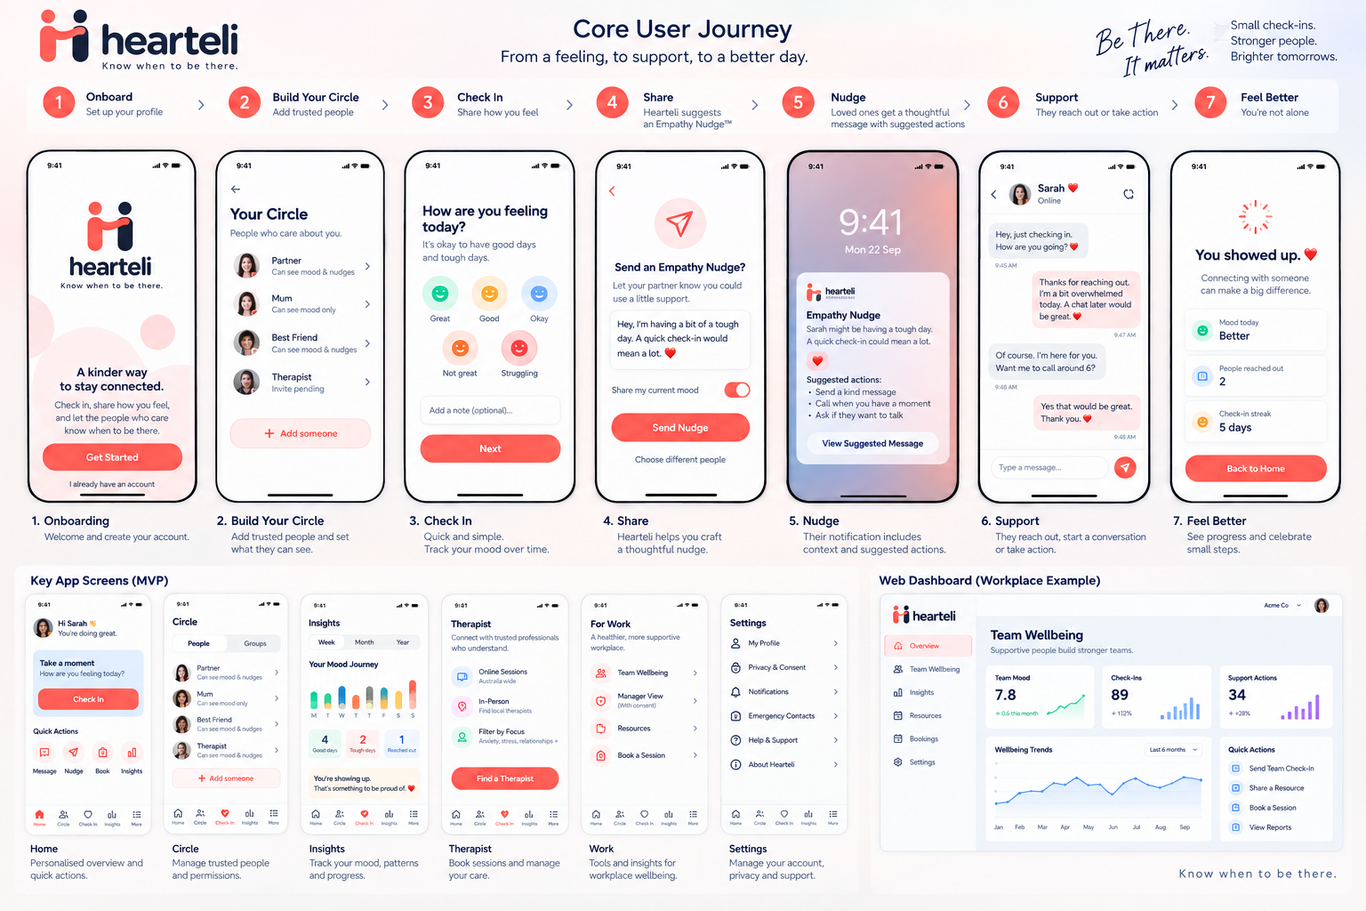

Appendix B — Approved Core Flow Wireframes
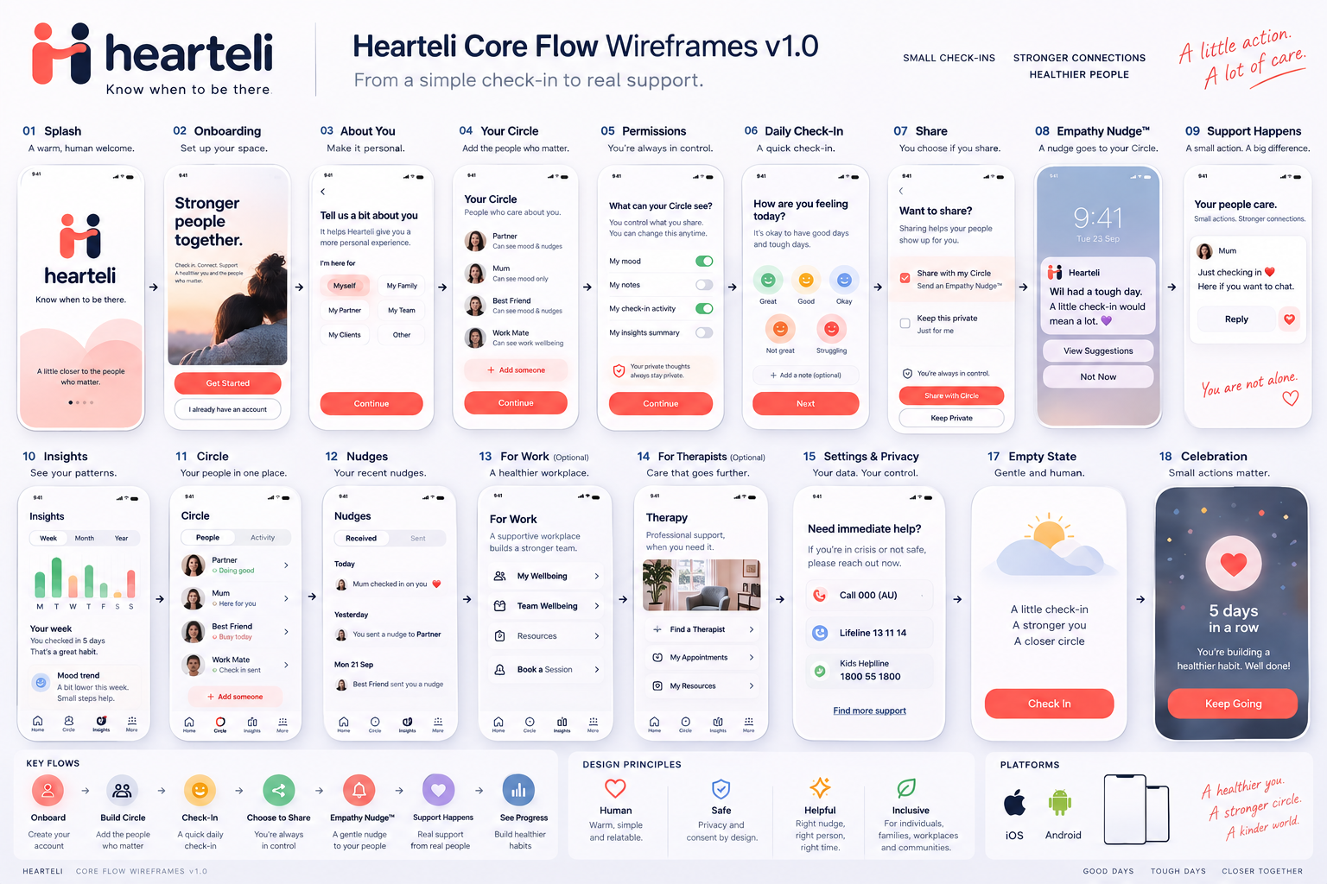

Appendix C — Approved Visual Brand Board
