 | NAMAL UNIVERSITY MIANWALI
 | Department of Computer Science
 | Web Application Development — Assignment 1

Instructor: | Ammar Ahmad Khan
Due Date: | 20-March-2026
Student Name: | Abu Bakar
Roll Number: | NUM-BSCS-2022-41

1. Project Overview
Rumi House Hub is a student engagement portal webpage for Rumi House at Namal University. The project shows societies, upcoming events, and a membership registration system — all built with pure HTML5 and an external CSS file (no frameworks or JavaScript).
The webpage fulfills all four assignment tasks: semantic HTML structure, content elements (forms, tables, lists, multimedia), CSS styling with the Box Model, and responsive layout using Flexbox, CSS Grid, and media queries.
2. Task 1 — HTML Webpage Structure
The document uses a proper HTML5 skeleton with:
- <!DOCTYPE html> declaration and <html lang="en">
- <head> containing <meta charset>, <meta viewport>, <meta description>, <meta keywords>, and <title>
- Headings (h1–h4), paragraphs, anchor links, and images with alt text
- Semantic elements: <header>, <nav>, <main>, <section>, <article>, <footer>, <figure>, <figcaption>, <address>
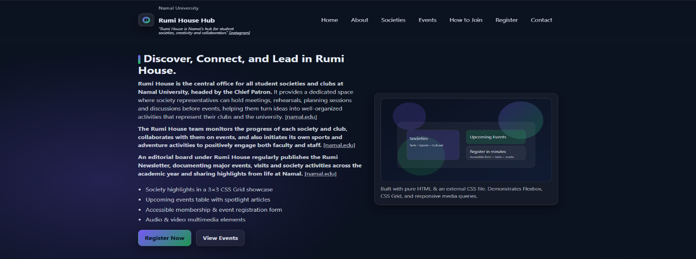

Figure 1: Header with Flexbox navigation bar and hero section with CSS Grid two-column layout
3. Task 2 — Content Elements
3.1 HTML Form
The registration form includes all eight required input types:

Input Type | Field Name | Status
text | Student Name | ✔ Implemented
email | Namal Email | ✔ Implemented
password | Portal Password | ✔ Implemented
checkbox | Society Interests + Agree | ✔ Implemented
radio | Preferred Role (Member/Executive/Volunteer/Observer) | ✔ Implemented
date | Preferred Join Date | ✔ Implemented
file | Profile Picture Upload | ✔ Implemented
submit | Submit Membership Request button | ✔ Implemented

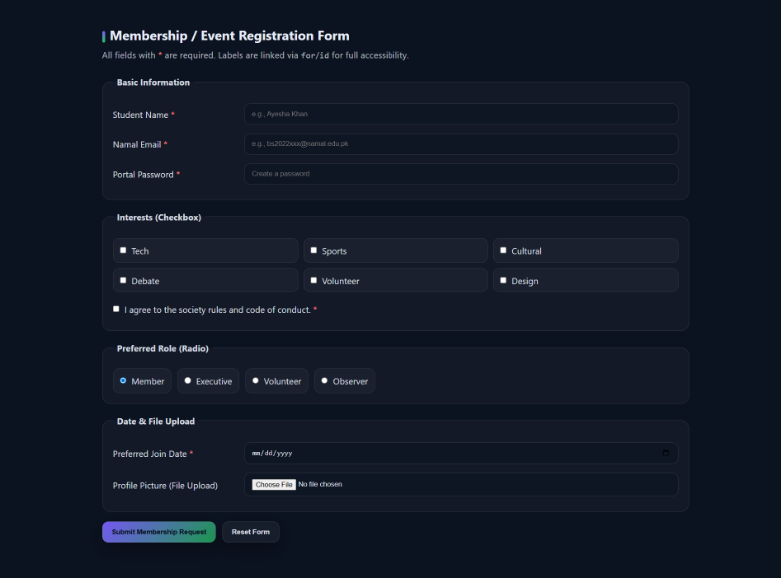
Figure 2: Registration form with labeled inputs, fieldset+legend grouping, and checkbox grid
3.2 Table
A 4-column, 4-row event schedule table with <thead>, <tbody>, and scope="col" on header cells for accessibility.
3.3 Lists
- Ordered list “Steps to Register" with 6 items.
- Unordered list “Benefits of Joining Societies" with 6 items.

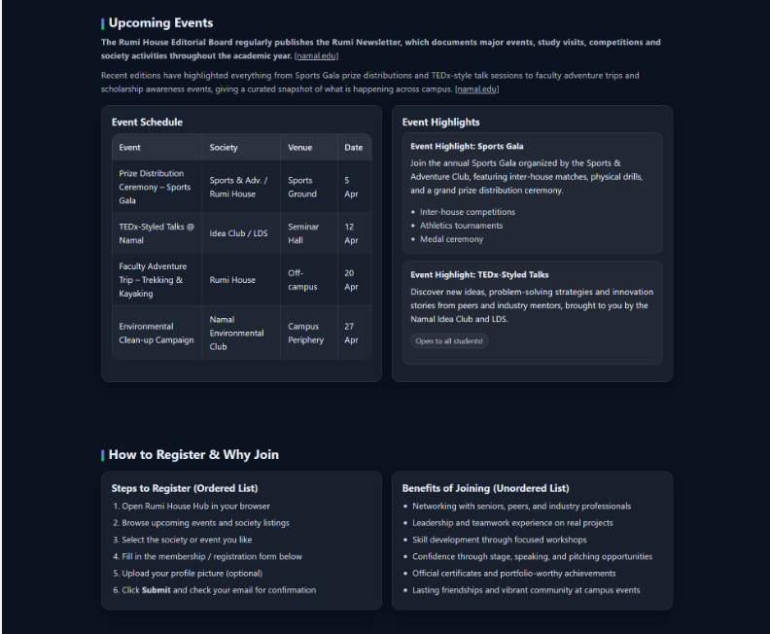
Figure 3: Events table (4 columns × 4 rows) alongside spotlight articles in Flexbox two-column layout

3.4 Multimedia
- Audio — <audio controls> element with WAV source (rumi-intro.wav)
- Video — <video controls> element with MP4 source (rumi-tour.mp4)
- Both include browser-fallback text.
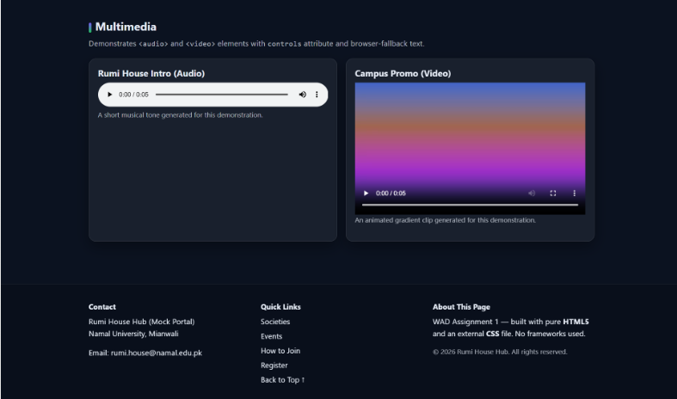
Figure 4: Working audio player (5s) and video player (5s MP4), with date/file inputs and submit button above.
3.5 Accessibility
- All images have descriptive alt text.
- All form fields have associated <label> elements (via for/id or implicit wrapping)
- Skip-to-content link for keyboard users
- ARIA attributes: aria-label, aria-labeled, role="radiogroup"
4. Task 3 — CSS Styling and Box Model
4.1 External CSS
All styles are in styles.css, linked via <link rel="stylesheet">. No inline or embedded styles.
4.2 CSS Selectors Used

Selector Type | Examples
Element selectors | body, html, p, a, img, h1
Class selectors | .container, .card, .btn, .form-row, .hero-grid
ID selectors | #main-header
Grouping selectors | h1, h2, h3, h4 { } and input[type="text"], input[type="email"], … { }
Pseudo-classes | a:hover, a:focus-visible, input:focus, .card:hover, tr:nth-child(even)
Pseudo-elements | p::first-line, .section h2::before (gradient accent bar)
4.3 CSS Box Model
All five Box Model properties are demonstrated throughout the stylesheet:

Property | Where used
margin | .card, .spotlight, .form, .footer
padding | .panel, .card, .btn, .form-fieldset, inputs
border | .card, .table th/td, .form-fieldset, #main-header
width | .container, .table, .card, inputs
height | .card { min-height }, .section h2::before { height }
box-sizing | * { box-sizing: border-box; }
5. Task 4 — Layout and Responsiveness
5.1 Flexbox
- Navigation bar — .nav-list { display: flex }
- Header bar — .header-bar { display: flex } (brand left, nav right)
- Main content — .two-col { display: flex } for side-by-side panels
- Footer — .footer-grid { display: flex } (3-column layout)
- CTA buttons — .hero-actions { display: flex }
5.2 CSS Grid
- 3×3 society grid — .grid-3x3 { display: grid; grid-template-columns: repeat(3, 1fr) }
- Hero layout — .hero-grid { display: grid; grid-template-columns: 1.1fr 0.9fr }
- Form rows — .form-row { display: grid; grid-template-columns: 240px 1fr }

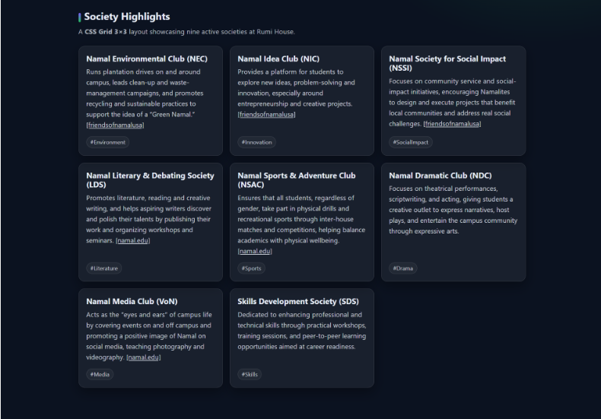
Figure 5: About section and the 3×3 CSS Grid layout displaying 8 society cards.
5.3 Responsive Media Queries

Breakpoint | Target | Key Changes
≤ 600px | Mobile | Single-column grid, stacked nav/footer, adjusted font size to 15px
601–991px | Tablet | 2-column society grid, stacked hero, narrower form labels, font 16px
≥ 992px | Desktop | Full 3-column grid, two-column hero, wide form labels, font 17px
6. File Structure

File / Folder | Description
index.html | Main HTML webpage
styles.css | External CSS stylesheet
media/logo.svg | Brand logo image (SVG)
media/hero.svg | Hero illustration image (SVG)
media/rumi-intro.wav | Audio clip — 5-second intro tone
media/rumi-tour.mp4 | Video clip — 5-second animated gradient
screenshots/ | Rendered page screenshots for this report
7. Conclusion
This assignment demonstrates a strong understanding of all core web development fundamentals. The webpage implements proper semantic HTML5, uses an external CSS file with all required selector types, clearly demonstrates the CSS Box Model, and achieves responsive layouts through Flexbox, CSS Grid, and three distinct media query breakpoints. The project is clean, well-commented, and ready to be expanded into a full web application.

