
NAMAL UNIVERSITY MIANWALI

DEPARTMENT OF Computer Science

Assignment 2

Instructor: Ammar Ahmad Khan Due Date: 03-May-2026

Student: Abu Bakar Roll No: NUM-BSCS-2022-41

Brief Description of Work
For Assignment 2, I transformed the initial static HTML structure from Assignment 1 into a fully interactive and responsive web application called Rumi House Hub, which serves as a student engagement platform for Rumi House at Namal University.
I utilized Bootstrap 5 via CDN to build a responsive grid layout and integrate modern UI components. Furthermore, I implemented Vanilla JavaScript (ES6+) to handle DOM manipulation, real-time form validation, and asynchronous data fetching from a local JSON file using the fetch() API. To adhere to best practices, the codebase was kept clean and strictly separated into four files: index.html, style.css, script.js, and data.json.

Task 1: Bootstrap Integration & Layout
- Integration: Bootstrap 5 was integrated successfully into the project using the official CDN links for both the CSS stylesheet (in the `<head>`) and the JS Bundle (before the closing `</body>` tag).
- Responsive Layout: The web page layout is structurally divided using semantic HTML (`<header>`, `<main>`, `<footer>`).
- Grid System: The Bootstrap Grid system was utilized to ensure complete responsiveness across all devices. For example, the dynamically generated society cards use the `.col-md-6` and `.col-lg-4` classes, meaning they take up 100% of the screen on mobile, 50% on tablets, and 33% on desktops.

Task 2: UI Design with Bootstrap
- Utilities: Extensive use of Bootstrap utilities was applied for typography (`.display-4`, `.fw-bold`, `.text-muted`) and spacing (`.mb-5`, `.py-3`, `.p-4`) to create a breathable, modern UI.
- Components:
- Navbar: Implemented a `.navbar-expand-lg` with a toggler icon for mobile screens, including a functioning "Societies" dropdown menu.
- Buttons: Applied varied button styles corresponding to their actions, such as `.btn-primary` for form submission, `.btn-success` for loading data, and `.btn-outline-primary` for the society cards.
- Cards: The Contact Form is wrapped securely inside a `.card` with shadows, and the society data is dynamically rendered into beautiful UI cards with headers, bodies, and footers.
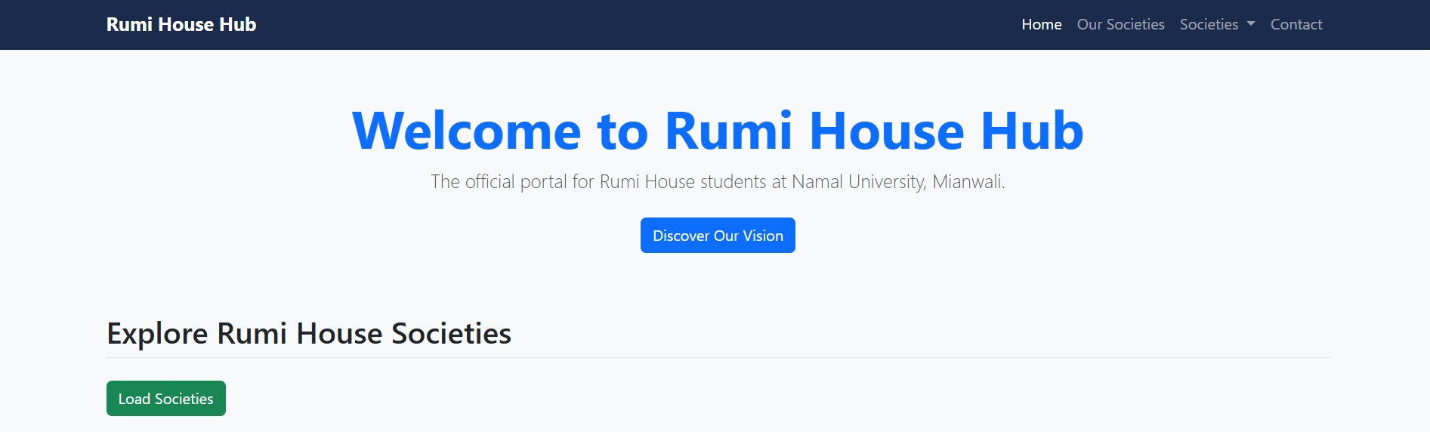

Task 3: Forms and Styling
- Contact Form: Built a structured contact form containing inputs for Name (`text`), Student Email (`email`), and Message (`textarea`), all styled uniformly using Bootstrap’s `.form-control` and `.form-label` classes.
- Custom Styling: Customized the default Bootstrap look by creating an external `style.css` file. A custom CSS class (`.rumi-bg-dark`) was created using a deep navy blue (`#1a2b4c`) to represent the Rumi House branding, which was applied to the Navbar, Contact Form Header, and Footer. Custom classes like `.error-text` were also created to style the validation messages.

Task 4: JavaScript Fundamentals & Logic
- Variables & Data Types: Used modern variable declarations (`const` for unchanging DOM elements and arrays; `let` for state flags like `isVisible`). Used a variety of data types, including Strings, Arrays (for colors), Booleans, and JSON Objects.
- Logic & Control Flow:
- Operators: Used strict equality (`===`), logical AND (`&&`), and logical NOT (`!`).
- Conditionals: Applied `if/else` statements heavily in the form validation to check string lengths and empty inputs.
- Loops: Used the `.forEach()` array method to iterate over the society data.

Task 5: DOM Manipulation & Events
- Event Listeners: Interactivity was driven by adding `.addEventListener('click', ...)` and `.addEventListener('submit', ...)` to specific DOM elements, ensuring HTML and JS remained cleanly separated.
- Dynamic Updates:
- Show/Hide: Clicking the "Discover Our Vision" button toggles a hidden section by dynamically changing its CSS `display` property from `none` to `block`, while simultaneously updating the text inside the button.
- Form Validation: The form listens for the `submit` event, prevents the default page reload (`e.preventDefault()`), and dynamically shows or hides red error messages under invalid fields in real-time.
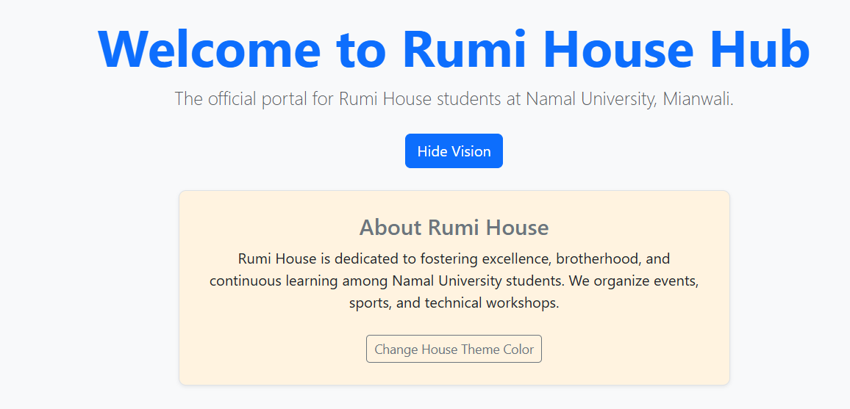

Task 6: Modern JavaScript (ES6+) & Integration
- Modern Syntax: Outdated `var` and `function()` declarations were entirely avoided. Arrow functions `() => {}` were used exclusively for callbacks and helper functions (e.g., the `isEmailValid` email checker).
- Template Literals: Used backticks and `${}` syntax to dynamically inject JavaScript variables into long HTML strings, avoiding messy string concatenation.
- CSS Modification: JavaScript is used to dynamically alter the CSS. Clicking the "Change Theme" button calculates a random index using `Math.random()`, picks a hex code from an Array, and applies it dynamically via `element.style.backgroundColor`.
- Separation of Concerns: The script is cleanly isolated in an external `script.js` file linked at the bottom of the HTML document.

Task 7: API / Data Handling
- Fetch API & Async/Await: Instead of hardcoding data into HTML, the `fetch()` API was used inside an `async` function to asynchronously load society data from a local `data.json` file.
- Loading State: A Bootstrap spinner (`.spinner-border`) is dynamically shown when the fetch request begins and hidden when the data finishes loading.
- Error Handling: The entire data-fetching logic is wrapped in a `try...catch` block. If the local file fails to load or the response is not `ok`, the `catch` block intercepts the error and displays a safe, readable error message on the screen using a Bootstrap alert, preventing the application from crashing.
- Dynamic Rendering: Once parsed, the JSON array is mapped into dynamic Bootstrap cards and injected directly into the DOM using `innerHTML`.
