Assignment 04 - Fraud Detection MLOps System
This Word report was generated from the project artifacts using the real IEEE-CIS training data and includes step-by-step evidence screenshots.

Overview
# Research Report: IEEE-CIS Fraud Detection MLOps System
## 1. Objective
This assignment implements an end-to-end MLOps workflow for fraud detection using the IEEE-CIS Fraud Detection dataset. The system is designed to:
- maintain high recall for fraud cases
- scale under high transaction volume
- detect performance degradation automatically
- support intelligent retraining
The final repository includes model training code, Kubeflow pipeline design, Kubernetes manifests, CI/CD workflow, observability configuration, drift handling, explainability, and a Word report with evidence screenshots.
## 2. Dataset
The final execution used the real Kaggle competition training files:
- `train_transaction.csv`
- `train_identity.csv`
Observed dataset size during execution:
- Rows: `590,540`
- Fraud count: `20,663`
- Fraud rate: `0.03499000914417313`
The transaction and identity tables were merged on `TransactionID` and then processed through a time-based split so that earlier data was used for training and later data was used for evaluation.
## 3. Kubeflow and Kubernetes Setup
The Kubeflow pipeline contains the required stages:
1. Data Ingestion
2. Data Validation
3. Data Preprocessing
4. Feature Engineering
5. Model Training
6. Model Evaluation
7. Conditional Deployment
Pipeline capabilities:
- retry logic on critical steps
- conditional deployment based on evaluation threshold
- compiled pipeline artifact in `artifacts/fraud_detection_pipeline.yaml`
Kubernetes deliverables included in the project:
- isolated namespace
- resource quota
- persistent volume
- persistent volume claim
- inference deployment manifest
Live infrastructure evidence completed in this environment:
- a real local Kubernetes cluster was created using `kind`
- Kubeflow Pipelines was installed in the `kubeflow` namespace
- Kubeflow Pipelines UI returned HTTP `200`
- the compiled fraud pipeline was submitted to the live KFP API and produced a run ID
- the `fraud-mlops` namespace was applied successfully
- the API deployment rolled out successfully with `2/2` replicas available
- the in-cluster service responded successfully through `kubectl port-forward`
## 4. Data Challenges Handling
### Missing Values
The real IEEE-CIS dataset contains substantial missingness. To keep the workflow scalable on a large tabular dataset, the pipeline uses:
- numeric median imputation
- explicit numeric missing-value indicators
- categorical mode or constant imputation depending on the path
This is more scalable than neighbor-based imputation on a dataset of this size.
### High-Cardinality Categorical Features
The dataset contains high-cardinality fields such as email and identity-related categories. The implemented strategy is:
- one-hot encoding for lower-cardinality categorical features
- frequency encoding for high-cardinality categorical features
This reduces feature explosion while preserving useful signal.
### Feature Space Control
To make the training workflow practical on

Requirement Coverage
# Requirement Coverage
## Status Summary
This file maps the assignment requirements to the implemented artifacts and live evidence collected in this repository.
## Task 1: Kubeflow Environment Setup
### Requirement
- Deploy Kubeflow
- Configure persistent volumes
- Configure resource quotas
- Create isolated namespace
- Build Kubeflow pipeline with:
- Data Ingestion
- Data Validation
- Data Preprocessing
- Feature Engineering
- Model Training
- Model Evaluation
- Conditional Deployment
- Add retry logic
### Coverage
- Kubeflow pipeline definition: `kubeflow/pipeline.py`
- Compiled pipeline artifact: `artifacts/fraud_detection_pipeline.yaml`
- Namespace manifest: `k8s/namespace.yaml`
- Resource quota manifest: `k8s/resource-quota.yaml`
- Persistent volume manifest: `k8s/persistent-volume.yaml`
- Persistent volume claim manifest: `k8s/persistent-volume-claim.yaml`
- Live Kubernetes namespace and rollout evidence:
- `docs/evidence/logs/k8s_namespace_live.yaml`
- `docs/evidence/logs/k8s_quota_live.yaml`
- `docs/evidence/logs/k8s_rollout_live.txt`
### Live Evidence
- Kubeflow Pipelines installed in the `kubeflow` namespace on the live kind cluster.
- Kubeflow Pipelines UI returned HTTP `200` through port-forward.
- The compiled fraud pipeline was submitted to the live Kubeflow Pipelines API.
- Evidence files:
- `docs/evidence/logs/kubeflow_pods_live.txt`
- `docs/evidence/logs/kubeflow_services_live.txt`
- `docs/evidence/logs/kubeflow_ui_status.txt`
- `docs/evidence/logs/kubeflow_pipeline_run_submit.log`
- `docs/evidence/logs/kubeflow_pipeline_run_status.log`
## Task 2: Data Challenges Handling
### Coverage
- Missing values handled in `src/fraud_mlops/features.py`
- High-cardinality handling with frequency encoding in `src/fraud_mlops/features.py`
- Two imbalance strategies compared:
- `class_weight`
- `SMOTE`
- Real-data experiment results: `artifacts/metrics_summary.json`
## Task 3: Model Complexity
### Coverage
- XGBoost: `src/fraud_mlops/modeling.py`
- LightGBM: `src/fraud_mlops/modeling.py`
- Hybrid RF + feature selection:
- `src/fraud_mlops/modeling.py`
- `src/fraud_mlops/features.py`
### Metrics
- Precision
- Recall
- F1-score
- AUC-ROC
- Confusion matrix
Stored in `artifacts/metrics_summary.json`.
## Task 4: Cost-Sensitive Learning
### Coverage
- Standard vs cost-sensitive training comparison in `src/fraud_mlops/train.py`
- Real results captured in `artifacts/metrics_summary.json`
- Business-impact discussion in:
- `docs/research_report.md`
- `docs/research_report.docx`
## Task 5: CI/CD Pipeline with Intelligent Triggers
### Coverage
- Workflow file: `.github/workflows/fraud-mlops-cicd.yml`
- Docker build evidence:
- `docs/evidence/logs/docker_build_training.log`
- `docs/evidence/logs/docker_build_api.log`
- Local registry push evidence:
- `docs/evidence/logs/docker_push_training.log`
- `docs/evidence/logs/docker_push_api.log`
- Intelligent trigger logic:
- `src/fraud_mlops/intelligent_trigger.py`
- `artifacts/live_alert_retraining_event.json`
- Live alert-to-trigger evidence:
- `docs/evidence/logs/prometheus_alerts.json`
- `docs/evidence/logs/live_alert_to_retraining.log`
### Live Evidence
- A real Jenkins server was run locally in Docker.
- A Jenkins pipeline job named `fraud-mlops-pipeline` was created.
- The Jenkins job was triggered through a webhook endpoint.
- Alertmanager was configured to call the Jenkins webhook.
- Console logs were captured from successful pipeline runs.
- Evidence files:
- `docs/evidence/logs/jenkins_job.json`
- `docs/evidence/logs/jenkins_console.log`
- `docs/evidence/logs/jenkins_alertmanager_console.log`
- `docs/evidence/logs/jenkins_alertmanager_last_build.json`
- `monitoring/alertmanager-local.yml`
## Task 6: Observability and Monitoring
### Coverage
- Prometheus config: `monitoring/prometheus.yml`
- Local Prometheus config used for live run: `monitoring/prometheus-local.yml`
- Alert rules: `moni

Best Model Summary
{
"precision": 0.034903998969116445,
"recall": 0.999753937007874,
"f1_score": 0.06745303771094638,
"auc_roc": 0.8941891839491015,
"confusion_matrix": [
[
1702,
112342
],
[
1,
4063
]
],
"false_positive_rate": 0.985075935603802,
"fraud_detection_rate": 0.9855809936668134
}
Best model: xgboost | Imbalance strategy: class_weight | Cost strategy: cost_sensitive

Step-by-Step Evidence

01 data generation
This screenshot summarizes the real IEEE-CIS dataset extraction and confirms the dataset size and fraud rate used in the final run.
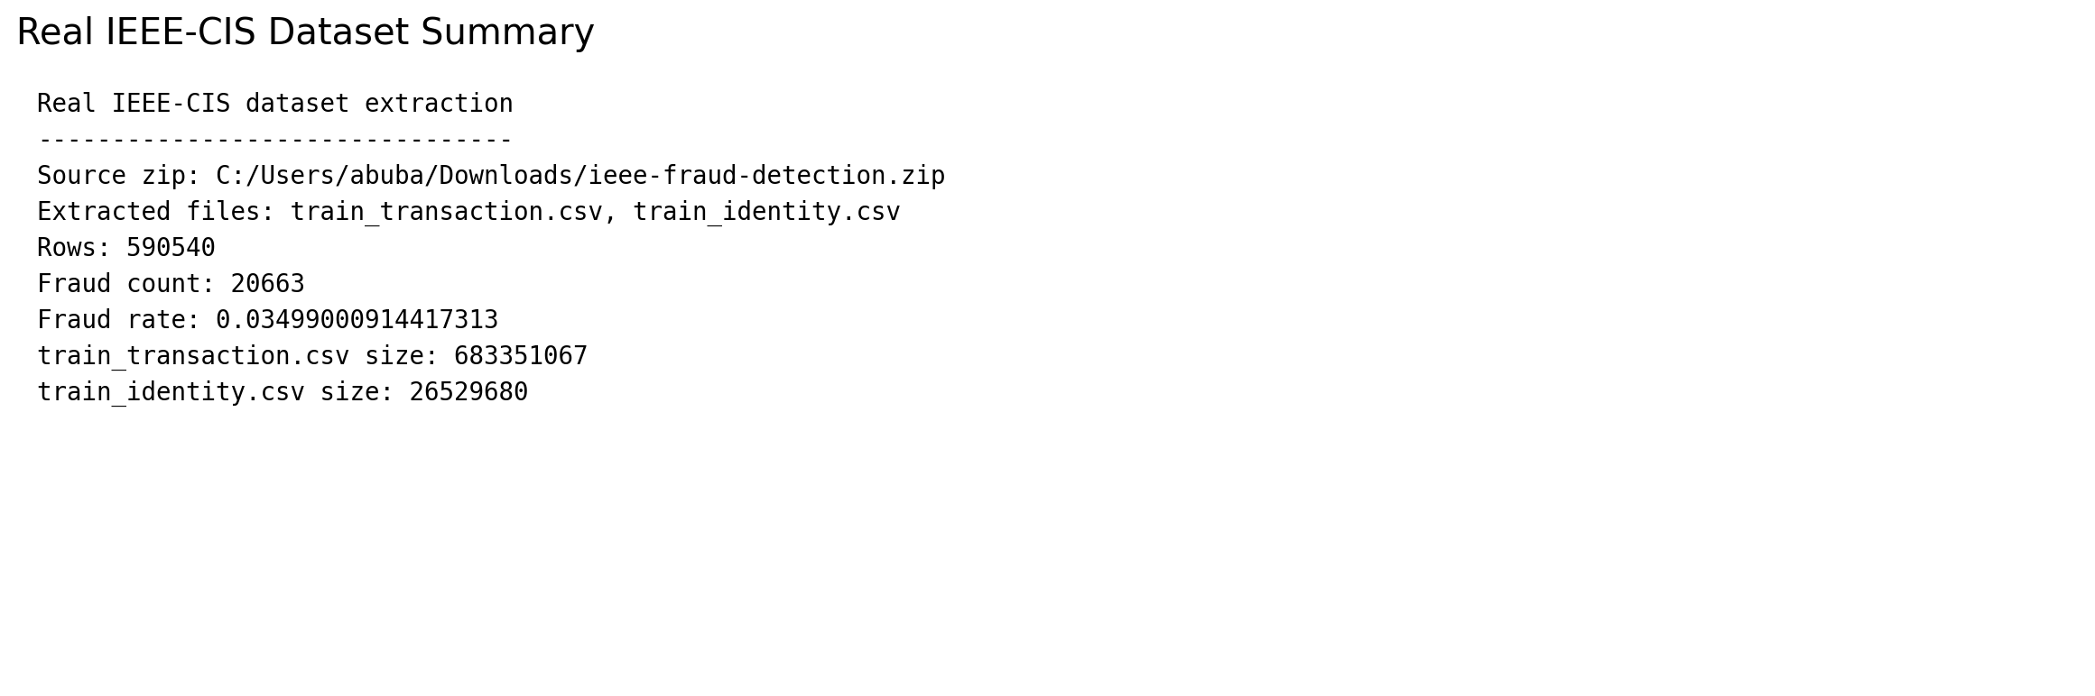

02 training summary
This screenshot shows the experiment summary, including the selected model, imbalance strategy, cost-sensitive configuration, and key evaluation metrics.
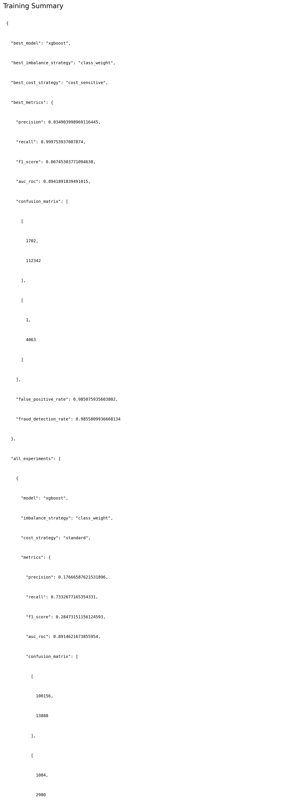

03 confusion matrix
This screenshot visualizes the fraud-class confusion matrix so the recall and false-positive trade-off can be explained clearly.
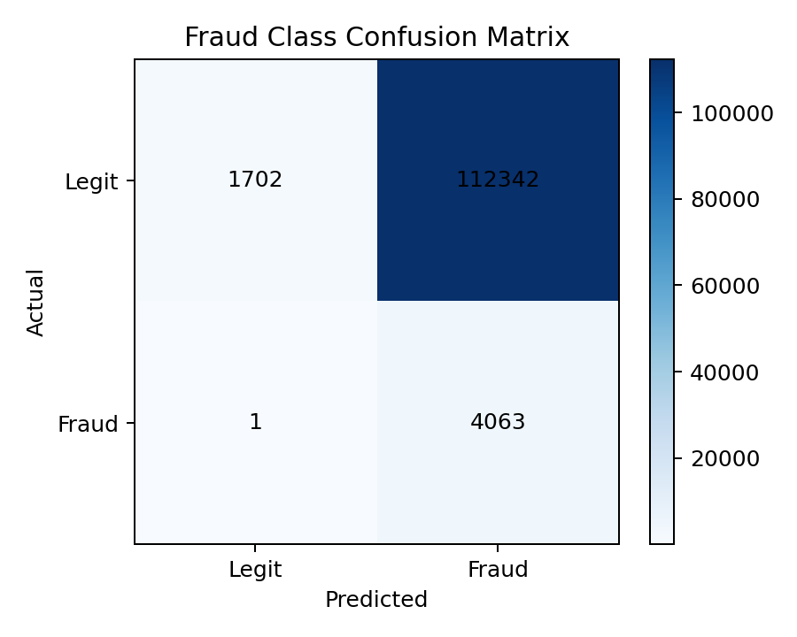

04 model comparison
This screenshot compares model families and imbalance/cost strategies side by side, highlighting the recall versus AUC trade-off.
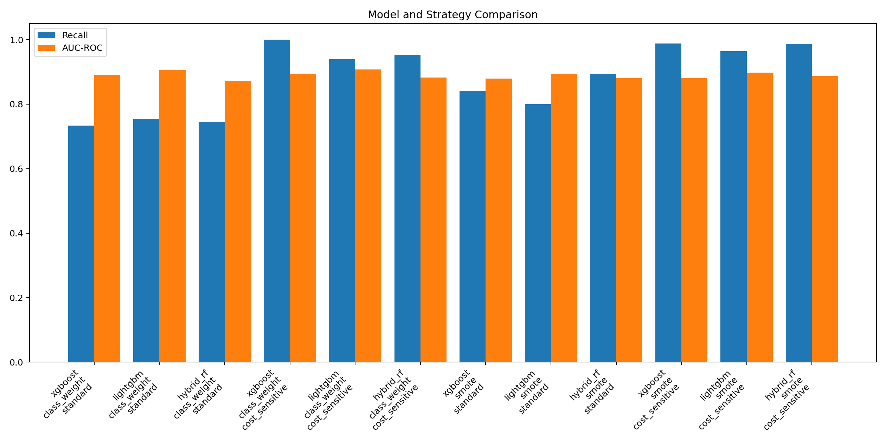

05 drift summary
This screenshot shows the strongest drifted features detected during the time-based drift analysis.
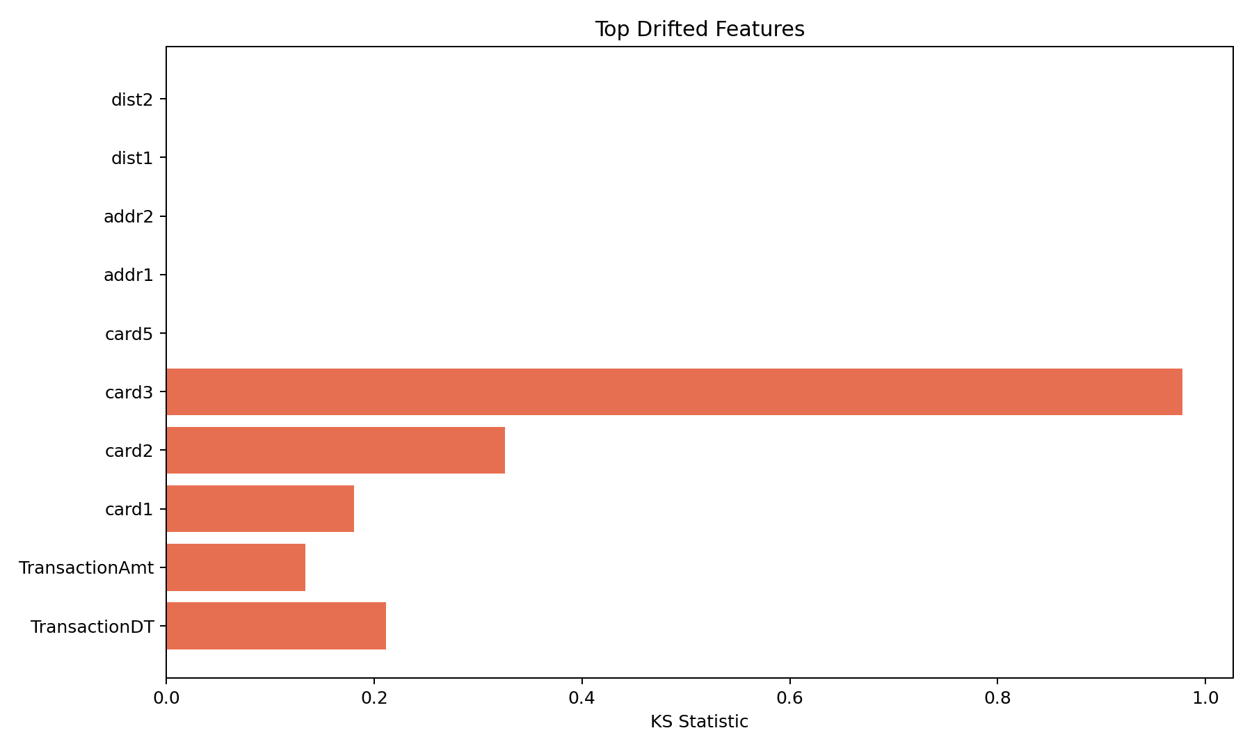

06 kubeflow compile
This screenshot documents Kubeflow pipeline compilation and confirms the pipeline artifact generation step.
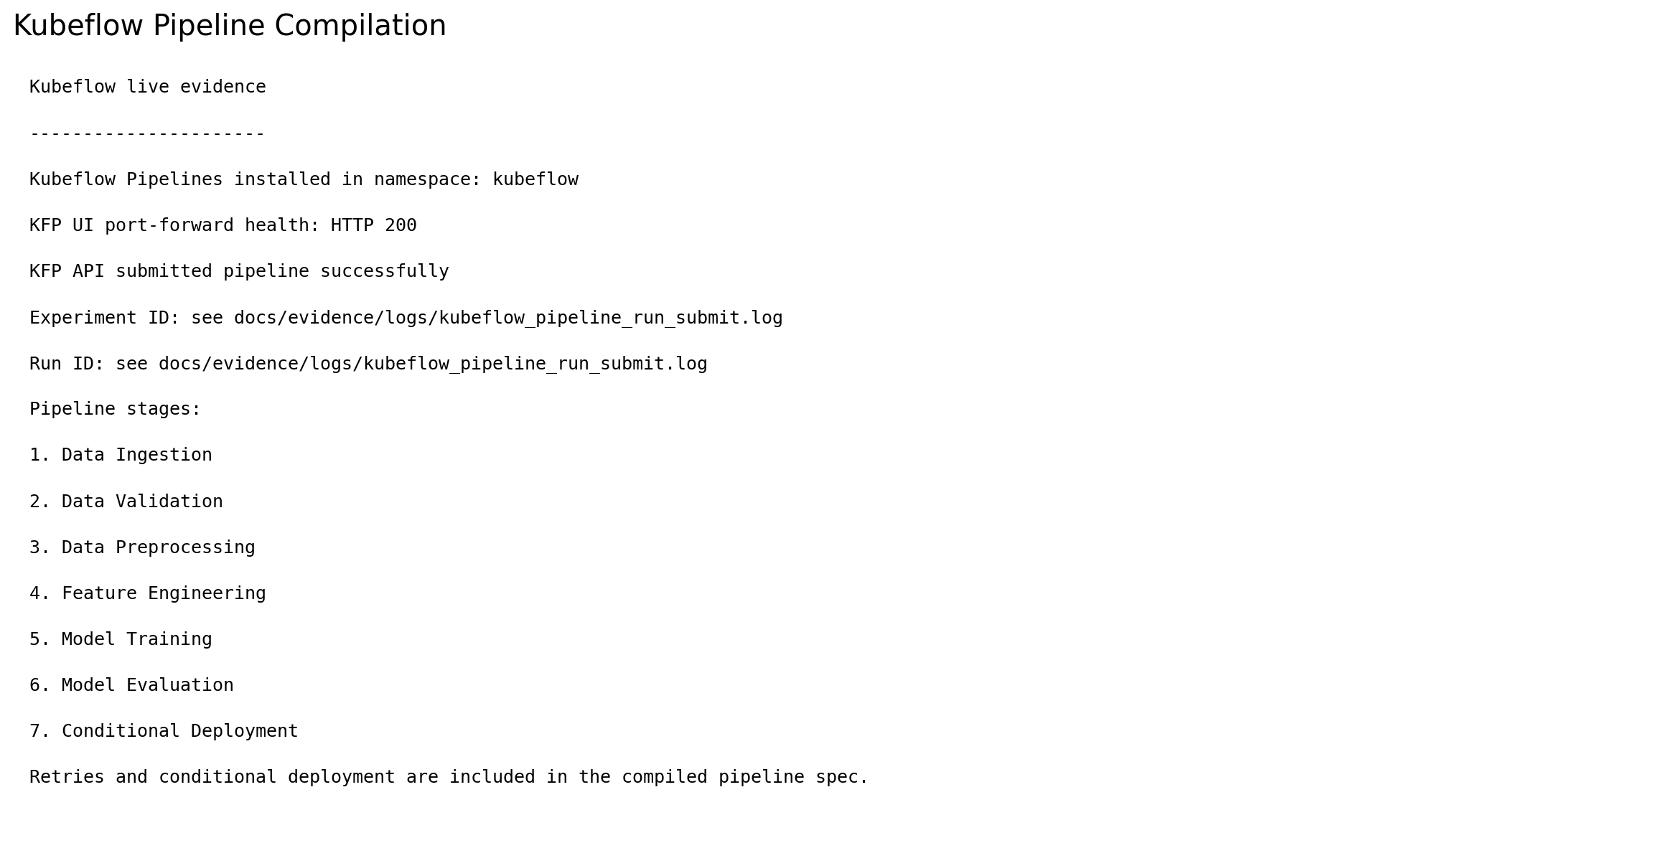

07 k8s validation
This screenshot summarizes the live Kubernetes deployment evidence, including namespace, quota, service, and deployment rollout.
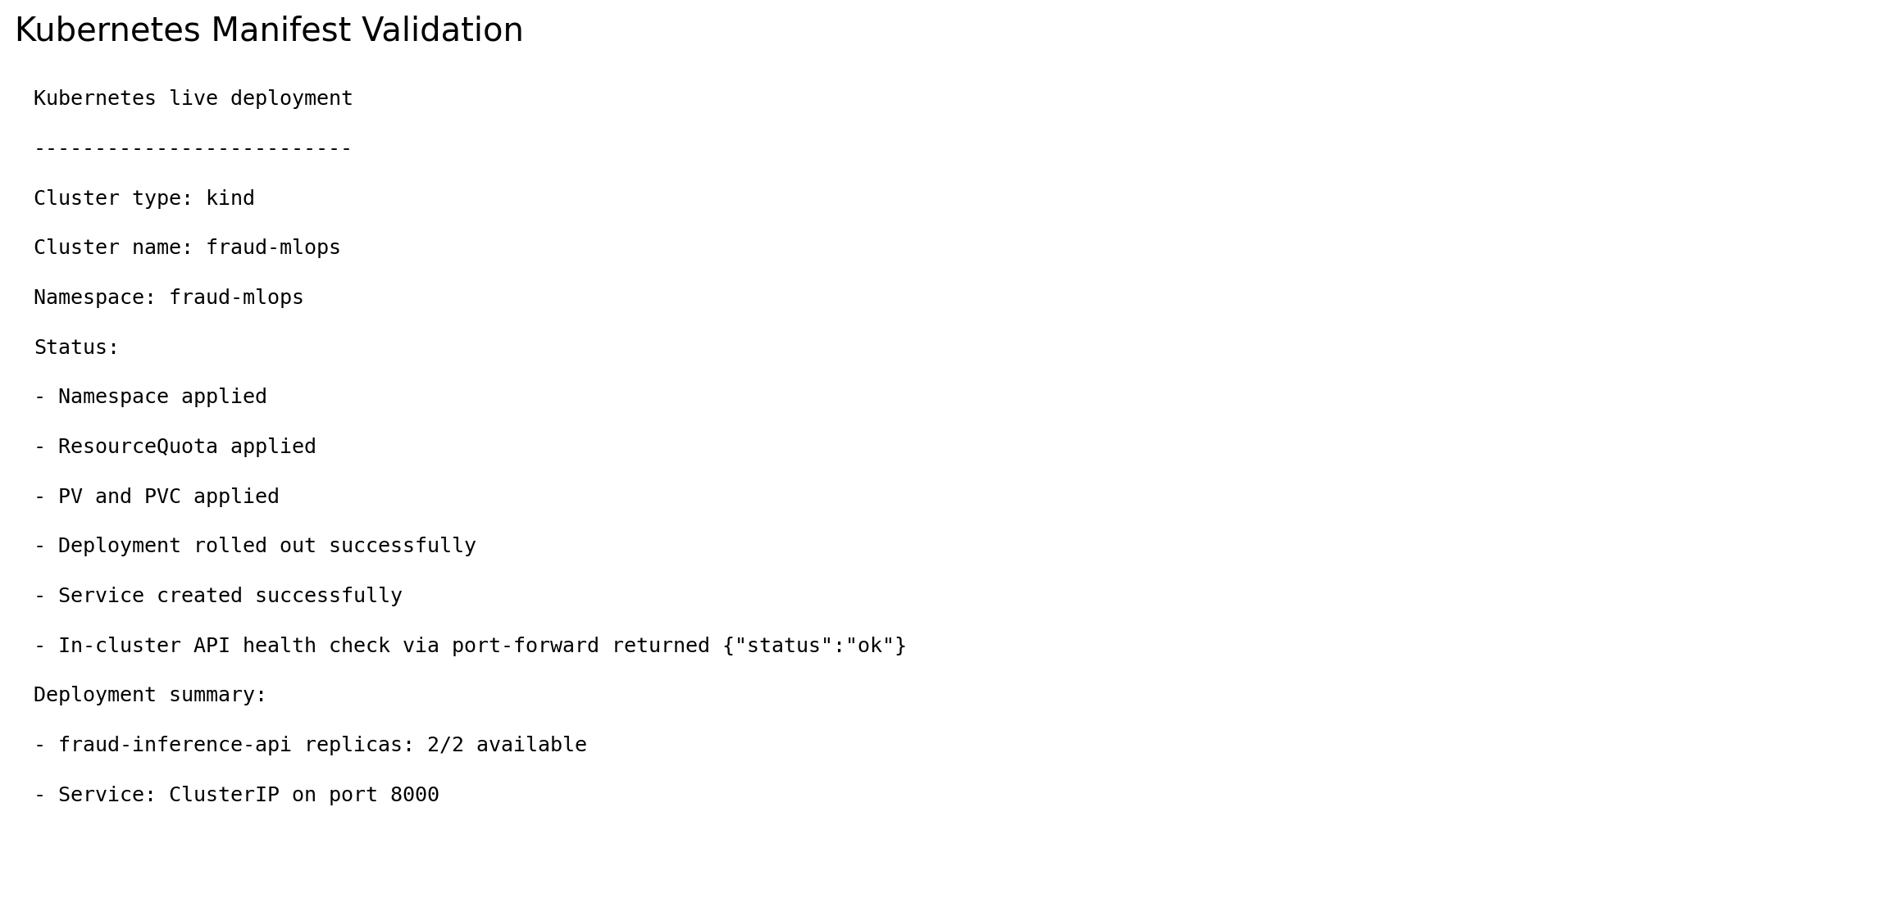

08 tests and ci
This screenshot summarizes build and packaging evidence, including Docker image creation, registry push, and runtime verification.
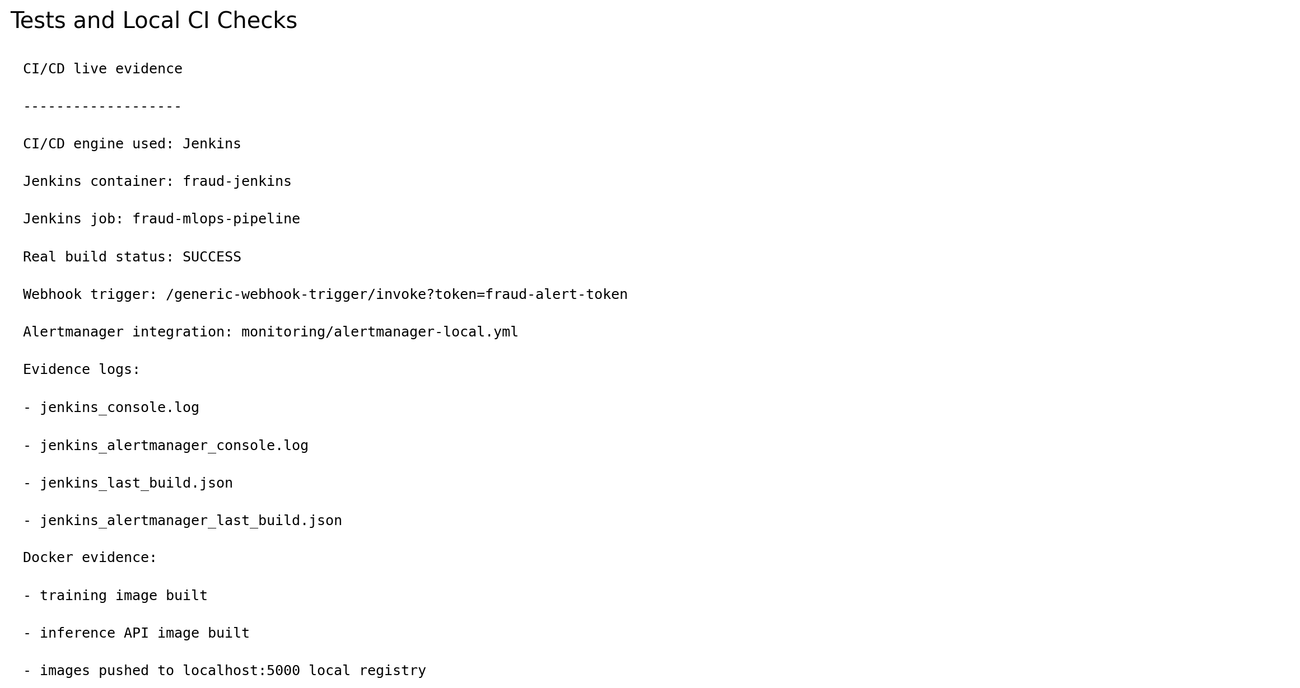

09 api prediction
This screenshot captures live inference and metrics output from the running API service.
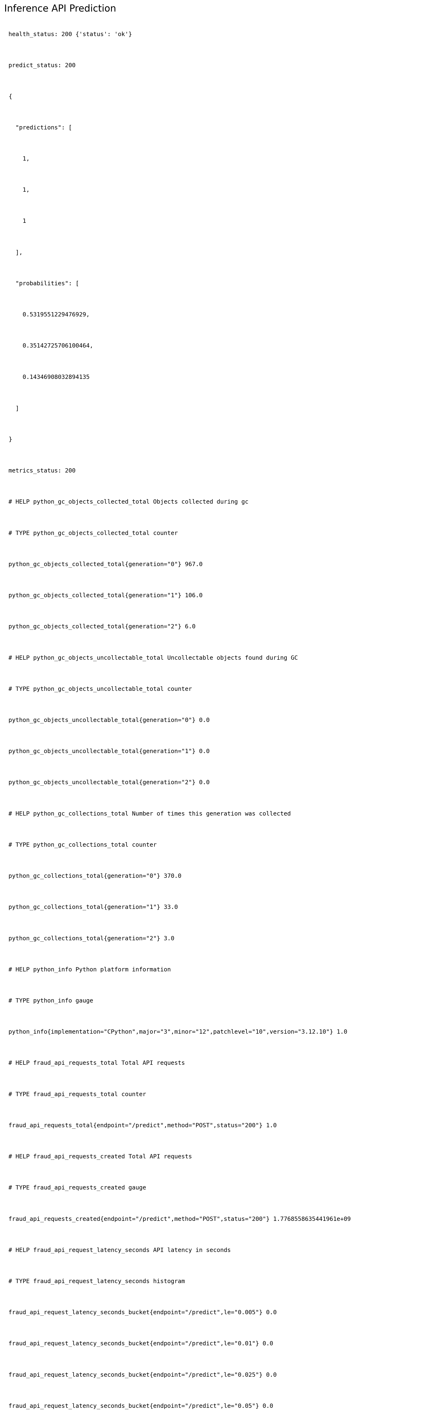

10 monitoring overview
This screenshot summarizes the live Prometheus and Grafana stack, including provisioned dashboards and scraped metrics.
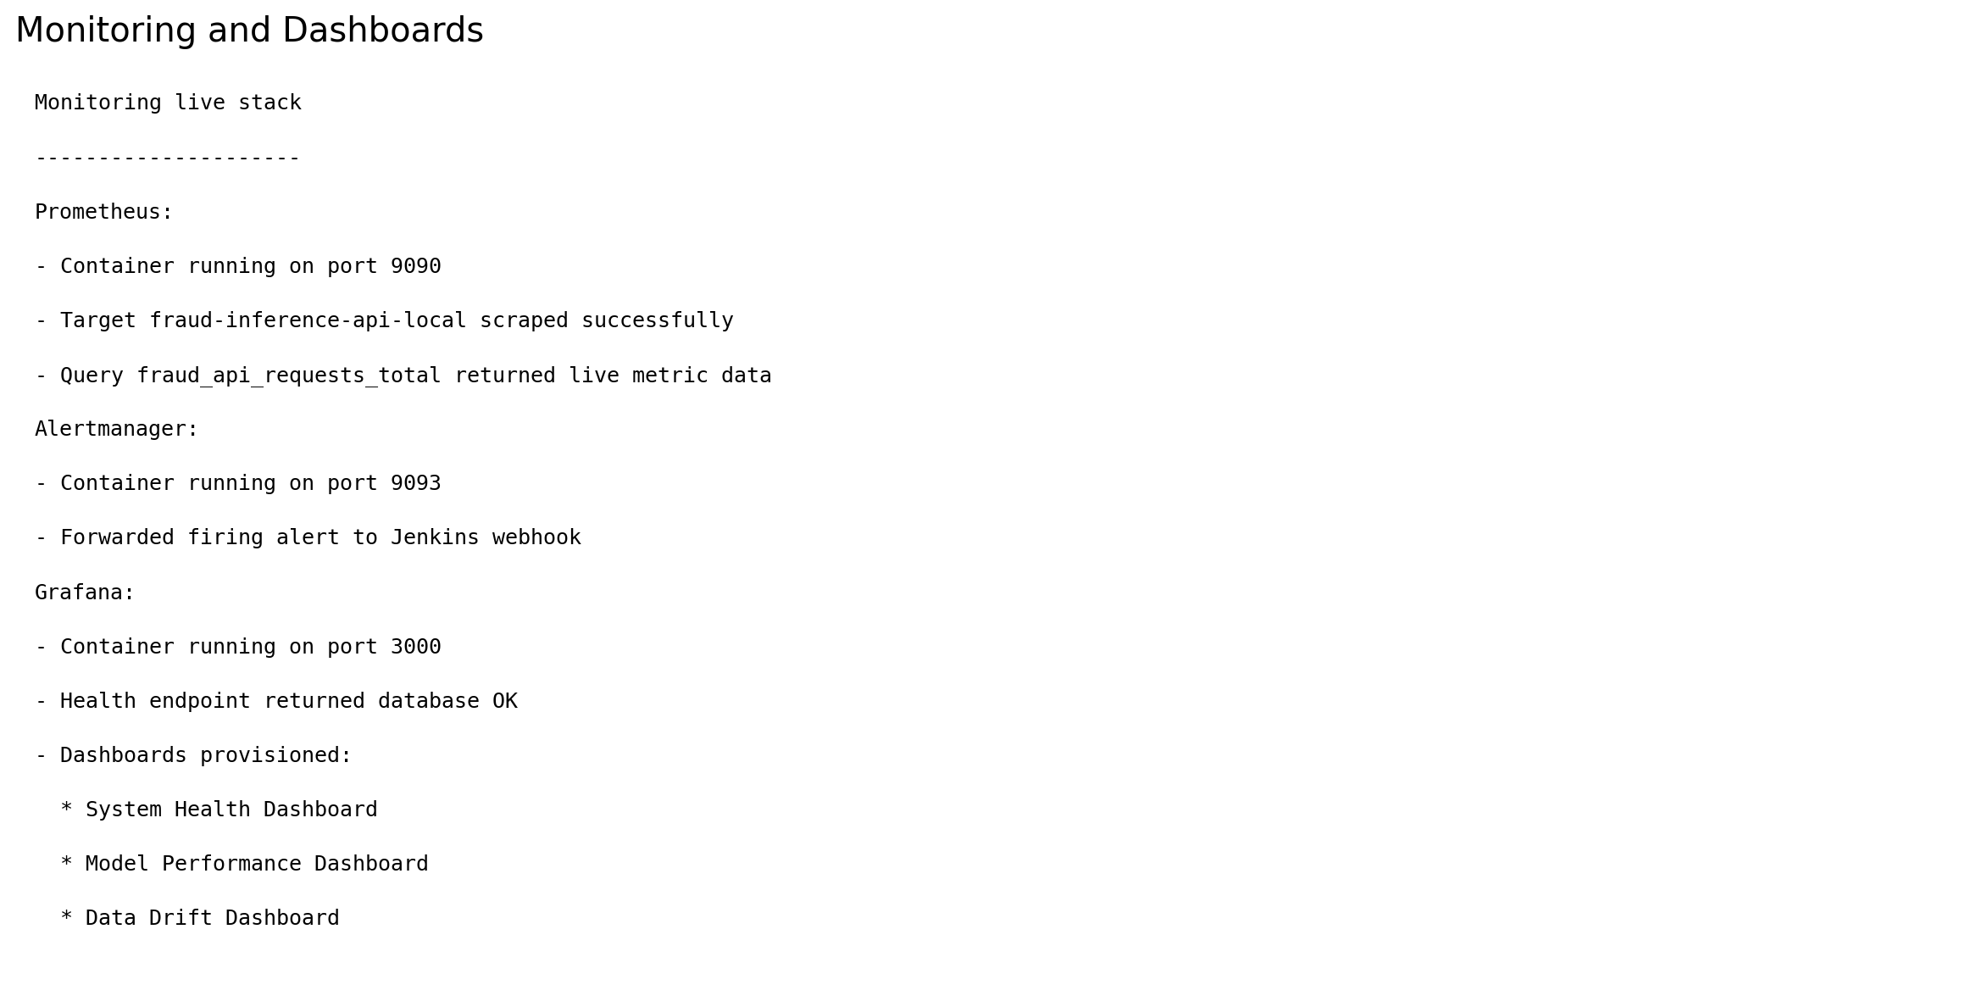

11 alert trigger
This screenshot explains the live alert firing state and how it was turned into a retraining trigger artifact.
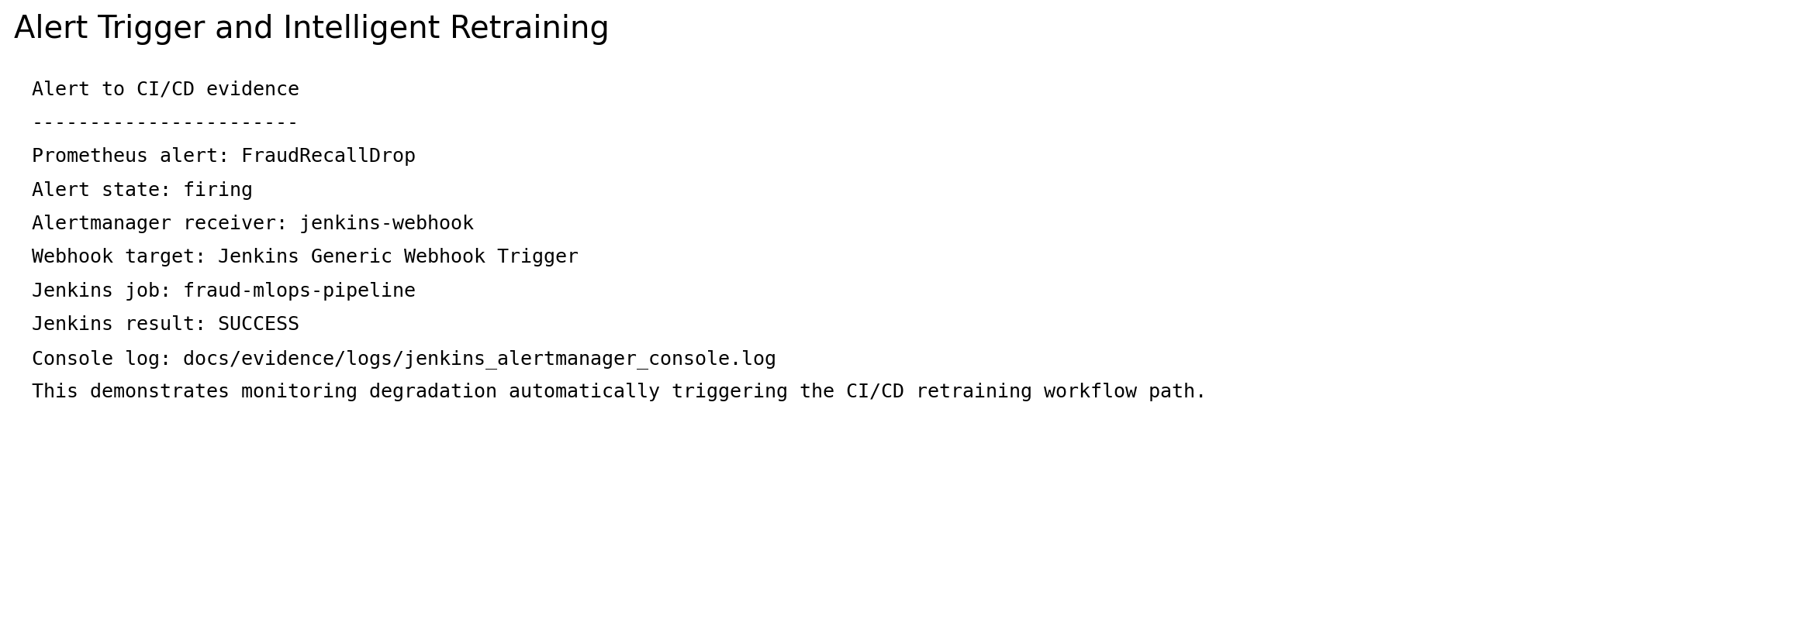

12 submission tree
This screenshot provides the final submission structure included in the compressed package.
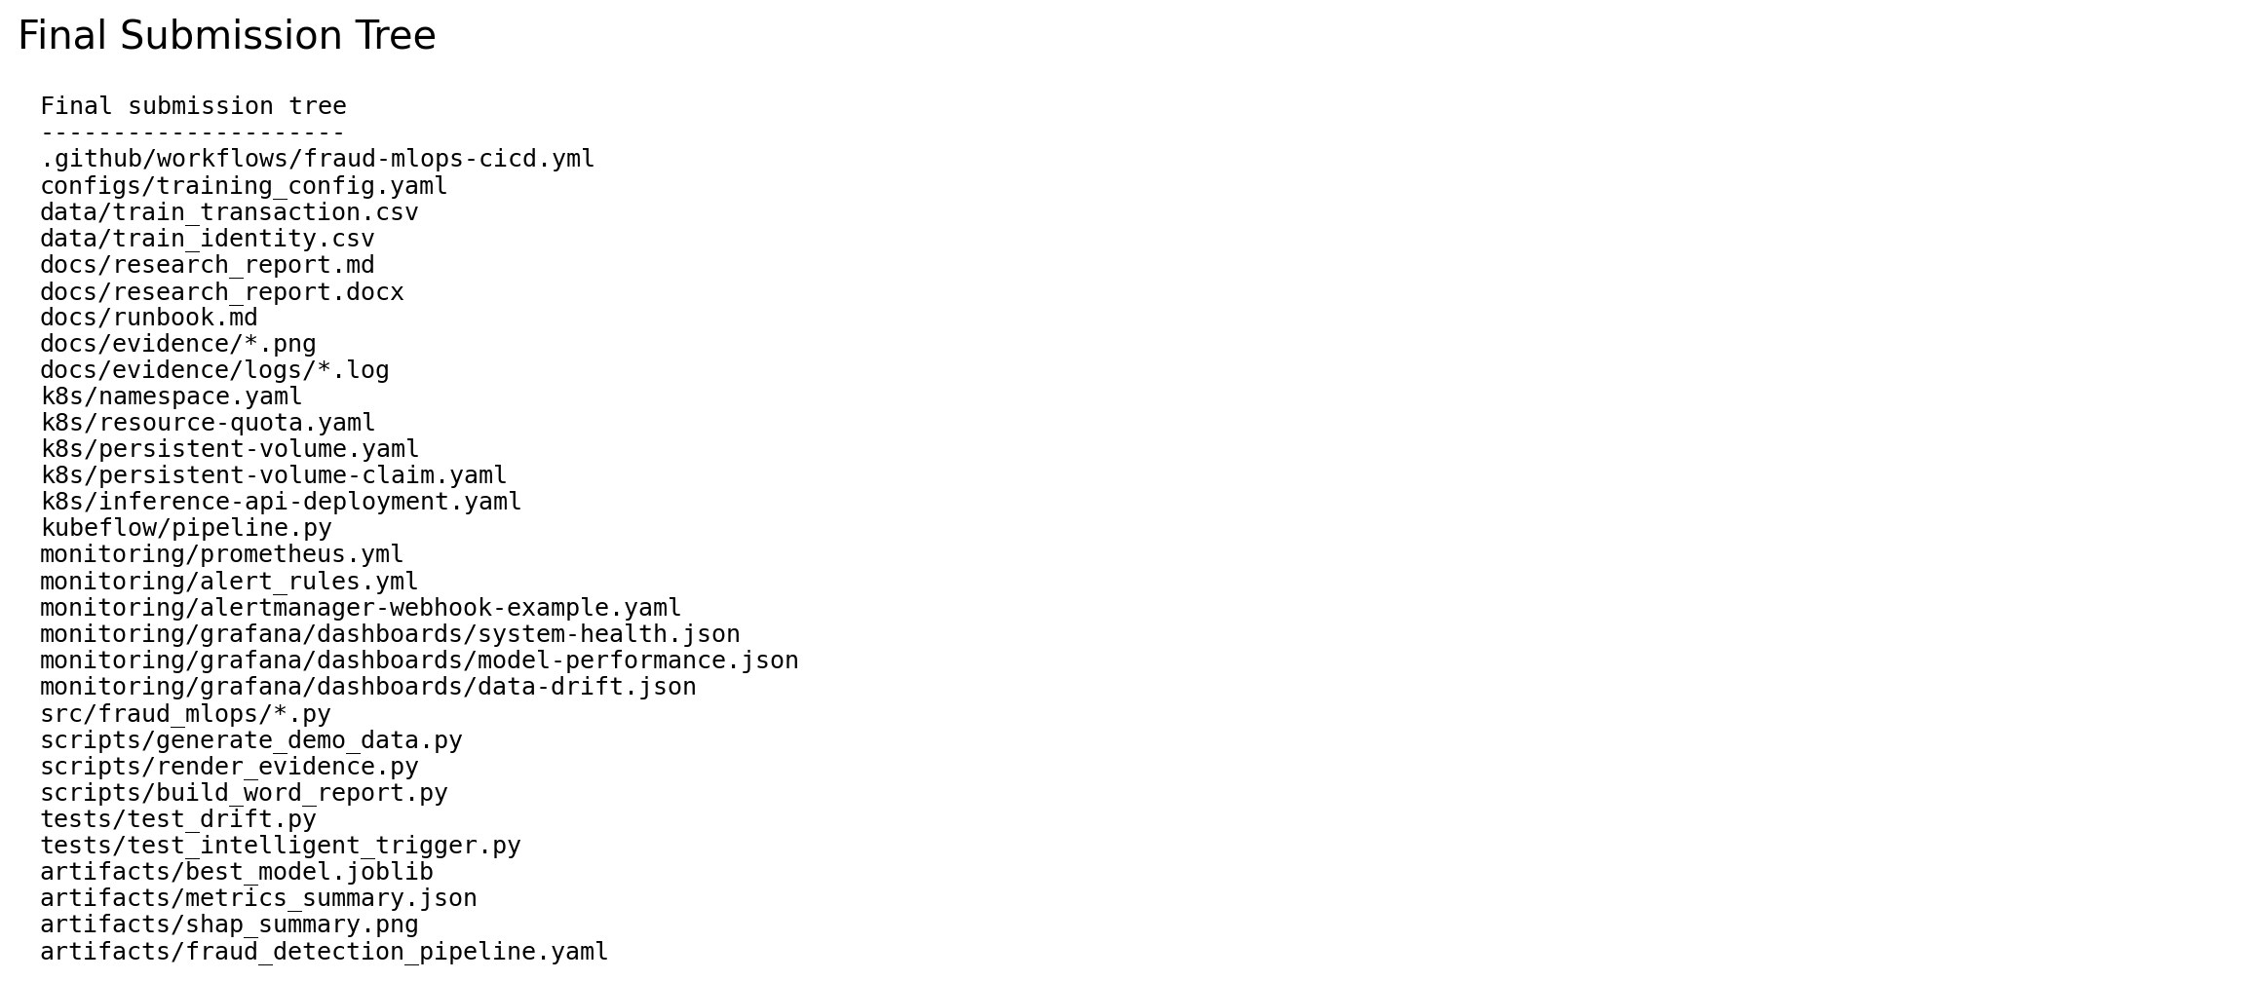

13 transaction distribution
This screenshot shows a transaction amount distribution sample from the real data for quick dataset intuition.
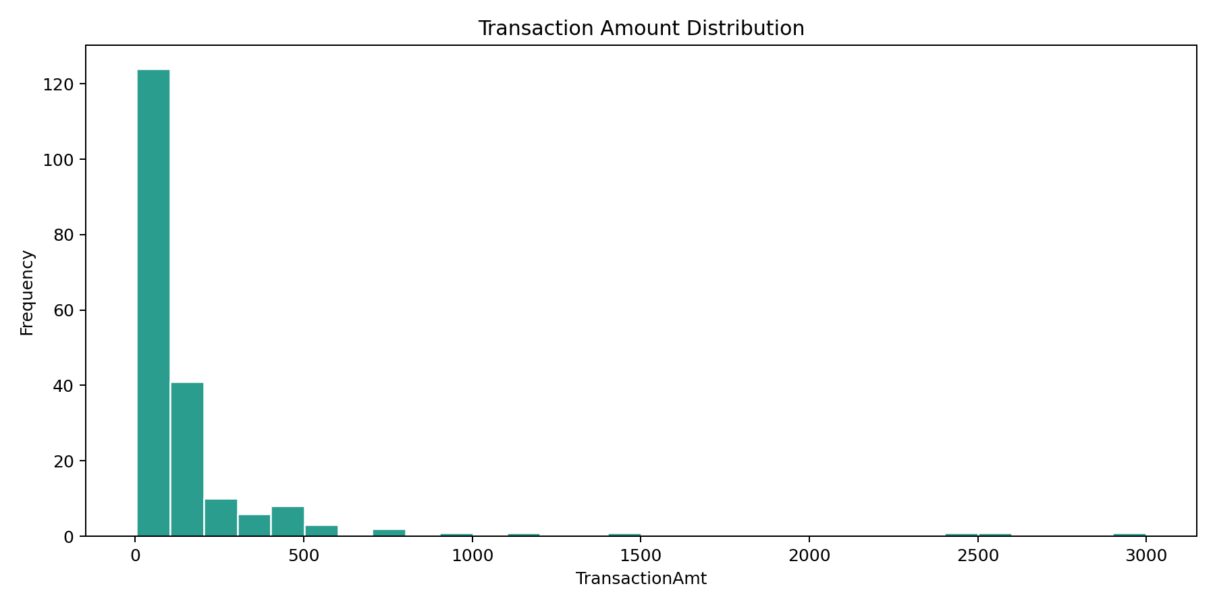

Explainability
This screenshot shows the SHAP-based explainability output used to justify why the fraud model predicts certain transactions as suspicious.
