

**Submitted to:**

Ma’am Atka

(Lecturer Air University)

**Air University**

Inventory Management System

**Submitted by:**

M Umer

Abubakar Amir

M Ahmad Ijaz

**DEPARTMENT OF COMPUTER SCIENCE**

AIR UNIVERSITY MULTAN CAMPUS

**IMS**

**PROJECT REPORT**

**Table of Contents**

Introduction 4

Background 4

Overview of Social Network Analysis Tool(SNAT) 4

Existing Tools and Technologies 4

Objectives of the Project 4

System Design and Architecture 5

Functional Requirements 5

Non-Functional Requirements 5

System Architecture Diagram 5

Implementation 6

Tools and Technologies Used 6

Data Structures Used in Program 7

Key Features and Functionalities 7

Data Collection and Preprocessing 8

Data Sources 8

Cleaning and Transformation 8

Network Representation 8

Analytical Methods 8

Login & Registration: 8

User & Relationship Management: 8

Search User: 8

Influential User 8

Community: 8

Posts 9

Messages: 9

Admin Profile page: 9

Code 9

Results and Visualization 9

Welcome page: 9

Option 1 Clicked: 10

Logins: 11

User Profile Page: 12

12

User & Relationship Management: 12

Search User: 15

16

Influential User: 16

Settings: 16

Community: 16

Messages: 18

Posts: 19

Logout: 21

Admin: 22

Admin Profile Page: 23

Applications and Uses 27

Marketing and Advertising 27

Social Science Research 27

Business Intelligence 27

Public Health 27

Security and Surveillance 27

Social Media Management 27

Education 28

Conclusion 28

# **Evaluation Table:**

|  |  |  |  |  |  |  |
| --- | --- | --- | --- | --- | --- | --- |
| **Student Name** | **Roll No** | **Design (20%)** | **Functionality (30%)** | **Code Efficiency (20%)** | **Documentation & Presentation (30%)** | **Marks Obtained** |
|  |  |  |  |  |  |  |
|  |  |  |  |  |  |  |
|  |  |  |  |  |  |  |
|  |  |  |  |  |  |  |

# **2.** **Introduction**

## **Overview of Project:**

The **Inventory Management System (IMS)** is a software application designed to assist businesses in efficiently managing their inventory. The primary goal of the IMS is to provide a comprehensive solution that enables users to track inventory levels, manage product information, and streamline order processing.

The IMS allows users to add and remove inventory items, track sales, manage orders, and generate detailed reports. It serves various industries, including retail, manufacturing, and distribution, providing a scalable solution that adapts to the user’s growing needs.

**2.2 Problem Statement and Background:**

Inadequate inventory control can negatively impact businesses financially as well as reputationally. Problems such as overstocked items leading to wasted resources, or stockouts that result in lost sales hinge on poor inventory practices. The need for accurate, real-time inventory information is paramount within companies of all sizes to maintain operational efficiency.

### **2.3 Significance of the Problem:**

Inventory is often the largest asset on a company's balance sheet, and therefore directly impacts profitability and cash flow. Poor inventory management can lead to excessive holding costs, spoilage, obsolescence, and ultimately customer dissatisfaction

Ineffective inventory management can have far-reaching consequences:

* **Financial Losses**: Excess inventory increases holding costs, while stockouts result in lost sales.
* **Operational Inefficiencies**: Wasted time and resources hinder productivity and growth.
* **Customer Dissatisfaction**: Delays and unavailability damage reputation and customer loyalty.

1. **Objectives**

**3.1 Primary Goals**

* Develop a user-friendly interface to reduce the learning curve.
* Implement real-time inventory tracking to ensure accurate stock visibility.
* Automate order management to streamline processes and reduce errors.
* Provide comprehensive reporting and analytics for data-driven decision-making.
* Enhance user management and security through role-based access.
* Enable integration with other business systems for seamless data exchange.

**3.2 Expected Outcomes**

* Increased inventory accuracy through automated updates.
* Improved order fulfillment speed.
* Enhanced decision-making capabilities with actionable insights.
* Cost savings from optimized inventory levels.
* Greater operational efficiency through automation.

1. **Features**

**4.1 Key Functionalities**

* **Real-Time Inventory** Tracking: Monitor stock levels with live updates.
* **Product Management**: Add, update, and categorize product details.
* **Order Management**: Create, track, and fulfill orders efficiently.
* **Reporting and Analytics:** Generate actionable reports for better decision-making.
* **User Management and Role-Based Access:** Secure user-specific access control.
* **Supplier Management**: Maintain supplier details and streamline procurement.
* **Barcode Scanning:** Simplify inventory updates with barcode inputs.
* **Integration Capabilities**: Connect seamlessly with other business tools.

**4.2 Innovative Aspects**

* **Real-Time Data Synchronization**: Ensure consistent data across locations.
* **Predictive Analytics:** Forecast inventory needs to avoid stock issues.
* **Mobile Accessibility:** Manage inventory on-the-go.
* **User-Centric Design**: Easy navigation and customizable dashboards.
* **Automated Alerts and Notifications:** Stay updated with critical inventory events.
* **Data Visualization Tools:** Present data in intuitive charts and graphs.
* **Sustainability Features**: Track product lifecycles for eco-friendly decisions.

1. **Business Logic**

**5.1 Description of Core Logic**

The IMS core logic handles inventory updates, transaction processing, and report generation. It uses a centralized database to capture all inventory-related actions in real-time, ensuring accuracy and consistency across the system.

**5.2 Problem-Solving Approach**

* **Transaction Handling:** Automatic inventory updates for each sale or purchase.
* **Alerts and Notifications:** Reordering thresholds and low-stock alerts.
* **Report Generation**: Customizable reports for proactive decision-making.

1. **Flow Chart**

**6.1 Application Flow Representation**

The application flow chart illustrates the user interactions and data movement within the system, including user login, dashboard overview, inventory management, order processing, reporting, user management, and logout.

**6.2 Annotations and Explanation**

* **User Login**: Secure access for authorized users.
* **Dashboard Overview**: Central hub for key metrics.
* **Inventory Management:** Real-time stock updates.
* **Order Management**: Efficient order handling.
* **Reporting:** Insightful data analysis.
* **User Management:** Role-based access control.
* **Logout**: Secure session termination.

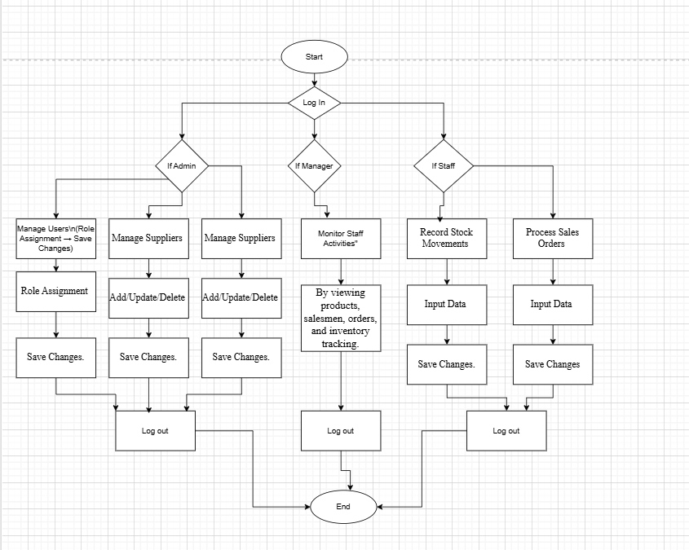

1. **Class Diagram**

7**.1 Overview of Class Structure**

* **User Class:** Handles user authentication and profile management.
* **Product Class:** Manages product details and stock levels.
* **Order Class:** Handles order creation and status updates.
* **Inventory Class:** Tracks stock levels and updates.
* **Report Class:** Generates and exports reports.

**7.2 Class Relationships**

* **User and Order:** One-to-many relationship.
* **Order and Product:** Many-to-many relationship via an intermediary class.
* **Inventory and Product:** Aggregation relationship.
* **Report and Order:** Composition relationship.

7.3 **Associations and Inheritance**

* **User Class Hierarchy:** AdminUser and Customer classes inherit from User.
* **Product Class Hierarchy:** PerishableProduct and NonPerishableProduct inherit from Product.
* 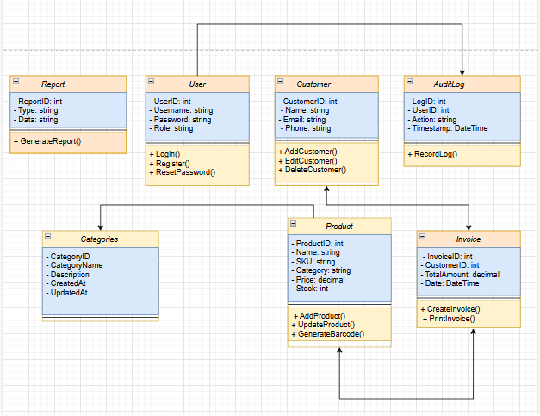

1. **Implementation**

8.1 **Development Process**

The development process followed Agile methodologies, involving requirements gathering, system design, coding, testing, deployment, training, and maintenance.

8.2 **Screenshots of all User Interfaces**

***Login Screen***

***Dashboard***

***Inventory Management Page***

***Order Management Page***

***Reporting Interface***

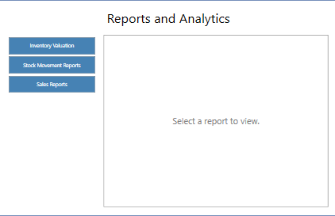

***User Management Page***

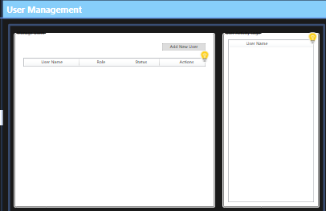

8.3 **Tools and Technologies Used**

* **Programming Language:** C#
* **Framework:** .NET Framework
* **Database:** Microsoft SQL Server
* **Version Control:** Git
* **IDE:** Visual Studio

8.4 **Challenges and Solutions**

* **Requirement Changes:** Agile methodology for flexibility.
* **Integration Issues:** Clear data mapping and API usage.
* **User Acceptance:** Training and user manuals.
* **Data Migration:** Validation and test migrations.
* **Performance Optimization:** Indexing and caching strategies.
* **Security Concerns:** Encryption and role-based access control.
* **Testing and Quality Assurance:** Comprehensive testing strategy.

1. **Conclusion and Results**

**9.1 Project Outcomes Summary**

* Improved inventory accuracy.
* Streamlined order processing.
* Enhanced reporting capabilities.
* Increased user satisfaction.
* Cost savings and operational efficiency.

**9.2 Comparison of Objectives and Results**

The IMS met its objectives, achieving efficient processes and positive user feedback.

**> Main Window Navigation  
  
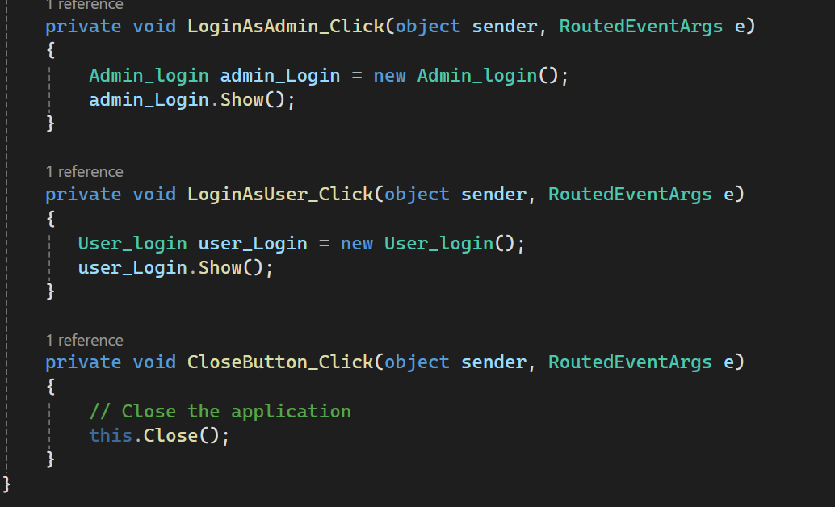**

**> Admin Login**

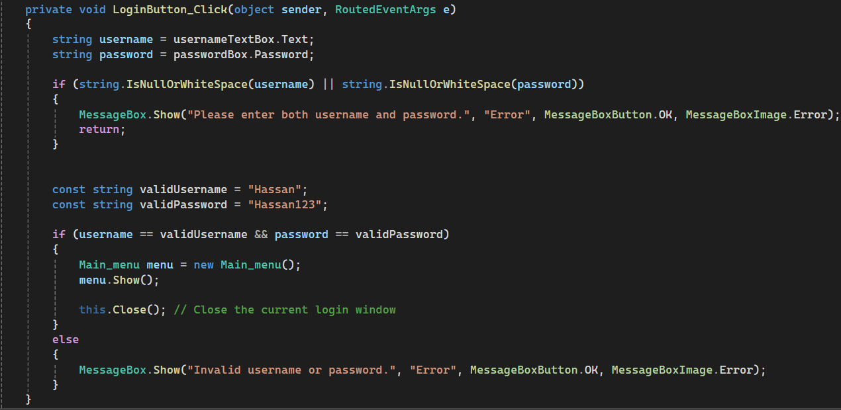

**> Product Management   
  
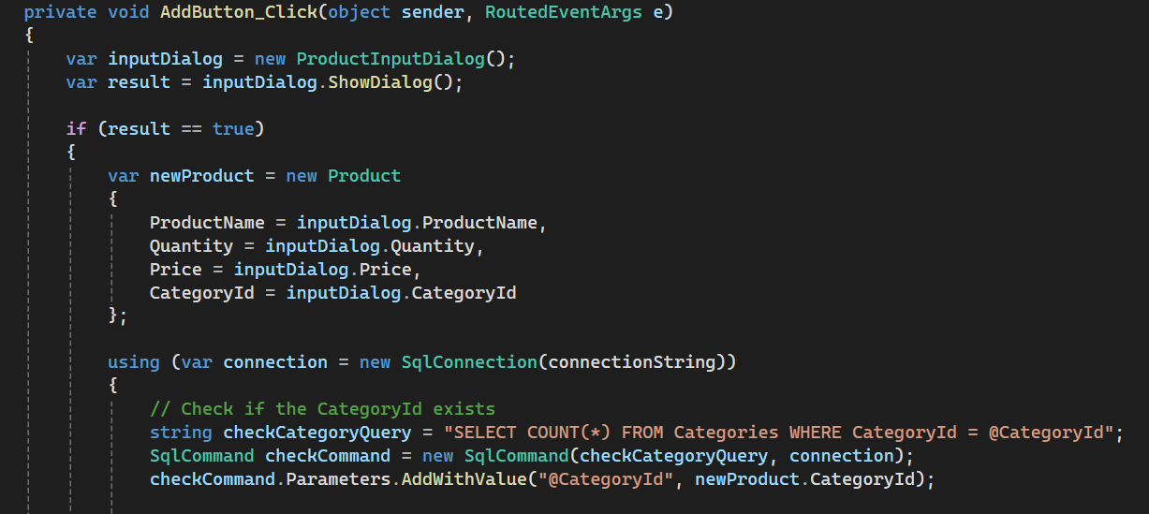**

**> Category Management**

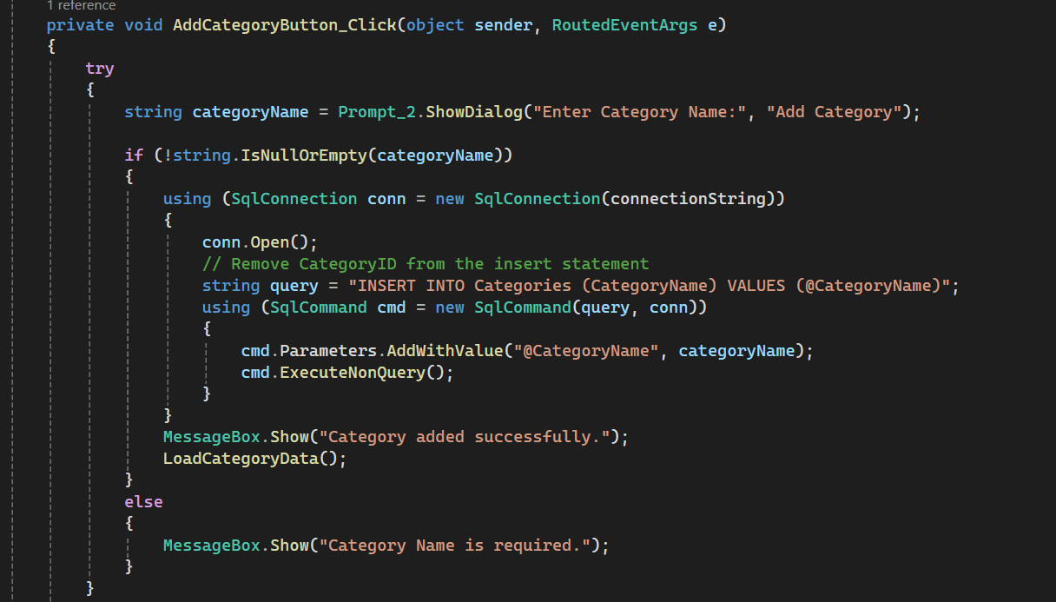

**> Order Management   
  
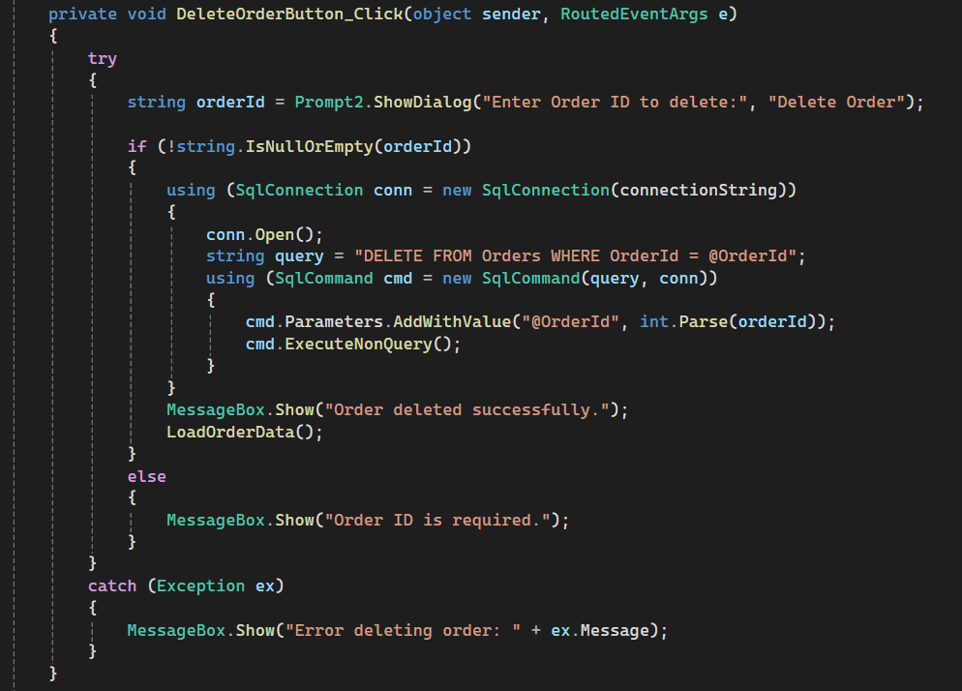**

**-------------------------------------------------------------------***The End*