**PROJECT REPORT**

**ON**

**Shopping Cart System**

*Submitted in partial fulfillment of*

*Bachelor's in computer science*



Session: 2023-2027

**DEPARTMENT OF COMPUTER SCIENCE**

AIR UNIVERSITY MULTAN CAMPUS

Submitted to: Submitted by:

**Ma’am Aatka Ali**  **M. AHMAD IJAZ (233566)**

(Lecturer Air University Multan) **M.Umer (233538)**

**Abubaker (233534)**

**Shopping Cart System**

**Table of Contents:**

**Introduction** 4

**Brief Description** 4

**Adding Products:** 4

**Removing Products:** 5

**Viewing Cart:** 6

**Calculating Total Price:** 6

**Checkout Process:** 7

**Technical Details** 7

**ShoppingCart Class:** 7

**Product Class:** 8

**Key Features** 9

**User -Friendly Interface:** 9

**Structured Class Design:** 9

**Potential Enhancements**: 9

**Future Enhancements** 10

**Graphical User Interface (GUI):** 10

**User Authentication:** 10

**Product Database:** 10

**Payment Integration:** 10

**Order History and Tracking:** 10

**Discount and Coupon System:** 10

**Inventory Management:** 10

**Product Reviews and Ratings:** 11

**Mobile Compatibility:** 11

**Analytics Dashboard:** 11

**Class Diagram** 11

**Conclusion** 11

**Output** 12

**Menu Print:** 12

**Add Product:** 12

**Selecting the Categories:** 12

**Entering the products:** 13

**Remove of Products:** 13

**View Cart:** 13

**Calculate total Price:** 13

**Checkout:** 14

**Product Recommendation:** 14

**Cart Expiration Check:** 14

# **Introduction**

The Shopping Cart Application is a console-based software developed in C# that simulates a basic online shopping experience. With the rise of e-commerce, understanding how shopping cart systems function is crucial for both developers and users. This application allows users to manage their shopping carts efficiently, providing functionalities that mimic real-world shopping scenarios.

## **Brief Description**

The application is designed to provide a user-friendly interface through a simple menu system. Users can easily navigate through the functionalities, ensuring a seamless shopping experience. Key features of the application include:

**Adding Products:**

Users can add items to their cart while ensuring stock availability. This feature simulates the process of selecting items in a physical store and adds realism to the shopping experience.

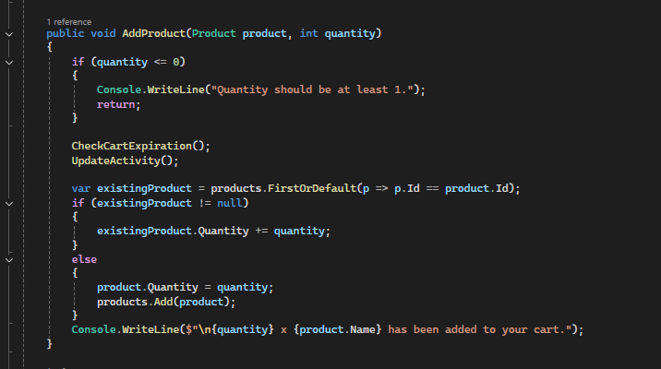

**Removing Products:**

Users have the option to remove items from their cart, either by specifying a quantity to reduce or by removing all of a specific product. This flexibility allows users to adjust their selections as they finalize their purchases.

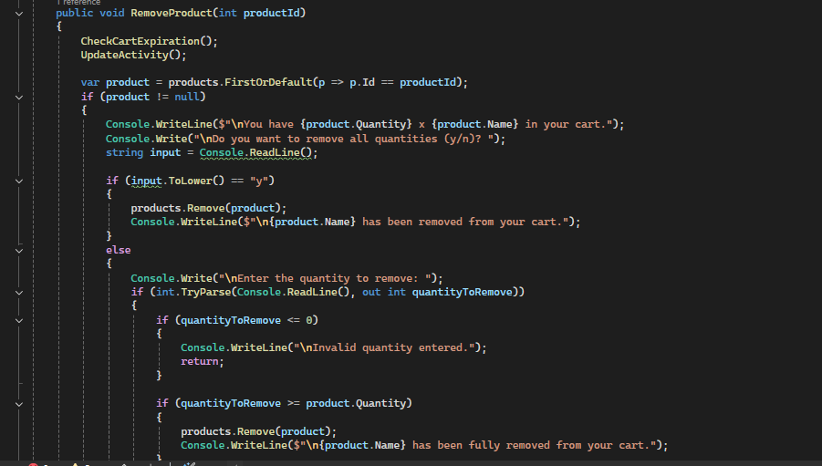

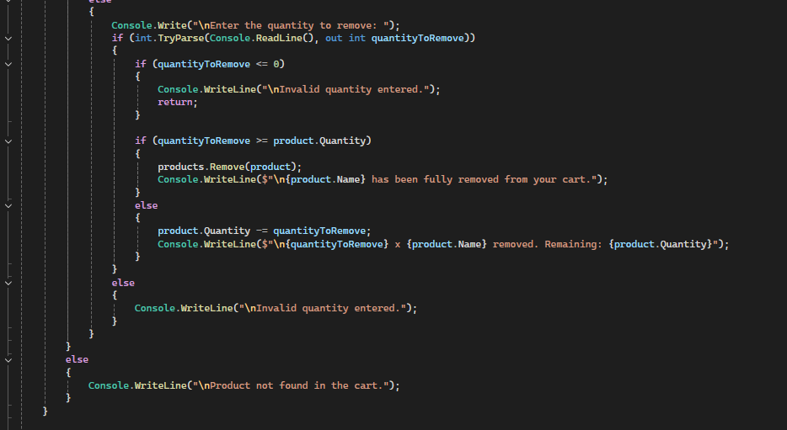

**Viewing Cart:**

The application displays the current contents of the cart, including product details such as name, price, and quantity. This transparency helps users make informed decisions before checking out.

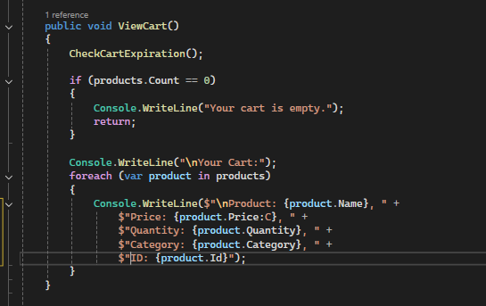

**Calculating Total Price:**

The application computes the subtotal of items in the cart, applies any discounts, and calculates tax to provide the total amount due. This feature is essential for users to understand their financial commitment before completing a purchase.

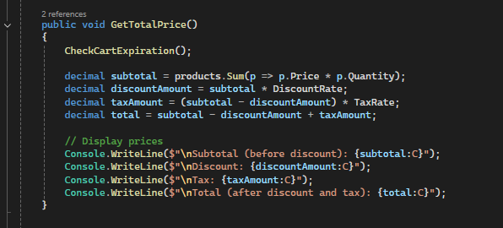

**Checkout Process:**

The checkout feature finalizes the purchase, clears the cart, and thanks the user for their order. This simulates the end of the shopping experience and reinforces positive user engagement.

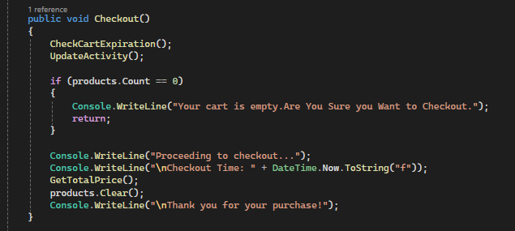

This project serves as a foundational tool for understanding e-commerce functionalities, providing a practical example of how shopping carts operate in online retail environments. It can be further enhanced with additional features such as user authentication, payment processing, and product reviews.

# **Technical Details**

The Shopping Cart Application is built using C# and utilizes a console-based interface for user interaction. The application employs a structured class design, which promotes modularity and ease of maintenance. Key components include:

**ShoppingCart Class:**

This class manages the list of products added to the cart. It provides methods for adding, removing, and viewing products, as well as calculating the total price. The encapsulation of cart functionalities within this class allows for easier updates and enhancements.

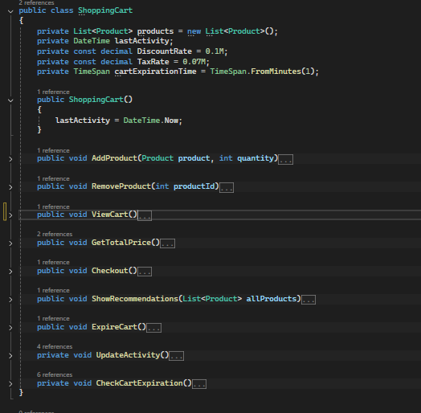

**Product Class:**

Represents individual products with properties such as name and price. This class facilitates the creation and management of product objects, allowing for scalability if additional product attributes (like description or stock quantity) are needed in the future.

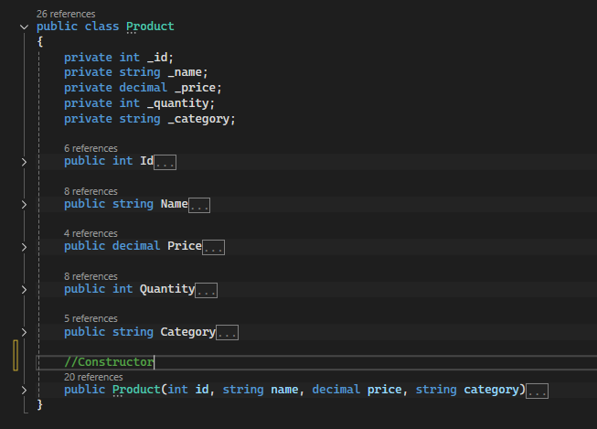

# **Key Features**

**User -Friendly Interface:**

The console interface allows users to interact with the application easily, navigating through options with simple commands. A well-designed menu system enhances the user experience by reducing confusion and streamlining interactions.

**Structured Class Design:**

The use of classes promotes organized code structure, making it easier to maintain and extend the application. Object-oriented principles such as encapsulation and abstraction are employed to manage complexity.

**Potential Enhancements**:

Future improvements could include adding a graphical user interface (GUI) for a more visually appealing experience, implementing data persistence to save user sessions, and enhancing the checkout process with payment integration, allowing users to make real purchases.

# **Future Enhancements**

To improve the Shopping Cart Application and expand its capabilities, several enhancements can be considered:

## **Graphical User Interface (GUI):**

Implementing a GUI would provide a more visually appealing and intuitive user experience, making navigation easier for users unfamiliar with console applications.

## **User Authentication:**

Adding user accounts with login functionality would allow users to save their shopping history, preferences, and personal information securely.

## **Product Database:**

Integrating a database to manage products would enable dynamic product management, including adding, updating, and removing products without modifying the source code.

## **Payment Integration:**

Implementing payment processing (e.g., credit card, PayPal) would allow users to complete real transactions, making the application a fully functional e-commerce platform.

## **Order History and Tracking:**

Providing users with access to their order history and tracking information would enhance the shopping experience and build trust.

## **Discount and Coupon System:**

Adding a feature for applying discounts and coupons during checkout would encourage users to make purchases and improve sales.

## **Inventory Management:**

Implementing inventory tracking would help manage stock levels, alerting users when products are low or out of stock.

## **Product Reviews and Ratings:**

Allowing users to leave reviews and ratings for products would provide valuable feedback for other users and enhance product credibility.

## **Mobile Compatibility:**

Developing a mobile version of the application or a mobile-friendly interface would cater to users who prefer shopping on their mobile devices.

## **Analytics Dashboard:**

Creating an admin dashboard for tracking sales, user behavior, and product performance would provide insights for future business decisions.

# **Class Diagram**

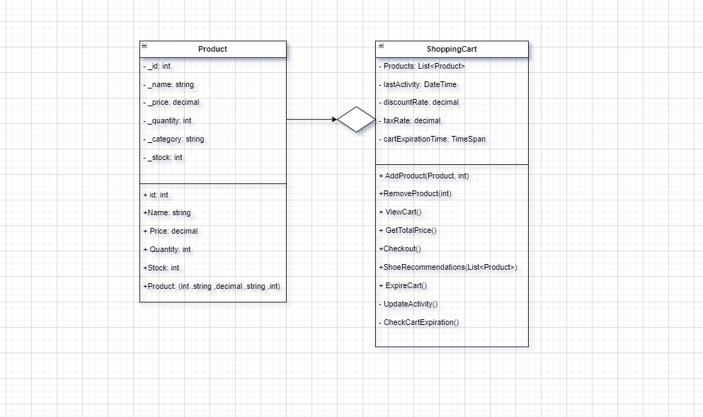

# **Conclusion**

The shopping cart project exemplifies fundamental programming concepts and best practice in software development. It serves as a comprehensive tool for managing online shopping interaction and is a solid foundation for further enhancements. With potential developments this application involves in providing users with a seamless shopping experience. this project not only demonstrates the technical capabilities of the C# but also offer valuable insights into to the user interface design and system architecture.

# **Output**

## **Menu Print:**

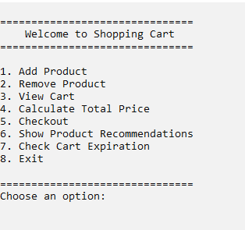

## **Add Product:**

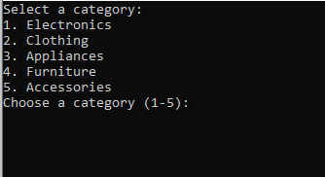

### **Selecting the Categories:**

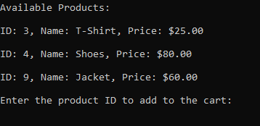

### **Entering the products:**

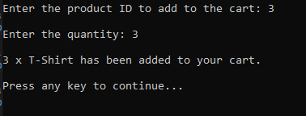

## **Remove of Products:**

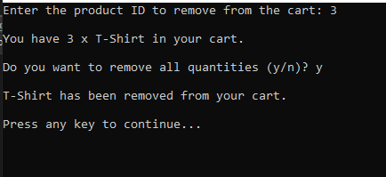

## **View Cart:**

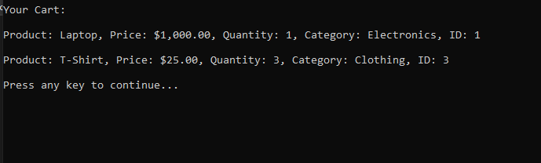

## **Calculate total Price:**

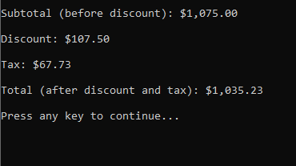

## **Checkout:**

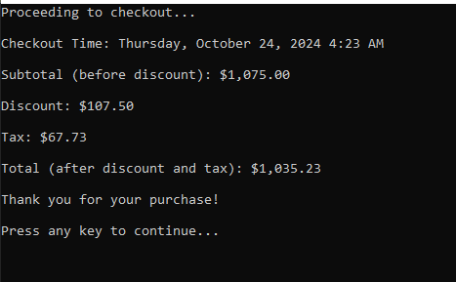

## **Product Recommendation:**

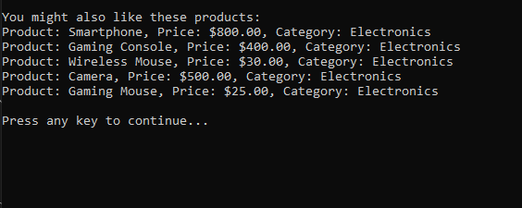

## **Cart Expiration Check:**

