# Ai-Chatbot Prompt

## Copy Writing Assistant:

According to user demand this Chatbot prompt is built to deal with queries regarding creating a social media post.

As input, you can provide the link of the or you can describe your product with various factors like Tone (exciting, informative etc.), Targeted Audience (children, athletes, busy professionals) and Main Key Words (Boost, Natural, Growth).

Bot than gather user’s requirements or provided link fetch the data and deliver an eye-catching   
Social Media Post.

## Guide to run Chatbot:

1. Extract the chatbotPrompt.zip file.
2. Open the chatbotPrompt folder in VS Code.
3. Open terminal and run command, pip install -r requirements.txt
4. Search in Windows for Edit the System Environment Variables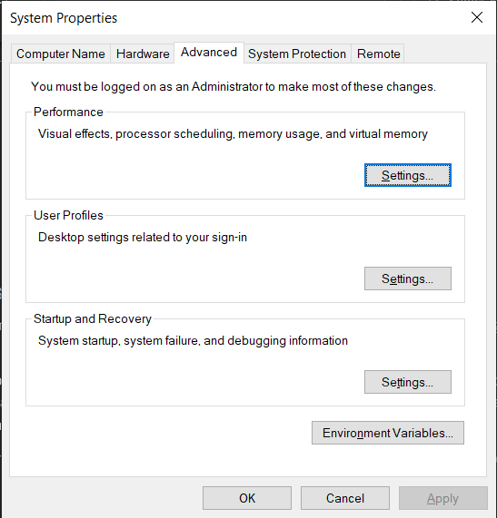
5. Click on Environment Variables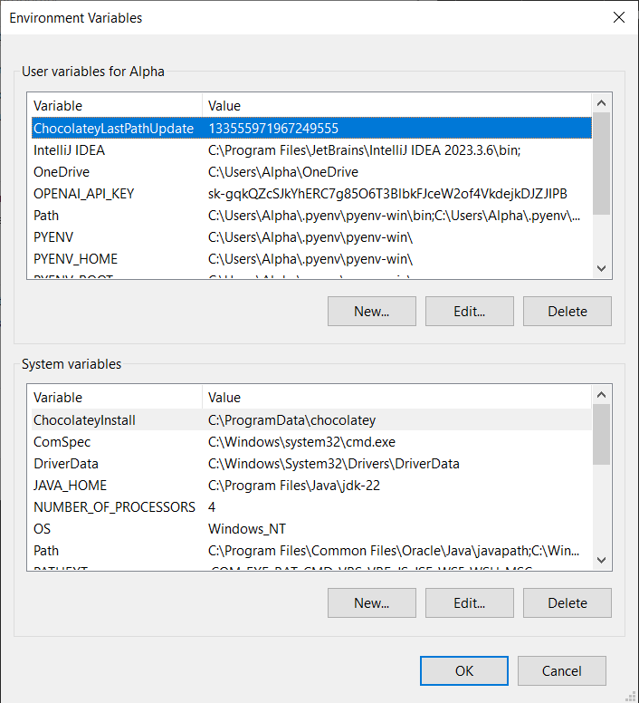
6. Click on New in Environment Variables and add New Variable, Keep the Variable Name as OPENAI_API_KEY and Variable value will be the OPENAI API KEY.  
   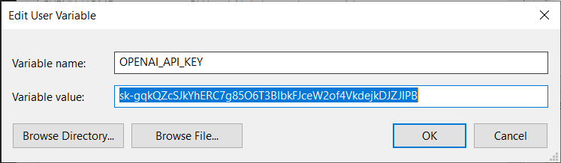
7. Go to terminal in VS code run command, Python app.py and click on Follow link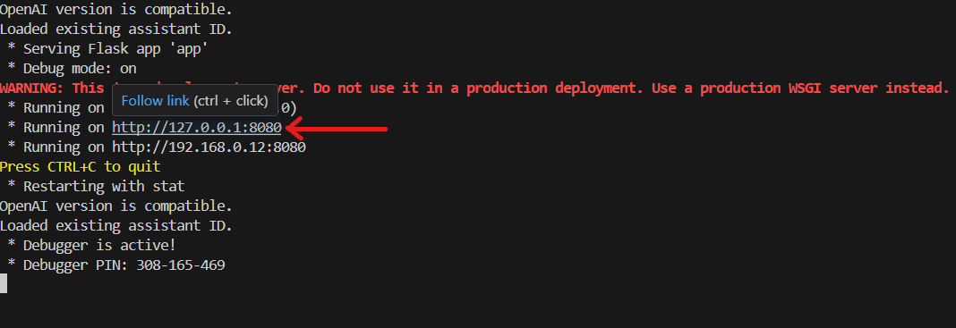

## You are Done now Enjoy your Chatbot!

Chatbot running locally, fetching data from link, providing the Informative Social Media post.

