Lighting Parameters and Effects on Children in Schools

This booklet summarizes the biological, psychological, and performance-related effects of classroom lighting parameters on students of different ages. Each section includes an explanation, recommended ranges, and references.

# CCT (Color Temperature)

Cooler CCT (4000–5000K) improves alertness and concentration in classrooms, while too warm (<3000K) reduces focus. Very high (>6500K) can cause visual discomfort.

Recommended Range: 3500 – 5000

Reference: CIE S 026/E:2018; Figueiro & Rea 2010, Lighting Research & Technology

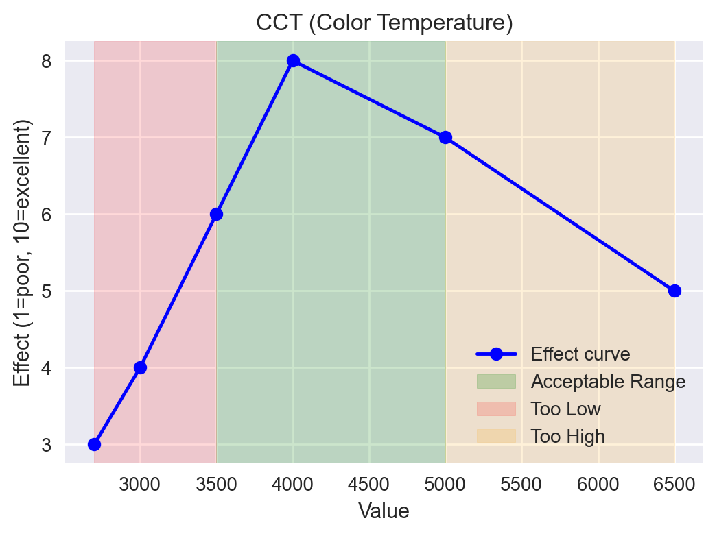

# CRI (Color Rendering Index)

Higher CRI (>90) ensures natural color perception, reduces eye strain, and supports accurate visual tasks in classrooms.

Recommended Range: 80 – 100

Reference: IES Lighting Handbook, 10th Edition; CIE 13.3-1995

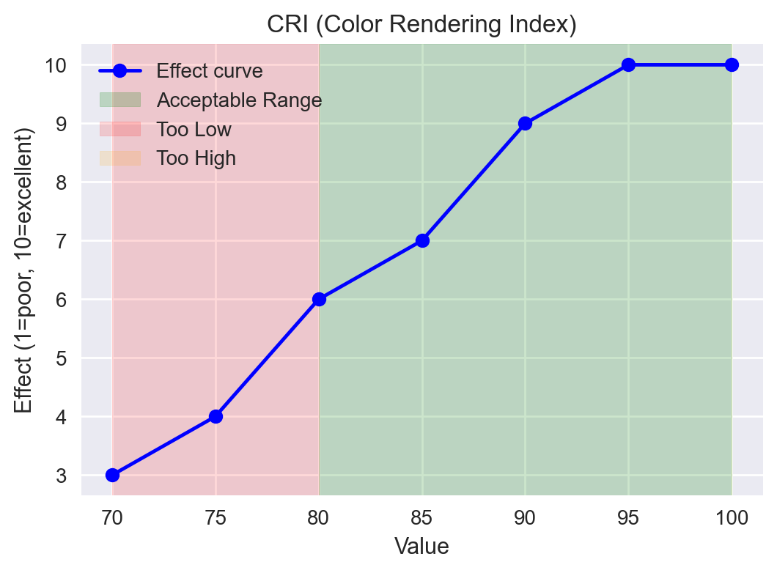

# Flicker

High flicker (>20%) is linked to headaches, eyestrain, and reduced reading performance in children.

Recommended Range: 0 – 10

Reference: IEEE Std 1789-2015; Wilkins et al., Brain (1989)

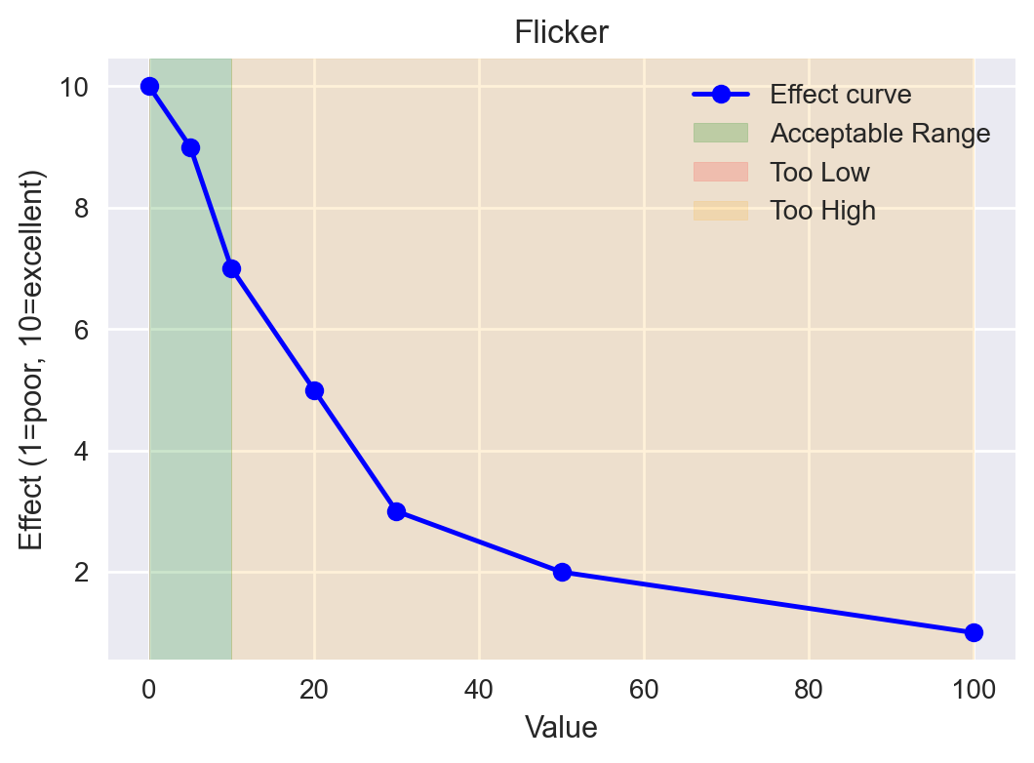

# Glare (UGR)

UGR above 22 causes visual discomfort and reduced attention. UGR <19 is recommended for classrooms.

Recommended Range: 16 – 19

Reference: EN 12464-1:2021 Lighting of Workplaces

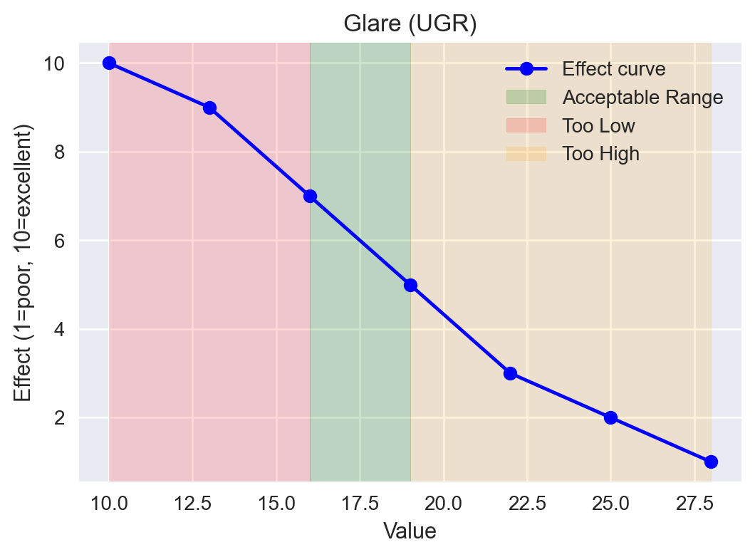

# Melanopic EDI

Melanopic Equivalent Daylight Illuminance (EDI) ≥ 200 lux in morning hours supports circadian entrainment and improves alertness.

Recommended Range: 200 – 350

Reference: CIE S 026/E:2018; Lucas et al., NPJ Biological Rhythms (2014)

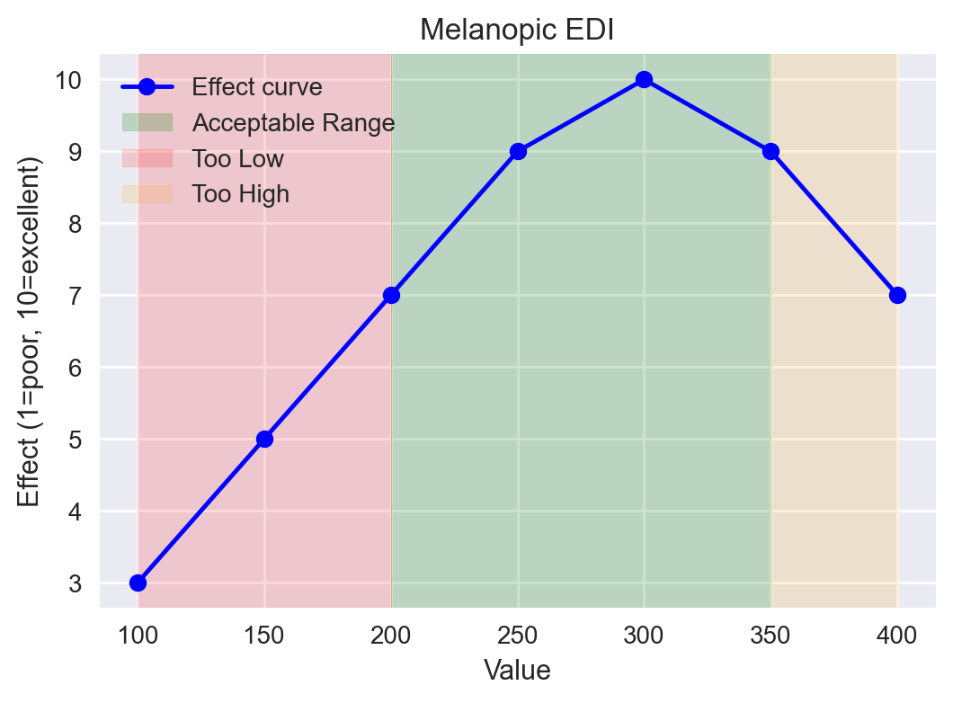

# Vertical Illuminance

Vertical illuminance at the eye ensures proper non-visual stimulation. 300–500 lux is ideal in classrooms.

Recommended Range: 300 – 500

Reference: WELL Building Standard v2; CIE S 026/E:2018

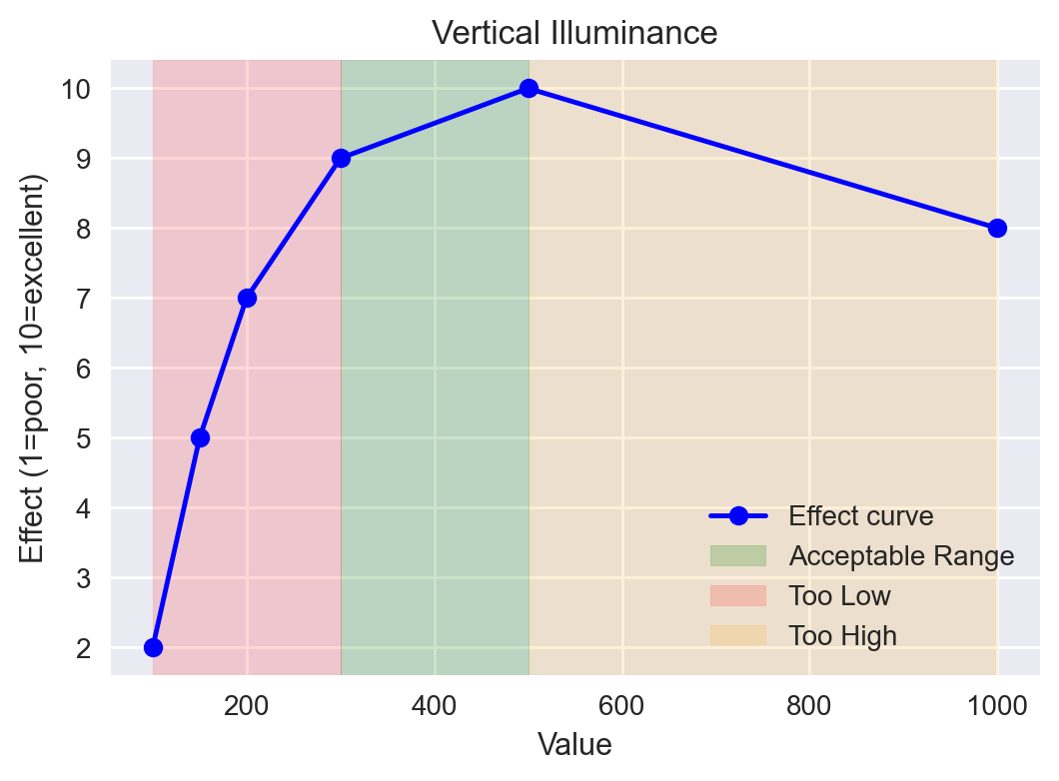

# Exposure Duration

2–4 hours of exposure to proper lighting is beneficial for children’s circadian rhythm and sustained focus.

Recommended Range: 2 – 4

Reference: Gooley et al., J. Clin. Endocrinol. Metab. (2011); CIE 2018

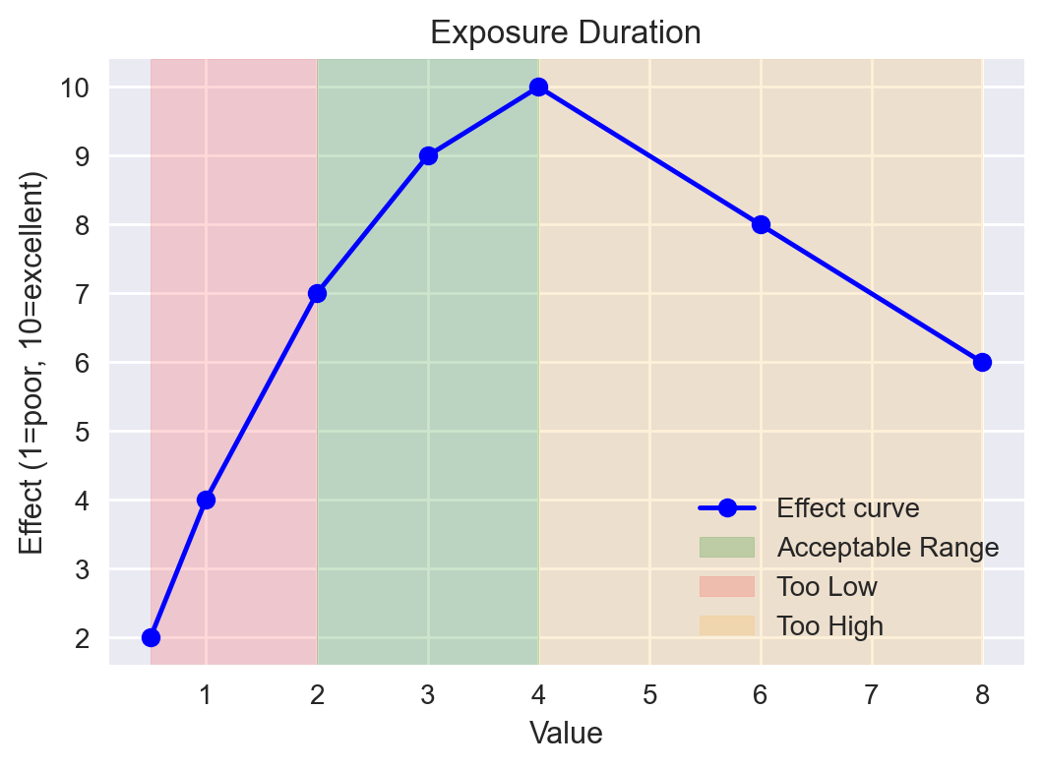

# Lux (Horizontal Illuminance)

300–500 lux at desk level improves reading speed, comprehension, and reduces eye strain. Too low (<200) impairs visual performance.

Recommended Range: 300 – 500

Reference: EN 12464-1:2021; IESNA Handbook

