The Effect of Light on Students in Schools

A concise, referenced booklet on how lighting parameters affect student concentration, biology, and psychology.

# 1) The Problem

Suboptimal school lighting (low/imbalanced illuminance, excessive flicker, high glare, inappropriate spectrum) is associated with headaches, visual fatigue, poor concentration, and circadian disruption, which can degrade academic performance.

Key standards and reviews emphasize illuminance, glare control (UGR), color rendering (CRI), and circadian-effective light.

# 2) The Idea

Study how measurable lighting parameters—CCT, CRI, Flicker, Glare (UGR), Melanopic EDI, Vertical Illuminance, Exposure Duration, and Horizontal Illuminance—affect children at different ages. Compare optimal vs. harmful ranges, with biological rationale and outcomes.

# 3) The Study: Parameters, Effects & Visuals

## CCT (Correlated Color Temperature, K)

Balanced 4000–5000 K supports alertness and visual comfort for classrooms. Too warm (<3000 K) can promote sleepiness; too cool (>6500 K) may increase discomfort/glare. Short, task-specific boosts at 6500 K/1000 lx can improve reading fluency during tests.

Optimal range: 4000–5000 | Caution: 3000–6500 (context-dependent).

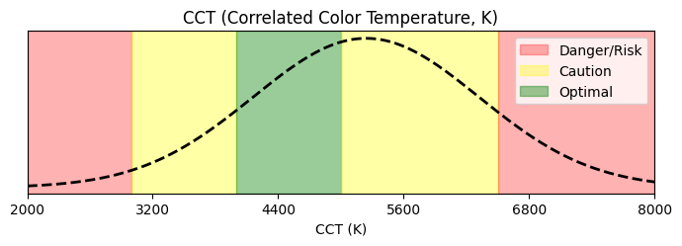

References:

• EN 12464-1: Indoor work lighting (general targets) — https://www.performanceinlighting.com/mo/en/en-12464-1

• Mott et al., 2012: High CCT/illuminance improved reading fluency — https://journals.sagepub.com/doi/abs/10.1177/1477153512446099

• Sleegers et al., 2013: Dynamic lighting and concentration — https://journals.sagepub.com/doi/abs/10.1177/1477153512446099

• Park et al., 2015: CCT, EEG & task performance — https://pmc.ncbi.nlm.nih.gov/articles/PMC4668153/

• Chen et al., 2022: CCT × illuminance responses — https://www.mdpi.com/1996-1073/15/12/4477

## CRI (Color Rendering Index, Ra)

CRI ≥80 supports natural color appearance and reduces visual fatigue. Art/graphics benefit from CRI ≥90. Very low CRI (<70) hampers color discrimination and comfort.

Optimal range: 80–100 | Caution: 70–80 (context-dependent).

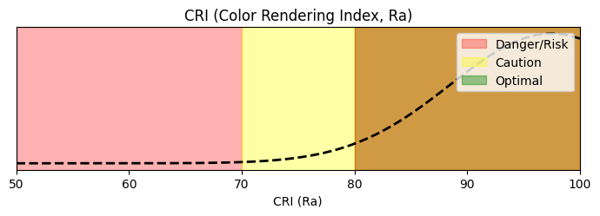

References:

• EN 12464-1: Ra ≥80 typical; ≥90 for demanding color tasks — https://www.performanceinlighting.com/mo/en/en-12464-1

## Flicker (% modulation at typical LED driving frequencies)

Keep percent flicker <5% to minimize headaches, eyestrain, and distraction. Between 5–20% some occupants are affected; >20% increases adverse effects. Use high-frequency drivers and avoid PWM at low frequencies per IEEE 1789.

Optimal range: 0–5 | Caution: 5–20 (context-dependent).

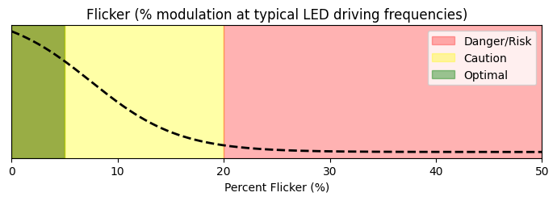

References:

• IEEE 1789-2015: Flicker recommended practice — https://www.lisungroup.com/wp-content/uploads/2020/02/IEEE-2015-STANDARDS-1789-Standard-Free-Download.pdf

• DOE/LightFair deck: factors increasing risk — https://www.energy.gov/sites/default/files/2022-11/ssl-miller-lehman_flicker_lightfair2015.pdf

• DIAL explainer on IEEE 1789 terms — https://www.dial.de/en-GB/articles/ieee-1789-a-new-standard-for-evaluating-flickering-leds

## Glare (UGR)

UGR <19 recommended for classrooms to avoid discomfort and maintain performance. Aim lower (≈16–18) near screens/interactive boards.

Optimal range: 10–19 | Caution: 19–22 (context-dependent).

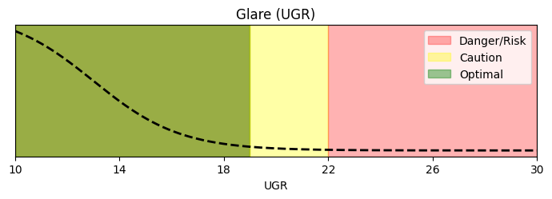

References:

• EN 12464-1: UGR targets for tasks — https://www.performanceinlighting.com/mo/en/en-12464-1

• CIBSE Factfile: importance of UGR — https://www.cibse.org/media/polbabib/factfile-15-the-importance-of-glare-and-calculating-ugr-jul2019.pdf

## Melanopic EDI (lux at eye, vertical)

Daytime ≥250 melanopic EDI at eye supports circadian entrainment and alertness (measure at ≈1.2 m seated, vertical). Evening levels should be much lower.

Optimal range: 250–500 | Caution: 100–250 (context-dependent).

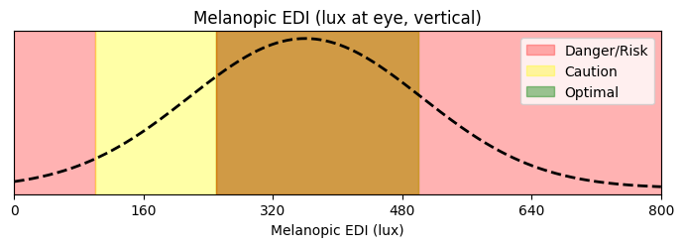

References:

• Global consensus (Brown et al., 2022): daytime ≥250 mEDI — https://journals.plos.org/plosbiology/article?id=10.1371/journal.pbio.3001571

• PMC version — https://pmc.ncbi.nlm.nih.gov/articles/PMC8929548/

• WELL v2 L03 circadian targets (EML/mEDI) — https://standard.wellcertified.com/light/circadian-lighting-design

## Vertical Illuminance (lux at eye/face)

Adequate vertical illuminance improves visibility of faces/boards and supports non-visual effects. Keep roughly 300–500 lx on faces in learning spaces; avoid very low or very high values.

Optimal range: 300–500 | Caution: 200–800 (context-dependent).

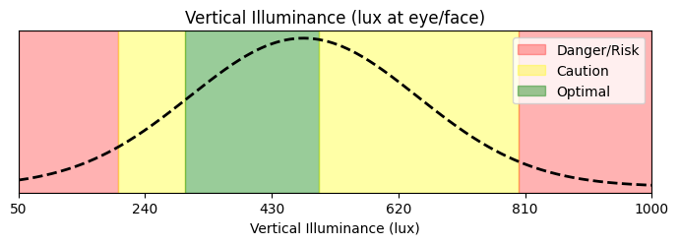

References:

• EN 12464-1: room surface/vertical illuminance guidance — https://www.performanceinlighting.com/mo/en/en-12464-1

• CIBSE LG5/education guidance (context) — https://www.cibse.org/knowledge-research/knowledge-portal/lg7-lighting-for-offices-2023

## Exposure Duration (hours of daytime light meeting targets)

Sustained exposure (≈3–6 h) to target illuminance/spectrum during the school day supports alertness and entrainment; very little or excessive high-intensity exposure is less beneficial.

Optimal range: 3–6 | Caution: 1–8 (context-dependent).

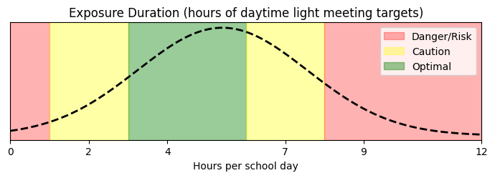

References:

• Consensus guidance on daytime vs evening exposure (Brown et al., 2022) — https://pmc.ncbi.nlm.nih.gov/articles/PMC8929548/

## Horizontal Illuminance (desk, lux)

Provide 300–500 lx at desks for most classroom tasks; 500–750+ lx for labs/graphics. Higher levels (≈1000 lx) may be used short-term for exams/focus sessions.

Optimal range: 300–500 | Caution: 200–1000 (context-dependent).

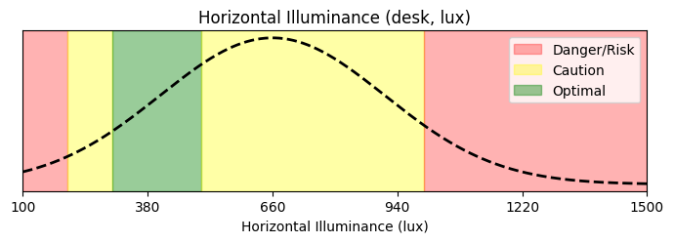

References:

• EN 12464-1: classroom/task illuminance — https://www.performanceinlighting.com/mo/en/en-12464-1

• Mott/Sleegers: high-lx focus settings evidence — https://journals.sagepub.com/doi/abs/10.1177/1477153512446099

# 4) The Solution: Evidence-Based Targets by Age & Environment

Below are practical set-points derived from standards and research. Horizontal illuminance/UGR/CRI from EN 12464-1; melanopic targets from Brown et al. (2022) and WELL v2 L03; flicker per IEEE 1789; CCT/task boosts per classroom studies.

• Kindergarten (3–5) – classroom

- Horizontal illuminance: 300–500 lx

- UGR: <19 | CRI: ≥80

- Daytime melanopic target: ≥250 mEDI (daytime)

- Typical CCT: 3500–4000 K

- Notes: Softer CCT to reduce arousal; keep flicker <5%; good vertical light for faces (≈300–400 lx).

- References:

• EN 12464-1: classroom lx/UGR/CRI — https://www.performanceinlighting.com/mo/en/en-12464-1

• Brown et al., 2022 mEDI ≥250 — https://pmc.ncbi.nlm.nih.gov/articles/PMC8929548/

• Primary (6–11) – classroom

- Horizontal illuminance: 300–500 lx

- UGR: <19 | CRI: ≥80

- Daytime melanopic target: ≥250–300 mEDI

- Typical CCT: 4000–5000 K

- Notes: Balanced spectrum/daylight; flicker <5%; vertical ≈300–500 lx on faces/boards.

- References:

• EN 12464-1 — https://www.performanceinlighting.com/mo/en/en-12464-1

• WELL v2 L03 circadian targets — https://standard.wellcertified.com/light/circadian-lighting-design

• Secondary (12–18) – classroom

- Horizontal illuminance: 300–500 lx

- UGR: <19 (≤16 near screens) | CRI: ≥80 (≥90 for art)

- Daytime melanopic target: ≥250–300 mEDI

- Typical CCT: 4000–5000 K

- Notes: Lower UGR near screens; can use short high-CCT/1000 lx sessions for tests.

- References:

• EN 12464-1 — https://www.performanceinlighting.com/mo/en/en-12464-1

• Mott/Sleegers focus setting — https://journals.sagepub.com/doi/abs/10.1177/1477153512446099

• Exam/Focus sessions (all ages)

- Horizontal illuminance: 500–1000 lx (short-term)

- UGR: <19 | CRI: ≥80

- Daytime melanopic target: ≥250–400 mEDI

- Typical CCT: 5000–6500 K

- Notes: Short deployments to boost alertness/reading fluency; avoid all-day cold light.

- References:

• Mott et al., 2012 — https://journals.sagepub.com/doi/abs/10.1177/1477153512446099

• Sleegers et al., 2013 — https://journals.sagepub.com/doi/abs/10.1177/1477153512446099

• Art/Graphics room

- Horizontal illuminance: 500–750 lx

- UGR: <19 | CRI: ≥90

- Daytime melanopic target: ≥250 mEDI

- Typical CCT: 4000–5000 K

- Notes: High CRI for accurate color tasks; good vertical light to evaluate work.

- References:

• EN 12464-1 (color-critical tasks) — https://www.performanceinlighting.com/mo/en/en-12464-1

• Science lab

- Horizontal illuminance: 500–750 lx

- UGR: <19 (≤16 preferred) | CRI: ≥80

- Daytime melanopic target: ≥250–300 mEDI

- Typical CCT: 4000–5000 K

- Notes: Higher task lx and glare control for practical work; minimize flicker.

- References:

• EN 12464-1 (laboratory tasks) — https://www.performanceinlighting.com/mo/en/en-12464-1

• Corridors / circulation

- Horizontal illuminance: 100–200 lx

- UGR: <22 | CRI: ≥80

- Daytime melanopic target: —

- Typical CCT: 3000–4000 K

- Notes: Comfortable navigation; avoid excessive brightness/glare.

- References:

• EN 12464-1 — https://www.performanceinlighting.com/mo/en/en-12464-1

## Implementation Notes (All Spaces)

• Keep flicker (percent modulation) <5% and avoid low-frequency PWM dimming (IEEE 1789).

• Aim for UGR <19; place luminaires to avoid direct view and specular reflections of boards/screens.

• Provide ≥250 melanopic EDI at eye (daytime); drastically lower in evening events to avoid circadian delay.

• Use CRI ≥80 (≥90 for color-critical work).

• Balance horizontal (desk) lx with adequate vertical illuminance for faces and boards.

# References (Titles + Links)

• EN 12464-1: Lighting of work places — Indoor — https://www.performanceinlighting.com/mo/en/en-12464-1

• CIBSE Factfile: Importance of UGR — https://www.cibse.org/media/polbabib/factfile-15-the-importance-of-glare-and-calculating-ugr-jul2019.pdf

• WELL v2 L03: Circadian Lighting Design — https://standard.wellcertified.com/light/circadian-lighting-design

• Brown et al., 2022 (PLOS Biology): Global consensus on melanopic EDI — https://journals.plos.org/plosbiology/article?id=10.1371/journal.pbio.3001571

• PMC mirror for Brown et al., 2022 — https://pmc.ncbi.nlm.nih.gov/articles/PMC8929548/

• IEEE 1789-2015: Flicker Recommended Practice — https://www.lisungroup.com/wp-content/uploads/2020/02/IEEE-2015-STANDARDS-1789-Standard-Free-Download.pdf

• DOE/LightFair deck: Flicker risk factors — https://www.energy.gov/sites/default/files/2022-11/ssl-miller-lehman_flicker_lightfair2015.pdf

• Mott et al., 2012 / Sleegers et al., 2013: Focus settings in classrooms — https://journals.sagepub.com/doi/abs/10.1177/1477153512446099

• Park et al., 2015: CCT, EEG & task performance — https://pmc.ncbi.nlm.nih.gov/articles/PMC4668153/

• Chen et al., 2022: CCT × Illuminance responses — https://www.mdpi.com/1996-1073/15/12/4477