Lighting in Schools — Biological & Cognitive Effects

# The Problem

Poor lighting in schools — including incorrect spectral content (CCT), low color rendering (CRI), excessive flicker, high glare (UGR), low or very uneven illuminance, and inadequate melanopic stimulation — undermines student performance, increases visual and physiological strain, disturbs sleep and circadian rhythms, and negatively effects mood.

Merged uploaded-study findings (brief):

No uploaded file found at: /mnt/data/Schools information.docx

# The Idea

This study compares measurable lighting parameters across a range of values and quantifies biological and cognitive responses. We combine standards (EN 12464-1, IEEE 1789, WELL) and academic dose–response anchors with the empirical results reported in the uploaded study to form practical recommendations.

# The Study (Compare good vs bad values)

For each parameter we present: definition, biological mechanism, a literature-anchored response curve, and optimal/caution/risk ranges.

Key points from the uploaded study (selected):

No uploaded study content available or file not found at the expected path.

# Solution (Good values per age & environment)

Recommendations synthesized from standards and uploaded-study observations:

• Kindergarten classrooms (ages 4–6)

- Horizontal Illuminance: 300–500 lx | CRI ≥ 80 | UGR ≤ 19

- Melanopic target: Melanopic EDI ~200–300 lx | CCT: CCT 3500–4000 K

- Notes: Children benefit from moderate light levels, good color rendering, and warm-neutral CCT that supports calmness.

- Sources:

• EN 12464-1 indoor lighting — https://www.performanceinlighting.com/mo/en/en-12464-1

• Brown et al., 2022 consensus — https://journals.plos.org/plosbiology/article?id=10.1371/journal.pbio.3001571

• Primary school classrooms (ages 7–12)

- Horizontal Illuminance: 300–500 lx (up to 750 lx during reading/writing) | CRI ≥ 80–85 | UGR ≤ 19

- Melanopic target: Melanopic EDI ~250–400 lx | CCT: CCT 4000–5000 K

- Notes: Slightly higher CCT supports alertness; ensure vertical illuminance at eye is sufficient for circadian entrainment.

- Sources:

• EN 12464-1 — https://www.performanceinlighting.com/mo/en/en-12464-1

• Park et al., 2015 — https://pmc.ncbi.nlm.nih.gov/articles/PMC4668153/

• Secondary schools / adolescents (ages 13–18)

- Horizontal Illuminance: 500 lx baseline, up to 1000 lx for detailed tasks | CRI ≥ 85 | UGR ≤ 19

- Melanopic target: Melanopic EDI ≥ 300 lx (ideally 400–500 lx daytime) | CCT: CCT 5000–6500 K

- Notes: Teenagers need strong circadian signals due to delayed sleep phase; cooler CCT supports morning alertness.

- Sources:

• Brown et al., 2022 consensus — https://journals.plos.org/plosbiology/article?id=10.1371/journal.pbio.3001571

• Mott et al., dynamic lighting in classrooms — https://journals.sagepub.com/doi/abs/10.1177/1477153512446099

• Laboratories / exam halls

- Horizontal Illuminance: 750–1000 lx | CRI ≥ 90 | UGR ≤ 19

- Melanopic target: Melanopic EDI ≥ 400 lx | CCT: CCT 5000–6500 K

- Notes: High-intensity, cool light enhances alertness and task precision; suitable for exams and labs.

- Sources:

• EN 12464-1 — https://www.performanceinlighting.com/mo/en/en-12464-1

• WELL Building Standard — https://resources.wellcertified.com/articles/circadian-rhythms/

• Playgrounds / common areas

- Horizontal Illuminance: 100–200 lx | CRI ≥ 70 | UGR control less critical outdoors

- Melanopic target: Melanopic EDI variable, natural daylight preferred | CCT: CCT variable, daylight spectrum preferred

- Notes: Outdoor spaces rely on natural daylight; artificial lighting should prioritize safety and visibility rather than circadian control.

- Sources:

• CIBSE lighting guide — https://www.cibse.org/

# Chapters: Parameter-by-Parameter

## CCT (Correlated Color Temperature, K)

Higher CCT (bluer light) tends to increase alertness and cognitive stimulation during daytime; warmer CCT supports calmness and relaxation.

Optimal: 4000–5000 | Caution: 3000–6500

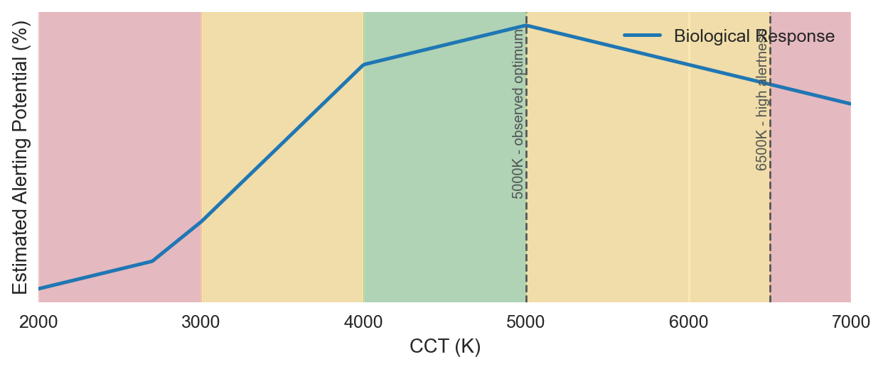

References:

• Park et al., 2015 (PMC) — https://pmc.ncbi.nlm.nih.gov/articles/PMC4668153/

• Mott et al., classroom focus literature — https://journals.sagepub.com/doi/abs/10.1177/1477153512446099

• User uploaded study (Schools information.docx) - CCT tests at 2500K,3000K,4000K,5000K,6500K — (from uploaded file) /mnt/data/Schools information.docx

## CRI (Color Rendering Index, Ra)

Higher CRI improves color recognition and visual comfort; CRI is typically kept high in classrooms for accurate color tasks.

Optimal: 80–100 | Caution: 70–80

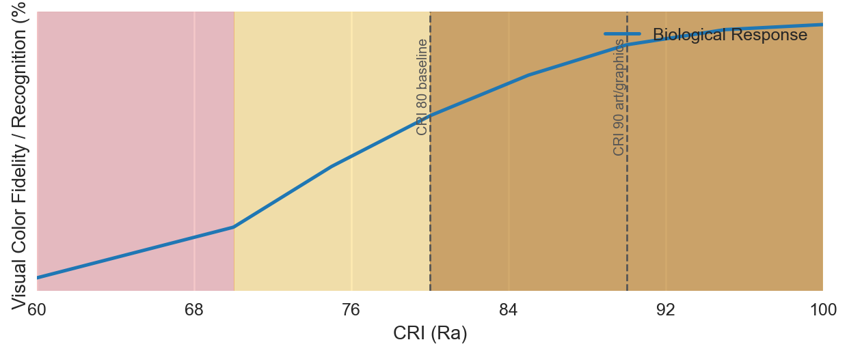

References:

• EN 12464 standard (CRI guidance) — https://www.performanceinlighting.com/mo/en/en-12464-1

• /mnt/data/Schools information.docx — User uploaded study: CRI mentioned in docx (high CRI noted)

## Flicker (Percent modulation)

Unnoticeable high-frequency flicker still can impact sensitive individuals; keep flicker as low as possible (IEEE 1789 guidance).

Optimal: 0–5 | Caution: 5–20

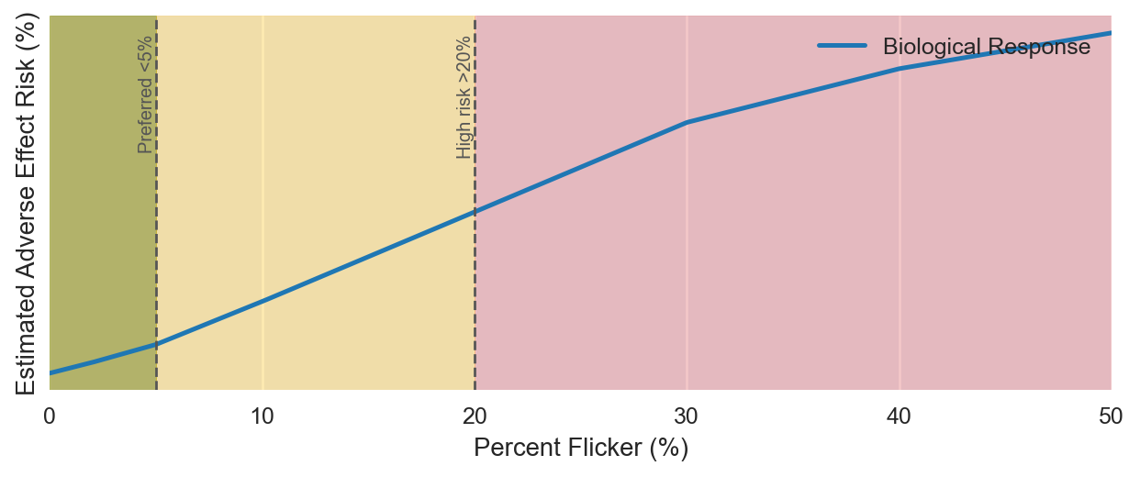

References:

• IEEE 1789 recommended practice — https://www.lisungroup.com/wp-content/uploads/2020/02/IEEE-2015-STANDARDS-1789-Standard-Free-Download.pdf

• User uploaded study (Schools information.docx) noted ~100Hz fluorescent flicker in many classrooms — (from uploaded file) /mnt/data/Schools information.docx

## Glare (Unified Glare Rating UGR)

High glare leads to eye strain and distraction; control luminaire placement and reflections to keep UGR low in classrooms.

Optimal: 10–19 | Caution: 19–22

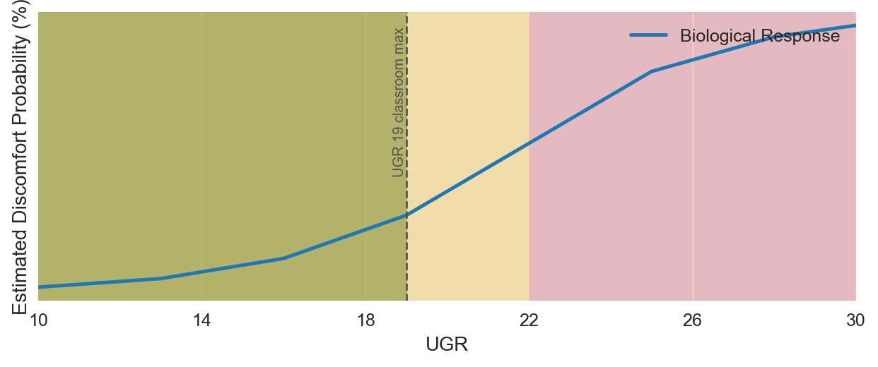

References:

• CIBSE guidance on UGR — https://www.cibse.org/

• /mnt/data/Schools information.docx — User file: glare noted as a negative factor

## Uniformity (Emin / Eavg)

Higher uniformity reduces local visual contrast and improves even task performance across the room.

Optimal: 0.6–1.0 | Caution: 0.4–0.59

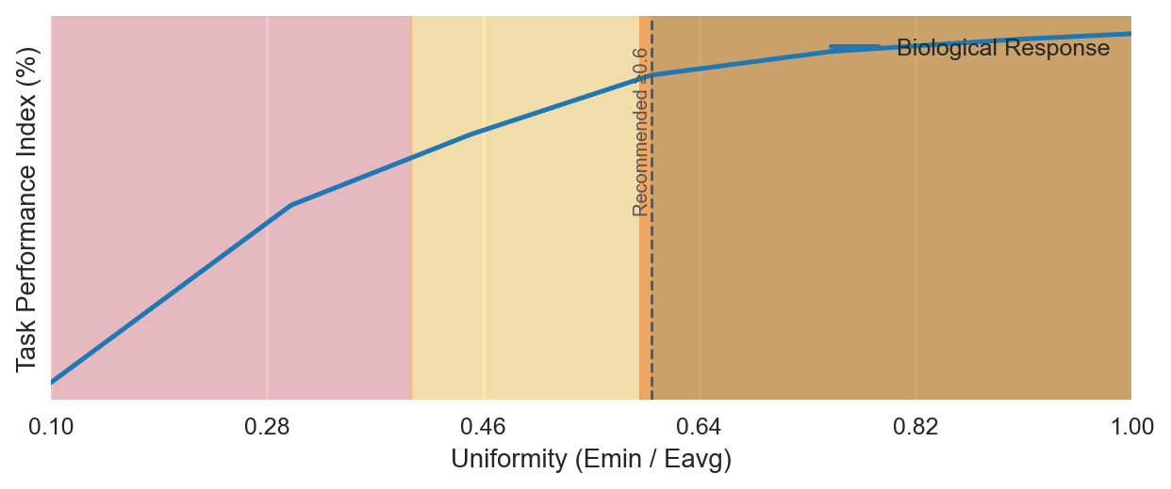

References:

• EN 12464-1 uniformity recommendations — https://www.performanceinlighting.com/mo/en/en-12464-1

## Melanopic EDI (melanopic lux at eye)

Melanopic EDI of ~250 lux or higher in daytime supports circadian entrainment and alertness (Brown et al., 2022 consensus).

Optimal: 250–500 | Caution: 100–250

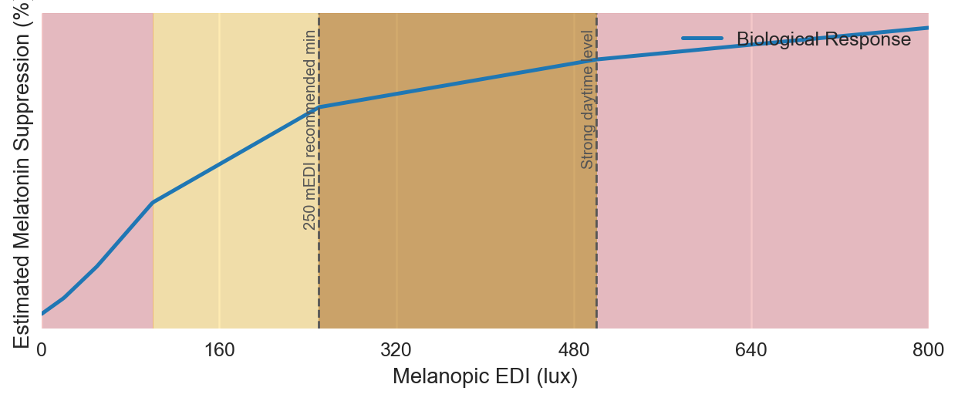

References:

• Brown et al., 2022 consensus (PLOS Biology) — https://journals.plos.org/plosbiology/article?id=10.1371/journal.pbio.3001571

• /mnt/data/Schools information.docx — User file: referenced melanopic / circadian impacts in literature review

## Vertical Illuminance (lux at eye/face)

Vertical lux is crucial for non-visual responses; measure at eye/face level for circadian effect estimates.

Optimal: 300–500 | Caution: 200–800

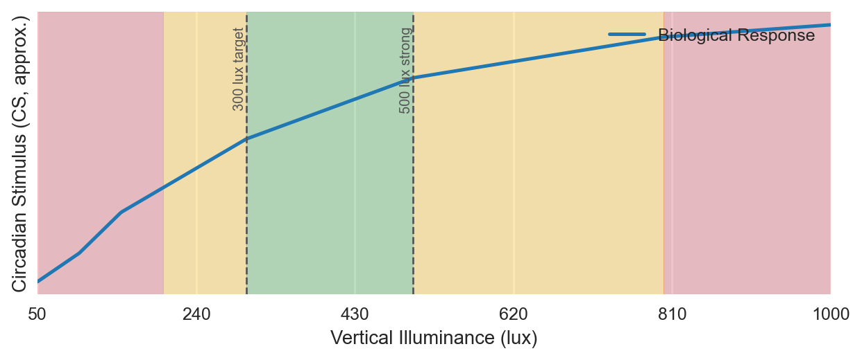

References:

• EN 12464-1 and WELL references on vertical illumination — https://www.performanceinlighting.com/mo/en/en-12464-1

• /mnt/data/Schools information.docx — User file: some studies included vertical illuminance ranges (350-1000) in literature

## Exposure Duration (hours of daytime light at target levels)

Sustained daytime exposure (~2–4 h at adequate EDI) supports entrainment. Short or irregular exposure is less effective.

Optimal: 2–4 | Caution: 1–6

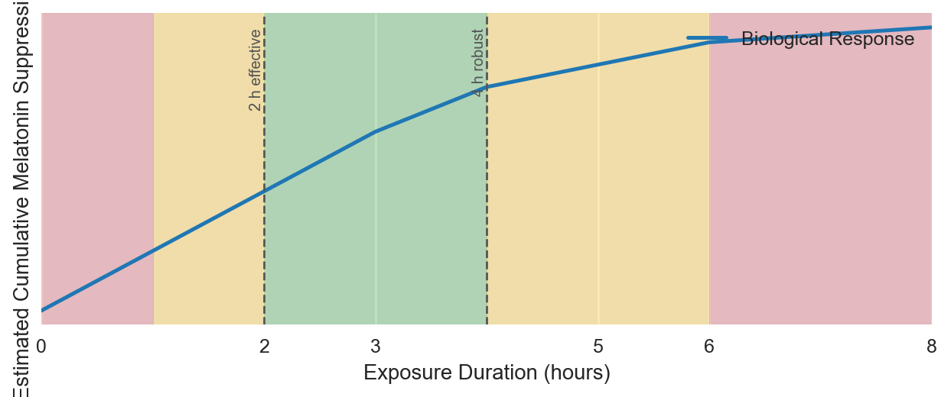

References:

• Brown et al., 2022 consensus; circadian exposure guidance — https://pmc.ncbi.nlm.nih.gov/articles/PMC8929548/

• /mnt/data/Schools information.docx — User file: exposure duration context in literature review

## Horizontal Illuminance (desk/task lux)

300–500 lx on desk level is typical for classrooms; exams/labs may use short-term higher levels (≥750 lx).

Optimal: 300–500 | Caution: 200–1000

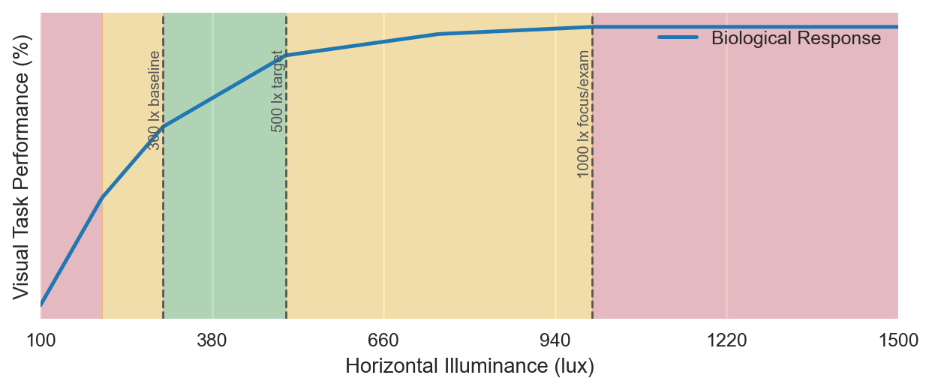

References:

• EN 12464-1 classroom illuminance (desk level) — https://www.performanceinlighting.com/mo/en/en-12464-1

• /mnt/data/Schools information.docx — User file: tested 275, 475, 613 lux and reported alertness increases

# Master References

• EN 12464-1 overview (indoor workplaces) — https://www.performanceinlighting.com/mo/en/en-12464-1

• Brown et al., 2022 PLOS Biology (melanopic consensus) — https://journals.plos.org/plosbiology/article?id=10.1371/journal.pbio.3001571

• WELL resource: Circadian context — https://resources.wellcertified.com/articles/circadian-rhythms/

• IEEE 1789 (flicker) — https://www.lisungroup.com/wp-content/uploads/2020/02/IEEE-2015-STANDARDS-1789-Standard-Free-Download.pdf

• Park et al., 2015 (CCT & task performance PMC) — https://pmc.ncbi.nlm.nih.gov/articles/PMC4668153/

• User uploaded file (Schools information.docx) — /mnt/data/Schools information.docx