Lighting in Schools: Biological & Cognitive Effects

A referenced booklet on eight lighting parameters and their effects on student concentration, biology, and psychology.

# The Problem

Suboptimal school lighting—too little or too much illuminance, excessive flicker, high glare (UGR), poor spectrum/CCT balance, low CRI, and inadequate melanopic stimulus—has been linked with headaches, eye strain, reduced reading performance, lower attention, and circadian disruption. These factors can degrade learning outcomes, increase fatigue, and negatively affect behavior and mood.

# The Idea

Systematically study how measurable lighting parameters (CCT, CRI, Flicker, Glare/UGR, Melanopic EDI, Vertical Illuminance, Exposure Duration, and Horizontal Illuminance) affect children of different ages. Quantify biological and cognitive outcomes using literature-anchored dose–response curves and compare good versus poor ranges.

# The Study (What We Compare)

For each parameter, we present a definition, biological relevance, a literature-anchored response curve with optimal, caution, and risk zones, and links to standards or peer-reviewed sources. The combined visuals indicate where classroom lighting supports attention, visual comfort, and circadian health—and where it does not.

# Solution (Targets by Age & Environment)

The following age × environment recommendations synthesize standards (EN 12464-1 for lx/UGR/CRI), consensus guidance on melanopic EDI (Brown et al., 2022), WELL v2 context on circadian lighting, and flicker guidance (IEEE 1789).

• Kindergarten (3–5) – classroom

- Horizontal lx: 300–500 | UGR: <19 | CRI: ≥80

- Melanopic EDI (day): ≥250 | CCT: 3500–4000 K

- Notes: Softer CCT reduces over-arousal; keep flicker <5%; vertical ~300–400 lx for faces.

- References:

• EN 12464-1 overview — https://www.performanceinlighting.com/mo/en/en-12464-1

• Brown et al., 2022 (PMC) — https://pmc.ncbi.nlm.nih.gov/articles/PMC8929548/

• Primary (6–11) – classroom

- Horizontal lx: 300–500 | UGR: <19 | CRI: ≥80

- Melanopic EDI (day): ≥250–300 | CCT: 4000–5000 K

- Notes: Balanced spectrum/daylight; flicker <5%; vertical ~300–500 lx faces/boards.

- References:

• EN 12464-1 overview — https://www.performanceinlighting.com/mo/en/en-12464-1

• WELL circadian article — https://resources.wellcertified.com/articles/circadian-rhythms/

• Secondary (12–18) – classroom

- Horizontal lx: 300–500 | UGR: <19 (≤16 near screens) | CRI: ≥80 (≥90 for art)

- Melanopic EDI (day): ≥250–300 | CCT: 4000–5000 K

- Notes: Lower UGR near screens; short high-CCT/high-lx sessions can support exam focus.

- References:

• EN 12464-1 overview — https://www.performanceinlighting.com/mo/en/en-12464-1

• Exam/Focus (short sessions, all ages)

- Horizontal lx: 500–1000 | UGR: <19 | CRI: ≥80

- Melanopic EDI (day): ≥300–400 | CCT: 5000–6500 K

- Notes: Short deployments to boost alertness; avoid all-day cold light.

- References:

• Park et al., 2015 — https://pmc.ncbi.nlm.nih.gov/articles/PMC4668153/

• Chen et al., 2022 — https://www.mdpi.com/1996-1073/15/12/4477

• Art/Graphics room

- Horizontal lx: 500–750 | UGR: <19 | CRI: ≥90

- Melanopic EDI (day): ≥250 | CCT: 4000–5000 K

- Notes: High CRI for color judgment; strong vertical lighting to evaluate work.

- References:

• EN 12464-1 overview — https://www.performanceinlighting.com/mo/en/en-12464-1

• Science lab

- Horizontal lx: 500–750 | UGR: <19 (≤16 preferred) | CRI: ≥80

- Melanopic EDI (day): ≥250–300 | CCT: 4000–5000 K

- Notes: Higher task illumination and glare control for practical work; minimize flicker.

- References:

• EN 12464-1 overview — https://www.performanceinlighting.com/mo/en/en-12464-1

• Corridors / circulation

- Horizontal lx: 100–200 | UGR: <22 | CRI: ≥80

- Melanopic EDI: — | CCT: 3000–4000 K

- Notes: Comfortable navigation; avoid glare and harsh contrasts.

- References:

• EN 12464-1 overview — https://www.performanceinlighting.com/mo/en/en-12464-1

# Chapters: Parameter-by-Parameter

## CCT (Correlated Color Temperature, K)

Daytime 4000–5000 K generally supports alertness and visual comfort; short task-specific use of 6500 K may boost performance but can increase discomfort if overused.

Optimal: 4000–5000 | Caution: 3000–6500 (context dependent)

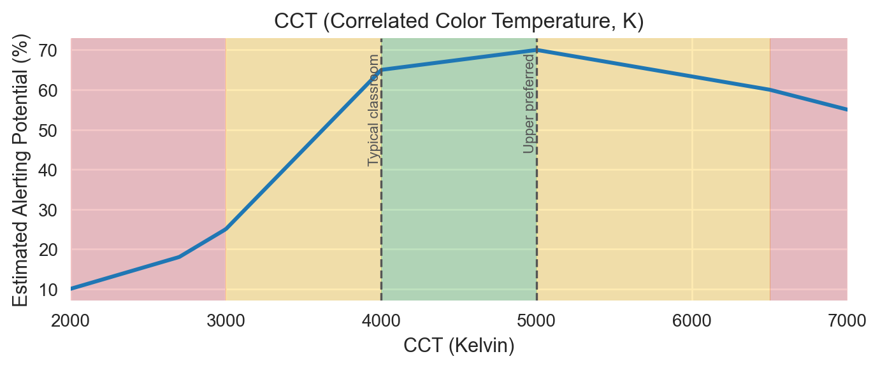

References:

• EN 12464-1 overview (indoor workplaces: illuminance, UGR, CRI) — https://www.performanceinlighting.com/mo/en/en-12464-1

• Park et al., 2015: CCT, EEG & task performance — https://pmc.ncbi.nlm.nih.gov/articles/PMC4668153/

• Chen et al., 2022: CCT × illuminance effects — https://www.mdpi.com/1996-1073/15/12/4477

## CRI (Color Rendering Index, Ra)

CRI ≥80 is generally recommended for classrooms; ≥90 for art/graphics where color evaluation matters.

Optimal: 80–100 | Caution: 70–80 (context dependent)

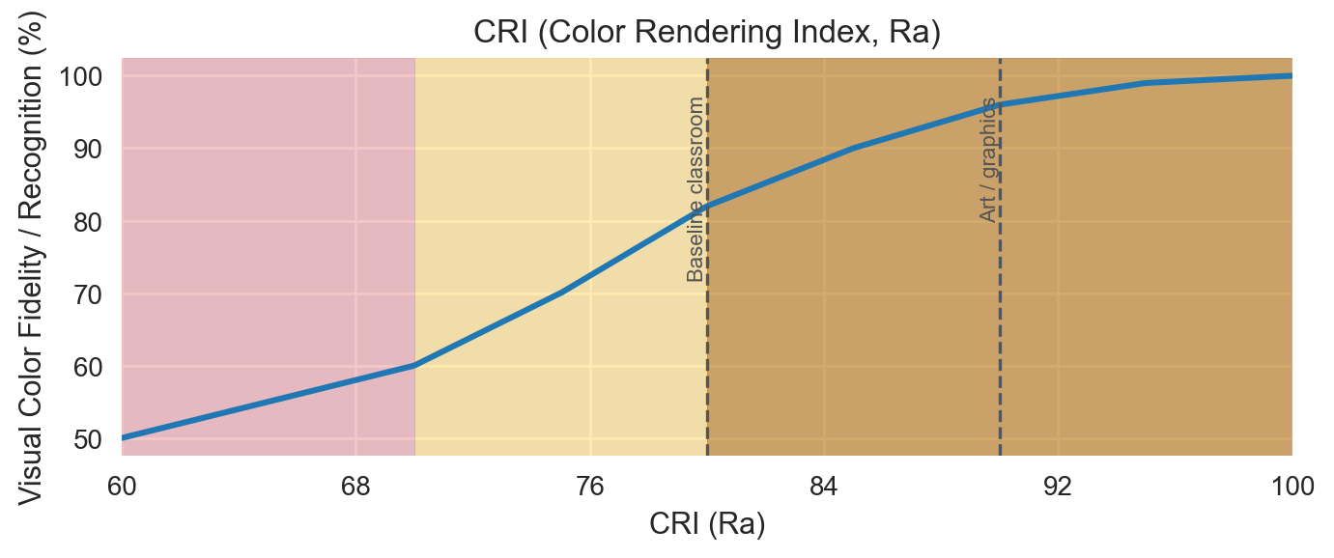

References:

• EN 12464-1 overview (Ra requirements) — https://www.performanceinlighting.com/mo/en/en-12464-1

## Flicker (Percent Modulation, typical LED)

Keep percent flicker as low as practical (<5%). Avoid low-frequency PWM; follow IEEE 1789 guidance.

Optimal: 0–5 | Caution: 5–20 (context dependent)

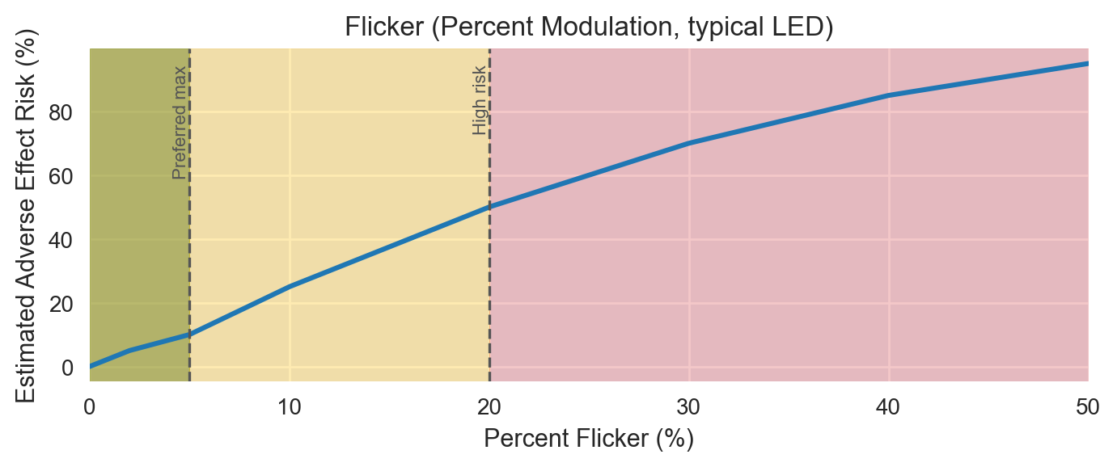

References:

• IEEE 1789-2015: Flicker Recommended Practice (PDF) — https://www.lisungroup.com/wp-content/uploads/2020/02/IEEE-2015-STANDARDS-1789-Standard-Free-Download.pdf

• DOE/LightFair: Understanding IEEE Flicker Practice (PDF) — https://www.energy.gov/sites/default/files/2022-11/ssl-miller-lehman_flicker_lightfair2015.pdf

• Miller et al., 2022 review (PDF) — https://www.energy.gov/sites/default/files/2022-08/ssl-miller-etal-2022-LRT-flicker-review-tlm-stimulus-response.pdf

## Glare (Unified Glare Rating, UGR)

Aim UGR <19 for classrooms; even lower (≈16–18) near screens/IBs to minimize discomfort and distraction.

Optimal: 10–19 | Caution: 19–22 (context dependent)

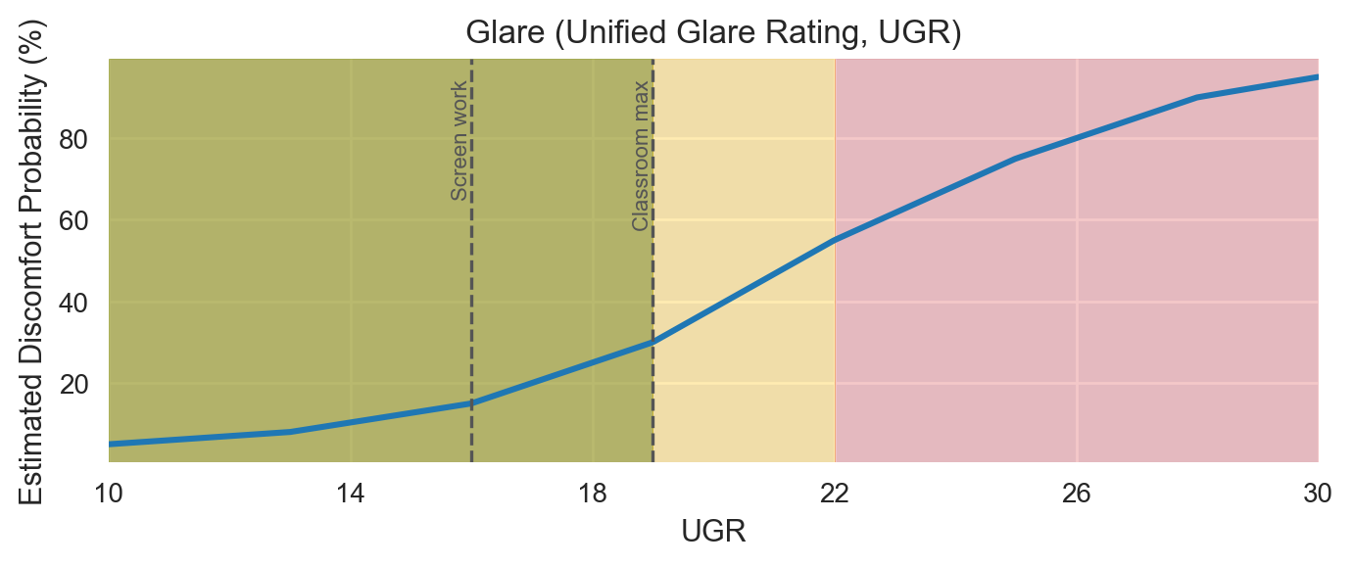

References:

• CIBSE Factfile: Importance of glare & calculating UGR (PDF) — https://www.cibse.org/media/polbabib/factfile-15-the-importance-of-glare-and-calculating-ugr-jul2019.pdf

• EN 12464-1 overview (UGR contexts) — https://www.performanceinlighting.com/mo/en/en-12464-1

## Melanopic EDI (melanopic lux at eye, vertical)

Provide ≥250 melanopic EDI during the day for circadian entrainment and alertness (measured vertically at ~1.2 m).

Optimal: 250–500 | Caution: 100–250 (context dependent)

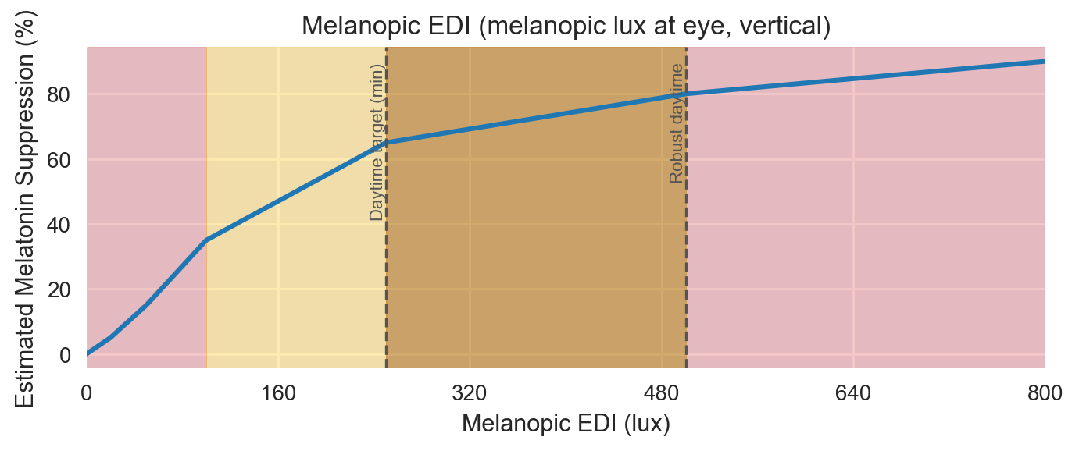

References:

• Brown et al., 2022 (PLOS Biology): Consensus recommendations — https://journals.plos.org/plosbiology/article?id=10.1371/journal.pbio.3001571

• Brown et al., 2022 (PMC) — https://pmc.ncbi.nlm.nih.gov/articles/PMC8929548/

• WELL v2 – Circadian Lighting context (Article) — https://resources.wellcertified.com/articles/circadian-rhythms/

## Vertical Illuminance (lux at eye/face)

Aim ~300–500 lx vertical on faces/eye for daytime non-visual benefits; much lower levels are advisable in evening school events.

Optimal: 300–500 | Caution: 200–800 (context dependent)

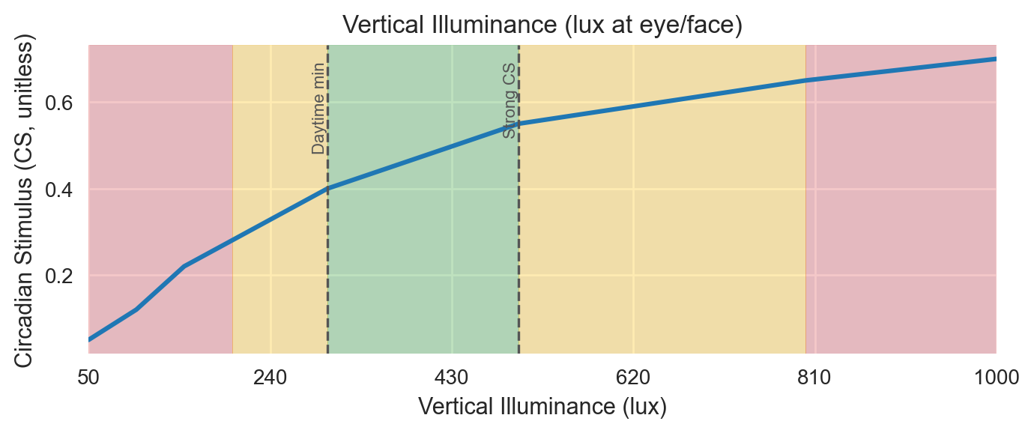

References:

• EN 12464-1 overview; vertical/ambient aspects — https://www.performanceinlighting.com/mo/en/en-12464-1

• WELL v2 circadian context (Article) — https://resources.wellcertified.com/articles/circadian-rhythms/

## Exposure Duration (hours of daytime light meeting target)

Sustained daytime exposure (~2–4 h at adequate spectrum/levels) supports alertness and entrainment; avoid excessive high-intensity late-day exposure.

Optimal: 2–4 | Caution: 1–6 (context dependent)

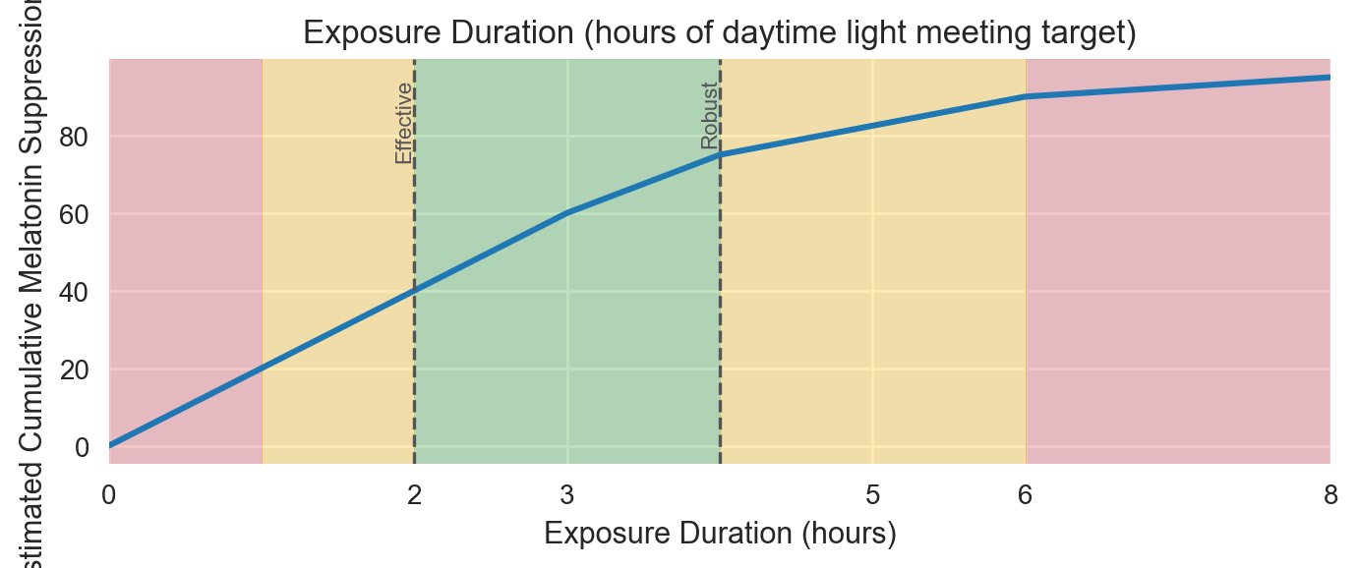

References:

• Brown et al., 2022 (PMC): Day vs evening guidance — https://pmc.ncbi.nlm.nih.gov/articles/PMC8929548/

## Horizontal Illuminance (desk/task, lux)

Provide 300–500 lx at desks for general classrooms; 500–750+ lx for labs/graphics. Short-term 800–1000 lx can be used for exam focus.

Optimal: 300–500 | Caution: 200–1000 (context dependent)

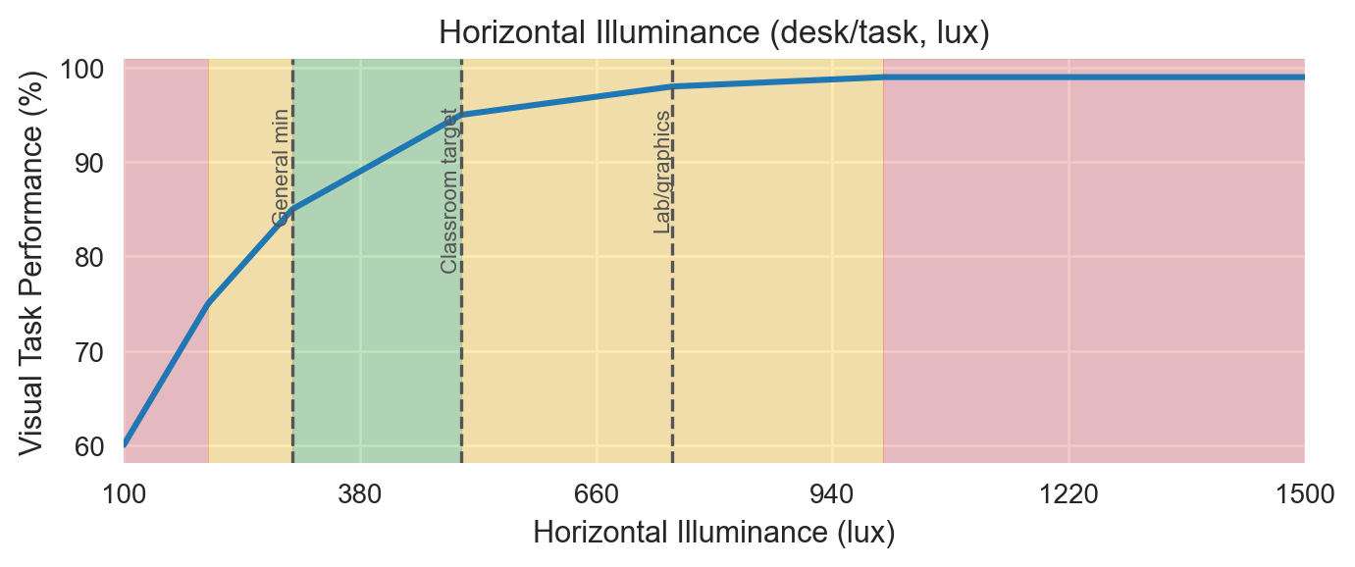

References:

• EN 12464-1 overview (classroom/task lx) — https://www.performanceinlighting.com/mo/en/en-12464-1

• MDPI (2025) review referencing EN 12464-1 classroom levels — https://www.mdpi.com/2075-5309/15/8/1233

# Master Reference List (Live URLs)

• EN 12464-1 overview (indoor workplaces: illuminance, UGR, CRI) — https://www.performanceinlighting.com/mo/en/en-12464-1

• CIBSE Factfile: Importance of glare & calculating UGR (PDF) — https://www.cibse.org/media/polbabib/factfile-15-the-importance-of-glare-and-calculating-ugr-jul2019.pdf

• Brown et al., 2022 (PLOS Biology): Consensus recommendations — https://journals.plos.org/plosbiology/article?id=10.1371/journal.pbio.3001571

• Brown et al., 2022 (PMC mirror) — https://pmc.ncbi.nlm.nih.gov/articles/PMC8929548/

• WELL v2 Circadian context article (IWBI) — https://resources.wellcertified.com/articles/circadian-rhythms/

• IEEE 1789-2015 (PDF copy) — https://www.lisungroup.com/wp-content/uploads/2020/02/IEEE-2015-STANDARDS-1789-Standard-Free-Download.pdf

• DOE/LightFair deck on IEEE 1789 (PDF) — https://www.energy.gov/sites/default/files/2022-11/ssl-miller-lehman_flicker_lightfair2015.pdf

• Miller et al., 2022 flicker review (PDF) — https://www.energy.gov/sites/default/files/2022-08/ssl-miller-etal-2022-LRT-flicker-review-tlm-stimulus-response.pdf

• Park et al., 2015: CCT, EEG & task performance (PMC) — https://pmc.ncbi.nlm.nih.gov/articles/PMC4668153/

• Chen et al., 2022: CCT × illuminance (MDPI) — https://www.mdpi.com/1996-1073/15/12/4477

• MDPI 2025 review referencing EN 12464-1 classroom levels — https://www.mdpi.com/2075-5309/15/8/1233