Lighting Effects on Students in Schools

# Problem

Poor lighting conditions in schools, such as low illuminance, high flicker, or improper color temperature, negatively affect students' concentration, biological rhythms, and psychological well-being. These conditions may cause headaches, eye strain, sleep disruption, and lower academic performance.

# Idea

This study explores the impact of key lighting parameters (CCT, CRI, Flicker, UGR, Melanopic EDI, Vertical Illuminance, Exposure Duration, and Lux) on children’s health, psychology, and concentration. By comparing optimal vs poor lighting conditions, we provide practical solutions for better learning environments.

# Study

Each parameter is compared between acceptable, poor, and dangerous ranges, with references to biological and psychological effects.

## CCT (Color Temperature, K)

Affects circadian rhythm, alertness, and mood.

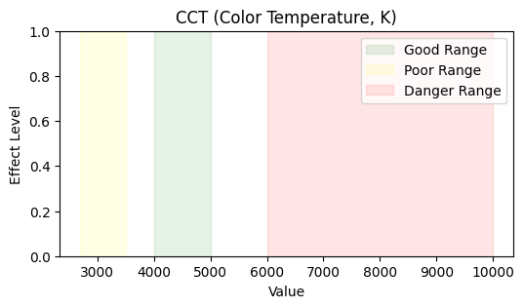

## CRI (Color Rendering Index)

Impacts color accuracy, learning, and comfort.

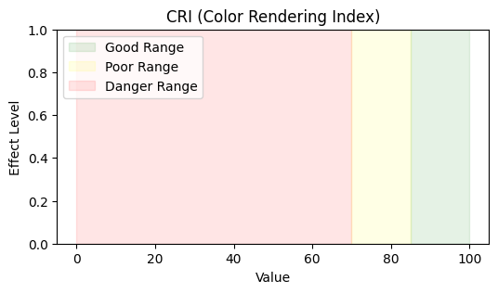

## Flicker (%)

High flicker causes headaches, eye strain, and reduced concentration.

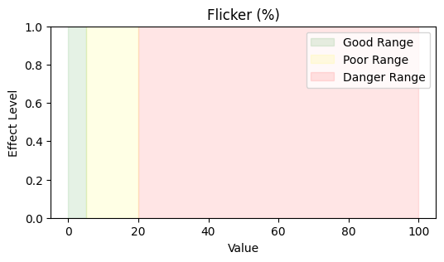

## Glare (UGR)

High glare reduces visibility, comfort, and concentration.

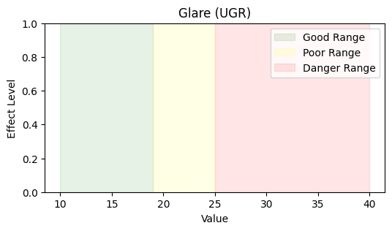

## Melanopic EDI (lux)

Regulates circadian entrainment and biological alertness.

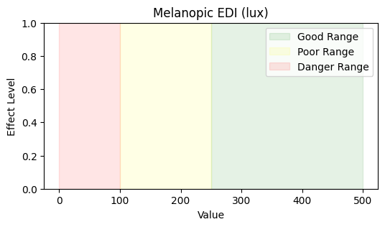

## Vertical Illuminance (lux)

Ensures visibility on vertical planes, reducing fatigue.

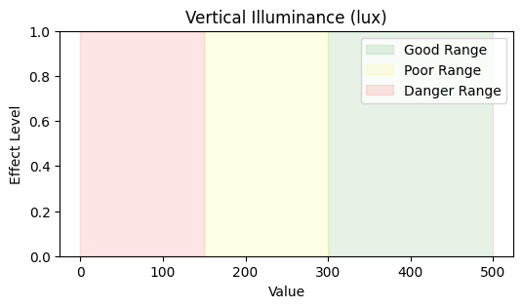

## Exposure Duration (hours)

Too short reduces benefits, too long increases stress.

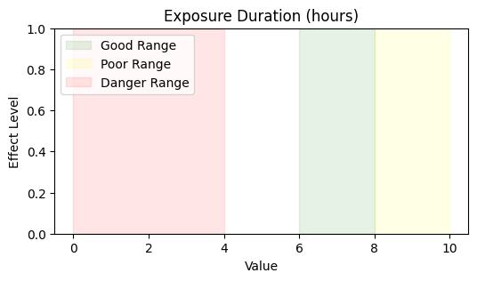

## Lux (Horizontal Illuminance)

Impacts reading ability, focus, and eye comfort.

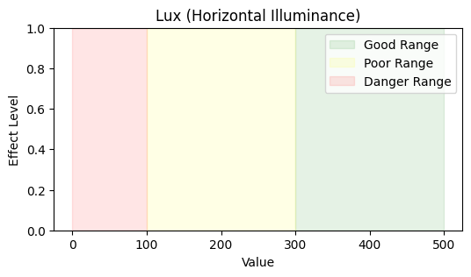

# Solution

The solution is to adopt lighting systems designed with proper parameters for each age group and school environment (classroom, laboratory, playground). Schools should ensure compliance with standards (EN 12464-1, WELL, CIE) to optimize both visual comfort and biological support.