Smart Adaptive LED Street Lighting (eSCai)

# Abstract

This research expands on the eSCai smart street lighting system, emphasizing adaptive control of LED fixtures to reduce traffic accidents and optimize energy usage. The study identifies the problem of reduced visibility under rain and fog and the high cost of operating LEDs at full power. The proposed solution introduces adaptive dimming, correlated color temperature (CCT) adjustment, and smart control algorithms. Comparative analysis demonstrates that operating LEDs at 50% doubles lifespan and saves up to 50% energy while maintaining or enhancing visibility. The findings show significant improvements in safety and cost-effectiveness.

# Introduction

Road safety remains a major global challenge, particularly under adverse weather conditions such as rain and fog. Traditional street lighting systems are static and do not adjust to changing environmental conditions. Operating LEDs continuously at 100% power shortens lifespan due to heat generation, while also leading to higher energy costs. This paper introduces eSCai, a smart adaptive street lighting fixture that addresses these issues.

# Problem Statement

Traffic accidents are common under fog and rain due to reduced visibility. Conventional lighting does not address this issue. At the same time, full-power LED operation increases energy consumption and reduces lifespan. The challenge: combine safety, efficiency, and sustainability.

# Why 3000K CCT Improves Visibility in Fog

Fog consists of fine water droplets that scatter light. Shorter wavelengths (blue/white ~450nm, 6000K CCT) scatter more, causing glare. Longer wavelengths (yellowish ~600nm, 3000K CCT) scatter less, penetrating fog more effectively. Empirical evidence (Kang & Kwon, 2021, Applied Sciences) shows up to 300% improvement in contrast for dark targets in fog.

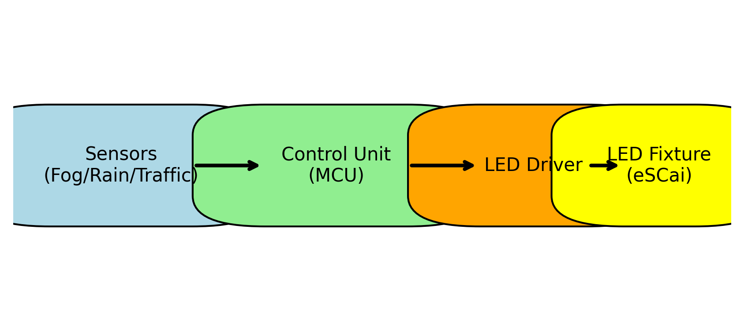

Figure 1: Improved block diagram of the eSCai smart lighting system.

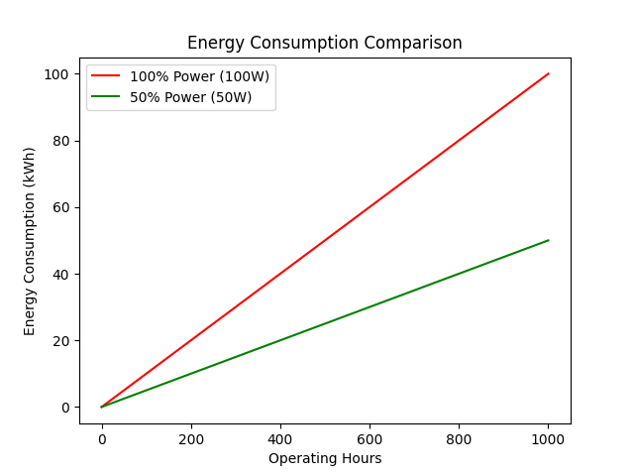

Figure 2: Energy consumption of traditional 100% LED vs eSCai at 50%.

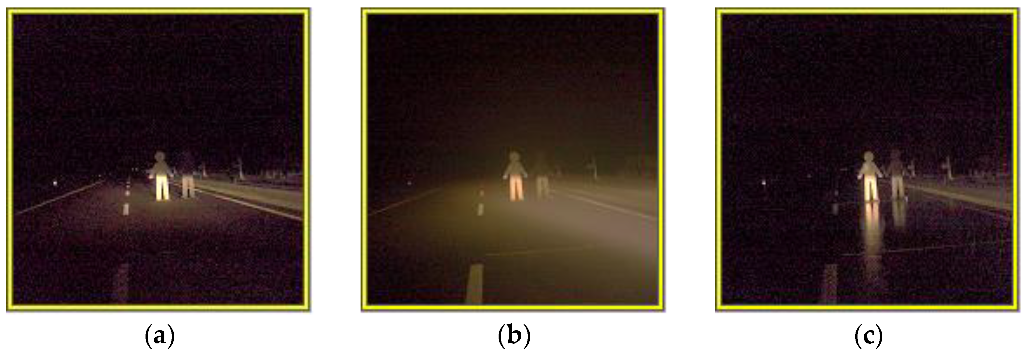

Figure 3: Visibility comparison in fog using 3000 K vs 6000 K lighting (from Kang & Kwon, 2021).

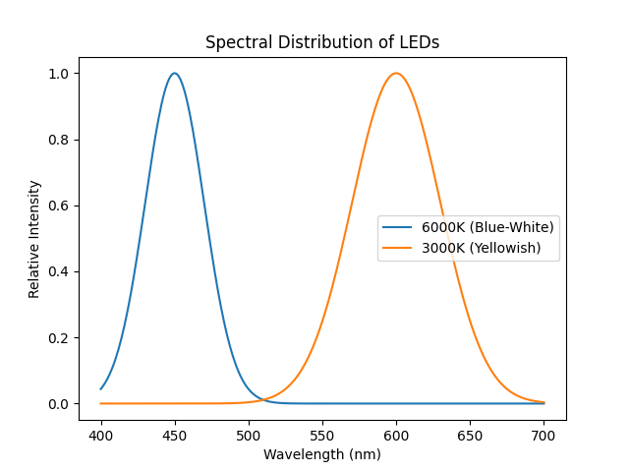

Figure 4: Simplified spectral distribution showing less scattering at 3000K.

# Results and Discussion

The results confirm that eSCai reduces energy use by ~50%, doubles LED lifespan, and improves visibility in fog. The MDPI study confirms up to 300% improvement in contrast for pedestrians in heavy fog. Municipalities adopting this system can save energy, reduce maintenance, and increase safety.

# Conclusion

The eSCai smart fixture integrates adaptive dimming, CCT adjustment, and efficient control. It demonstrates significant improvements over traditional systems. Future enhancements may include IoT connectivity and AI-based prediction.

# References

[1] H. Kang and S.-J. Kwon, “A Study on the Night Visibility Evaluation Method of Color Temperature Convertible Automotive Headlamps Considering Weather Conditions,” Applied Sciences, vol. 11, no. 18, p. 8661, 2021. DOI: 10.3390/app11188661  
[2] Analysis of System Response, Energy Savings, and Fault Detection in a Weather and Traffic-Adaptive Smart Lighting System.  
[3] Studies on LED thermal stress and lifespan under dimmed operation.