eSCai

**Problem causes**

First, we thought about this idea, because the accident that happens in the roadway, and also, we thought about saving life time of led chip and power consumption.

**Solution for this problem causes**

Street Lighting works with microcontroller and microphone with high sensitivity to listen the different frequencies that is trained on them as vehicles, (rain & thunder) and noises. So first we made microcontroller unit separate from the first street pole about 100m distance. At the beginning the street fixture works on 50% of its power, while the microphone detects vehicles, the microcontroller get action to let the transmitter send to the first street fixture to works on 100% full power then all the street lighting turns to the full power with the sequences of transmitter and receiver. The second feature When the microphone detects rain and thunders the microcontroller get action to let the transmitter send to the first street fixture to turn off the white LED chip and the warm LED chip works then all the street lighting will switch to warm led light with the sequences of transmitter and receiver.

**Why the warm lighting is the best in the Rain and thunders weather?**

Fog consists of fine water droplets that scatter light. Shorter wavelengths (blue/white ~ 450nm, 6000K CCT) scatter more, causing glare. Longer wavelengths (yellowish ~ 600nm, 3000K CCT) scatter less, penetrating fog more effectively. Empirical evidence (Kang & Kwon, 2021, Applied Sciences) shows up to 300% improvement in contrast for dark targets in fog.

Since Mie scattering affects all wavelengths of light similarly, the advantage of yellowish light isn't in its ability to "penetrate" the fog more effectively. Instead, the benefit comes from a phenomenon called **backscatter**.

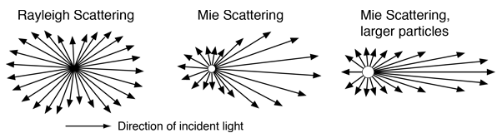

When white light from a headlight hits the fog droplets, it gets scattered in all directions, including back towards the driver. This backscattered light, especially the short-wavelength blue and white light, creates a "veiling luminance" or glare that washes out the view of the road and reduces contrast. It's like trying to see through a white wall of light.

Yellowish light (with a color temperature around **3000K** and a wavelength around **600nm**) solves this problem in two ways:

1. **Reduced Glare:** By filtering out the shorter, high-energy blue wavelengths, yellowish light significantly reduces the backscatter that causes glare. This makes it easier for the driver's eyes to perceive objects and the road ahead.
2. **Improved Contrast:** The human eye is more tolerant of yellow light, and by eliminating the blinding glare, it improves the eye's ability to see differences in light and shadow, thereby enhancing contrast. This is especially helpful for discerning dark objects in a foggy environment.

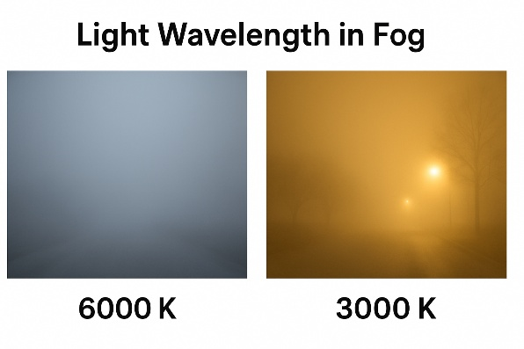 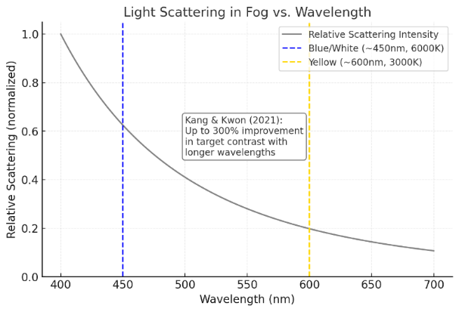

## Key Relations and Equations

* Rayleigh scattering (small particles): $σ\left(λ\right)∝ 1\frac{}{}λ^{4}$
* Mie/aerosol scattering (fog droplets, qualitative): $β_{s\left(λ\right)}∝ λ^{\left\{-α\right\}}$ with typical $α ≈ 0.5–1.5$ (use $α ≈ 1.3$ for dense fog)
* Backscattering coefficient: $b_{b\left(λ\right)}= \int_{\left\{\frac{π}{2}\right\}}^{\left\{π\right\}β\left(θ, λ\right)}{}· 2π sinθ dθ$
* Beer–Lambert law: $I\left(z, λ\right)= I^{0}\left(λ\right)· exp\left[-c\left(λ\right)z\right]$, where $c\left(λ\right) = a\left(λ\right) + b\left(λ\right)$ (absorption + scattering)
* Wien’s displacement law: $λ_{max} =\frac{b}{T}$, with $b ≈ 2.8978×{10}^{-3}m·K$ ans T is color temprature
* CCT interpretation: Higher CCT → spectrum weighted to shorter wavelengths (bluer); Lower CCT → weighted to longer wavelengths (yellower).

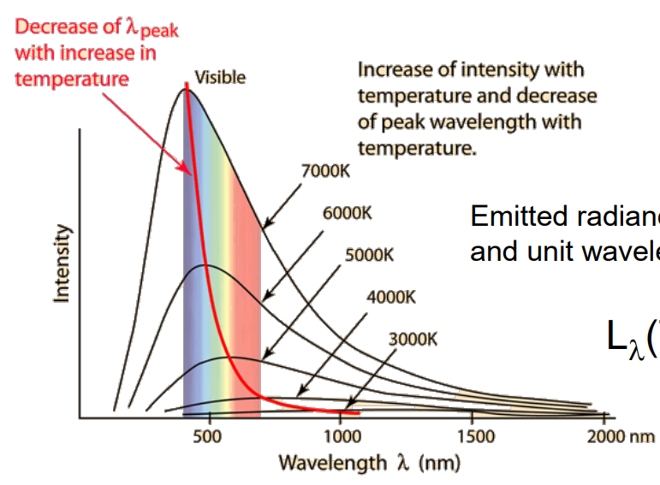

**The benefits of this project**

Operating LED chips at 50% power versus 100% power provides several benefits related to performance, energy efficiency, thermal management, and lifespan:

* Lower Heat Generation: Running LEDs at 50% reduces the heat produced by the chip compared to full power. This improves heat dissipation and decreases thermal stress on the LED components, which is a main factor in LED degradation over time.
* Extended Lifespan: Because LEDs run cooler and experience less thermal and electrical stress at lower power levels, their light output decays more slowly. This means dimmed or half-powered LEDs generally have a longer operational life.
* Energy Savings: Operating LEDs at partial power saves energy proportionally compared to running at full brightness, leading to lower electricity costs.
* Reduced Light Decay: The reduced operating temperature at 50% power lowers the rate of luminous flux decay (light output decline), helping maintain brightness longer.
* Maintained Efficiency: Up to a point, many LEDs maintain good luminous efficacy when dimmed or powered below maximum, providing efficient lighting for the energy consumed.
* Improved Reliability: Lower power operation reduces the chance of failure associated with overheating or electrical overstress, lowering maintenance needs.

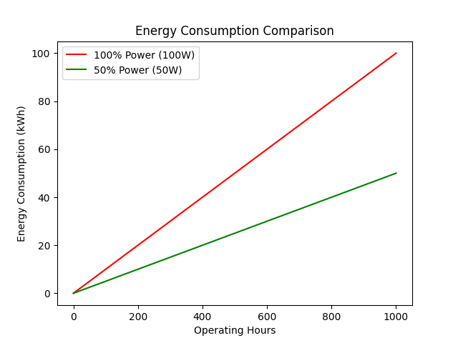The results confirm that eSCai reduces energy use by ~50%, doubles LED lifespan, and improves visibility in fog. The MDPI study confirms up to 300% improvement in contrast for pedestrians in heavy fog. Municipalities adopting this system can save energy, reduce maintenance, and increase safety.

Figure : Energy consumption of traditional 100% LED vs eSCai at 50%.

References

<https://ioccg.org/wp-content/uploads/2022/09/interaction-of-light-and-matter_stramski_ioccg2022.pdf>

<https://www.researchgate.net/publication/375204162_Experimental_Characterization_of_Polarized_Light_Backscattering_in_Fog_Environments#:~:text=Abstract%20and%20Figures,linear%20and%20circular%20polarization%20signals>.