**Creating Local Repositories with Git and Adding/Checking in Files**

1. Create a CodeCommit Repository and copy the clone URL (HTTPS) for future use.

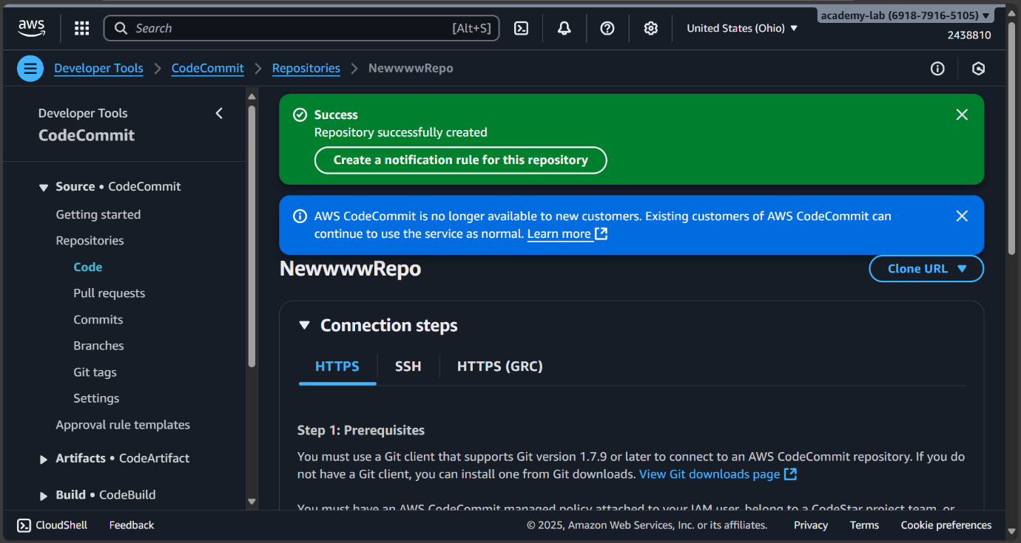

2. Create an EC2 Instance (Amazon Linux 2) and SSH into it via Sessions Manager Option. Note: Make sure the role CCL-EC2-Role is attached to the instance, only then can you select the Sessions Manager Option.

3. Change user to super user or root user and change directory to ~

4. Make sure Git is installed, if not install Git. Then perform the following configurations:

git config --global user.name “<Some Name>” git config --global user.email “<Some email>”

5. Navigate to IAM > Users> Your UserName > Security Credentials > HTTPS Git Credentials for CodeCommit. Here generate credentials and save them.

6. Clone the created repo by pasting the copied URL from Step 1.

7. Change directory to the created repo

8. Create a new file with some content and perform the following steps:

git add <file name>

git commit -m “Commit Message”

git push origin main

9. Go to the created repo and check if the pushed file is available there

