**Essential Source Control with Git**

1. Create a CodeCommit Repository.

2. Create an EC2 Instance (Amazon Linux 2) and SSH into it using the Sessions Manager Option. Note: Make sure CCL-EC2-Role is attached to the instance, only then SSH is possible with Sessions Manager Option.

3. Use the command to install git:

sudo su –

sudo yum install git -y

4. Configure the system with the user email and user name:

git config –global user.name <user name>

git config –global user.email <user email>

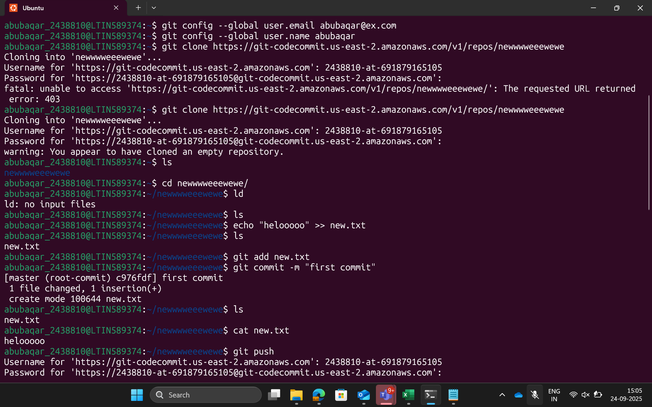

5. Navigate to IAM > Users> Your UserName > Security Credentials > HTTPS Git Credentials for CodeCommit. Here generate credentials and save them.

6. Clone the CodeCommit repository using the git clone command which can be found in Step 3 under Connection Steps in created repository.

git clone <repo>

7. Navigate to the repo folder:

cd repo

8. Create some text file with some content in the folder.

9. Give the following commands to push the file to the repository: Note: The git push command pushes the code by default to Master Branch.

git add <file name>

git commit -m “Commit message”

git push

10. Verify if the file is reflected in the Code commit Console Page.

11. Create a new branch:

git branch <branch name>

12. Switch to the new branch with the following command:

sudo git checkout xyz

13. Create a new file and use git command to add the file to stage:

sudo git add <filename>

14. From the existing list of files, create change in them and then add it to the branch:

sudo vi <filename>

sudo git add <filename>

15. Commit your changes using the command:

sudo git commit -m “Enter Commit Message”

16. Push the changes into the source repository using the following command:

sudo git push –set-upstream origin <Branch Name>

Note: A new pull request for the branch is sent to the source repository. Check it in the CodeCommit Console in Branches tab.

