**Source Code Management using GitHub**

1. Sign up for GitHub using this link. If you already have an account, log in to that.

2. Create a new repository by clicking on New in GitHub Home Page.

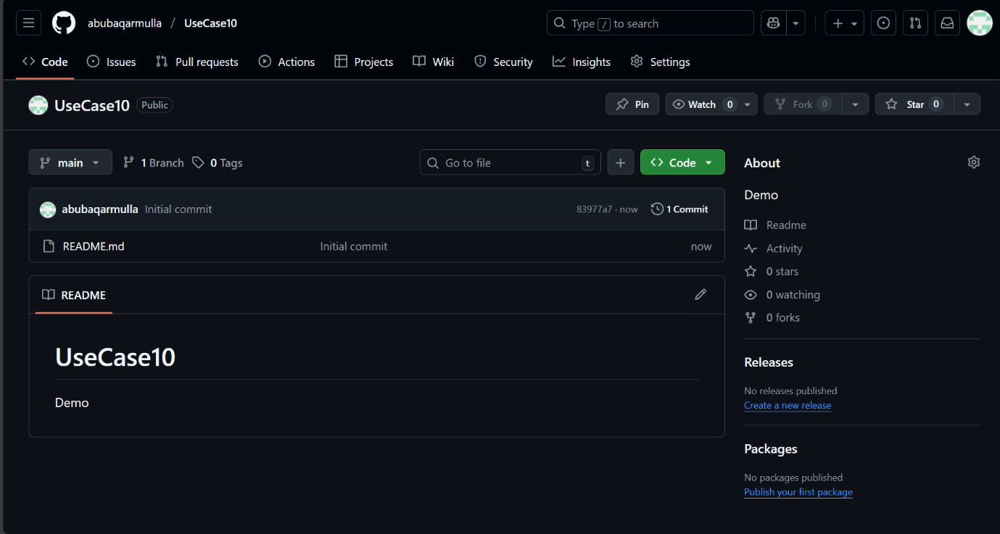

3. Create a sample repository directly and give some name to it. Note: There is no need to add a README file or gitignore file or choose a license.

4. Once the repository is created, you can upload a file by clicking on Add file > upload files. Or you can create a file then and there using the option Add file > Create new file.

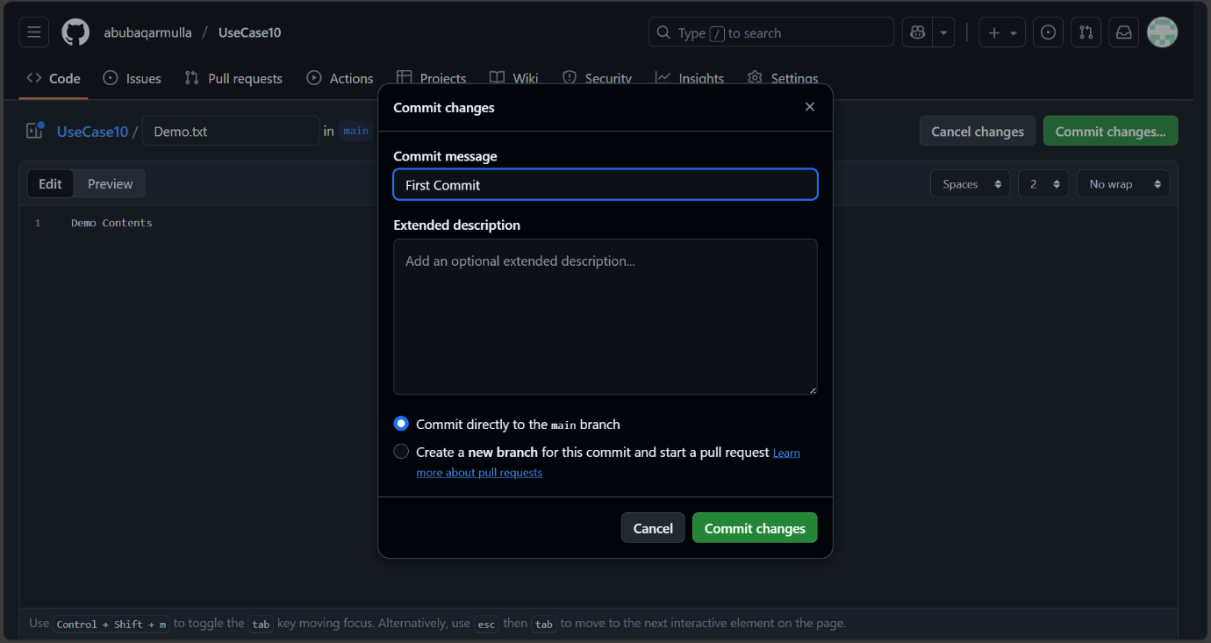

5. If you selected upload files option, drag and drop the file you wish to upload.

6. Once you dropped the files, in the Commit Changes section, give some title and description for the upload.

7. Click on Commit Changes. Note: This process is called staging and committing. If Git Bash is being used, you need to enter the command for stage and commit. In this case it is not required. Once Committed, you can see the file in the repository. Now assume this is your master code. Master code should never be touched directly. It should be changed only via Branches and Pull Requests (PR).

8. In our case, create a Branch named Dev or something. To perform this, click on master and type the name of the branch.

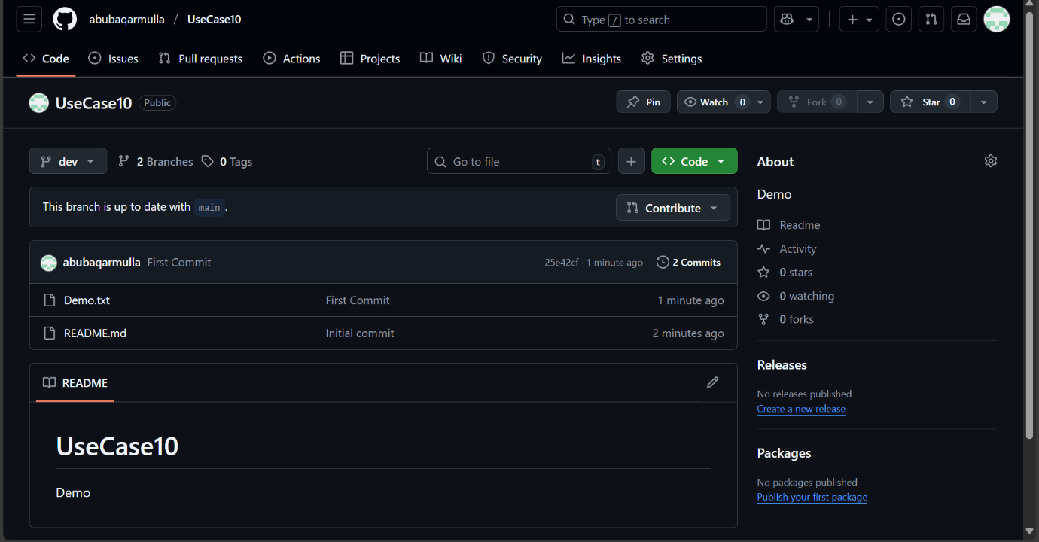

9. Make sure that you are in sample branch. Now edit the file that was uploaded and commit the changes.

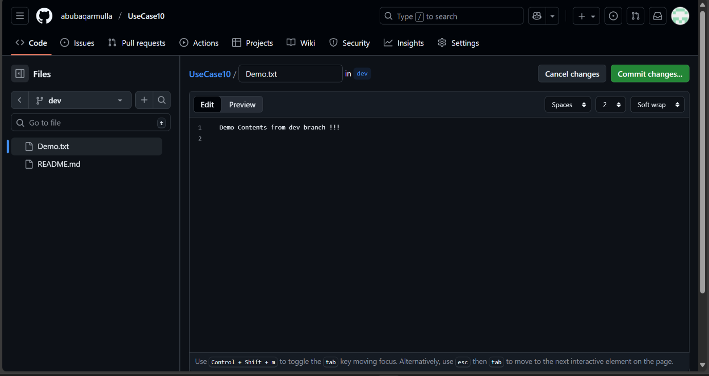

10. Once you changed the file, move to Repository Home page. Make sure that you are in Sample Branch.

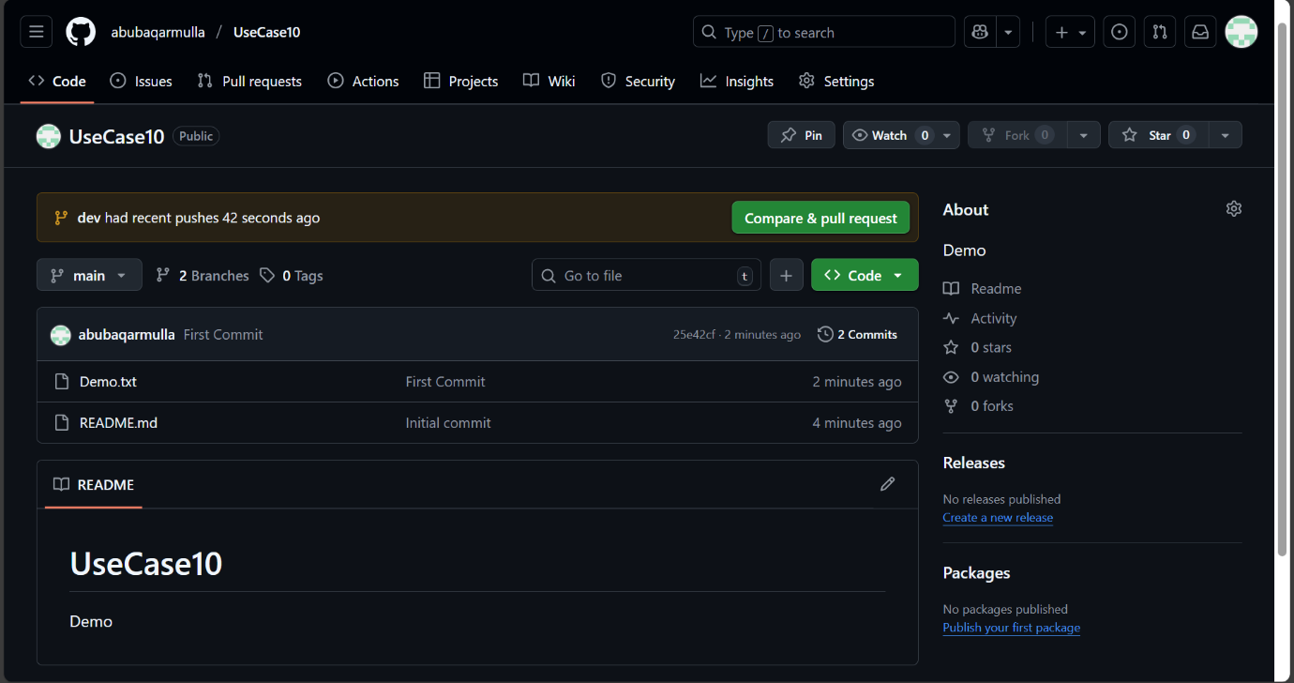

11. You should be seeing an option stating, had recent pushes Compare and Pull Request.

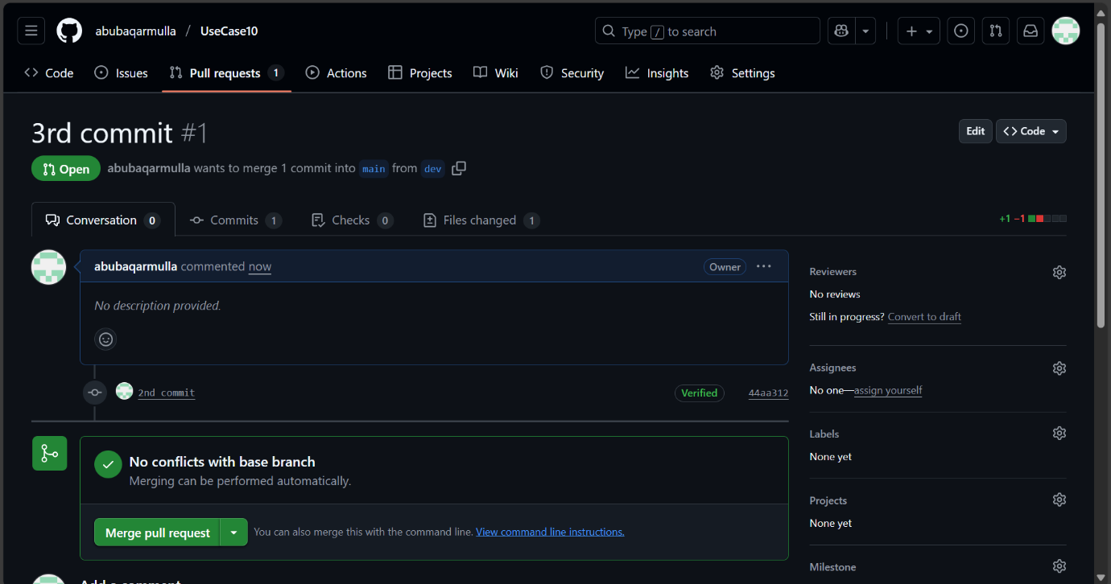

12. Click on Compare and Pull request. You should be finding Able to Merge.

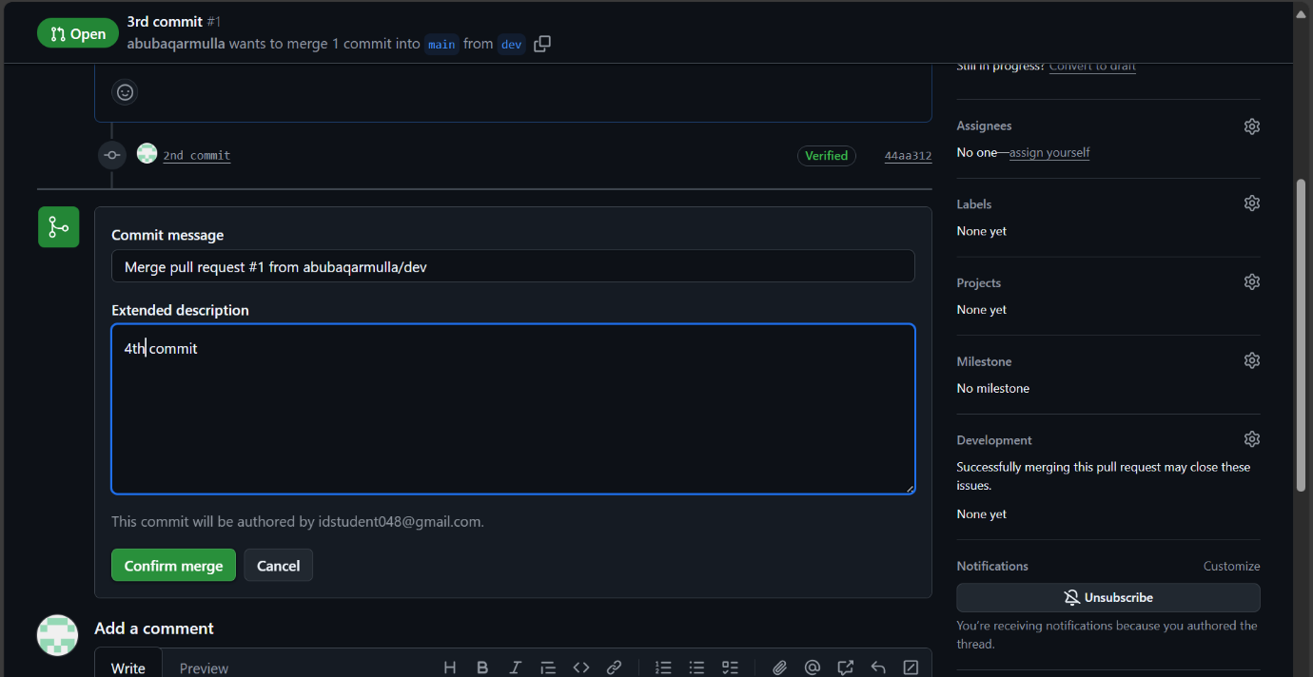

13. Give some title and some description for the PR and create a PR.

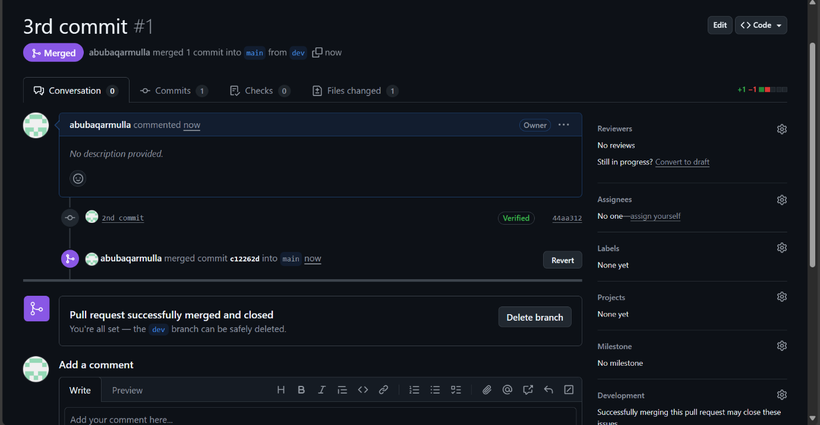

14. Now it displays This branch has no conflicts with the base branch. Merge Pull request.

15. Click on merge pull request and the change will be added to the master branch and click on delete branch to delete the branch that was created recently.



16. If you navigate to the repository home, it should display master as the branch. Check the file that was edited and you should find the changes integrated. This is the general flow of GitHub Source Control

