Habit Mastery League
Project 1 Proposal | Mobile Application Development | Undergraduate
Team members: Abubeker Mohammed and Jalen Artis
Proposal date: October 16, 2026 | Submission deadline: October 17, 2026
Status: Planning only. Development will begin after instructor’s approval.

1. App idea and purpose
Our app is called Habit Mastery League. It will help students keep track of habits they want to improve. For example, a student can add studying, reading, exercise, or drinking water. They can set a goal for the week and mark the days they finish it. We want the app to be easy to use, and it should also work without internet.

2. Users and user stories
User story | Success criteria
As a student, I want to add a habit with a weekly goal so I can plan what to do. | The habit saves with a name, category, and valid target. It appears in the habit list.
As a user, I want to record a check-in so I can track my habit. | I can save and edit a check-in, and the updated progress appears on screen.
As a user, I want to see my history so I can check my progress. | I can filter habits and see my check-in history and weekly completion rate.

3. Planned screens and app flow
We plan to make five screens: Home/Habit List, Add/Edit Habit, Habit Check-In, History/Progress, and Settings. The bottom menu will help users go to Home, Check-In, History, and Settings. They can open Add/Edit from the Home screen. After adding a habit, they can check it off and look at their progress in History.
If a user has no habits yet, the app will show a message instead of an empty list. It will also check the habit name and goal before saving. The app will ask before deleting or resetting anything. At least one setting will be saved on the device.

4. Wireframe plan
These are our first ideas for how the five screens may look. They are only designs, not a finished app. The habits and numbers shown in the pictures are examples.
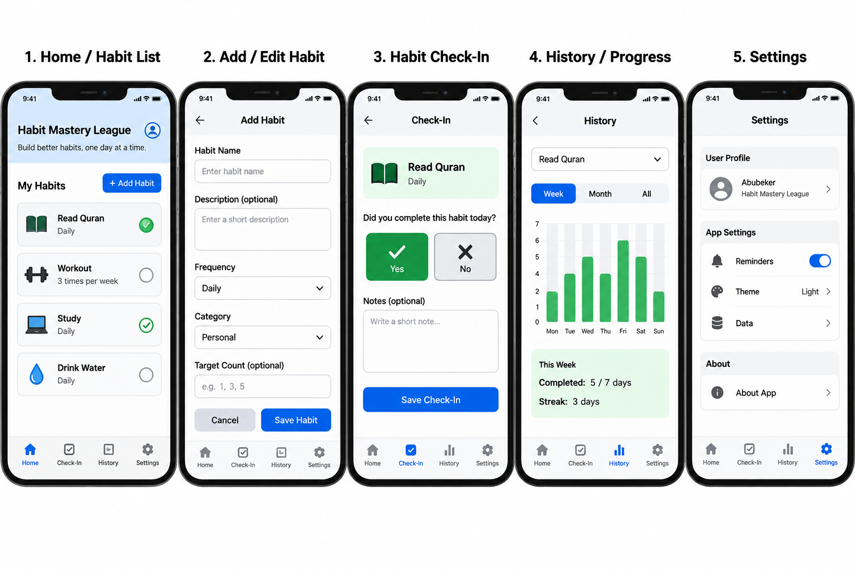
Screen flow: Home → Add/Edit Habit → Home → Check-In → History. Settings can be opened from the bottom navigation.

5. Local database and app behavior
The app will use Flutter and Dart. SQLite will store the main records, while SharedPreferences will save simple settings. There will be no cloud database or cloud AI service.
SQLite table | Planned fields | Purpose
Habits | habit_id (primary key), name, category, weekly_goal, is_active | Store habits and their weekly targets.
CheckIns | checkin_id (primary key), habit_id (foreign key), checkin_date, completed, note | Store check-ins linked to a habit.
Both tables will support Create, Read, Update, and Delete. A habit can have many check-ins. When a user deletes a habit, we plan to show a warning and delete its linked check-ins in the same local database operation. Users will be able to start a habit, mark progress, finish or reset a weekly cycle, and see saved records after restarting the app.
For reporting, the app will include a category filter and a weekly completion rate. We plan to prevent invalid weekly goals, empty habit names, and accidental repeat check-ins for the same habit and date. The final rules will be tested after approval.

6. Small smart-helper plan
We will add a small helper that looks at past check-ins and suggests a weekly goal. It will explain the suggestion, and the user can accept it or ignore it. It uses simple rules and works offline. We will compare it to a fixed goal and try five types of cases, including missing or wrong data and a suggestion that does not help. We will write about the results after we build the app.

7. Planned team responsibilities
Team member | Initial work plan
Abubeker Mohammed | Home and Add/Edit screens; SQLite table and CRUD work; proposal writing.
Jalen Artis | Check-In, History, and Settings screens; smart-helper planning and implementation; wireframes.
Both | Review designs, test the app, document the work, and prepare submission.
This is how we plan to share the work for now. We may switch some tasks later. If we do, we will update ClickUp and GitHub to show what each person worked on.

8. Project tools, workflow, and dates
GitHub repository: https://github.com/abubekerm1/habit_mastery_league
ClickUp board: https://app.clickup.com/90141776119/v/b/2kydwp7q-414
We use these ClickUp columns: Backlog → Ready → In progress → Review / test → Done. Each of us will work on one active task at a time, and we will keep no more than two tasks in Review / test. We will move a task to Done after checking the work. When we start coding, we will add GitHub links to the related tasks.
Milestone | Target date
Proposal and approval request | October 17, 2026
UI and navigation checkpoint (after approval) | October 20, 2026
Core functionality checkpoint (after approval) | October 23, 2026
Testing, documents, and final delivery | October 24–27, 2026
Before implementation, we will finish proposal review and wireframe planning. The team will wait for instructor approval before writing the Flutter app.

9. ClickUp planning snapshot
The following screenshots were captured on October 16, 2026. They show our Backlog tasks. These are planning records, not evidence of completed implementation.

Figure 1. ClickUp board planning screenshot
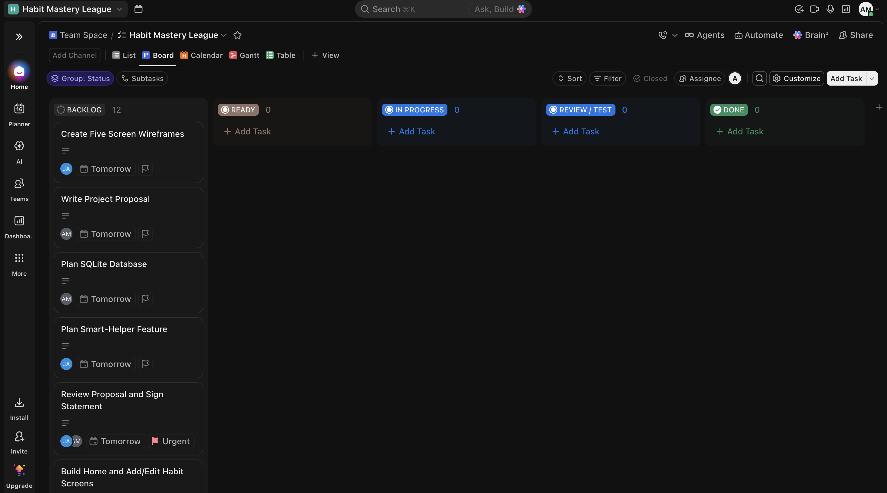
Figure 2. ClickUp board planning screenshot
