SELECT Doc_name FROM Doctor;

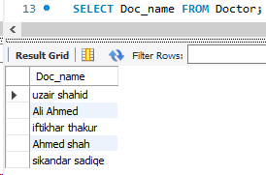

SELECT * FROM Schedules order by Doc_Sche_Date;

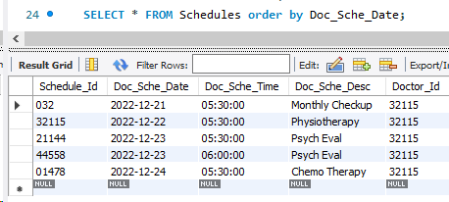

SELECT Doctor.*, Patient.* FROM Doctor JOIN Patient On Doctor.Doctor_Id = Patient.Doctor_Id;

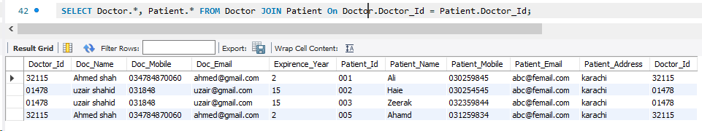

SELECT Doctor.*, Patient.*, Schedules.* FROM Doctor

JOIN Patient On Doctor.Doctor_Id = Patient.Doctor_Id

JOIN Schedules ON Schedules.Doctor_Id = Patient.Doctor_Id;

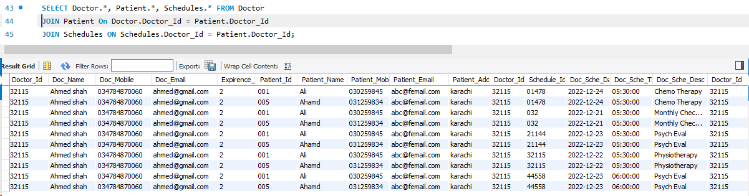

SELECT Doctor.*, Doc_Qualification.* FROM Doctor

JOIN Doc_Qualification On Doctor.Doctor_Id = Doc_Qualification.Doctor_Id where Doc_Qualification.Qualification_name = 'MBBS';

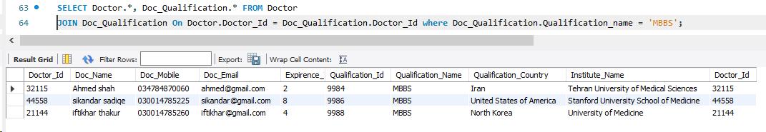

SELECT Doctor.*, Doc_Qualification.* FROM Doctor

JOIN Doc_Qualification On Doctor.Doctor_Id = Doc_Qualification.Doctor_Id where Doc_Qualification.Qualification_Country in ('Iran', 'North Korea');

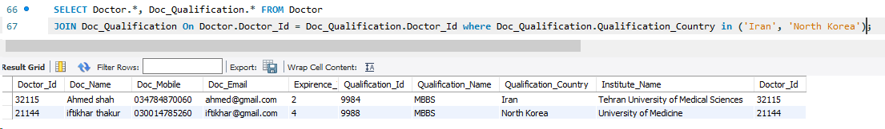

SELECT Doctor.Doc_Name, Doc_Qualification.Qualification_Name, Patient.Patient_Name, CONCAT(Schedules.Doc_Sche_Date," ", Schedules.Doc_Sche_Time) as `Schedule`

FROM Doctor

JOIN Doc_Qualification On Doctor.Doctor_Id = Doc_Qualification.Doctor_Id

JOIN Patient on Patient.Doctor_Id = Doctor.Doctor_Id

JOIN Schedules on Schedules.Doctor_id = Patient.Doctor_Id

where Doctor.Doc_Name = 'Ahmed shah' and Schedules.Doc_Sche_Date like'%24%';

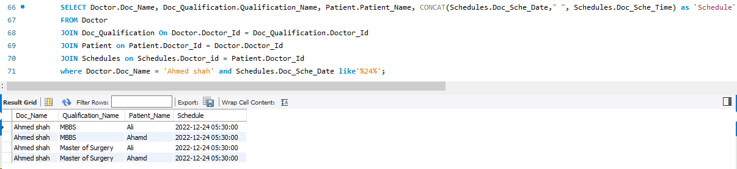

DELIMITER ??

CREATE PROCEDURE sp_GetDoctorsInRange(IN max INT)

BEGIN

SELECT * FROM Fees WHERE Fees.Doc_Fee_Amount <= max;

END ??

DELIMITER ;

CALL sp_GetDoctorsInRange("9000NGN");

