# Übe - Philosophy Chat Room User Manual

Welcome to Übe! Übe is a philosophy-based chat room website and app where users can build communities, debate and discuss philosophical ideas, play games, and ponder dilemmas.

## Features

* Chat rooms (with basic CRUD as well as privilege authorization)
* Topics / tags for each chat which can be created by the admins
* Messages (With CRUD)
* Authentication
* Private messaging

## Chat Rooms

Übe allows users to join and participate in different chat rooms based on their interests. Each chat room has a unique topic or tag, which can be created by the admins.

To view all available chat rooms, click on the “Chat Rooms” tab on the main menu. You will be able to see a list of all the available chat rooms and the topics/tags associated with each one. To join a chat room, simply click on its name.

Once you have joined a chat room, you will be able to participate in the conversation by sending messages. The chat room will show the messages in real-time, and you can scroll through the conversation history to see previous messages.

Admins have the ability to edit and delete chat rooms, as well as manage the privilege level of users in the chat room. This means they can promote or demote users to different privilege levels, such as moderator or member.

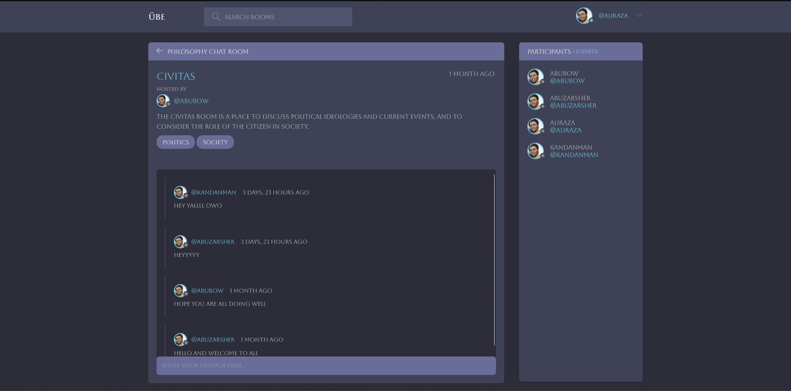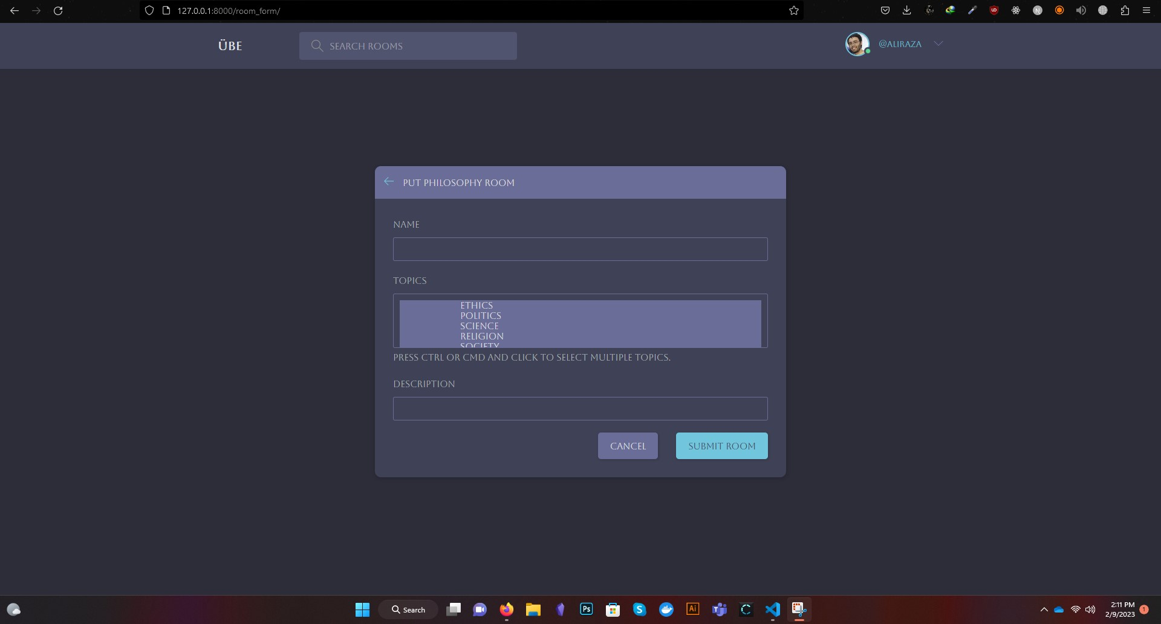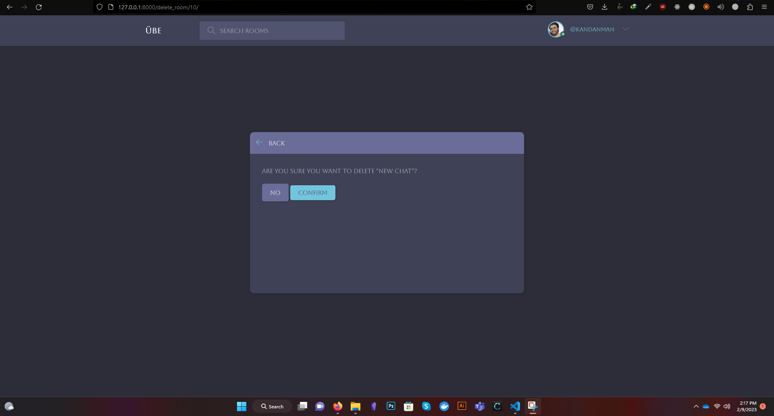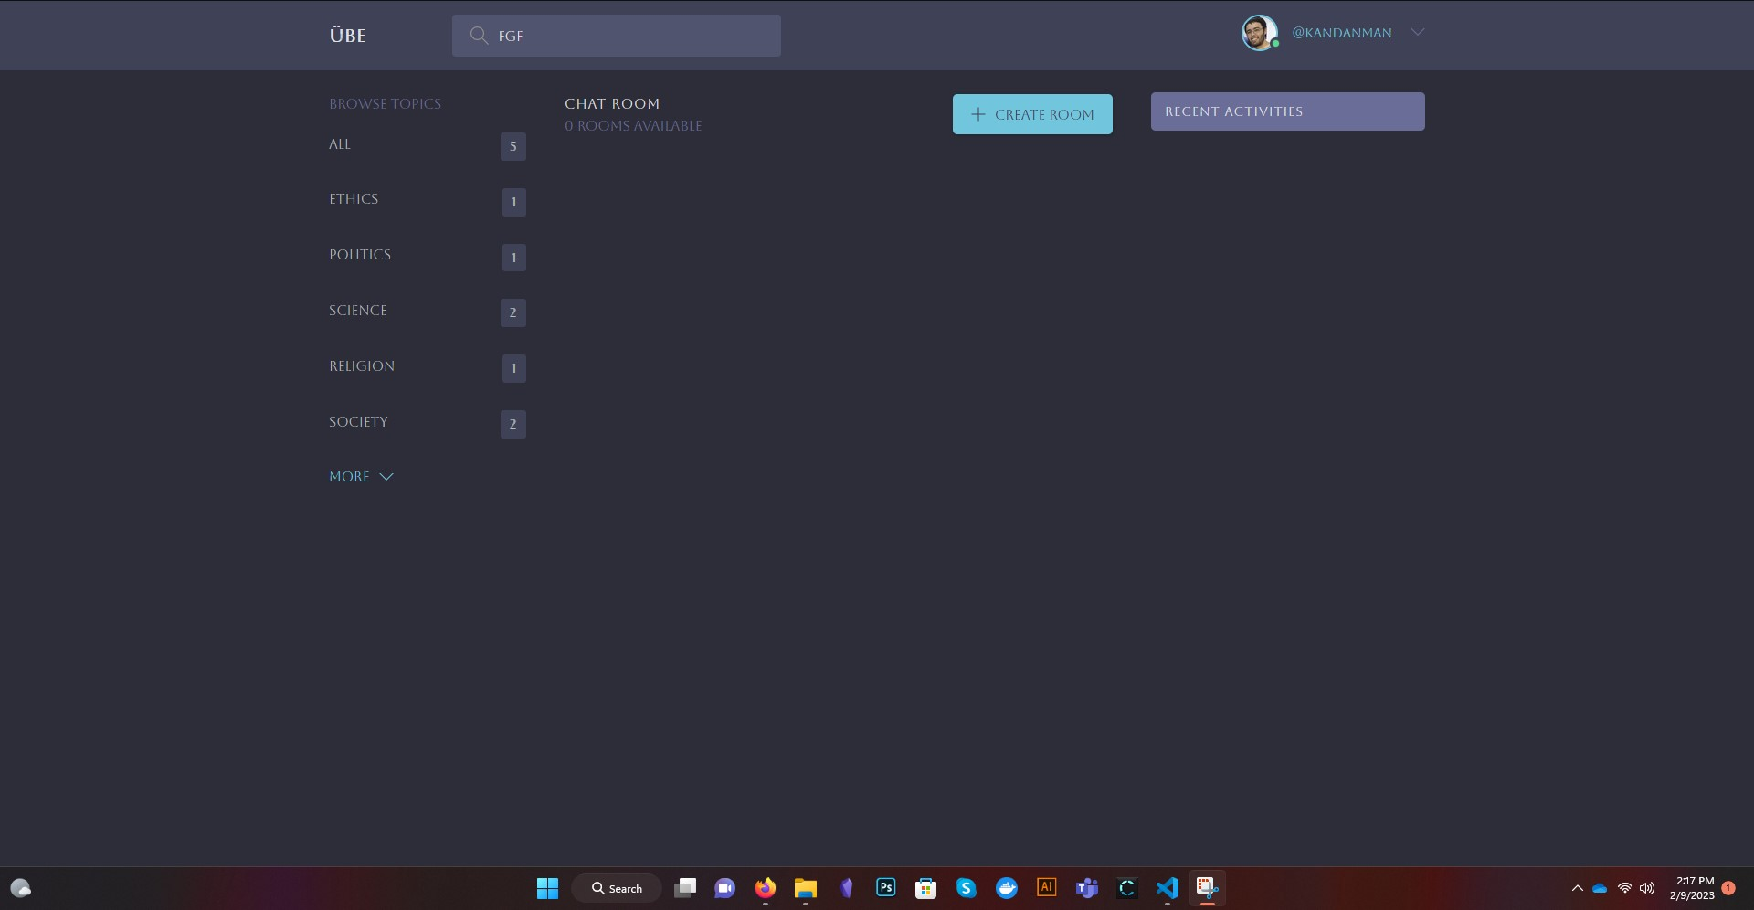

## Topics / Tags

Topics or tags are used to categorize the chat rooms in Übe. They are created by the admins, and users can join chat rooms based on the topics that interest them.

For example, if there is a chat room about “Ethics”, the topic/tag for that chat room would be “Ethics”. This allows users to easily find chat rooms that are of interest to them.

## 

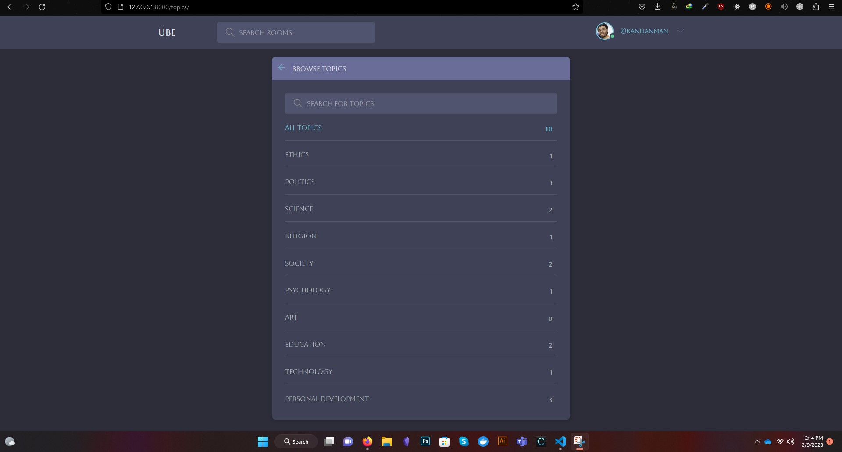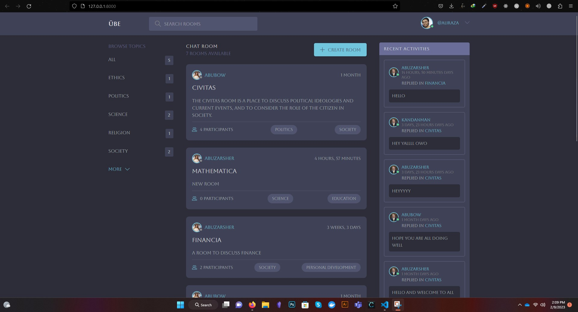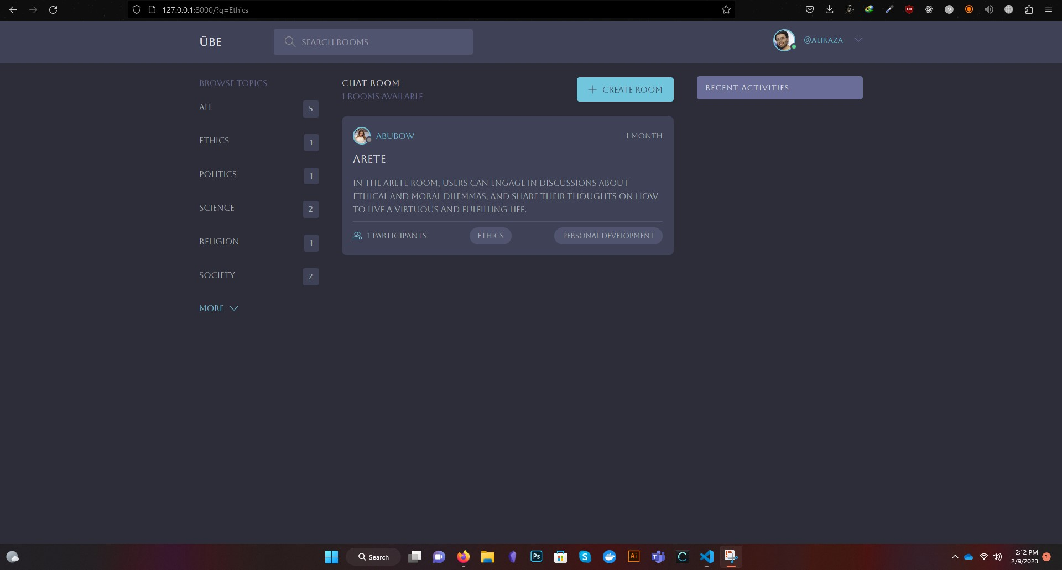

## Messages

In Übe, users can send messages to each other in the chat rooms. You can send a message by typing in the message input field and hitting the “Send” button. You can also edit or delete your own messages.

Admins have the ability to edit and delete any message in the chat room. This allows them to maintain the quality of the conversation and ensure that all messages are appropriate.



## Authentication

In order to use Übe, you need to create an account. You can do this by clicking on the “Sign Up” button on the main menu and entering your email and password.

Once you have created an account, you can log in by entering your email and password on the “Log In” page.

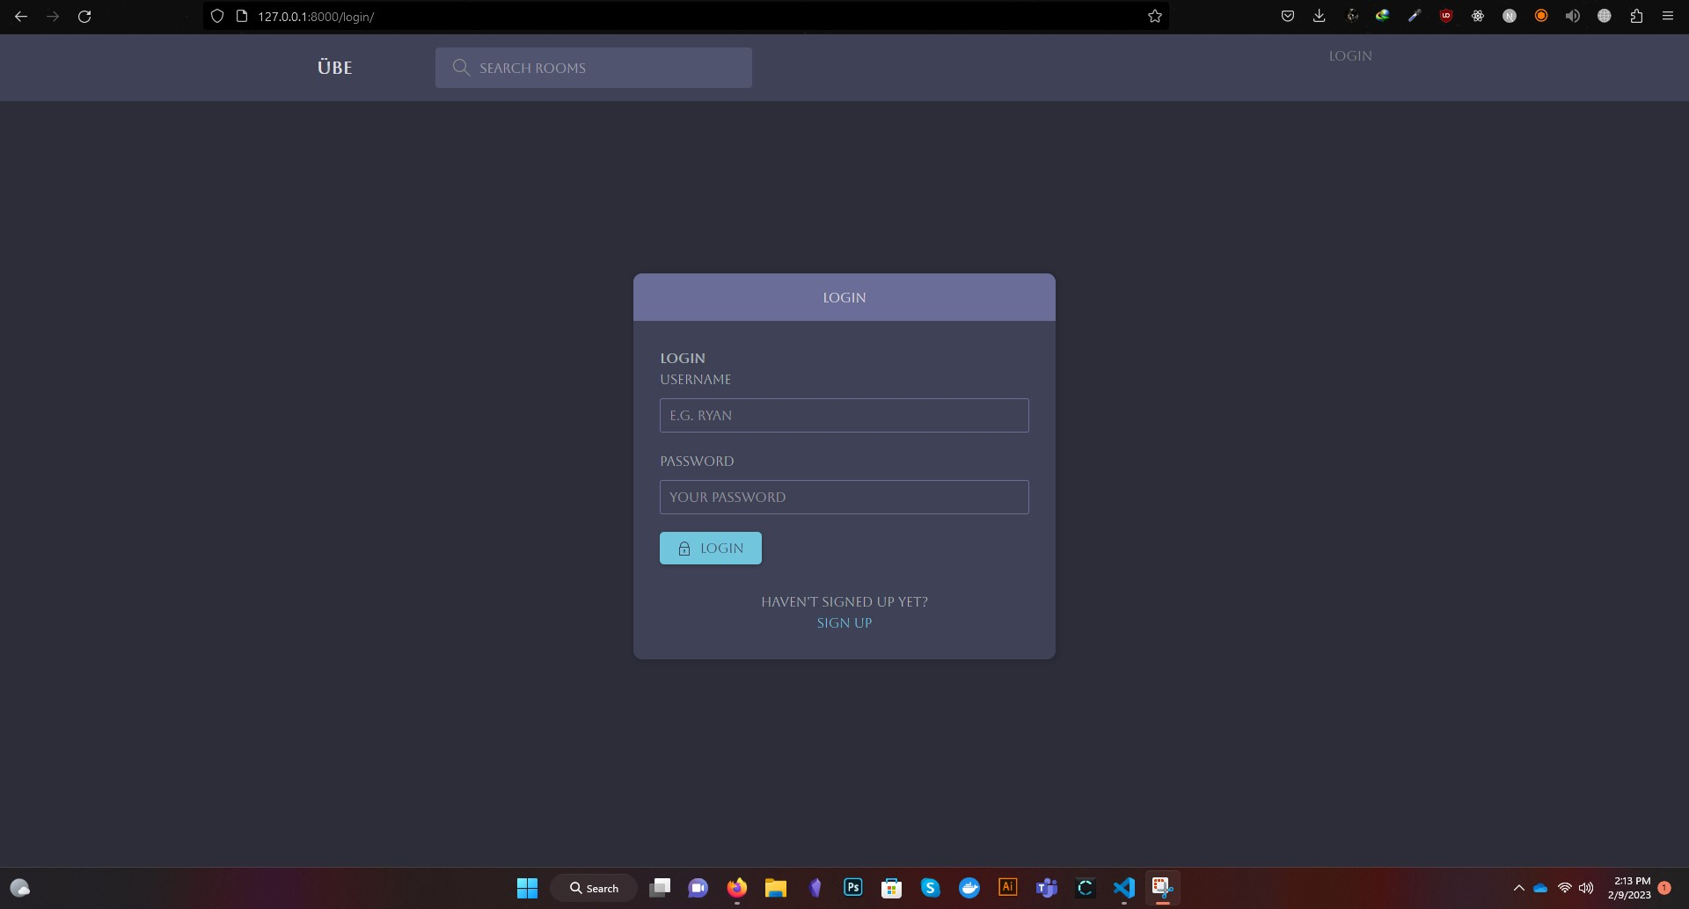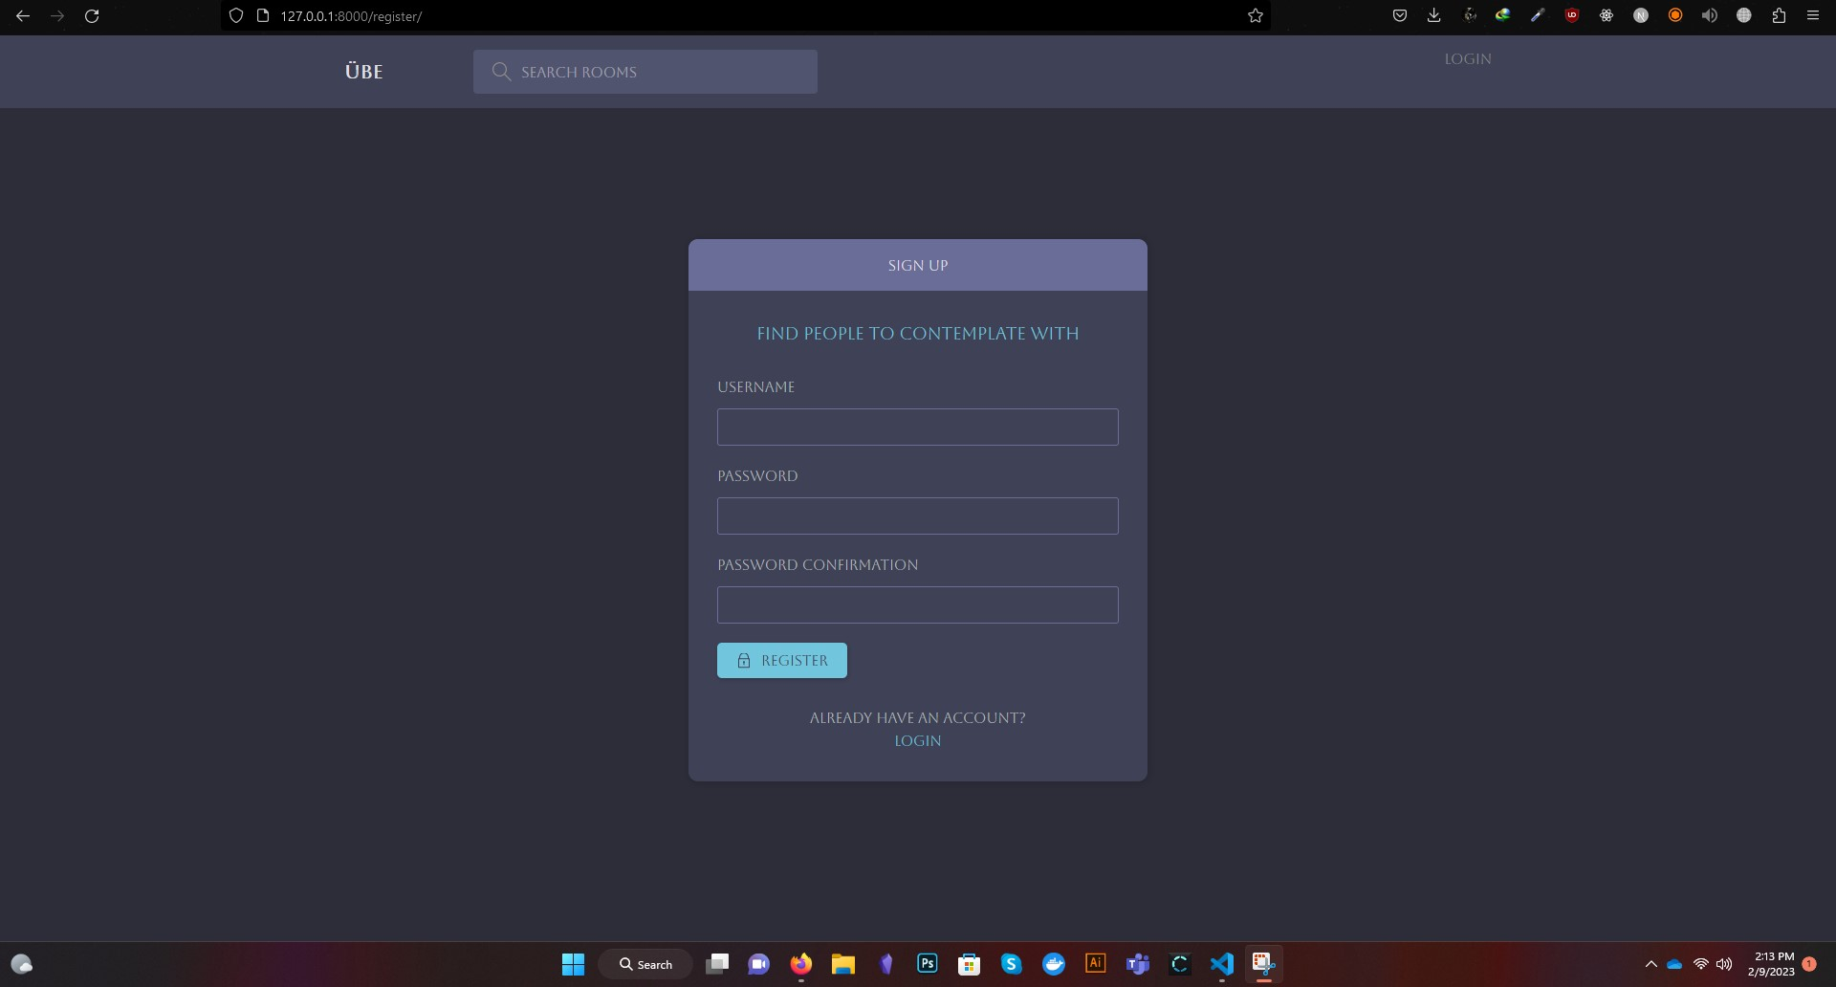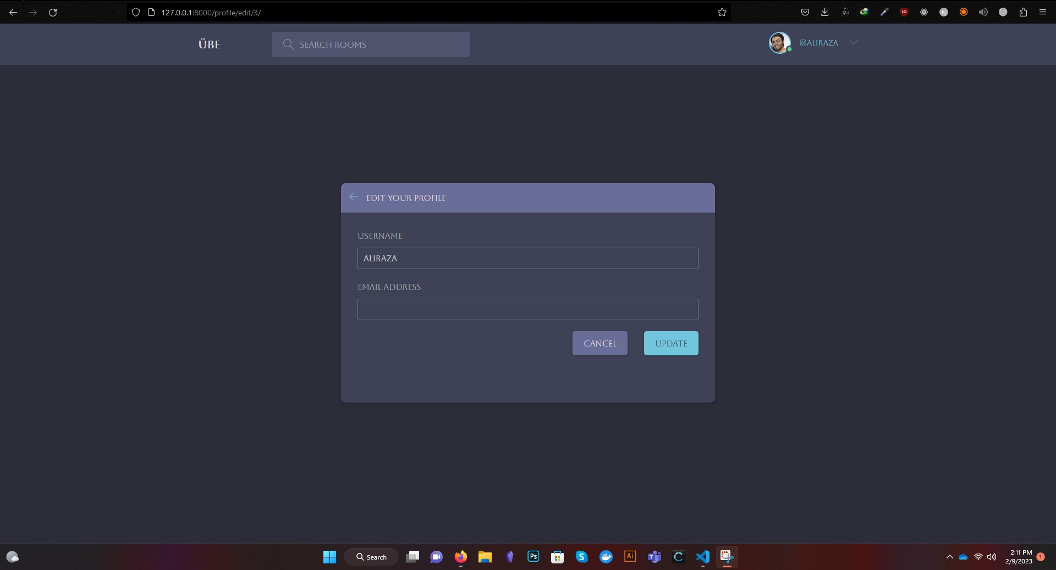

## Private Messaging

Übe also allows you to send private messages to other users. To send a private message, click on the “Private Message” button in the chat room screen, select the recipient, and type your message.

Only you and the recipient will be able to see the private messages. This allows you to have a more intimate conversation with another user without having it be part of the public chat room.

We hope you enjoy using Übe! If you have any questions or feedback, please contact us at [contact@ube.com](mailto:contact@ube.com).