**Data Mart - NYC Parking Violation**

**Design**

Fact Table is parking_violation_ticket_info :

* Fact table is partitioned based on state (NYC) and year/month/day
* Aggregate Columns:
  + Total violations in day
  + Total no stand/stop violations in day
  + Total hydrant violations in day
  + Total double parking violations in day
  + Max parking days
  + Min parking time
  + Max feet from curb
  + Min feet from curb

**IMPLEMENTED ER DIAGRAM (STAR SCHEMA)**

[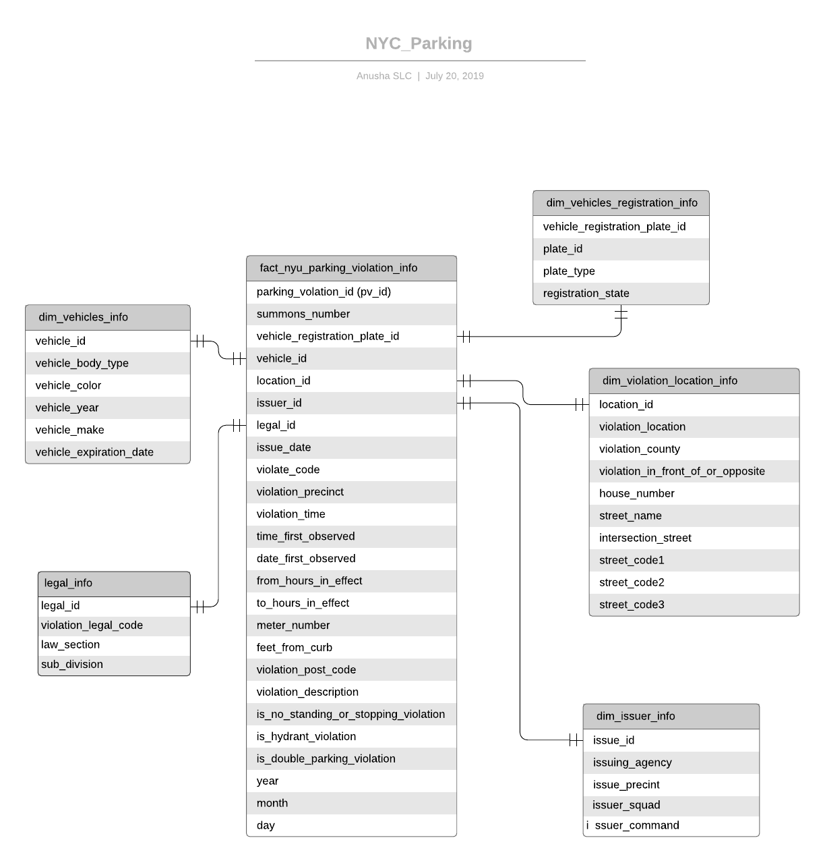](https://www.lucidchart.com/documents/edit/eaefca9c-f449-4e01-be63-ab156c2684b2/0?callback=close&name=docs&callback_type=back&v=3639&s=612)

**Scenarios:**

* Find if the plate used is valid, what if fake plate is used?
* Find number of hydrants in the area, are they within the city limits?
* Accuracy of NTA device, do you need to replace the device?
* What’s causing more parking violations, is it because there’s no public parking nearby?
* Cause for more parking violations in the area, is it because new ice cream/ retail shop opened or airport nearby or event happening in the area?
* Can you make more money if you open a commercial parking garage in the area?
* Are the violations valid?
* Which agency issued violations more in a year?

**Batch Processing:**

The job runs daily to aggregate the data for the aggregation columns specified above

**ETL (Notebook) Progress:**

**Fact and Dimension tables ETL job:**

Created dimensions and facts and stored as parquet. Fact is stored based on partition column(year/month/day).

Due to limitations in data storage, only 2017 issue date year is processed

**Database:**

dm_nyu_parking

**Dimension Tables and Columns:**

dim_vehicles_registration_info:

vehicle_registration_plate_id:long

plate_id:string

registration_state:string

unregistered_vehicle:integer

Plate_type:string

dim_issuer_info:

issuer_id:long

issuer_precinct:integer

issuer_code:integer

issuer_command:string

Issuer_squad:string

issuing_agency:string

dim_vehicles_info:

vehicle_id:long

vehicle_body_type:string

vehicle_make:string

vehicle_year:integer

Vehicle_color:string

vehicle_expiration_date:integer

dim_violation_location_info:

location_id:long

violation_location:integer

violation_county:string

violation_in_front_of_or_opposite:string

house_number:string

street_name:string

intersecting_street:string

street_code1:integer

street_code2:integer

Street_code3:integer

dim_legal_info:

legal_id:long

law_section:integer

sub_division:string

Violation_legal_code:string

**Fact table columns:**

Fact_nyu_parking_violation_info:

Parking_violation_id:bigint

summons_number:long

issue_date:date

Violation_code:integer

violation_precinct:integer

violation_time:string

time_first_observed:string

date_first_observed:integer

days_parking_in_effect:string

from_hours_in_effect:string

to_hours_in_effect:string

unregistered_vehicle:integer

meter_number:string

feet_from_curb:integer

violation_post_code:string

violation_description:string

no_standing_or_stopping_violation:string

hydrant_violation:string

double_parking_violation:string

vehicle_registration_plate_id:long

issuer_id:long

location_id:long

vehicle_id:long

legal_id:long

year:integer

month:integer

Day:integer

I’ve used a counter for dimension id but you can also use hashkey but counter, which is integer is faster than hashkey, disadvantage of counter, in my logic, is it’s not continuous increment.

**Code:**

[**https://databricks-prod-cloudfront.cloud.databricks.com/public/4027ec902e239c93eaaa8714f173bcfc/5041140880827814/4014305827219043/2252038084290521/latest.html**](https://databricks-prod-cloudfront.cloud.databricks.com/public/4027ec902e239c93eaaa8714f173bcfc/5041140880827814/4014305827219043/2252038084290521/latest.html)

**Agg ETL job:**

agg_nyu_parking_violation_info:

year:integer

month:integer

day:integer

violation_time:string

location_id:long

issuer_id:long

vehicle_registration_plate_id:long

violation_description:string

count_summons_number:long

count_no_stand_number:long

count_hydrant_violation_number:long

count_double_parking_violation_number:long

max_days_parking_in_effect_number:string

min_days_parking_in_effect_number:string

max_feet_from_curb_number:integer

Min_feet_from_curb_number:integer

**Aggregrate columns:**

1. Total violations in day
2. Total no stand/stop violations in day
3. Total hydrant violations in day
4. Total double parking violations in day
5. Max parking days
6. Min parking time
7. Max feet from curb
8. Min feet from curb

**Code:**

[**https://databricks-prod-cloudfront.cloud.databricks.com/public/4027ec902e239c93eaaa8714f173bcfc/5041140880827814/3333566614432119/2252038084290521/latest.html**](https://databricks-prod-cloudfront.cloud.databricks.com/public/4027ec902e239c93eaaa8714f173bcfc/5041140880827814/3333566614432119/2252038084290521/latest.html)

**IDEAL ER DIAGRAM** (SNOWFLAKE SCHEMA)

[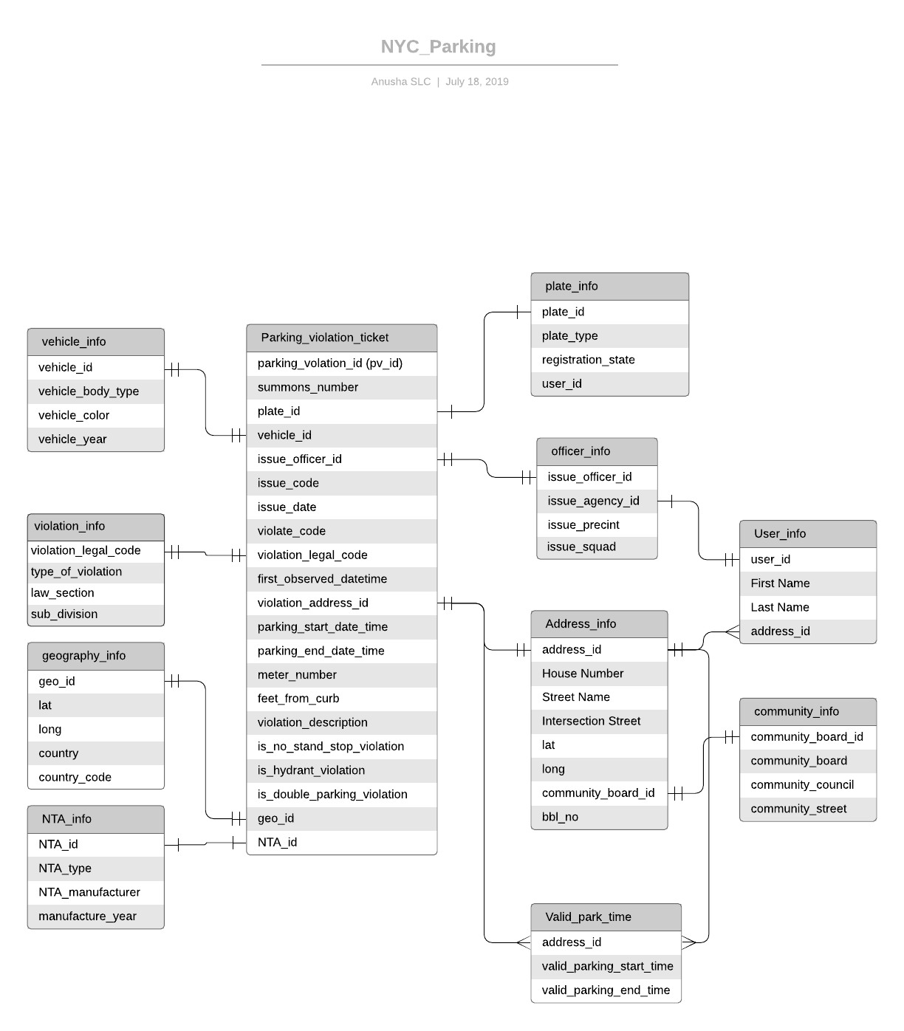](https://www.lucidchart.com/documents/edit/eaefca9c-f449-4e01-be63-ab156c2684b2/0?callback=close&name=docs&callback_type=back&v=2421&s=612)

**Query Results**

**With Fact**

[**https://databricks-prod-cloudfront.cloud.databricks.com/public/4027ec902e239c93eaaa8714f173bcfc/5041140880827814/4014305827219070/2252038084290521/latest.html**](https://databricks-prod-cloudfront.cloud.databricks.com/public/4027ec902e239c93eaaa8714f173bcfc/5041140880827814/4014305827219070/2252038084290521/latest.html)

**With Agg**

[**https://databricks-prod-cloudfront.cloud.databricks.com/public/4027ec902e239c93eaaa8714f173bcfc/5041140880827814/2634234997705643/2252038084290521/latest.html**](https://databricks-prod-cloudfront.cloud.databricks.com/public/4027ec902e239c93eaaa8714f173bcfc/5041140880827814/2634234997705643/2252038084290521/latest.html)