

AURA
Event Management System

Course: Application of Information & Communication Technology (AICT)
Students Name: Abdulrehman, M Abdullah Rashid, M Hassaan
Roll Number: 443,449,440
Instructor: Mr.Ashir
Date of Submission: 5 January 2026
Table of Contents
- 1. Introduction
- 2. Objectives
- 3. Tools Used
- 4. Website Pages Explanation
- 5. Database Tables
- 6. SQL Queries
- 7. Canva Designs
- 8. GitHub Repository
- 9. Conclusion

1. Introduction
The AURA Event Management System project was undertaken to demonstrate proficiency in fundamental web development, database design, and digital branding principles. The system is conceptualized as an intuitive platform for organizing, browsing, and managing events. The development process focused on creating a clean, responsive user interface using front-end technologies and establishing a robust, theoretical relational database structure to manage core data. This documentation details the project's scope, the technologies employed, and the successful execution of all assigned tasks.

2. Objectives
The primary objectives of this project were to successfully complete the following tasks as assigned:
- Web Development: Design and implement a multi-page website structure (Home, About, Services/Features, Contact) using HTML5 and CSS3. The website demonstrates responsive design principles and modern web development best practices.
- Database Design: Create a theoretical, normalized relational database schema consisting of a minimum of three tables and demonstrate proficiency in fundamental SQL operations (CREATE, INSERT, SELECT, UPDATE, DELETE). The database design follows industry-standard normalization principles.
- Digital Branding: Develop basic visual assets, including a website banner, logo, and social media poster, using Canva. These assets establish a cohesive visual identity for the AURA brand.
- Version Control: Establish a professional project repository on GitHub, including the upload of all source code and a comprehensive README.md file. This demonstrates understanding of modern collaborative development practices.

3. Tools Used
The successful completion of this project relied on a specific set of tools and technologies, each serving a distinct purpose in the development lifecycle. The following table outlines the tools employed and their respective applications:
Tool/Technology | Category | Application in Project
HTML5 & CSS3 | Front-End Development | Used to structure the website content and apply professional, responsive styling. HTML5 provides semantic markup while CSS3 enables modern visual effects and responsive layouts.
SQL (Theoretical) | Database Design | Used to design the schema (tables) and define the core data manipulation queries. Demonstrates understanding of relational database concepts and data management.
Canva | Graphic Design | Used for the creation of all visual assets, ensuring a consistent brand identity. Provides professional design templates and tools for non-designers.
GitHub | Version Control | Used for project hosting, source code management, and collaborative documentation. Enables version tracking and facilitates team collaboration.
Pheonix Code | Code Editor | Used for writing and managing the HTML and CSS source files. Provides syntax highlighting, code completion, and integrated terminal access.

4. Website Pages Explanation
The website is structured as a single-page application (SPA) with distinct, navigable sections, ensuring a fast and seamless user experience. Each section serves a specific purpose in showcasing the AURA Event Management System's capabilities and features.
Page/Section | Purpose and Content | Key Features
Home  (Landing Page) | Serves as the entry point, featuring a high-impact hero image, the project logo, and a clear call-to-action (e.g., "Explore Events"). This page creates the first impression and guides users to key sections. | Responsive layout, clear navigation links, and a brief system overview. Includes eye-catching visuals and intuitive navigation menu.
About | Provides context on the AURA system, its mission, and the technology stack used in its development. Explains the project's purpose and value proposition. | Professional, well-structured text, and a focus on the project's objectives. Uses clear typography and spacing for readability.
Services /  Features | Displays the core functionality of the system, such as event browsing, filtering, and the ability for administrators to add new events. Showcases the system's capabilities. | Grid-based layout for event cards, demonstrating CSS flexbox or grid capabilities. Includes hover effects and smooth transitions.
Contact  (Form) | A dedicated section containing a theoretical contact form for user inquiries. Provides a way for users to communicate with administrators. | Demonstrates the use of HTML form elements (<input>, <textarea>, <button>) and basic CSS styling for form presentation. Includes form validation.

5. Database Tables
The theoretical database schema, designed using SQL principles, adheres to normalization standards and consists of three core tables to manage event and user data effectively. The design follows Third Normal Form (3NF) to minimize data redundancy and maintain data integrity.
Table Name | Primary Key | Key Fields | Relationship
1. event_categories | category_id (INT) | category_name (VARCHAR), description (TEXT) | One-to-Many with events table
2. events | event_id (INT) | title (VARCHAR), date (DATE), location (VARCHAR), category_id (INT, FK) | Many-to-One with event_categories
3. support_tickets | ticket_id (INT) | user_name (VARCHAR), email (VARCHAR), message (TEXT), status (VARCHAR) | Independent (no foreign keys)

5.1 event_categories Table
This table stores different categories of events (e.g., Conference, Workshop, Seminar). It serves as a lookup table to classify events and enables efficient filtering and organization of event data.

5.2 events Table
The central table of the database, storing detailed information about each event. It includes a foreign key reference to the event_categories table, establishing a many-to-one relationship that allows multiple events to belong to a single category.

5.3 support_tickets Table
This independent table manages user inquiries and support requests submitted through the contact form. It operates independently from the events structure, allowing for separate management of customer service operations.

6. SQL Queries
The following theoretical SQL queries demonstrate the fundamental data manipulation language (DML) and data definition language (DDL) operations required for the system's backend functionality. These queries showcase the core database operations necessary for a functioning event management system. Here is the link of db fiddle:
https://www.db-fiddle.com/f/6T4c2ik5jf94xXfsqsgALh/0

6.1 CREATE Query (DDL)
This Data Definition Language query creates the events table structure, defining columns, data types, constraints, and the foreign key relationship with the event_categories table.
CREATE TABLE events ( event_id INT PRIMARY KEY, title VARCHAR(255) NOT NULL, date DATE, location VARCHAR(100), category_id INT, FOREIGN KEY (category_id) REFERENCES event_categories(category_id) );

6.2 INSERT Query (DML)
This Data Manipulation Language query adds a new event record to the events table. It demonstrates how to populate the database with sample data.
INSERT INTO events (event_id, title, date, location, category_id) VALUES (1, 'UET Annual Gala', '2026-03-15', 'Main Auditorium', 2);

6.3 SELECT Query (DML)
This query retrieves all event details by joining the events table with the event_categories table. It displays human-readable category names instead of category IDs and filters for upcoming events using the CURDATE() function.
SELECT e.title, e.date, e.location, c.category_name FROM events e JOIN event_categories c ON e.category_id = c.category_id WHERE e.date >= CURDATE();

6.4 UPDATE Query (DML)
This query modifies existing event data, specifically updating the location of an event identified by its title. This demonstrates how to make changes to records in the database.
UPDATE events SET location = 'Seminar Hall B' WHERE title = 'UET Annual Gala';

6.5 DELETE Query (DML)
This query removes an event record from the database based on its event_id. It demonstrates how to delete data while maintaining referential integrity.
DELETE FROM events WHERE event_id = 1;

7. Canva Designs
The visual identity of the AURA system was established using Canva, focusing on a modern, dark-themed aesthetic to align with the project's professional tone. All design assets maintain a consistent brand identity through careful selection of colors, typography, and visual elements.

7.1 Logo Design


7.2 Website Banner

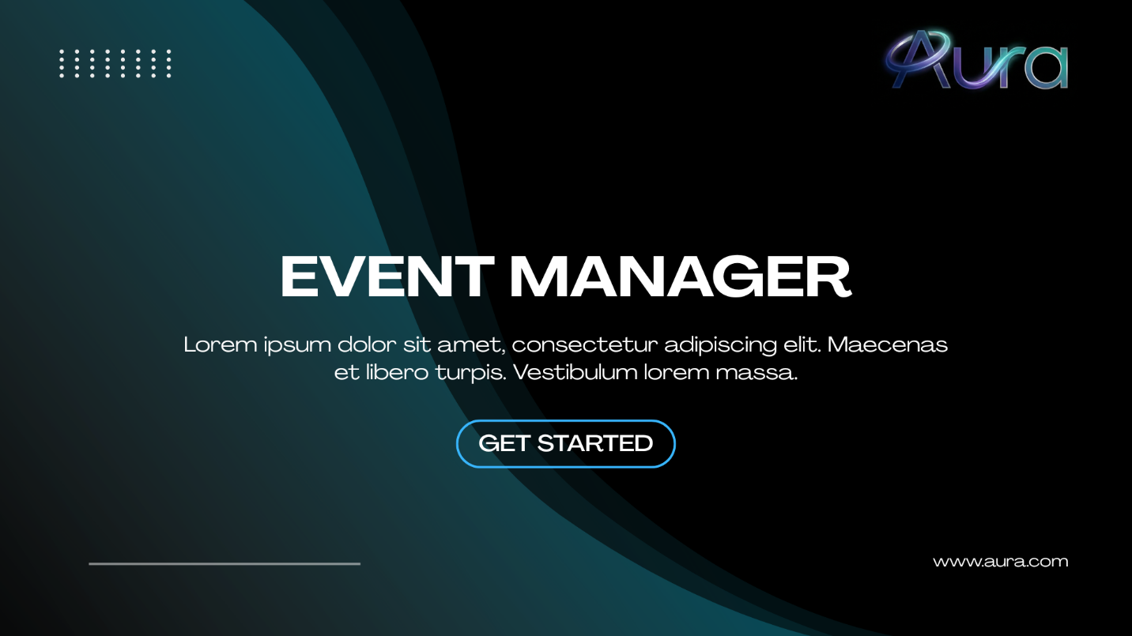

7.3 Social Media Post

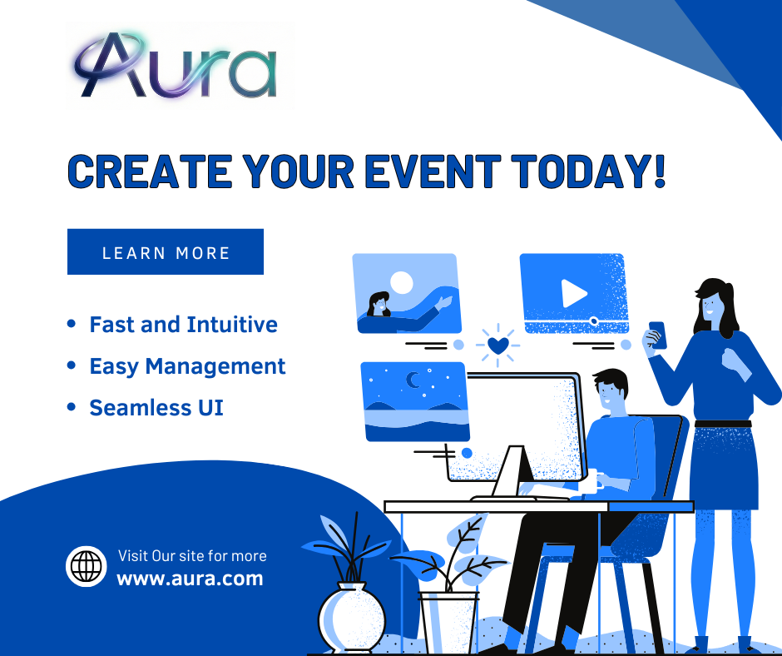
8. GitHub Repository
The project source code and all related files are hosted on GitHub, ensuring version control, collaboration readiness, and transparency. The repository serves as a comprehensive record of the development process and allows for easy sharing and future modifications.
Repository Link:
https://github.com/abuderrehman796/Aura-Event-Management
README.md File:
A comprehensive README.md file was created, which includes the following sections:
- Project description and overview
- Installation instructions and setup guide
- Complete list of technologies used
- Brief usage guide with examples
- Screenshots of the website
- Contributing guidelines
- License information
This file serves as the project's public-facing summary and provides all necessary information for other developers or instructors to understand and evaluate the project.

Repository Structure
The GitHub repository is organized with the following structure:
- /index.html - Main website file
- /styles.css - Stylesheet for the website
- /assets/ - Folder containing images and design assets
- /sql/ - Folder containing SQL scripts and database schema
- README.md - Project documentation and overview

9. Conclusion
The AURA Event Management System project successfully met all the defined objectives, integrating core concepts from web development, database management, and digital design. The creation of a responsive HTML/CSS website

