meas_crowd: pipeline guide
Audrey Budlong

Pipeline overview
The pipeline fits every star in a crowded field jointly with a PSF model, starting from Gaia positions. It alternates between finding sources and improving the PSF and background until neither changes. It runs on one cutout at a time. A whole detector is a grid of cutouts (tiles) whose results are stitched back together.
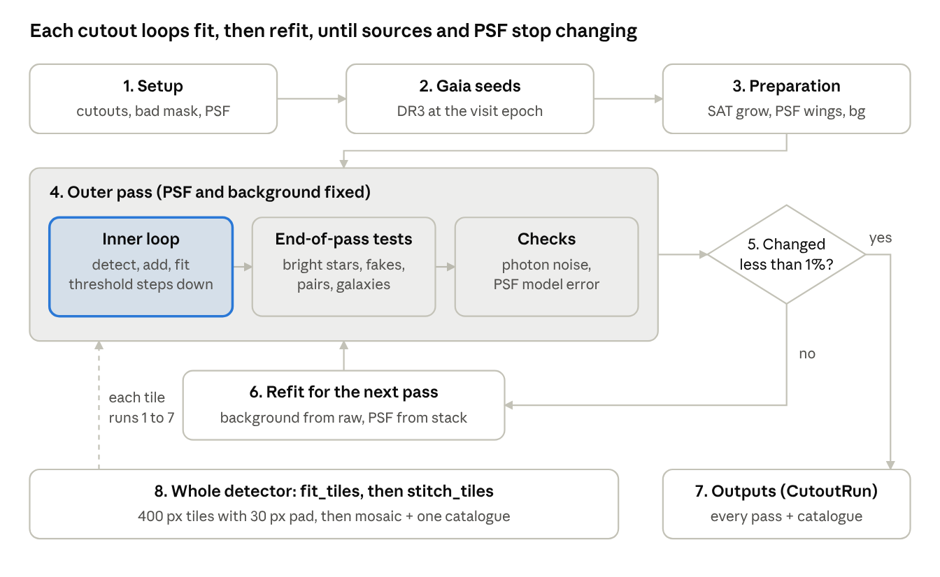
pipeline flow · 8 steps, one loop
Steps 4–6 repeat until the source count and the PSF each change by less than 1%; a whole-detector run repeats steps 1–7 for every tile.
- Setup (prepare_session): loads the visit_image from the Butler. Cuts out each requested box grown by pad px, before any background subtraction. Builds the bad-pixel mask (SAT, CR, BAD, INTRP, EDGE) and sets up the detector-level PSF, either the visit's own PSF or a fresh refit (see Key parameters).
- Gaia seeds (attach_gaia, select_seeds): Gaia DR3 sources over the detector, moved to the visit epoch with their proper motions and cached on disk. Sources up to 1.5 FWHM outside a cutout are kept, so stars just over the edge are modelled.
- Preparation (start of run_seeded_pipeline): grows the saturated mask by 2 px and marks saturated-star zones. Extends the PSF kernel from 41 to 81 px with a Moffat wing and smooths its outer part. In refit mode it subtracts the detector-level background. It also removes a global Gaia-vs-image offset.
- Outer pass (repeated): one full fit with a fixed PSF and background.
  - Inner loop (run_inner_seeded): fit the current sources, then detect in the residual, add, joint-fit, refine centroids and clean up. The detection threshold steps down (from 5σ with Gaia seeds to a 3σ floor; later passes start at the floor) until the residual has no significant excess.
  - End-of-pass tests: per-star corrections for bright and saturated stars, and removal of fake sources in halos and rings. Then a joint position polish, a test for unresolved pairs, and a test for small galaxies (elliptical model).
  - Checks: measures the photon noise the variance plane misses and the PSF model error.
- Convergence test: stop when the source count changed by less than 1% and the PSF by less than 1% (after at least 2 passes and at most max_outer). Otherwise go to step 6.
- Refit for the next pass: re-derive the background from the raw cutout with this pass's model masked. Update the PSF from a residual stack of up to 25 clean stars, then measure its wings from the bright stars. Return to step 4.
- Outputs (run_cutout_gaia → CutoutRun): the full history of every pass (run.outer_history), a source catalogue with Gaia matches, a summary, and on request photometry (measure_photometry) and files on disk (save_run).
- Whole detector (fit_tiles → stitch_tiles → plot_detector): 400 px tiles, each fitted with 30 px padding and written to tile_<name>.fits. These are stitched into detector_mosaic.fits (DATA, MODEL, RESIDUAL, VARIANCE, BAD, TILE) and one catalogue in which each source appears once.
The DATA image in every output is the image the fit used, after background subtraction, so residual = data − model.

Key parameters and options
The most important choice is the PSF source; everything else has a working default in V5_TESTING_CONFIG. Options are passed to make_config(...) or as keyword overrides to run_session_gaia(sess, cfg, max_outer=3, ...); an unknown name raises an error. crowd.SEEDED_DEFAULTS lists every option with a comment.
PSF source (prepare_session(..., psf_source=...), also fit_tiles and the crowdDetector.py CLI):
- "visit" (recommended, CLI default): use the PSF stored with the visit_image. Fast. The visit image is already background-subtracted, so pass 1 starts with no extra background.
- "refit": build a new detector-level PSF: subtract an Akima-spline background, detect at 3σ, select stars by size (ObjectSizeStarSelectorTask) and fit a PCA PSF (spatial order 1, 512 px cells). The background is kept as session.bgImage and subtracted in pass 1; the candidate and used stars are kept as session.starCat and session.psf_used_xy.
In both cases the PSF is then refined inside each cutout between passes (refit_psf).
Option | Default | What it controls
pad (prepare_session) | 0 (examples use 20) | Extra px fitted around each cutout so edge stars have their neighbours
refit_psf | "stack" | PSF update between passes: "stack" (residual stack of clean stars, cross-validated), True (re-detect + PCA refit in the cutout), False (keep the PSF)
psf_stack_n, psf_stack_min_snr | 25, 50 | Number and minimum peak S/N of the clean stars in the stack
psf_wing_size, psf_ext_blend | 81 px, (12, 16) px | Kernel size after the wing extension and the radii of the Moffat blend
wings_from_stars | True | Measure the outer wings from bright and saturated stars
psf_spatial | False | Let the PSF vary linearly across the cutout
min_outer, max_outer | 2, 6 (CLI 3) | Number of outer passes
outer_growth_tol, psf_tol | 0.01, 0.01 | Convergence: change in source count and in the PSF kernel
max_inner | 30 (CLI 15) | Cap on inner iterations per pass
seed_threshold_start | 5.0 σ | First detection threshold when Gaia seeds are used
inner_kwargs | start 8, step −1, floor 3 σ | Detection thresholds without seeds and the floor
min_snr | 3.0 | Minimum S/N to keep a source
gmag_max (run_session_gaia) | None | Seed only Gaia stars brighter than this G magnitude
fit_gaia_offset, seed_max_drift_px | True, 1.5 px | Remove a global WCS offset; how far a seed may move
subtract_initial_bg | True | Subtract session.bgImage in pass 1 (refit mode only)
bg_bin_size, bg_sat_mask_fwhm | 32 px, 6 FWHM | Background refit grid; mask around saturated stars
sat_grow_px, near_sat_frac | 2 px, 0 (off) | Grow the SAT mask; mask near-saturated cores
bright_corr | True | Per-star shift, width and radial-profile terms for bright stars
split_test, ellip_test, keep_extended | True | Unresolved pairs, elliptical galaxies, broadened-PSF galaxies
final_polish | True | Joint position polish at the end of each inner loop
auto_poisson, model_err_measure | True | Add missing photon noise; measure the PSF model error
fast_stamps | True | C++ stamp rendering (NumPy fallback), checked against the stack
keep_all_fits | False | Keep every iteration's per-source stamps (needed for source pages of earlier iterations)
n_jobs (run_session_gaia) | 1 | Fit cutouts in parallel processes
tile, pad (fit_tiles) | 400, 30 px | Tile interior size and padding for whole-detector runs

How-to recipes
Every recipe below uses functions in the package; the stage plots in items 2–5 and the single-tile plot in item 6 are new in this version (stagePlots.py, detector.plot_tile). Items 2–5 need a cutout run held in memory (runs from run_session_gaia). Tile runs keep only the final images and catalogue, so for stage plots of a detector region, run that region as a cutout.

1. Run the whole pipeline
At USDF, from a terminal (build once with scons):
source /sdf/group/rubin/sw/w_latest/loadLSST.bash
setup lsst_distrib
cd ~/meas_crowd && scons && setup -k -r .
Cutouts, in Python or a notebook. Load the visit image yourself so you can reuse it for plots:
import lsst.meas.crowd as crowd
from lsst.daf.butler import Butler
VISIT, DET = 2025062100433, 144
butler = Butler("dp2_prep", collections="LSSTCam/runs/DRP/DP2")
refs = butler.query_datasets("visit_image", collections="LSSTCam/runs/*", find_first=False,
where=f"instrument='LSSTCam' AND visit={VISIT} AND detector={DET}")
visit_image = butler.get(refs[0])
cfg = crowd.make_config(crowd.V5_TESTING_CONFIG)
sess = crowd.prepare_session(VISIT, DET, cutouts=["1000,1000,300", "2500,2000,300"], pad=20,
psf_source="visit", # or "refit"
visit_image=visit_image)
crowd.attach_gaia(sess) # Gaia DR3 seeds, cached in gaia_cache/
runs = crowd.run_session_gaia(sess, cfg, out_dir="results", max_outer=3, max_inner=15)
run = runs[next(iter(runs))]
crowd.report(run) # what each pass did
phot = crowd.measure_photometry(run) # PSF + aperture magnitudes
The whole detector as a Slurm array (25 tasks share about 100 tiles, then one stitch job):
VISIT=2025062100433 DETECTOR=144 bash examples/usdf_detector_array.sh
Or step by step (--region limits a test run to a few tiles):
OUT=$HOME/meas_crowd_results/v2025062100433_d144
python bin.src/crowdDetector.py fit 2025062100433 144 --out $OUT --region 1000 1800 1000 1800
python bin.src/crowdDetector.py stitch --out $OUT
python bin.src/crowdDetector.py plot --out $OUT

2. PSF candidate stars and the model PSF
psf_star_positions returns candidate and used stars from one of three PSF determinations; show_psf_stars draws them on an image next to the PSF kernel and its radial profile.
# a) detector-level PSF, psf_source="refit": stars the PCA PSF was built from
stars = crowd.psf_star_positions(session=sess)
crowd.show_psf_stars(visit_image, stars, psf=sess.psf)
# b) the visit's own PSF, psf_source="visit": stars flagged calib_psf_candidate / calib_psf_used
# (the dataset name depends on the pipeline version: butler.registry.queryDatasetTypes("*star*"))
cat = butler.get("single_visit_star_unstandardized", dataId=refs[0].dataId,
collections="LSSTCam/runs/*")
crowd.show_psf_stars(visit_image, crowd.psf_star_positions(catalog=cat),
view=(500, 1500, 500, 1500)) # optional zoom
# c) the in-cutout PSF update after each pass (residual stack of clean stars)
hist = run.outer_history
for k in range(len(hist) - 1):
crowd.show_psf_stars(hist[k]["exposure"], crowd.psf_star_positions(run=run, outer=k),
psf=hist[k + 1]["psf"]) # the PSF this update produced
crowd.fitLib.plot_psf_models_by_outer_pass(hist) # kernel used in each pass
Orange circles are candidates, green squares the stars used. The title of the kernel panel gives its size and FWHM.

3. Initial background and each background iteration
crowd.show_backgrounds(run, initial=sess.bgImage)
The top row shows the background entering each pass; the bottom row shows the change from the previous pass. With psf_source="visit", sess.bgImage is None and pass 1 shows "nothing subtracted". Later passes then show only the small residual sky the refit finds.

4. Model images and residuals per round
crowd.show_rounds(run, level="outer") # one row per outer pass
crowd.show_rounds(run, level="inner", outer=0) # inner iterations of pass 1
crowd.show_rounds(run, level="inner", outer=-1, view=(1100, 1200, 1100, 1200)) # zoom
crowd.fitLib.plot_outer_loop_summary(run.outer_history) # residual std and N per pass
Each row shows data | model | residual | residual/σ on common colour scales, and the function prints the robust residual std per row. Passing viz=True to run_session_gaia also draws the per-pass overview while the fit runs.

5. Source cutouts linked to boxes on the data, model and residual
# brightest sources, 6 per page, 2 pages
crowd.show_linked_source_pages(run, source_view="all", sources_per_page=6, max_pages=2)
# chosen sources, by index or by detector position (nearest source)
crowd.show_linked_source_pages(run, sources=[(1150.0, 1120.0), (1210.5, 1033.0), 51])
# every source into one PDF
from matplotlib.backends.backend_pdf import PdfPages
with PdfPages("results/source_pages.pdf") as pdf:
crowd.show_linked_source_pages(run, max_pages=None, pdf=pdf)
The first figure is data | model | residual of the whole cutout with one coloured box per source. Each box is exactly the window shown in that source's row, and the row is framed in the same colour. source_view="new" or "changed" picks the sources added or changed in that iteration. Pages for earlier iterations (snap=...) need keep_all_fits=True. For the magnitude-labelled version use crowd.plot_source_cutouts(run, how="worst", n=8, phot=phot).

6. Individual tiles
import glob
for path in sorted(glob.glob(f"{OUT}/tile_*.fits"))[:4]:
crowd.plot_tile(path) # data | model | residual | residual/sigma
t = crowd.load_tile(f"{OUT}/tile_x0400_y0400_400x400.fits") # arrays + catalogue
Each plot covers the tile's whole fitted area; the outlined box is the interior that goes into the mosaic. Its catalogue's owned column marks the sources kept from this tile.

7. Full detector: data, model, residual
m = crowd.load_mosaic(OUT) # after stitch_tiles / the stitch job
crowd.plot_detector(m, out=f"{OUT}/detector.png") # whole detector, binned for display
crowd.plot_detector(m, view=(1000, 1400, 1000, 1400), binning=1, sources=True) # zoom
detector_mosaic.fits also opens in DS9 (DATA, MODEL, RESIDUAL, VARIANCE, BAD and TILE extensions).

Unit tests: running them and checking the results
The suite has 82 tests in tests/: 80 pass and 2 are skipped without the Rubin stack. Each test builds a small synthetic image with a known answer, runs one function on it and checks the result. The stand-ins in tests/lsstStubs.py let all tests except test_fastStampsStack.py run on a laptop without the stack.

Running tests
From the tests/ directory. Without the stack, put the package on the path first; with the stack, setup -k -r .. is enough.
cd ~/meas_crowd/tests
export PYTHONPATH=../python MPLBACKEND=Agg # no-stack only; Agg = no plot windows
python -m pytest -q . # everything
python -m pytest -v test_photometry.py # one file, one line per test
python -m pytest -v test_photometry.py::ApertureTestCase # one class
python -m pytest -v "test_photometry.py::ApertureTestCase::testApertureFluxOfGaussian"
python -m pytest -v -k "aperture or flux_to_mag" . # by name
python test_photometry.py # plain unittest also works
With the stack set up, scons tests also runs the suite and writes logs to tests/.tests/.
File | What it checks
test_fastKernels.py | Lanczos weights, sub-pixel shifts against an analytic Gaussian, C++ = NumPy, flux conservation, derivatives
test_fastStampsStack.py | Fast stamps reproduce psf.computeImage (stack only)
test_photometry.py | Magnitudes and zero points, aperture fluxes, aperture correction, Fisher errors, full photometry of a synthetic run
test_pipelineFunctions.py | PSF regularisation and correction, bright-star terms, model error, saturation level, ring and split tests
test_diagnostics.py | Residual diagnostics (perfect model, brighter-fatter, broad PSF) and the run-level plots
test_sourcePlots.py | Per-source cutout data, source selection and the cutout pages
test_stagePlots.py | PSF stars, backgrounds per pass, rounds, colour-linked source pages
test_detector.py | Tiling, per-task splitting, resuming, ownership, stitching, tile and mosaic plots, CLI
test_docstrings.py | Every public function has an LSST (numpydoc) docstring

Reading the results
- . = passed, F = an assertion failed (the function gave a wrong answer), E = it raised an error, s = skipped.
- -rs prints why tests were skipped, e.g. "needs the Rubin stack (lsst.afw)".
- On a failure pytest shows the assert line with both values, e.g. assert 997.8 == 1000.0 ± 0.5. Add --tb=long for the full traceback, or --pdb to open a debugger at the failure.
- -x stops at the first failure, --lf reruns only last time's failures, and --durations=10 lists the slowest tests.

Testing one function yourself and showing it works
Use the same synthetic data as the tests, in a notebook or python, run from the repository root. The example checks that PSF photometry recovers the true fluxes and that a perfect model leaves pure noise:
import sys; sys.path[:0] = ["tests", "python"]
import lsstStubs; lsstStubs.install() # does nothing if the stack is set up
import numpy as np, fakeRun
from lsst.meas.crowd import photometry, stagePlots
run = fakeRun.make_run(seed=1) # 16 Gaussian stars, Poisson noise, perfect model
phot = photometry.measure_photometry(run, verbose=False)
ratio = np.asarray(phot["psf_flux"]) / run.truth_flux
print(np.median(ratio), np.std(ratio)) # 1.0006, 0.0065: fluxes right to 0.1%
pull = (np.asarray(phot["psf_flux"]) - run.truth_flux) / np.asarray(phot["psf_flux_err"])
print(np.std(pull)) # 1.15 with 16 stars: errors are about right
rows = stagePlots.show_rounds(run, out="rounds.png")
print(rows[-1]["chi_std"]) # 0.999: residual/sigma is pure noise
Three checks to apply to any function:
- Known answer: feed it input whose answer you can work out by hand. For example, a 2-D Gaussian holds 39.3% of its flux within 1σ, which testApertureFluxOfGaussian checks.
- Noise behaves: residual/σ and (measured − true)/error should have a standard deviation near 1.
- Picture: most plotting functions take out="file.png"; save one and look at it. The tests check that the file is written, not what it looks like.
To keep a check, add it as a test in the matching file (or a new tests/test_<name>.py) and run that test alone:
import unittest
import lsstStubs
lsstStubs.install()
import fakeRun # noqa: E402
from lsst.meas.crowd import photometry # noqa: E402
class MyCheckTestCase(unittest.TestCase):
def testFluxesRecovered(self):
run = fakeRun.make_run(seed=1)
phot = photometry.measure_photometry(run, verbose=False)
ratio = phot["psf_flux"] / run.truth_flux
self.assertAlmostEqual(float(ratio.mean()), 1.0, delta=0.01)
if __name__ == "__main__":
unittest.main()
When a test fails after a code change, rerun it alone with -v --tb=long, print the intermediate values in the snippet above, and compare with the expected number in the assert.

