LUMINA MART
Dairy Intelligence Dashboard
Fresh Insights, Better Decisions

108M EGP  Net Sales | 26M EGP  Total Profit | 22%  Profit Margin | 50.15%  YoY Growth | 0.36%  Return Rate

Power BI • Business Intelligence • Data Analytics
Egyptian Dairy Market | DEPI – Next Academy Graduation Project | 2026

1. Project Overview

Project Name: LUMINA MART – Dairy Intelligence Dashboard
Industry: FMCG / Egyptian Dairy Market
Tool: Microsoft Power BI Desktop
Scope: End-to-end BI solution covering sales, product, promotions, returns, and customer survey data

Project Summary
LUMINA MART is a comprehensive Power BI dashboard designed for the Egyptian dairy retail sector. It transforms raw transactional and survey data into actionable intelligence across six analytical domains, enabling stakeholders to monitor performance, identify growth opportunities, and make data-driven decisions with confidence.

1.1 Business Problem
- Lack of centralized visibility into sales performance across products, areas, and sales reps
- No clear measurement of promotional campaign effectiveness vs. organic sales
- Difficulty identifying high-return products and understanding quality complaints
- Limited understanding of customer preferences and brand loyalty drivers

1.2 Solution Approach
- Built a multi-page interactive Power BI report with cross-filtering and drill-through
- Created a unified data model integrating sales, product, promotions, returns, and survey tables
- Designed an intuitive navigation system with a landing page and 6 dedicated report pages
- Implemented custom KPI cards, composite metrics, and a revenue performance gauge

2. Dashboard Pages

2.1 Home / Landing Page
A polished entry screen that summarises the five headline KPIs and provides one-click navigation to all report pages. Designed to give any audience an immediate feel for overall business health before diving deeper.

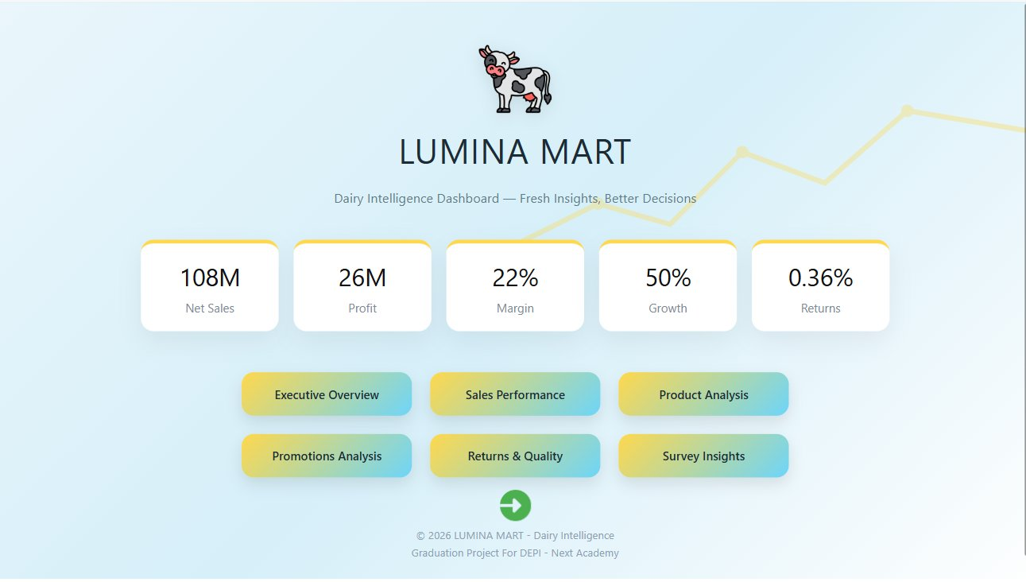
Figure 1 – Home Page: headline KPIs and navigation hub

2.2 Executive Overview
The executive layer consolidates revenue, profitability, customer ranking, and segment distribution. A composite performance gauge (scored 0.78 – 'Good') combines sales, profit, and return behavior into a single headline metric.

26M EGP  Total Profit | 108M EGP  Net Sales |  | 22%  Profit Margin | 0.36%  Return Rate

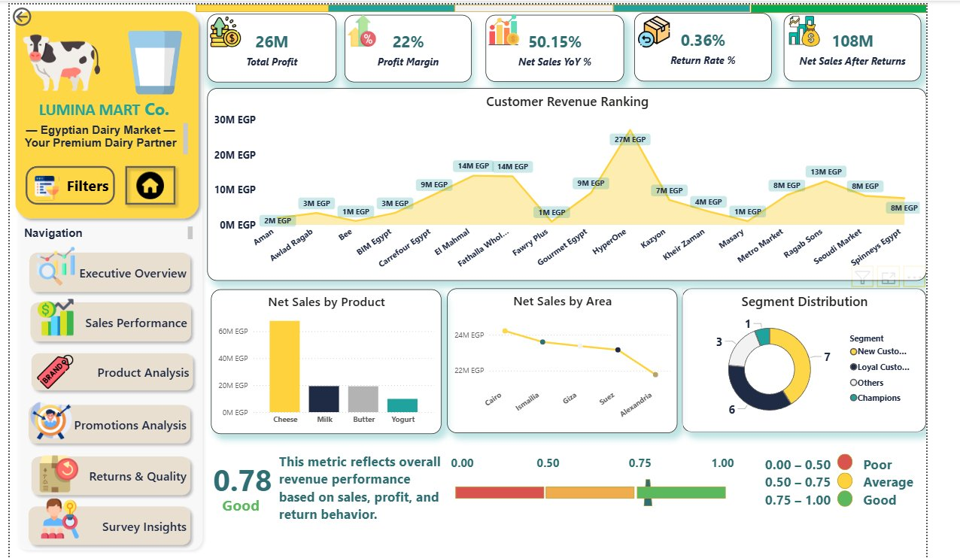
Figure 2 – Executive Overview: customer ranking, area breakdown, and performance gauge

2.3 Sales Performance
Tracks monthly sales vs. last year, top 5 sales representatives, segment distribution (Wholesale 51%, Retail 32%), product growth share, and cumulative profit waterfall. Filters for Segment, Product, and Year are provided for ad-hoc analysis.

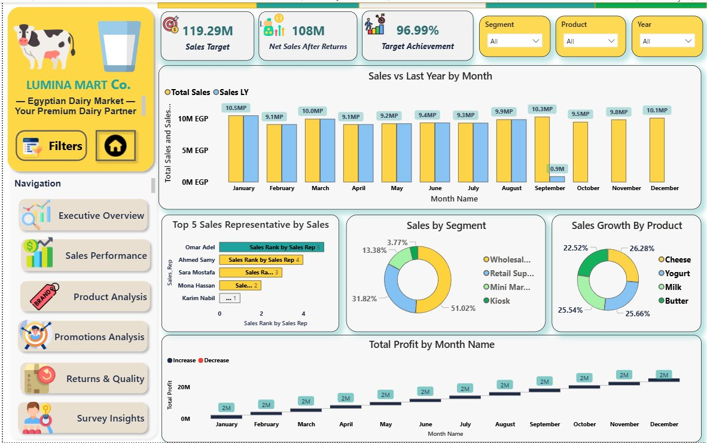
Figure 3 – Sales Performance: YoY comparison, rep ranking, and profit waterfall

- Sales Target: 119.29M EGP | Achieved: 108M EGP | Achievement Rate: 96.99%
- Wholesale leads segment distribution at 51.02%, followed by Retail Supply at 31.82%
- All four product categories (Cheese, Yogurt, Milk, Butter) hold roughly equal growth share (~25%)

2.4 Product Analysis
Analyses category sales vs. return rate, brand profitability margins, and a profit-share matrix across all seven product SKUs and eight brands. Filters for Brand, Product, and Area allow granular investigation.

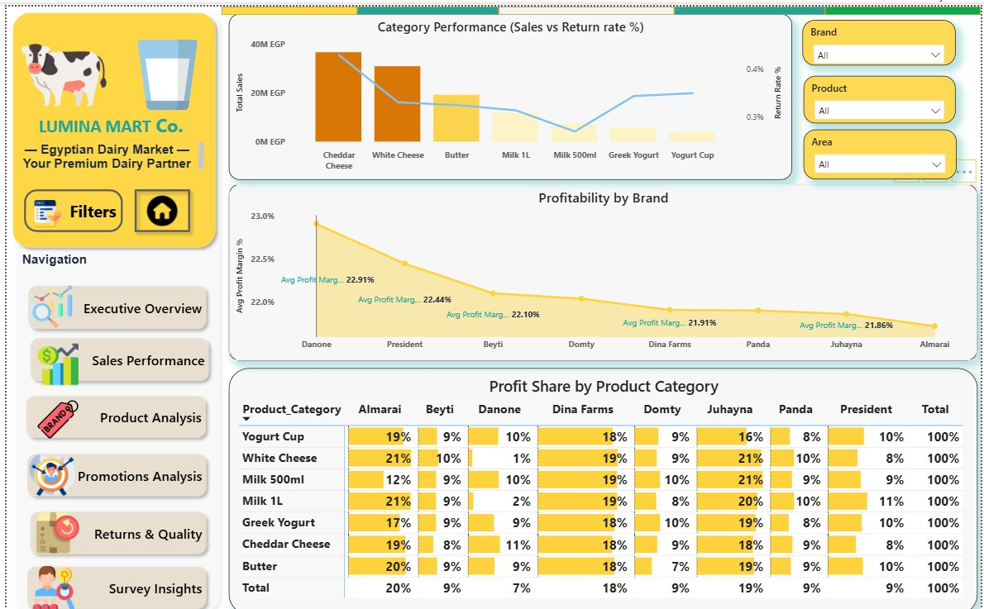
Figure 4 – Product Analysis: category performance, brand margins, and profit-share matrix

- Cheddar Cheese and White Cheese are the highest-revenue categories
- Danone leads brand profitability at 22.91% average margin; Almarai trails at 21.86%
- The profit-share matrix reveals diversified contribution across all brand–category combinations

2.5 Promotions Analysis
Evaluates campaign effectiveness relative to organic baseline sales, the financial profit impact of promotions, and offer vs. standard revenue split by product category.

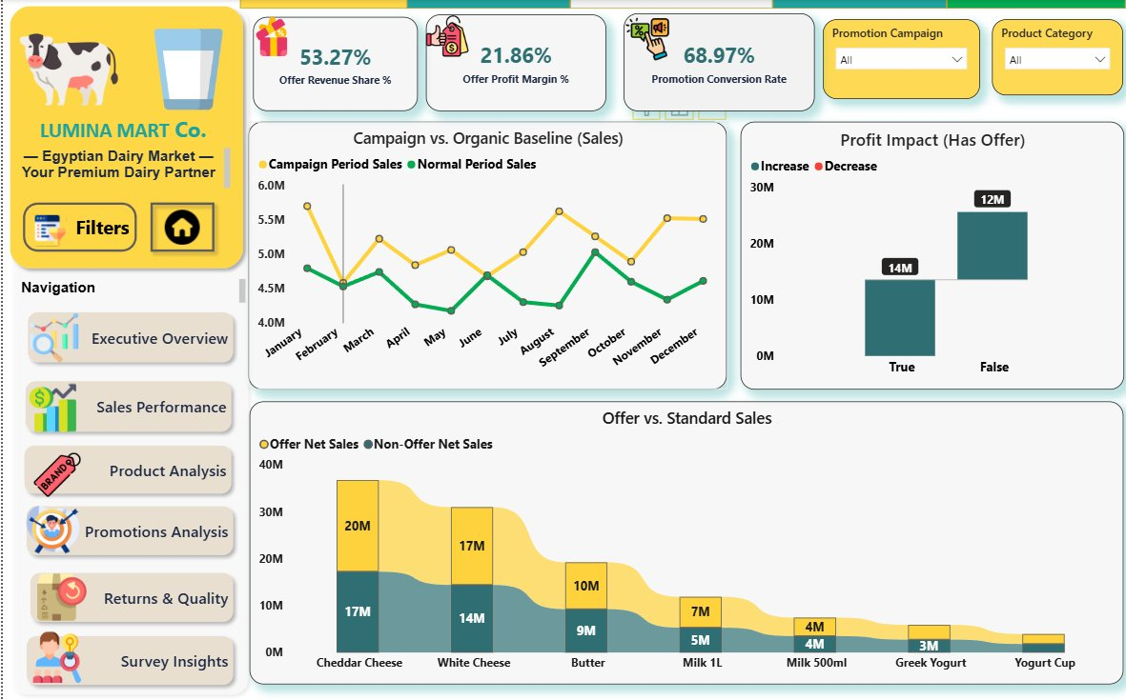
Figure 5 – Promotions Analysis: campaign baseline, profit impact, and offer vs. standard sales

Key Promotion Metrics
Offer Revenue Share: 53.27% – More than half of all revenue is generated during promotional periods
Offer Profit Margin: 21.86% – Promotions maintain healthy margins despite discounted pricing
Promotion Conversion Rate: 68.97% – High conversion confirms strong campaign effectiveness

2.6 Returns & Quality
Monitors monthly return rate trends, the financial impact of returns by product category, geographic return distribution, near-expiry exposure, and complaint frequency by brand.

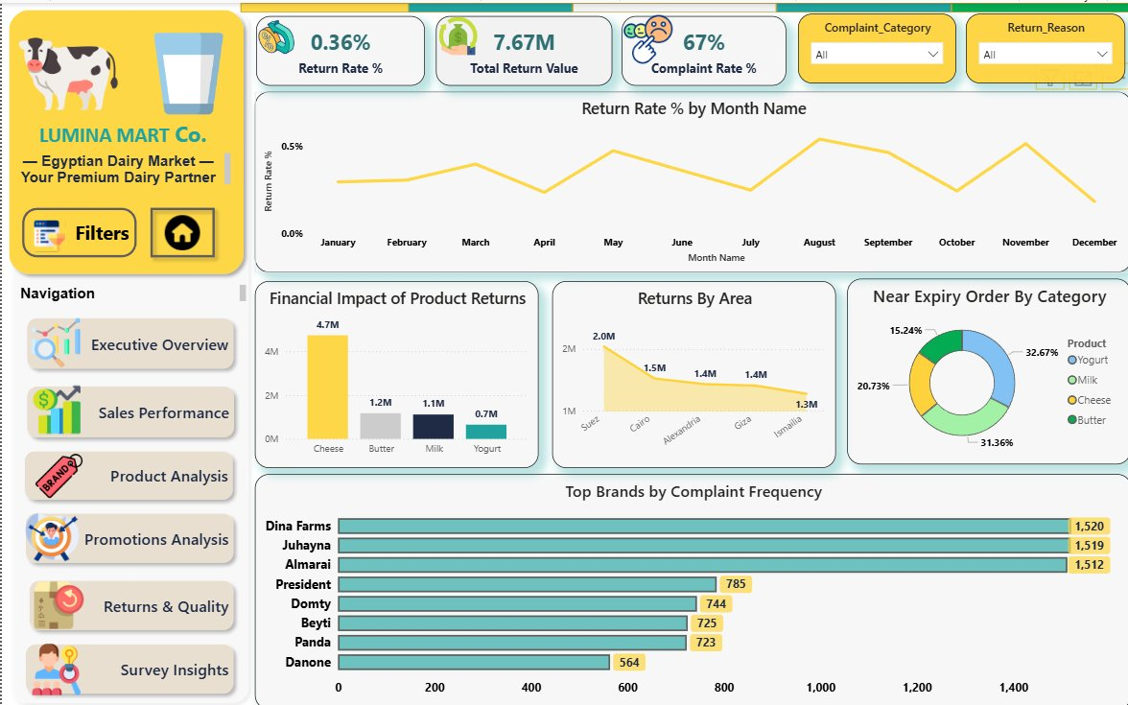
Figure 6 – Returns & Quality: return rate trend, financial impact, area map, and brand complaints

- Overall return rate is very low at 0.36%, indicating strong product quality control
- Cheese accounts for the highest return value at 4.7M EGP, driven by volume rather than defect rate
- Suez region shows the highest returns by area (2.0M EGP)
- Dina Farms, Juhayna, and Almarai top complaint frequency – likely reflecting their larger sales volumes

2.7 Survey Insights
Presents findings from a 112-respondent consumer survey covering monthly spending habits, purchase decision factors, promotional influence, and brand loyalty under price-increase scenarios.

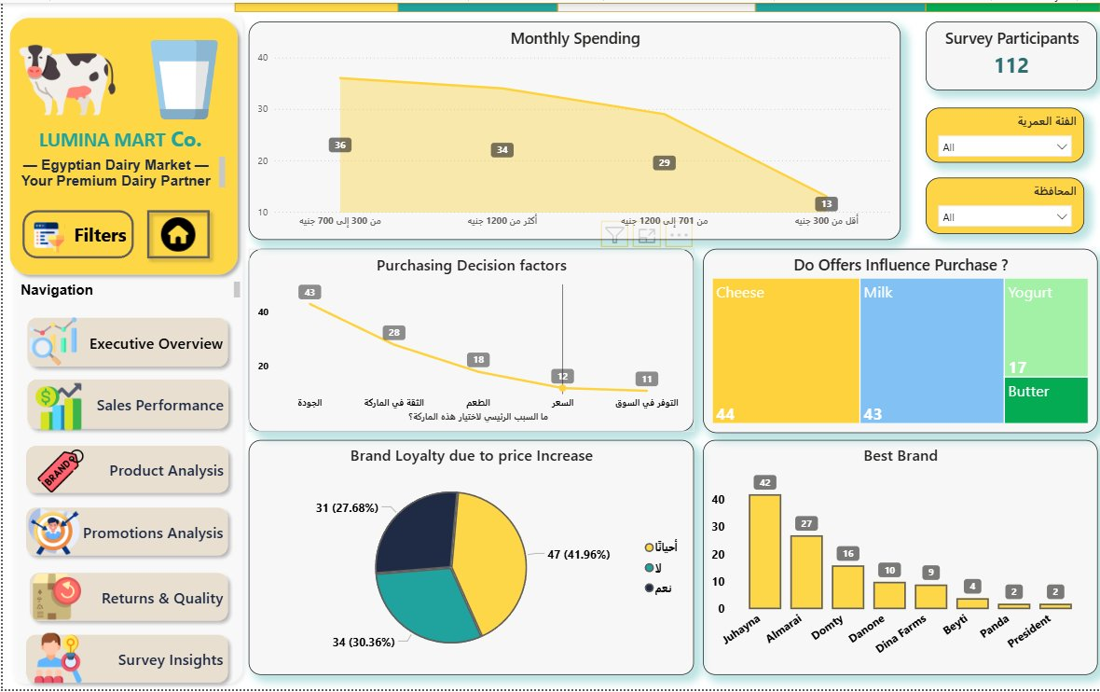
Figure 7 – Survey Insights: spending bands, decision factors, offer influence, and brand loyalty

- Quality (43 respondents) is the #1 purchase driver, followed by Brand Trust (28) and Taste (18)
- Juhayna is rated the #1 best brand (42 votes), followed by Almarai (27) and Domty (16)
- 41.96% of customers would 'sometimes' switch brands on price increase; only 30.36% show strong loyalty
- Offers strongly influence purchase decisions across Cheese (44) and Milk (43) categories

3. Data Model & Technical Highlights

Data Model  - Star schema with a central fact table (Sales Transactions)  - Dimension tables: Products, Customers, Dates, Areas, Sales Reps, Promotions  - Separate return and survey tables linked via shared keys  - Calculated columns and measures in DAX for KPIs and composite scores  DAX Highlights  - YoY Net Sales % using SAMEPERIODLASTYEAR  - Composite Revenue Performance Score (0–1 scale)  - Offer Revenue Share % and Promotion Conversion Rate  - Running total profit waterfall with Increase/Decrease logic | Power BI Features Used  - Bookmarks & Buttons for page navigation  - Conditional formatting on matrix heat-map  - Dynamic titles and card visuals with icon images  - Gauge visual for composite performance scoring  - Area/line combo charts for YoY and campaign baseline  - Drillthrough and cross-filter synchronization  Data Sources  - Transactional sales data (Egyptian dairy market)  - Returns and quality complaints log  - Consumer survey (112 participants)  - Promotional campaign calendar

4. Key Business Insights

📈 Sales Growth: 50.15% YoY growth demonstrates strong market expansion, nearly reaching the 119.29M EGP sales target (96.99% achievement).
🧀 Product Leadership: Cheese dominates revenue across sales, returns impact, and promotional performance, confirming its role as the core category.
🎯 Promotions Effectiveness: With 53.27% of revenue generated during campaign periods and a 68.97% conversion rate, promotional strategy is a proven revenue lever.
⭐ Brand Equity: Juhayna leads consumer preference in the survey, yet Danone leads in profitability margin — signalling a gap between volume performance and margin efficiency.
📦 Quality Strength: A 0.36% return rate is well below industry norms, reflecting rigorous supply chain and quality management.
👥 Customer Segments: Wholesale (51%) is the dominant revenue channel; Loyal Customers and Champions represent the highest-value retention cohorts.

5. Conclusion

The LUMINA MART Dairy Intelligence Dashboard delivers a 360-degree view of business performance across six strategic dimensions. By consolidating transactional, promotional, return, and survey data into a single interactive Power BI report, the project empowers decision-makers to act on evidence rather than intuition.

The dashboard is designed for scalability — new data periods, product lines, and regions can be incorporated with minimal rework, making it a sustainable BI asset for continued growth in the Egyptian dairy market.

© 2026 LUMINA MART – Dairy Intelligence | DEPI – Next Academy Graduation Project

