Anthony Bugatto

EE 436: Microwave Engineering

April, 4, 2018

Coupler Design

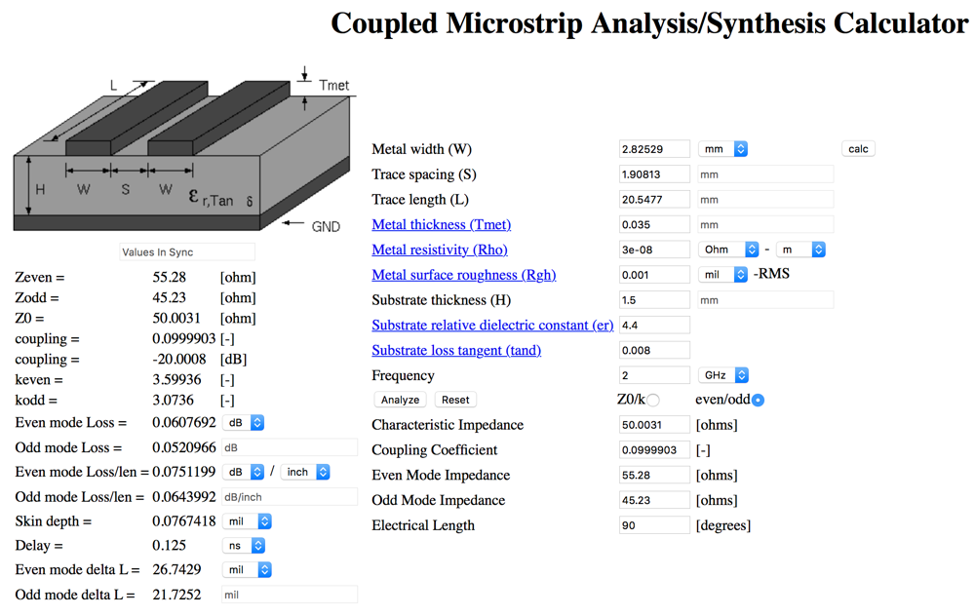

Figure 1: Online calculator design with parameters

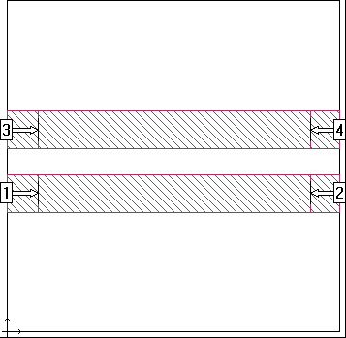

Figure 2: Sonnet Design

This lab was to design and implement a directional coupler in sonnet and microstrip transmission line. This coupler had to be designed using copper tape and FR4 with a 20dB coupling at 2GHz. The design was identical to the example we had in class except that we couldn’t use the charts due to the different e_r and instead we used the online calculator in figure 1 to find the width, spacing, and length. As you can see the sonnet response has S11 having a steep 35-45dB attenuation which means almost no reflection. You can see this figure 5 with the exception that S11 has a >20dB attenuation instead of a >35dB attenuation. S21 is simulated as a roughly 0dB attenuation for the frequency band and in figure 6 we can see that there are a couple small resonances but overall the attenuation is 0dB. S31 is almost identical on the simulation and figure 7 in that it has a steep attenuation at around 20-30dB and then a 50dB resonance at around 4GHz. S41 is also nearly exact in that it is a decreasing attenuation from around 38dB to 15dB in both the simulation and figure 8. You can see the current distribution for 2GHz in figure 4.

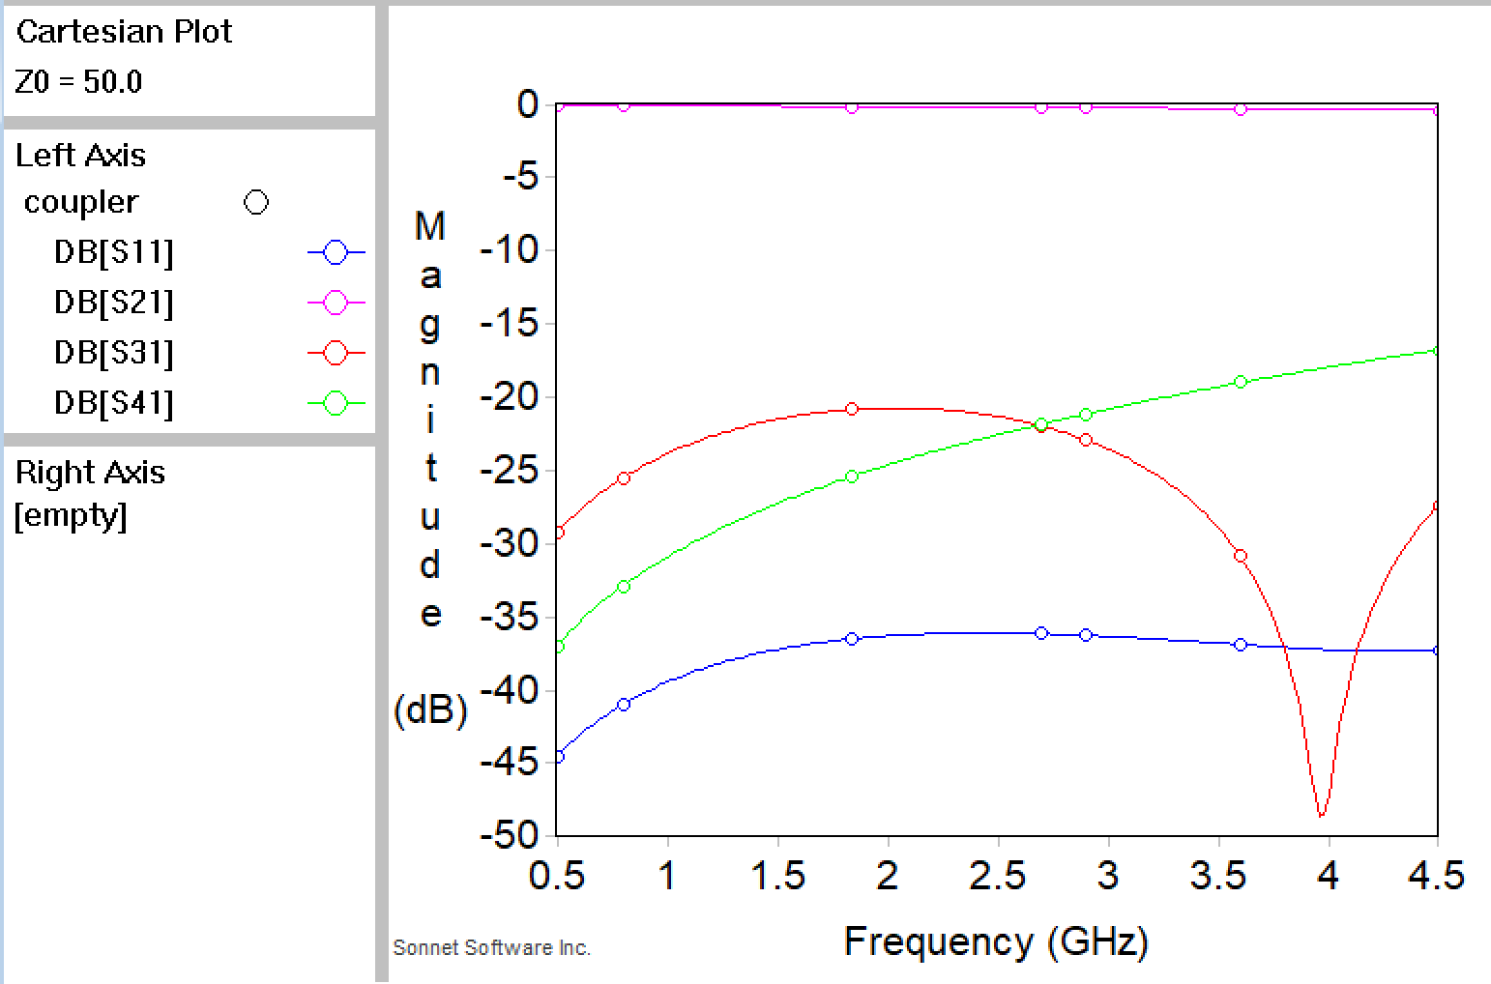

Figure 3: Sonnet S11, S21, S31, and S41

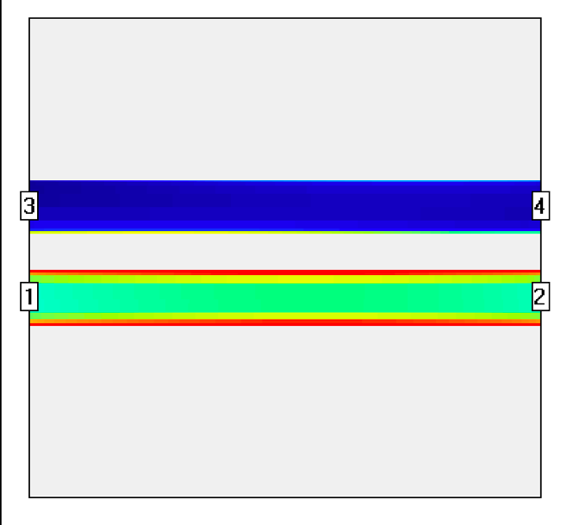

Figure 4: Sonnet Current Distribution

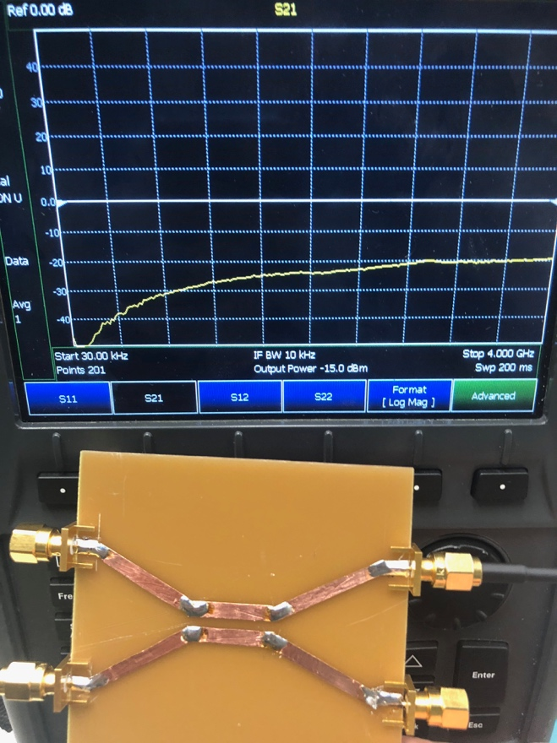

Figure 8: S41

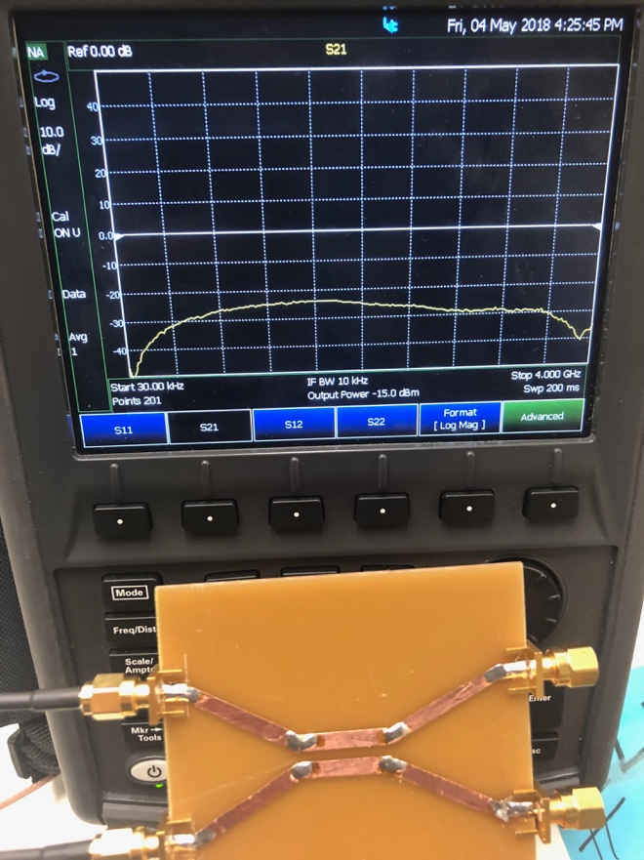

Figure 7: S31

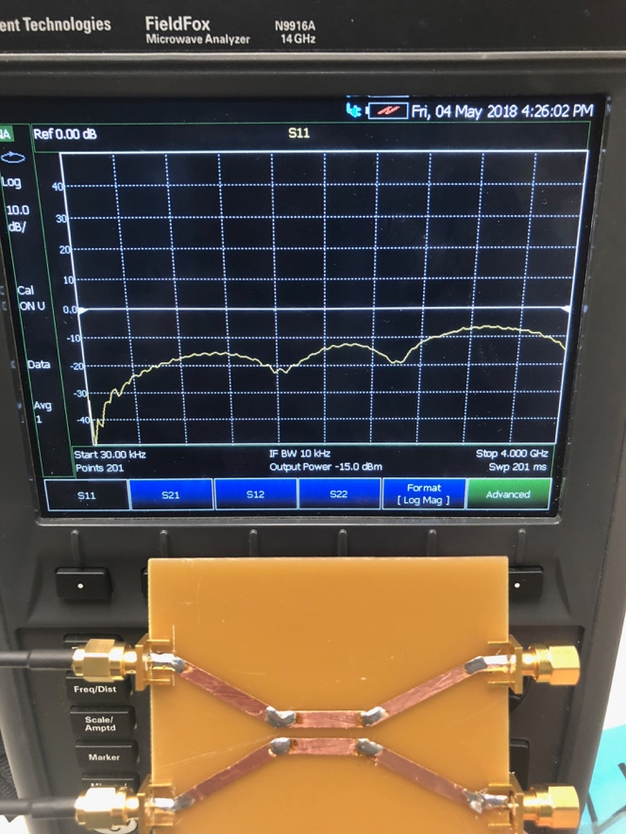

Figure 6: S21

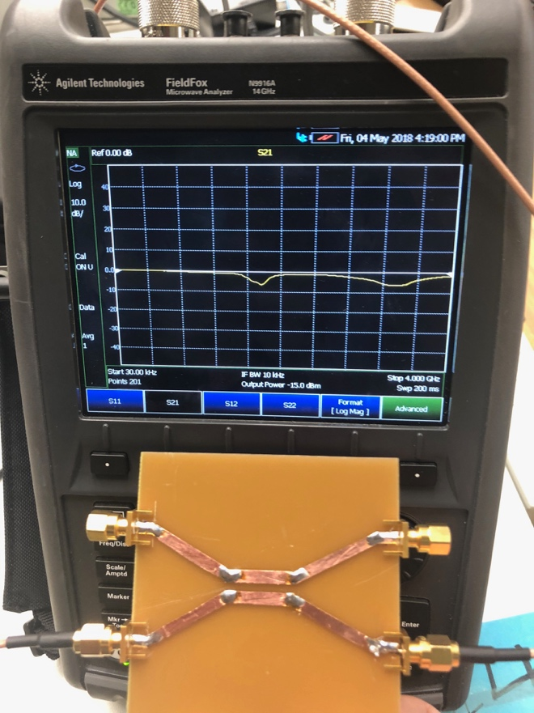

Figure 5: S11