Anthony Bugatto

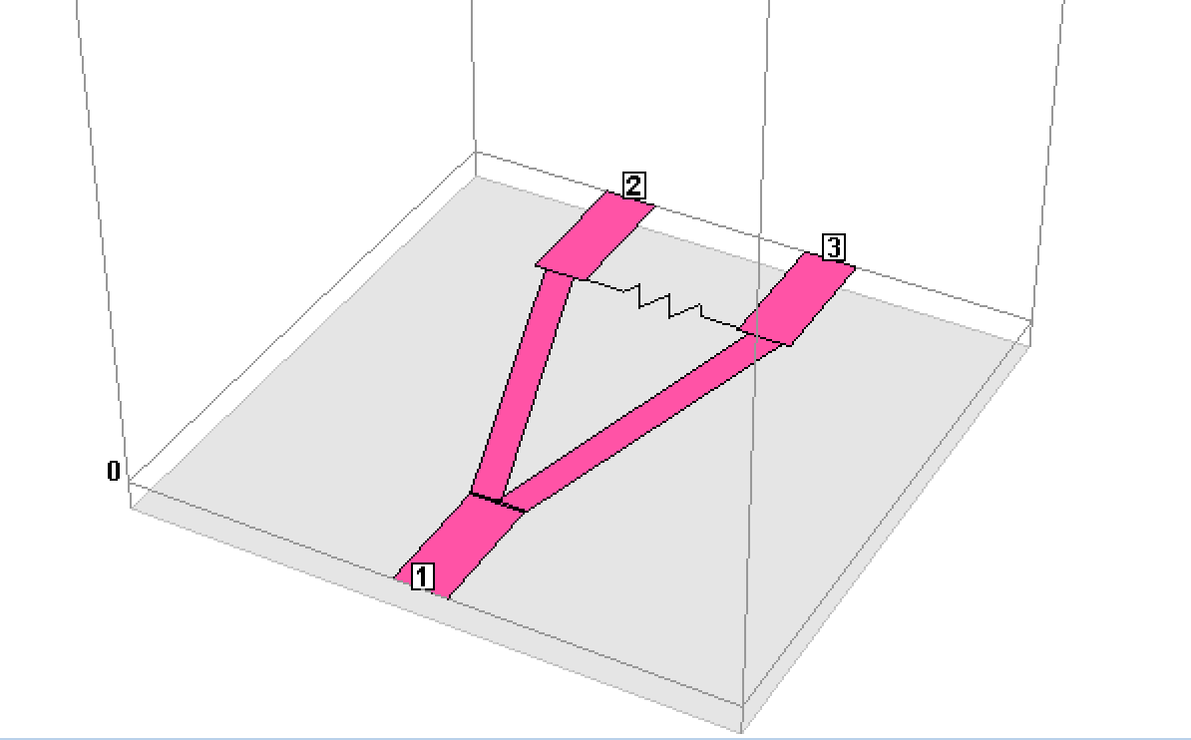

Figure 1: 3D Model

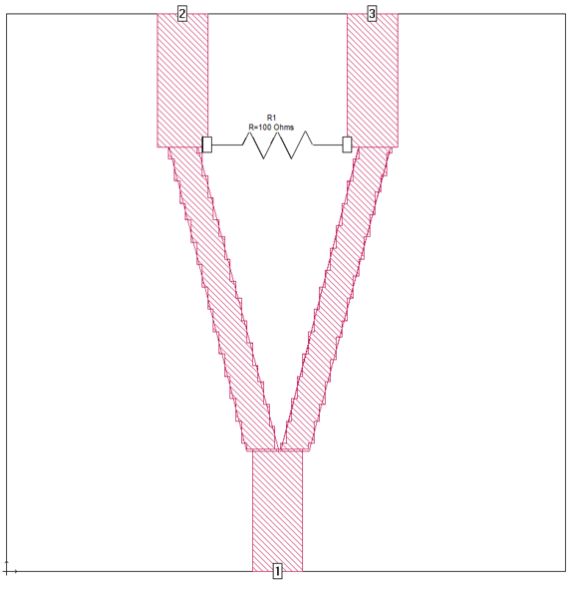

Figure 2: Schematic

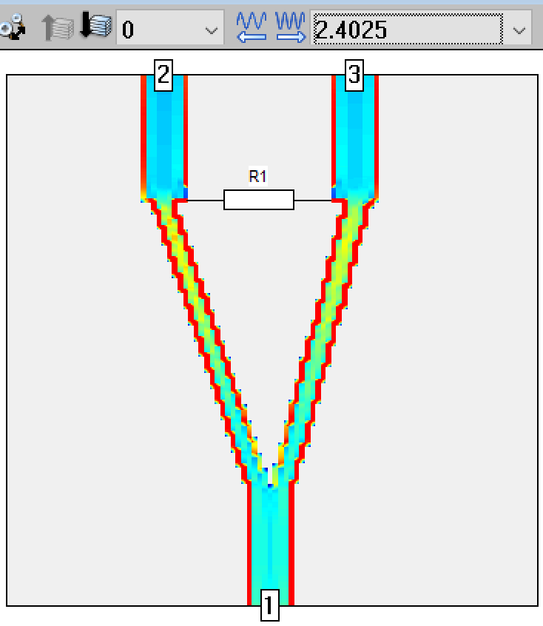

Figure 3: Current Distribution at 2.4GHz

Lab 6: Wilkinson Power Divider

April 20, 2018

This simulation went very well and got very similar results to the expected outcome. The objective if using designing the Wilkinson power divider was to take the power from port 1 and divide it in half between ports 2 and 3. In order to accomplish this we needed to create transmission lines of the given impedances from the directions at a frequency of 2.4GHz. This was accomplished by plugging the data into a transmission line calculator for each line in the power divider. Figure 1 shows the 3D design, Figure 2 shows the schematic, and Figure 3 shows the current distribution from these calculations. Figure 4 shows the reflectance coefficients (S11, S22, S33) at each port. We can see that Port one seems to resonate at around 2.4GHz like designed but ports 2 and 3 are off on when they resonate compared to each other. In theory they should be the same and nearly flat. This may be due to small errors in my geometric design. Figure 5 shows the response of ports 2 and 3 relative to the input. In theory this should produce a half power 3dB attenuation on each port relative to the input at 2.4GHz and fortunately the graph looks almost exact. Overall this turned out to be nearly exactly what it should’ve been.

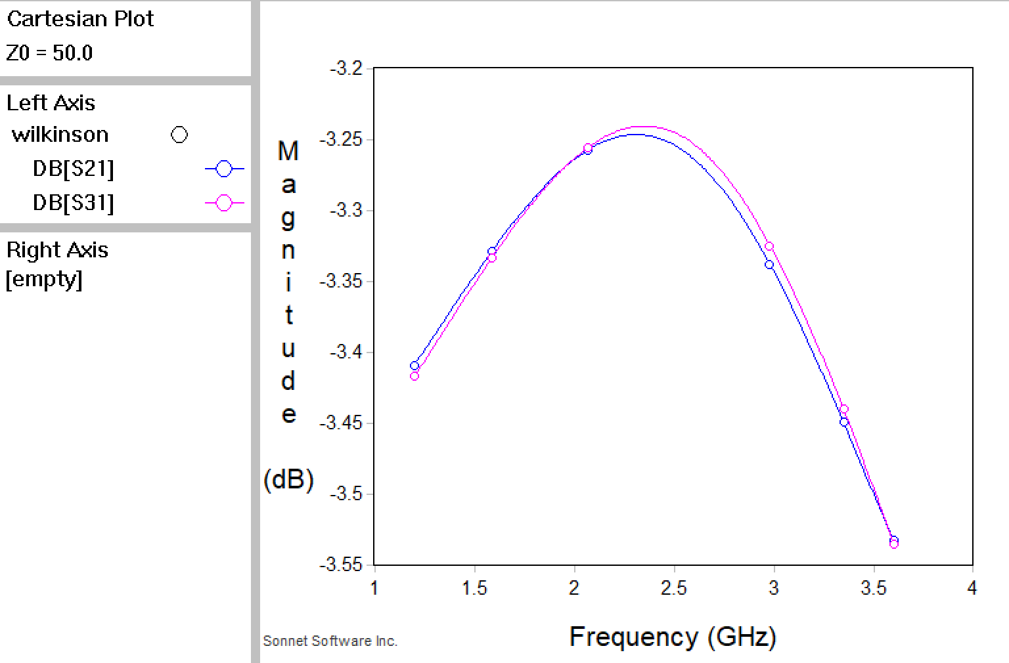

Figure 5: Coupling Coefficients for each port

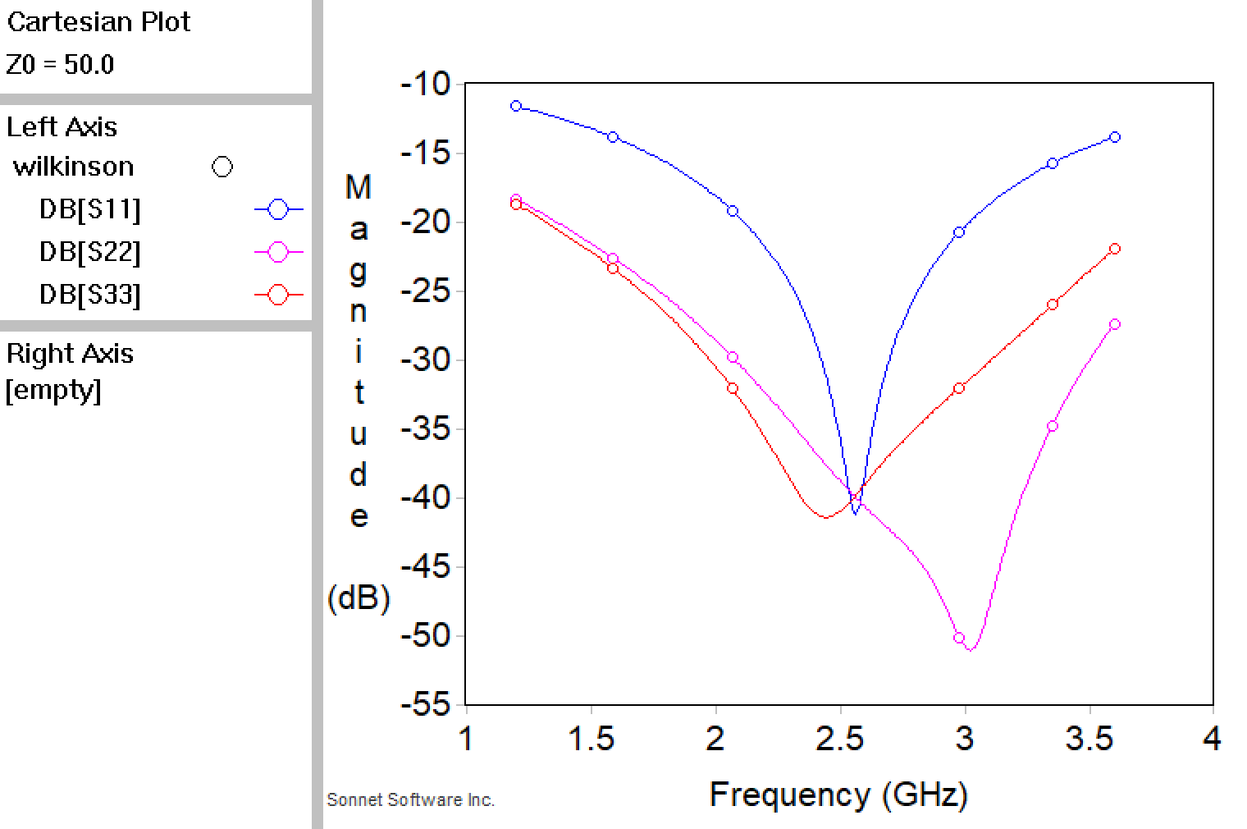

Figure 4: S11, S22, and S33 reflectance coefficients for each port