Experiment 1
Slotted-line Measurement System

Objective:
The objective of this experiment is become familiar with the measurement of fundamental microwave quantities. The slotted line will be used to measure guide wavelength, voltage standing-wave ratio (VSWR), and to determine an unknown load impedance.

Theory:
Slotted-Line
The slotted line is a high frequency measurement tool that can be used to visualize some of the basic concepts of standing waves and mismatched transmission lines. Although somewhat outdated, it is still used in applications involving high-millimeter wave frequencies, or where it is critical to avoid connector mismatches while working with unknown impedances.

A slotted line is a transmission line configuration (typically waveguide or coax) that allows the sampling of the electric field magnitude of a standing wave in a terminated transmission line. In this experiment, a section of uniform, lossless transmission line with a longitudinal slot provides access for a crystal detector probe in the waveguide. This probe is used to detect voltage variations as it is moved along the waveguide by an adjustable carriage. The slotted-line measurement system is shown in Fig. 1-1.
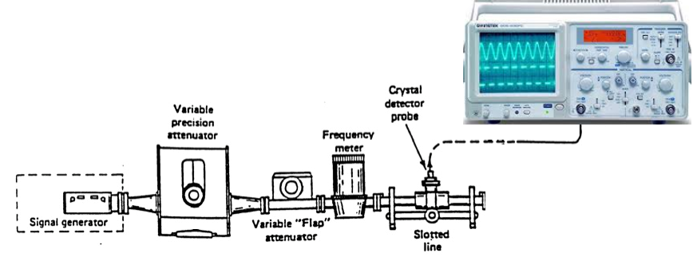
Fig. 1-1 Slotted-Line Measurement System

Wavelength and Frequency

When a standing wave is produced on a line, the distance between two adjacent maxima or minima is one half of a guide wavelength (λ_{g}/2). The guide wavelength can thus be found by using the slotted line to measure the distance between two consecutive voltage minima or maxima.
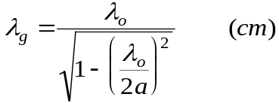
(1)
Another method of calculating the guide wavelength is given by
Where a is the broad dimension of the waveguide (2.286 cm) and λ_{o} is the wavelength in free space (cm). The wavelength in free space can be found by
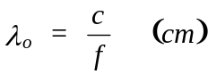 (2)
where c is the velocity of light in free space (29.98 × 10⁹ cm/s) and f is the frequency (Hz). Note that, in the case of a waveguide, the wavelength along the guide will be somewhat longer than the corresponding wavelength in free space.
Voltage Standing-Wave Ratio

The voltage standing wave ratio is measured on an Fieldfox. The voltage in the waveguide can be measured by an oscilloscope connected to the crystal detector probe output.
Moving the carriage toward a minimum will cause the voltage on the oscilloscope to increase. If the slotted line is terminated with a short there will be total reflection and the VSWR (V_{max}/V_{min}) will be infinite. When terminated with a matched load there will be no reflection, thus the VSWR will be 1.

Load Impedance

In order to determine an unknown load impedance, a short is first connected to the output of the slotted line. The locations of two consecutive minima are then measured and the guide wavelength (λ_{g}) is found. Since the reflection coefficient and input impedance repeat every λ/2, the load terminals can also be effectively located at each of the voltage minima.

The short is then replaced by the unknown load. Two consecutive voltage minima are located and the VSWR caused by the load is measured and plotted on a Smith Chart. When the short is replaced by the unknown load the voltage minima will shift. The distance of this minimum shift towards the load (Δd) in terms of guide wavelength is given by
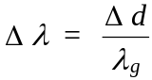 (5)
Using Smith Chart theory, it is known that the unknown impedance will lie on the VSWR circle. In order to find the exact location of the unknown load, move from the location on the VSWR circle where a voltage minimum occurs (which is the highest voltage on the oscilloscope) toward the load a distance of Δλ. This point will give the normalized impedance (z_{L}). The load impedance, Z_{L} can then be found from:

where Z_{o} is the characteristic line impedance and is calculated using:
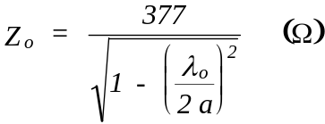 (7)

Procedure:

A. Impedance Measurement and Smith Chart

1. Connect the test setup as shown in Fig. 1-1. Turn on the signal generator and set the amplitude to about 0 dBm. Allow for warm-up time (at least 30 minutes), set the generator frequency to 10 GHz. Turn on the Fieldfox (VNA mode) and calibrate .

Note: Whenever the output of the slotted line is open, attenuate the signal by increasing the attenuation on the variable attenuator; otherwise, a setting of ~3dB is acceptable.

2. Connect the Fieldfox at the input port of the slotted line and measure VSWR of a matched load.

3. Replace the matched load by a shorting plate or an adjustable short. Connect the output of the crystal detector to the oscilloscope.

4. Run the probe carriage along the slotted line and measure and record the location of two consecutive minima (to the left of the dial). Determine the guide wavelength, λ_{g}. Pick one of the minima as the reference point.

3. Replace the short by an unknown load supplied by your instructor.

4. Measure and record the VSWR caused by the load using the Fieldfox. Determine and record the location of a minimum in the VSWR pattern (use the oscilloscope).

5. Find the minimum shift, Δd. This is the distance from the reference point to the next minimum (to the right) caused by the load. (Be careful not to go to the left of the reference point).

6. Using Equation (5), compute the distance, in terms of wavelength (Δλ), from the reference point to the first minimum of the VSWR pattern.

7. Plot the VSWR circle measured in Step 4 on a Smith chart.

8. Starting at the voltage minimum (the point at which the VSWR circle crosses the horizontal line and to the left of the 1.0 point), follow the VSWR circle toward the load a distance of Δλ. This point represents the load.

9. Record the normalized impedance (z_{L}) from the chart. Using Equation (6) and (7) compute the actual load impedance (Z_{L}).

10. Include your Smith chart work (hand-drawn is OK in this case) and your step-by-step calculations in your report.

11. Measure the input impedance of the slotted line terminated with the unknown load. Using the input impedance equation shown below, verify your measured input impedance.
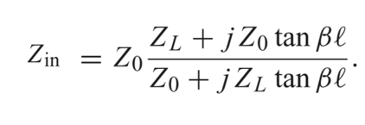
where β=2π/λ_{g}

