Experiment 3
Directional Couplers And Tee Junctions

OBJECTIVE:

The objective of this experiment is to measure the coupling, directivity, and isolation of directional couplers and to demonstrate the properties of a hybrid tee junction.

THEORY:

Directional Coupler

A directional coupler is a four port device that can also be used for power sampling and to measure VSWR. Two common methods used to represent directional couplers are given in Figure 2. As shown, a wave incident at Port 1 is coupled to Port 3. The remaining signal is then delivered to Port 2 and, ideally, no power is delivered to Port 4 (which becomes the isolated port).
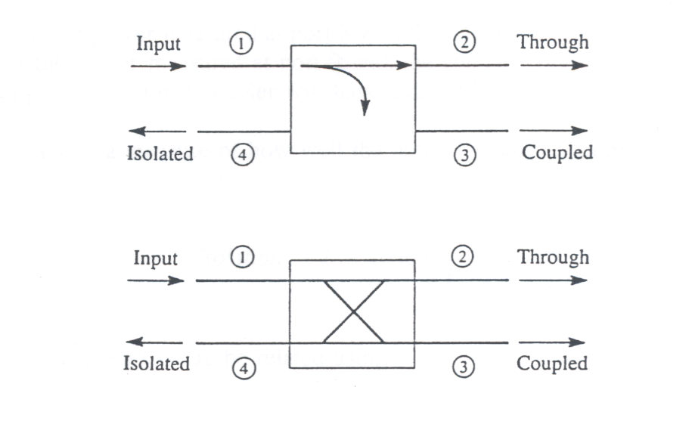
Figure 2: Two commonly used symbols for directional couplers

The performance of a directional coupler is specified in terms of coupling, directivity, and isolation. Coupling is a measure of the amount of signal that is coupled between Ports 1 and 3, and is given as:

Coupling = C = 10 log 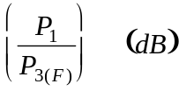 (1)

If the coupling of a directional coupler is known, a small amount of power at Port 3 can be used to determine the power of the incident (input) signal. For example, if -10 dBm is measured at Port 3 of a 15 dB coupler, the incident signal will be 5 dBm.

Directivity is the measure of how well the coupler sends power in the correct direction (to Port 3) versus how much is sent in the wrong direction (to Port 4), and can be found using:

Directivity 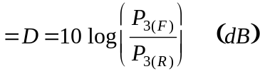 (2)

where P_{3 (F)} is the power measured at Port 3 with the directional coupler in the forward direction and P_{3 (R)} is the power measured at Port 3 with the coupler connected in the reverse direction. A well-designed directional coupler will have a directivity of 30 to 35 dB.

In an ideal waveguide coupler, the signal coupled to the isolated port will cancel. However, in "real life," not all of the signal will cancel and there will be a small portion of signal coupled to the isolated port. Isolation is a measure of how well the output is isolated from the input. The isolation is given as:

Isolation = I = 10 log 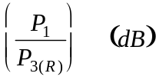 (3)
Equations (1) through (3) can be related using:
I = D + C (4)
Tee Junctions

Waveguide junctions have many applications. They are typically used as power dividers, mixers, and sampling junctions. The most common type of junction is the waveguide tee. If the axis of the arm is placed parallel to the electric field of the main transmission line, the junction is considered an E-plane junction or series tee. If the axis of the arm is placed parallel to the magnetic field, the junction is an H-plane junction or a shunt tee. A hybrid tee is a combination of E- and H-plane tees. Because tee junctions are poorly matched, hybrid junctions typically have tuning rods in the E- and H-plane arms (which provide a better match). A typical hybrid junction is shown in Figure 4.

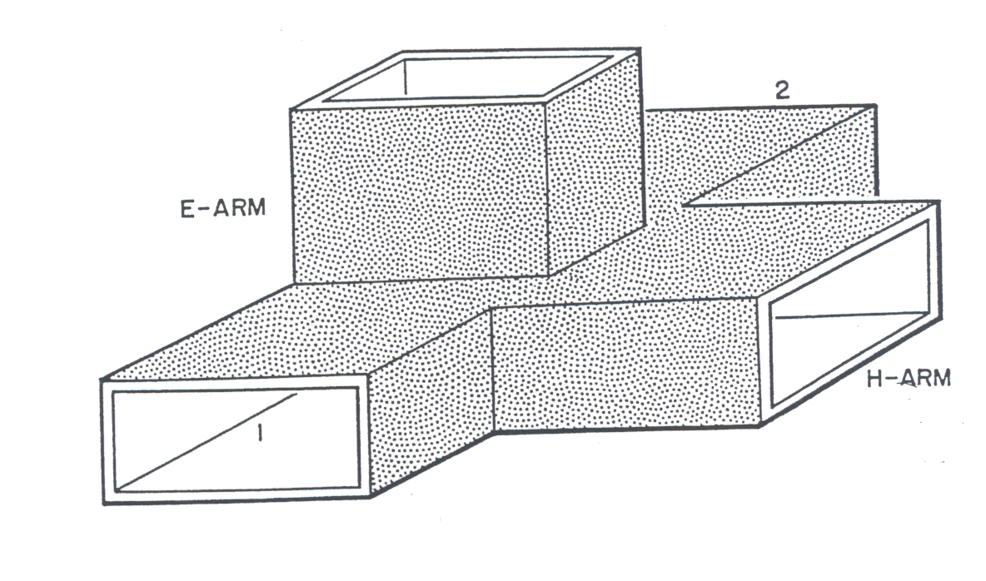
Figure 4: Hybrid junction tee
Power input into the H-plane branch will divide equally and in phase between the two main guide arms (Port 1 and 2). No power will be coupled to the E-plane arm. When power is input to the E-plane arm, the power will divide equally and be out of phase in Port 1 and 2 and no power will be coupled to the H-plane port. If two input signals are input into port 1 and 2 of the hybrid tee, the output of the H-plane port will be the sum of the two signals and the output of the E-plane port will be the difference of the two signals.

Hybrid tees can be used as mixers because they provide for sufficient isolation between the signals that are input into the E- and H-plane ports. They can also be used as phase shifters when the E- and H-plane ports are terminated by moving shorts. The S-parameter matrix for a hybrid tee is given as:

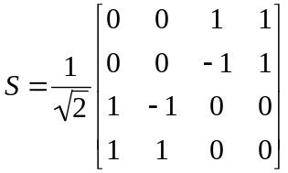 (5)

A. Characteristics of a Hybrid Tee

1. Set the source frequency to 10 GHz. Set the power level to about 0 dBm and the variable attenuator to 3 dB. Measure the power at the output of the slotted line, if needed.

2. Connect the H-plane arm (Port 4) of the hybrid tee to the output of the slotted line. Measure and record the power at each one of the other three arms of the tee (terminate the ports that are not being measured with matched loads).

3. Connect the E-plane arm (Port 3) of the hybrid tee to the output of the slotted line. With all of the other ports matched, measure the power at each of the ports.

4. Using the measured data, and assuming that

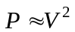 (6)

determine the S-parameter matrix for the hybrid tee. Show all assumptions and calculations. Compare the measured matrix with the theoretical matrix. Discuss any differences.

B. Directional Coupler

- Acquire a coupler that the instructor provides.
- Calibrate the Fieldfox Network Analyzer from 0–16 GHz (full range) using the 3.5mm Calibration Kit.
- Use the Network Analyzer to build your S-Matrix at 1.0 GHz:
  - Terminate two ports with matched loads.
  - Find S₁₁, S₁₂, S₂₁, and S₂₂ using the Network Analyzer and record the results in your S-Matrix (don’t forget to “translate” the S_{xx} numbers based upon the ports you are actually measuring).
  - Repeat (a) and (b) until your matrix is full.
- Look at the overall frequency response from 0 H z to 16 GHz (full range). Describe what you see and comment on the bandwidth of your coupler. Comment on:
  - Response at 1 GHz versus your design specifications
  - Approximate Bandwidth
Ref.:
1: waveguide-components.com
2: indiamart.com

