



***The University of Jordan***

***King Abdullah II School for Information Technology***

***Department of Computer Science***

***Graduation Project Title: Mr. Nutrition***

***Done by:***

|  |  |
| --- | --- |
| Student name | Student num. |
| Mohammed Moen Mohammed | 0178544 |
| Abdul Kareem Zaid Alzareer | 0178035 |
| Rashed Fayiz AlAdwan | 0176650 |
| Ali Khader Abuhajeb | 0164921 |

Supervised by:

Dr. Basel Mahafzah Dr. Mohammed AlShraideh

**Acknowledgment**

After thanking Allah for everything, we would like to express our special thanks of gratitude to our supervisors (Dr. Basel Mahafzah & Dr. Mohammed AlShraideh) who gave us the golden opportunity to do this wonderful project on the topic (Mr. Nutrition) Secondly, we would also like to thank our families and friends who helped us a lot in finalizing this project within the limited time frame.

**ABSTRACT**

It’s often difficult to find an appropriate products for maintaining bodies healthy with delivery service and it’s difficult to find nutritionists with good price for medical advises.

In our project we will provide a database for professional nutritionists and customers, where people can easily find a professional nutritionists and the nutritionists can advise them.

The database will include (the name of users, location, and rating).

This database will be linked to a mobile application and a website as an interface, this application will allow the user to search for nutritionists, communicate with them and evaluate their work.

We will discuss the benefits and motivation behind this project.

We will also review the requirements and specifications that we have developed in this application.

**TABLE OF CONTENTS:**

**1.0 Chapter One: Introduction**  page

1.1 Preamble…………………………………………………………….…….………..…………8

1.2 Project Motivation………………………………………………………....…….……………8

1.3 Problem Statement……………………………………………………...….….……..………..8

1.4 Project Aim and Objectives………………………………………………. ….…....................8

1.5 Project Scope………………………………………………………….….………...................9

1.6 Project Software and Hardware Requirements……………………………..….......................9

1.6.1 Software Requirements………………………………………………………………..9

16.2 Hardware Requirements………………………………………………………………..9

1.8 Project limitation……………………………………………………………..…….................9

1.7 Project Schedule………………………………………………………………..…………….10

1.9 Project Expected Output………………………………………………………………………10

**2.0 Chapter Two: Related Existing Systems**

2.1 Introduction………………………………………………………….………….…………….12

2.2 Existing Systems……………………………………………………………....……...............11

2.3 Overall Problems of Existing Systems……………………….…….….……….……………..11

2.3.1 User Interface…………………………………………………………………………...11

2.4 Overall Solution Approach…………………….………………………….….….……………12

2.4.1 User Interface……………………………………………………………………………12

2.5 Summary…………………………………….……………………………..………................12

**3.0 Chapter Three: System Requirement Engineering & Analysis**

3.1 Introduction…………………………………..……..…………………………………………13

3.2 Feasibility Study …………………………………………………………….….…….............13

3.2.1 Technical Feasibility ……………………………………………………….............13

3.2.2 Operational Feasibility ……………………………………………………..............13

3.2.3 Economic Study ………………………………………………………..………….14

3.2.3.1 Personal Cost……………………………………………………………….14

3.2.3.2 Hardware Cost………………………………………………………………14

3.3 Requirements election techniques……………………………………………………............15

3.4 Functional Requirements …………………………………………………………................19

3.5 non-Functional Requirements …………………….…………..……………...….…………..20

**4.0 Chapter Four: System design**

4.1 Introduction………………………………………………………………………………...21

4.2 UML Data Flow Diagram…………………………………………………………….........21

4.2.1 Context Diagram…………………………………………………………………….21

4.2.2 Data Flow Diagram………………………………………………………………….22

4.3 UML Use Case Diagram……………………………………………………………….......22

4.3.1 Admin Use Case……………………………………………………………………...22

4.3.2 Customer Use Case…………………………………………………………………..23

4.3.3 Nutritionist Use Case…………………………………………………………….......24

4.3.4 Driver Use Case……………………………………………………………………...25

4.3.5 Store Manager Use Case……………………………………………………………..26

4.4 Class Diagram…………………………………………………………………………….27

4.5 Entity Relation Diagram………………………………………………………………..28

4.6 Sequence Diagram…………………………………………………………………….28

4.6.1 Signup Sequence Diagram……………………………………………………28

4.6.2 Login Sequence Diagram………………………………………………………29

4.6.3 Choose Nutritionist Sequence Diagram…………………………………………20

4.6.4 Choose the amount of Item Sequence Diagram………………………………….30

4.7 Summary……………………………………………………………………………31

**LIST OF FIGURES**

Figure 3.2.3.1: payback without discount………………………………………………………15

Figure 3.2.3.1: payback with discount 10%.................................................................................15

Figure 4.2.1: context diagram……………………………………………………………………21

Figure 4.2.1: Data Flow Diagram………………………………………………………………..22

Figure 4.2.2: Admin Use Case Diagram…………………………………………………………22

Figure 4.3.1: Customer Use Case Diagram………………………………………………………23

Figure 4.3.2: Nutritionists Use Case Diagram……………………………………………………24

Figure 4.3.3: Driver Use Case Diagram………………………………………………………….25

Figure 4.3.4: Store manager Use Case Diagram………………………………………………….26

Figure 4.4: Class Diagram……………………………………………………………………….27

Figure 4.5: ERD………………………………………………………………………………….28

Figure 4.6.1: Signup Sequence Diagram…………………………………………………………28

Figure 4.6.2: Login Sequence Diagram………………………………………………………….29

Figure 4.6.3: Choose Nutritionist Sequence Diagram……………………………………………30

Figure 4.6.4: Choose Amount of Items Sequence Diagram……………………………………...30

**LIST OF TABLES**

Table 1.6.1: Software Requirements……………………………………………9

Table 1.6.2: Hardware Requirements…………………………………………..9

Table 1.9: Project Schedule…………………………………………………….10

Table 3.2.3.1: Personal Cost……………………………………………………14

Table 3.2.3.2: Hardware Cost…………………………………………………..14

Table 3.4: Functional Requirements……………………………………………19

Table 3.5: Non-Functional Requirements………………………………………20

**CHAPTER 1.0**

**INTRODUCTION**

* 1. **Preamble**

Sometimes the people want to maintain them health, but they don’t know how they can do it because of inexperience in a ways of maintaining them bodies healthy and strong. So, in this application (Mr. Nutrition) you can communicate with nutritionists by private chat or public post to advise you which product and food that are suitable for you and you are going to find all products that you need to make your body strong and we will deliver the products for you in any place you live with lowest time and cost.

* 1. **Project Motivation**

The our motivation in this project is to help our community to be more experience in maintaining health and to give people the ways and products that make them bodies healthy.

* 1. **Problem Statement**

In current time the delivery applications become common use in our society, but there are a lot of applications for delivering healthy products and food, but missing some features. Unfortunately, the most of delivery application is interested with deliver a fast food and as we know that it has downsides that harm our bodies unlike healthy products and food.

* 1. **Project Aims & Objectives**

In this project we aim to create an application to search for nutritionists for medical advises and for giving you good exercises for maintaining bodies and deliver the needs for maintaining your body for all people and reduce time consuming, high cost and increase the people’s awareness in health.

* 1. **Project Scope**

We are going to create and develop this application via android using Java, database using SQL, and create a website using front end (HTML, CSS, and JavaScript) and back end.

* 1. **Project Software and Hardware Requirements**
     1. **Software Requirements**

|  |  |
| --- | --- |
| Development Requirement | Operating System |
| IntelliJ IDEA, Net Beans, Android studio  SQL server, StarUML/Greatly, Notepad++ | * windows 7 and higher * android 5 or higher |

***Table 1.6.1: Software Requirements***

* + 1. **Hardware Requirements**

|  |  |
| --- | --- |
| Laptop and PC’s | Smartphones |
| * Processor: Intel(R) Core(TM) i3-6006U * Memory(RAM): 4GB * Storage: 40GB HDD | * Processor: * Memory: 2GB RAM * Storage: 8GB |

***Table 1.6.2: Hardware Requirements***

**1.7 Project Limitation**

We faced obstacles and problems during collecting the opinions of users due their different opinions, because this project done by students, there is possibility that does not meet the supervisor’s expectation.

**1.8 Project Expected Output**

The expected output is an application that enable you to communicate with nutritionists for advising to buy suitable healthy products for body building players or normal people by online payment.

**1.9 Project Schedule**

|  |  |  |
| --- | --- | --- |
| **Task** | **description** | **Duration** |
| **T1** | Gathering information | 10 days |
| **T2** | Feasibility study | 2 days |
| **T3** | Gathering data | 3 days |
| **T4** | Functional requirements | 4 days |
| **T5** | Non-functional requirements | 5 days |
| **T6** | UML Diagram | 14 days |

**Table 1.9: project schedule**

**CHAPTER 2.0**

**Related Existing System**

**2.1 Introduction**

In this era, there are a lot of application interested with delivery healthy products but you always face a problem that you can’t choose the appropriate product for your body. So, we found a lot of application that provide a delivery of health products like nutrition supplements but we didn’t find an application presents service like the communication with nutritionists for advising which we will provide it for clients and companies.

In this chapter we will show the related, we will present some of the existing systems that provide services to companies and clients and present some problems that these sites face.

**2.2 Existing System**

1- KABS FITFACTORY

2- Doctor nutrition

**2.3 Overall Problems of Existing System**

**2.3.1 User Interface**

The most important thing is to create an interactive, simple, usable user interface, but the existing system has a slow interaction user interface that make the user uncomfortable when he uses it and he will not back to use the application again.

**2.4 Overall Solution Approach**

**2.4.1 User Interface**

We are going to create a simple, useable, easy, interactive user interface that make the user more comfortable when he is using the application and it will be supported by Arabic and English languages, as the buttons and colors will be well-placed.

**2.5 Summary**

In this chapter we presented two related existing system with our project and we are going to improve its advantages and ignore its disadvantages and we will proposed our solutions for creating a new android system.

**CHAPTER 3.0**

**System Requirements Engineering and Analysis**

**3.1 Introduction**

To make the system well, we must conduct a general feasibility study and gather functional and non-functional requirements. Upon completion of all the required procedures, we know whether the project is viable or not applicable and can describe the system to be operated and its characteristics and know the total cost.

3.2 **Feasibility Study**:

3.2.1 **Operational Study**:

Study to determine the acceptable solutions for problems in two cases internal issues or external issues and if system still effective when upgraded in adequate throughput, response time, provide end user and managers with timely and accurate useful formatted information and reliable service and flexible.

3.2.2 **Technical Study**:

Since the system has been built using android (Java language), it might require technical support. The department that will use the system may need someone to support them if any bugs or errors appears.

* + 1. **Economic study:**

We applied the economic study to the study of recovery analysis to see the interest in the schedule, development study and operational cost to demonstrate that the project can be given resource constraints and returns profits.

**3.2.3.1** **Personal Costs**:

|  |  |  |  |  |
| --- | --- | --- | --- | --- |
| **# of Person** | **Employee** | **Cost/hours** | **Hours** | **Total** |
| **3** | **Programmer** | **15*3=45JD** | **50hr.** | **2250JD** |
| **1** | **System analyst** | **10 JD** | **30hr.** | **300JD** |
| **1** | **System design** | **12 JD** | **20hr.** | **240JD** |
|  |  |  | **100hr.** | **2790JD** |

**Table 3.2.3.1: personal cost**

**3.2.3.2** **Hardware Costs**:

|  |  |  |
| --- | --- | --- |
| **# of Hardware** | **Hardware** | **Costs** |
| **3** | **Laptops** | **400*3=1200JD** |
| **1** | **Smartphone** | **150JD** |
| **4** | **Total** | **1350JD** |

**Table 3.2.3.2: hardware cost**

Cos = 2790+1350 = 4140 JD

1. Payback without discount

**Figure 3.2.3.1: payback without discount**

2) Payback with discount 10%

**Figure 3.2.3.2: payback with discount 10%**

3.3 **Requirements Elicitation Techniques:**

We have published a form for different age groups of people to collect information on whether our program is useful to them and the results are as follows:

1. The gender:

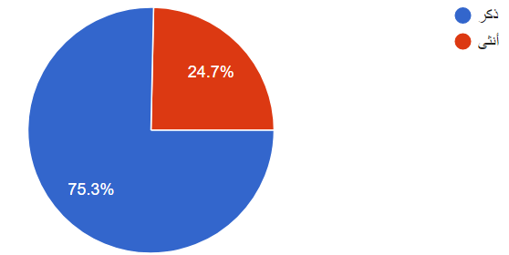

1. What is your age group?

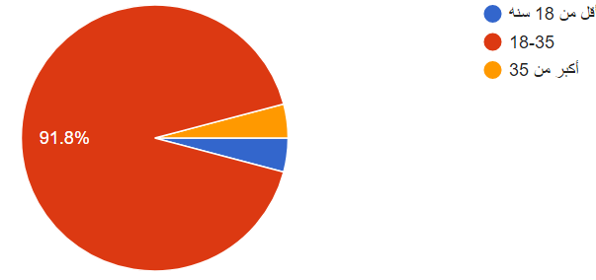

1. Do you think that most health problems are due to a poor diet?

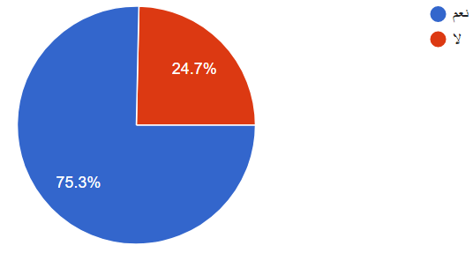

4) Are you having problems finding a nutritionists who feeds on diets?

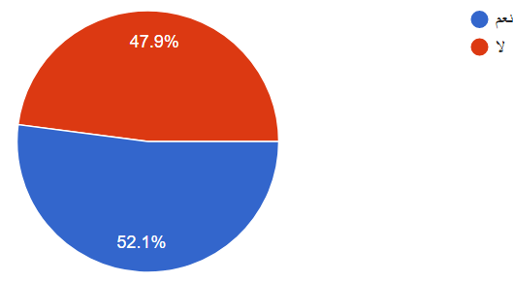

**5)** If there was an easy way to find healthy, would that increase your percentage of healthy obedience and appropriate for your age?

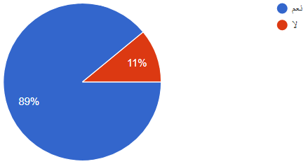

**3.4 Functional Requirement Specification:**

|  |  |  |  |  |
| --- | --- | --- | --- | --- |
| R# | Requirements | Description |  | Note |
| 1. 1 | Interface | Display GUI for the system |  |  |
| 1. 4 | signup | User will be able to create an account |  |  |
| 1. 7 | Login | User will be able to use system by owns account |  |  |
| 1. 11 | Find | User will be able to find nutrition specialist (location) |  |  |
| 1. 12 | rating | User will be able to write feedback about the nutrition specialist |  |  |
| 1. 33 | Send message | User and nutrition specialist able to exchange messages |  |  |
| 1. 34 | Call | User will be able to call nutrition specialist by his number |  |  |
| 1. 35 | Add advertise | User will be able to add post about what problem who face. |  |  |
| 1. 42 | Distance | System able to find nearest  worker |  |  |
| 1. 46 | Push notification | System send notifications to users |  |  |
|  | Logout | User are able to logout from the system |  |  |

**Table 3.4: functional requirements**

**3.5 non-Functional Requirement**

|  |  |  |
| --- | --- | --- |
| R# | Requirements | Description |
| 1 | Reliability | The system should provide the services as specified; when a user/admin selects the service he/she wants, then the system will response and offer it as required. |
| 2 | Usability | All the users can use the services offered by the system through an easy to use and simple interface. |
| 3 | Availability | The system is available to be used at any time; when a admin/user requests a service, then the system should be ready to provide it at the time of doing such request. |
| 4 | Security | The system should be able to prevent any unauthorized access to its components, and prevent users from make any violations, this achieved system during checks processes. |
| 5 | Maintainability | This system is coded in an organized maintainable way, to make it easier to add new features that users need and be able to understand by the maintenance team. |
| 6 | Efficiency | The system will save time and money, also facilitate the operations by the information provided by the system. |
| 7 | Accuracy | The information accuracy must be to accurate to provide information in real time |

**Table 3.5: non-functional requirements**

**Chapter 4.0**

**System Design**

**4.1 Introduction**

System design is the process that describe the system architecture components, database design, output layouts, user interface, detailed design and processing logic for system.

**4.2 UML Data Flow Diagram**

**4.2.1 Context Diagram**

**Figure 4.2.1: context diagram**

**4.2.2 Data Flow Diagram**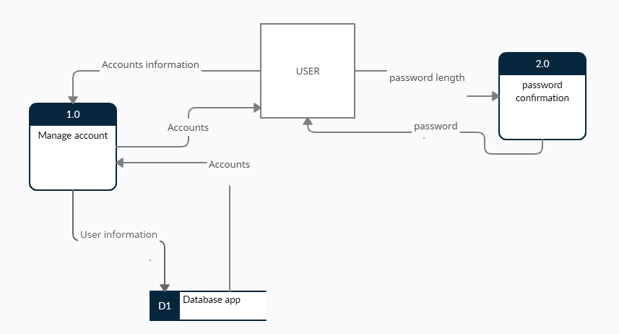

**Figure 4.2.2: Data Flow Diagram**

**4.3 UML Use Case Diagram**

**4.3.1 Admin Use Case**

**Figure 4.3.1: Admin Use Case**

The admin can register as admin, login, communicate with all users and rate them, order and post.

**4.3.2 Customer Use Case**

**Figure 4.3.2: Customer Use Case**

The customer can register as customer, login, rate nutritionist, order, post, and communicate with admin and nutritionist.

**4.3.3 Nutritionist Use Case**

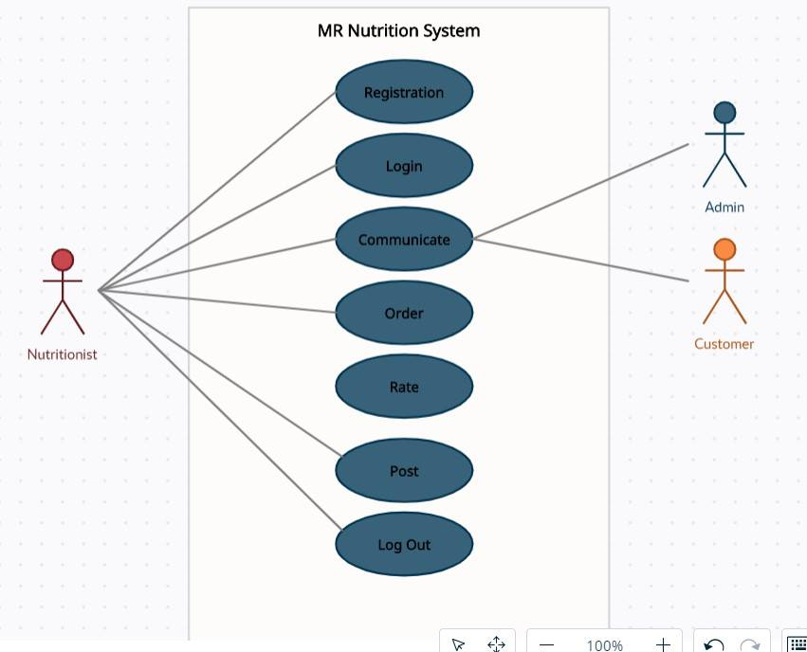

**Figure 4.3.3: Nutritionist Use Case**

The nutritionist can register as nutritionist, login, communicate with admin and customer, rate, order, and post.

**4.3.4 Driver Use Case**

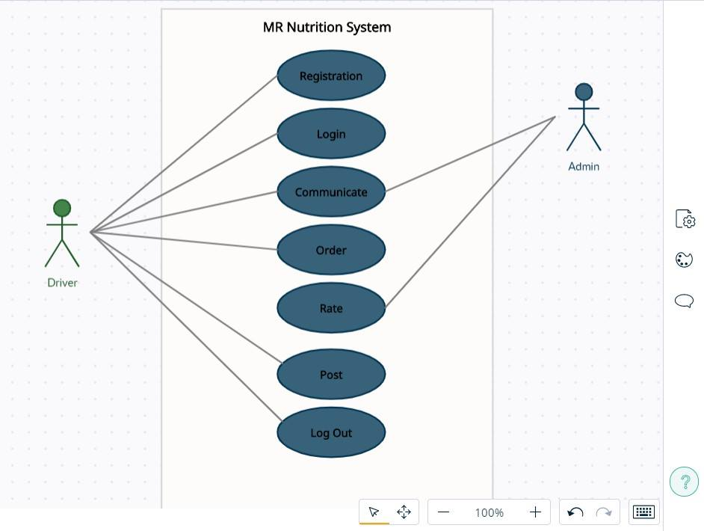

**Figure 4.3.4: Driver Use Case**

The driver can register as driver, login, rate, order, post, and communicate with admin.

**4.3.5 Store Manager Use Case**

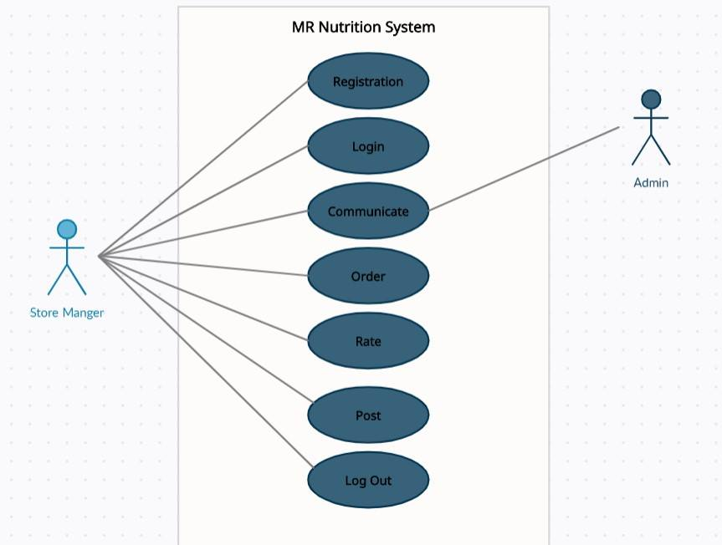

**Figure 4.3.5: Store manager Use Case**

The store manager can register as store manager, login, rate, order, post, and communicate with admin.

**4.4 Class Diagram**

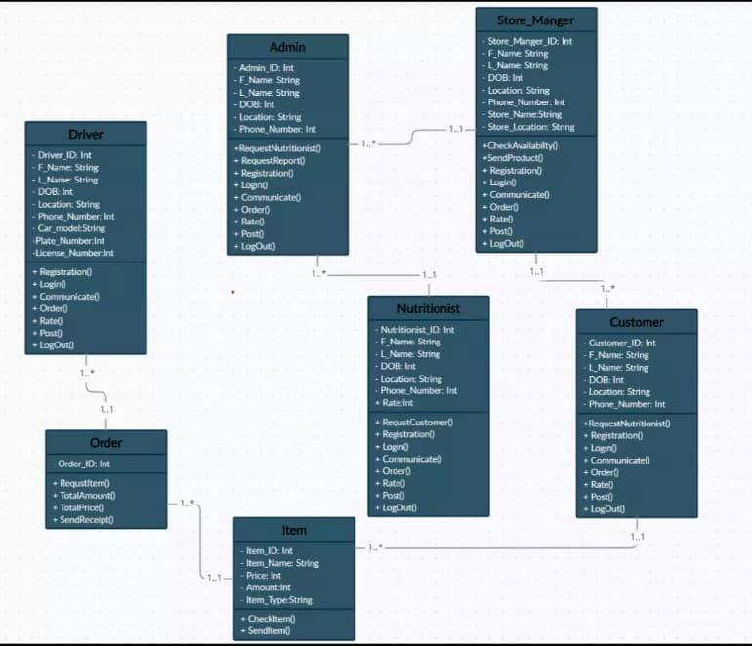

**Figure 4.4: Class Diagram**

**4.5 Entity Relation Diagram**

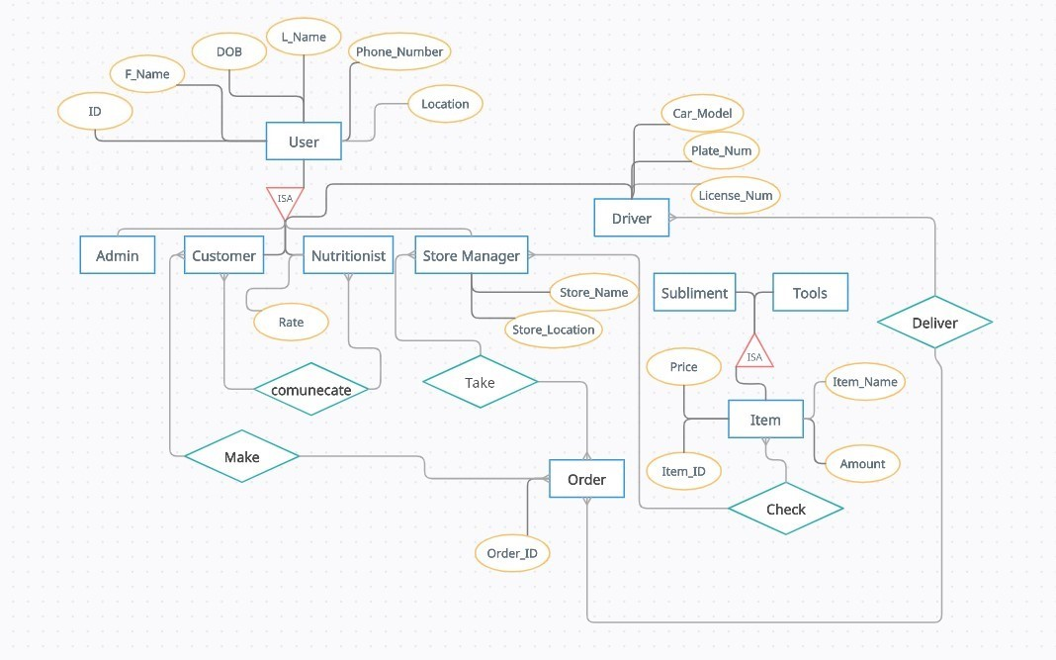

**Figure 4.4: ERD**

**4.6 Sequence Diagram**

**4.6.1 Signup Sequence Diagram**

**Figure 4.6.1: Signup Sequence Diagram**

The user will enter the name and password then if it valid the system will save the information else the system will display “Register failed” message.

**4.6.2 User Login Sequence Diagram**

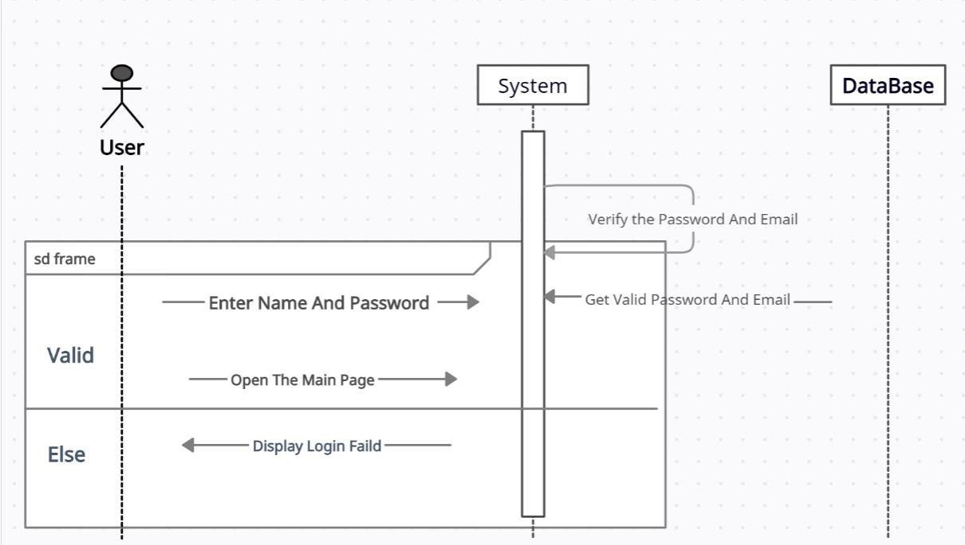

**Figure 4.6.2: User Login Sequence**

The user will enter the name and password then the system will check the database and if it’s valid the system will open the main page else the system will display “login failed” message.

**4.6.3 Choose Nutritionist Sequence Diagram**

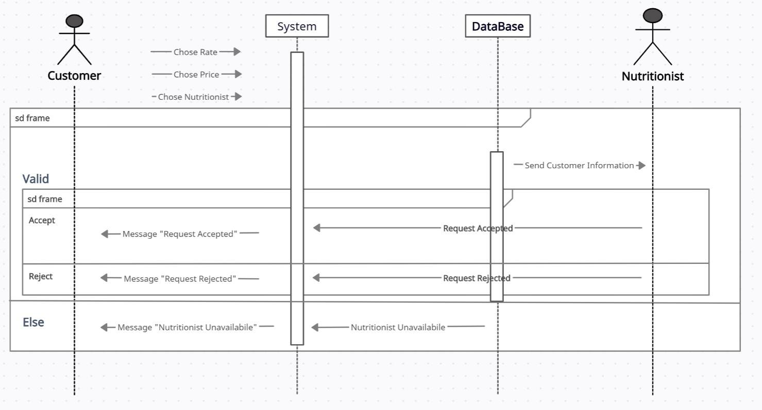

**Figure 4.6.3: Choose Nutritionist Sequence Diagram**

The customer will choose rate, price, and nutritionist then the system will send customer information to the nutritionist and if the nutritionist accepts the request the system will display “Request Accepted” message else the system will display “Request Rejected” else the system will display “Nutritionist Unavailable”.

**4.6.4 Choose amount of Items Sequence Diagram**

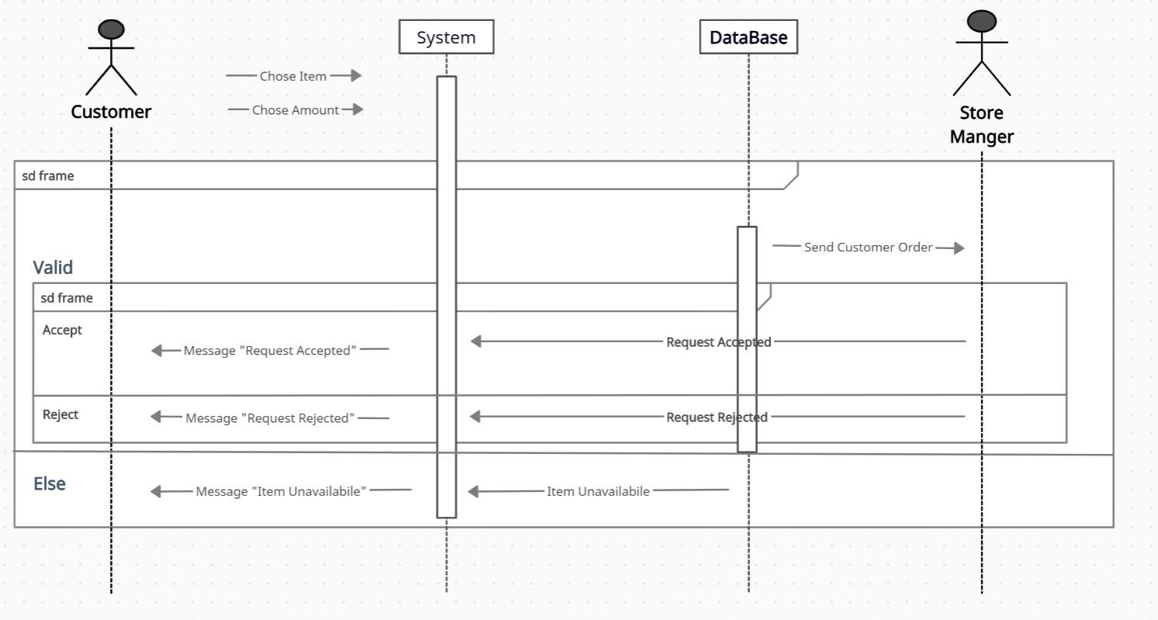

**Figure 4.6.4: Choose amount of Items Diagram**

The customer will choose item, and amount then the system will send customer order to the store manager and if the store manager accepts the request the system will display “Request Accepted” message else the system will display “Request Rejected” else the system will display “Item Unavailable”.

**4.7 Summary**

This chapter contains the system design models which are: class diagram, sequence diagram, context diagram and data flow diagram.

We described every use case and presented the sequence diagram for every possible stakeholders.