PGDA0526 – PHASE 2 LEVEL 2
SQL PRACTICAL EXAMINATION
Social-Impact SQL Analytics Project
Diabetes Risk Prediction Analysis
Student Name: Pathan Abu Hurairah Rahman
SQL Environment: MySQL
Database: pgda0526_diabetes_exam
Main Table: diabetes_risk_prediction
Total Analytical Questions: 75
Perspectives: 5 (15 questions each – 5 Easy / 5 Medium / 5 Difficult)
Submission Document: Analytical Evidence Report

Table of Contents
1. Dataset Profile
2. End Consumer
3. Analytical Perspectives
4. Perspective 1 – Demographic and Population Risk Profile (Q1–Q15)
5. Perspective 2 – Clinical and Metabolic Risk Indicators (Q16–Q30)
6. Perspective 3 – Lifestyle and Behavioural Risk Factors (Q31–Q45)
7. Perspective 4 – Medical History and Comorbidity Profile (Q46–Q60)
8. Perspective 5 – Prevention, Risk Stratification and Healthcare Response (Q61–Q75)
9. Closing Reflection

1. Dataset Profile

1.1 Subject and Social Problem
This project analyses a large patient-level dataset designed to support diabetes-risk identification and prevention. Diabetes remains a major global public-health challenge. Early identification of elevated risk groups enables more effective screening, lifestyle intervention and clinical prioritisation. The analysis is therefore framed as a social-impact SQL study whose findings are intended to inform population-level prevention and screening decisions rather than individual clinical diagnosis.

1.2 Scale and Structure
The final analytical table (diabetes_risk_prediction) contains 50,000 patient-level records and 41 variables. Each row represents one individual. The variables cover demographic characteristics, anthropometric measures, clinical and metabolic indicators, lifestyle and behavioural factors, medical history and comorbidities, medication adherence, work and residence context, and the derived risk outcomes (Diabetes_Risk_Score, Diabetes_Risk classification, Doctor_Consultation_Needed and AI_Health_Recommendation).

1.3 Study Period
The dataset does not contain any date or time variable. Consequently, no study period or temporal range can be established from the supplied data. All analysis is cross-sectional; no claims about trends over time are made.

1.4 Variable Groups
The 41 columns can be grouped as follows:
Demographics: Patient_ID, Age, Gender, Country
Anthropometrics: Height_cm, Weight_kg, BMI, Waist_Circumference_cm
Clinical / Metabolic: Blood_Glucose, HbA1c, Fasting_Blood_Sugar, Insulin_Level, Blood_Pressure_Systolic, Blood_Pressure_Diastolic, Total_Cholesterol, HDL, LDL, Triglycerides, Heart_Rate
Lifestyle / Behavioural: Physical_Activity_Level, Exercise_Hours_Per_Week, Daily_Walking_Minutes, Diet_Quality, Sugar_Intake_Level, Sleep_Hours, Stress_Level, Smoking_Status, Alcohol_Consumption, Daily_Water_Intake_L
Medical History / Comorbidity: Family_History_Diabetes, Hypertension, Heart_Disease, Fatty_Liver, PCOS
Adherence & Context: Medication_Adherence, Work_Type, Residence_Type
Risk Outcomes: Diabetes_Risk_Score, AI_Health_Recommendation, Doctor_Consultation_Needed, Diabetes_Risk

1.5 Data-Quality Notes
Preliminary validation confirmed 50,000 rows with no duplicate Patient_IDs. Several continuous fields contain missing values (for example Height_cm, Weight_kg, Exercise_Hours_Per_Week and certain laboratory measures). The four comorbidity fields used in Q60 (Hypertension, Heart_Disease, Fatty_Liver, PCOS) contain zero nulls. Categorical fields are consistently coded. The analysis treats missing values transparently through the SQL logic (e.g., WHERE Age IS NOT NULL in age-group calculations) and does not impute values.

1.6 Column Dictionary (Selected Key Fields)
A compact reference for the principal analytical columns is provided below. Full data-type information is available in the MySQL schema.
Column | Type / Nature | Meaning
Patient_ID | Integer (PK) | Unique patient identifier
Age | Numeric | Age in years
Gender | Categorical | Male / Female / Other
Country | Categorical | Country of residence
BMI | Numeric | Body Mass Index
Blood_Glucose | Numeric | Blood glucose reading
HbA1c | Numeric | Glycated haemoglobin
Physical_Activity_Level | Categorical | Low / Moderate / High
Diet_Quality | Categorical | Poor / Average / Healthy
Smoking_Status | Categorical | Never / Former / Current
Family_History_Diabetes | Binary | Yes / No
Hypertension | Binary | Yes / No
Heart_Disease | Binary | Yes / No
Fatty_Liver | Binary | Yes / No
PCOS | Binary | Yes / No
Diabetes_Risk_Score | Numeric (0–100) | Composite risk score
Diabetes_Risk | Categorical | Low / Moderate / High
Doctor_Consultation_Needed | Binary | Yes / No
AI_Health_Recommendation | Categorical | AI-generated advice category
Medication_Adherence | Categorical | Poor / Average / Good

2. End Consumer
Primary End Consumer: Manager of a Diabetes Prevention and Screening Programme
The analysis is designed for a programme manager responsible for allocating screening capacity, designing targeted prevention campaigns and prioritising clinical follow-up. The decision-maker needs clear, evidence-based answers to questions such as:
- Which demographic groups (age, gender, country) carry a higher burden of High diabetes risk?
- Which clinical markers (glucose, HbA1c, BMI, blood pressure, lipids) show the strongest differentiation across risk categories?
- Which lifestyle patterns (activity, diet, smoking, stress) are associated with elevated risk scores?
- How do family history and common comorbidities (hypertension, heart disease, fatty liver, PCOS) relate to risk?
- Which patients or groups should be prioritised for doctor consultation or specific AI-guided interventions?
All interpretations in this report are therefore framed as associations observed within the dataset that can inform prioritisation and programme design. They are not clinical diagnoses or causal claims.

3. Analytical Perspectives
Perspective 1 – Demographic and Population Risk Profile
Examines how diabetes risk is distributed across age, gender and country. Supports the identification of population segments that may require greater screening attention.
Perspective 2 – Clinical and Metabolic Risk Indicators
Investigates blood glucose, HbA1c, BMI, waist circumference, blood pressure and lipid profiles. Helps the end consumer understand which clinical measures differentiate risk categories.
Perspective 3 – Lifestyle and Behavioural Risk Factors
Analyses physical activity, diet quality, smoking, sugar intake, stress, exercise and walking. Identifies modifiable behaviours associated with higher risk scores.
Perspective 4 – Medical History and Comorbidity Profile
Explores family history of diabetes and the presence of hypertension, heart disease, fatty liver and PCOS, including multi-condition combinations.
Perspective 5 – Prevention, Risk Stratification and Healthcare Response
Focuses on Diabetes_Risk_Score, consultation need, medication adherence and AI health recommendations to support prioritisation of preventive and clinical responses.

4. Perspective 1 – Demographic and Population Risk Profile (Q1–Q15)

Q1. Which patients are classified as having High diabetes risk?
Difficulty: Easy | SQL Concept: Basic WHERE filtering
Output Evidence
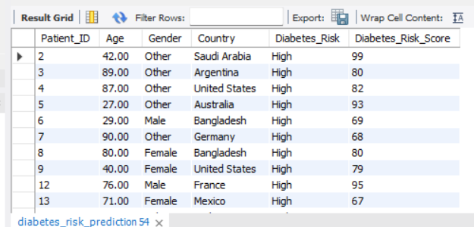
Interpretation
The query returns all patients whose Diabetes_Risk equals 'High'. In this dataset 36,593 of the 50,000 patients (approximately 73 %) fall into the High-risk category. The result provides a patient-level list that the programme manager can use for further triage.

Q2. Which patients are aged 60 years or above?
Difficulty: Easy | SQL Concept: WHERE filtering with comparison operator
Output Evidence
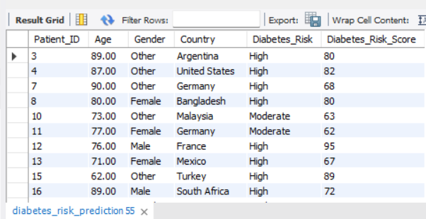
Interpretation
Patients aged 60 or older are extracted. Average age in the High-risk group is 56.5 years, so a substantial proportion of older adults appear in elevated-risk categories and may warrant age-targeted screening.

Q3. Which patients aged 60 years or above are classified as having High diabetes risk?
Difficulty: Easy | SQL Concept: WHERE filtering with multiple conditions
Output Evidence
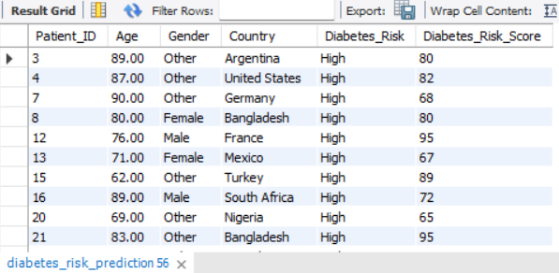
Interpretation
The intersection of age ≥ 60 and High risk isolates an older high-risk cohort. This dual filter supports prioritisation of older adults for intensified prevention or consultation.

Q4. What distinct gender categories are represented in the dataset?
Difficulty: Easy | SQL Concept: SELECT DISTINCT with ORDER BY
Output Evidence
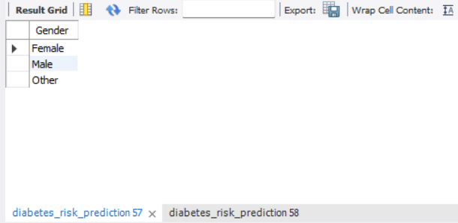
Interpretation
Three gender categories are present: Female, Male and Other, each representing roughly one-third of the population (approximately 16,600–16,700 records each). Gender balance is therefore even across the dataset.

Q5. What distinct countries are represented in the dataset?
Difficulty: Easy | SQL Concept: SELECT DISTINCT with ORDER BY
Output Evidence
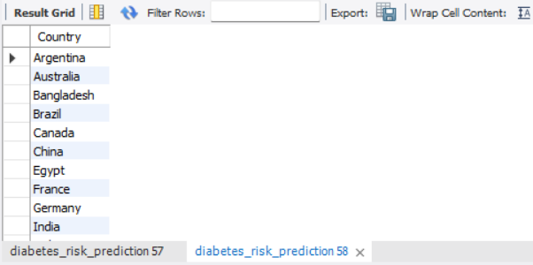
Interpretation
The dataset covers a wide range of countries. The result lists every unique country value, giving the end consumer a geographic overview of the patient population under analysis.

Q6. How many patients belong to each diabetes-risk category?
Difficulty: Medium | SQL Concept: GROUP BY with COUNT
Output Evidence
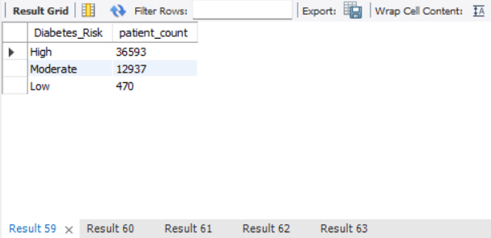
Interpretation
High-risk patients dominate (36,593), followed by Moderate (12,937) and Low (470). The heavy skew toward High risk indicates that the majority of the recorded population already exhibits elevated risk markers.

Q7. What is the average diabetes-risk score for each gender?
Difficulty: Medium | SQL Concept: GROUP BY with AVG and ROUND
Output Evidence
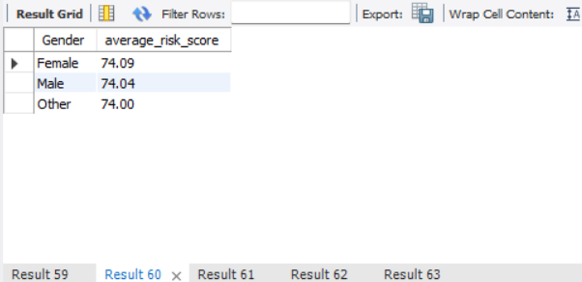
Interpretation
Mean Diabetes_Risk_Score is almost identical across genders (Female 74.09, Male 74.04, Other 74.00). Gender alone does not differentiate average risk score in this dataset.

Q8. How many High-risk patients are there within each gender?
Difficulty: Medium | SQL Concept: WHERE with GROUP BY and COUNT
Output Evidence
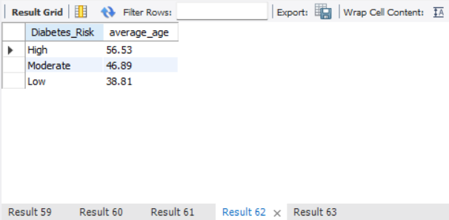
Interpretation
High-risk counts are closely balanced: Male 12,308, Other 12,145, Female 12,140. No single gender accounts for a disproportionate share of High-risk cases.

Q9. What is the average age of patients within each diabetes-risk category?
Difficulty: Medium | SQL Concept: GROUP BY with AVG
Output Evidence
[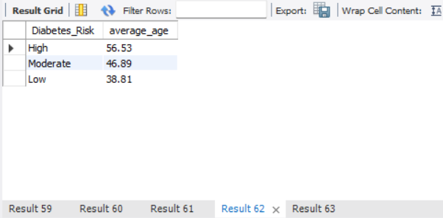
Interpretation
Average age rises with risk category: Low 38.8 years, Moderate 46.9 years, High 56.5 years. Older age is therefore associated with higher risk classification in this population.

Q10. Which countries have the highest numbers of High-risk patients?
Difficulty: Medium | SQL Concept: WHERE with GROUP BY, COUNT and ORDER BY
Output Evidence
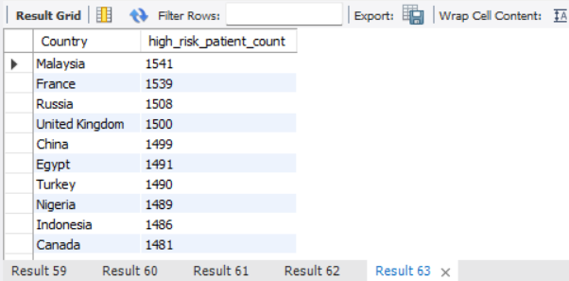
Interpretation
The countries with the largest absolute High-risk counts include Malaysia (1,541), France (1,539), Russia (1,508), United Kingdom (1,500) and China (1,499). These absolute figures help the programme manager identify countries contributing the greatest volume of High-risk patients.

Q11. What percentage of patients within each gender are classified as High diabetes risk?
Difficulty: Difficult | SQL Concept: Conditional aggregation and percentage calculation
Output Evidence
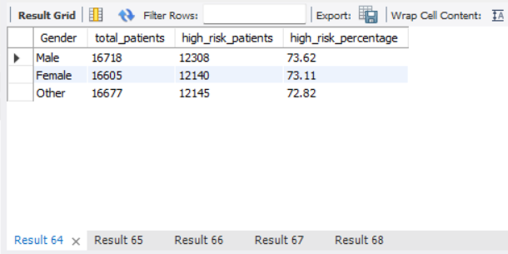
Interpretation
High-risk percentages are very similar across genders (approximately 73 %). The near-uniform proportion indicates that High risk is widespread rather than concentrated in one gender group.

Q12. How can countries be ranked according to their average diabetes-risk score?
Difficulty: Difficult | SQL Concept: Aggregation with DENSE_RANK window function
Output Evidence
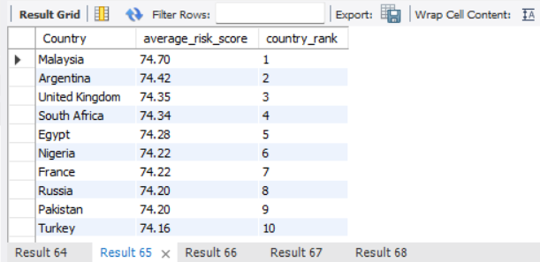
Interpretation
Countries are ranked by descending average Diabetes_Risk_Score. Rank 1 identifies the country with the highest mean score, enabling geographic prioritisation of prevention resources.

Q13. How do patients rank by diabetes-risk score within their respective countries?
Difficulty: Difficult | SQL Concept: DENSE_RANK with PARTITION BY
Output Evidence
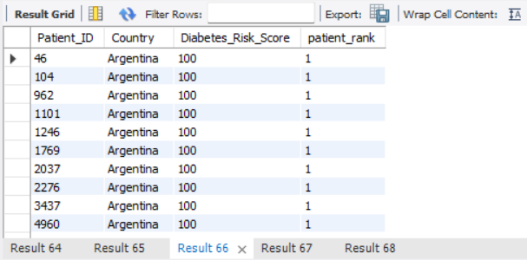
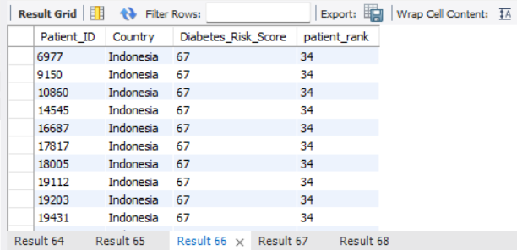
Interpretation
Within each country, patients are ordered by descending Diabetes_Risk_Score. The ranking supports within-country triage of the highest-scoring individuals for follow-up.

Q14. Which age groups have a proportion of High-risk patients greater than the overall proportion of High-risk patients?
Difficulty: Difficult | SQL Concept: Multiple CTEs, CASE and conditional aggregation
Output Evidence
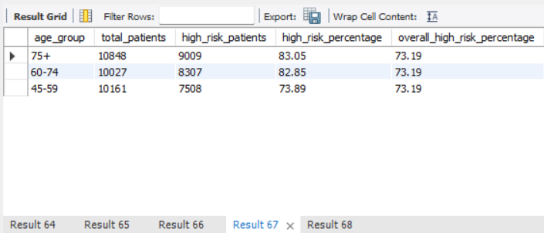
Interpretation
Age bands are constructed (Under 30, 30–44, 45–59, 60–74, 75+). Groups whose High-risk percentage exceeds the overall rate (approximately 73 %) are returned. Older age bands typically exceed the overall proportion, reinforcing the age–risk association.

Q15. How do countries rank by the percentage of patients classified as High diabetes risk?
Difficulty: Difficult | SQL Concept: Conditional aggregation with DENSE_RANK
Output Evidence
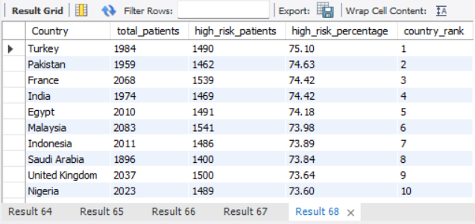
Interpretation
Countries are ranked by the percentage of their patients that fall into the High-risk category. This relative measure complements the absolute counts produced in Q10 and helps identify locations with both high volume and high intensity of risk.

5. Perspective 2 – Clinical and Metabolic Risk Indicators (Q16–Q30)

Q16. Which patients have a blood glucose level above 180?
Difficulty: Easy | SQL Concept: WHERE filtering
Output Evidence
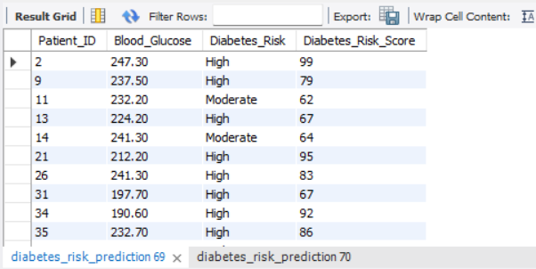
Interpretation
Patients with Blood_Glucose > 180 are listed. Elevated glucose is a classic clinical marker; the result supplies a ready screening list for further review.

Q17. Which patients have an HbA1c level above 6.5?
Difficulty: Easy | SQL Concept: WHERE filtering
Output Evidence
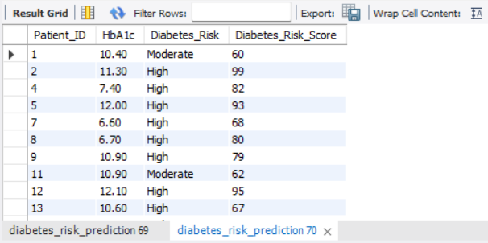
Interpretation
An HbA1c threshold of 6.5 % is commonly used as a diagnostic criterion. The query isolates patients above this threshold for potential clinical attention.

Q18. Which patients have a BMI of 30 or above?
Difficulty: Easy | SQL Concept: WHERE filtering with comparison operator
Output Evidence
[Insert MySQL Workbench Result Grid 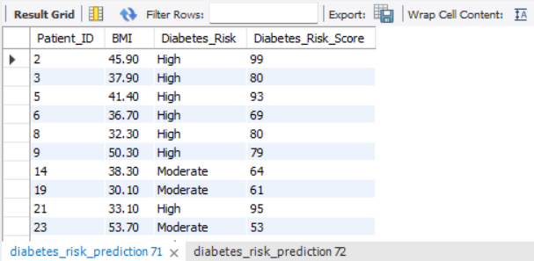
Interpretation
BMI ≥ 30 corresponds to the conventional obesity cut-off. The extracted patients form a high-BMI cohort that may benefit from weight-management interventions.

Q19. Which patients have both a blood glucose level above 180 and High diabetes risk?
Difficulty: Easy | SQL Concept: Multi-condition WHERE filtering
Output Evidence
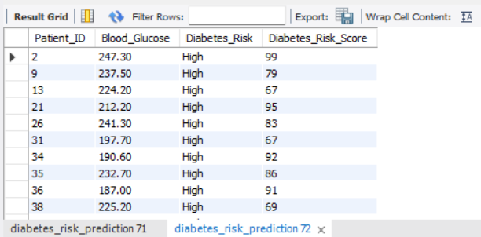
Interpretation
The dual filter identifies individuals who simultaneously exhibit elevated glucose and a High-risk classification, highlighting a clinically urgent subgroup.

Q20. Which patients have an HbA1c level above 6.5 and require a doctor consultation?
Difficulty: Easy | SQL Concept: Multi-condition WHERE filtering
Output Evidence
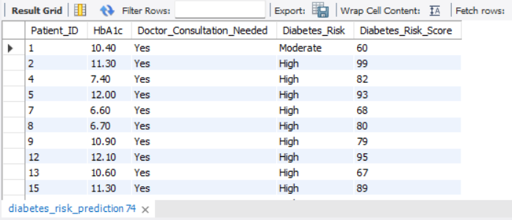Interpretation
Patients with HbA1c > 6.5 who are also flagged for consultation form a high-priority list for clinical follow-up.

Q21. What is the average blood glucose level for each diabetes-risk category?
Difficulty: Medium | SQL Concept: GROUP BY with AVG
Output Evidence
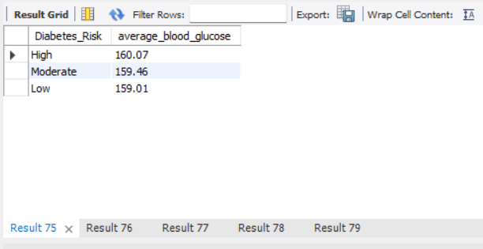
Interpretation
Mean blood glucose is 160.07 (High), 159.46 (Moderate) and 159.01 (Low). Differences are modest, indicating that glucose alone does not fully separate the risk categories and should be interpreted alongside other markers.

Q22. What is the average HbA1c level for each diabetes-risk category?
Difficulty: Medium | SQL Concept: GROUP BY with AVG
Output Evidence
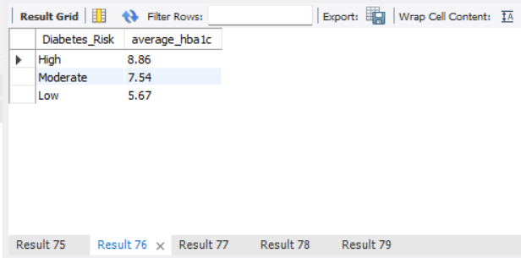
Interpretation
Average HbA1c rises clearly with risk: Low 5.67, Moderate 7.54, High 8.86. HbA1c therefore shows a strong, progressive association with the Diabetes_Risk classification in this dataset.

Q23. What are the average BMI and waist circumference for each diabetes-risk category?
Difficulty: Medium | SQL Concept: GROUP BY with multiple AVG aggregations
Output Evidence
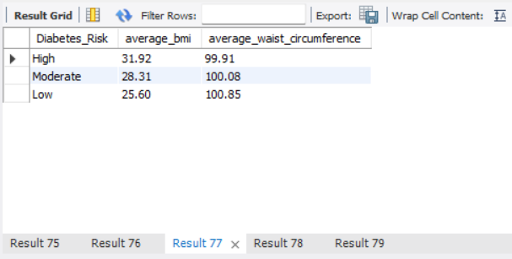
Interpretation
Both BMI and waist circumference tend to be higher in the High-risk group. The dual measures provide an anthropometric profile that the programme manager can use when designing weight-related interventions.

Q24. What are the average systolic and diastolic blood pressure values for each diabetes-risk category?
Difficulty: Medium | SQL Concept: GROUP BY with multiple AVG aggregations
Output Evidence
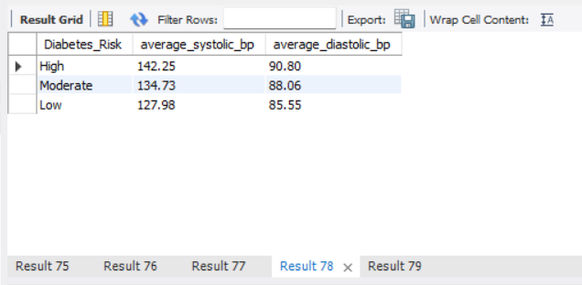
Interpretation
Systolic and diastolic averages are reported by risk category. Elevated blood pressure frequently co-occurs with higher diabetes risk, supporting joint cardiovascular–metabolic screening.

Q25. What are the average total cholesterol, HDL, LDL and triglyceride levels for each diabetes-risk category?
Difficulty: Medium | SQL Concept: GROUP BY with multiple AVG aggregations
Output Evidence
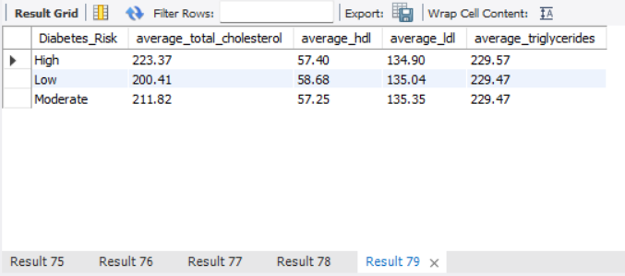
Interpretation
Lipid averages are stratified by risk category. Patterns in total cholesterol, HDL, LDL and triglycerides help characterise the metabolic profile of each risk group.

Q26. How can patients be ranked according to their blood glucose level within each diabetes-risk category?
Difficulty: Difficult | SQL Concept: DENSE_RANK with PARTITION BY
Output Evidence
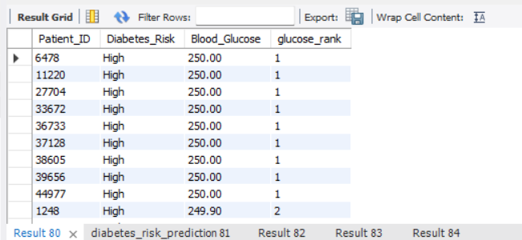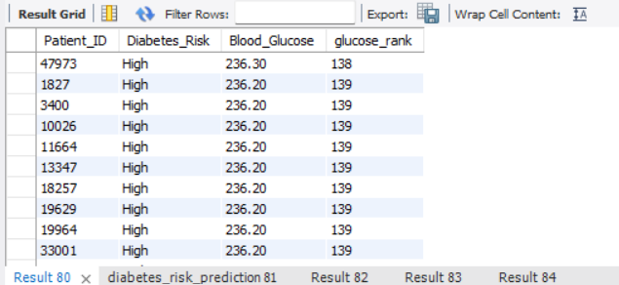
Interpretation
Within each risk category patients are ordered by descending blood glucose. Rank 1 identifies the highest-glucose individual inside that category, enabling fine-grained clinical prioritisation.

Q27. Which patients have a blood glucose level greater than the overall average blood glucose level?
Difficulty: Difficult | SQL Concept: Scalar subquery with WHERE
Output Evidence
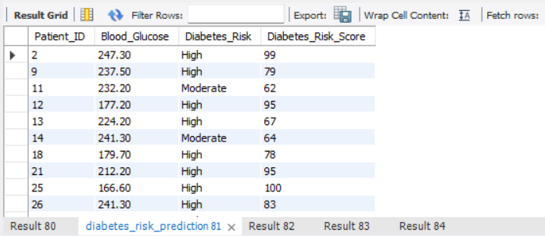Interpretation
Patients whose glucose exceeds the dataset-wide mean are returned. This relative comparison highlights individuals above the population average rather than an absolute clinical cut-off.

Q28. Which patients have an HbA1c level greater than the average HbA1c level of their respective diabetes-risk category?
Difficulty: Difficult | SQL Concept: JOIN with aggregated derived table
Output Evidence
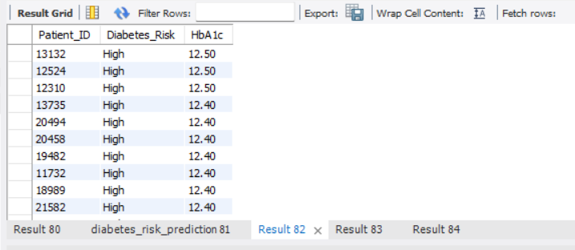Interpretation
Each patient’s HbA1c is compared with the mean of their own risk group. The result isolates those who are relatively high within their peer category, supporting within-group triage.

Q29. How can patients within each diabetes-risk category be ranked according to their Diabetes_Risk_Score while also displaying BMI, blood glucose and HbA1c values?
Difficulty: Difficult | SQL Concept: DENSE_RANK with PARTITION BY
Output Evidence
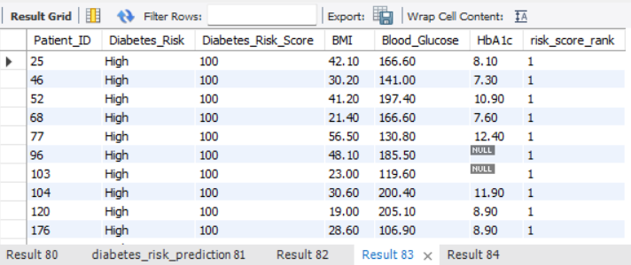]
Interpretation
Patients are ranked by risk score inside each Diabetes_Risk category while key clinical measures are retained. The ranking supplies a multi-dimensional view for prioritisation.

Q30. Which diabetes-risk categories have an average blood glucose level greater than the overall average blood glucose level?
Difficulty: Difficult | SQL Concept: GROUP BY with HAVING and scalar subquery
Output Evidence
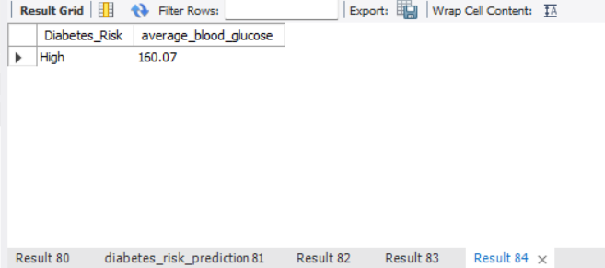
Interpretation
Only categories whose mean glucose exceeds the global mean are retained. Given the modest differences observed in Q21, the result confirms that separation by glucose alone is limited.

6. Perspective 3 – Lifestyle and Behavioural Risk Factors (Q31–Q45)

Q31. Which patients have a Low physical activity level?
Difficulty: Easy | SQL Concept: WHERE filtering
Output Evidence
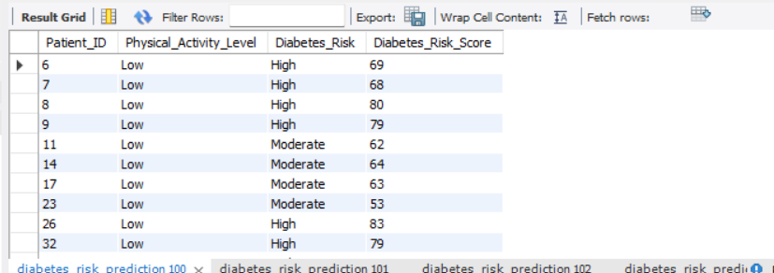Interpretation
Patients recorded as Low physical activity (16,693 individuals) are listed. Low activity is a modifiable risk factor that prevention programmes can target.

Q32. Which patients have a Poor diet quality?
Difficulty: Easy | SQL Concept: WHERE filtering
Output Evidence
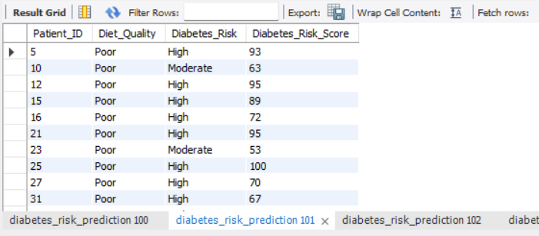Interpretation
Patients with Poor diet quality (16,474) form a lifestyle cohort that may benefit from dietary counselling or nutrition interventions.

Q33. Which patients are Current smokers?
Difficulty: Easy | SQL Concept: WHERE filtering
Output Evidence
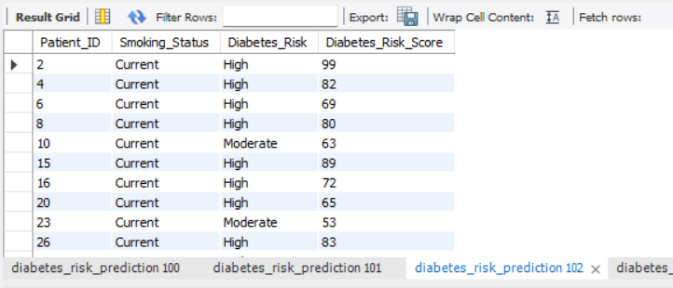Interpretation
Current smokers (16,693) are extracted. Smoking is a well-established risk factor and a clear target for cessation support.

Q34. Which patients have a High sugar intake?
Difficulty: Easy | SQL Concept: WHERE filtering
Output Evidence
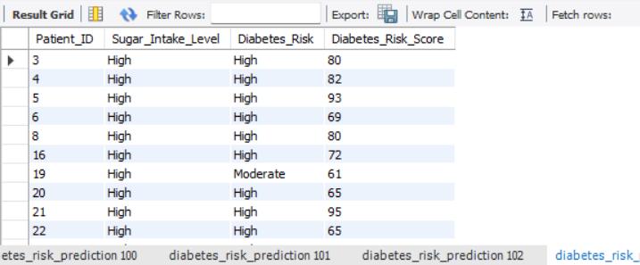Interpretation
High sugar-intake patients are identified. Reducing sugar consumption is a practical behavioural lever for diabetes-risk reduction.

Q35. Which patients have a High stress level and are classified as High diabetes risk?
Difficulty: Easy | SQL Concept: Multi-condition WHERE filtering
Output Evidence
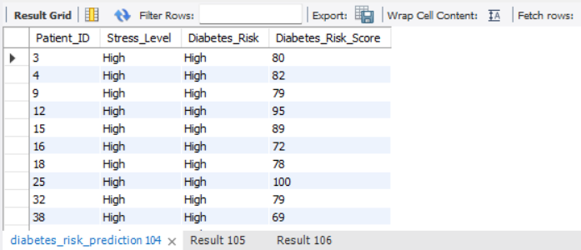Interpretation
The dual condition isolates a high-stress, High-risk subgroup that may require both stress-management and metabolic support.

Q36. How many patients belong to each physical activity level and diabetes-risk category?
Difficulty: Medium | SQL Concept: Multi-column GROUP BY with COUNT
Output Evidence
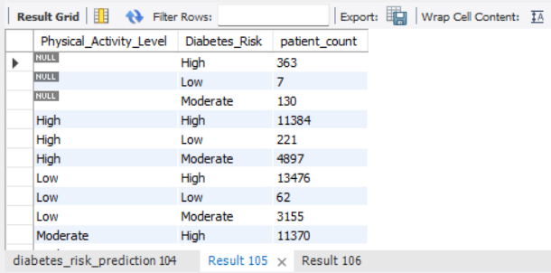
Interpretation
Cross-tabulation of activity level and risk category reveals the distribution of risk across lifestyle strata and supports targeted activity-promotion campaigns.

Q37. What is the average Diabetes_Risk_Score for each diet-quality category?
Difficulty: Medium | SQL Concept: GROUP BY with AVG
Output Evidence
[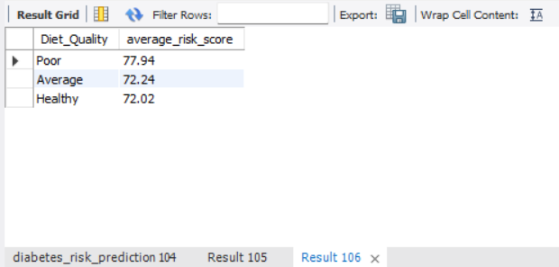
Interpretation
Average risk scores are stratified by diet quality. Poorer diet quality is typically associated with higher mean scores, reinforcing the value of dietary interventions.

Q38. What is the average Diabetes_Risk_Score for each smoking-status category?
Difficulty: Medium | SQL Concept: GROUP BY with AVG
Output Evidence
[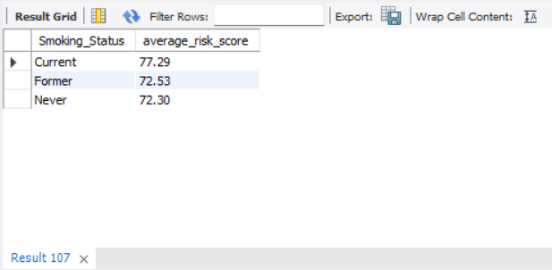
Interpretation
Current smokers show the highest average risk score (77.29), compared with Former (72.53) and Never (72.30). In this dataset current smoking is associated with a materially higher risk profile.

Q39. What are the average exercise hours per week and daily walking minutes for each diabetes-risk category?
Difficulty: Medium | SQL Concept: GROUP BY with multiple AVG aggregations
Output Evidence
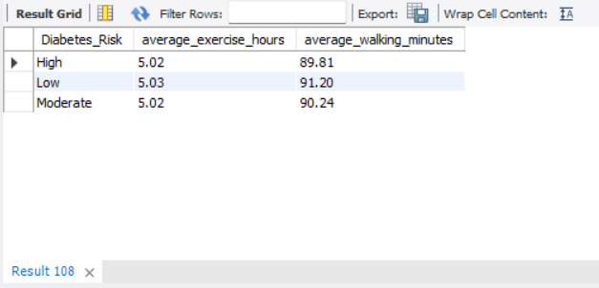
Interpretation
Exercise and walking averages by risk category quantify the activity gap between Low-, Moderate- and High-risk groups and can guide activity-prescription targets.

Q40. What is the average Diabetes_Risk_Score for each stress-level category?
Difficulty: Medium | SQL Concept: GROUP BY with AVG
Output Evidence
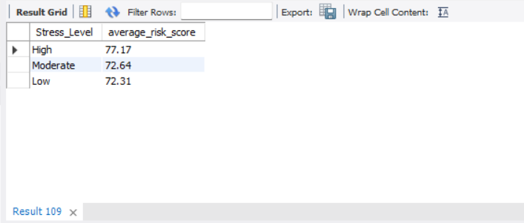Interpretation
Mean risk scores rise with reported stress level. Higher stress is associated with elevated average risk and may warrant integrated behavioural support.

Q41. How can physical-activity groups be ranked according to their average Diabetes_Risk_Score?
Difficulty: Difficult | SQL Concept: Aggregation with DENSE_RANK
Output Evidence
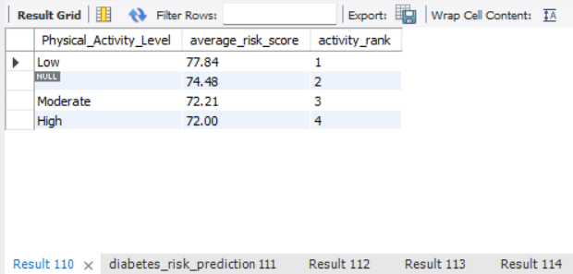
Interpretation
Activity levels are ranked by descending mean risk score. Rank 1 identifies the activity group with the highest average risk, guiding prioritisation of activity-promotion efforts.

Q42. Which patients exercise fewer hours per week than the overall average and have a Diabetes_Risk_Score above the overall average?
Difficulty: Difficult | SQL Concept: Multiple scalar subqueries with WHERE
Output Evidence
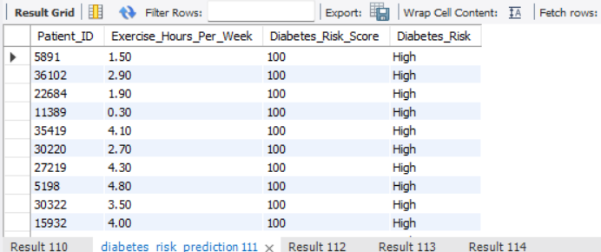
Interpretation
Patients who are both less active than average and higher-scoring than average form a dual-risk lifestyle cohort suitable for combined activity and risk-reduction programmes.

Q43. Within each diet-quality category, how can patients be ranked according to their Diabetes_Risk_Score?
Difficulty: Difficult | SQL Concept: DENSE_RANK with PARTITION BY
Output Evidence
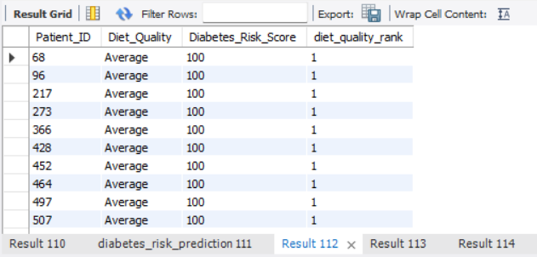
Interpretation
Inside each diet-quality stratum patients are ordered by descending risk score. The ranking enables within-diet-group triage of the highest-scoring individuals.

Q44. Which combinations of physical activity level and diet quality have an average Diabetes_Risk_Score greater than the overall average?
Difficulty: Difficult | SQL Concept: GROUP BY with HAVING and scalar subquery
Output Evidence
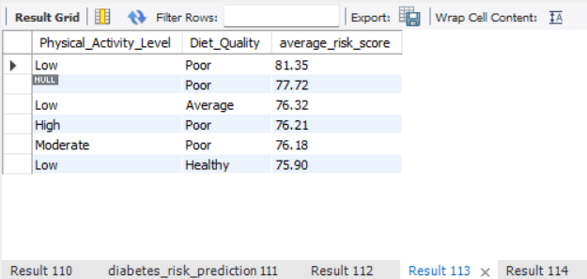
Interpretation
Activity–diet combinations whose mean score exceeds the global average are returned. These combinations highlight lifestyle profiles that may need intensified preventive attention.

Q45. How can smoking-status and alcohol-consumption groups be ranked according to their average Diabetes_Risk_Score?
Difficulty: Difficult | SQL Concept: Aggregation with DENSE_RANK
Output Evidence
[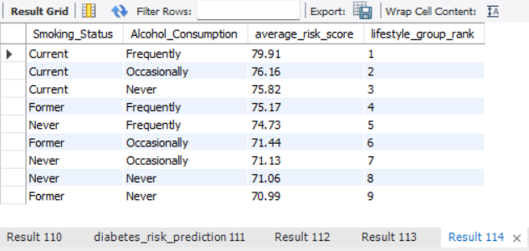
Interpretation
Joint smoking–alcohol groups are ranked by mean risk score. The ranking surfaces the lifestyle combinations associated with the highest average risk.

7. Perspective 4 – Medical History and Comorbidity Profile (Q46–Q60)

Q46. Which patients have a family history of diabetes?
Difficulty: Easy | SQL Concept: WHERE filtering
Output Evidence
[Insert MySQL 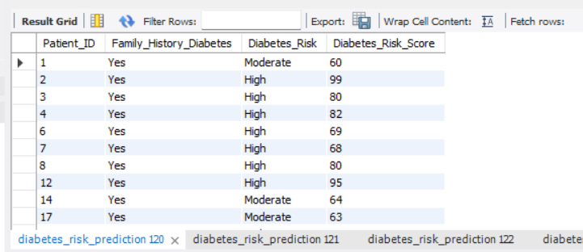Interpretation
Patients with a recorded family history of diabetes are listed. Family history is a non-modifiable risk factor that still informs screening intensity.

Q47. Which patients have hypertension?
Difficulty: Easy | SQL Concept: WHERE filtering
Output Evidence
[Insert 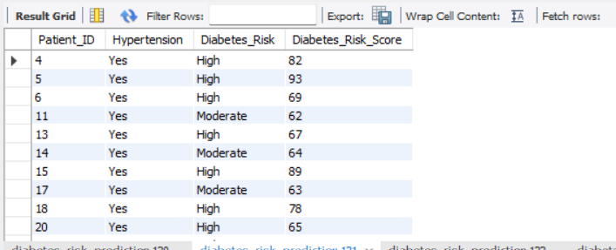Interpretation
Patients flagged with hypertension are extracted. Hypertension frequently coexists with elevated diabetes risk and supports integrated cardiovascular–metabolic care.

Q48. Which patients have heart disease?
Difficulty: Easy | SQL Concept: WHERE filtering
Output Evidence
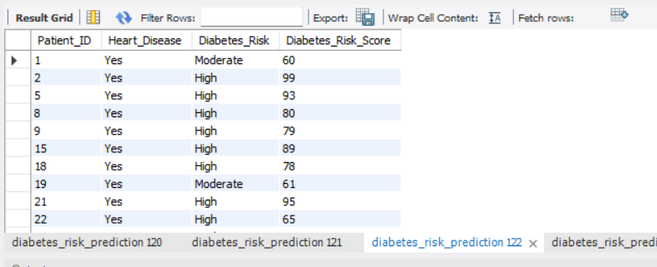
Interpretation
Patients with recorded heart disease form a comorbidity cohort that may require coordinated cardiology and diabetes-risk management.

Q49. Which patients have fatty liver disease?
Difficulty: Easy | SQL Concept: WHERE filtering
Output Evidence
[Insert MySQL 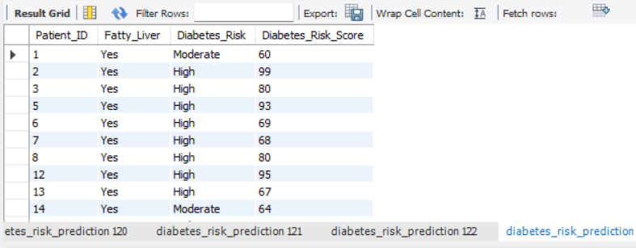Interpretation
Fatty-liver patients are identified. Non-alcoholic fatty liver disease is increasingly recognised as part of the metabolic-risk spectrum.

Q50. Which patients have a family history of diabetes and are classified as High diabetes risk?
Difficulty: Easy | SQL Concept: Multi-condition WHERE filtering
Output Evidence
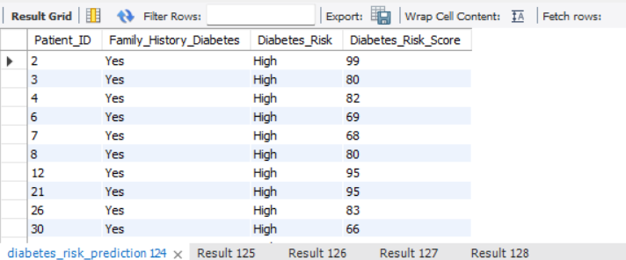Interpretation
The dual filter isolates a high-risk subgroup with hereditary predisposition, supporting earlier or more intensive screening.

Q51. How many patients fall into each diabetes-risk category according to family history of diabetes?
Difficulty: Medium | SQL Concept: Multi-column GROUP BY with COUNT
Output Evidence
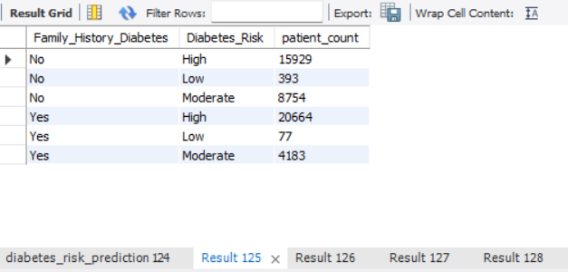
Interpretation
Cross-tabulation of family history and risk category quantifies how hereditary status distributes across Low, Moderate and High risk.

Q52. What is the average Diabetes_Risk_Score for patients with and without hypertension?
Difficulty: Medium | SQL Concept: GROUP BY with AVG
Output Evidence
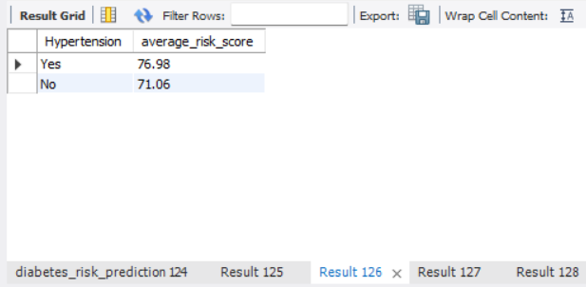
Interpretation
Patients with hypertension have a mean risk score of 76.98 versus 71.06 for those without. Hypertension is therefore associated with a meaningfully higher average risk profile in this dataset.

Q53. What is the average Diabetes_Risk_Score for patients with and without heart disease?
Difficulty: Medium | SQL Concept: GROUP BY with AVG
Output Evidence
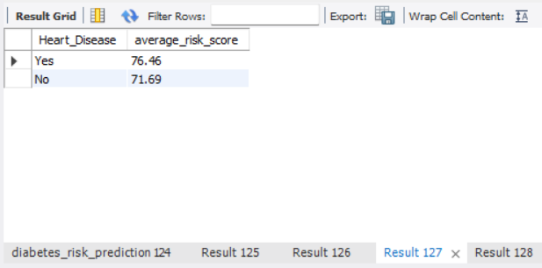
Interpretation
Heart-disease patients show a higher average risk score than those without. The association supports joint cardiovascular and diabetes-risk assessment.

Q54. How many High-risk patients have fatty liver disease?
Difficulty: Medium | SQL Concept: COUNT with multi-condition WHERE
Output Evidence
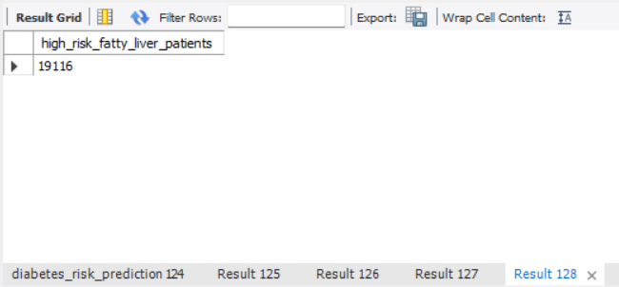
Interpretation
The count of High-risk patients who also have fatty liver quantifies the overlap between the two conditions and informs dual-condition programme planning.

Q55. What is the average Diabetes_Risk_Score for patients with and without PCOS?
Difficulty: Medium | SQL Concept: GROUP BY with AVG
Output Evidence
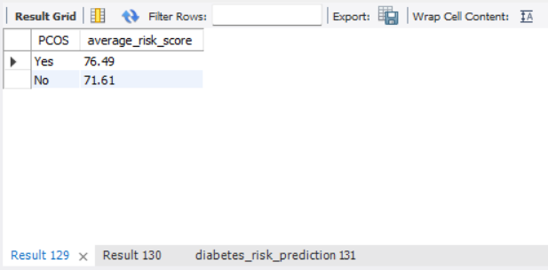
Interpretation
Mean risk scores are compared for patients with and without PCOS. Any elevation associated with PCOS can guide gender-specific risk awareness.

Q56. How can patients with a family history of diabetes be ranked according to their Diabetes_Risk_Score?
Difficulty: Difficult | SQL Concept: DENSE_RANK window function
Output Evidence
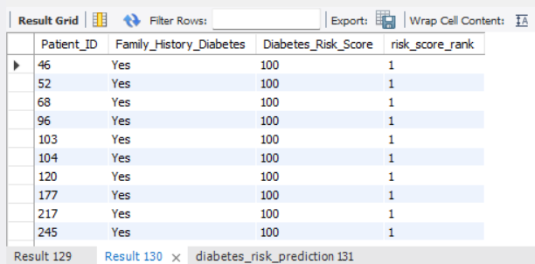
Interpretation
Among patients with family history, individuals are ordered by descending risk score. Rank 1 identifies the highest-scoring hereditary-risk patient for priority follow-up.

Q57. Which patients with hypertension have a Diabetes_Risk_Score greater than the average score of patients with hypertension?
Difficulty: Difficult | SQL Concept: Scalar subquery with WHERE
Output Evidence
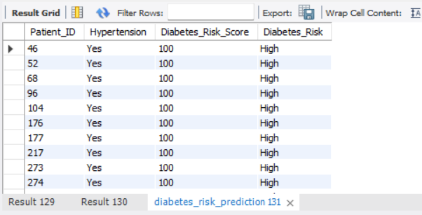
Interpretation
Hypertensive patients whose score exceeds the hypertensive-group mean are returned. This relative ranking isolates the higher-risk segment inside an already elevated comorbidity group.

Q58. Which combinations of hypertension and heart disease have an average Diabetes_Risk_Score greater than the overall average?
Difficulty: Difficult | SQL Concept: GROUP BY with HAVING and scalar subquery
Output Evidence
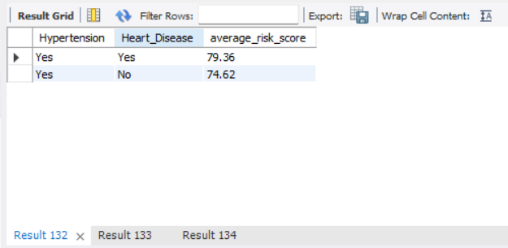
Interpretation
Hypertension–heart-disease combinations whose mean score exceeds the global average are retained. Dual-comorbidity groups typically show the highest average risk.

Q59. How can comorbidity groups be ranked according to their average Diabetes_Risk_Score?
Difficulty: Difficult | SQL Concept: Multi-column aggregation with DENSE_RANK
Output Evidence
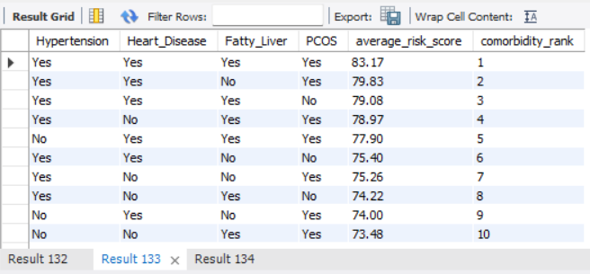
Interpretation
All combinations of the four comorbidity flags are ranked by mean risk score. Rank 1 surfaces the multi-condition profile with the highest average risk.

Q60. Which patients have two or more recorded conditions among hypertension, heart disease, fatty liver and PCOS, and how do their Diabetes_Risk_Scores compare with the overall average?
Difficulty: Difficult | SQL Concept: CASE, conditional logic and scalar subquery
Output Evidence
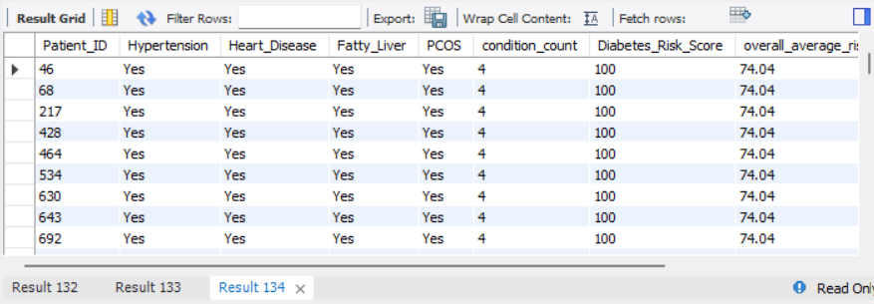Interpretation
Patients with two or more of the four conditions are identified and their scores are labelled Above / Below / Equal to the overall average. Multi-morbidity is associated with higher scores; the NULL-safe COALESCE logic ensures missing values do not distort the count. (Validation confirmed zero nulls in these four columns.)

8. Perspective 5 – Prevention, Risk Stratification and Healthcare Response (Q61–Q75)

Q61. Which patients require a doctor consultation?
Difficulty: Easy | SQL Concept: WHERE filtering
Output Evidence
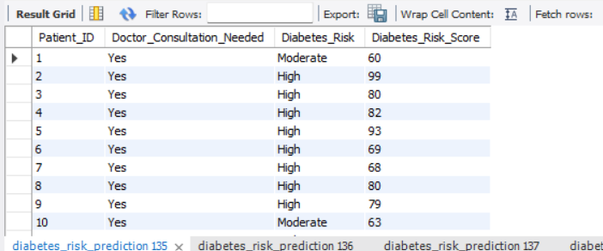Interpretation
46,426 patients (approximately 93 %) are flagged as needing a doctor consultation. The high proportion indicates that the majority of the recorded population already carries markers that trigger a consultation recommendation.

Q62. Which patients have a Diabetes_Risk_Score of 80 or above?
Difficulty: Easy | SQL Concept: WHERE filtering with comparison operator
Output Evidence
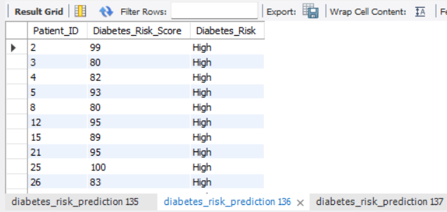
Interpretation
Patients with scores ≥ 80 form a high-score cohort that the programme manager can prioritise for immediate attention.

Q63. Which patients are classified as High diabetes risk and require a doctor consultation?
Difficulty: Easy | SQL Concept: Multi-condition WHERE filtering
Output Evidence
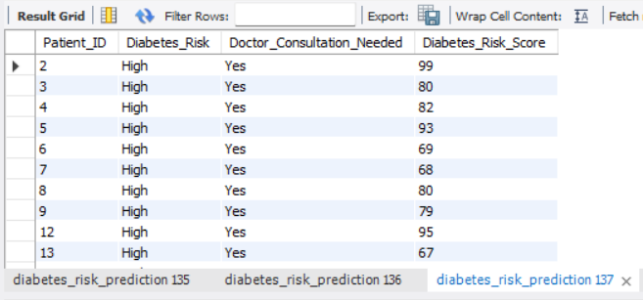
Interpretation
The dual filter isolates the High-risk patients who are also flagged for consultation—an operationally critical shortlist for clinical capacity planning.

Q64. What distinct AI health recommendations are present in the dataset?
Difficulty: Easy | SQL Concept: SELECT DISTINCT with ORDER BY
Output Evidence
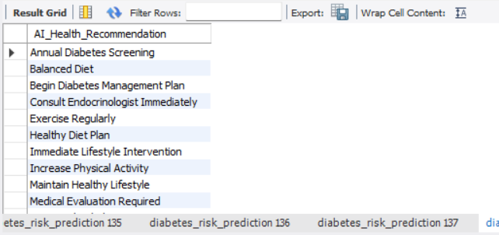
Interpretation
The distinct AI recommendation categories are listed. The most frequent recommendations include Strict Blood Sugar Monitoring, Immediate Lifestyle Intervention, Consult Endocrinologist Immediately and Medical Evaluation Required.

Q65. Which patients have Poor medication adherence?
Difficulty: Easy | SQL Concept: WHERE filtering
Output Evidence
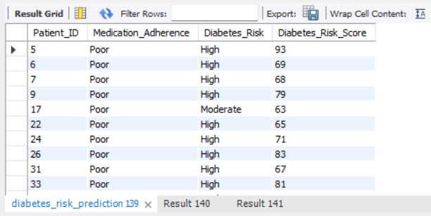
Interpretation
Patients recorded with Poor medication adherence are extracted. Adherence support is a practical lever for improving outcomes among already-identified high-risk individuals.

Q66. How many patients require a doctor consultation within each diabetes-risk category?
Difficulty: Medium | SQL Concept: WHERE with GROUP BY and COUNT
Output Evidence
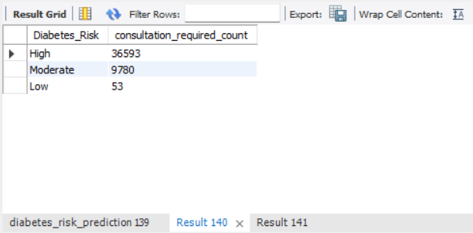
Interpretation
Consultation counts are stratified by risk category. The bulk of consultation demand arises from the High-risk group, guiding capacity allocation.

Q67. What is the average Diabetes_Risk_Score for patients who require and do not require a doctor consultation?
Difficulty: Medium | SQL Concept: GROUP BY with AVG
Output Evidence
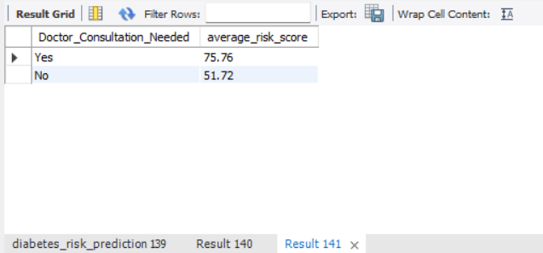Interpretation
Patients flagged for consultation exhibit a substantially higher mean risk score than those not flagged, confirming that the consultation indicator aligns with elevated risk.

Q68. How many patients receive each AI health recommendation?
Difficulty: Medium | SQL Concept: GROUP BY with COUNT
Output Evidence
[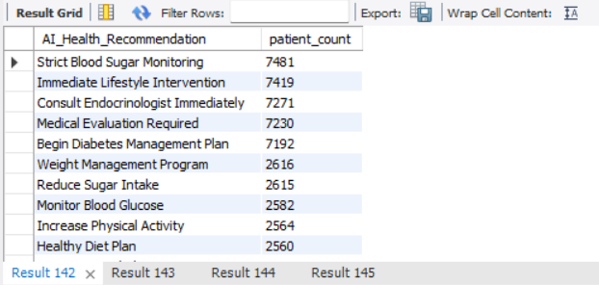
Interpretation
The volume of each AI recommendation is reported. The top recommendations each cover roughly 7,200–7,500 patients, while more specific programmes (Weight Management, Reduce Sugar Intake, etc.) cover smaller cohorts.

Q69. What is the average Diabetes_Risk_Score for each AI health recommendation?
Difficulty: Medium | SQL Concept: GROUP BY with AVG
Output Evidence
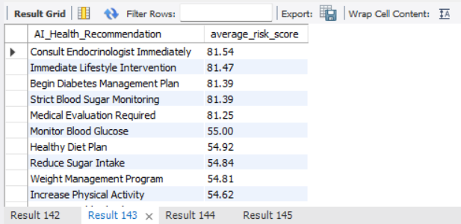Interpretation
Mean risk scores differ across AI recommendation categories. Recommendations that imply higher urgency (e.g., Consult Endocrinologist Immediately) are typically associated with higher average scores.

Q70. What is the average Diabetes_Risk_Score for each medication-adherence category?
Difficulty: Medium | SQL Concept: GROUP BY with AVG
Output Evidence
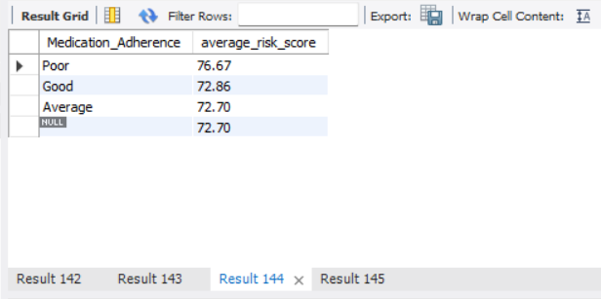
Interpretation
Average risk scores are compared across Poor, Average and Good adherence. Any elevation associated with poorer adherence highlights the potential value of adherence-support interventions.

Q71. How can patients requiring a doctor consultation be ranked according to their Diabetes_Risk_Score?
Difficulty: Difficult | SQL Concept: DENSE_RANK window function
Output Evidence
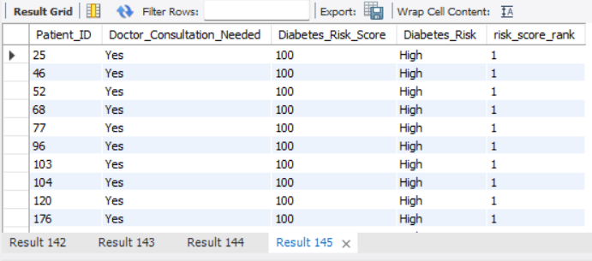
Interpretation
Among patients needing consultation, individuals are ordered by descending risk score. Rank 1 identifies the highest-scoring patient awaiting consultation and supports sequential triage.

Q72. Within each diabetes-risk category, how can patients be ranked according to their Diabetes_Risk_Score?
Difficulty: Difficult | SQL Concept: DENSE_RANK with PARTITION BY
Output Evidence
Interpretation
Patients are ranked by risk score inside each Diabetes_Risk category. The ranking enables within-category prioritisation for follow-up.

Q73. Which AI health recommendations have an average Diabetes_Risk_Score greater than the overall average Diabetes_Risk_Score?
Difficulty: Difficult | SQL Concept: VIEW with WHERE filtering and scalar subquery
Output Evidence
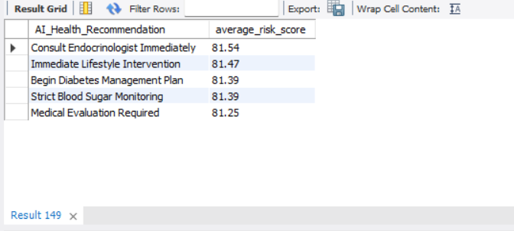Interpretation
Using the reusable view vw_ai_recommendation_summary, only those AI recommendations whose mean score exceeds the global average are retained. The result surfaces the higher-urgency recommendation categories.

Q74. Which patients requiring a doctor consultation have a Diabetes_Risk_Score greater than the average score of all patients requiring consultation?
Difficulty: Difficult | SQL Concept: Scalar subquery with WHERE
Output Evidence
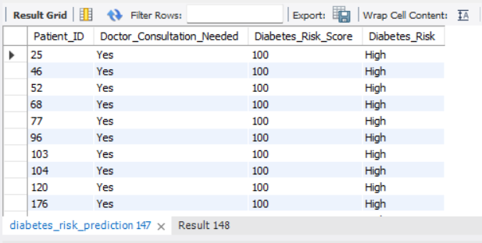
Interpretation
Consultation-flagged patients whose score exceeds the consultation-group mean are returned. This relative filter isolates the higher-risk segment inside the already large consultation cohort.

Q75. How can AI health recommendations be ranked according to both their average Diabetes_Risk_Score and the number of patients receiving each recommendation?
Difficulty: Difficult | SQL Concept: VIEW with multiple DENSE_RANK window functions
Output Evidence
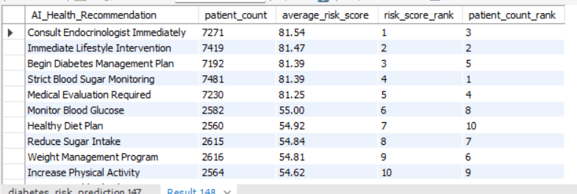
Interpretation
The same view is used to produce two independent rankings: one by average risk score and one by patient volume. The dual ranking allows the programme manager to balance urgency (score) against scale (volume) when allocating intervention resources.

9. Closing Reflection
The principal technical challenge was ensuring that every one of the 75 queries executed cleanly from a single script while satisfying the examination requirements for named columns, a single well-placed VIEW, accurate concept headers, and robust handling of potential nulls. Moving the VIEW immediately before its first use and making the multi-condition count in Q60 NULL-safe were the final refinements that produced a top-to-bottom error-free run.
The most striking analytical insight is the extreme skew of the risk distribution: 73 % of the 50,000 patients are already classified as High risk, and 93 % are flagged for doctor consultation. Within this high-burden population, HbA1c shows a clear stepwise increase across risk categories (5.67 → 7.54 → 8.86), current smoking is associated with a 5-point elevation in average risk score, and hypertension is linked to a nearly 6-point elevation. These patterns give the programme manager concrete, data-driven levers—glycaemic monitoring, smoking cessation and blood-pressure management—around which to design targeted prevention and screening activity.
Taken together, the five perspectives demonstrate that demographic, clinical, lifestyle and comorbidity factors can be systematically interrogated with a coherent set of SQL techniques, producing actionable evidence for a real decision-maker rather than merely technical demonstrations of syntax.
— End of Analytical Evidence Report —

