Subsitution Cipher Directions

In order for this program to work, you must first make a folder, it can be anywhere you want, but the easier to access the better. For example, make it on your desktop. You can name it whatever you want as well. I made mine on my desktop and named the folder java. You will also have to place the downloaded Sub_Cipher.java file into this folder.

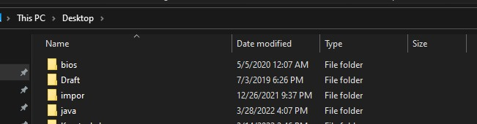

Next, you will want to make a txt file where you will put your own set of text into. I named mine

”input.txt“. After this, you will want to make another text file which you can also name whatever. I named that one ”output.txt”. The output text file will have the encrypted text generated onto it. Shown below is my example.

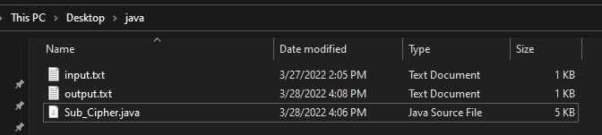

Next up, you will want to open up your command prompt. You will have to access wherever you stored your files. I stored mine in my desktop folder so you might have to type in something different. Shown below is how I accessed my java file.

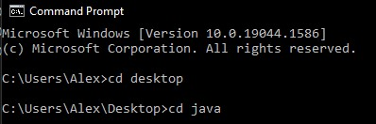

Next, you will access the java file by typing in ”javac Sub_Cipher.java”. This will generate a class. Next, you will want to run the file by typing in java Sub_Cipher.

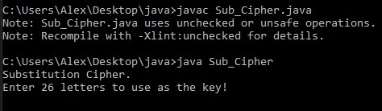

Next, you will want to enter 26 letters in any sort of combination you want. Shown below is what I typed in.



Once you have generated your key, the program will ask you to enter the location of your input.txt file.

Shown in the screenshot below is the location of the input.txt file being entered.



Once that has been completed, you will have to enter the location of the output.txt file in order for the program to generate the encrypted text onto it. You will have to enter two \\’s instead of one. Shown below is my example of how I entered my output.txt location.



Once you enter the location of it, the program will prompt you to enter the location of the output.txt file in order to run the letter frequency analysis.



The program will then print out the analysis, as well as the ciphertext and plaintext.

