Abu Khan
Home Work 1

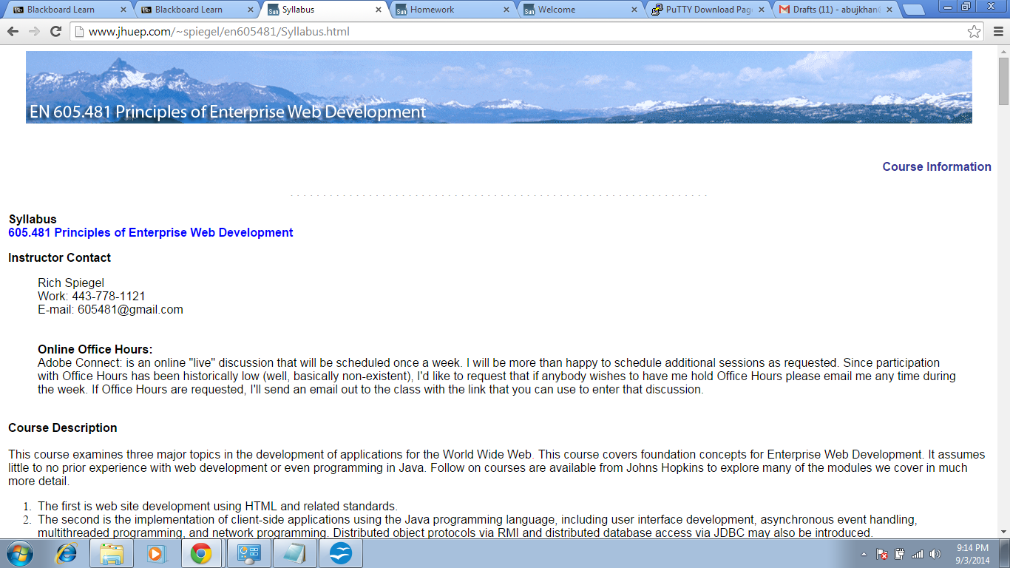
Fig.1 Screen Shot of the Syllabus Page

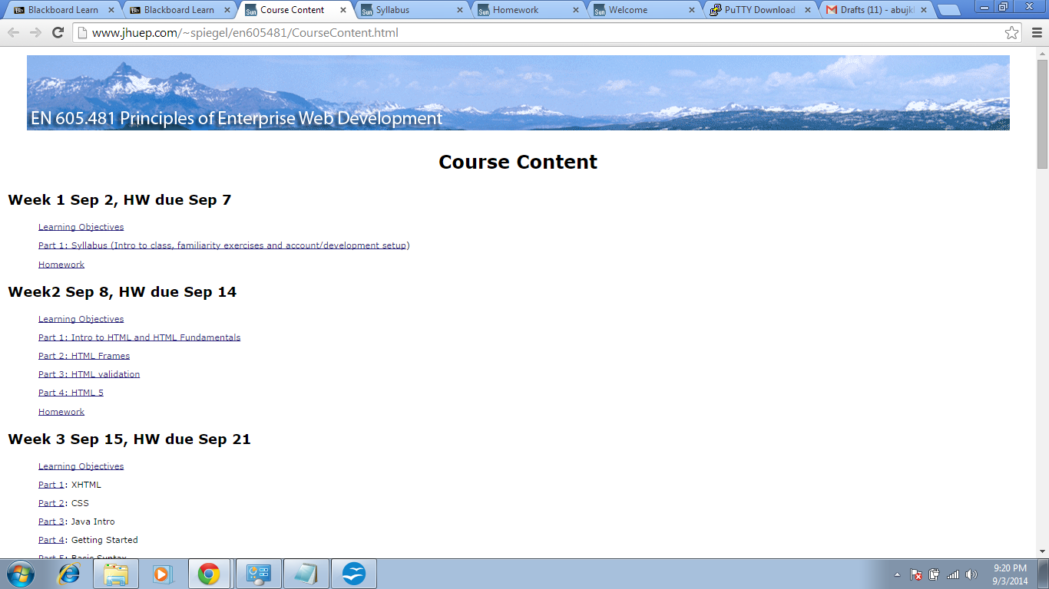
Fig.2 Screen Shot of the Course Outline Page

