HomeWork 3
by
Abu Khan
9/18/2014

Url for the deployed xhtml site:

http://web6.jhuep.com/~mkhan49/homework3/index.html

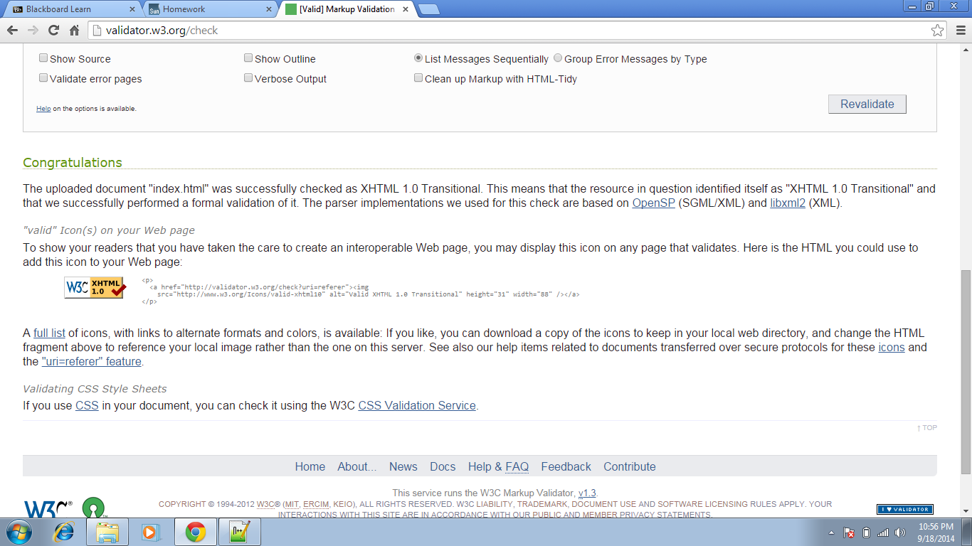
Fig. 1. XHTML Validation Result for the index.html page

Fig 2. CSS Validator results for style.css

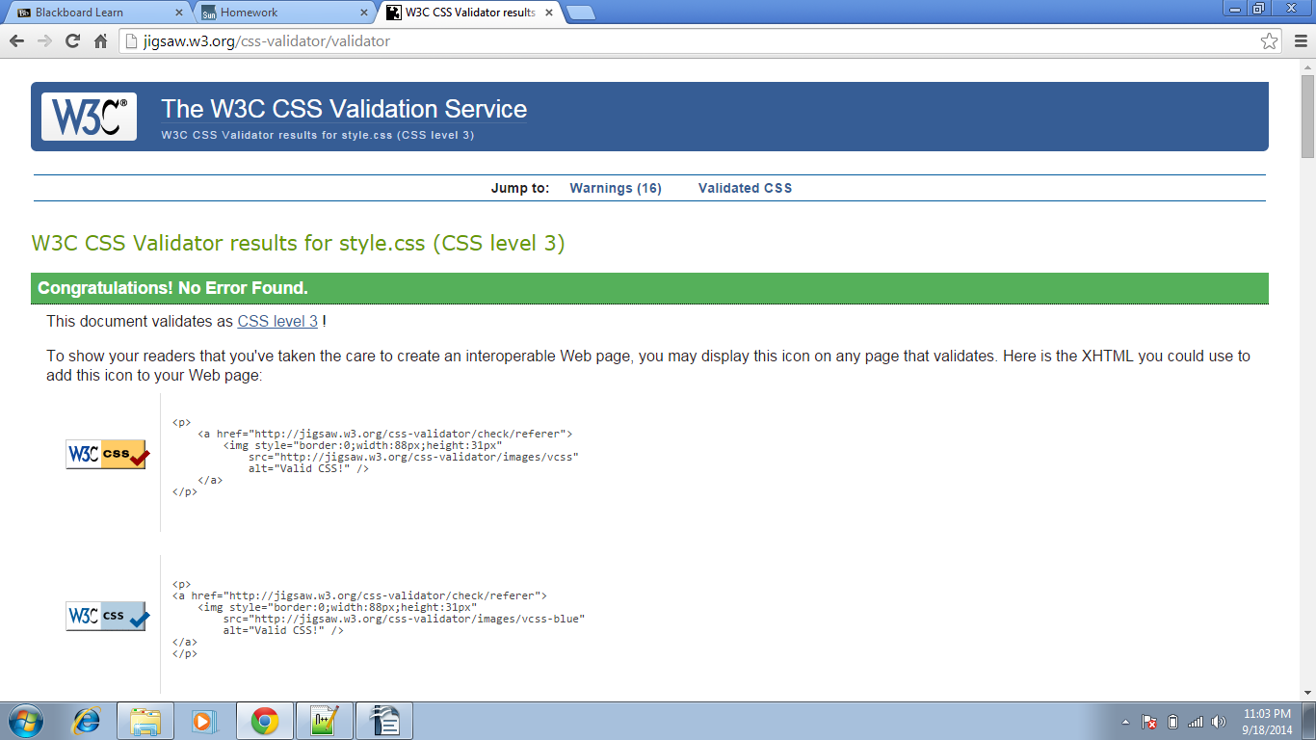

JavaSource files: AbuKhan_Homework3.zip

Class name: Calculate (in Calculate.java file)
Class name with main method (for testing): TestCalculate (in TestCalculate.java file)

Fig 3. Result of program run of two integers, 40 and -50

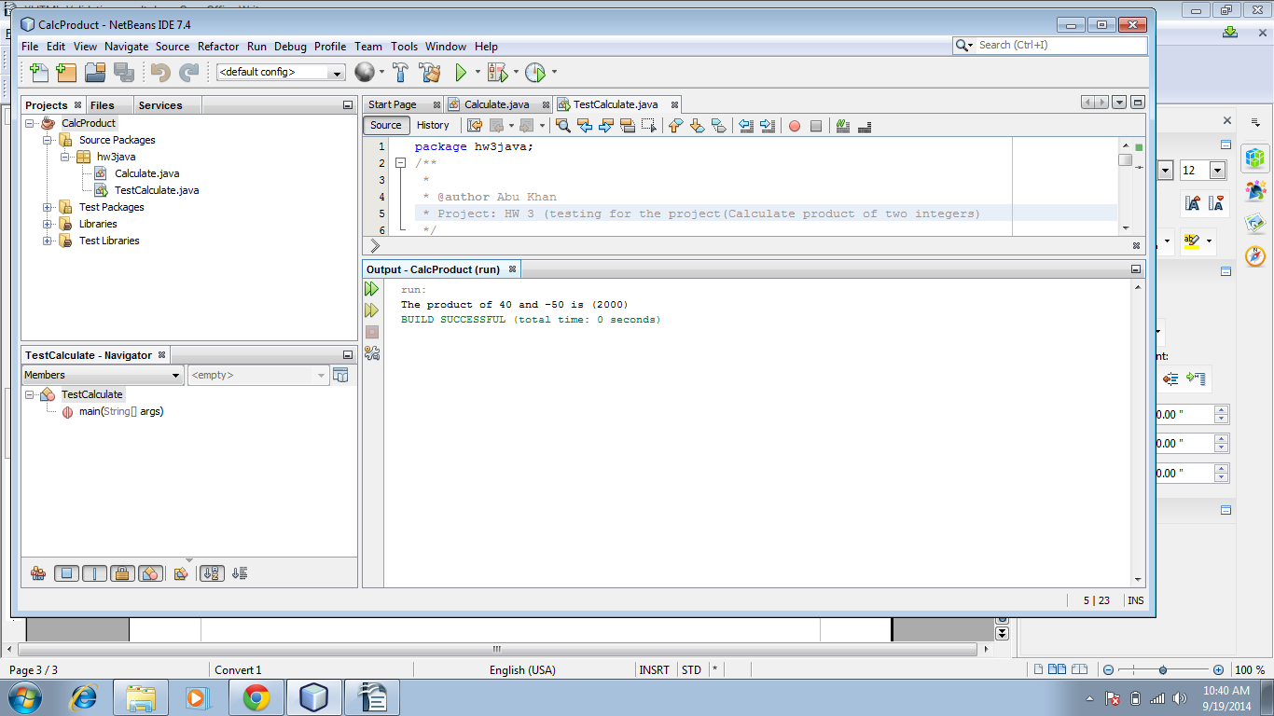

Fig 4. Result of Program run of two integers 40 and 20
