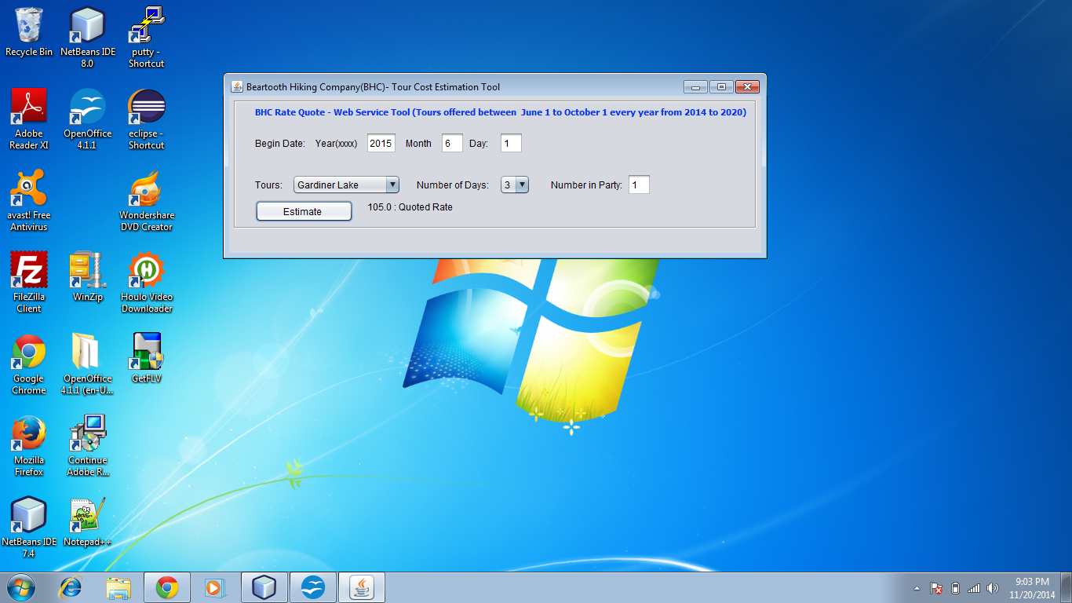
Fig.1. Web Service call result (good data)

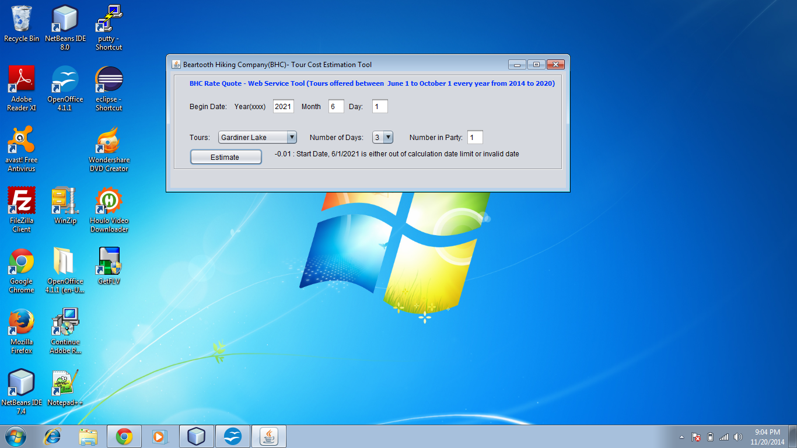
Fig.2 Web Service call result(bad data)

