Princess Sumaya University for Technology

King Abdullah II Faculty of Engineering

Electrical Engineering Department



|  |
| --- |
| **Embedded Systems 22442**  **Final Project Report**  **Greenhouse Control System**  **Fall 2022** |

|  |  |  |  |
| --- | --- | --- | --- |
| *Authors:* |  |  | *Supervisor:* |
| Laith AlKhdour  Omar Abujumaa  Mutaz Azzam | 20190130  20190561  20190683  Group no. 8 | Computer Engineering  NIS Engineering  Computer Engineering | Dr. B. Sababha |

*January22, 2023*

***Abstract***

*This project was built with the PIC16F877A controller as the core microcontroller that controls an autonomous Greenhouse to stabilize the inner atmosphere that meets the requirements of the plants. For each second that passes, the water pump allows the flow of water to the plant for 0.5 sec, considering that the plant should be irrigated every such amount of time. The servo motor will be rotating 900 anticlockwise whenever the LDR, connected to RB0, senses light, and return to its origin point at dark. The LCD will display the temperature, which will be detected by a temperature sensor,and the state of the servo motor.*

Table of Contents

1 Introduction 2

1.1 Components 2

1.2 Design 2

1.3 Equations Guidelines 4

2 Problems and Recommendations 5

2.1 LCD delays 5

2.2 Water pump 6

2.3 Temperature sensor readings 6

2.4 Difficulty in moving the ceiling 6

3 Conclusions 6

4 References 7

# Introduction

The greenhouse could be thought of as a shelter for plants from extreme and devastating weather conditions [1]. This project is aimed to build a PIC microcontroller (MCU) autonomous system that controls the internal atmosphere of a greenhouse. PIC16F877A MCU will be used and will be the core component of the system that controls different peripherals used.

## Components

* 1 PIC16F877A
* 1 LM35 (temperature sensor)
* 1 3-5V water pump
* 1 16X2 LCD display
* 1 servo motor
* 1 Breadboard
* 1 LDR (light-dependent sensor)
* Wires (male-male, female-male)
* 1 TIP31 (NPN transistor)

## Design

Figure 1 shows a schematic diagram of the model.A servo motor will be responsible for opening /and closing the ceiling. When there is sufficient sunlight outside, the servo motor will be rotated 90o anticlockwise and wait for some amount of time before rotating back clockwise. The LDR sensor will be connected to RB0. When the light intensity increases, the resistance decreases [2]. This increases the current passing through the voltage divider circuit connected to RB0 (a schematic diagram is shown in figure 1). As a result, the voltage drop will increase and the voltage at the point connected to RB0 will decrease exponentially. Figure 1 shows how the light intensity affects the resistance.

A 3–5 volt water pump will be used to pump water to the plant every amount of time. TMR0 interrupt will be responsible for such timing. Every 1 ms, TMR0 will overflow, causing an interrupt. The water pump will be connected to a collector of a transistor, while RB3 will have the base of the transistor connected to it.

The LCD will be used to display the temperature inside the greenhouse in Celsius. The temperature will be measured with an LM35 temperature sensor. Details into how the LM35 sensor’s functionality and voltage conversions are described in section 1.3. Figure 3 shows a simplified flow chart of the model.

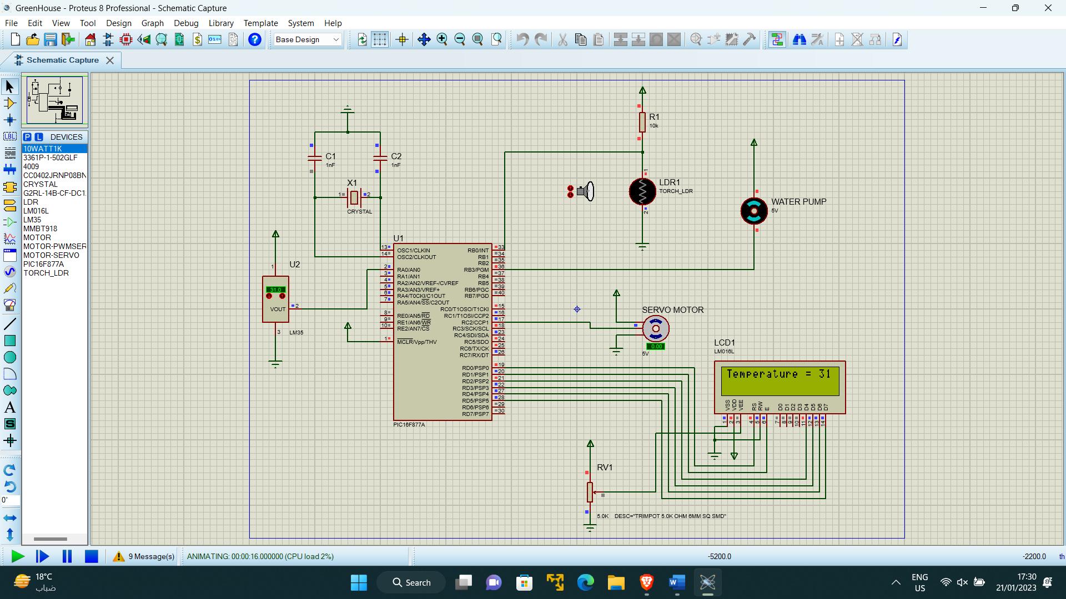

Figure 1 Schematic Diagram

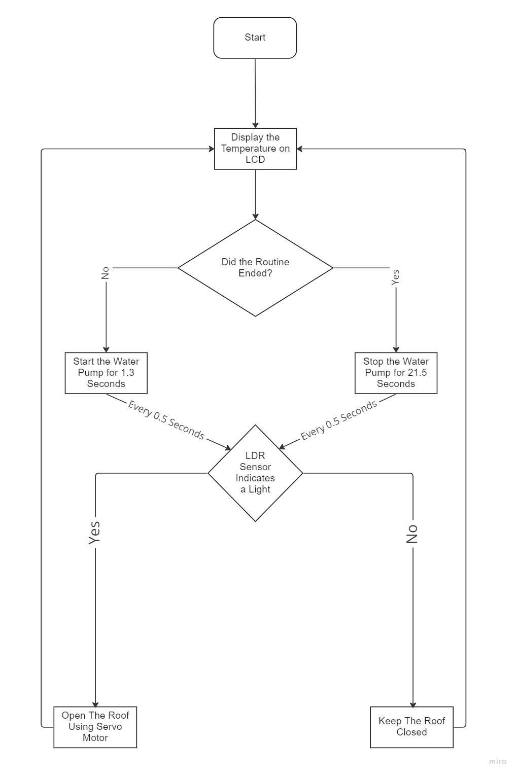

Figure 2 Flow chart

## Equations Guidelines

1. TMR0 interrupt

The frequency of the oscillator used is 8MHz. By doing the math, we can conclude that TMR0 will increment every 0.5 us. By setting the Prescaler to 256, TMR0 will increment every 128 us. To let it overflow every 1 ms, we will need to initialize TMR0 to 248. Every 8 increments take roughly 1 ms (1.024 ms). Accordingly, TMR0 will be initially set to 248 and will cause an interrupt every 1 ms.Every time TMR0 overflows, it should be initialized again to 248. This is because when TMR0 overflows, it will return to 0 and starts incrementing from there. This causes irrelevant functionality of the model.

1. TMR1 interrupt

TMR1 has similar functionality as TMR0, but with some differences. TMR0 is an 8-bits register, while TMR1 is a 16-bit register [3]. This provides flexibility with using time delays since it can be used for providing longer time intervals before causing an interrupt. The TMR1 register is divided into 2 flags; TMR1H and TMR1L [4]. For this project, both TMR1H and TMR1L will be initialized to 0. The aim of using TMR1 is to provide the servo motor with the required signal safely.

1. Temperature sensor

LM35 sensor is used to measure the temperature of the surrounding. Any change in the temperature of the surroundings leads to a change in voltage readings by the sensor. Equation 1 shows the voltage change of the sensor leads to a change in the temperature readings.

$$T=\frac{r*4.88}{10.0}×100 -(1)$$

Where T – temperature (in C)

r – result (which is read by ADC_read)

1. INTCON register.

INTCON register is given the value A0H. The first 4 bits on the right clearall the flags that an interrupt has occurred. GIE and TOIE are set to 1 to enable the TMR0 and Global interrupt

1. OPTION_REG

Use Fosc/4 to trigger TMR0, (Fosc=8MHz) TMR0 will increment every 0.5us. ThePrescaleris set to 256. This makes TMR0 interrupt increments every 128 us. For the TMR0 to overflow every 1 ms, we need to set it to 248. This makes TMR0 overflow every 1 ms.

1. PIE1

This register is set to 04H to allow the CCP1 interrupt. This turn the CCP to RC2, which will be connected to the servo motor.

# Problems and Recommendations

## LCD delays

LCD will take some time before displaying any change in the temperature that was read by the sensor. The LCD code is written in the main function, and every time TMR0 or TMR1 overflows, an interrupt is triggered, creating some delays before the execution of the remaining code of the LCD.

For this issue to be resolved, it is highly recommended to minimize the usage of Timers interrupts. However, due to the presence of a servo motor, TMR1 was needed.

## Water pump

The water pump used in this experiment works in a voltage range of 3-5 volts. This ensures that no intermediary device is required to be connected between the MCU and the pump. However, the pump did not work as desired, despite the efficiency of the code when programmed on the training kit.

This problem could be solved by using an NPN transistor. The water pump should be connected to the collector of the transistor, and the base will be connected to the port of the MCU.

## Temperature sensor readings

The temperature reading displayed on the LCD was changing illogically. Between each reading and the one preceding it, there was a huge difference. Such readings do not reflect the actual temperature change of the surrounding.

For this problem to be resolved, double-check the equation used to convert the voltage read of the temperature sensor to temperature. If the problem still exists, then the problem may arise due to a fault in the sensor used.

## Difficulty in moving the ceiling

The servo motor was incapable of lifting the ceiling, despite using soft-weight material in building it. This could be due to the thickness of the ceiling used.

This problem could be resolved by using thinner material. This ensures that the servo motor rotates without showstoppers. If this problem does not get resolved, then use lighter materials.

# Conclusions

After designing the system and testing its functionality, we can conclude that the model made can be enhanced and modified to improve its efficiency and introduce additional functions and capabilities. However, the idea can be helpful in the intervention of computers and technology in the agriculture field and can provide substantial assistance in operating the model.

# References

|  |  |
| --- | --- |
| [1] | "What is a Light Dependent Resistor and Its Applications," WatElectronics.com, [Online]. Available: https://www.watelectronics.com/light-dependent-resistor-ldr-with-applications/. |
| [2] | "greenhouse," Britannica, The Editors of Encyclopaedia., 30 May 2019. [Online]. Available: https://www.britannica.com/topic/greenhouse. |
| [3] | "PIC16F877A timer," OpenLab pro, [Online]. Available: https://openlabpro.com/guide/pic16f877a-timer/. |
| [4] | "PIC16F877A Timer1 module and interrupt with CCS C compiler," Simple Projects, [Online]. Available: https://simple-circuit.com/pic16f877a-timer1-module-interrupt/. |