App Dev Project Report

1. Student Details
Name: [Your Name] Roll Number: [Your Roll Number] Email: [Your Email] About Me: [Brief description about yourself]

2. Project Details

Project Title: Hospital Management System (HMS)

Problem Statement:
To design and build a web-based application that streamlines hospital operations by managing doctors, patients, appointments, and medical records. The system aims to facilitate efficient healthcare delivery, reduce administrative overhead, and improve the overall patient experience through digital appointment booking and record keeping.

Approach:
The app was built using Flask as the backend framework with a modular structure using Blueprints. The frontend is developed with Vue.js 3 and Vite for a modern, responsive user interface. The system implements Role-Based Access Control (RBAC) to distinguish between Admins, Doctors, and Patients. Background tasks are handled using Celery and Redis for performance optimization.

3. AI/LLM Declaration
I used AI tools to assist in generating boilerplate code, debugging complex errors, and formatting documentation. The extent of AI/LLM usage is around 10–15%, limited to code suggestions and documentation formatting. All final implementation logic, debugging, and integration were done manually.

4. Technologies and Frameworks Used
Technology / Library | Purpose
Flask | Core backend web framework
SQLAlchemy | Object Relational Mapper for SQLite database
Flask-JWT-Extended | User authentication and secure session management (JWT)
Celery & Redis | Asynchronous background job processing
Vue.js 3 | Frontend JavaScript framework for building the UI
Vite | Frontend build tool and development server
Bootstrap 5 | Frontend styling and responsive design
SQLite | Lightweight local database for storing application data

5. Database Schema / ER Diagram
Tables:
- User — stores user authentication details (id, username, email, password_hash, role, is_active)
- Department — stores hospital departments (id, name, description)
- Doctor — stores doctor profiles linked to users (id, user_id, department_id, experience_years, availability)
- Patient — stores patient profiles linked to users (id, user_id, date_of_birth, contact_number, address)
- Appointment — logs appointments between doctors and patients (id, doctor_id, patient_id, date, time, status)
- Treatment — stores medical records for appointments (id, appointment_id, diagnosis, prescription, notes, date_created)
Relationships:
- One-to-One → User → Doctor
- One-to-One → User → Patient
- One-to-Many → Department → Doctor
- One-to-Many → Doctor → Appointment
- One-to-Many → Patient → Appointment
- One-to-One → Appointment → Treatment
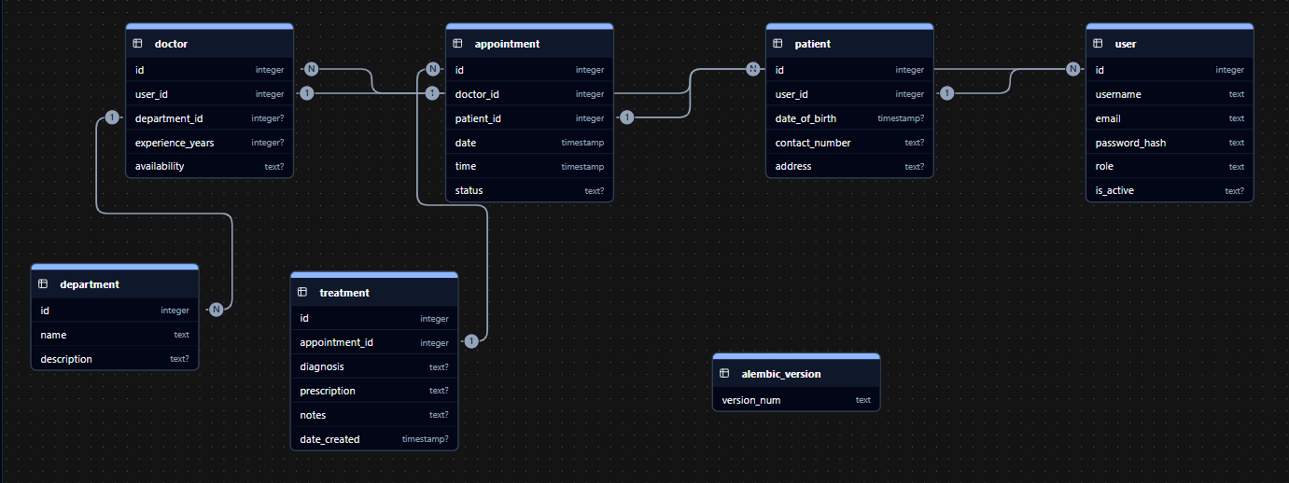

6. API Resource Endpoints
Endpoint | Method | Description
/login | POST | Authenticate user and return JWT access token
/register | POST | Register a new user (Patient role by default)
/api/patient/doctors | GET | Search for doctors by department
/api/patient/appointments | GET | Fetch all past and upcoming appointments for the logged-in patient
/api/patient/appointments | POST | Book a new appointment with a doctor
/api/patient/profile | GET/PUT | Retrieve or update patient profile details
/api/admin/departments | GET/POST | Manage hospital departments
YAML API Definition File: Included separately in the submission ZIP as api.yaml.

7. Architecture and Features

Architecture Overview:
- backend/app.py – Main Flask application entry point and configuration.
- backend/models.py – Database models defined using SQLAlchemy.
- backend/routes/ – Flask Blueprints separating logic for Auth, Patient, Doctor, and Admin.
- frontend/src/ – Vue.js source code including Components, Views, and Router.
- celery_worker.py – Entry point for Celery background workers.

Implemented Features:
- User Authentication: Secure login and registration with password hashing and JWT.
- Role-Based Access: Distinct portals for Admins, Doctors, and Patients.
- Appointment Booking: Patients can search for doctors and book appointments.
- Medical Records: Doctors can add diagnoses and prescriptions to appointments.
- Profile Management: Users can update their personal and contact information.
- Responsive UI: A clean and mobile-friendly interface built with Bootstrap 5.
- Background Jobs: Asynchronous tasks handled by Celery (e.g., email notifications, reminders).

8. Video Presentation
Drive Link: [Insert your Google Drive Video Link Here] (Accessible to all with “View” permission.)

