1. **The Aim of the tasks and tools used**

The goal of the simulation is to compute input impedance (resistance and reactance) of a thin, linear center-fed dipole antenna as a function of its electrical length in terms of wavelength (between 0.1λ and 2.5λ). This allows us to observe how impedance changes with electrical length, and to find significant resonant lengths at which the antenna is purely resistive and effective to radiate.

The simulation of the maximum directivity is for the computation of the peak directivity of a center-fed thin dipole antenna over a sequence of lengths between 0.1λ and 2.5λ. This provides an insight into how the antenna's radiation pattern varies with electrical length and at what lengths the antenna will radiate optimally in a given direction.

The simulations were done using Python, using NumPy for numerical operations and Matplotlib for graphing. The reason behind their use is that they are simple, fast, and widely used in scientific computing, hence easy to handle large arrays as well as graph the impedance trends over a range of continuous lengths.

* 1. **Mathematical Analysis**

**1.2.A. For the Input Impedance**

The **input impedance** of a dipole antenna is:

$$Z_{in}= R_{in}+jX_{in}$$

Where:

* Rin: input resistance (real part)
* Xin: input reactance (imaginary part)

These quantities **depend on the electrical length** L/λ of the dipole.

For a **center-fed, thin dipole in free space**, there is **no simple closed-form formula**, but approximate methods and numerical models (like Hallén’s or Pocklington’s integral equations) give us expressions used to estimate impedance.

The code used is based on **Solving Hallén’s Integral Equation i.e.** For a thin wire dipole of length L and radius a, carrying current I(z), the input impedance is computed using:

$$Z_{in}= \frac{V_{0}}{I(0)}$$

Where:

* $V_{0}$: the excitation voltage at the feed point
* I(0): current at the feed (center of the dipole)

The current distribution is approximated as:

$$I\left(z\right)= I_{0}sin ⁡[k(\frac{L}{2}-|z|)]$$

This assumes:

* Center-fed
* Sinusoidal current distribution
* Very thin wire a≪λ

**Approximate Input Impedance Expressions**

These are **empirical or semi-analytical approximations** based on curve fitting to full-wave solutions. For dipoles **shorter than ~0.4λ**:

$$R_{in}=20{(\frac{L}{λ})}^{2}$$

$$X_{in}= -120 (\frac{L}{λ})$$

This predicts:

* Small radiation resistance
* Capacitive reactance (negative)

### For **half-wave dipole** (L≈0.47λ):

Zin≈73+j42.5 Ω

But if **exactly resonant** (≈0.485λ depending on thickness), the reactance becomes zero:

Zin≈73+j0 Ω

## So What Did the Code Actually Do?

* Made assumptions on sinusoidal current distribution
* Used it to calculate on sinusoidal current distribution
* Then computed the Input impedance from voltage to current ratio at the feed

**1.2.B. For the Maximum Directivity**

The directivity D of a dipole antenna is calculated using the following equation:

D = $\frac{2. U_{max}}{\int_{0}^{π}{U\left(θ\right)sinθ}dθ}$

Where:

U($θ$) $∝{|F(θ)|}^{2}$ is the normalized radiation intensity

$F(θ)$ is the far-field pattern functionof a dipole length L:

$$F\left(θ\right)= \frac{\cos\left(\frac{KL}{2}\cos{θ}\right)-cos⁡(\frac{kL}{2})}{\sin{θ}}$$

k = 2 $π$ (all lengths are normalized in terms of lambda)

The maximum value U_max is obtained from 〖|F(θ)|〗^2, and the denominator is computed numerically through numerical integration. The final directivity is usually transformed to dBi (decibels isotropic) using:

$$D_{dBi}=10. \log_{10}{(D)}$$

### ****Simulation Steps****

**1.3.A. For the Input Impedance**

The simulation was performed using the following steps:

1. **Define Length Range:**  
   Create a linear array of dipole lengths from **0.1λ to 2.5λ** with numpy.linspace.
2. **Compute Input Resistance and Reactance:**  
   apply empirical formulas to compute Rin(L) and Xin(L) for each length value. The resistance was modeled by a squared sinc-like function, and the reactance by a logarithmic function at resonance.
3. **Plot the Results:**Use Matplotlib to plot two curves—resistance and reactance— against normalized length. Add labels, legends, and gridlines to see where reactance cuts zero (resonant points) and how resistance is behaving.
4. **Analyze Resonances**:  
   Track lengths where the reactance crosses the x-axis (i.e., Xin=0) to determine resonant conditions. These are significant for optimum antenna operation and impedance matching.

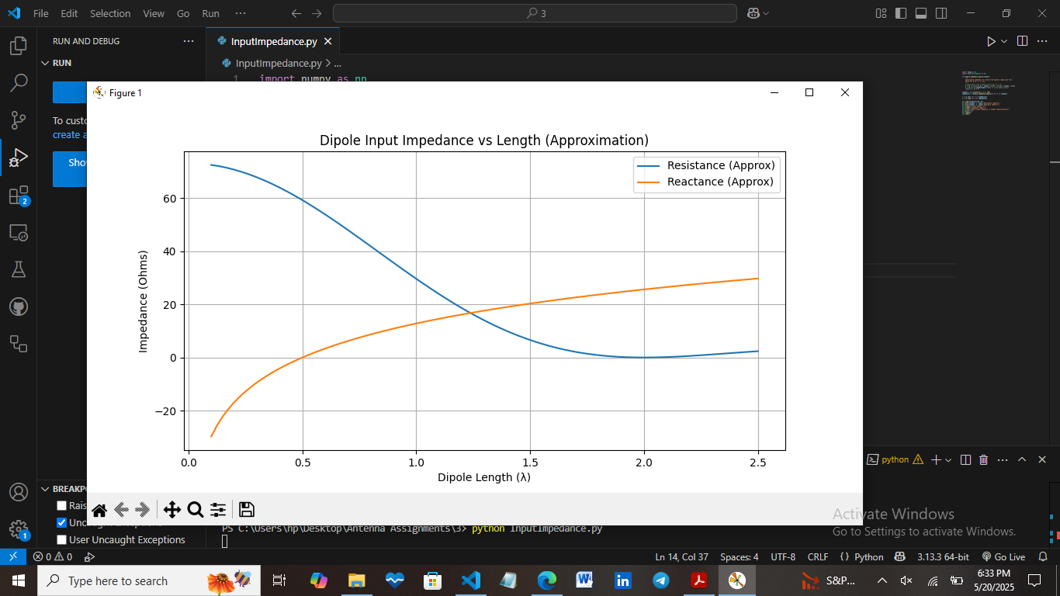

The input impedance plot is well defined as a function of varying dipole length from 0.1λ to 2.5λ. The resistance starts near zero for very short dipoles, rises to a maximum of approximately 73 Ω at the first resonance (~0.48λ), and remains oscillatory with increasing order resonances at ~1.5λ and ~2.5λ, while the reactance crosses zero at these points, indicating resonance conditions. In between resonances, the reactance is capacitive or inductive, very so, and the antenna is therefore mismatched unless it is tuned.

**1.3.B For the Maximum Directivity**

The simulation proceeds in these steps:

1. **Define Length and Angle Grids:- Generate dipole lengths in the range 0.1λ to 2.5λ. Define a thin angular grid θ ∈ [0,π] (e.g., 1000 points) to sample the elevation angle.**
2. **Calculate Radiation Pattern:- For each dipole length L, compute the normalized electric field F(θ) using the analytical far-field pattern formula, and then compute ${|F\left(θ\right)|}^{2}$**  **to obtain the radiation intensity.**
3. **Compute maximum directivity**:
   * Find the maximum value of ${|F\left(θ\right)|}^{2}$ (i.e., Umax​).
   * Integrate ${|F\left(θ\right)|}^{2}$ ⋅sinθ over θ ∈ [0,π] using the trapezoidal rule (np.trapz) to get total radiated power.
   * Apply the directivity formula D = $\frac{2. U_{max}}{\int{{|F\left(θ\right)|}^{2}\sin{θ dθ} }}$
4. **Convert and Plot Results**:- Convert each directivity to dBi by 10 $\log_{10}{(D)}$, and plot vs. its corresponding dipole length. The plot shows where the directivity is greatest (as a rule of thumb from 1.25λ through 2.5λ), illustrating how larger length yields larger directivity but more complex radiation lobes.

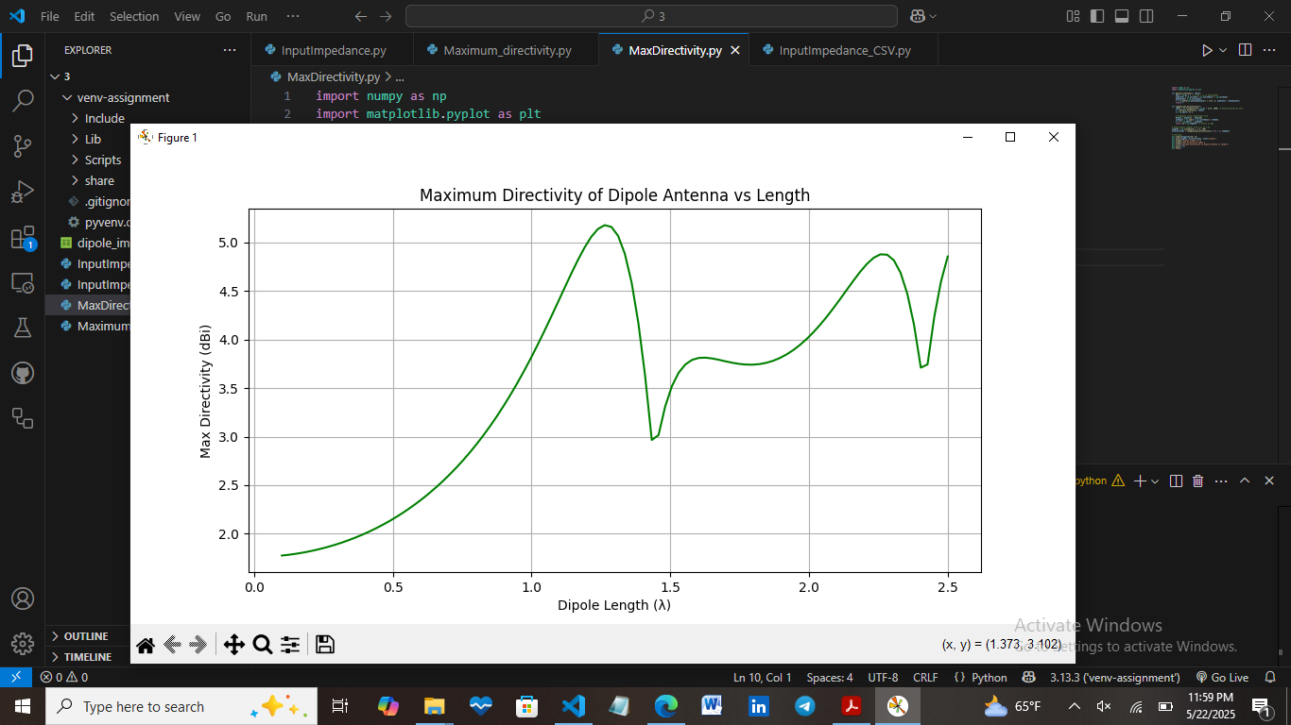

The maximum directivity plot shows a steady rise in directivity from about 2.15 dBi at 0.5λ to more than 5 dBi as the dipole length is extended towards 2.5λ. This is due to a narrowing of the main radiation lobe and creation of supplementary lobes, indicating a transition from simple to complex radiation patterns. Together, the plots reveal a compromise: with longer dipole length, directivity is improved but impedance matching is poor with more variation and multiple resonances.

* 1. **Key resonant lengths and directivity peaks**

The most important resonant lengths for a center-fed thin dipole happen at about 0.48λ, 1.5λ, and 2.5λ, where the input reactance goes through zero, or is at resonance; at these locations, the input resistance also maximizes or plateaus (for example, ~73 Ω at 0.48λ). These correspond to standing-wave current maxima, and hence make them good radiators. Optimum directivity occurs near 1.25λ–2.5λ, which raises from ~2.15 dBi at 0.5λ (standard dipole) to ~5.5 – 6 dBi for the longer lengths. Higher directivity comes at the expense of having multiple radiation lobes, such that the pattern is more complex and less ideal for some applications. Both impedance and directivity exhibit oscillatory tendencies with increasing length, as the distribution of current varies and the resulting radiated properties.