一、实验内容：

系统框架：

主要由五个页面组成: register.jsp 、Index.jsp、buycar.jsp、realCar.jsp、selfInfo.jsp
register.jsp注册
已实现：
注册账号、完善个人信息
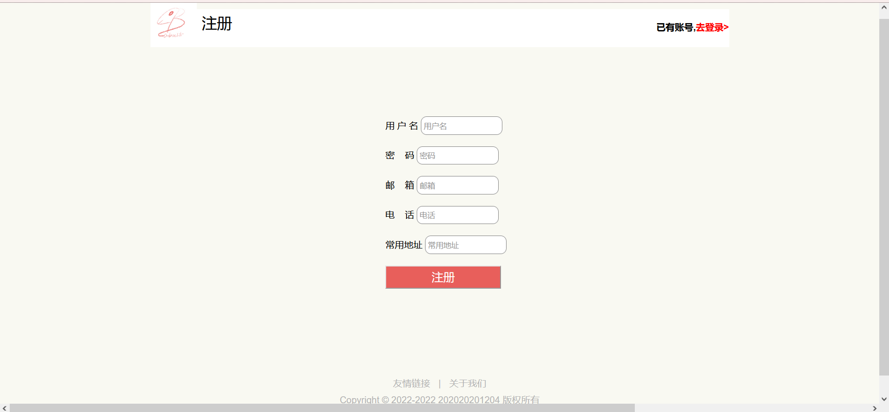
Index.jsp主页
由三部分组成，其中已实现：
点击相应功能实现页面跳转，搜索商品类别
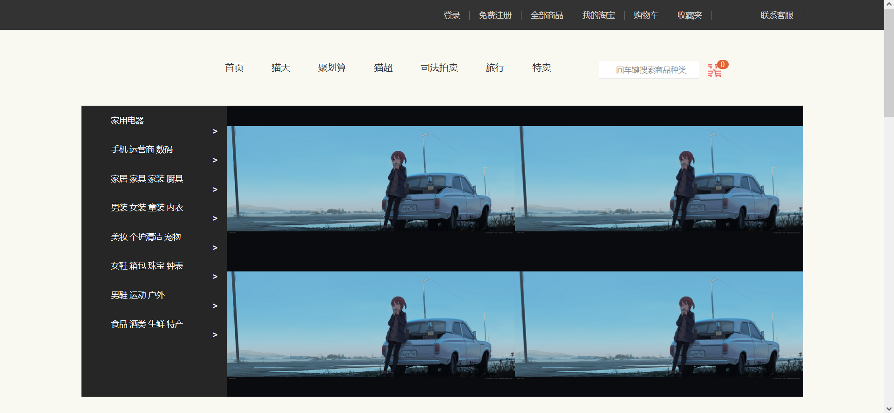
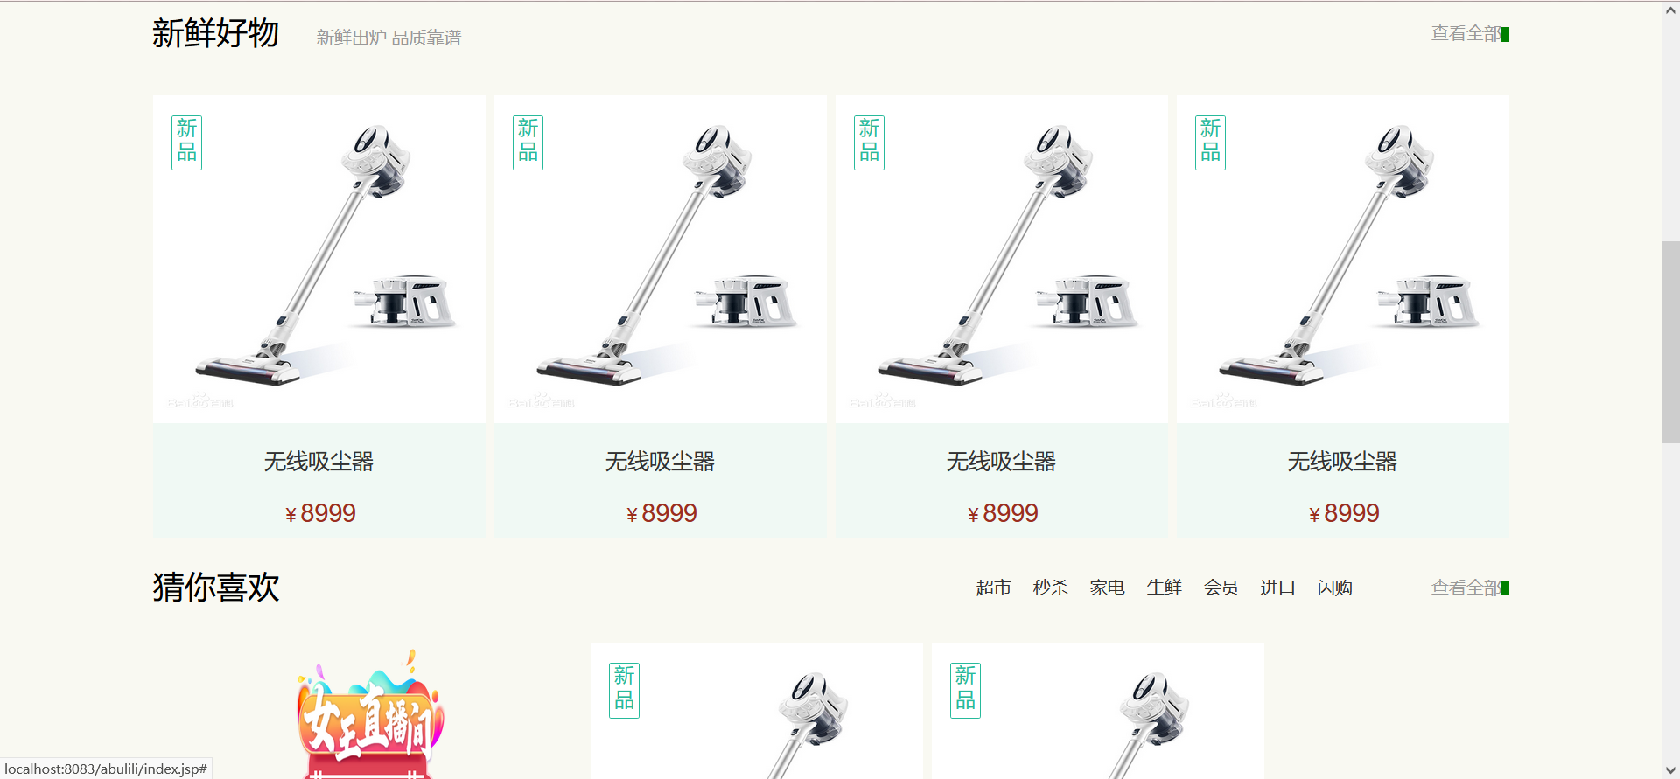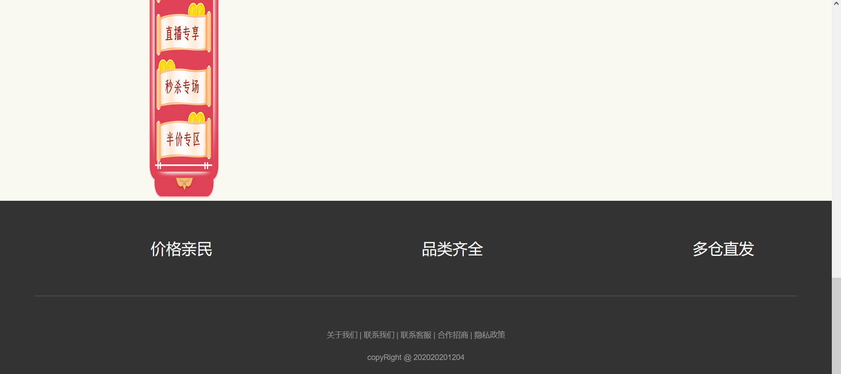
<%@ page language="java" contentType="text/html; charset=UTF-8"
pageEncoding="UTF-8"%>
<!DOCTYPE html>
<html>
<head>
<meta charset="UTF-8">
<title>Insert title here</title>
<link rel="stylesheet" href="css/bootstrap.css" type="text/css" />
<!--引入JQuery的JS文件：JQuery的JS文件要在BootStrap的js的文件的前面引入-->
<script type="text/javascript" src="js/jquery-1.11.3.min.js"></script>
<script type="text/javascript" src="js/vue.js"></script>
<!--引入BootStrap的JS的文件-->
<script type="text/javascript" src="js/bootstrap.js"></script>
<link rel="stylesheet" type="text/css" href="./css/base.css">
<link rel="stylesheet" type="text/css" href="./css/common.css">
<link rel="stylesheet" type="text/css" href="./css/index.css">
<style>
body{
margin: 0;
padding: 0;
}
.lunbo{
width:100%;
height:720px;
background-image: url(./image/1.png);/*背景图片*/
background-size:100% 100%;
}
</style>
</head>
<body>
<div class="shortcut">
<div class="wrapper">
<!-- 因为每一个a都相同 -->
<ul>
<li>
<%
if(session.getAttribute("user")!=null)
{
String uname=(String)session.getAttribute("user");
out.print("<a href='DoInvalidate'>欢迎"+uname + " 注销</a>");
}
else
{
out.print("<a href='login.jsp'>登录</a>");
}
%>
</li>
<li><a href="register.jsp">免费注册</a></li>
<li><a href="buycar.jsp">全部商品</a></li>
<li><a href="selfInfo.jsp">我的淘宝</a></li>
<li><a href="realCar.jsp">购物车</a></li>
<li><a href="#">收藏夹</a></li>
<li><a href="#"><span></span>联系客服</a></li>
</ul>
</div>
</div>
<div class="header wrapper">
<div class="logo">
<h1><a href="index.jsp">购物网站</a></h1>
</div>
<div class="nav">
<ul>
<li><a href="index.jsp">首页</a></li>
<li><a href="#">猫天</a></li>
<li><a href="#">聚划算</a></li>
<li><a href="#">猫超</a></li>
<li><a href="#">司法拍卖</a></li>
<li><a href="#">旅行</a></li>
<li><a href="#">特卖</a></li>
</ul>
</div>
<div class="search">
<input type="text" placeholder="回车键搜索商品种类" id="input" onkeydown="if(event.keyCode==13) dosome()" style="width:100%">
<span></span>
<script type="text/javascript">
var dosome = function(){
document.location.href ='doSerach.jsp?species=' + $("#input").val();
return false;
}
</script>
</div>
<div class="car">
<span>0</span>
</div>
</div>
<!-- banner -->
<div class="banner">
<div class="wrapper">
<!-- 图 -->
<ul>
<li><a href="#"><img src="/study/app.jpg" alt=""></a></li>
</ul>
<!-- 侧导航 -->
<div class="aside">
<ul>
<li><a href="#"><span>家用电器</span></a></li>
<li><a href="#"><span>手机 运营商 数码</span></a></li>
<li><a href="#"><span>家居 家具 家装 厨具</span></a></li>
<li><a href="#"><span>男装 女装 童装 内衣</span></a></li>
<li><a href="#"><span>美妆 个护清洁 宠物</span></a></li>
<li><a href="#"><span>女鞋 箱包 珠宝 钟表</span></a></li>
<li><a href="#"><span>男鞋 运动 户外</span></a></li>
<li><a href="#"><span>食品 酒类 生鲜 特产</span></a></li>
</ul>
</div>
<ol class="lunbo"></ol>
<script type="text/javascript">
var index = 1;
function lunbo(){
index ++ ;
//判断number是否大于3
if(index > 2){
index = 1;
}
//获取img对象
var img = document.getElementsByClassName("lunbo")[0];
img.style.background = "url(./image/"+index+".png)";
img.style.backgroundSize="50% 50%";
}
//2.定义定时器
setInterval(lunbo,4000);
</script>
</div>
</div>

<!-- 新鲜好物 -->
<div class="goods wrapper">
<!-- hd headder 头部 -->
<div class="hd">
<h2>新鲜好物<span>新鲜出炉 品质靠谱</span></h2>
<a href="#">查看全部</a>
</div>
<div class="bd clearfix">
<ul>
<li>
<a href="#">
<img src="./image/吸尘.png" alt="">
<h3>无线吸尘器</h3>
<div>￥<span>8999</span></div>
<b>新品</b>
</a>
</li>
<li>
<a href="#">
<img src="./image/吸尘.png" alt="">
<h3>无线吸尘器</h3>
<div>￥<span>8999</span></div>
<b>新品</b>
</a>
</li>
<li>
<a href="#">
<img src="./image/吸尘.png" alt="">
<h3>无线吸尘器</h3>
<div>￥<span>8999</span></div>
<b>新品</b>
</a>
</li>
<li>
<a href="#">
<img src="./image/吸尘.png" alt="">
<h3>无线吸尘器</h3>
<div>￥<span>8999</span></div>
<b>新品</b>
</a>
</li>
</ul>
</div>
</div>
<!-- 生鲜 -->
<div class="shengxian wrapper">
<div class="hd">
<h2>猜你喜欢</h2>
<a href="#" class="more">查看全部</a>
<ul>
<li><a href="#">超市</a></li>
<li><a href="#">秒杀</a></li>
<li><a href="#">家电</a></li>
<li><a href="#">生鲜</a></li>
<li><a href="#">会员</a></li>
<li><a href="#">进口</a></li>
<li><a href="#">闪购</a></li>
</ul>
</div>
<div class="clearfix goods">
<div class="left" style="float:left;">
<a href="#"><img src="./image/leftt.png" style="width:400px;height:800px" alt=""></a>
</div>
<div class="right bd" style="float:left;">
<ul>
<li>
<a href="#">
<img src="./image/吸尘.png" alt="">
<h3>无线吸尘器</h3>
<div>￥<span>8999</span></div>
<b>新品</b>
</a>
</li>
<li>
<a href="#">
<img src="./image/吸尘.png" alt="">
<h3>无线吸尘器</h3>
<div>￥<span>8999</span></div>
<b>新品</b>
</a>
</li>
</ul>
</div>
</div>
</div>
<!-- 版权区域 -->
<div class="footer">
<div class="wrapper">
<div class="top">
<ul>
<li>
<!-- 通过伪元素添加标签实现精灵图 -->
<span>价格亲民</span>
</li>
<li>
<span>品类齐全</span>
</li>
<li>
<span>多仓直发</span>
</li>
</ul>
</div>
<div class="bottom">
<p>
<a href="#">关于我们</a> |
<a href="#">联系我们</a> |
<a href="#">联系客服</a> |
<a href="#">合作招商</a> |
<a href="#">隐私政策</a>
</p>
<p>copyRight @ 202020201204</p>
</div>
</div>
</div>
</body>
</html>
buycar.jsp全部商品浏览
已实现：
删除商品、添加商品进购物车、搜索商品种类、未登录自动跳转至登录页面
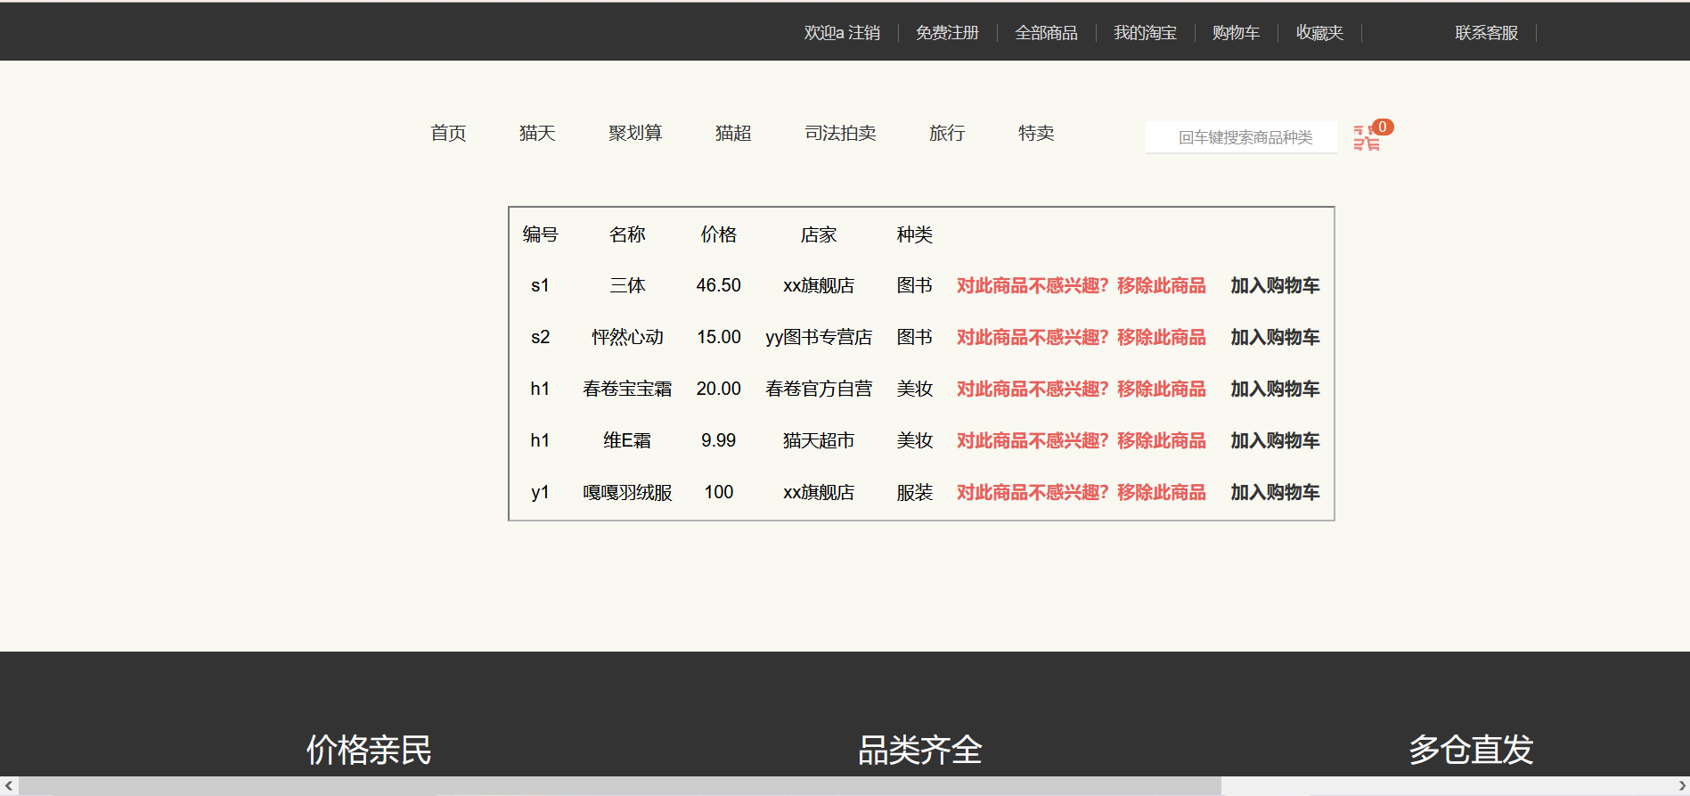
<%@ page import="com.xh.oa2.bean.Dept" %>
<%@ page contentType="text/html;charset=UTF-8" language="java" %>
<%@ page import="java.sql.Connection" %>
<%@ page import="java.sql.DriverManager" %>
<%@ page import="java.sql.ResultSet" %>
<%@ page import="java.sql.SQLException" %>
<%@ page import="java.sql.Statement" %>
<!DOCTYPE html>
<html>
<head><meta charset="utf-8">
<title>部门详情</title>
<!--引入JQuery的JS文件：JQuery的JS文件要在BootStrap的js的文件的前面引入-->
<script type="text/javascript" src="js/jquery-1.11.3.min.js"></script>
<script type="text/javascript" src="js/vue.js"></script>
<!--引入BootStrap的JS的文件-->
<script type="text/javascript" src="js/bootstrap.js"></script>
<link rel="stylesheet" type="text/css" href="./css/base.css">
<link rel="stylesheet" type="text/css" href="./css/common.css">
<link rel="stylesheet" type="text/css" href="./css/index.css">
<link rel="stylesheet" type="text/css" href="./css/car.css">
</head>
<body>
<div class="shortcut">
<div class="wrapper">
<!-- 因为每一个a都相同 -->
<ul>
<li>
<%
if(session.getAttribute("user")!=null)
{
String uname=(String)session.getAttribute("user");
out.print("<a href='DoInvalidate'>欢迎"+uname + " 注销</a>");
}
else
{
out.print("<a href='login.jsp'>登录</a>");
}
%>
</li>
<li><a href="register.jsp">免费注册</a></li>
<li><a href="buycar.jsp">全部商品</a></li>
<li><a href="#">我的淘宝</a></li>
<li><a href="realCar.jsp">购物车</a></li>
<li><a href="#">收藏夹</a></li>
<li><a href="#"><span></span>联系客服</a></li>
</ul>
</div>
</div>
<div class="header wrapper">
<div class="logo">
<h1><a href="index.jsp">购物网站</a></h1>
</div>
<div class="nav">
<ul>
<li><a href="index.jsp">首页</a></li>
<li><a href="#">猫天</a></li>
<li><a href="#">聚划算</a></li>
<li><a href="#">猫超</a></li>
<li><a href="#">司法拍卖</a></li>
<li><a href="#">旅行</a></li>
<li><a href="#">特卖</a></li>
</ul>
</div>
<div class="search">
<input type="text" placeholder="回车键搜索商品种类" id="input" onkeydown="if(event.keyCode==13) dosome()" style="width:100%">
<span></span>
<script type="text/javascript">
var dosome = function(){
document.location.href ='doSerach.jsp?species=' + $("#input").val();
return false;
}
</script>
</div>
<div class="car">
<span>0</span>
</div>
</div>
<%
String driver="com.mysql.cj.jdbc.Driver";
String url="jdbc:mysql://localhost:3306/buyweb?characterEncoding=utf-8&serverTimezone=UTC";
String user="root";
String pwd="Root@123";
Connection conn=null;
Statement sm=null;
ResultSet rs=null;
try {
Class.forName(driver);
conn=DriverManager.getConnection(url,user,pwd);
sm=conn.createStatement();
} catch (ClassNotFoundException e) {
// TODO Auto-generated catch block
e.printStackTrace();
} catch (SQLException e) {
// TODO Auto-generated catch block
e.printStackTrace();
}

String sql = "select *from goods";
rs = sm.executeQuery(sql);
%>
<div class="middle">
<table>
<tr>
<td>编号</td>
<td>名称</td>
<td>价格</td>
<td>店家</td>
<td>种类</td>
<td> </td>
</tr>
<%
while(rs.next())
{
%>

<tr>
<td name="vid"><%=rs.getString("vid") %></td>
<td name="name"><%=rs.getString("name") %></td>
<td name="price"><%=rs.getString("price") %></td>
<td name="hosts"><%=rs.getString("hosts") %></td>
<td name="species"><%=rs.getString("species") %></td>
<!-- <script>
a=document.getElementById('vid').innerText;
alter(a);
</script> -->
<td class="tddel"><a href="dodel.jsp?vid=<%=rs.getString("vid")%>"><b class="del">对此商品不感兴趣？移除此商品</b></a></td>
<td><a href="addCar.jsp?vid=<%=rs.getString("vid")%>&name=<%=rs.getString("name")%>&price=<%=rs.getString("price") %>&hosts=<%=rs.getString("hosts") %>&species=<%=rs.getString("species")%>"><b class="del">加入购物车</b></td>
</tr>

<%
}
%>
</table>
</div>
<div class="footer">
<div class="wrapper">
<div class="top">
<ul>
<li>
<!-- 通过伪元素添加标签实现精灵图 -->
<span>价格亲民</span>
</li>
<li>
<span>品类齐全</span>
</li>
<li>
<span>多仓直发</span>
</li>
</ul>
</div>
<div class="bottom">
<p>
<a href="#">关于我们</a> |
<a href="#">联系我们</a> |
<a href="#">联系客服</a> |
<a href="#">合作招商</a> |
<a href="#">隐私政策</a>
</p>
<p>copyRight @ 202020201204</p>
</div>
</div>
</div>
</body>
</html>
realCar.jsp购物车
已实现：
删除购物车内商品、搜索商品种类、未登录自动跳转至登录页面
（若该用户未添加商品，则显示空字）
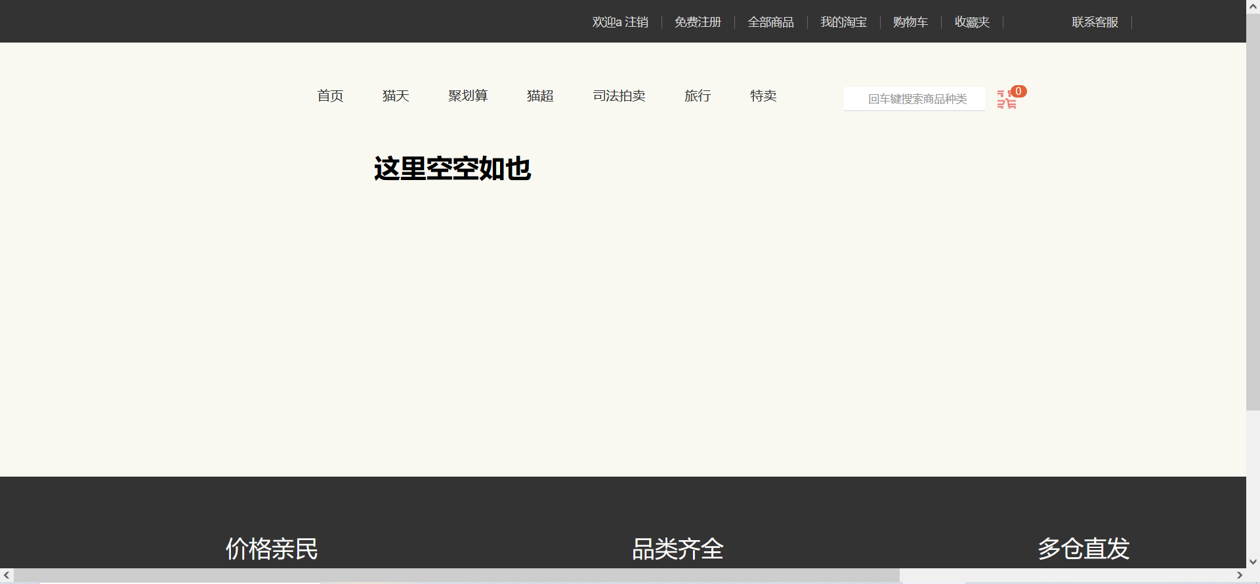
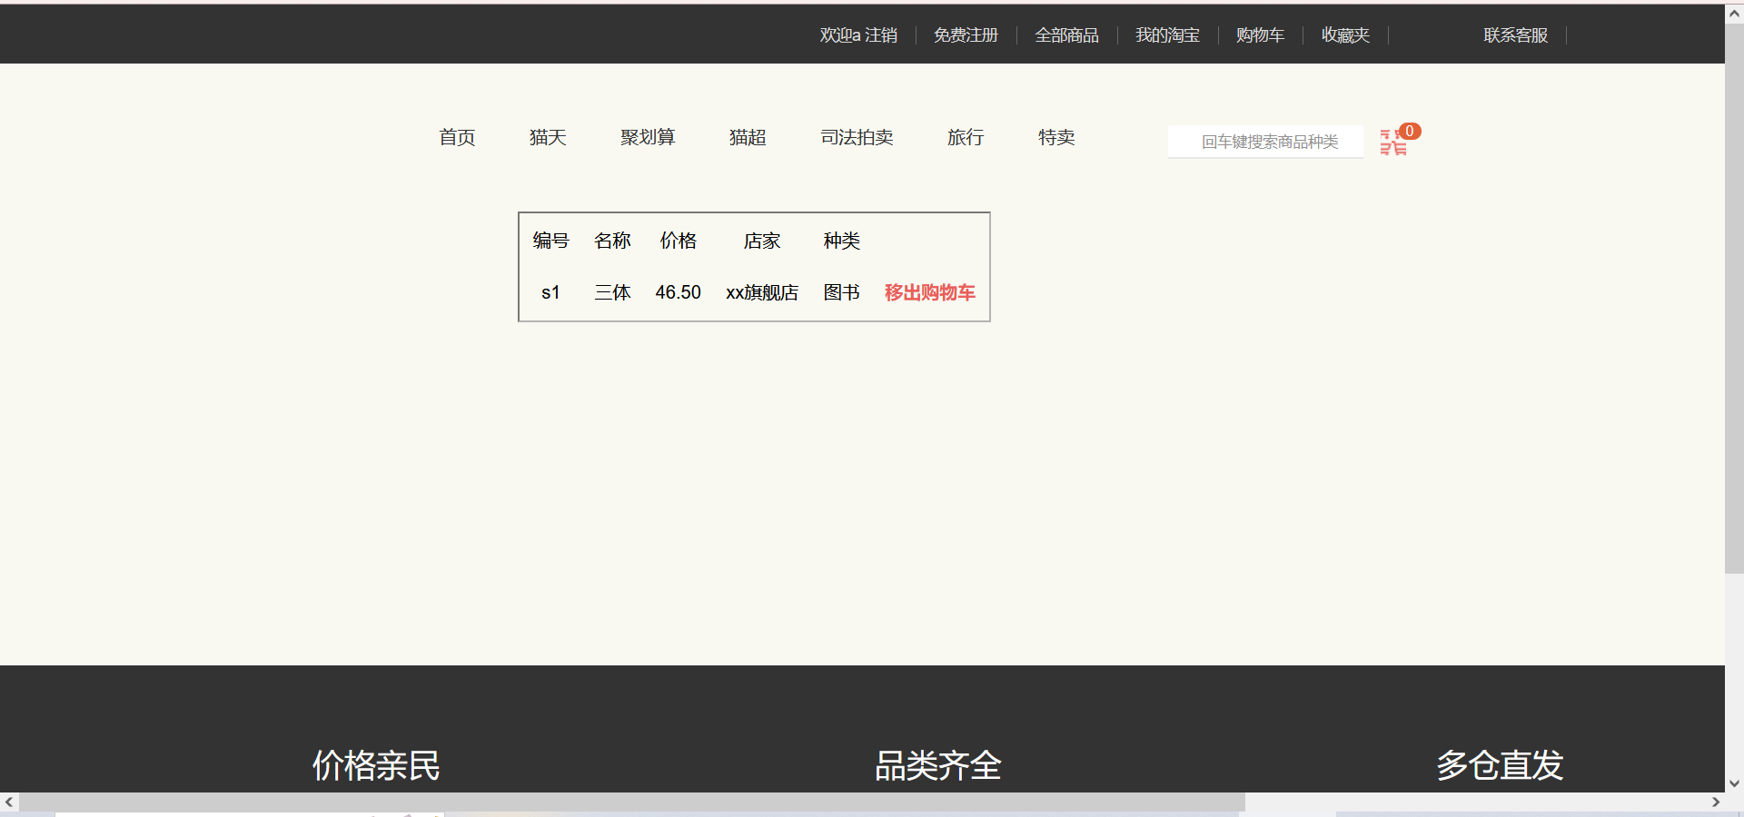
<%@ page import="com.xh.oa2.bean.Dept" %>
<%@ page contentType="text/html;charset=UTF-8" language="java" %>
<%@ page import="java.sql.Connection" %>
<%@ page import="java.sql.DriverManager" %>
<%@ page import="java.sql.ResultSet" %>
<%@ page import="java.sql.SQLException" %>
<%@ page import="java.sql.Statement" %>
<!DOCTYPE html>
<html>
<head><meta charset="utf-8">
<title>部门详情</title>
<!--引入JQuery的JS文件：JQuery的JS文件要在BootStrap的js的文件的前面引入-->
<script type="text/javascript" src="js/jquery-1.11.3.min.js"></script>
<script type="text/javascript" src="js/vue.js"></script>
<!--引入BootStrap的JS的文件-->
<script type="text/javascript" src="js/bootstrap.js"></script>
<link rel="stylesheet" type="text/css" href="./css/base.css">
<link rel="stylesheet" type="text/css" href="./css/common.css">
<link rel="stylesheet" type="text/css" href="./css/index.css">
<link rel="stylesheet" type="text/css" href="./css/car.css">
</head>
<body>
<div class="shortcut">
<div class="wrapper">
<!-- 因为每一个a都相同 -->
<ul>
<li>
<%
if(session.getAttribute("user")!=null)
{
String uname=(String)session.getAttribute("user");
out.print("<a href='DoInvalidate'>欢迎"+uname + " 注销</a>");
}
else
{
out.print("<a href='login.jsp'>登录</a>");
RequestDispatcher rd = request.getRequestDispatcher("login.jsp");
rd.forward(request,response);
}
%>
</li>
<li><a href="register.jsp">免费注册</a></li>
<li><a href="buycar.jsp">全部商品</a></li>
<li><a href="selfInfo.jsp">我的淘宝</a></li>
<li><a href="realCar.jsp">购物车</a></li>
<li><a href="#">收藏夹</a></li>
<li><a href="#"><span></span>联系客服</a></li>
</ul>
</div>
</div>
<div class="header wrapper">
<div class="logo">
<h1><a href="index.jsp">购物网站</a></h1>
</div>
<div class="nav">
<ul>
<li><a href="index.jsp">首页</a></li>
<li><a href="#">猫天</a></li>
<li><a href="#">聚划算</a></li>
<li><a href="#">猫超</a></li>
<li><a href="#">司法拍卖</a></li>
<li><a href="#">旅行</a></li>
<li><a href="#">特卖</a></li>
</ul>
</div>
<div class="search">
<input type="text" placeholder="回车键搜索商品种类" id="input" onkeydown="if(event.keyCode==13) dosome()" style="width:100%">
<span></span>
<script type="text/javascript">
var dosome = function(){
document.location.href ='doSerach.jsp?species=' + $("#input").val();
return false;
}
</script>
</div>
<div class="car">
<span>0</span>
</div>
</div>
<%
String driver="com.mysql.cj.jdbc.Driver";
String url="jdbc:mysql://localhost:3306/buyweb?characterEncoding=utf-8&serverTimezone=UTC";
String user="root";
String pwd="Root@123";
Connection conn=null;
Statement sm=null;
ResultSet rs=null;
try {
Class.forName(driver);
conn=DriverManager.getConnection(url,user,pwd);
sm=conn.createStatement();
} catch (ClassNotFoundException e) {
// TODO Auto-generated catch block
e.printStackTrace();
} catch (SQLException e) {
// TODO Auto-generated catch block
e.printStackTrace();
}
String username =(String)session.getAttribute("user");
String sql = "select *from cars where username='" + username + "'";
rs = sm.executeQuery(sql);
%>
<div class="middle">

<%
if(!rs.next()){
out.print("<h1>这里空空如也</h1>");}
else{
rs = sm.executeQuery(sql);
while(rs.next())
{
%>
<table>
<tr>
<td>编号</td>
<td>名称</td>
<td>价格</td>
<td>店家</td>
<td>种类</td>
<td> </td>
</tr>
<tr>
<td name="vid"><%=rs.getString("vid") %></td>
<td name="name"><%=rs.getString("name") %></td>
<td name="price"><%=rs.getString("price") %></td>
<td name="hosts"><%=rs.getString("hosts") %></td>
<td name="species"><%=rs.getString("species") %></td>
<!-- <script>
a=document.getElementById('vid').innerText;
alter(a);
</script> -->
<td class="tddel"><a href="dodelCar.jsp?vid=<%=rs.getString("vid")%>"><b class="del">移出购物车</b></a></td>
</tr>

<%
}
}
%>
</table>
</div>
<div class="footer">
<div class="wrapper">
<div class="top">
<ul>
<li>
<!-- 通过伪元素添加标签实现精灵图 -->
<span>价格亲民</span>
</li>
<li>
<span>品类齐全</span>
</li>
<li>
<span>多仓直发</span>
</li>
</ul>
</div>
<div class="bottom">
<p>
<a href="#">关于我们</a> |
<a href="#">联系我们</a> |
<a href="#">联系客服</a> |
<a href="#">合作招商</a> |
<a href="#">隐私政策</a>
</p>
<p>copyRight @ 202020201204</p>
</div>
</div>
</div>
</body>
</html>
selfInfo.jsp个人信息
已实现：
修改个人信息、未登录自动跳转至登录页面
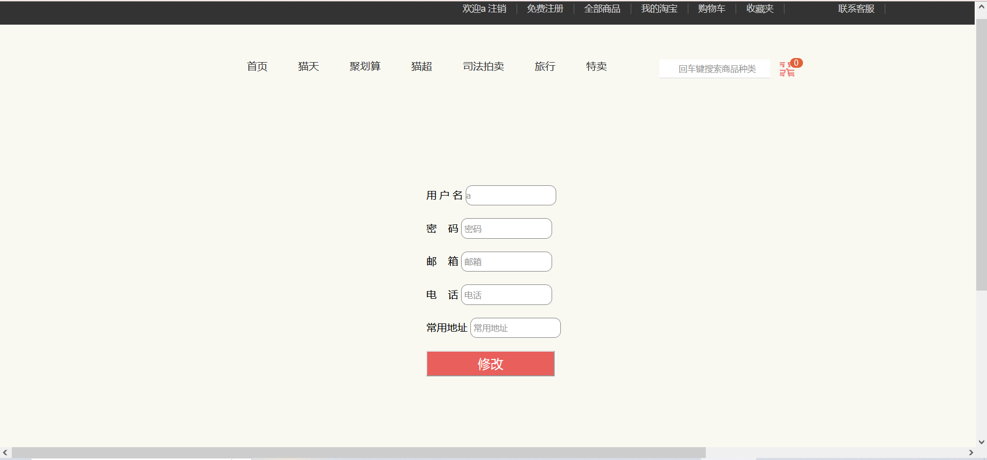
<%@ page language="java" contentType="text/html; charset=utf-8"
pageEncoding="utf-8"%>
<%@ page import="com.hkd.doimp.GoodsDaoImp" %>
<%@ page import="com.hkd.entity.Goods" %>
<%@ page import="java.util.ArrayList" %>
<%@ page import="java.sql.Connection" %>
<%@ page import="java.sql.DriverManager" %>
<%@ page import="java.sql.ResultSet" %>
<%@ page import="java.sql.SQLException" %>
<%@ page import="java.sql.Statement" %>
<!DOCTYPE html>
<html>
<head>
<meta charset="UTF-8">
<title>Insert title here</title>
<link rel="stylesheet" href="css/bootstrap.css" type="text/css" />
<!--引入JQuery的JS文件：JQuery的JS文件要在BootStrap的js的文件的前面引入-->
<script type="text/javascript" src="js/jquery-1.11.3.min.js"></script>
<script type="text/javascript" src="js/vue.js"></script>
<!--引入BootStrap的JS的文件-->
<script type="text/javascript" src="js/bootstrap.js"></script>
<link rel="stylesheet" type="text/css" href="./css/base.css">
<link rel="stylesheet" type="text/css" href="./css/common.css">
<link rel="stylesheet" type="text/css" href="./css/index.css">
<link rel="stylesheet" type="text/css" href="./css/selfInfo.css"/>
<style>
body{
margin: 0;
padding: 0;
}
.lunbo{
width:100%;
height:720px;
background-image: url(./image/1.png);/*背景图片*/
background-size:100% 100%;
}
</style>
</head>
<body>
<div class="shortcut">
<div class="wrapper">
<!-- 因为每一个a都相同 -->
<ul>
<li>
<%
if(session.getAttribute("user")!=null)
{
String uname=(String)session.getAttribute("user");
out.print("<a href='DoInvalidate'>欢迎"+uname + " 注销</a>");
}
else
{
out.print("<a href='login.jsp'>登录</a>");
RequestDispatcher rd = request.getRequestDispatcher("login.jsp");
rd.forward(request,response);
}
%>
</li>
<li><a href="register.jsp">免费注册</a></li>
<li><a href="buycar.jsp">全部商品</a></li>
<li><a href="selfInfo.jsp">我的淘宝</a></li>
<li><a href="realCar.jsp">购物车</a></li>
<li><a href="#">收藏夹</a></li>
<li><a href="#"><span></span>联系客服</a></li>
</ul>
</div>
</div>
<div class="header wrapper">
<div class="logo">
<h1><a href="index.jsp">购物网站</a></h1>
</div>
<div class="nav">
<ul>
<li><a href="index.jsp">首页</a></li>
<li><a href="#">猫天</a></li>
<li><a href="#">聚划算</a></li>
<li><a href="#">猫超</a></li>
<li><a href="#">司法拍卖</a></li>
<li><a href="#">旅行</a></li>
<li><a href="#">特卖</a></li>
</ul>
</div>
<div class="search">
<input type="text" placeholder="回车键搜索商品种类" id="input" onkeydown="if(event.keyCode==13) dosome()" style="width:100%">
<span></span>
<script type="text/javascript">
var dosome = function(){
document.location.href ='doSerach.jsp?species=' + $("#input").val();
return false;
}
</script>
</div>
<div class="car">
<span>0</span>
</div>
</div>

<div class="middle">
<div class="content">
<div class="rebox">
<form class="form-horizontal" role="form" action='doUpdate.jsp'>
<div class="form-group" style="margin-left: 200px;">
<div class="col-sm-5">
<label for="inputEmail3" class="col-sm-2 control-label">用&nbsp;户&nbsp;名</label>
<input type="text" class="form-control" placeholder=<%=(String)session.getAttribute("user")%> class="login-label"
name="uname" id="uname" readonly="readonly"/>
</div>
<div id="info" style="display: inline"></div>
</div>
<div class="form-group" style="margin-left: 200px">
<div class="col-sm-5">
<label for="inputPassword3" class="col-sm-2 control-label" class="login-label">密&nbsp;&nbsp;&nbsp;&nbsp;码</label>
<input type="password" class="form-control" id="inputPassword3"
placeholder=" 密码" name="pwd">
</div>
</div>
<div class="form-group" style="margin-left: 200px;">
<div class="col-sm-5">
<label for="inputEmail3" class="col-sm-2 control-label" class="login-label">邮&nbsp;&nbsp;&nbsp;&nbsp;箱</label>
<input type="text" class="form-control" placeholder=" 邮箱"
name="email">
</div>
</div>
<div class="form-group" style="margin-left: 200px;">
<div class="col-sm-5">
<label for="inputEmail3" class="col-sm-2 control-label" class="login-label">电&nbsp;&nbsp;&nbsp;&nbsp;话</label>
<input type="text" class="form-control" placeholder=" 电话"
name="phone">
</div>
</div>
<div class="form-group" style="margin-left: 200px;">
<div class="col-sm-5">
<label for="inputEmail3" class="col-sm-2 control-label" class="login-label">常用地址</label>
<input type="text" class="form-control" placeholder=" 常用地址"
name="addr1">
</div>
</div>
<div class="form-group" style="margin-left: 200px;">
<div class="col-sm-offset-2 col-sm-10">
<button type="submit" class="btn btn-default">修改</button>
</div>
</div>
</form>
</div>
</div>
</div>
<div class="footer">
<div class="wrapper">
<div class="top">
<ul>
<li>
<!-- 通过伪元素添加标签实现精灵图 -->
<span>价格亲民</span>
</li>
<li>
<span>品类齐全</span>
</li>
<li>
<span>多仓直发</span>
</li>
</ul>
</div>
<div class="bottom">
<p>
<a href="#">关于我们</a> |
<a href="#">联系我们</a> |
<a href="#">联系客服</a> |
<a href="#">合作招商</a> |
<a href="#">隐私政策</a>
</p>
<p>copyRight @ 202020201204</p>
</div>
</div>
</div>
</body>

</html>

addCar.jsp、dodel.jsp、dologin.jsp、doRegister.jsp、doSerach.jsp、doUpdate.jsp、dodelCar.jsp为相应的增删改查jsp页面
addCar.jsp添加进购物车
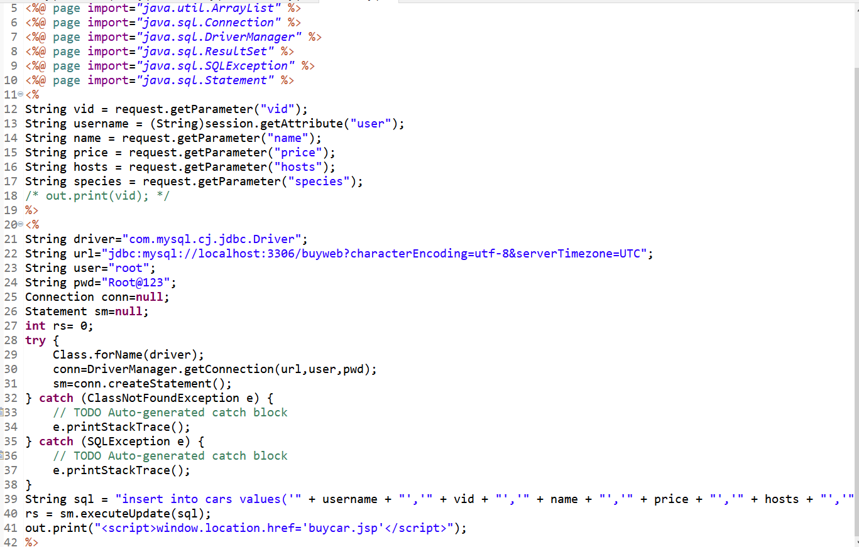
dodel.jsp删除指定商品
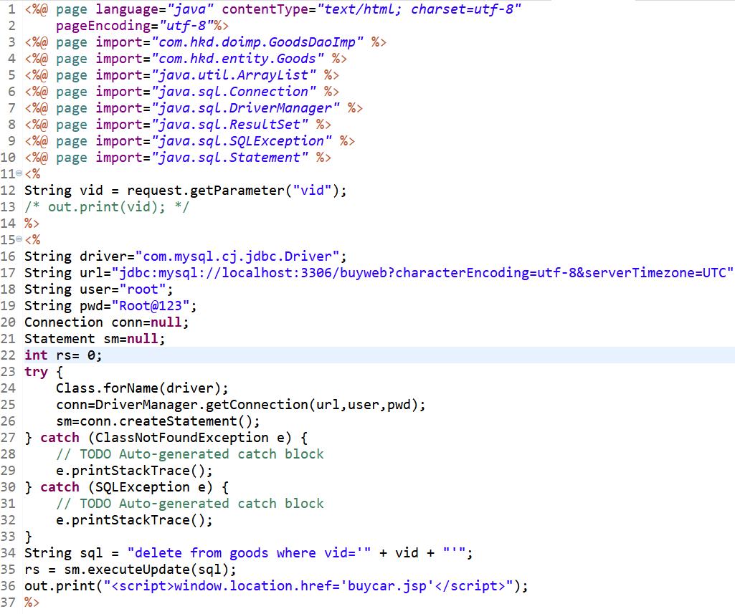
dologin.jsp登录验证
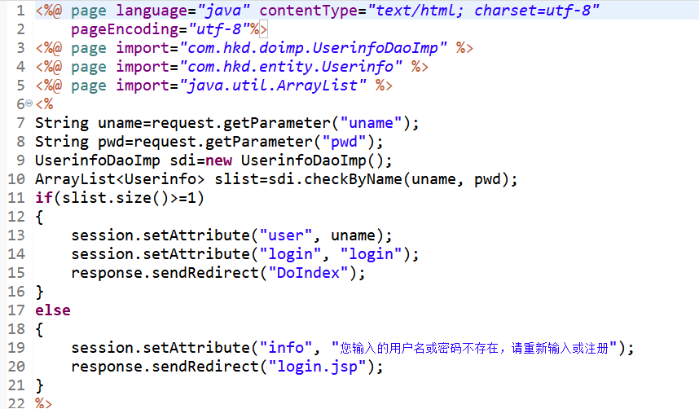
doRegister.jsp注册验证
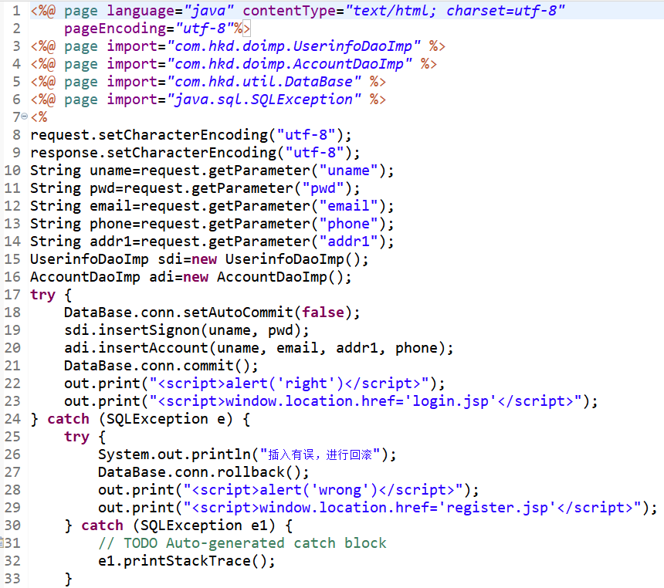
doSerach.jsp商品种类搜索
<%@ page language="java" contentType="text/html; charset=utf-8"
pageEncoding="utf-8"%>
<%@ page import="com.hkd.doimp.GoodsDaoImp" %>
<%@ page import="com.hkd.entity.Goods" %>
<%@ page import="java.util.ArrayList" %>
<%@ page import="java.sql.Connection" %>
<%@ page import="java.sql.DriverManager" %>
<%@ page import="java.sql.ResultSet" %>
<%@ page import="java.sql.SQLException" %>
<%@ page import="java.sql.Statement" %>
<!DOCTYPE html>
<html>
<head><meta charset="utf-8">
<title>部门详情</title>
<!--引入JQuery的JS文件：JQuery的JS文件要在BootStrap的js的文件的前面引入-->
<script type="text/javascript" src="js/jquery-1.11.3.min.js"></script>
<script type="text/javascript" src="js/vue.js"></script>
<!--引入BootStrap的JS的文件-->
<script type="text/javascript" src="js/bootstrap.js"></script>
<link rel="stylesheet" type="text/css" href="./css/base.css">
<link rel="stylesheet" type="text/css" href="./css/common.css">
<link rel="stylesheet" type="text/css" href="./css/index.css">
<link rel="stylesheet" type="text/css" href="./css/car.css">
</head>
<body>
<div class="shortcut">
<div class="wrapper">
<!-- 因为每一个a都相同 -->
<ul>
<li>
<%
if(session.getAttribute("user")!=null)
{
String uname=(String)session.getAttribute("user");
out.print("<a href='DoInvalidate'>欢迎"+uname + " 注销</a>");
}
else
{
out.print("<a href='login.jsp'>登录</a>");
}
%>
</li>
<li><a href="register.jsp">免费注册</a></li>
<li><a href="buycar.jsp">全部商品</a></li>
<li><a href="selfInfo.jsp">我的淘宝</a></li>
<li><a href="realCar.jsp">购物车</a></li>
<li><a href="#">收藏夹</a></li>
<li><a href="#"><span></span>联系客服</a></li>
</ul>
</div>
</div>
<div class="header wrapper">
<div class="logo">
<h1><a href="index.jsp">购物网站</a></h1>
</div>
<div class="nav">
<ul>
<li><a href="index.jsp">首页</a></li>
<li><a href="#">猫天</a></li>
<li><a href="#">聚划算</a></li>
<li><a href="#">猫超</a></li>
<li><a href="#">司法拍卖</a></li>
<li><a href="#">旅行</a></li>
<li><a href="#">特卖</a></li>
</ul>
</div>
<div class="search">
<input type="text" placeholder="回车键搜索商品种类" id="input" onkeydown="if(event.keyCode==13) dosome()" style="width:100%">
<span></span>
<script type="text/javascript">
var dosome = function(){
document.location.href ='doSerach.jsp?species=' + $("#input").val();
return false;
}
</script>
</div>
<div class="car">
<span>0</span>
</div>
</div>
<%
String species = request.getParameter("species");
String driver="com.mysql.cj.jdbc.Driver";
String url="jdbc:mysql://localhost:3306/buyweb?characterEncoding=utf-8&serverTimezone=UTC";
String user="root";
String pwd="Root@123";
Connection conn=null;
Statement sm=null;
ResultSet rs= null;
try {
Class.forName(driver);
conn=DriverManager.getConnection(url,user,pwd);
sm=conn.createStatement();
} catch (ClassNotFoundException e) {
// TODO Auto-generated catch block
e.printStackTrace();
} catch (SQLException e) {
// TODO Auto-generated catch block
e.printStackTrace();
}
String sql = "select * from goods where species='" + species + "'";
rs = sm.executeQuery(sql);
%>
<div class="middle">

<%
if(!rs.next()){
out.print("<h1>找不到相关内容呢</h1>");
out.print("<a href='buycar.jsp' style='color:#e85f5b'>查找其它内容🔍</a>");
}
else {
while(rs.next())
{
%>
<table>
<tr>
<td>编号</td>
<td>名称</td>
<td>价格</td>
<td>店家</td>
<td>种类</td>
<td> </td>
</tr>
<tr>
<td name="vid"><%=rs.getString("vid") %></td>
<td name="name"><%=rs.getString("name") %></td>
<td name="price"><%=rs.getString("price") %></td>
<td name="hosts"><%=rs.getString("hosts") %></td>
<td name="species"><%=rs.getString("species") %></td>
<!-- <script>
a=document.getElementById('vid').innerText;
alter(a);
</script> -->
<td class="tddel"><a href="dodel.jsp?vid=<%=rs.getString("vid")%>"><b class="del">对此商品不感兴趣？移除此商品</b></a></td>
</tr>

<%
}
}
%>
</table>
</div>
<div class="footer">
<div class="wrapper">
<div class="top">
<ul>
<li>
<!-- 通过伪元素添加标签实现精灵图 -->
<span>价格亲民</span>
</li>
<li>
<span>品类齐全</span>
</li>
<li>
<span>多仓直发</span>
</li>
</ul>
</div>
<div class="bottom">
<p>
<a href="#">关于我们</a> |
<a href="#">联系我们</a> |
<a href="#">联系客服</a> |
<a href="#">合作招商</a> |
<a href="#">隐私政策</a>
</p>
<p>copyRight @ 202020201204</p>
</div>
</div>
</div>
</body>
</html>
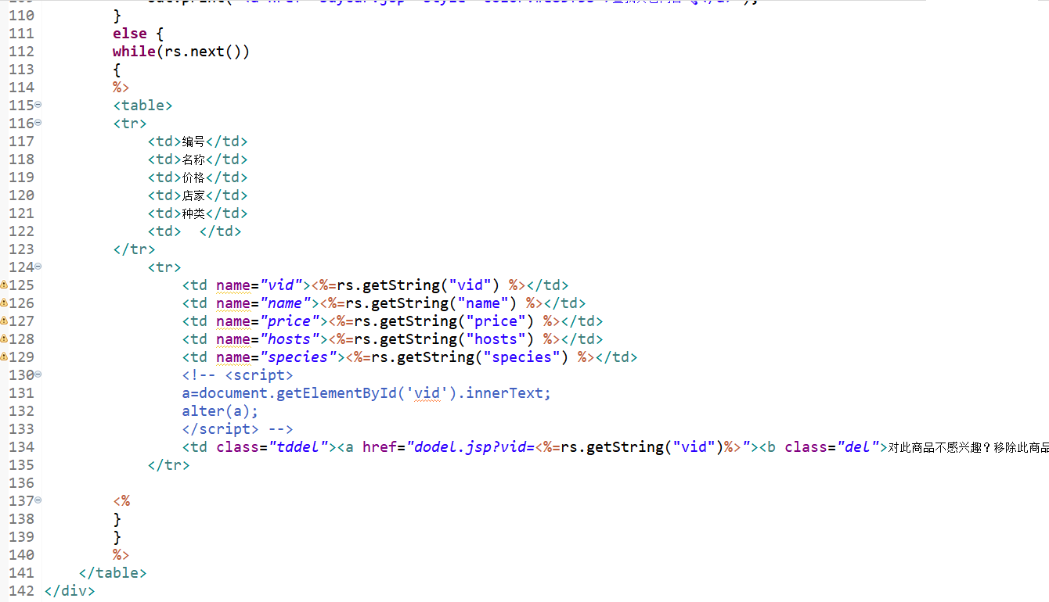
doUpdate.jsp更新个人信息
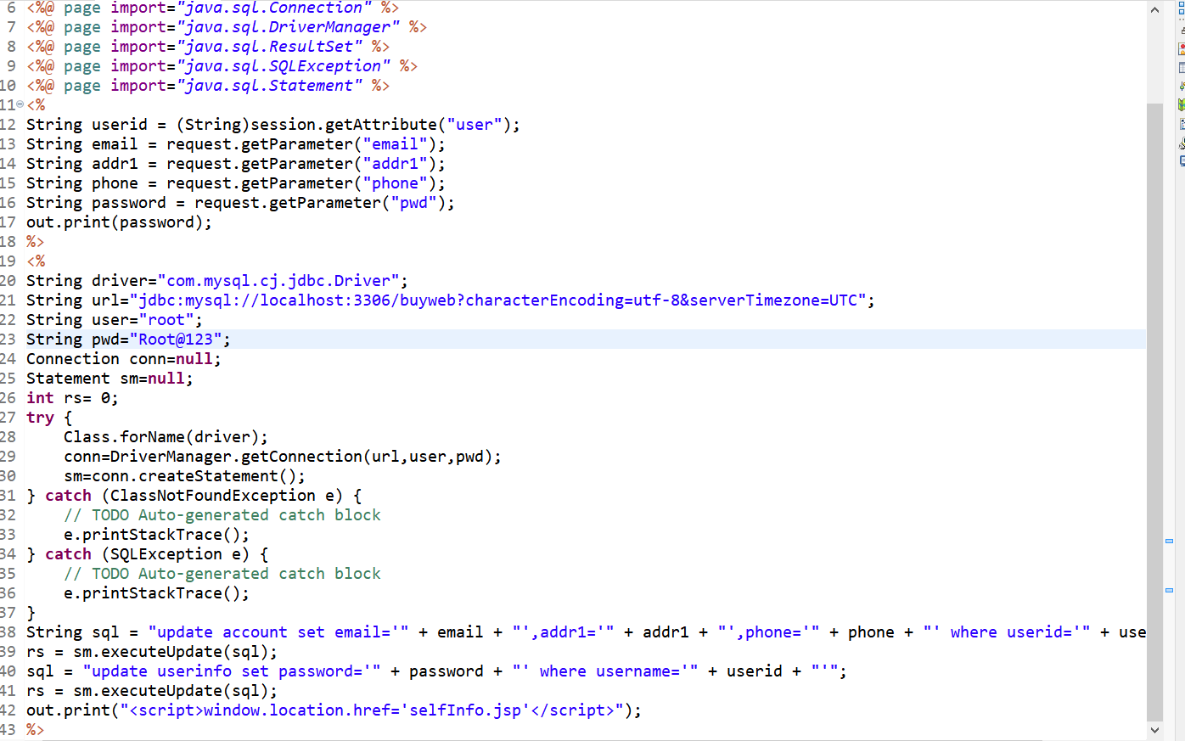
dodelCar.jsp删除购物车商品
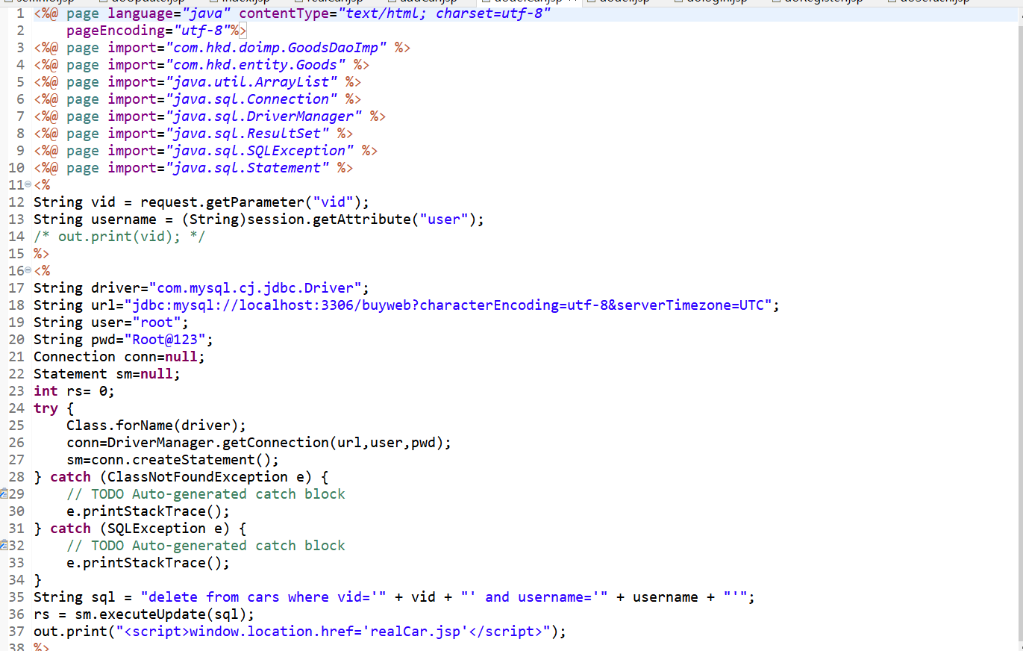

有相应包com.hkd.dao、com.hkd.doimp、com.hkd.entity、com.hkd.servlet、com.hkd.util、com.hkd.util、com.xh.oa2.bean(测试包，无实际用途)对数据库进行操作
com.hkd.dao:
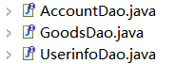
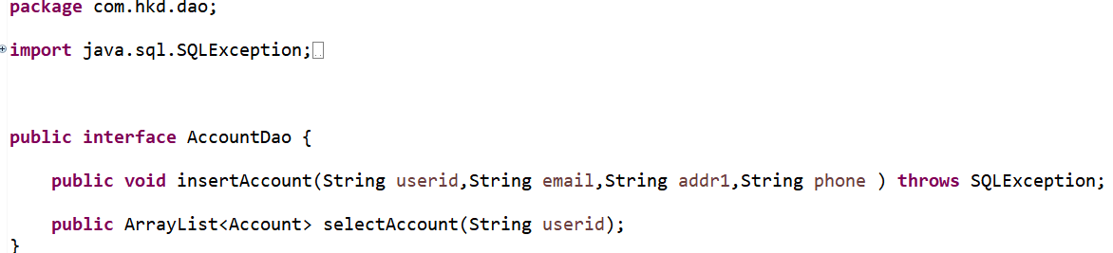
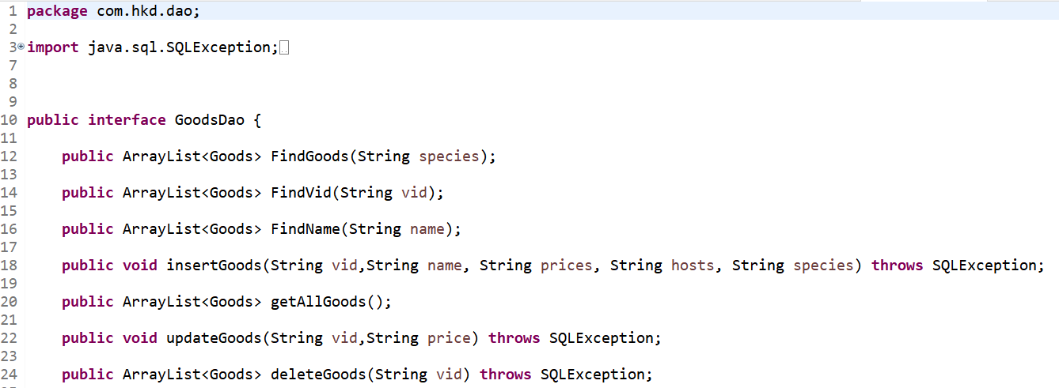
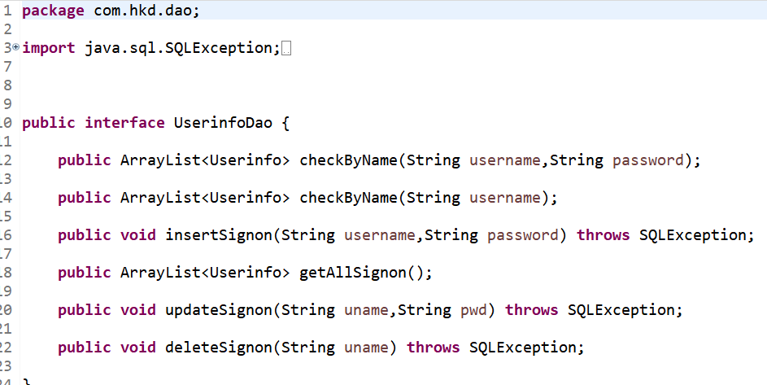
com.hkd.doimp
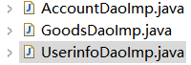
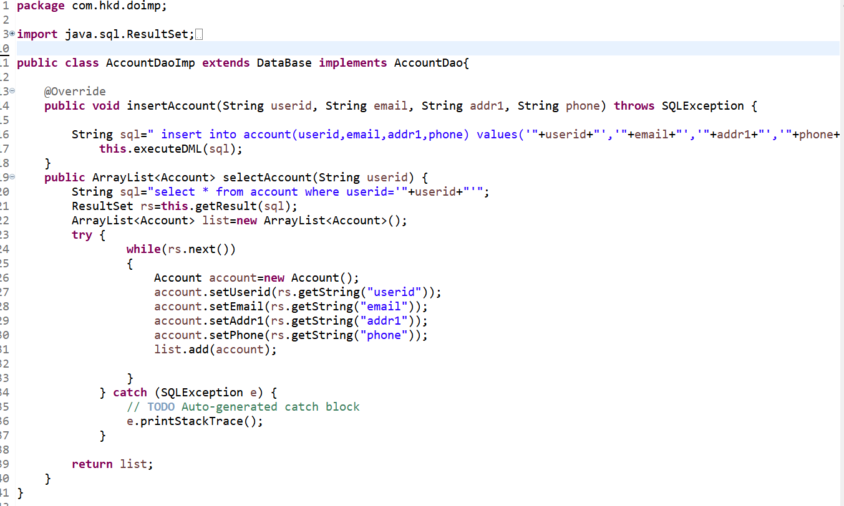
package com.hkd.doimp;

import java.sql.ResultSet;
import java.sql.SQLException;
import java.util.ArrayList;

import com.hkd.dao.GoodsDao;
import com.hkd.entity.Goods;
import com.hkd.util.DataBase;

public class GoodsDaoImp extends DataBase implements GoodsDao{

@Override
public ArrayList<Goods> FindGoods(String species) {
String sql="select * from goods where species='"+species+"'";

ArrayList<Goods> list=new ArrayList<Goods> ();
ResultSet rs=this.getResult(sql);
try {
while(rs.next())
{
Goods signon=new Goods();
signon.setVid("vid");
signon.setName("name");
signon.setPrice("price");
signon.setHosts("hosts");
signon.setSpecies("specices");
list.add(signon);
}
} catch (SQLException e) {
// TODO Auto-generated catch block
e.printStackTrace();
}
return list;
}

public ArrayList<Goods> FindVid(String vid) {
String sql="select * from goods where vid='"+vid+"'";

ArrayList<Goods> list=new ArrayList<Goods> ();
ResultSet rs=this.getResult(sql);
try {
while(rs.next())
{
Goods signon=new Goods();
signon.setVid("vid");
signon.setName("name");
signon.setPrice("price");
signon.setHosts("hosts");
signon.setSpecies("specices");
list.add(signon);
}
} catch (SQLException e) {
// TODO Auto-generated catch block
e.printStackTrace();
}
return list;
}

@Override
public void insertGoods(String vid, String name, String prices, String hosts, String species) throws SQLException {
String sql="insert into userinfo values('"+vid+"','"+ name + "','" + prices + "','" + hosts + "','" + species +"')";
this.executeDML(sql);

}

@Override
public ArrayList<Goods> getAllGoods() {

String sql="select * from goods";

ArrayList<Goods> list=new ArrayList<Goods> ();
ResultSet rs=this.getResult(sql);
try {
while(rs.next())
{
Goods signon=new Goods();
signon.setVid(rs.getString("vid"));
signon.setName(rs.getString("name"));
signon.setPrice(rs.getString("price"));
signon.setHosts(rs.getString("hosts"));
signon.setSpecies(rs.getString("species"));
list.add(signon);

}
} catch (SQLException e) {
// TODO Auto-generated catch block
e.printStackTrace();
}
return list;

}

@Override
public void updateGoods(String vid,String price) throws SQLException {
String sql="update Goods set prices='"+price+"' where vid='"+vid+"'";
this.executeDML(sql);

}

@Override
public ArrayList<Goods> deleteGoods(String vid) throws SQLException {
String sql="delete from goods where vid='"+vid+"'";
this.executeDML(sql);

sql="select * from goods where vid='"+vid+"'";
ArrayList<Goods> list=new ArrayList<Goods> ();
ResultSet rs=this.getResult(sql);
try {
while(rs.next())
{
Goods signon=new Goods();
signon.setVid(rs.getString("vid"));
signon.setName(rs.getString("name"));
signon.setPrice(rs.getString("price"));
signon.setHosts(rs.getString("hosts"));
signon.setSpecies(rs.getString("species"));
list.add(signon);

}
} catch (SQLException e) {
// TODO Auto-generated catch block
e.printStackTrace();
}
return list;
}

@Override
public ArrayList<Goods> FindName(String name) {

String sql="select * from goods where name='"+name+"'";
ArrayList<Goods> list=new ArrayList<Goods> ();
ResultSet rs=this.getResult(sql);
try {
while(rs.next())
{
Goods signon=new Goods();
signon.setVid(rs.getString("vid"));
signon.setName(rs.getString("name"));
signon.setPrice(rs.getString("price"));
signon.setHosts(rs.getString("hosts"));
signon.setSpecies(rs.getString("species"));
list.add(signon);

}
} catch (SQLException e) {
// TODO Auto-generated catch block
e.printStackTrace();
}
return list;
}

}
package com.hkd.doimp;

import java.sql.ResultSet;
import java.sql.SQLException;
import java.util.ArrayList;

import com.hkd.dao.UserinfoDao;
import com.hkd.entity.Userinfo;
import com.hkd.util.DataBase;

public class UserinfoDaoImp extends DataBase implements UserinfoDao{

@Override
public ArrayList<Userinfo> checkByName(String username, String password) {
String sql="select * from userinfo where username='"+username+"' and password='"+password+"'";

ArrayList<Userinfo> list=new ArrayList<Userinfo> ();
ResultSet rs=this.getResult(sql);
try {
while(rs.next())
{
Userinfo signon=new Userinfo();
signon.setUserName(rs.getString("username"));
signon.setPassword(rs.getString("password"));
list.add(signon);
}
} catch (SQLException e) {
// TODO Auto-generated catch block
e.printStackTrace();
}
return list;
}

@Override
public void insertSignon(String username, String password) throws SQLException {
String sql="insert into userinfo values('"+username+"','"+password+"')";
this.executeDML(sql);

}

@Override
public ArrayList<Userinfo> getAllSignon() {

String sql="select * from userinfo";

ArrayList<Userinfo> list=new ArrayList<Userinfo> ();
ResultSet rs=this.getResult(sql);
try {
while(rs.next())
{
Userinfo signon=new Userinfo();
signon.setUserName(rs.getString("username"));
signon.setPassword(rs.getString("password"));
list.add(signon);

}
} catch (SQLException e) {
// TODO Auto-generated catch block
e.printStackTrace();
}
return list;

}

@Override
public void updateSignon(String uname,String pwd) throws SQLException {
String sql="update userinfo set password='"+pwd+"' where username='"+uname+"'";
this.executeDML(sql);

}

@Override
public void deleteSignon(String uname) throws SQLException {
String sql="delete from userinfo where username='"+uname+"'";
this.executeDML(sql);

}

@Override
public ArrayList<Userinfo> checkByName(String username) {

String sql="select * from userinfo where username='"+username+"'";
ArrayList<Userinfo> list=new ArrayList<Userinfo> ();
ResultSet rs=this.getResult(sql);
try {
while(rs.next())
{
Userinfo signon=new Userinfo();
signon.setUserName(rs.getString("username"));
signon.setPassword(rs.getString("password"));
list.add(signon);

}
} catch (SQLException e) {
// TODO Auto-generated catch block
e.printStackTrace();
}
return list;
}

}
com.hkd.entity
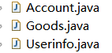
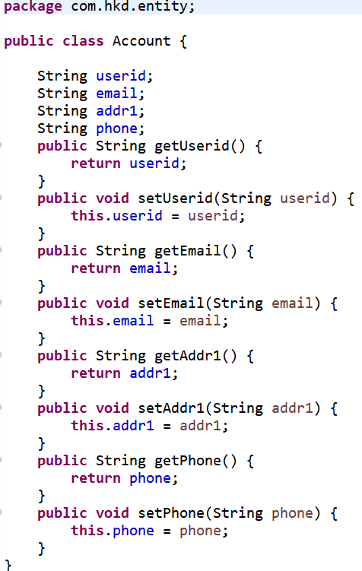
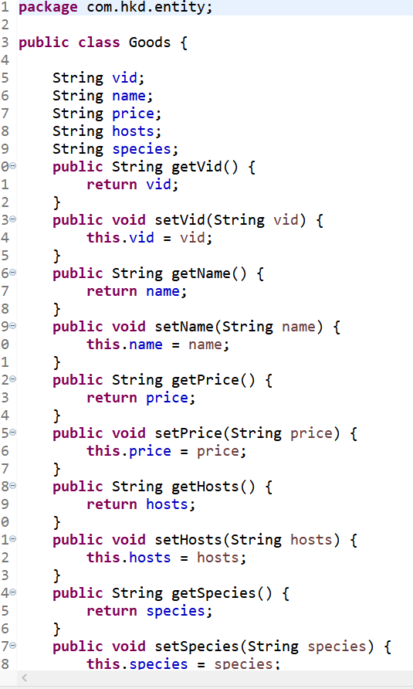
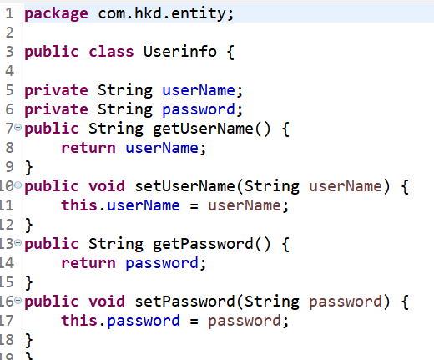
com.hkd.servlet
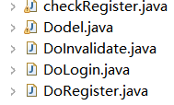
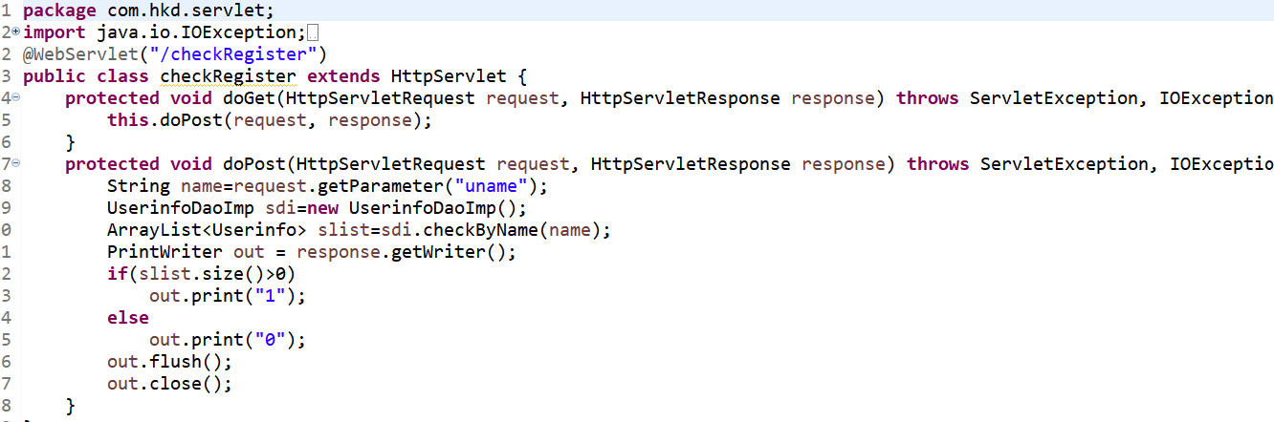
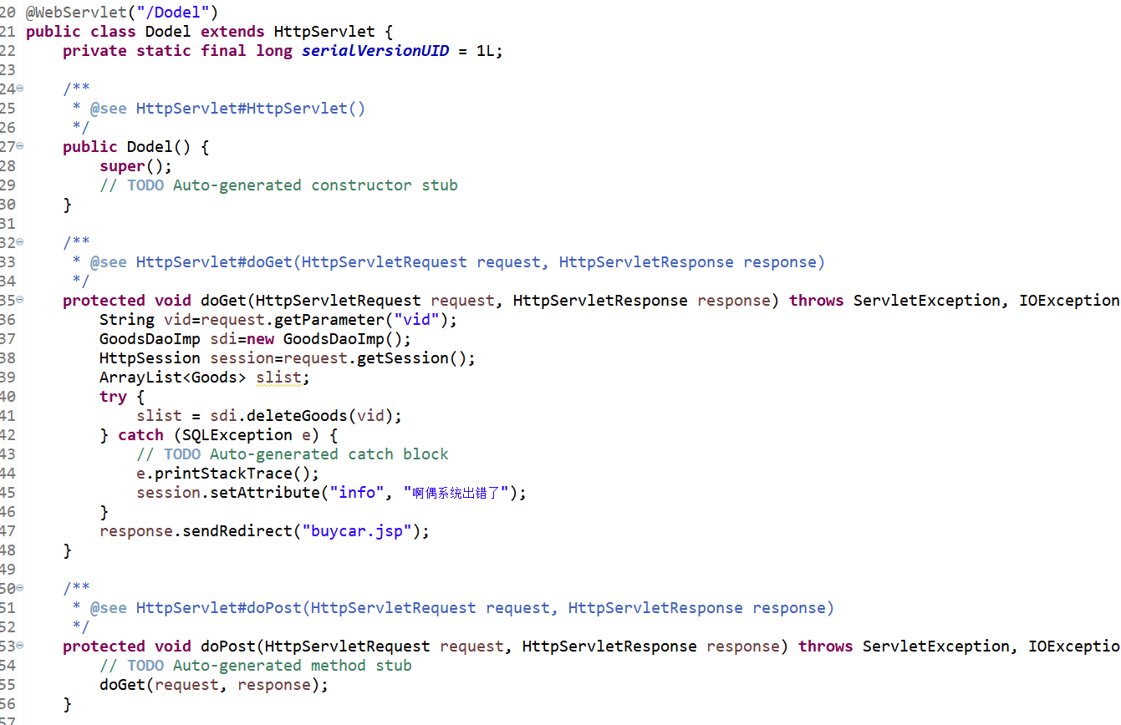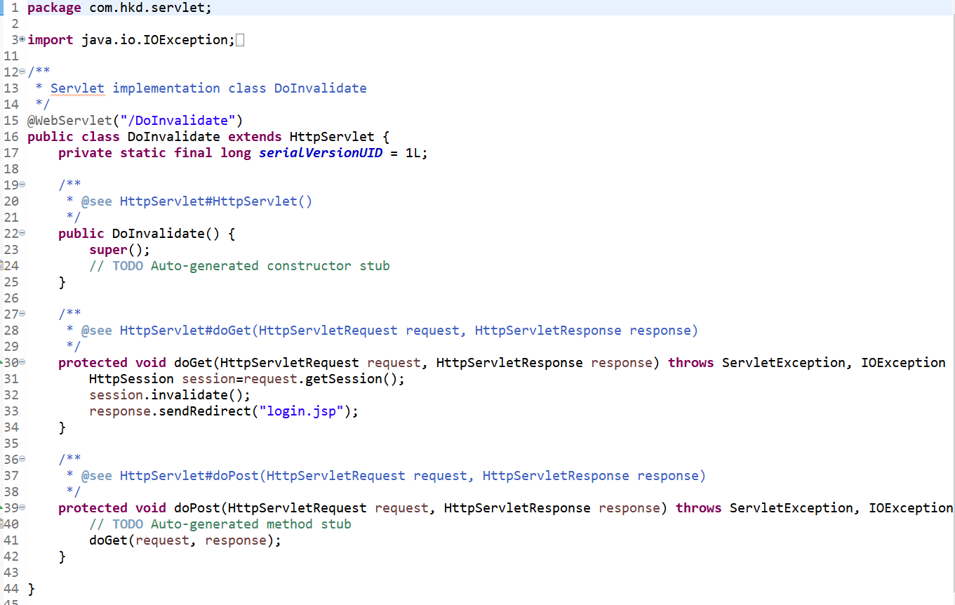
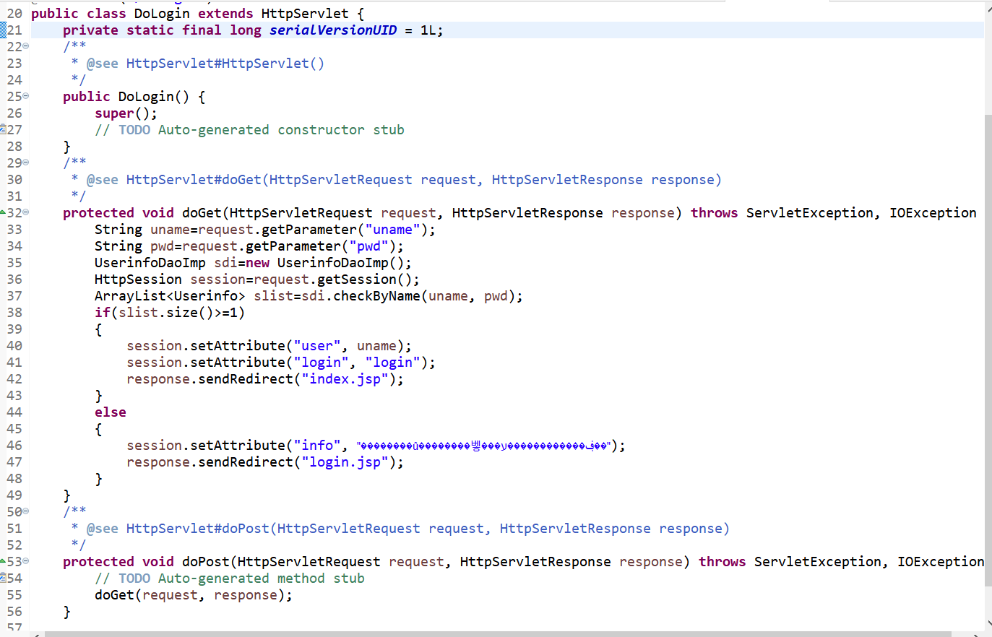
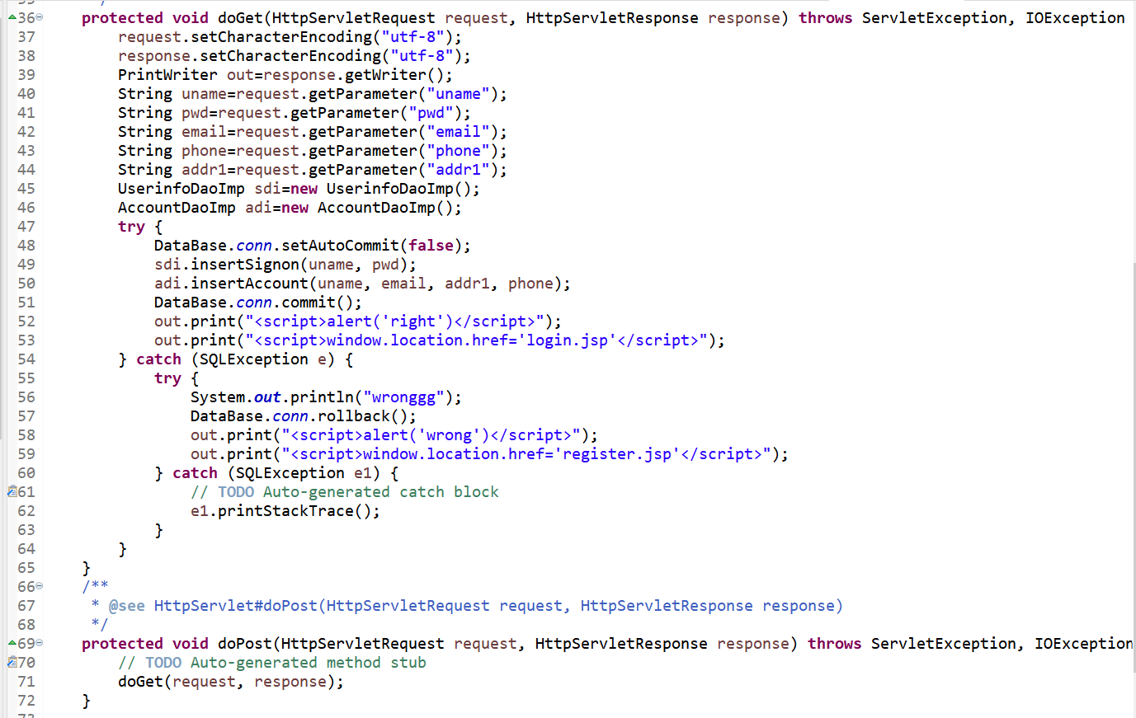
com.hkd.util
package com.hkd.util;

import java.sql.Connection;
import java.sql.DriverManager;
import java.sql.ResultSet;
import java.sql.SQLException;
import java.sql.Statement;

public class DataBase {
static String driver="com.mysql.cj.jdbc.Driver";
static String url="jdbc:mysql://localhost:3306/buyweb?characterEncoding=utf-8&serverTimezone=UTC";
static String user="root";
static String pwd="Root@123";
public static Connection conn=null;
static Statement sm=null;
ResultSet rs=null;
static {
try {
Class.forName(driver);
conn=DriverManager.getConnection(url,user,pwd);
sm=conn.createStatement();
} catch (ClassNotFoundException e) {
// TODO Auto-generated catch block
e.printStackTrace();
} catch (SQLException e) {
// TODO Auto-generated catch block
e.printStackTrace();
}
}
public ResultSet getResult(String sql) {
try {
rs=sm.executeQuery(sql);
} catch (SQLException e) {
// TODO Auto-generated catch block
e.printStackTrace();
}
return rs;
}
public void executeDML(String sql) throws SQLException {

sm.executeUpdate(sql);

}
public void closeDb() {
try {
if(rs!=null)
rs.close();
if(sm!=null)
sm.close();
if(conn!=null)
conn.close();
} catch (SQLException e) {
// TODO Auto-generated catch block
e.printStackTrace();
}
}
}

包含mysql数据库buyweb，有表account，cars，goods，userinfo，goodsInfo
Account用户相关信息表
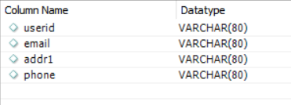
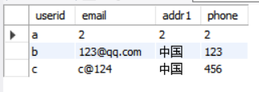
Cars购物车信息表
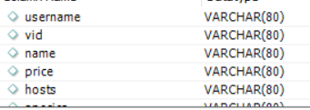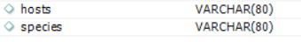
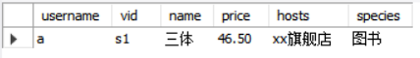
Goods商品信息表
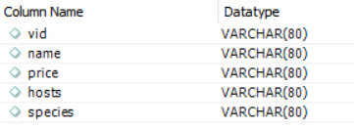
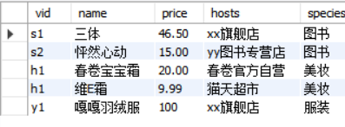
Userinfo用户信息表
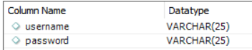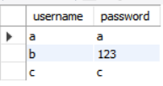
goodsInfo商品数量信息表
