.Net企业级应用系统开发

题 目： 贪吃蛇游戏管理系统

专 业： 计算机科学与技术

学 号： 2020202021204

姓 名 ： 蔡彬

数据库
Blacklist(黑名单)：
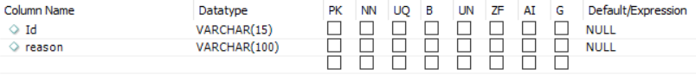
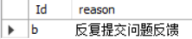
Pictureinfo(用户图片管理路径)：
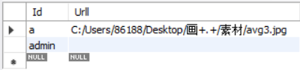
Questioninfo(问题列表):

Rankinfo(排名):
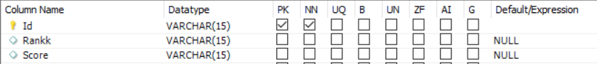
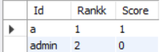
Userinfo(用户信息)：
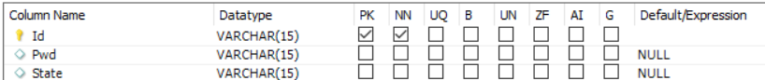
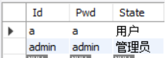

Frm_login
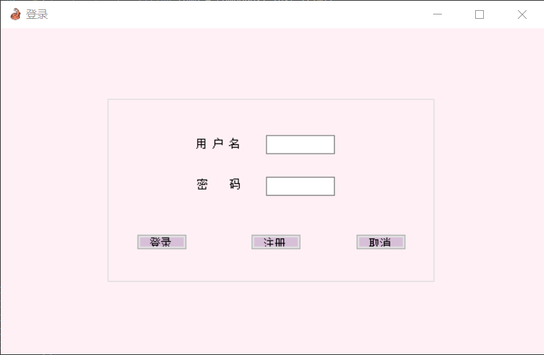
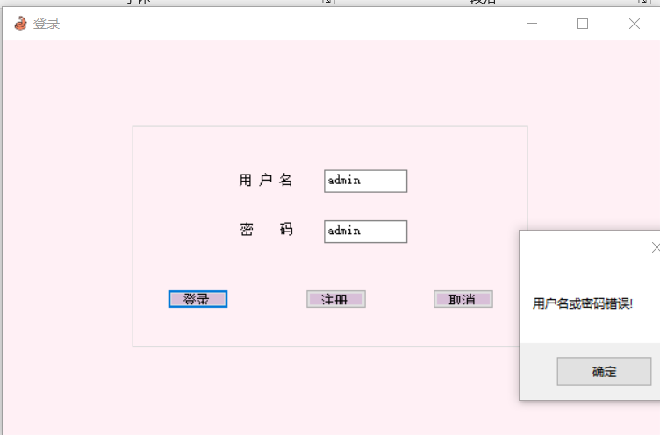
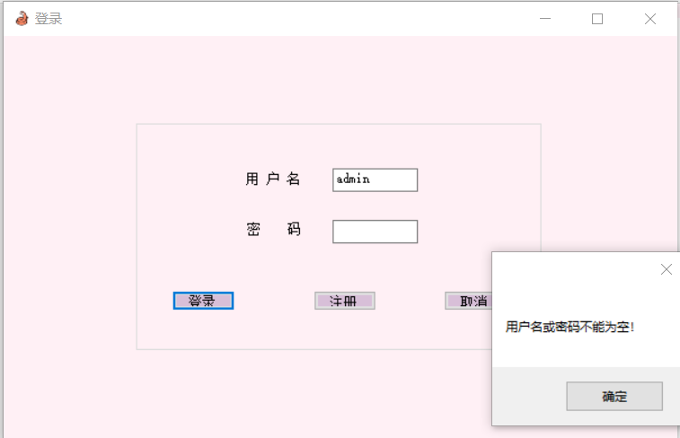
using System;
using System.Collections.Generic;
using System.ComponentModel;
using System.Data;
using System.Drawing;
using System.Linq;
using System.Text;
using System.Threading.Tasks;
using System.Windows.Forms;
using MySql.Data.MySqlClient;
namespace net_wo
{
public partial class frm_log : Form
{
public static frm_log frmlogin;
public frm_log()
{
InitializeComponent();
}

private void button2_Click(object sender, EventArgs e)
{
//取消
Application.Exit();
}

private void butt_log_Click(object sender, EventArgs e)
{
string connStr = "server=localhost;port=3306;database=snakeGame;user=root;password=Root@123";
MySqlConnection conn = new MySqlConnection(connStr);
conn.Open();

string sql = "select State from userinfo where Id='" + text_name.Text.Trim() + "' and Pwd='" + text_pwd.Text.Trim() + "'";
//MessageBox.Show(sql);
MySqlCommand comm = new MySqlCommand(sql, conn);

if (text_name.Text.Trim() != "" && text_pwd.Text.Trim() != "")
{
string role = (string)comm.ExecuteScalar();
if (role != null)
{
this.Hide();//隐藏登录窗口
frmlogin = this;//静态全局变量
frm_main frm = new frm_main(text_name.Text.Trim(), role, text_pwd.Text.Trim());
frm.Show(); //MessageBox.Show(role);
conn.Close();//及时关闭
}
else MessageBox.Show("用户名或密码错误!");
}
else MessageBox.Show("用户名或密码不能为空！");
conn.Close();
}

private void butt_no_Click(object sender, EventArgs e)
{
Application.Exit();
}

private void text_name_KeyDown_1(object sender, KeyEventArgs e)
{
if (e.KeyValue == 13)
{
text_pwd.Focus();
}
}

private void text_pwd_KeyDown(object sender, KeyEventArgs e)
{
if (e.KeyValue == 13)
{
butt_log.Focus();
}
}
private void butt_new_Click(object sender, EventArgs e)
{
this.Hide();
frm_newuser frm = new frm_newuser();
frm.Show();
}
}
}

Frm_newuser
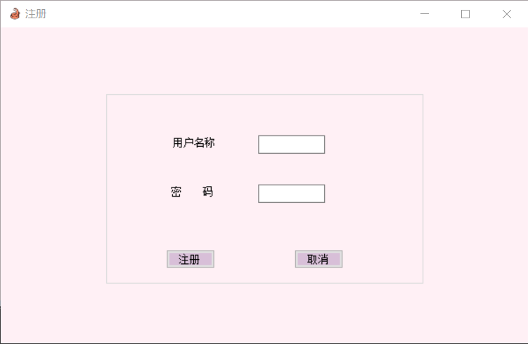
using System;
using System.Collections.Generic;
using System.ComponentModel;
using System.Data;
using System.Drawing;
using System.Linq;
using System.Text;
using System.Threading.Tasks;
using System.Windows.Forms;
using MySql.Data.MySqlClient;
namespace net_wo
{
public partial class frm_newuser : Form
{
public frm_newuser()
{
InitializeComponent();
}

private void button_add_Click(object sender, EventArgs e)
{
string sql = "";
MySqlConnection conn = null;
MySqlCommand comm = null;
DataSet ds = null;
MySqlDataAdapter da = null;

if (textBox_name.Text.Trim() != "" && textBox_pwd.Text.Trim() != "")
{
sql = "select * from userinfo where Id='" + textBox_name.Text.Trim() + "'";
comm = new MySqlCommand(sql, conn);
ds = new DataSet();
da = new MySqlDataAdapter(comm);
da.Fill(ds);
if (comm.ExecuteScalar() == null)
{
sql = String.Format("insert into userinfo values('{0}','{1}','用户')", textBox_name.Text.Trim(), textBox_pwd.Text.Trim());
comm.CommandText = sql;
comm.ExecuteNonQuery();

sql = "insert into pictureinfo values('" + textBox_name.Text.Trim() + "',' ')";
comm.CommandText = sql;
comm.ExecuteNonQuery();

sql = "insert into rankinfo values('" + textBox_name.Text.Trim() + "','none', '0')";
comm.CommandText = sql;
comm.ExecuteNonQuery();

MessageBox.Show("注册成功！");
conn.Close();

frm_log frm = new frm_log();
this.Close();
frm.Show();
}
else MessageBox.Show("已存在该昵称！");
}
else MessageBox.Show("不能为空！");
}

private void butt_no_Click(object sender, EventArgs e)
{
frm_log frm = new frm_log();
frm.Show();
this.Close();
}
}
}

Frm_main
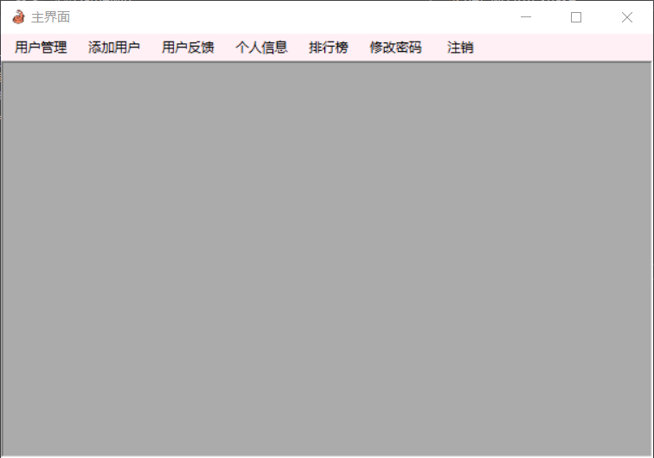
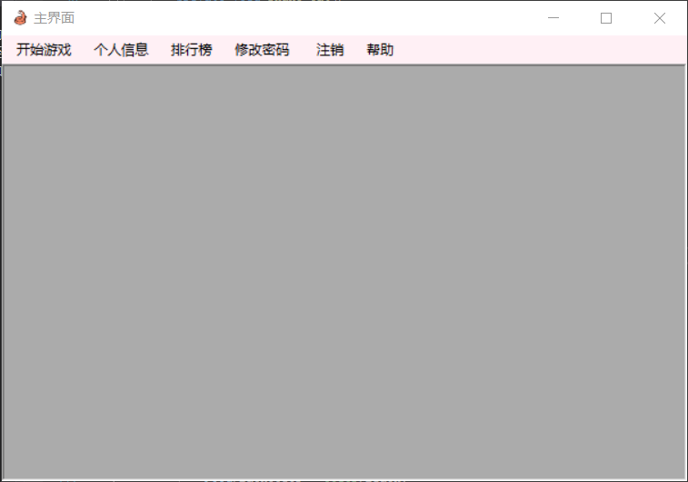
using System;
using System.Collections.Generic;
using System.ComponentModel;
using System.Data;
using System.Drawing;
using System.Linq;
using System.Text;
using System.Threading.Tasks;
using System.Windows.Forms;
using MySql.Data.MySqlClient;
namespace net_wo
{
public partial class frm_main : Form
{
String UserName = "", Role = "", PassWord = "";
bool logout = false;

private void 注销_Click(object sender, EventArgs e)
{
frm_log.frmlogin.Show();
logout = true;
this.Close();
}

private void frm_main_FormClosing(object sender, FormClosingEventArgs e)
{
if (!logout)
{
frm_log.frmlogin.Close();
}
}

private void 修改密码_Click(object sender, EventArgs e)
{
frm_changePwd frm = new frm_changePwd(UserName);
frm.MdiParent = this;
frm.WindowState = FormWindowState.Maximized;
frm.FormBorderStyle = FormBorderStyle.None;
frm.Show();
}

private void 个人信息_Click(object sender, EventArgs e)
{
frm_user frm = new frm_user(UserName);
frm.MdiParent = this;
frm.WindowState = FormWindowState.Maximized;
frm.FormBorderStyle = FormBorderStyle.None;
frm.Show();
}

private void 用户管理_Click(object sender, EventArgs e)
{
frm_manage frm = new frm_manage(UserName);
frm.MdiParent = this;
frm.WindowState = FormWindowState.Maximized;
frm.FormBorderStyle = FormBorderStyle.None;
frm.Show();
}

private void 帮助ToolStripMenuItem_Click(object sender, EventArgs e)
{
frm_help frm = new frm_help(UserName);
frm.MdiParent = this;
frm.WindowState = FormWindowState.Maximized;
frm.FormBorderStyle = FormBorderStyle.None;
frm.Show();
}

private void 排行榜ToolStripMenuItem_Click(object sender, EventArgs e)
{
frm_rank frm = new frm_rank();
frm.MdiParent = this;
frm.WindowState = FormWindowState.Maximized;
frm.FormBorderStyle = FormBorderStyle.None;
frm.Show();
}

private void 添加用户_Click(object sender, EventArgs e)
{
frm_adduser frm = new frm_adduser();
frm.MdiParent = this;
frm.WindowState = FormWindowState.Maximized;
frm.FormBorderStyle = FormBorderStyle.None;
frm.Show();
}

private void 用户反馈_Click(object sender, EventArgs e)
{

frm_info frm = new frm_info();
frm.MdiParent = this;
frm.WindowState = FormWindowState.Maximized;
frm.FormBorderStyle = FormBorderStyle.None;
frm.Show();
}

private void 开始游戏_Click(object sender, EventArgs e)
{
frm_snake frm = new frm_snake(UserName);
frm.MdiParent = this;
frm.WindowState = FormWindowState.Maximized;
frm.FormBorderStyle = FormBorderStyle.None;
frm.Show();
}

public frm_main(string username, string role, string password)
{
InitializeComponent();
UserName = username;
Role = role;
PassWord = password;

if(role == "管理员")
{
用户管理.Visible = true;
用户反馈.Visible = true;
添加用户.Visible = true;
开始游戏.Visible = false;
帮助.Visible = false;
}
}
}
}

Frm_adduser
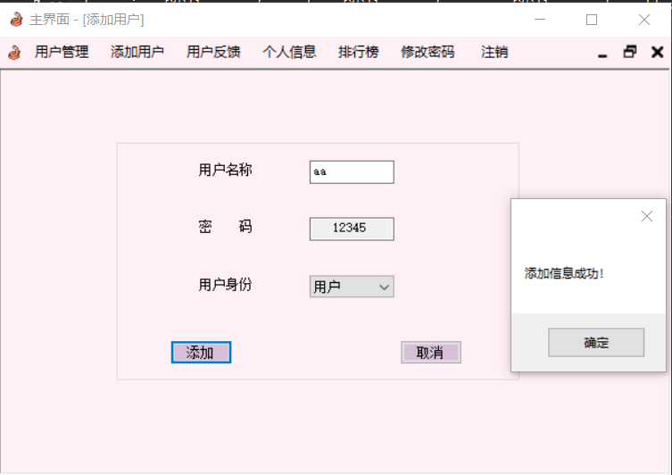
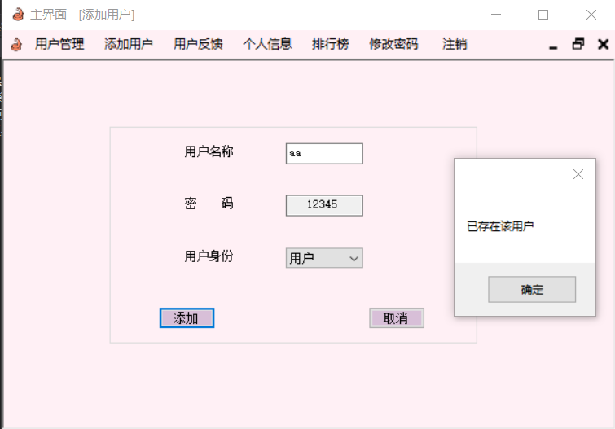
using System;
using System.Collections.Generic;
using System.ComponentModel;
using System.Data;
using System.Drawing;
using System.Linq;
using System.Text;
using System.Threading.Tasks;
using System.Windows.Forms;
using MySql.Data.MySqlClient;
namespace net_wo
{
public partial class frm_adduser : Form
{
string sql = "";
MySqlConnection conn = null;
MySqlCommand comm = null;
DataSet ds = null;
MySqlDataAdapter da = null;
public frm_adduser()
{
InitializeComponent();

string connstr = "server=localhost;port=3306;database=snakeGame;user=root;password=Root@123";
conn = new MySqlConnection(connstr);
conn.Open();

comboBox1.SelectedIndex = 1;
}

private void button_add_Click(object sender, EventArgs e)
{
if (textBox_name.Text.Trim() != "" && textBox_pwd.Text.Trim() != "")
{
sql = "select * from userinfo where Id='" + textBox_name.Text.Trim() + "'";
comm = new MySqlCommand(sql, conn);
ds = new DataSet();
da = new MySqlDataAdapter(comm);
da.Fill(ds);
if (comm.ExecuteScalar() == null)
{
string users = comboBox1.Text.Trim();
sql = String.Format("insert into userinfo values('{0}','12345','{1}')", textBox_name.Text.Trim(), users);
comm.CommandText = sql;
comm.ExecuteNonQuery();

sql = "insert into pictureinfo values('" + textBox_name.Text.Trim() + "',' ')";
comm.CommandText = sql;
comm.ExecuteNonQuery();

sql = "insert into rankinfo values('" + textBox_name.Text.Trim() + "','none', '0')";
comm.CommandText = sql;
comm.ExecuteNonQuery();

MessageBox.Show("添加信息成功！");
}
else MessageBox.Show("已存在该用户");
}
else MessageBox.Show("不能为空！");
}

private void butt_no_Click(object sender, EventArgs e)
{
conn.Close();
this.Close();
}
}
}

Frm_changePwd
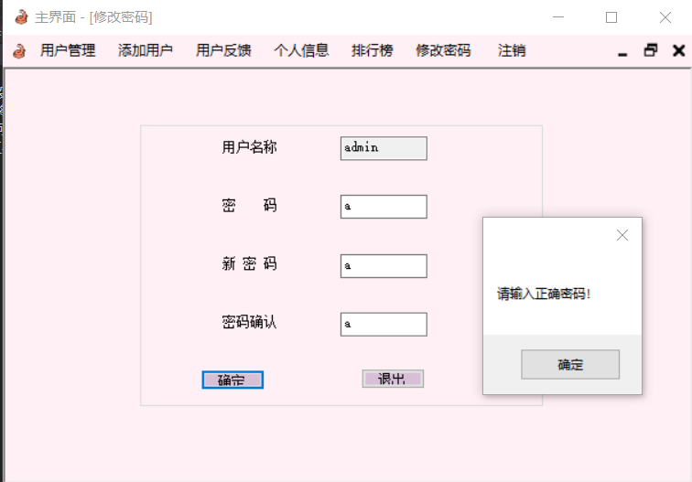
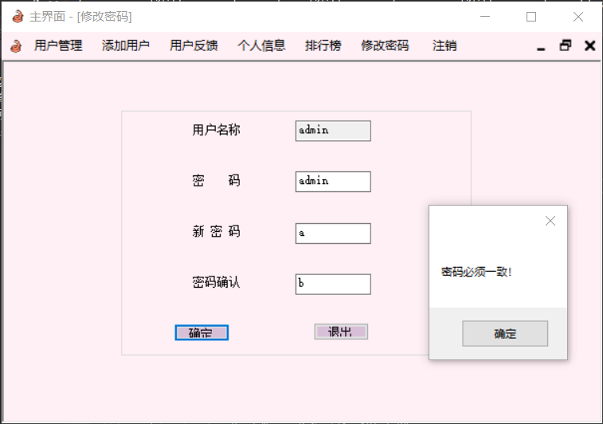
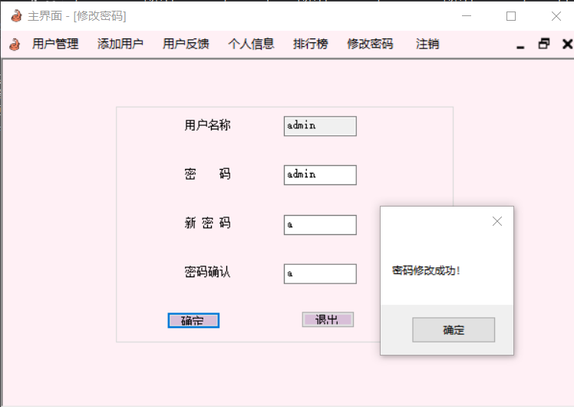
using System;
using System.Collections.Generic;
using System.ComponentModel;
using System.Data;
using System.Drawing;
using System.Linq;
using System.Text;
using System.Threading.Tasks;
using System.Windows.Forms;
using MySql.Data.MySqlClient;
namespace net_wo
{
public partial class frm_changePwd : Form
{
MySqlDataAdapter da = null;//最好初始化
DataSet ds = null;
MySqlConnection conn = null;
MySqlCommand comm = null;
string sql = "";
public frm_changePwd(String role)
{
InitializeComponent();
text_user.Text = role;

string connStr = "server=localhost;port=3306;database=snakeGame;user=root;password=Root@123";
conn = new MySqlConnection(connStr);
conn.Open();

sql = "select Id from userinfo";
comm = new MySqlCommand(sql, conn);
ds = new DataSet();
da = new MySqlDataAdapter(comm);
da.Fill(ds);
}

private void butt_ok_Click(object sender, EventArgs e)
{
if(text_user.Text.Trim() != "" && text_pa.Text.Trim() != "" && text_pa_new.Text.Trim() != "" && text_pa_ok.Text.Trim() != "")
{
sql = "select Pwd from userinfo where Id='" + text_user.Text + "'";
comm = new MySqlCommand(sql, conn);
ds = new DataSet();
da = new MySqlDataAdapter(comm);
da.Fill(ds);
string passwd = (string)comm.ExecuteScalar();

if (passwd != text_pa.Text.Trim())
{
MessageBox.Show("请输入正确密码！");
}
else
{
if (text_pa_ok.Text.Trim() == text_pa_new.Text.Trim())
{
sql = "update userinfo set Pwd='" + text_pa_new.Text.Trim() + "' where Id='" + text_user.Text + "'";
comm.CommandText = sql;
comm.ExecuteNonQuery();

MessageBox.Show("密码修改成功！");
}
else MessageBox.Show("密码必须一致！");
}
}
else MessageBox.Show("所有信息不能为空！");
}

private void butt_no_Click(object sender, EventArgs e)
{
this.Close();
}
}
}

Frm_help
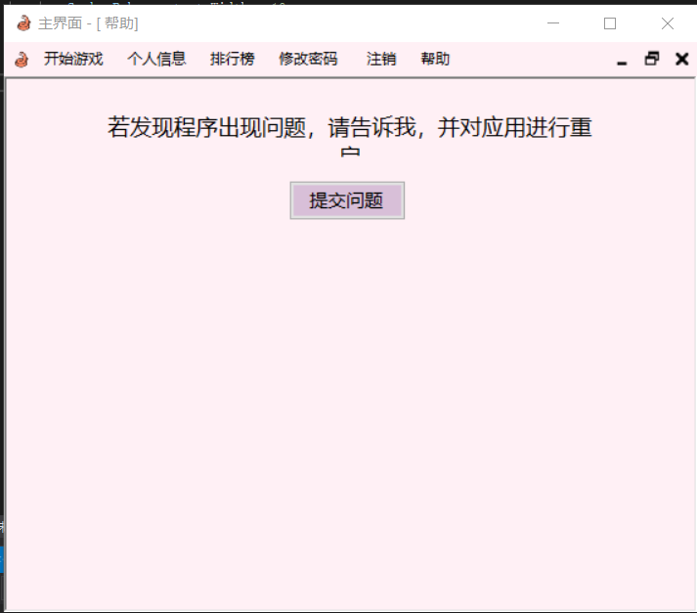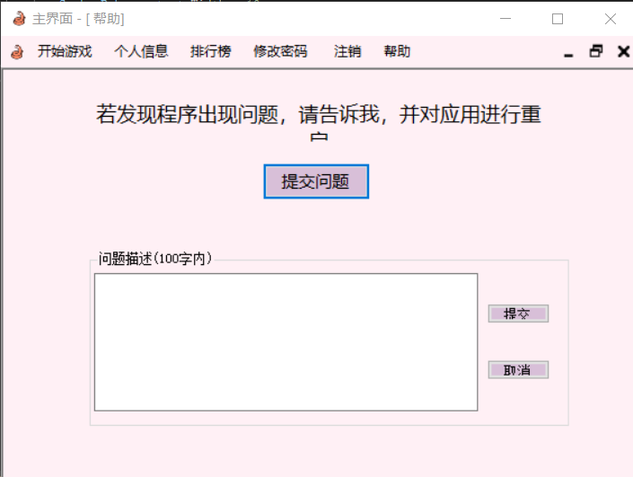
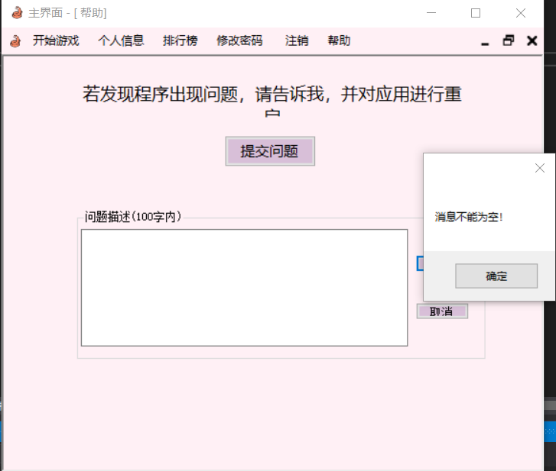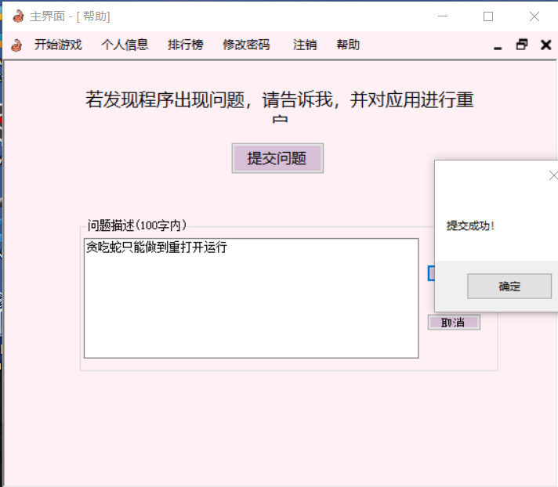
using System;
using System.Collections.Generic;
using System.ComponentModel;
using System.Data;
using System.Drawing;
using System.Linq;
using System.Text;
using System.Threading.Tasks;
using System.Windows.Forms;
using MySql.Data.MySqlClient;
namespace net_wo
{
public partial class frm_help : Form
{
MySqlDataAdapter da = null;//最好初始化
DataSet ds = null;
MySqlConnection conn = null;
MySqlCommand comm = null;
string sql = "", Username = "", role = "";
public frm_help(String user)
{
InitializeComponent();
Username = user;
}

private void button_no_Click(object sender, EventArgs e)
{
this.Close();
}

private void button_wanna_Click(object sender, EventArgs e)
{
groupBox1.Visible = true;
}

private void butt_sub_Click(object sender, EventArgs e)
{
string connStr = "server=localhost;port=3306;database=snakeGame;user=root;password=Root@123";
conn = new MySqlConnection(connStr);
conn.Open();
if (textBox_sub.Text.Trim() != "")
{
if(textBox_sub.Text.Trim().Length > 100)
{
MessageBox.Show("超出字数！");
}
else
{
sql = String.Format("insert into questioninfo values('{0}','{1}')", Username, textBox_sub.Text.Trim());
comm = new MySqlCommand(sql, conn);
ds = new DataSet();
da = new MySqlDataAdapter(comm);
da.Fill(ds);
MessageBox.Show("提交成功！");
}
textBox_sub.Text = "";
}
else
{
MessageBox.Show("消息不能为空！");
}
conn.Close();
}
}
}

Frm_info
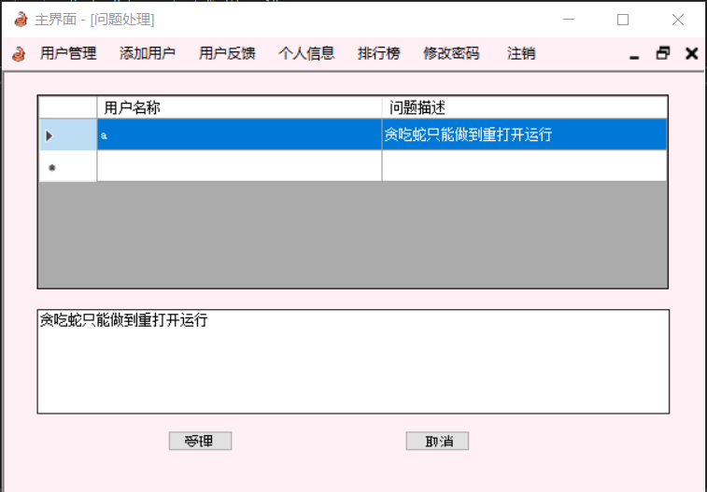
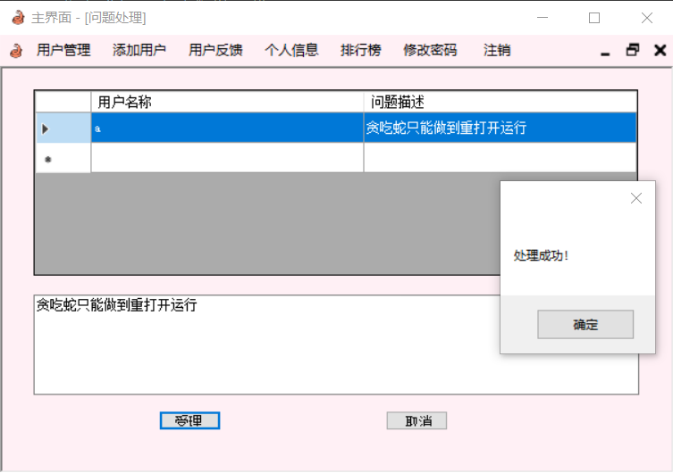
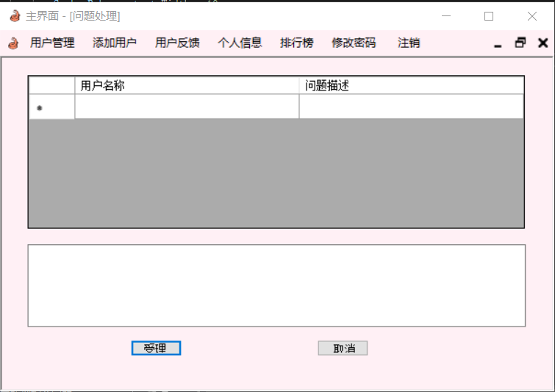
using System;
using System.Collections.Generic;
using System.ComponentModel;
using System.Data;
using System.Drawing;
using System.Linq;
using System.Text;
using System.Threading.Tasks;
using System.Windows.Forms;
using MySql.Data.MySqlClient;
namespace net_wo
{
public partial class frm_info : Form
{
string sql = "";
MySqlConnection conn = null;
MySqlCommand comm = null;
DataSet ds = null;
MySqlDataAdapter da = null;
public frm_info()
{
InitializeComponent();

string connStr = "server=localhost;port=3306;database=snakeGame;user=root;password=Root@123";
conn = new MySqlConnection(connStr);
conn.Open();

sql = "select * from questioninfo";
comm = new MySqlCommand(sql, conn);

ds = new DataSet();
da = new MySqlDataAdapter(comm);
da.Fill(ds);
dataGridView1.DataSource = ds.Tables[0];
}

private void dataGridView1_CellContentClick(object sender, DataGridViewCellEventArgs e)
{
dataGridView1.ColumnHeadersDefaultCellStyle.Alignment = DataGridViewContentAlignment.MiddleCenter;
}

private void button_ok_Click(object sender, EventArgs e)
{
sql = "delete from questioninfo where Ques = '" + textBox1.Text + "'";
comm.CommandText = sql;
comm.ExecuteNonQuery();
MessageBox.Show("处理成功！");

textBox1.Text = "";
sql = "select * from questioninfo";
comm.CommandText = sql;
comm.ExecuteNonQuery();

ds.Clear();
da.Fill(ds);
dataGridView1.DataSource = ds.Tables[0];
}

private void button_no_Click(object sender, EventArgs e)
{

conn.Close();
this.Close();
}

private void dataGridView1_CellMouseDown(object sender, DataGridViewCellMouseEventArgs e)
{
if (e.RowIndex >= 0)
{
dataGridView1.Rows[e.RowIndex].Selected = true;
textBox1.Text = dataGridView1.Rows[e.RowIndex].Cells[1].Value.ToString();
}
else MessageBox.Show("未选中任何行");
}
}
}

Frm_manage
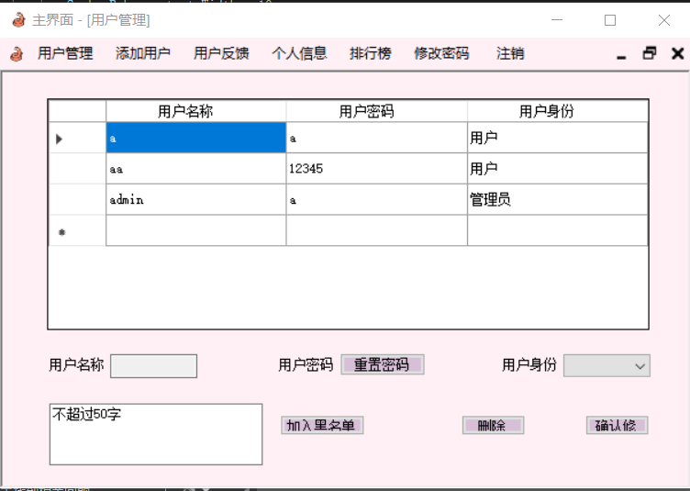
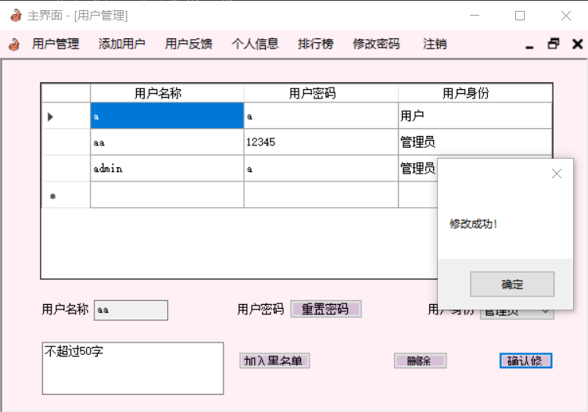
using System;
using System.Collections.Generic;
using System.ComponentModel;
using System.Data;
using System.Drawing;
using System.Linq;
using System.Text;
using System.Threading.Tasks;
using System.Windows.Forms;
using MySql.Data.MySqlClient;

namespace net_wo
{
public partial class frm_manage : Form
{
MySqlDataAdapter da = null;//最好初始化
DataSet ds = null;
MySqlConnection conn = null;
MySqlCommand comm = null;
string sql = "";
String username = "";
public frm_manage(String name)
{
InitializeComponent();
dataGridView1.ColumnHeadersDefaultCellStyle.Alignment = DataGridViewContentAlignment.MiddleCenter;

username = name;
string connStr = "server=localhost;port=3306;database=snakeGame;user=root;password=Root@123";
conn = new MySqlConnection(connStr);
conn.Open();

sql = "select * from userinfo";
comm = new MySqlCommand(sql, conn);

ds = new DataSet();
da = new MySqlDataAdapter(comm);
da.Fill(ds);
dataGridView1.DataSource = ds.Tables[0];
}

private void but_rePwd_Click(object sender, EventArgs e)
{
sql = "update userinfo set Pwd='12345' where Id = '" + text_name.Text + "'";
comm.CommandText = sql;
string temp = text_name.Text;
comm.ExecuteNonQuery();
comboBox_state.SelectedIndex = 0;
sql = "select * from userinfo";
MessageBox.Show(sql);
comm.CommandText = sql;
comm.ExecuteNonQuery();

ds.Clear();
da.Fill(ds);
dataGridView1.AutoGenerateColumns = false;
dataGridView1.DataSource = ds.Tables[0];
MessageBox.Show("重置成功！");
}

private void butt_del_Click(object sender, EventArgs e)
{
if (text_name.Text != "")
{
sql = "delete from userinfo where Id='" + text_name.Text + "'";
comm.CommandText = sql;
comm.ExecuteNonQuery();

comboBox_state.SelectedIndex = 0;

sql = "select * from userinfo";
comm.CommandText = sql;
comm.ExecuteNonQuery();

ds.Clear();
da.Fill(ds);
dataGridView1.AutoGenerateColumns = false;
dataGridView1.DataSource = ds.Tables[0];
MessageBox.Show("成功删除该用户！");
}
else MessageBox.Show("没有选中任何行！");
}

private void butto_ok_Click(object sender, EventArgs e)
{
sql = "update userinfo set State='"+ comboBox_state.Text + "' where Id = '" + text_name.Text + "'";
comm.CommandText = sql;
comm.ExecuteNonQuery();

sql = "select * from userinfo";
comm.CommandText = sql;
comm.ExecuteNonQuery();

ds.Clear();
da.Fill(ds);
dataGridView1.AutoGenerateColumns = false;
dataGridView1.DataSource = ds.Tables[0];

MessageBox.Show("修改成功！");
}

private void dataGridView1_CellMouseDown(object sender, DataGridViewCellMouseEventArgs e)
{
if (e.RowIndex >= 0)
{
dataGridView1.Rows[e.RowIndex].Selected = true;
text_name.Text = dataGridView1.Rows[e.RowIndex].Cells[0].Value.ToString();
comboBox_state.Text = dataGridView1.Rows[e.RowIndex].Cells[2].Value.ToString();
}
else MessageBox.Show("未选中任何行");
}

private void 删除_Click(object sender, EventArgs e)
{
butt_del_Click(sender, e);
}

private void but_bad_Click(object sender, EventArgs e)
{
sql = "delete from userinfo where id='" + username + "'";
comm.CommandText = sql;
comm.ExecuteNonQuery();

sql = "insert into blacklist values('" + username + "','" + text_reasion.Text.Trim().ToString() + "')";
comm.CommandText = sql;
comm.ExecuteNonQuery();

MessageBox.Show("加入成功，后续请重新添加此用户");
}
}
}

Frm_rank
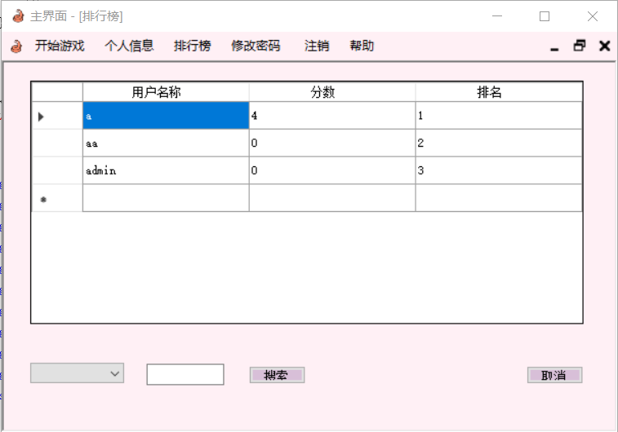
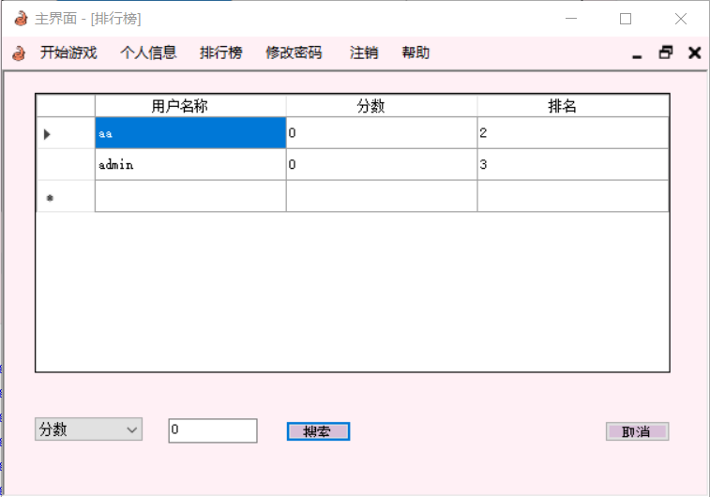
using System;
using System.Collections.Generic;
using System.ComponentModel;
using System.Data;
using System.Drawing;
using System.Linq;
using System.Text;
using System.Threading.Tasks;
using System.Windows.Forms;
using MySql.Data.MySqlClient;
namespace net_wo
{
public partial class frm_rank : Form
{
MySqlDataAdapter da = null;
DataSet ds = null;
MySqlConnection conn = null;
MySqlCommand comm = null;
string sql = "";
public frm_rank()
{
InitializeComponent();
dataGridView1.ColumnHeadersDefaultCellStyle.Alignment = DataGridViewContentAlignment.MiddleCenter;

string connStr = "server=localhost;port=3306;database=snakeGame;user=root;password=Root@123";
conn = new MySqlConnection(connStr);
conn.Open();

//sql = "SELECT (@Rankk:=@Rankk+1) Rankk,Id,Score FROM rankinfo, (SELECT @Rankk:=0) as Rankk ORDER BY Score";
// sql = "SELECT @Rankk:=0; SELECT (@Rankk:=@Rankk+1) Rankk, Id, Score FROM rankinfo ORDER BY Score";
sql = "select *from rankinfo ORDER BY Score desc";
//MessageBox.Show(sql);
comm = new MySqlCommand(sql, conn);

ds = new DataSet();
da = new MySqlDataAdapter(comm);
da.Fill(ds);
dataGridView1.DataSource = ds.Tables[0];

//遍历
string sett = "", namee = "";
for(int i = 0; i < dataGridView1.Rows.Count - 1; ++i)//空对象（多一行
{
sett = (i + 1).ToString();
string temp = dataGridView1.Rows[i].Cells["排名"].Value.ToString();
//MessageBox.Show(temp);
if (sett == temp) continue;

dataGridView1.Rows[i].Cells["排名"].Value = sett;
namee = dataGridView1.Rows[i].Cells["用户名称"].Value.ToString();
sql = "update rankinfo set Rankk='" + sett + "' where Id='" + namee + "'";
//MessageBox.Show(sql);
comm.CommandText = sql;
comm.ExecuteNonQuery();
}
//conn.Close();
}
private void button_search_Click(object sender, EventArgs e)
{
if(comboBox1.Text.Trim() != "" && textBox1.Text.Trim() != "")
{
string temp = comboBox1.Text.Trim();
if (temp == "用户名称")
{
sql = "select *from rankinfo where Id='" + textBox1.Text.Trim() + "'";
}
else if(temp == "分数")
{
sql = "select *from rankinfo where Score='" + textBox1.Text.Trim() + "'";
}
else if(temp == "排名")
{
sql = "select *from rankinfo where Rankk='" + textBox1.Text.Trim() + "'";
}
comm.CommandText = sql;
comm.ExecuteNonQuery();

ds.Clear();
da.Fill(ds);
dataGridView1.DataSource = ds.Tables[0];
}
else
{
MessageBox.Show("填写完全部信息后方可搜索");
}
}
}
}

Frm_snake
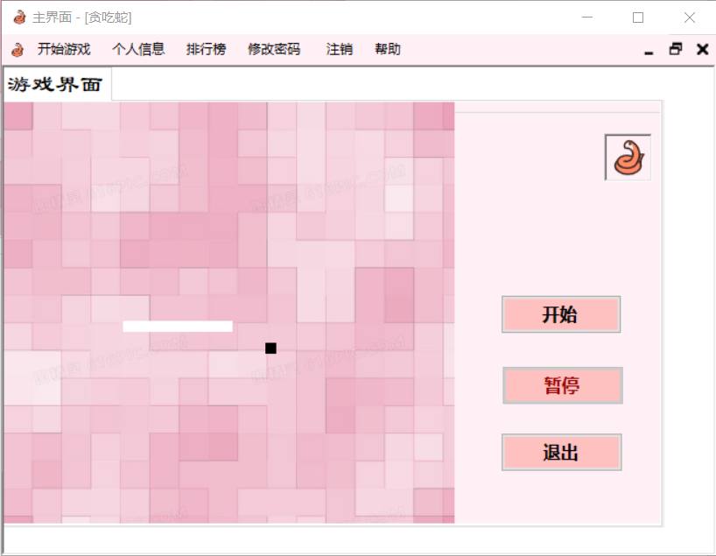
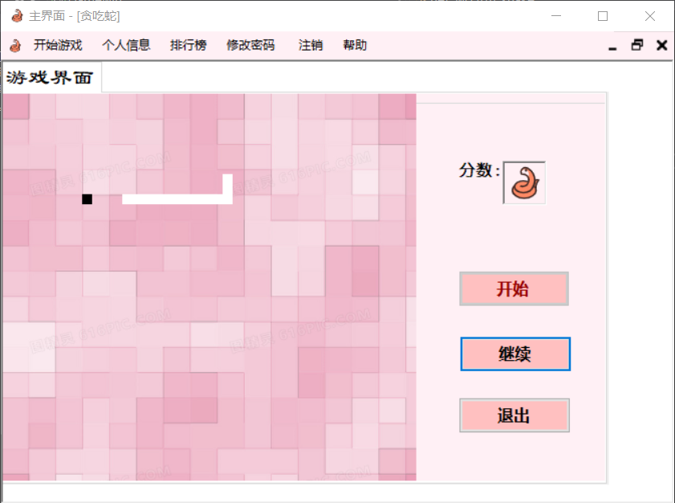
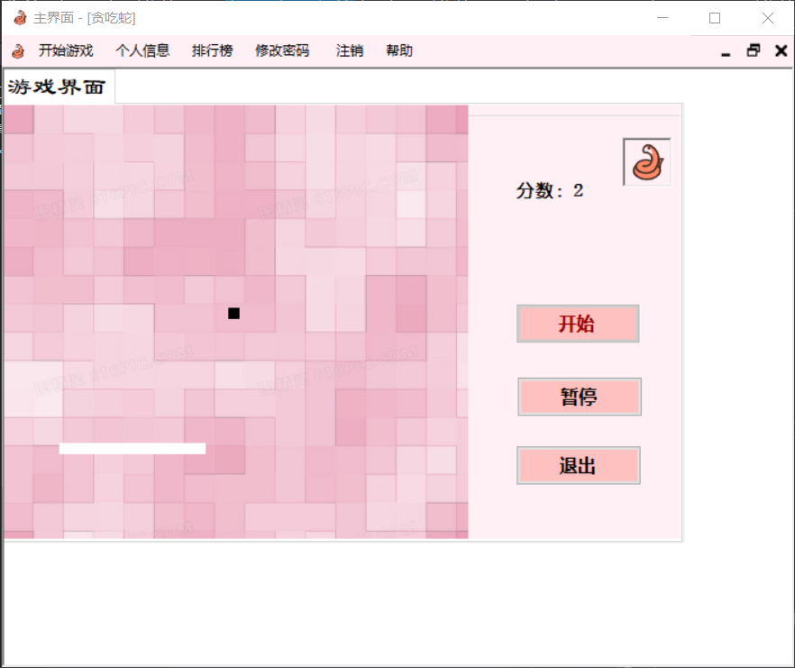
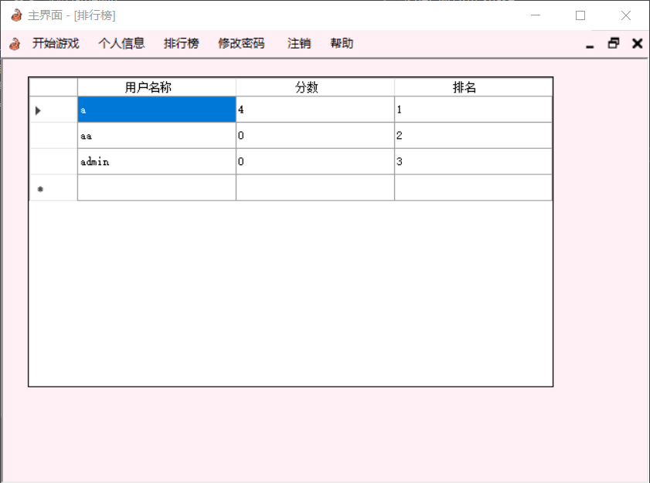
using System;
using System.Collections.Generic;
using System.ComponentModel;
using System.Data;
using System.Drawing;
using System.Linq;
using System.Text;
using System.Windows.Forms;
using MySql.Data.MySqlClient;
namespace net_wo
{
public partial class frm_snake : Form
{

string username = "";
public frm_snake(string name)
{
InitializeComponent();
username = name;
}

string Key_Name = "stop";
Label[] Snake_Boby=new Label[200] ;
Random R = new Random();
int Snake_Boby_content_x = 0, Snake_Boby_content_y = 0;
int score = 0;
bool isalive = false;

public void Form1_KeyDown(object sender, KeyEventArgs e)
{
int x, y;
x = Snake_Boby[0].Left;
y = Snake_Boby[0].Top;
Key_Name = e.KeyCode.ToString();
if (e.KeyCode == Keys.Right)
{
Snake_Boby[0].Left = x + 10;
Snake_move(x, y);
}
if (e.KeyCode == Keys.Up)
{
Snake_Boby[0].Top = y - 10;
Snake_move(x, y);
}
if (e.KeyCode == Keys.Down)
{
Snake_Boby[0].Top = y + 10;
Snake_move(x, y);
}
if (e.KeyCode == Keys.Left)
{
Snake_Boby[0].Left = x - 10;
Snake_move(x, y);
}
Eat_time();
}

public void Eat_time()
{
double x1 = 10, y1 = 10, x2 = 10, y2 = 10;
foreach (Label lb in this.pictureBox1.Controls)
{
if (lb.Tag.ToString() == "food".ToString())
{
x2 = lb.Left;
y2 = lb.Top;
}
if (lb.Tag.ToString() == "0".ToString())
{
x1 = lb.Left;
y1 = lb.Top;
}
}
if (x2 == x1 && y2 == y1)
{
Snake_eat();
foreach (Label lb in this.pictureBox1.Controls)
{
if (lb.Tag.ToString() == "food".ToString())
{
lb.Top = R.Next(1, 18) * 20;
lb.Left = R.Next(1, 19) * 20;
lb.BackColor = Color.Black;
}
}
}
}
private void Snake_eat()
{
int i = 0;
for (; Snake_Boby[i] != null; i++) ;
Label Snake_Boby_content = new Label();
Snake_Boby_content.Width = 10;
Snake_Boby_content.Height = 10;
Snake_Boby_content.Top = Snake_Boby_content_y;
Snake_Boby_content.Left = Snake_Boby_content_x;
Snake_Boby_content.BackColor = Color.White;
Snake_Boby_content.Tag = i;
Snake_Boby[i] = Snake_Boby_content;

this.pictureBox1.Controls.Add(Snake_Boby_content);
this.score++;
this.labelScore.Text = "得分：" + this.score.ToString();
}

public void Snake_food()
{

Label Food = new Label();
Food.Width = 10;
Food.Height = 10;
Food.Top = R.Next(1, 18) * 20;
Food.Left = R.Next(1, 19) * 20;
Food.Tag = "food";
Food.BackColor = Color.Black;
this.pictureBox1.Controls.Add(Food);

}
public void Snake_move(int x, int y)
{
int temp_x = 0, temp_y = 0;
for (int i = 1; Snake_Boby[i] != null; i++)
{
if (i >= 3)
{
temp_x = Snake_Boby_content_x;
temp_y = Snake_Boby_content_y;
}
if (i == 1)
{
temp_x = Snake_Boby[i].Left;
temp_y = Snake_Boby[i].Top;
Snake_Boby[i].Left = x;
Snake_Boby[i].Top = y;
}
else
{
Snake_Boby_content_x = Snake_Boby[i].Left;
Snake_Boby_content_y = Snake_Boby[i].Top;
Snake_Boby[i].Left = temp_x;
Snake_Boby[i].Top = temp_y;
}
}
}

private void timer1_Tick_1(object sender, EventArgs e)
{
if (isalive)
{
int x, y;
x = Snake_Boby[0].Left;
y = Snake_Boby[0].Top;
if (Key_Name == "start")
{
Snake_Boby[0].Left = x + 10;
Snake_move(x, y);
}
if (Key_Name == "Right")
{
Snake_Boby[0].Left = x + 10;
Snake_move(x, y);
}
if (Key_Name == "Up")
{
Snake_Boby[0].Top = y - 10;
Snake_move(x, y);
}
if (Key_Name == "Down")
{
Snake_Boby[0].Top = y + 10;
Snake_move(x, y);
}
if (Key_Name == "Left")
{
Snake_Boby[0].Left = x - 10;
Snake_move(x, y);
}
Eat_time();
Snake_dead(x, y);
}

}

public void Snake_dead(int x,int y)
{
if (x<pictureBox1.Location.X||x>pictureBox1.Location.X+pictureBox1.Width-20||y<pictureBox1.Location.Y||y>pictureBox1.Location.Y+pictureBox1.Height-20)
{
this.button2.Enabled = false;
gameover.Visible = true;
gameover.Text = "游戏结束，得分："+score;
timer_gameover.Enabled = false;
timer_gameover.Interval = 2000;
timer_gameover.Enabled = true;
timer_game.Enabled = false;
isalive = false;
Array.Clear(Snake_Boby, 5, 5+score);
Key_Name = "stop";
}

}

private void Form1_Load(object sender, EventArgs e)
{
this.button2.Enabled = false;

this.Top = 100;
this.Left = 300;

gameover.Visible = false;
this.BackColor = Color.White;
for (int i = 0; i < 10; i++)
{
Label Snake_Boby_content = new Label();
Snake_Boby_content.Height = 10;
Snake_Boby_content.Width = 10;
Snake_Boby_content.Top = 200;
Snake_Boby_content.Left = 200 - i * 10;
Snake_Boby_content.BackColor = Color.White;
Snake_Boby_content.Tag = i;
Snake_Boby[i] = Snake_Boby_content;
this.pictureBox1.Controls.Add(Snake_Boby_content);
}

this.KeyDown += new KeyEventHandler(Form1_KeyDown);
Snake_food();
timer_game.Start();
}

private void button2_Click(object sender, EventArgs e)
{
if (button2.Text.Equals("暂停"))
{
timer_game.Enabled = false;

button2.Text = "继续";
}else if (button2.Text.Equals("继续"))
{
timer_game.Enabled = true;
button2.Text = "暂停";
this.pictureBox1.Focus();
}

}

private void button3_Click(object sender, EventArgs e)
{
this.Hide();
}

private void timer_gameover_Tick(object sender, EventArgs e)
{
gameover.Visible = false;
gameover.Enabled = false;
isalive = false;

string connStr = "server=localhost;port=3306;database=snakeGame;user=root;password=Root@123";
MySqlConnection conn = new MySqlConnection(connStr);
conn.Open();
string sql = "select *from rankinfo where Id='" + username + "'";
MySqlCommand comm = new MySqlCommand(sql, conn);
sql = "select Score from rankinfo where Id='" + username + "'";
comm.CommandText = sql;
string temp = (string)comm.ExecuteScalar();
int allscore = int.Parse(temp);
// MessageBox.Show(allscore.ToString() + "," + score.ToString());
if (allscore < this.score)
{
//MessageBox.Show("?");
sql = "update rankinfo set Score='" + score.ToString() + "' where Id='" + username + "'";
comm.CommandText = sql;
comm.ExecuteNonQuery();
DataSet ds = new DataSet();
MySqlDataAdapter da = new MySqlDataAdapter(comm);
da.Fill(ds);
}
conn.Close();
this.Close();
}

private void but_again_Click(object sender, EventArgs e)
{
}

private void button1_Click_1(object sender, EventArgs e)
{
Key_Name = "start";
isalive = true;
this.button1.Enabled = false;
this.button2.Enabled = true;
this.pictureBox1.Focus();
}
}
}

Frm_user
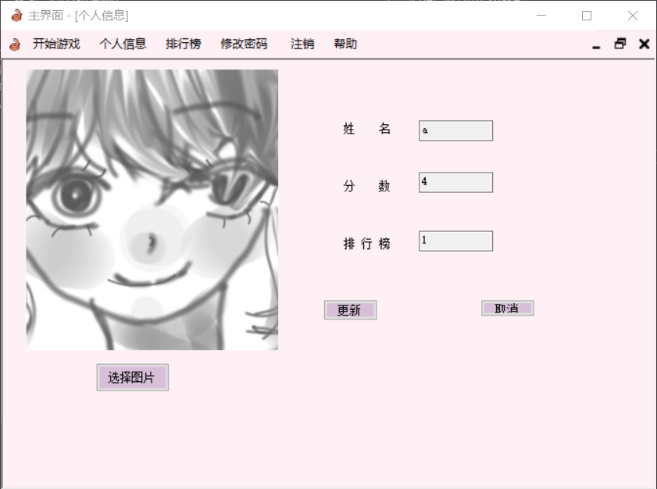
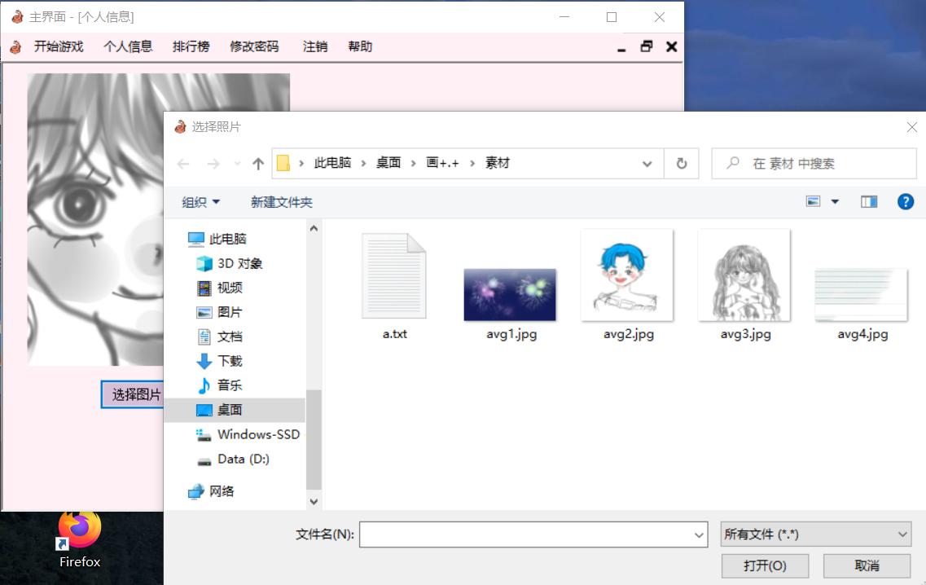
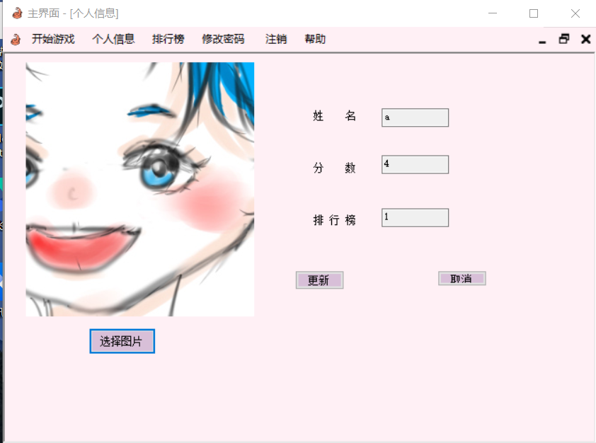
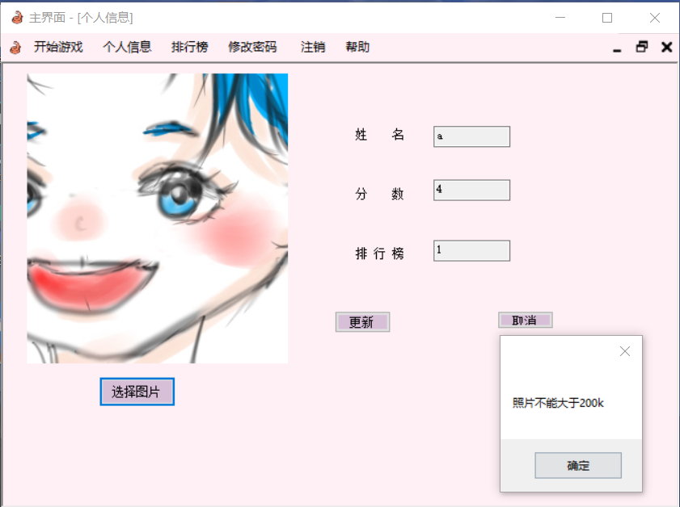
using System;
using System.Collections.Generic;
using System.ComponentModel;
using System.Data;
using System.Drawing;
using System.Linq;
using System.Text;
using System.Threading.Tasks;
using System.Windows.Forms;
using MySql.Data.MySqlClient;
using System.IO;
using MySql.Data.MySqlClient;
using AForge.Video.DirectShow;
namespace net_wo
{
public partial class frm_user : Form
{
MySqlDataAdapter da = null;//最好初始化
DataSet ds = null;
MySqlConnection conn = null;
MySqlCommand comm = null;
string sql = "", Username = "";

string oldFileName = string.Empty;
string imageName = string.Empty;
string filepath = "";
bool flag = false;
public frm_user(string name)
{
InitializeComponent();
Username = name;
string connStr = "server=localhost;port=3306;database=snakeGame;user=root;password=Root@123";
conn = new MySqlConnection(connStr);
conn.Open();
sql = "select *from rankinfo where Id='" + Username +"'";
comm = new MySqlCommand(sql, conn);
ds = new DataSet();
da = new MySqlDataAdapter(comm);
da.Fill(ds);

// 添加查询参数
comm.Parameters.AddWithValue("@Id", name);
// 创建MySqlDataReader对象
using (MySqlDataReader reader = comm.ExecuteReader())
{
// 读取结果集中的数据
while (reader.Read())
{
textBox1.Text = reader[0].ToString();
textBox2.Text = reader[2].ToString();
textBox3.Text = reader[1].ToString();
//Console.WriteLine("{0} {1} {2}", reader[0], reader[1], reader[2]);
break;
}
}

sql = "select Urll from pictureinfo where Id='" + name + "'";
comm.CommandText = sql;
filepath = (string)comm.ExecuteScalar();
//MessageBox.Show(filepath);
if(filepath.Trim() != "")
{
Image image = Image.FromFile(filepath);
pictureBox1.Image = image;
}
}

private void frm_user_Load(object sender, EventArgs e)
{

}

private void button5_Click(object sender, EventArgs e)
{

}

private void butt_no_Click(object sender, EventArgs e)
{
this.Close();
}
OpenFileDialog ofdImage;
private void butt_choseJpg_Click(object sender, EventArgs e)
{
ofdImage = new OpenFileDialog();
ofdImage.Title = "选择照片";
ofdImage.Filter = "所有文件 (*.*) | *.*|JPG图片(*.jpg)|*.jpg|PNG图片(*.png)|*.png ";
OpenFileDialog ofd = new OpenFileDialog();
ofdImage.Multiselect = false;
if (ofdImage.ShowDialog() == DialogResult.OK)
{
filepath = ofdImage.FileName;
FileInfo fileinfo = new FileInfo(ofdImage.FileName);
if(fileinfo.Length > 204800)
{
MessageBox.Show("照片不能大于200k");
}
else
{
pictureBox1.Image = Image.FromFile(ofdImage.FileName);
oldFileName = ofdImage.FileName;
flag = true;
}
}
}

private void butt_ok_Click(object sender, EventArgs e)
{
if (flag == true)
{
string result = oldFileName.Replace('\\', '/');
sql = "update pictureinfo set Urll='" + result + "' where Id='" + Username + "'";
//MessageBox.Show(sql);
}
comm.CommandText = sql;
comm.ExecuteNonQuery();

ds.Clear();
da.Fill(ds);
}
}
}

