BanglaFactGuard
A Multimodal Fact Checking System for Bangla News
Software Requirements Specification and Technical Report
SE 801: Software Project Lab III
Supervised by:
Toukir Ahammed
Lecturer
Institute of Information Technology
University of Dhaka
Submitted by:
Md. Abul Kalam Azad
Roll: BSSE-1425
Institute of Information Technology
University of Dhaka
Submitted to:
SPL-03 Program Committee
Revision Date: 07 October, 2026
Institute of Information Technology
University of Dhaka

Letter of Transmittal
07 October, 2026
BSSE 4th Year Exam Committee
Institute of Information Technology
University of Dhaka
Subject: Updated SRS and Technical Report Submission for BanglaFactGuard
Dear Sir,
I am pleased to submit the updated Software Requirements Specification and technical report for my Software Project Lab III project, BanglaFactGuard: A Multimodal Fact Checking System for Bangla News. This revision documents the current implementation of the web application, backend services and Chrome browser extension as of 7 October 2026.
The report presents the functional and non-functional requirements, system models, database schema, AI engineering design, testing plan and implementation status. It describes checking against verified news sources, image-based photocard extraction, preliminary multimodal predictions and the human review process used to establish final verdicts.
I have revised the earlier design to reflect the implemented workflows and to distinguish completed functionality from validation and deployment work. I would be grateful for your assessment and feedback on this report.
Thank you for your consideration.
Sincerely,
Md. Abul Kalam Azad
Roll: BSSE-1425
Institute of Information Technology
University of Dhaka
____________________________
Supervisor's Signature
Toukir Ahammed

Acknowledgement
I am sincerely grateful to the Institute of Information Technology, University of Dhaka, for giving me the opportunity to carry out my Software Project Lab III on the project titled BanglaFactGuard: A Multimodal Fact Checking System. This project has given me the chance to apply theoretical knowledge of software engineering, natural language processing, computer vision and information retrieval to a practical, socially relevant problem.
I would like to express my heartfelt gratitude to my respected supervisor, Toukir Ahammed, Lecturer, Institute of Information Technology, University of Dhaka, for his continuous guidance, constructive criticism and encouragement throughout this work. His insights into multimodal machine learning, Bangla natural language processing and system design have helped shape the direction, design and scope of this system.
I am also thankful to my other faculties and classmates for their cooperation, helpful discussions and suggestions during different phases of the project. Finally, I acknowledge the resources and academic environment provided by the Institute of Information Technology, which made the progress of this project possible.

Abstract
BanglaFactGuard is a Bangla news verification platform that combines automated analysis with human expert review. Its implementation consists of an Angular web application, a FastAPI backend and a Chrome browser extension. The interface uses English while accepting Bangla content. Users can submit claims anonymously or associate submissions with an account.
The system supports three methods. Text & source checks a headline and an optional body and publication date against verified news sources. It reports source correspondence, Headline Alteration and date findings independently; an optional body is evaluated through four similarity measurements. Photo card accepts an image, uses Gemini to read the printed headline, recognize a verified news outlet and extract an available printed date, and then checks the extracted headline through the shared evidence pipeline. Text & image combines BanglaBERT text features with EfficientNet-B4 image features to produce a preliminary Fake or Non-Fake prediction.
Automated outputs remain preliminary. Experts cast an overall verdict of Real, Fake, Misleading or Altered. Credibility weights, a minimum number of votes, a leading-score threshold and a lead margin determine consensus. Undecided claims can be escalated under configurable limits for an administrator to resolve. Source, headline and date assessments remain separate from the overall vote.
The implementation includes durable background jobs, compatible-result reuse, public fact exploration, personal submission history, account notifications, final-result email delivery and browser-extension activity tracking. This report updates the requirements, use cases, activities, data model, model architecture and test criteria to match this implementation. Recorded notebook evaluation results are distinguished from deployment performance, and production validation remains a separate activity.

Contents
Letter of Transmittal 2
Acknowledgement 3
Abstract 4
List of Figures 7
List of Tables 8
1. Introduction 9
1.1 Purpose 9
1.2 Motivation 9
1.3 Problem Statement 9
1.4 Objectives 10
1.5 Scope 10
1.5.1 In Scope 10
1.5.2 Out of Scope 10
1.6 Deliverables 10
1.7 Purpose of this Document 10
2. Project Description and Requirements Analysis 11
2.1 Normal Requirements 11
2.2 Expected Requirements 12
2.3 Exciting Requirements 13
2.4 Non-Functional Requirements 13
2.5 Stakeholders 14
2.6 External Interfaces and Business Rules 15
2.6.1 Input and Result Rules 15
3. System Modeling 16
3.1 Use Case Diagrams and Descriptions 16
3.1.1 Level 0 System Context 16
3.1.2 Level 1 Modules of BanglaFactGuard 16
3.1.3 Authentication and Registration 17
3.1.4 Profile Management 18
3.1.5 Verification Service 19
3.1.6 Expert Review and Voting 20
3.1.7 Fact Explorer 21
3.1.8 Browser Extension 22
3.1.9 Administration 23
3.1.10 Notification Management 24
3.2 Activity Diagrams 25
3.2.1 Authentication and Registration 25

Contents continued
3.2.2 Fact Explorer 26
3.2.3 Browser Extension 27
3.2.4 Multimodal Verification 28
3.2.5 Notifications 29
3.2.6 Photo Card Verification 30
3.2.7 Profile Management 31
3.2.8 Expert Review and Voting 32
3.2.9 Text and Source Verification 33
3.2.10 Verified Source Management 34
3.3 Submission Lifecycle and System Architecture 35
3.3.1 Deployment Components 36
4. Data and Information Modeling 37
4.1 ER Diagram and Database Schema 37
4.1.1 Review and Delivery Relationships 38
4.1.2 Database Schema 39
4.2 Dataset Description 57
5. AI Engineering Design 58
5.1 AI Pipeline and Model Selection 58
5.1.1 Multimodal Verification Architecture 58
5.1.2 Text and Source Verification Pipeline 59
5.1.3 Pipeline Stage Reference 60
5.1.4 Independent Finding Semantics 61
5.1.5 Body Similarity and Date Verification 62
5.1.6 Photo Card Extraction and Verification 63
5.2 Model Selection 64
5.3 Recorded Multimodal Evaluation 64
5.4 Expert Consensus and Result Reuse 65
6. Test Plan and Verification Status 66
6.1 Testing Objectives 66
6.2 Features to be Tested 66
6.3 Test Cases 66
6.4 Requirements Traceability and Test Evidence 73
6.5 Remaining Validation 73
7. Timeline and Current Implementation Status 74
8. Conclusion 75
9. References 75
9.1 Implementation Reference Index 76

List of Figures
Figure 3.1: System context use case diagram 16
Figure 3.2: Authentication and Registration use case diagram 17
Figure 3.3: Profile Management use case diagram 18
Figure 3.4: Verification Service use case diagram 19
Figure 3.5: Expert Review and Voting use case diagram 20
Figure 3.6: Fact Explorer use case diagram 21
Figure 3.7: Browser Extension use case diagram 22
Figure 3.8: Administration use case diagram 23
Figure 3.9: Notification Management use case diagram 24
Figure 3.10: Authentication and registration activity 25
Figure 3.11: Fact Explorer activity 26
Figure 3.12: Browser Extension activity 27
Figure 3.13: Multimodal Verification activity 28
Figure 3.14: Notifications activity 29
Figure 3.15: Photo Card Verification activity 30
Figure 3.16: Profile Management activity 31
Figure 3.17: Expert Review and Voting activity 32
Figure 3.18: Text and Source Verification activity 33
Figure 3.19: Verified Source Management activity 34
Figure 3.20: Submission lifecycle 35
Figure 3.21: Application and service architecture 36
Figure 4.1: Submission and evidence entity relationships 37
Figure 4.2: Review and delivery entity relationships 38
Figure 4.3: Dataset partitions recorded in the training notebook 57
Figure 5.1: Implemented multimodal inference architecture 58
Figure 5.2: Shared evidence verification pipeline 59
Figure 5.3: Current photocard extraction and verification pipeline 63
Figure 7.1: Report and implementation milestones 74

List of Tables
Table 2.1: Non-functional requirements 13
Table 2.2: Quality and operational requirements 14
Table 2.3: Stakeholders and responsibilities 14
Table 2.4: External interfaces 15
Table 4.1: Database schema for users 39
Table 4.2: Database schema for refresh_tokens 40
Table 4.3: Database schema for password_reset_tokens 41
Table 4.4: Database schema for verified_sources 42
Table 4.5: Database schema for expert_profiles 43
Table 4.6: Database schema for credibility_weight_tiers 44
Table 4.7: Database schema for voting_config 45
Table 4.8: Database schema for submissions 46
Table 4.9: Database schema for source_evidence_queries 47
Table 4.10: Database schema for retrieved_articles 48
Table 4.11: Database schema for photocard_extractions 49
Table 4.12: Database schema for multimodal_analysis 50
Table 4.13: Database schema for verification_results 51
Table 4.14: Database schema for expert_reviews 53
Table 4.15: Database schema for verification_jobs 54
Table 4.16: Database schema for notifications 55
Table 4.17: Database schema for result_deliveries 56
Table 4.18: Recorded dataset split 57
Table 5.1: Shared pipeline stages 60
Table 5.2: Preliminary findings and interpretation 61
Table 5.3: Body comparison measures 62
Table 5.4: Current model and service roles 64
Table 5.5: Saved notebook test results 64
Table 6.1: Test scope and evidence 66
Table 6.2: Requirement to acceptance-test mapping 73
Table 7.1: Current status and follow-up 74
Table 9.1: Implementation evidence for this revision 76

1. Introduction
Bangla news is shared as article text, screenshots, photocards and images across news and social platforms. These representations can omit context, alter a headline or recirculate an older report. A verification system must preserve the distinction between finding relevant reporting, comparing a headline, measuring textual similarity and making an editorial judgment about a claim.
BanglaFactGuard provides one submission and reporting environment for these tasks. It retrieves evidence from verified news sources, records preliminary automated findings and supports subsequent expert review. A public Fact Explorer exposes available reports, and a Chrome side panel allows users to submit content while browsing.

1.1 Purpose
The purpose of the system is to help readers, journalists and fact-checkers examine Bangla news claims using traceable evidence and a clearly separated human verdict. The purpose of this revision is to define the current software baseline so that implementation, evaluation and future maintenance use consistent requirements.

1.2 Motivation
A screenshot may preserve a publisher logo while changing its headline. A matching headline may circulate with an incorrect date. A text-and-image classifier may detect patterns associated with misinformation without identifying a supporting article. Presenting these cases as one automatic true-or-false answer would hide meaningful differences. BanglaFactGuard therefore presents the available evidence, comparison findings and expert outcome separately.

1.3 Problem Statement
The project addresses the need to submit Bangla claims in multiple formats, check them against verified news sources, retain accessible evidence and support a consistent review process. It also addresses repeated processing, interrupted browser sessions and delayed expert decisions through reusable results, durable jobs and configurable escalation.

1.4 Objectives
• Provide Text & source, Photo card and Text & image verification through the website and browser extension.
• Check submitted text and extracted photocard headlines against verified news sources and retain the relevant article details.
• Keep source correspondence, headline comparison, publication date and body similarity distinct in automated reports.
• Publish a final overall verdict through expert consensus or administrative resolution of an escalated claim.
• Retain submission ownership, personal history, processing status and result notifications.
• Reduce repeated processing through scope-aware result reuse and multimodal duplicate checks.

1.5 Scope

1.5.1 In Scope
The current implementation includes account registration and login, password recovery, profile settings, verified-source management, all three verification methods, evidence reports, public exploration, expert voting, configurable credibility tiers, review escalation, background processing and personal result delivery. The extension provides text selection, image upload, selected-area capture, drafts, activity tracking and links to full reports.

1.5.2 Out of Scope
The system does not implement automatic final editorial decisions, audio or video verification, full-page scrolling screenshots, independent forensic image-authenticity analysis or a general web-search assistant. Multimodal inference does not itself retrieve corroborating articles. A dedicated mobile application and deployment-wide guarantees of accuracy, latency or availability are outside the demonstrated baseline.

1.6 Deliverables
Deliverables comprise the web application, API and worker services, Chrome extension, database migrations, multimodal training notebook, verification models and configuration, automated test code and this editable SRS and technical report.

1.7 Purpose of this Document
This document specifies observable behavior, role boundaries, workflows, data relationships and acceptance criteria. The implementation baseline is the repository available on 7 October 2026. “Implemented” indicates corresponding code exists; it does not by itself certify a successful live deployment or a newly completed acceptance test.

2. Project Description and Requirements Analysis
BanglaFactGuard uses an Angular client and a Preact Chrome extension to access versioned FastAPI endpoints. PostgreSQL stores operational records and the durable job queue, Redis supports caching, and MinIO stores images. Local machine-learning services analyze text and text-image pairs; Gemini provides photocard extraction. SMTP supports password-reset and final-result email delivery.

2.1 Normal Requirements
FR-01 Registration and login
The system shall register regular users, authenticate active accounts, issue access and refresh tokens and allow logout.
FR-02 Password recovery
The system shall validate an emailed password-reset OTP and a new password; an authenticated user shall be able to change a password after confirming the current password.
FR-03 Role control
The backend shall enforce regular-user, expert and administrator permissions independently of client route guards.
FR-04 Profile and history
A signed-in user shall view personal profile details and submissions across all methods. Expert profile information shall be editable through administration rather than self-service.
FR-05 Text submission
The system shall accept a headline and verified-source reference, with optional body text and publication date, and check the claim against verified news sources.
FR-06 Photo card submission
The system shall accept an image and extract its printed headline, recognized verified outlet and complete printed date when available.

2.1 Normal Requirements continued
FR-07 Multimodal submission
The system shall accept headline, body text and image; the body and image shall be used for multimodal inference and the headline retained for display.
FR-08 Background processing
An accepted asynchronous submission shall receive an identifier and durable job record so processing can continue after the client closes.
FR-09 Evidence report
The system shall retain article URLs, extracted content, ranking and available comparison findings with their reasons.
FR-10 Expert decision
Experts shall submit an overall verdict; the system shall evaluate weighted consensus and preserve the automated findings separately.
FR-11 Public exploration
Users shall browse, search and filter available reports and open the corresponding detail page.
FR-12 Administration
Administrators shall manage experts, verified news sources, credibility tiers, voting configuration and escalated decisions.

2.2 Expected Requirements
FR-13 Input validation
The system shall validate required text fields, supported image MIME types and upload size; report invalid input without fabricating an analysis.
FR-14 Source registry
The system shall use active verified news sources and their maintained names, domains, aliases and extraction/search configurations.
FR-15 Result interpretation
The system shall distinguish unavailable or incomplete findings from negative findings, and keep missing measurements null rather than showing zero.
FR-16 Personal delivery
The system shall notify the signed-in submitter of available preliminary and final results; queue final-result email and retry delivery failures.
FR-17 Status continuity
The system shall expose pending, processing, failed, expert-review, escalated and finalized states, with processing phase and failure reason where available.

2.3 Exciting Requirements
FR-18 Compatible-result reuse
The system shall reuse a compatible stored result for a repeated claim, retaining the new submission and its ownership. Claim scope and pipeline version shall participate in text-claim identity.
FR-19 Browser capture
The system shall allow headline/body import from selected text and image input through upload or a selected screenshot area, followed by local preview and cropping.
FR-20 Extension continuity
The system shall retain drafts and account-separated activity, poll pending submissions, and surface preliminary, final and failure notifications according to preferences.
FR-21 Configurable review
The system shall apply administrator-managed credibility weights, consensus parameters and time/vote escalation limits without changing program code.
FR-22 Explainable comparisons
The system shall expose Headline Alteration reasons, source/date outcomes and four body-similarity measures without conflating similarity with truth.

2.4 Non-Functional Requirements
The following requirements define quality expectations and observable acceptance conditions. They are not claims that load testing or production certification has already been completed.
Table 2.1: Non-functional requirements
ID | Requirement and acceptance condition
NFR-01 | Reliability: accepted jobs survive process restart and stale job locks are reclaimable. Recovery must not silently lose the submission.
NFR-02 | Integrity: results, reviews, source references and delivery records obey their foreign keys, uniqueness rules and transaction boundaries.
NFR-03 | Security: authenticated endpoints validate tokens and roles; stored account passwords are hashed; ordinary clients cannot change privileged configuration.

2.4 Non-Functional Requirements continued
Table 2.2: Quality and operational requirements
ID | Requirement and acceptance condition
NFR-04 | Responsiveness: background submission returns acknowledgement independently of completion; the interface retains a usable status view while processing continues.
NFR-05 | Performance observability: record available stage timings and distinguish processing from queue wait, notification delay and human review time. Measure deployment percentiles before promising an SLA.
NFR-06 | Usability: use consistent method names and result labels across website and extension; distinguish preliminary findings from a final verdict.
NFR-07 | Language: accept Bangla Unicode text; preserve meaning during normalization. The implemented interface language is English.
NFR-08 | Maintainability: separate API, service, repository and pipeline responsibilities; version database changes and model-dependent results.
NFR-09 | Failure transparency: distinguish failed extraction, incomplete evidence search, unavailable models and absent article dates from negative evidence.
NFR-10 | Privacy and access: account history is owner-scoped. Published report visibility follows the application policy; guest submissions do not imply authenticated ownership.
NFR-11 | Compatibility: support the Angular website and desktop Chrome Manifest V3 extension; verify capture and desktop alerts in an installed browser.
NFR-12 | Deployability: provide database migration, model, storage, SMTP and network configuration. Production backup, HTTPS and capacity validation remain deployment acceptance tasks.

2.5 Stakeholders
Table 2.3: Stakeholders and responsibilities
Stakeholder | Responsibilities and access
Anonymous user | Submit claims, browse available reports and track guest extension activity.
Registered user | All public functions plus personal history, profile and account result notifications.
Expert | Review claims, cast overall votes, add supplementary findings and view review history and credibility.
Administrator | Manage experts, verified news sources and voting rules; resolve escalated claims.
Supervisor and evaluators | Assess requirement alignment, design, experimental evidence and acceptance results.
Maintainer | Operate the API, workers, database, storage, models and external integrations.

2.6 External Interfaces and Business Rules
Table 2.4: External interfaces
Interface | Current contract
Web client | Angular 19 and REST/JSON; forms upload images as multipart requests.
Chrome extension | Manifest V3 side panel and background service worker; shares backend endpoints with the website.
Verified news sources | Registered publisher configurations supply evidence through configured internal search and Google-based retrieval.
Gemini | Reads photocard content; requires credentials and service availability. Extracted data is validated before verification.
PostgreSQL | Persistent users, submissions, evidence, reviews, jobs and delivery records; Alembic schema migrations.
Redis and MinIO | Cache service and object storage respectively. Stored image keys are exposed through temporary signed URLs.
SMTP | Password-reset OTP and final-result mail; final delivery has persisted retry state.

2.6.1 Input and Result Rules
Photo card is an image-only submission. There is no extracted-text editing or separate source/date entry step in this workflow. A recognized active verified outlet and a readable headline are required; an unavailable printed date remains absent. Text claims may be headline-only or include a body. Photocards are always headline-only for verification.
For asynchronous Text & image requests, the headline is required with a maximum of 2,000 characters; body text must contain at least 10 characters and fit the 50,000-character limit. Image uploads accept JPEG, PNG, GIF or WebP, with a 10 MB limit for multimodal uploads and the default photocard configuration.
An automated source or photocard report has no overall editorial verdict. An unconfirmed source does not establish that a claim is fake, and a mismatched date does not determine the headline result. A model confidence or similarity score must not be described as a calibrated probability of truth.

3. System Modeling

3.1 Use Case Diagrams and Descriptions

3.1.1 Level 0 System Context
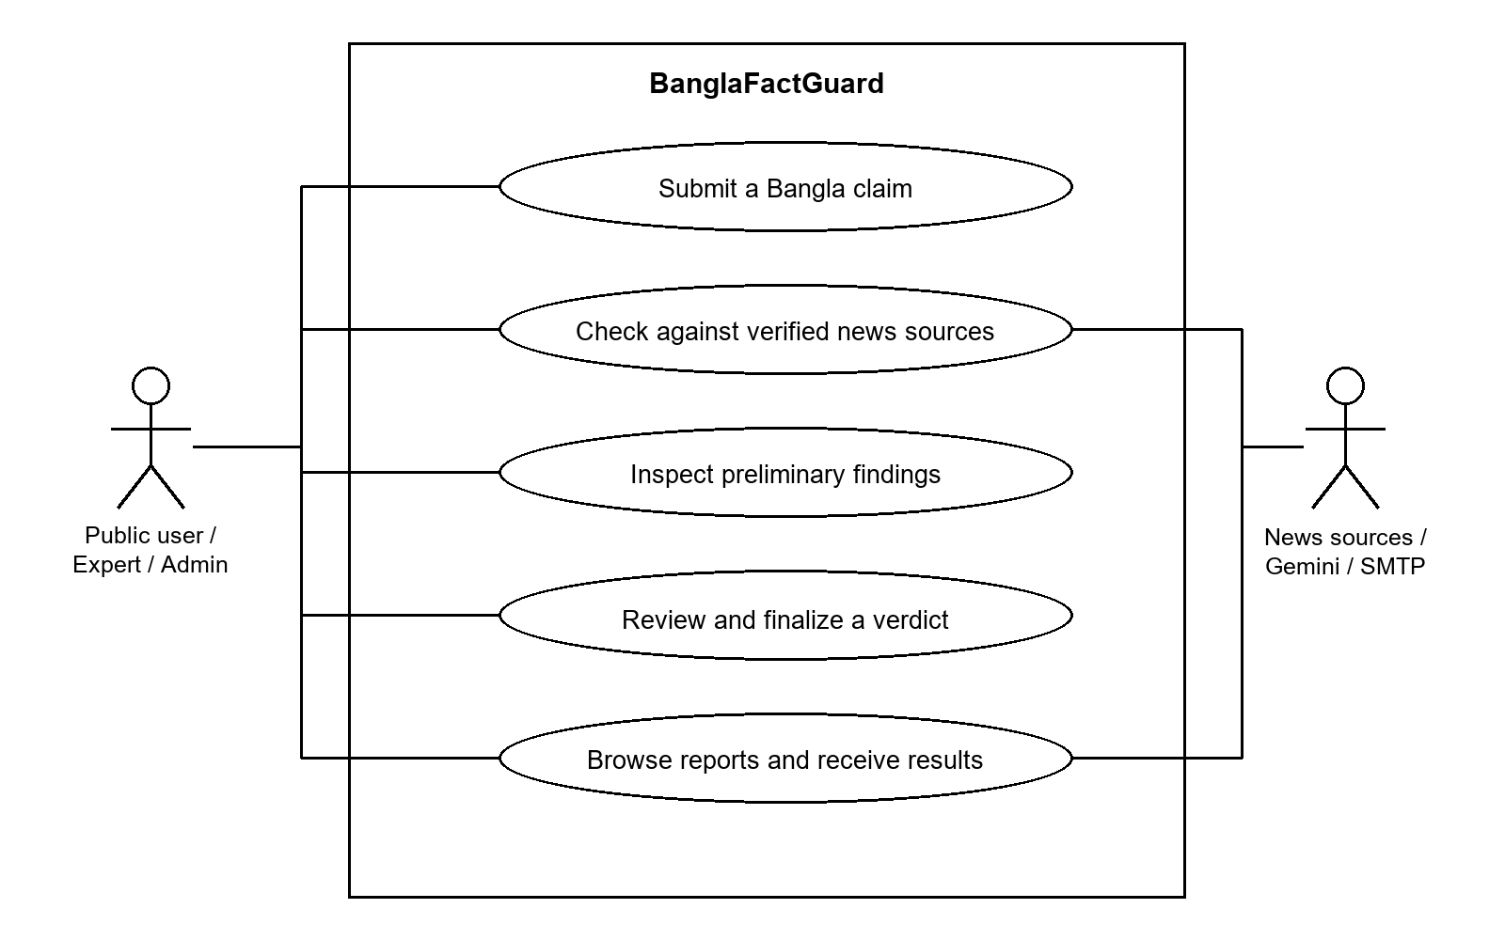
Figure 3.1: System context use case diagram
The system boundary includes the website, extension, API and background services. Users initiate submissions; experts and administrators perform privileged work through the website. News sources, image extraction and mail delivery are external integrations. Automated findings and final human decisions are separate outputs.

3.1.2 Level 1 Modules of BanglaFactGuard
The main modules are authentication, profile management, verification, expert review, Fact Explorer, browser extension, administration and personal notifications. Durable jobs and data persistence support all verification modes.

3.1.3 Authentication and Registration
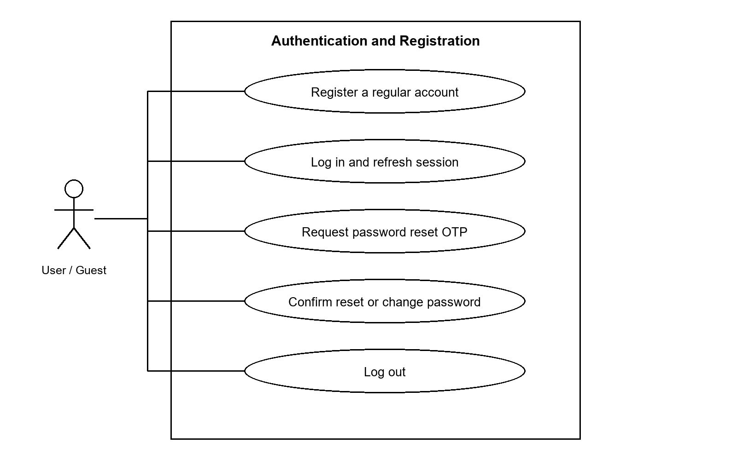
Figure 3.2: Authentication and Registration use case diagram
UC-01 Register or authenticate and establish a session.
Actor and precondition: Guest or account holder. The application is reachable; required services are configured.
Main flow: The user provides the required account details. Registration creates a regular active account. Login validates credentials and account state. The server issues tokens; refresh rotates refresh credentials, and logout revokes the supplied refresh token.
Alternative flow: Invalid credentials, duplicate email, inactive accounts and invalid or expired reset codes are rejected. Registration does not require an email-verification OTP; OTP applies to password recovery.
Postcondition: The session is established or the failure is reported without granting privileged access.

3.1.4 Profile Management
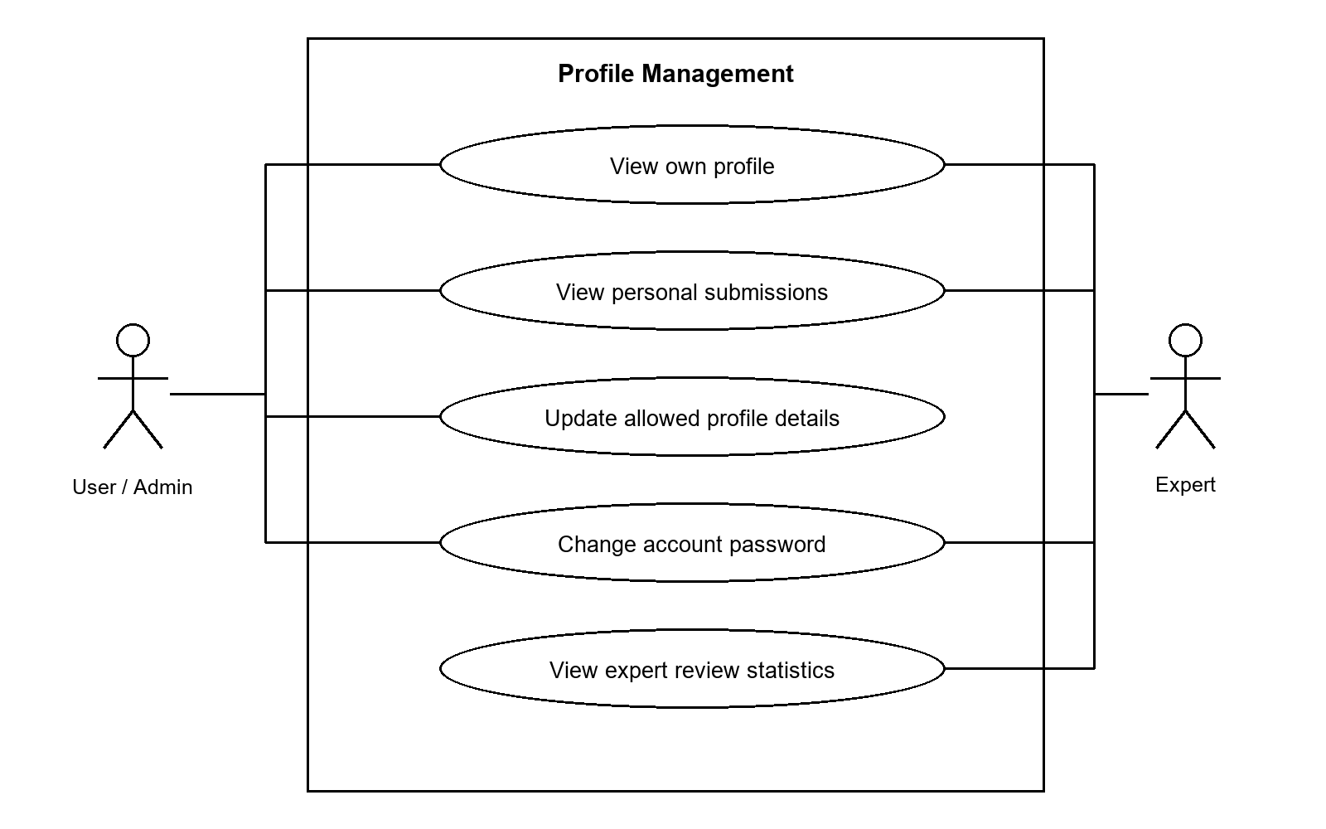
Figure 3.3: Profile Management use case diagram
UC-02 Inspect or maintain account information.
Actor and precondition: Authenticated account. The relevant role is authenticated.
Main flow: The user opens profile settings and retrieves their own profile. Regular users and administrators can update the allowed full-name field. Experts can view their profile and credibility statistics; an administrator manages expert profile changes.
Alternative flow: Unauthenticated requests are rejected. Expert self-service profile changes are denied. Invalid password changes do not modify credentials.
Postcondition: Allowed changes persist and personal history stays scoped to the account.

3.1.5 Verification Service
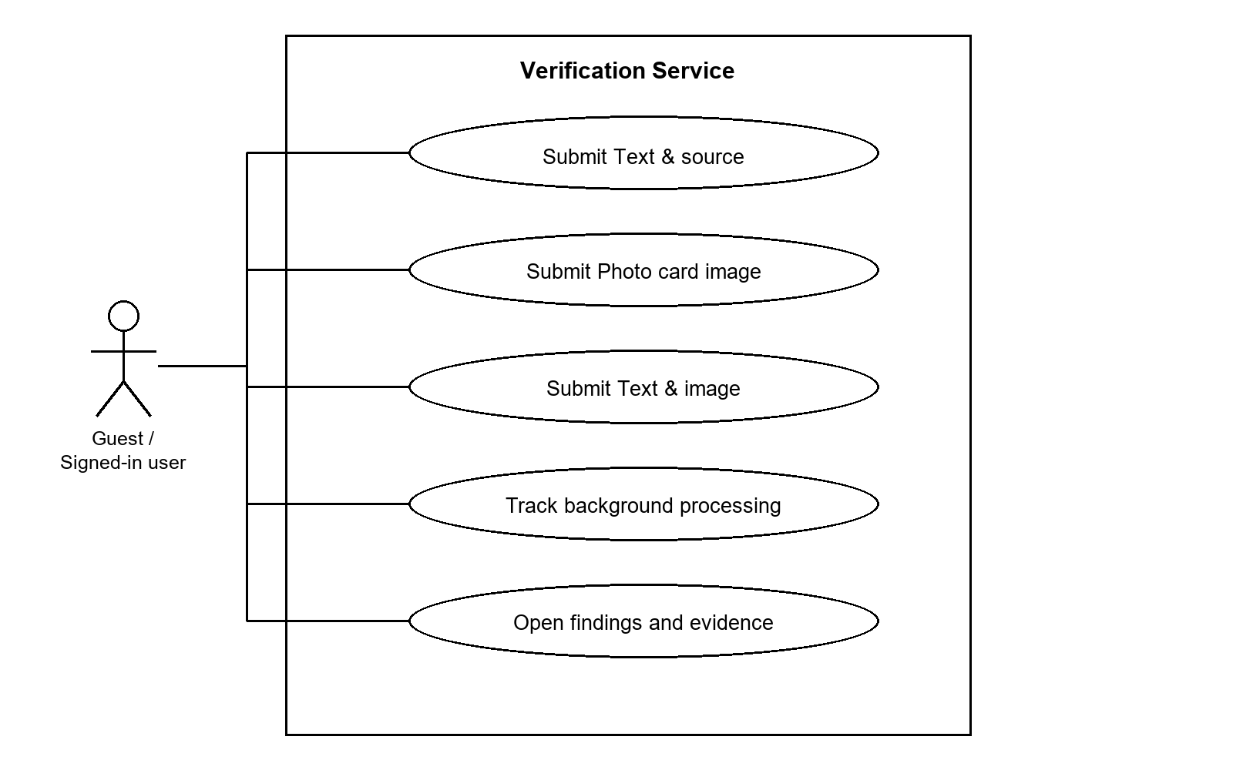
Figure 3.4: Verification Service use case diagram
UC-03 Submit a claim and obtain preliminary findings.
Actor and precondition: Public user. The application is reachable; required services are configured.
Main flow: The user selects a method and supplies the relevant input. The API validates and stores the request with a durable job. The worker runs extraction or inference and stores the result. The common detail route identifies the method before loading the corresponding report.
Alternative flow: Invalid input is rejected. Processing failures expose a reason. Incomplete searches and unavailable measurements remain explicitly qualified.
Postcondition: A saved report is available for review, or the submission has an explicit failed state.

3.1.6 Expert Review and Voting
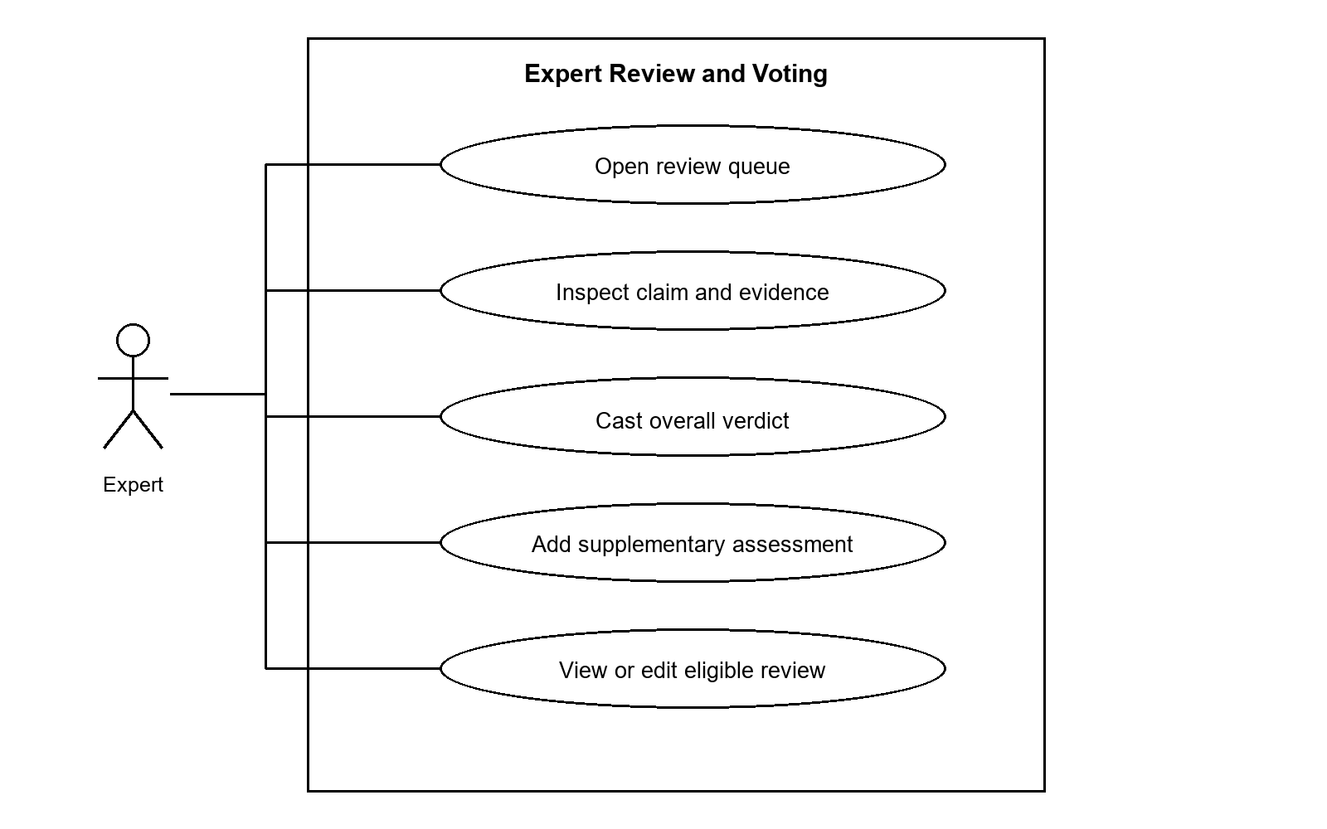
Figure 3.5: Expert Review and Voting use case diagram
UC-04 Review a claim and contribute to its final decision.
Actor and precondition: Active expert. The relevant role is authenticated.
Main flow: The expert examines the original claim, available evidence and preliminary result, then submits an overall Real, Fake, Misleading or Altered vote. For text and photocard claims, supplementary source/headline/date assessments can accompany the vote. The service snapshots the applied weight and evaluates consensus.
Alternative flow: Duplicate or unauthorized voting and edits after the allowed review stage are rejected. Ties do not finalize. Review limits can escalate an undecided claim.
Postcondition: The vote is saved and the claim remains open, is finalized or is escalated.

3.1.7 Fact Explorer
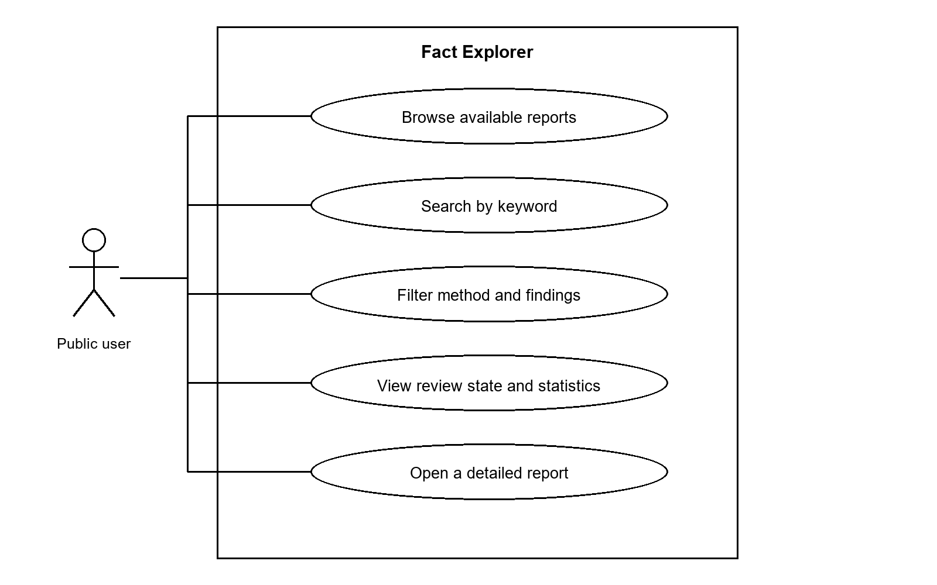
Figure 3.6: Fact Explorer use case diagram
UC-05 Find a previously processed claim.
Actor and precondition: Guest or signed-in user. The application is reachable; required services are configured.
Main flow: The user opens Fact Explorer, enters keywords or filters and receives paginated matches. Filters include method, relevant findings, final verdict, source, date range and review state. Selecting a result opens its method-aware detail page.
Alternative flow: No matches produce an empty result view. Pending, processing and failed account-owned submissions do not become ordinary public explorer entries.
Postcondition: A relevant report is opened with preliminary and finalized information distinguished.

3.1.8 Browser Extension
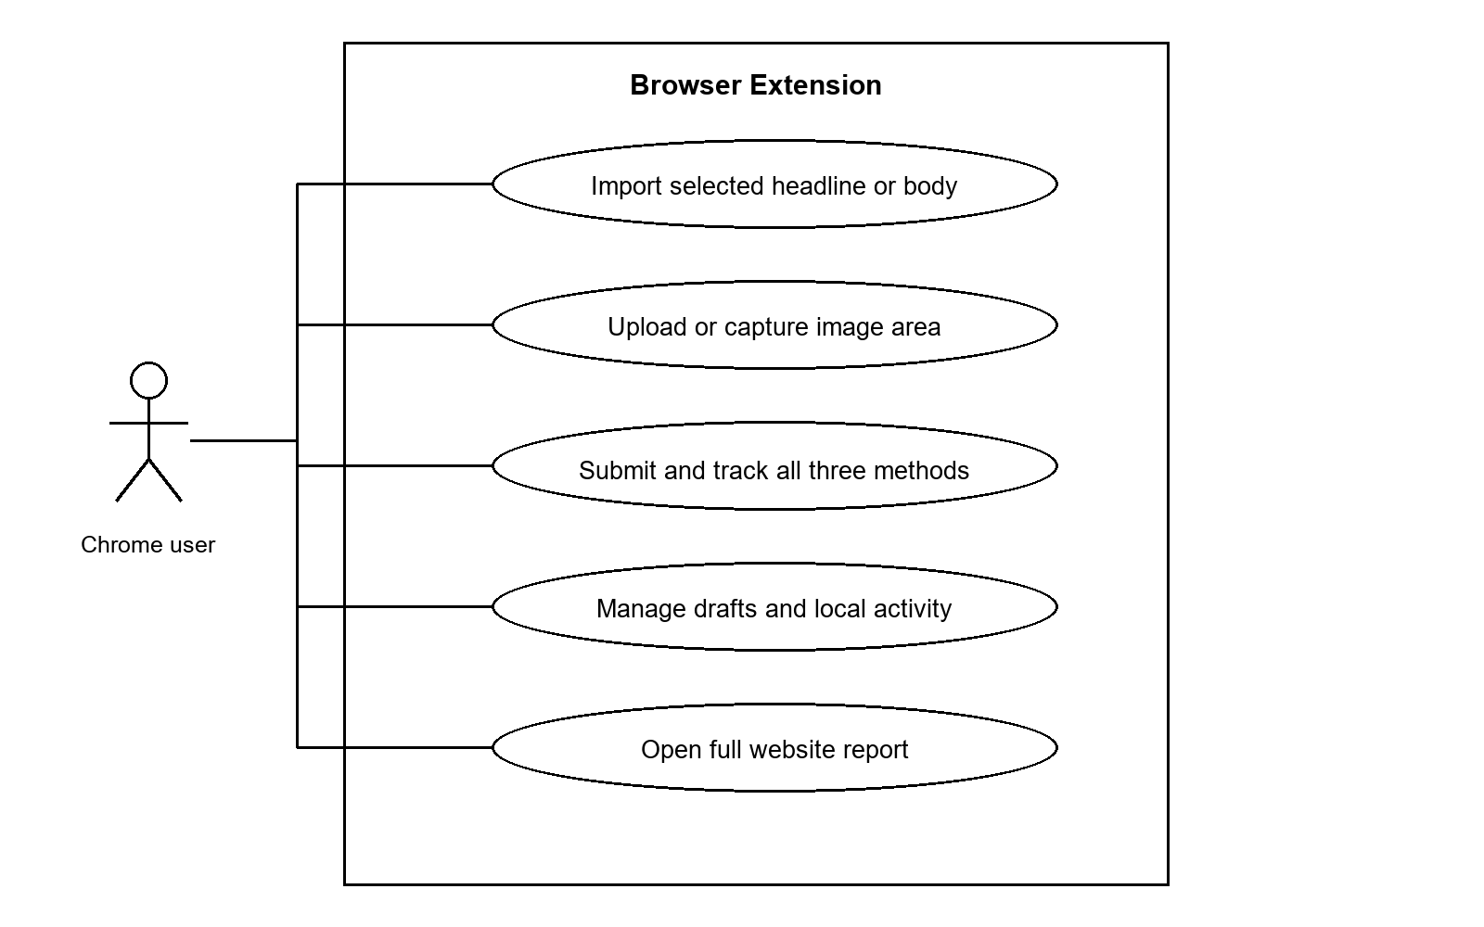
Figure 3.7: Browser Extension use case diagram
UC-06 Verify content while browsing.
Actor and precondition: Guest or signed-in Chrome user. The application is reachable; required services are configured.
Main flow: The user opens the side panel from the intended tab, chooses a method and enters or imports content. Capture saves the selected viewport area after local cropping. The extension sends an asynchronous request and records activity. Background polling updates result cards, notifications and the unread badge.
Alternative flow: Restricted pages require paste or upload. Account changes separate activity. The OFF state pauses new activity and alerts while accepted backend jobs continue.
Postcondition: The extension retains submission tracking and a link to the detailed website report.

3.1.9 Administration
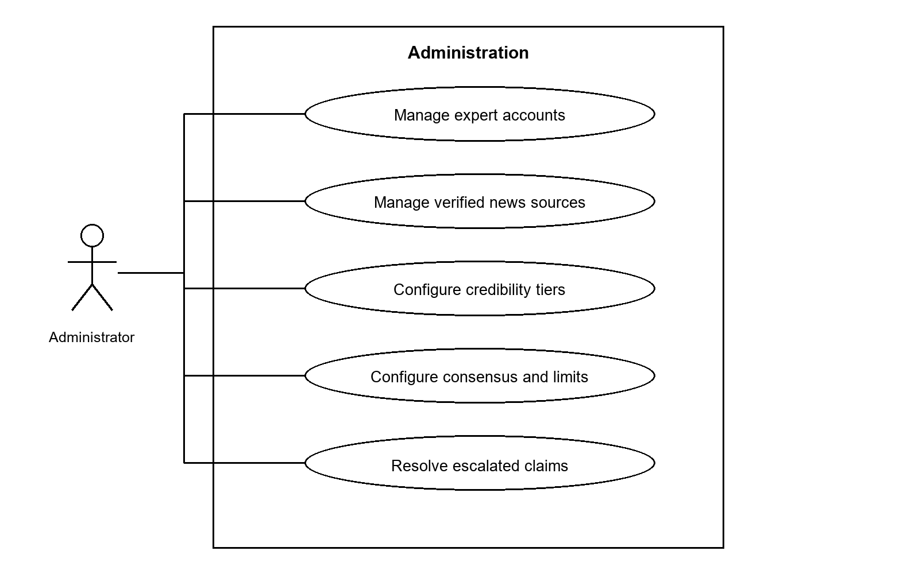
Figure 3.8: Administration use case diagram
UC-07 Maintain platform configuration and resolve escalation.
Actor and precondition: Authenticated administrator. The relevant role is authenticated.
Main flow: The administrator uses protected web pages to maintain experts and sources, set voting parameters and credibility tiers, and inspect operational queues. An escalated claim can receive a recorded administrative overall decision.
Alternative flow: Non-admin requests are rejected. The admin does not participate as a normal expert voter on an open claim. Referenced data must follow service rules and database constraints.
Postcondition: Configuration changes persist or an escalated claim is finalized with an attributable decision.

3.1.10 Notification Management
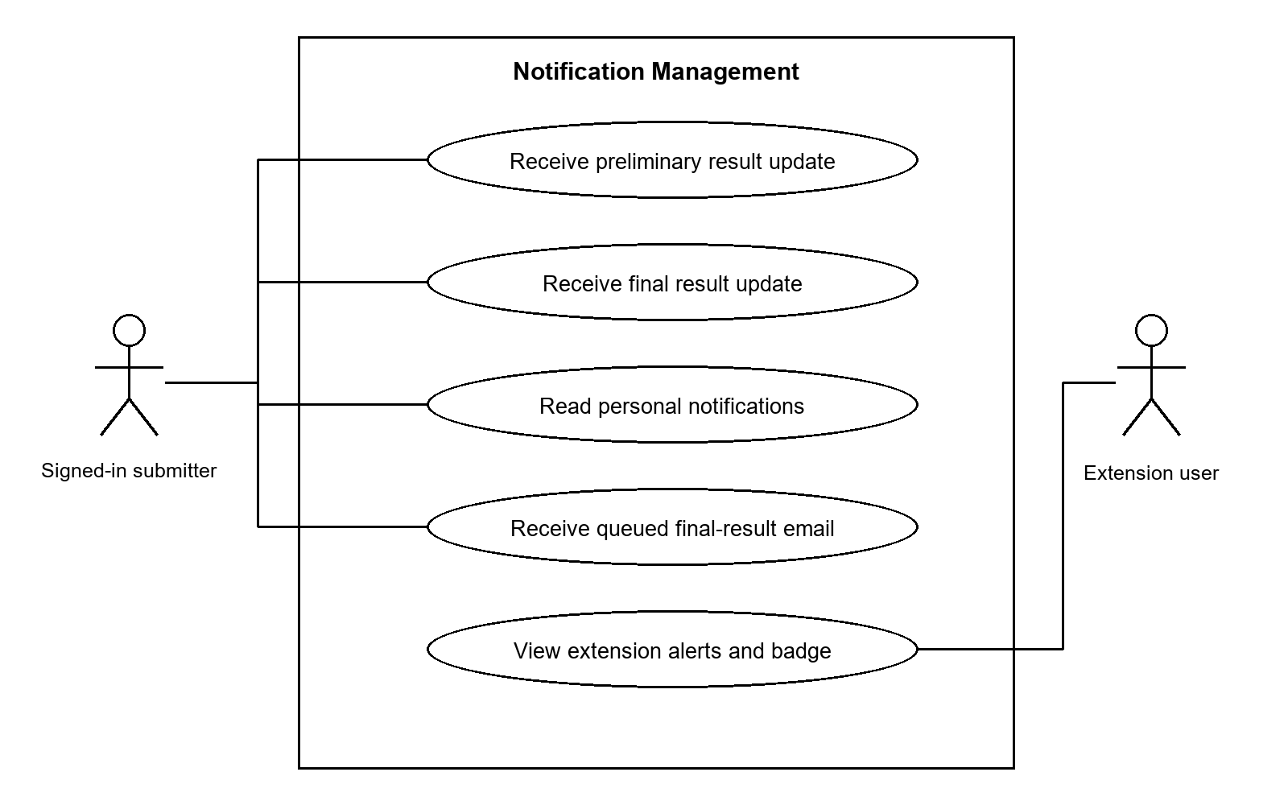
Figure 3.9: Notification Management use case diagram
UC-08 Learn when a personally submitted claim has progressed.
Actor and precondition: Submitter. The application is reachable; required services are configured.
Main flow: The delivery service reconciles saved results and creates preliminary/final in-app updates for the authenticated submitter. Final results are queued for email. The extension independently tracks its recorded submissions and applies local alert preferences.
Alternative flow: Guests have no account email delivery. Browser or operating-system settings may delay alerts. SMTP failures retain retry state; delivery is at-least-once.
Postcondition: Personal result information is accessible through notifications, history or extension Activity.
Administrators additionally receive targeted escalation notifications when a claim needs their decision. These are operational alerts rather than an all-facts broadcast feed.

3.2 Activity Diagrams
These activity diagrams summarize the main successful path and major decision points. Rounded rectangles represent actions, diamonds represent decisions, a filled circle indicates a start, and a double circle indicates the end of the illustrated path. Side branches describe alternative outcomes; the surrounding text specifies asynchronous and recovery behavior.

3.2.1 Authentication and Registration
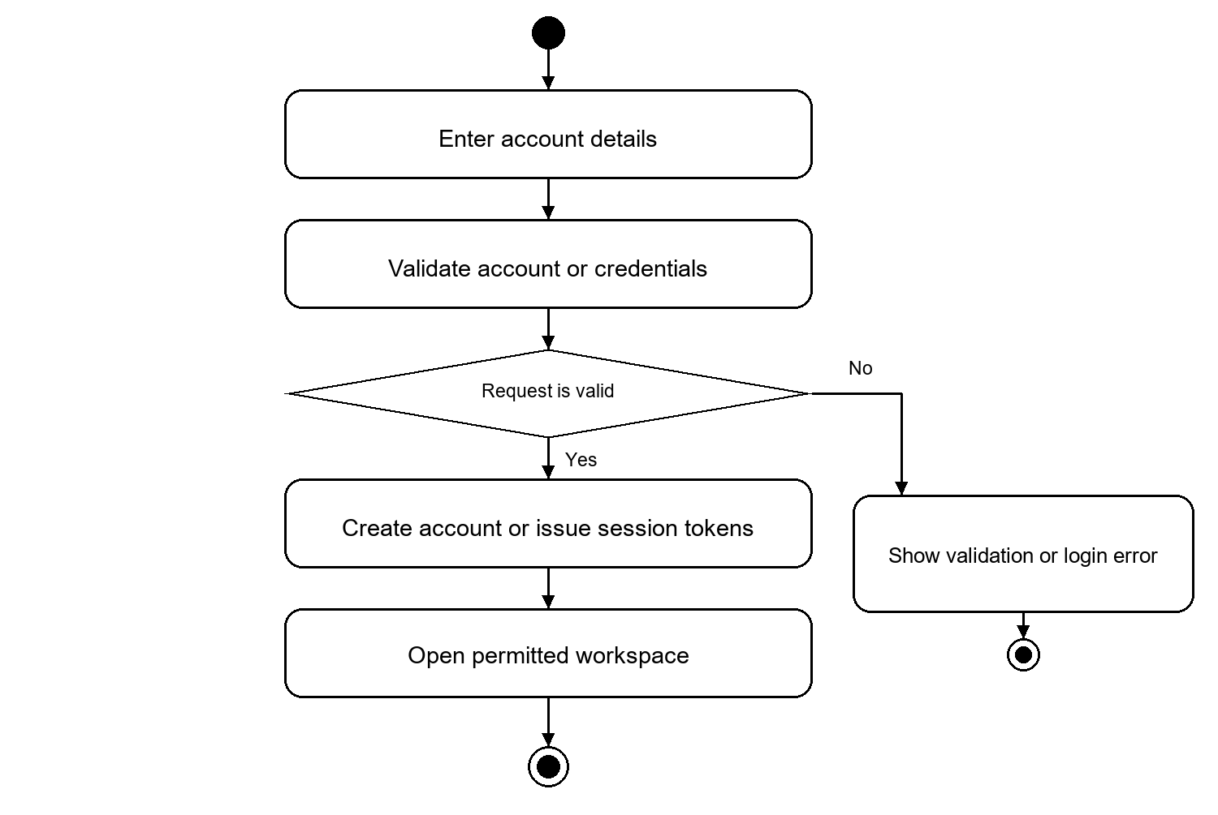
Figure 3.10: Authentication and registration activity
Registration establishes a regular account. Password recovery is a separate path: request an email OTP, validate the code and new password, and consume the reset token. Access and refresh tokens support an ongoing session; privileged actions still require server-side authorization.

3.2.2 Fact Explorer
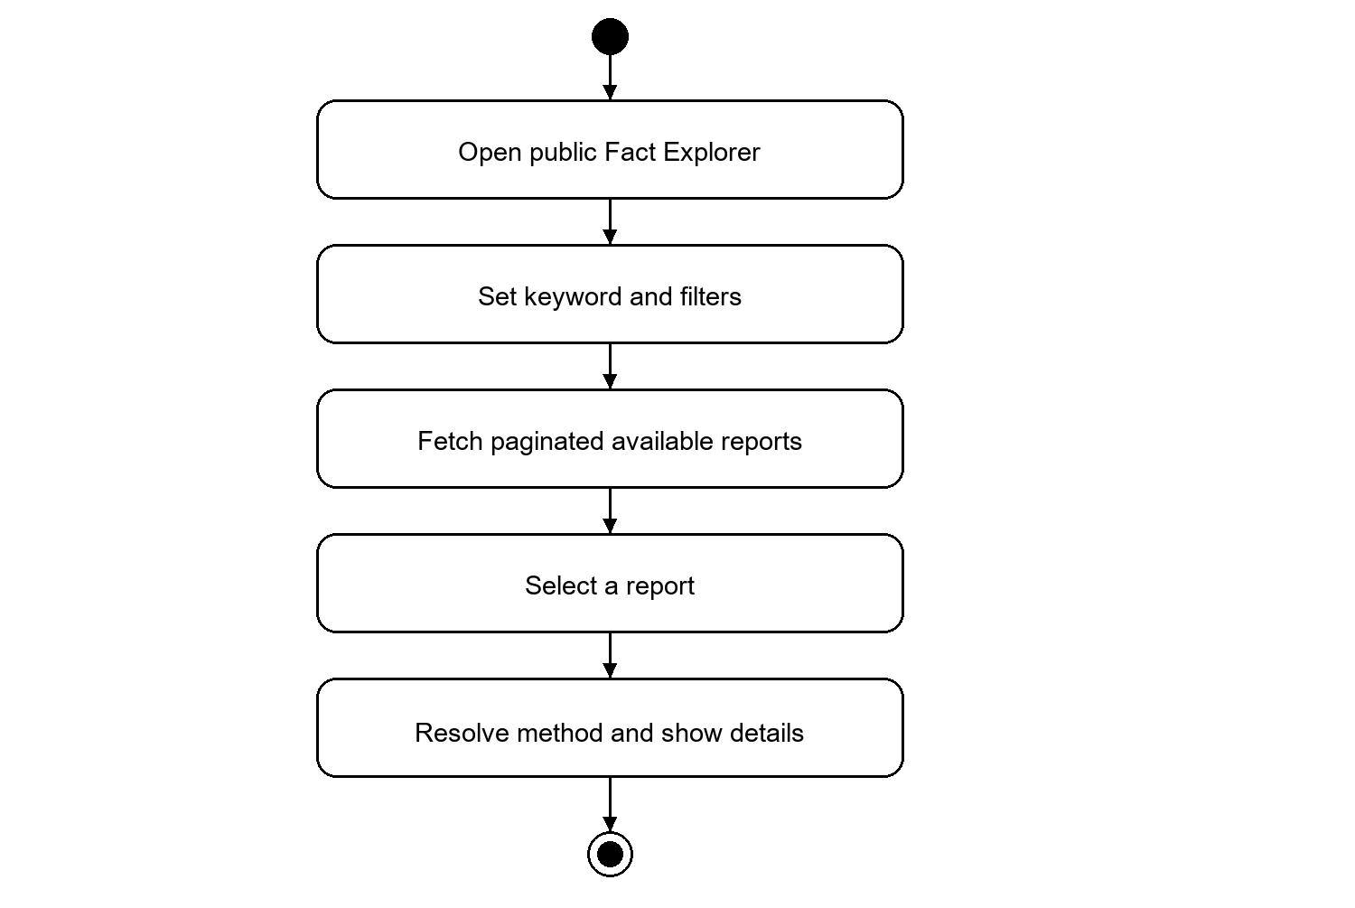
Figure 3.11: Fact Explorer activity
The explorer includes reports in expert review, finalized reports and escalated reports. A review-state filter distinguishes work awaiting human resolution from final results. Missing findings must remain absent rather than being converted into an editorial verdict.

3.2.3 Browser Extension
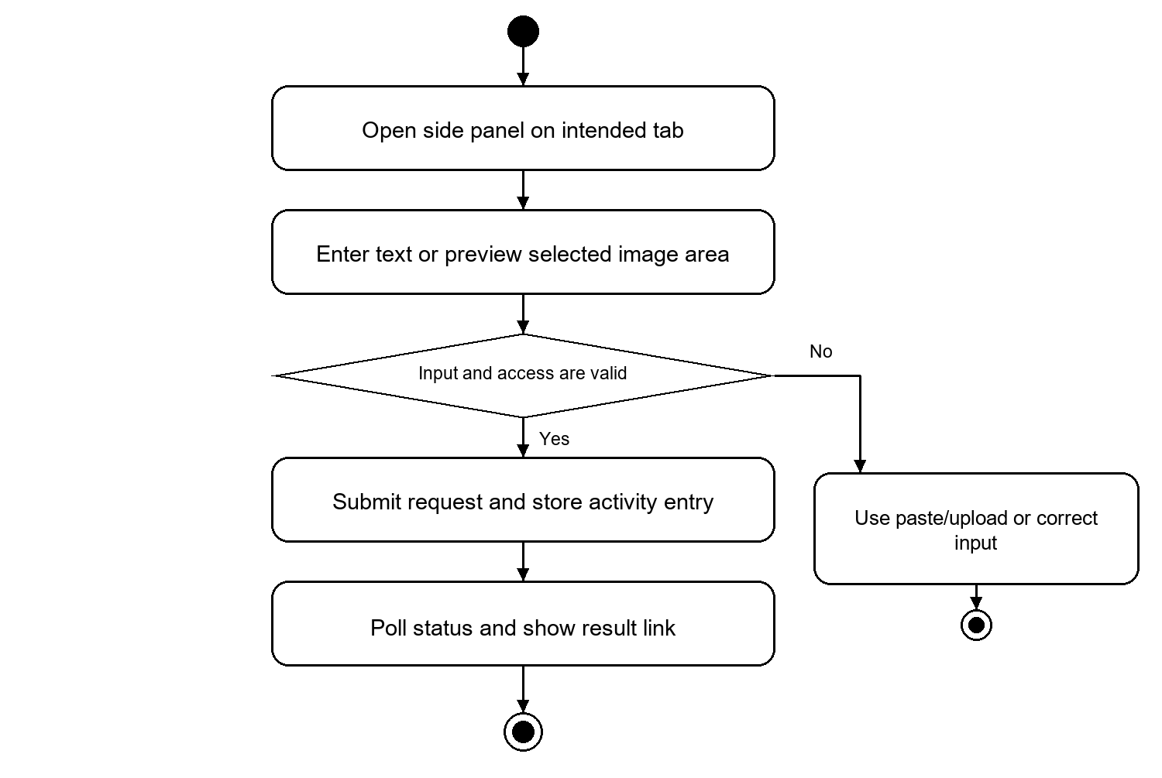
Figure 3.12: Browser Extension activity
Headline and body imports can replace or append text. The screenshot is cropped locally to the selected rectangle before storage/upload. Guest and account activity remain separate. Disabling the extension does not cancel a job already accepted by the server.

3.2.4 Multimodal Verification
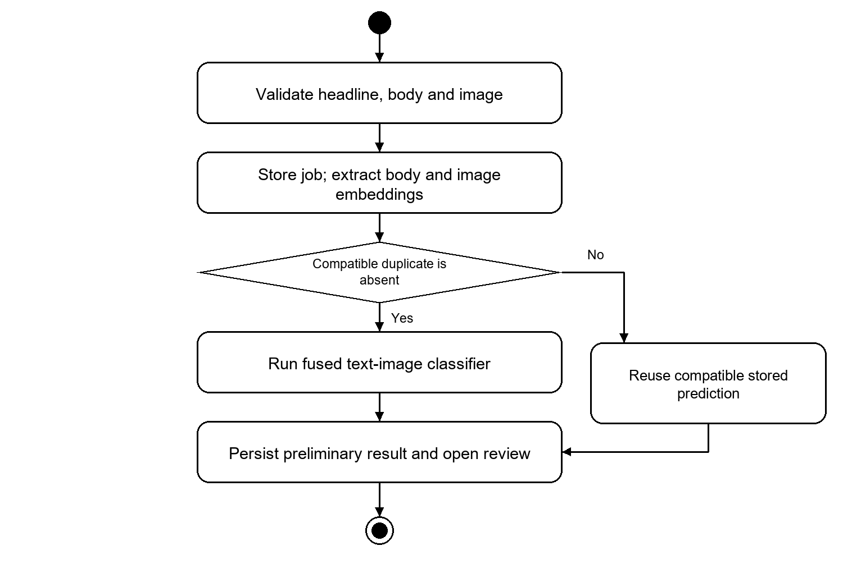
Figure 3.13: Multimodal Verification activity
The image and body drive inference; the headline supports display and identification. BanglaBERT and EfficientNet-B4 embeddings are concatenated for classification. Duplicate checks compare text, image and combined features. Model unavailability or inference errors are operational failures, not Fake predictions.

3.2.5 Notifications
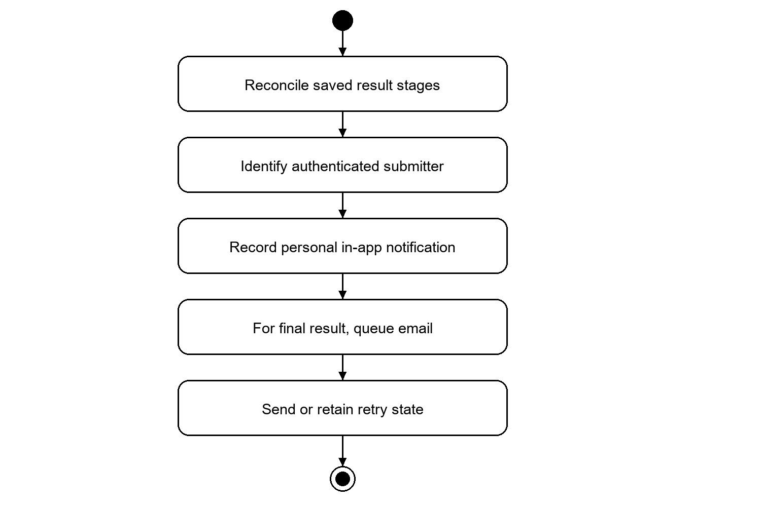
Figure 3.14: Notifications activity
The delivery record is keyed by submission and result stage. Final email retry state survives process restarts. Extension desktop notifications depend on locally tracked activity and browser permissions, so they are distinct from server-side in-app and email delivery.

3.2.6 Photo Card Verification
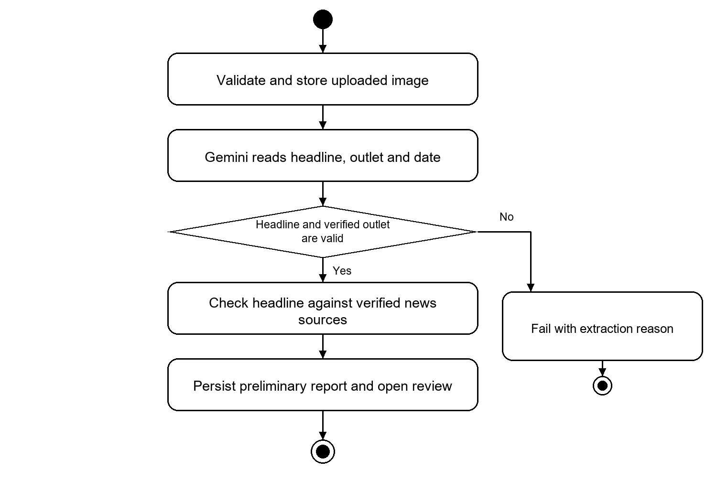
Figure 3.15: Photo Card Verification activity
The default extraction policy permits three batches of three requests with a ten-second pause between batches. No OCR fallback or user text-confirmation step is part of this workflow. The outlet must be recognized from visible evidence and the active source registry. An absent complete printed date remains null.

3.2.7 Profile Management
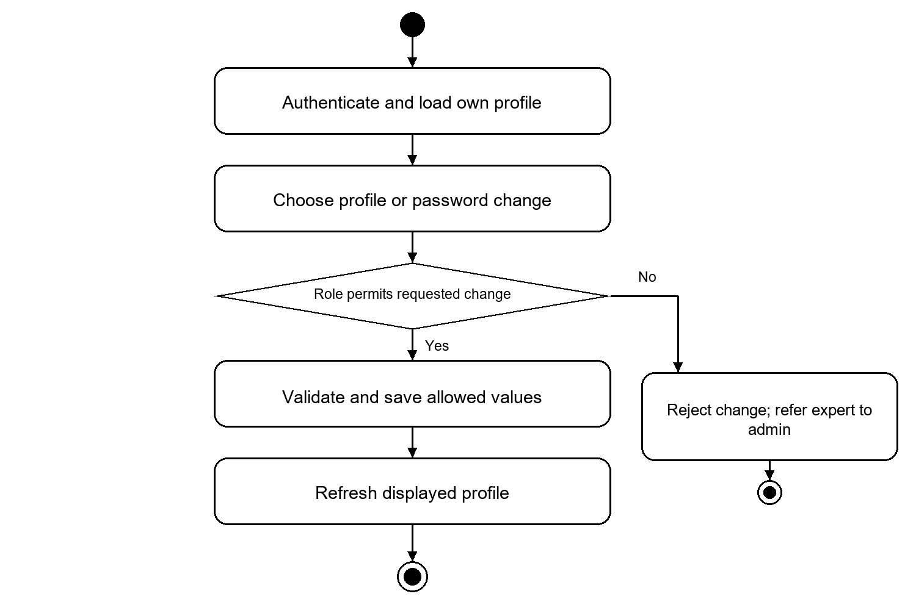
Figure 3.16: Profile Management activity
Expert profile details are read-only in self-service. Password change remains a separate authenticated operation requiring the current password. Personal history includes the three verification methods and their pending, failed, preliminary and final states.

3.2.8 Expert Review and Voting
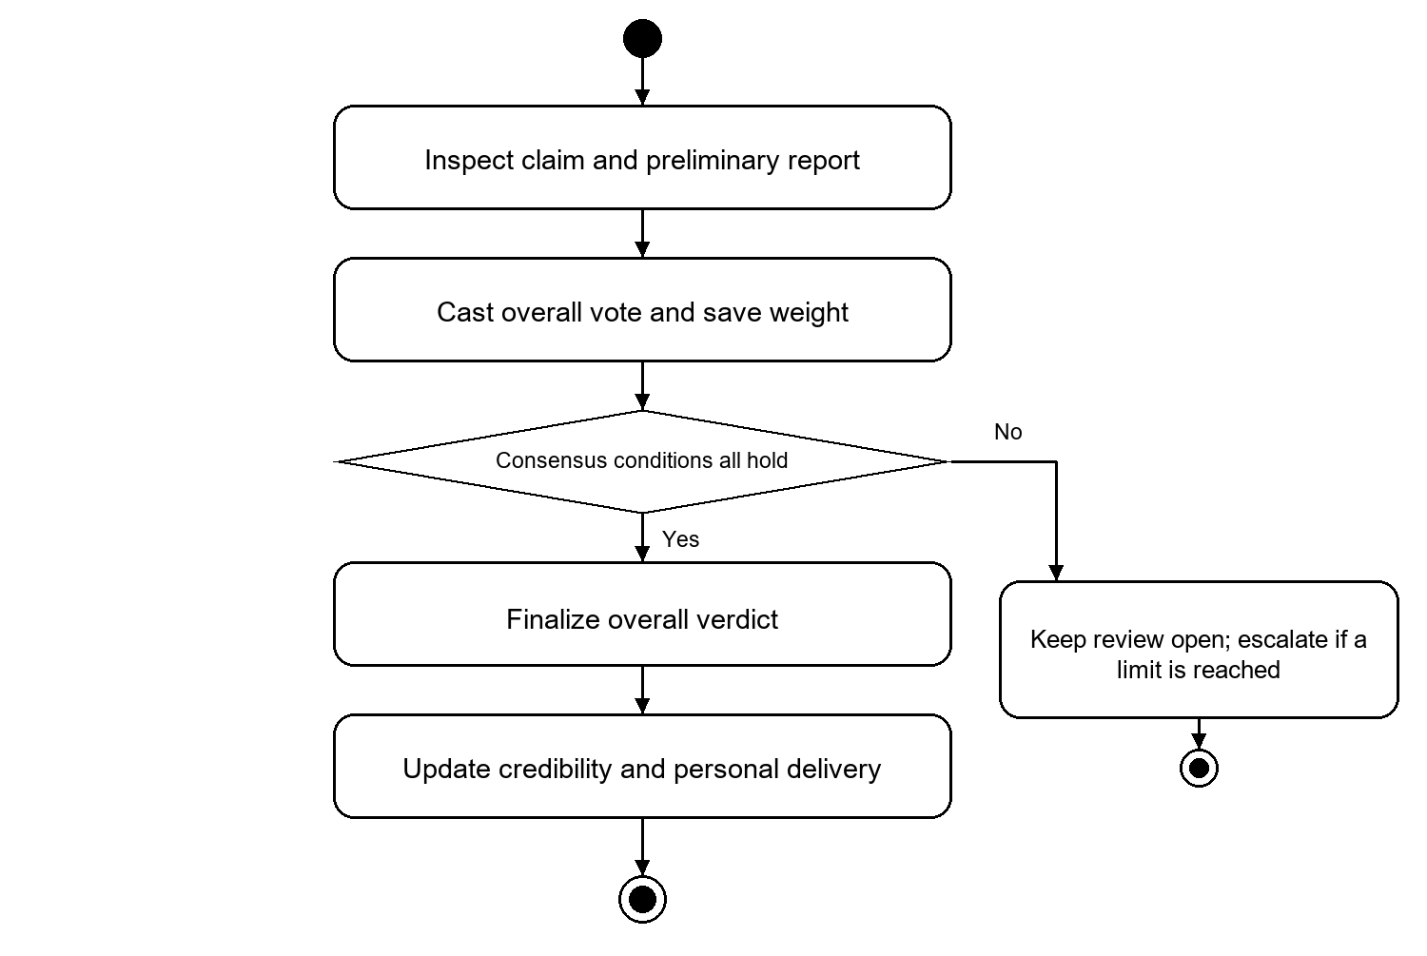
Figure 3.17: Expert Review and Voting activity
Only overall human votes participate in consensus. Supplementary findings and model predictions do not add voting weight. A unique leader must satisfy the configured minimum vote count, weighted score and margin. An administrator resolves an escalated claim; open expert review cannot be finalized by an arbitrary admin vote.
Consensus weight for verdict v is the sum of the stored weights of eligible expert reviews that vote for v. Before the configured completed-review threshold N, each expert has weight 1. Subsequent votes use the active tier resolved from completed-review accuracy. A later configuration change does not rewrite an existing vote weight.

3.2.9 Text and Source Verification
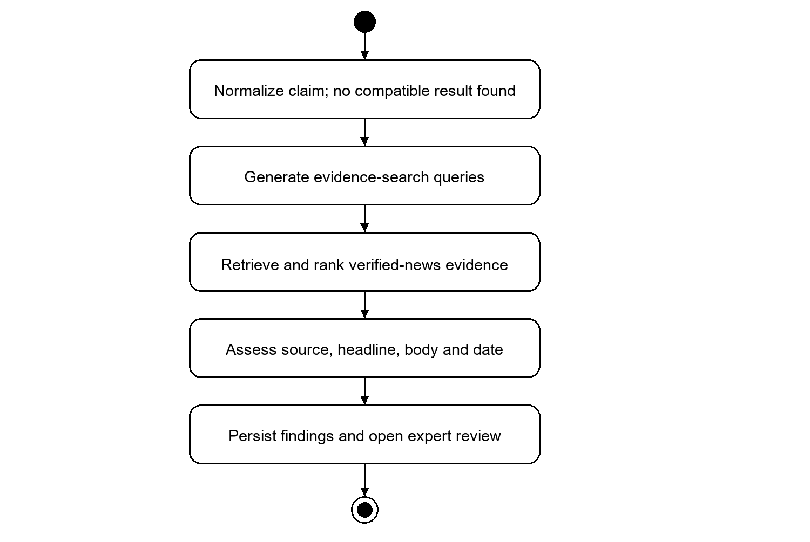
Figure 3.18: Text and Source Verification activity
This diagram shows the fresh-analysis path. A compatible existing result bypasses retrieval and comparison and is linked to the new submission. The shared pipeline separates source correspondence, headline-to-title comparison, optional body similarity and publication-date comparison. Empty evidence after an adequate search differs from an incomplete search. Article publication dates use retained provenance and the Asia/Dhaka calendar day.

3.2.10 Verified Source Management
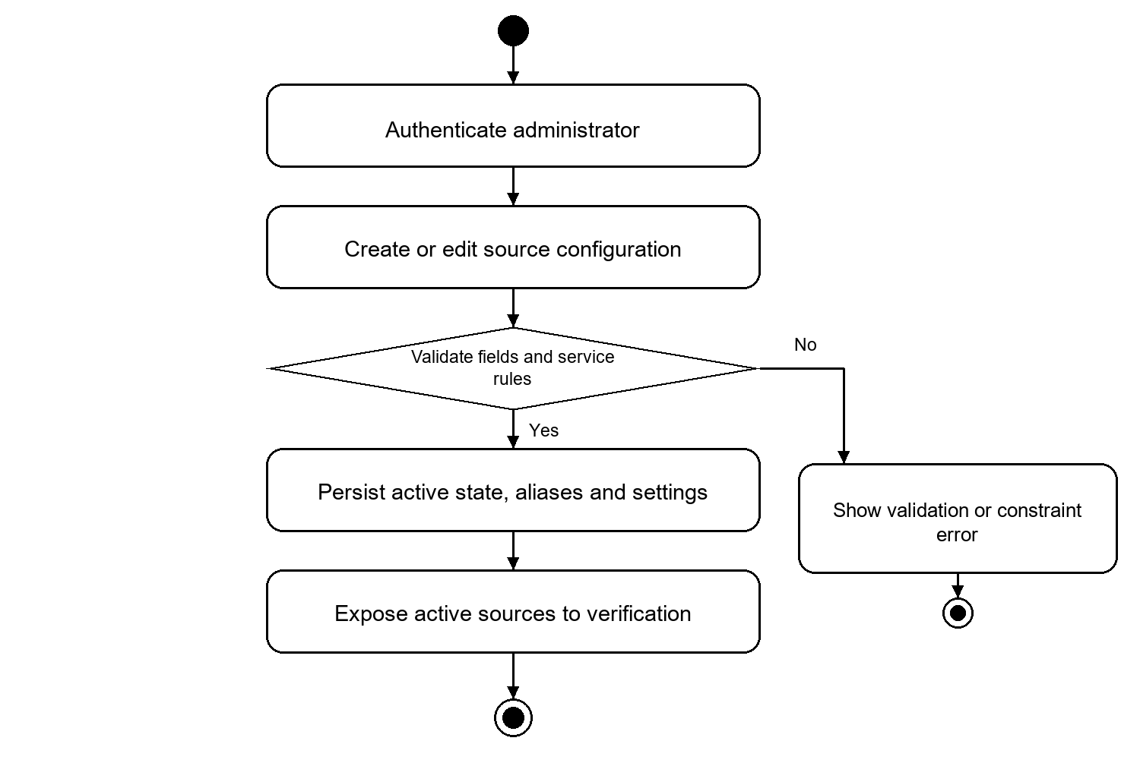
Figure 3.19: Verified Source Management activity
Verified news sources have a maintained registry entry and source-specific retrieval/extraction settings. Deactivation affects new source selection. Historical references follow foreign-key behavior; a record is not assumed to be universally safe to delete simply because its user interface has a delete action.

3.3 Submission Lifecycle and System Architecture
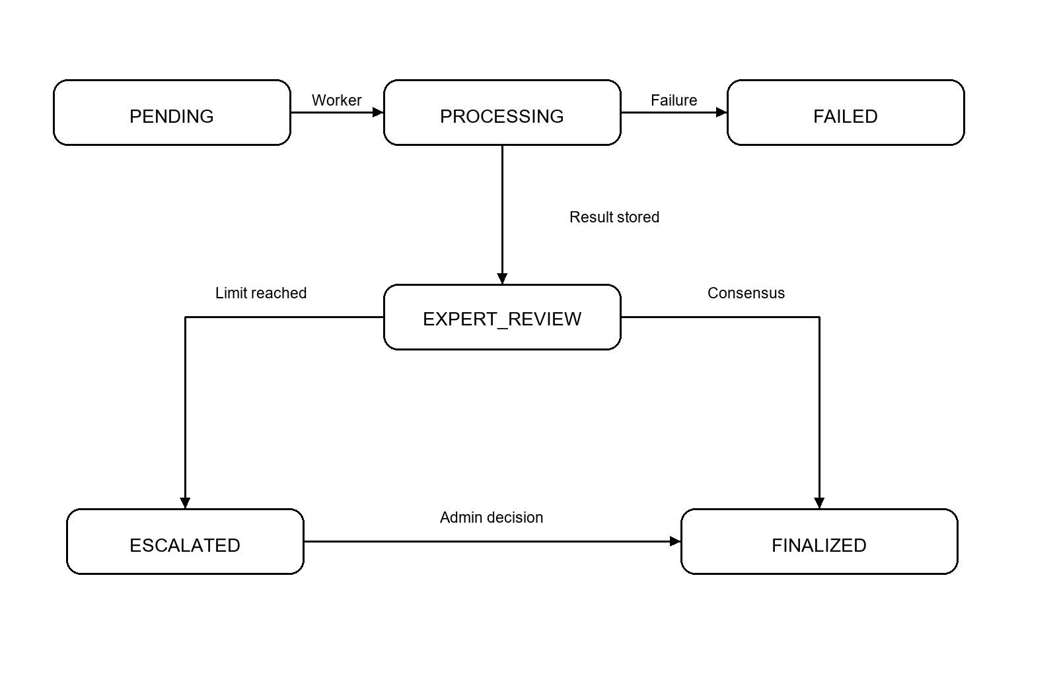
Figure 3.20: Submission lifecycle
PENDING and PROCESSING describe automated execution. EXPERT_REVIEW indicates that the preliminary report is available and human review can proceed. ESCALATED means an administrator must resolve the claim. FINALIZED records the human outcome. FAILED describes an operational failure, not a judgment that the content is false. Reused reports retain a link to their original submission and expose the effective review state.
Processing phases provide finer progress: QUEUED, EXTRACTING where applicable, VERIFYING, DONE or FAILED. PostgreSQL jobs and worker heartbeats support recovery; an enabled worker process must still be running to execute accepted work.

3.3.1 Deployment Components
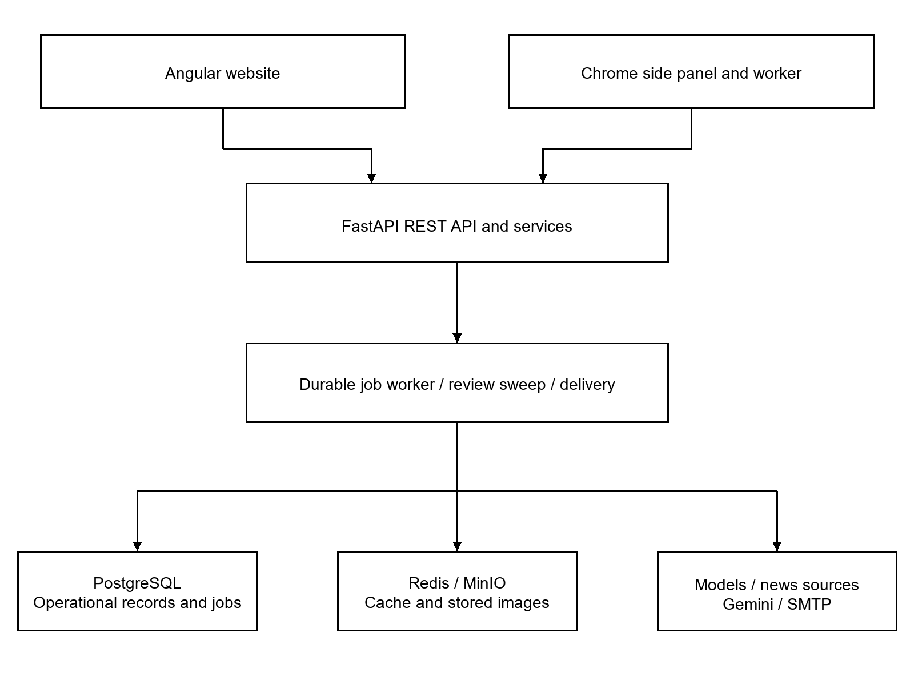
Figure 3.21: Application and service architecture
The backend groups HTTP routing, domain services, repositories and pipeline stages. CPU-intensive model operations use worker threads where implemented so they do not block unrelated API requests. PostgreSQL is the persistent authority for submissions and jobs; Redis is a cache. MinIO stores image objects while the database stores object keys and provenance.
The included local service configuration supplies Redis and MinIO; PostgreSQL is configured separately. Website and extension login sessions are separate. Detailed review and administration are performed on the website, while the extension focuses on capture, submission and tracking.

4. Data and Information Modeling

4.1 ER Diagram and Database Schema
The current schema has 17 application tables. The logical diagrams group the relationships for readability; the following data dictionary is derived from the current model declarations. UUID primary keys and creation/update timestamps are inherited where a model uses the corresponding shared mixins. Nullability and deletion rules determine whether historical records survive parent removal.
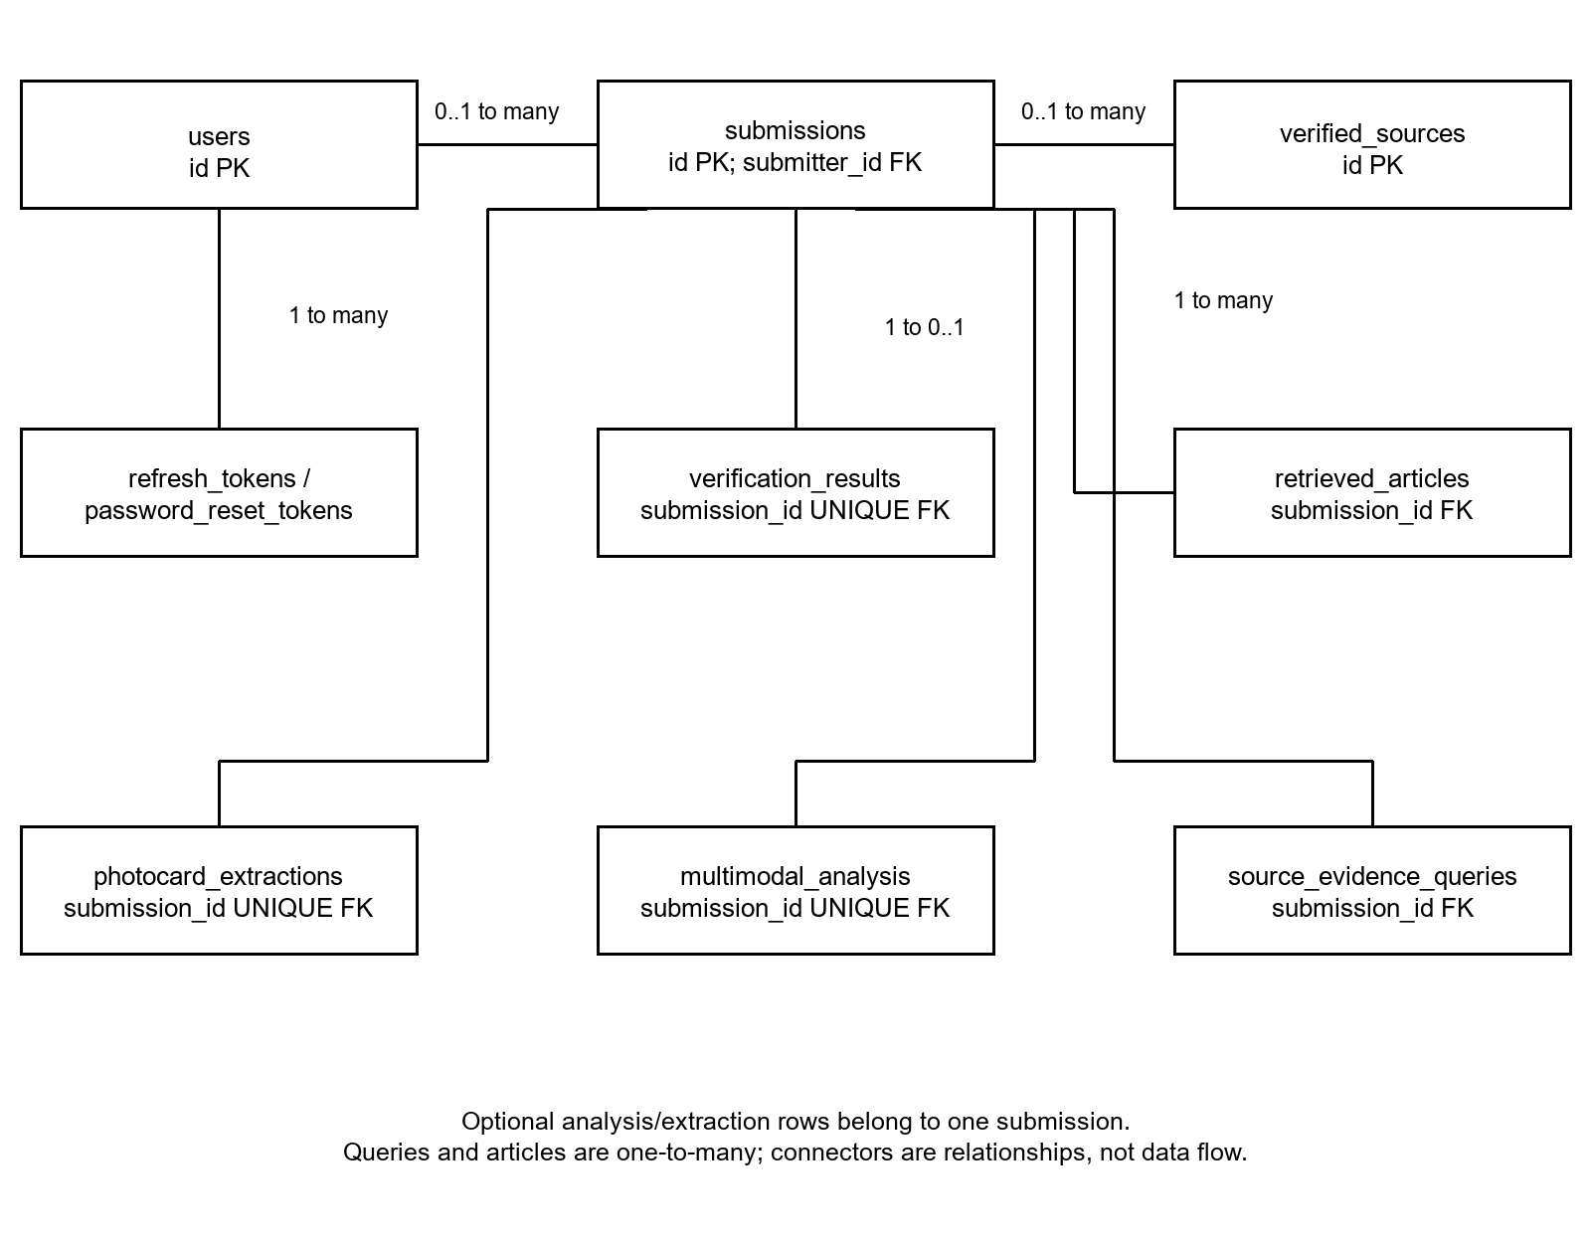
Figure 4.1: Submission and evidence entity relationships

4.1.1 Review and Delivery Relationships
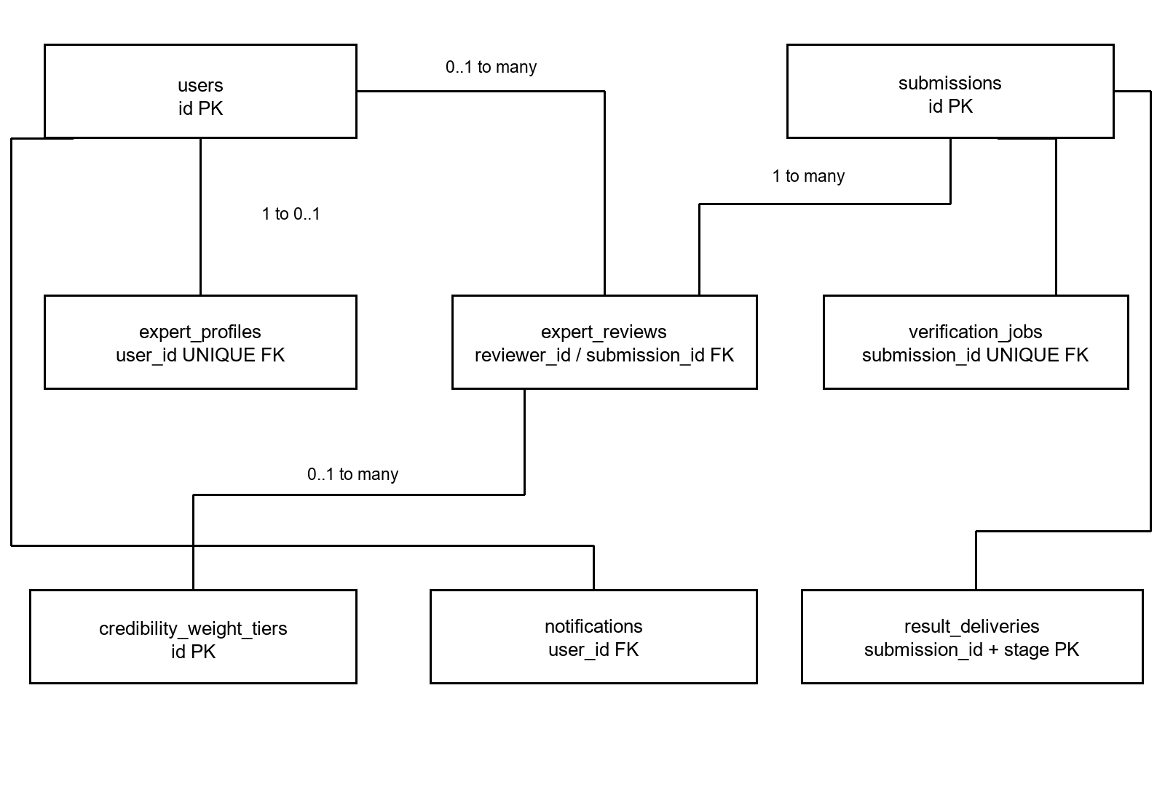
Figure 4.2: Review and delivery entity relationships
voting_config is an independent configuration table; the effective row supplies consensus parameters and escalation limits. Expert reviews snapshot the applied credibility tier and weight. Deleting a tier or reviewer may set those foreign keys to null while preserving the review record. Deleting a submission cascades to dependent analysis, job and delivery rows.
A submission can have multiple result-delivery stages, but each (submission_id, stage) pair is unique. Notification ownership is independent of public report visibility. The diagrams omit common timestamp fields and some optional cross-references; the schema tables below identify them.

4.1.2 Database Schema
Table 4.1: Database schema for users
Attribute | Type and constraints
id | UUID; primary key
email | VARCHAR(255); NOT NULL; UNIQUE; indexed
hashed_password | VARCHAR(255); nullable
full_name | VARCHAR(255); nullable
role | VARCHAR(50); NOT NULL; indexed; default 'user'
is_active | BOOLEAN; NOT NULL; indexed; default True
total_submissions | INTEGER; NOT NULL; default 0
created_at | TIMESTAMPTZ; creation timestamp
updated_at | TIMESTAMPTZ; last update timestamp
Accounts use the user, expert and admin roles. New public registrations receive the regular-user role. Removed legacy profile fields are not part of this current dictionary.
Additional constraints: role IN ('user', 'expert', 'admin').

4.1.2 Database Schema continued
Table 4.2: Database schema for refresh_tokens
Attribute | Type and constraints
id | UUID; primary key
user_id | UUID; NOT NULL; indexed; FK to users.id; ON DELETE CASCADE
token_hash | VARCHAR(64); NOT NULL; UNIQUE
expires_at | TIMESTAMPTZ; NOT NULL
revoked | BOOLEAN; NOT NULL; indexed; default False
created_at | TIMESTAMPTZ; NOT NULL

4.1.2 Database Schema continued
Table 4.3: Database schema for password_reset_tokens
Attribute | Type and constraints
id | UUID; primary key
user_id | UUID; NOT NULL; indexed; FK to users.id; ON DELETE CASCADE
token_hash | VARCHAR(64); NOT NULL; UNIQUE
expires_at | TIMESTAMPTZ; NOT NULL
used | BOOLEAN; NOT NULL; default False
created_at | TIMESTAMPTZ; NOT NULL

4.1.2 Database Schema continued
Table 4.4: Database schema for verified_sources
Attribute | Type and constraints
id | UUID; primary key
canonical_name | VARCHAR(255); NOT NULL; UNIQUE; indexed
display_name | VARCHAR(255); NOT NULL
display_name_en | VARCHAR(255); nullable
aliases | JSONB (PostgreSQL); nullable; default list
base_url | VARCHAR(512); NOT NULL
rss_url | VARCHAR(512); nullable
language | VARCHAR(10); NOT NULL; default 'bn'
search_language | VARCHAR(10); NOT NULL; default 'bn'
js_rendered | BOOLEAN; NOT NULL; default False
is_active | BOOLEAN; NOT NULL; indexed; default True
description | TEXT; nullable
body_selectors | JSONB (PostgreSQL); nullable; default list
title_selectors | JSONB (PostgreSQL); nullable; default list
date_selectors | JSONB (PostgreSQL); nullable; default list
internal_search_url | VARCHAR(512); nullable
article_url_patterns | JSONB (PostgreSQL); nullable; default list
created_at | TIMESTAMPTZ; creation timestamp
updated_at | TIMESTAMPTZ; last update timestamp
The source registry maintains publisher identity, activation state, aliases and retrieval/extraction configuration for checks against verified news sources.

4.1.2 Database Schema continued
Table 4.5: Database schema for expert_profiles
Attribute | Type and constraints
id | UUID; primary key
user_id | UUID; NOT NULL; UNIQUE; indexed; FK to users.id; ON DELETE CASCADE
area_of_expertise | VARCHAR(255); NOT NULL
credential_notes | TEXT; nullable
credibility_score | FLOAT; nullable; default None
total_votes | INTEGER; NOT NULL; default 0
correct_votes | INTEGER; NOT NULL; default 0
completed_reviews_count | INTEGER; NOT NULL; default 0
is_active | BOOLEAN; NOT NULL; default True
created_at | TIMESTAMPTZ; creation timestamp
updated_at | TIMESTAMPTZ; last update timestamp
Additional constraints: credibility_score >= 0.0 AND credibility_score <= 1.0.

4.1.2 Database Schema continued
Table 4.6: Database schema for credibility_weight_tiers
Attribute | Type and constraints
id | UUID; primary key
label | VARCHAR(100); NOT NULL
min_accuracy_pct | FLOAT; NOT NULL
max_accuracy_pct | FLOAT; NOT NULL
weight | FLOAT; NOT NULL; default 1.0
is_active | BOOLEAN; NOT NULL; default True
created_at | TIMESTAMPTZ; creation timestamp
updated_at | TIMESTAMPTZ; last update timestamp

4.1.2 Database Schema continued
Table 4.7: Database schema for voting_config
Attribute | Type and constraints
id | UUID; primary key
min_expert_votes | INTEGER; NOT NULL; default 3
activation_threshold_votes | INTEGER; NOT NULL; default 10
verified_threshold | FLOAT; NOT NULL; default 5.0
lead_margin | FLOAT; NOT NULL; default 1.0
max_review_votes | INTEGER; nullable
max_review_hours | INTEGER; nullable
created_at | TIMESTAMPTZ; creation timestamp
updated_at | TIMESTAMPTZ; last update timestamp
Default model values are M = 3, N = 10, T = 5.0 and lead margin = 1.0. Administrators can change active values. Null review limits impose no corresponding cap.
Additional constraints: min_expert_votes >= 1; activation_threshold_votes >= 0; verified_threshold > 0; lead_margin >= 0.

4.1.2 Database Schema continued
Table 4.8: Database schema for submissions
Attribute | Type and constraints
id | UUID; primary key
submission_type | ENUM SubmissionType; NOT NULL; indexed
headline | TEXT; nullable
body_text | TEXT; nullable
claimed_source_text | VARCHAR(255); nullable
claimed_source_id | UUID; nullable; indexed; FK to verified_sources.id; ON DELETE SET NULL
published_date | Date; nullable
submitter_id | UUID; nullable; indexed; FK to users.id; ON DELETE SET NULL
content_hash | VARCHAR(64); NOT NULL; indexed
duplicate_of_submission_id | UUID; nullable; FK to submissions.id; ON DELETE SET NULL
status | ENUM SubmissionStatus; NOT NULL; indexed; default SubmissionStatus.PENDING
is_published | BOOLEAN; NOT NULL; default False
view_count | INTEGER; NOT NULL; default 0
processing_phase | VARCHAR(16); nullable
failure_reason | TEXT; nullable
escalated_at | TIMESTAMPTZ; nullable
created_at | TIMESTAMPTZ; creation timestamp
updated_at | TIMESTAMPTZ; last update timestamp
Submission types are SOURCE_BASED, PHOTO_CARD and MULTIMODAL. Claim scope is retained within compatible-result identity and analysis. A nullable submitter supports guest submissions.

4.1.2 Database Schema continued
Table 4.9: Database schema for source_evidence_queries
Attribute | Type and constraints
id | UUID; primary key
submission_id | UUID; NOT NULL; indexed; FK to submissions.id; ON DELETE CASCADE
query_type | ENUM QueryType; NOT NULL
query_text | TEXT; NOT NULL
search_provider | ENUM SearchProvider; NOT NULL; indexed
results_count | INTEGER; NOT NULL; default 0
executed_at | TIMESTAMPTZ; NOT NULL; indexed

4.1.2 Database Schema continued
Table 4.10: Database schema for retrieved_articles
Attribute | Type and constraints
id | UUID; primary key
submission_id | UUID; NOT NULL; indexed; FK to submissions.id; ON DELETE CASCADE
url | TEXT; NOT NULL
url_hash | VARCHAR(64); NOT NULL
title | TEXT; nullable
body | TEXT; nullable
author | VARCHAR(255); nullable
published_date | Date; nullable
extraction_method | ENUM ExtractionMethod; nullable
extraction_success | BOOLEAN; NOT NULL; indexed; default False
rank_score | FLOAT; nullable; indexed
retrieved_at | TIMESTAMPTZ; NOT NULL
Additional constraints: rank_score IS NULL OR (rank_score >= 0.0 AND rank_score <= 1.0); UNIQUE (submission_id, url_hash).

4.1.2 Database Schema continued
Table 4.11: Database schema for photocard_extractions
Attribute | Type and constraints
id | UUID; primary key
submission_id | UUID; NOT NULL; UNIQUE; indexed; FK to submissions.id; ON DELETE CASCADE
image_object_key | VARCHAR(1024); NOT NULL
status | VARCHAR(20); NOT NULL; default 'PENDING'
failure_code | VARCHAR(40); nullable
model_version | VARCHAR(100); nullable
attempts | INTEGER; nullable
extraction_details | JSONB; nullable
created_at | TIMESTAMPTZ; creation timestamp
updated_at | TIMESTAMPTZ; last update timestamp
This table replaces the earlier OCR-oriented extraction design. Extracted claim values become submission fields; this record retains the image and extraction provenance.

4.1.2 Database Schema continued
Table 4.12: Database schema for multimodal_analysis
Attribute | Type and constraints
id | UUID; primary key
submission_id | UUID; NOT NULL; UNIQUE; indexed; FK to submissions.id; ON DELETE CASCADE
image_object_key | VARCHAR(1024); NOT NULL
prediction | ENUM MultimodalPredictionLabel; NOT NULL
confidence_fake | FLOAT; NOT NULL
confidence_real | FLOAT; NOT NULL
expert_overall_verdict | ENUM OverallVerdict; nullable
finalized_at | TIMESTAMPTZ; nullable
text_embedding | ARRAY(FLOAT); nullable
image_embedding | ARRAY(FLOAT); nullable
combined_embedding | ARRAY(FLOAT); nullable
model_version | VARCHAR(100); NOT NULL; indexed
is_duplicate_of_id | UUID; nullable; FK to multimodal_analysis.id; ON DELETE SET NULL; default None
created_at | TIMESTAMPTZ; creation timestamp
updated_at | TIMESTAMPTZ; last update timestamp
Additional constraints: confidence_fake >= 0.0 AND confidence_fake <= 1.0; confidence_real >= 0.0 AND confidence_real <= 1.0.

4.1.2 Database Schema continued
Table 4.13: Database schema for verification_results
Attribute | Type and constraints
id | UUID; primary key
submission_id | UUID; NOT NULL; UNIQUE; indexed; FK to submissions.id; ON DELETE CASCADE
ai_preliminary_label | VARCHAR(20); nullable
source_status | ENUM SourceStatus; nullable; indexed
content_status | ENUM ContentStatus; nullable
headline_check_status | VARCHAR(32); nullable
headline_exact_match | BOOLEAN; nullable
body_comparison_status | VARCHAR(24); nullable
date_status | ENUM DateStatus; nullable
final_source_status | ENUM SourceStatus; nullable
final_content_status | ENUM ContentStatus; nullable
final_date_status | ENUM DateStatus; nullable
overall_verdict | ENUM OverallVerdict; nullable; indexed
finalized_at | TIMESTAMPTZ; nullable
ai_consensus_label | ENUM ExpertVerdict; nullable; indexed
confidence | FLOAT; nullable
reasoning | TEXT; nullable
top_article_id | UUID; nullable; FK to retrieved_articles.id; ON DELETE SET NULL
avg_verification_time_ms | INTEGER; nullable
headline_similarity | FLOAT; nullable

4.1.2 Database Schema continued
Table 4.13: Database schema for verification_results continued
Attribute | Type and constraints
headline_keyword_coverage | FLOAT; nullable
passage_keyword_coverage | FLOAT; nullable
claim_scope | VARCHAR(24); nullable
pipeline_version | VARCHAR(40); nullable
analysis_details | JSONB; nullable
reused_from_submission_id | UUID; nullable; FK to submissions.id; ON DELETE SET NULL
created_at | TIMESTAMPTZ; creation timestamp
updated_at | TIMESTAMPTZ; last update timestamp
Source, headline and date findings are independent. Overall verdict and finalized time are populated by human resolution. Compatibility fields retained by the model are not new user-facing verdict categories.
Additional constraints: confidence IS NULL OR (confidence >= 0.0 AND confidence <= 1.0).

4.1.2 Database Schema continued
Table 4.14: Database schema for expert_reviews
Attribute | Type and constraints
id | UUID; primary key
submission_id | UUID; NOT NULL; indexed; FK to submissions.id; ON DELETE CASCADE
reviewer_id | UUID; nullable; indexed; FK to users.id; ON DELETE SET NULL
ai_overall_verdict | ENUM OverallVerdict; nullable
ai_source_status | ENUM SourceStatus; nullable
ai_content_status | ENUM ContentStatus; nullable
ai_date_status | ENUM DateStatus; nullable
vote_overall_verdict | ENUM OverallVerdict; NOT NULL
vote_source_status | ENUM SourceStatus; nullable
vote_content_status | ENUM ContentStatus; nullable
vote_date_status | ENUM DateStatus; nullable
justification | TEXT; nullable
credibility_weight | FLOAT; NOT NULL; default 0.5
applied_weight_tier_id | UUID; nullable; FK to credibility_weight_tiers.id; ON DELETE SET NULL
status | VARCHAR(50); NOT NULL; indexed; default 'pending'
is_admin_decision | BOOLEAN; NOT NULL; default False
created_at | TIMESTAMPTZ; creation timestamp
updated_at | TIMESTAMPTZ; last update timestamp
An overall vote is required for each method. Supplementary source/headline/date values and AI snapshots are retained for reference and do not contribute to the overall tally.

4.1.2 Database Schema continued
Table 4.15: Database schema for verification_jobs
Attribute | Type and constraints
id | UUID; primary key
submission_id | UUID; NOT NULL; UNIQUE; indexed; FK to submissions.id; ON DELETE CASCADE
kind | VARCHAR(20); NOT NULL
status | VARCHAR(12); NOT NULL; indexed; default 'QUEUED'
attempts | INTEGER; NOT NULL; default 0
max_attempts | INTEGER; NOT NULL; default 3
locked_at | TIMESTAMPTZ; nullable
locked_by | VARCHAR(64); nullable
finished_at | TIMESTAMPTZ; nullable
last_error | TEXT; nullable
payload | JSONB; nullable
created_at | TIMESTAMPTZ; creation timestamp
updated_at | TIMESTAMPTZ; last update timestamp

4.1.2 Database Schema continued
Table 4.16: Database schema for notifications
Attribute | Type and constraints
id | UUID; primary key
user_id | UUID; NOT NULL; indexed; FK to users.id; ON DELETE CASCADE
title | VARCHAR(255); NOT NULL
body | TEXT; NOT NULL
notification_type | VARCHAR(50); NOT NULL; indexed
link_url | VARCHAR(512); nullable
is_read | BOOLEAN; NOT NULL; indexed; default False
created_at | TIMESTAMPTZ; creation timestamp
updated_at | TIMESTAMPTZ; last update timestamp

4.1.2 Database Schema continued
Table 4.17: Database schema for result_deliveries
Attribute | Type and constraints
submission_id | UUID; PK; FK to submissions.id; ON DELETE CASCADE
stage | VARCHAR(20); PK
verdict | VARCHAR(20); nullable
email_status | VARCHAR(20); NOT NULL; indexed; default 'not_applicable'
email_attempts | INTEGER; NOT NULL; default 0
next_attempt_at | TIMESTAMPTZ; nullable
sent_at | TIMESTAMPTZ; nullable
created_at | TIMESTAMPTZ; creation timestamp
updated_at | TIMESTAMPTZ; last update timestamp
The composite primary key prevents duplicate logical stage records. Email retries are persisted; SMTP acceptance followed by a crash can still cause at-least-once redelivery.

4.2 Dataset Description
The repository includes the notebook MultiBanFake_BanglaBERT_EfficientNetB4.ipynb, which loads predefined training, validation and test CSV files and matches their image_id values to image files. Records missing an image path, description or label are excluded. The saved execution output reports that all 9,600 records were retained. The notebook uses the description as text input and integer labels 0 for Real/Non-Fake and 1 for Fake.
Table 4.18: Recorded dataset split
Subset | Recorded count | Proportion
Training | 7,680 | 80%
Validation | 960 | 10%
Testing | 960 | 10%
Total | 9,600 | 100%
The saved training distribution contains 3,840 records in each binary class. The test classification report contains 480 Real and 480 Fake examples. These figures describe the saved notebook execution; they do not establish the coverage or accuracy of the live evidence-retrieval and expert-review system.
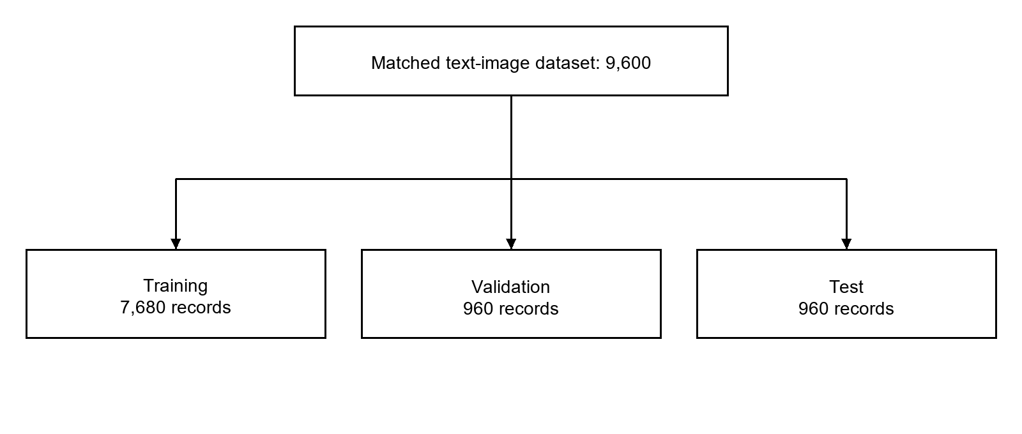
Figure 4.3: Dataset partitions recorded in the training notebook
The original report identifies MultiBanFakeDetect as the dataset background [1]. The runtime database of user submissions is operational data; expert voting does not automatically retrain the multimodal model. Any new training cycle requires a separate dataset, evaluation and model-release procedure.

5. AI Engineering Design

5.1 AI Pipeline and Model Selection

5.1.1 Multimodal Verification Architecture
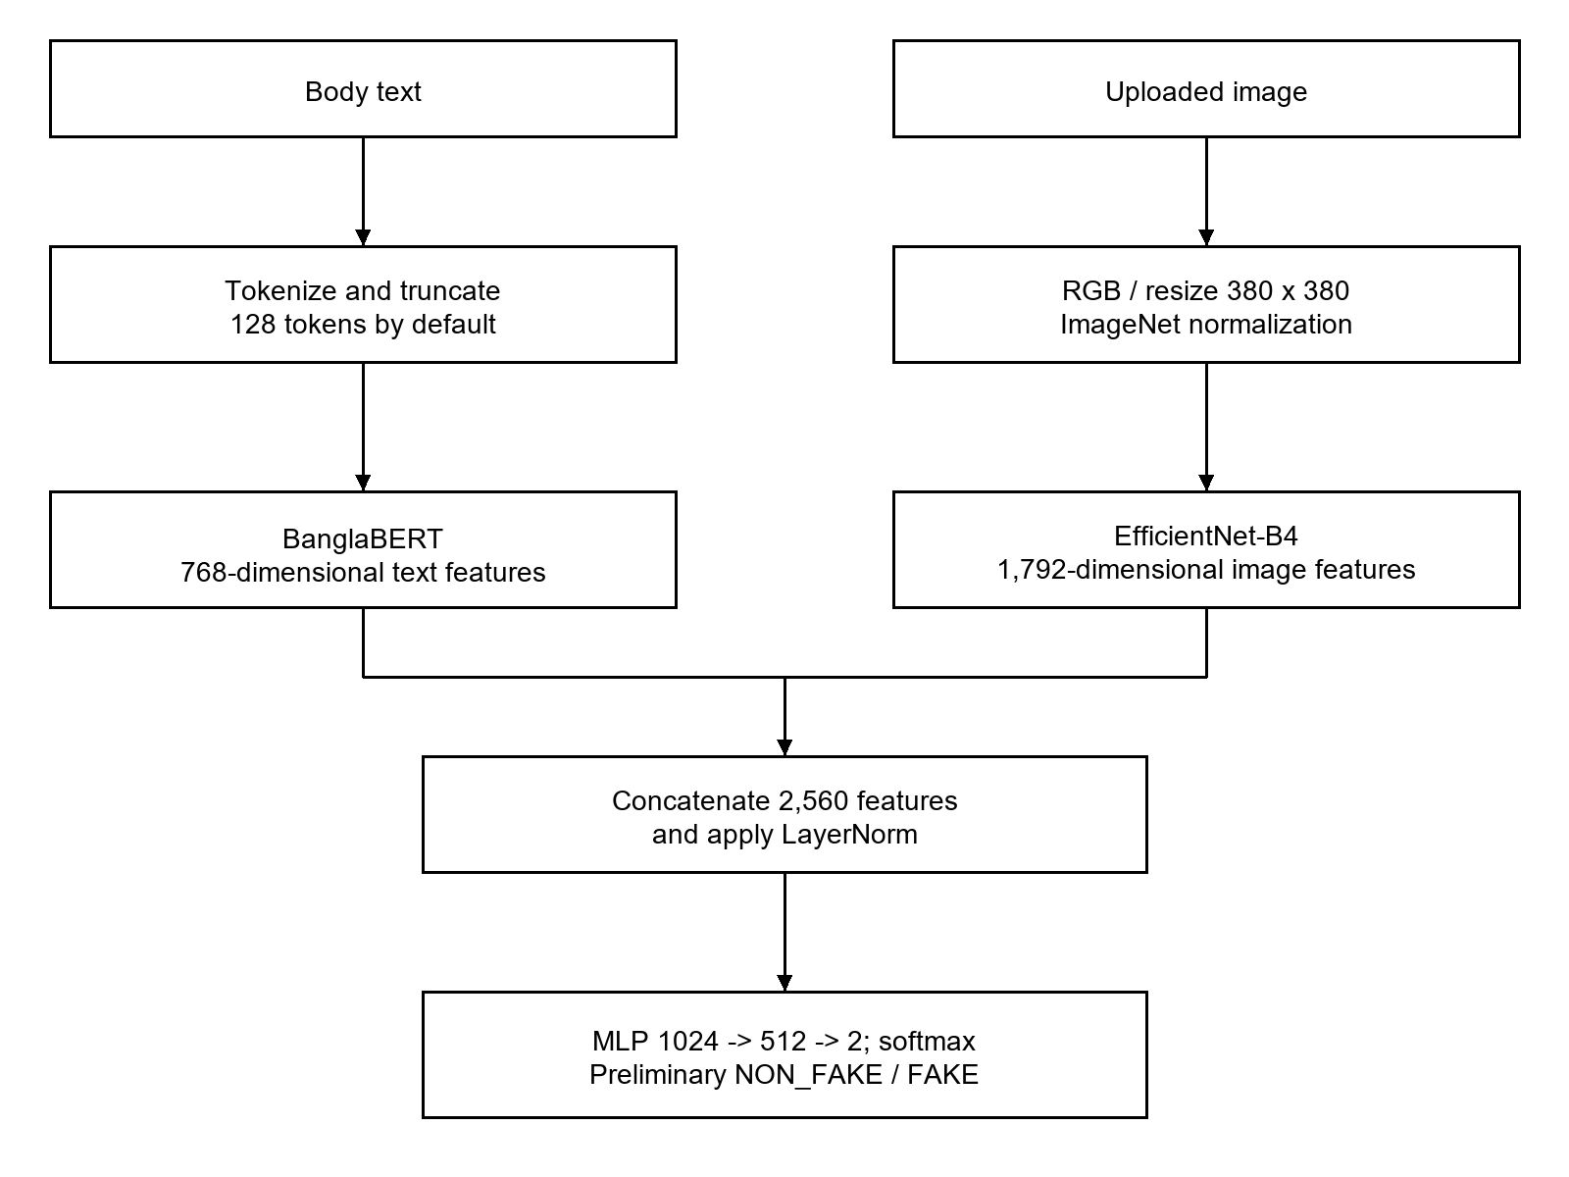
Figure 5.1: Implemented multimodal inference architecture
The classifier concatenates text and image features, applies LayerNorm, then linear layers of 1,024, 512 and 2 outputs with GELU and dropout between hidden layers. Dropout defaults to 0.4. Inference uses evaluation mode and softmax class probabilities. The displayed headline is not concatenated into the body model input.
Runtime preprocessing tokenizes and truncates body text, converts the image to RGB, resizes and normalizes it. Training augmentation is separate from inference. Spelling correction, generic stop-word removal and image-forgery detection are not established runtime stages.

5.1.2 Text and Source Verification Pipeline
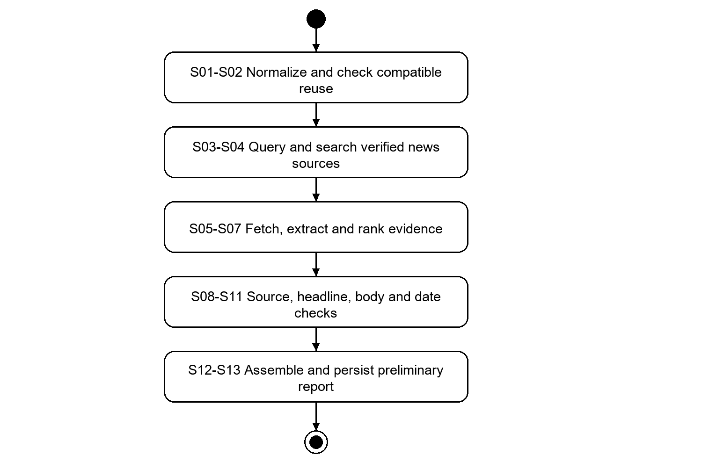
Figure 5.2: Shared evidence verification pipeline
The pipeline is assembled centrally and shared by typed claims and extracted photocard headlines. Its 13 stages separate retrieval from the interpretation of evidence. A compatible stored report may short-circuit repeated computation; reuse retains provenance and the new submission relationship.
Query generation uses headline and keyword variants, with dated variants where applicable, up to six queries. Configured publisher internal search and Google-based search support retrieval from verified news sources. Publication date is assessed separately and is not used to force the selected evidence article to match a supplied date.

5.1.3 Pipeline Stage Reference
Table 5.1: Shared pipeline stages
Stage | Name | Responsibility
S01 | Normalizer | Normalize Bangla input, resolve the verified-source registry entry and establish scope-aware claim identity.
S02 | Reuse lookup | Look for a compatible stored result before repeating search and analysis.
S03 | Query generator | Build headline and keyword queries; incorporate optional date variants.
S04 | Source search | Search verified news sources and retain provider outcome accounting.
S05 | Evidence retrieval | Fetch candidate pages and validate retrieval outcomes.
S06 | Article extractor | Extract title, body and publication metadata with provenance.
S07 | Evidence ranker | Rank candidates with semantic and keyword relevance and source correspondence; rerank when more than three candidates survive.
S08 | Source correspondence | Determine CONFIRMED, NOT_FOUND or INCOMPLETE using relevant evidence and search adequacy.
S09 | Headline Alteration | Compare the submitted headline with the selected article title; retain material differences and semantic assessment.
S10 | Body similarity | Compute four body-to-body measurements when a body exists; otherwise skip.
S11 | Date verification | Compare supplied and evidenced publication dates when applicable.
S12 | Result assembly | Build the structured preliminary report with explanations and availability states.
S13 | Persistence | Store result and evidence, update review state, maintain reuse data and support result delivery.
All stages have explicit responsibilities, but a degraded comparison does not always imply a failed submission. A completed report may legitimately contain unavailable or incomplete dimensions. Persisted timing metadata records stages actually executed; skipped stages are not zero-duration measurements.

5.1.4 Independent Finding Semantics
Table 5.2: Preliminary findings and interpretation
Dimension | Output | Interpretation
Source | CONFIRMED / NOT_FOUND / INCOMPLETE | Relevant reporting found; adequate search found none; or search/retrieval was insufficient.
Headline | MATCHED / ALTERED / null | A match or material alteration was established, or no supported verdict can be issued.
Headline display | EXACT_MATCHED / MEANING_PRESERVED / ALTERED | Distinguishes a normalized exact title match from a supported semantic match.
Body | COMPUTED / SKIPPED / UNAVAILABLE | At least one similarity measure exists; there is no claim body; or usable comparison data is absent.
Date | MATCHED / MISMATCHED / INCOMPLETE; absent when inapplicable | Comparison of claimed date and evidenced publication date, with no inferred date substitute.
Multimodal | FAKE / NON_FAKE | Preliminary classification displayed as Likely fake / Likely real.
Human overall | REAL / FAKE / MISLEADING / ALTERED | Final editorial decision from expert consensus or administrative resolution.

Headline comparison
An exact match under the implemented normalization can establish MATCHED immediately. Otherwise the comparator evaluates deterministic differences and semantic evidence, using NLI in both directions and LaBSE similarity. Differences may involve entities, quantities, dates, negation, attribution, scope, modality or subject-object roles. The comparison uses the article title, not the article body.
A null headline verdict carries a separate status such as SOURCE_NOT_FOUND, SOURCE_CHECK_INCOMPLETE, SOURCE_TITLE_MISSING, MODEL_UNAVAILABLE or UNDETERMINED. It is not a third alteration verdict. Body measurements never decide the headline result.

5.1.5 Body Similarity and Date Verification
For a claim with a body, the system compares that body with the selected article body through TF-IDF cosine, Jaccard, normalized Levenshtein and LaBSE embedding cosine similarity. These are measurements of textual overlap or resemblance. They do not prove truth, contradiction or manipulation.
Table 5.3: Body comparison measures
Measure | Meaning
TF-IDF cosine | Similarity of weighted lexical representations.
Jaccard | Overlap between token sets relative to their union.
Normalized Levenshtein | Character-sequence similarity based on edit distance.
LaBSE cosine | Semantic embedding similarity; the raw cosine and display value can be recorded separately.
Unavailable scores remain null with an explanation. A genuine computed zero is distinct from a missing measurement. Photocards have no claim body, so body comparison is skipped. Source correspondence may use relevant article passages, but the headline alteration decision remains a title comparison.

Publication date rules
Date comparison uses the article publication date and retained provenance, such as structured datePublished metadata. A modified date or crawl time must not silently replace publication time. The comparison uses the Asia/Dhaka calendar day. Missing or ambiguous publication metadata yields INCOMPLETE when a comparison is applicable. If no date was supplied or extracted, the date check is not applicable.

Search and failure accounting
The report retains provider call outcomes including successful, empty, failed, skipped and cached operations. A source result of NOT_FOUND requires adequate search evidence. A total retrieval failure is not a confident negative. NLI or embedding model unavailability must remain visible in the affected comparison rather than being converted into a match.

5.1.6 Photo Card Extraction and Verification
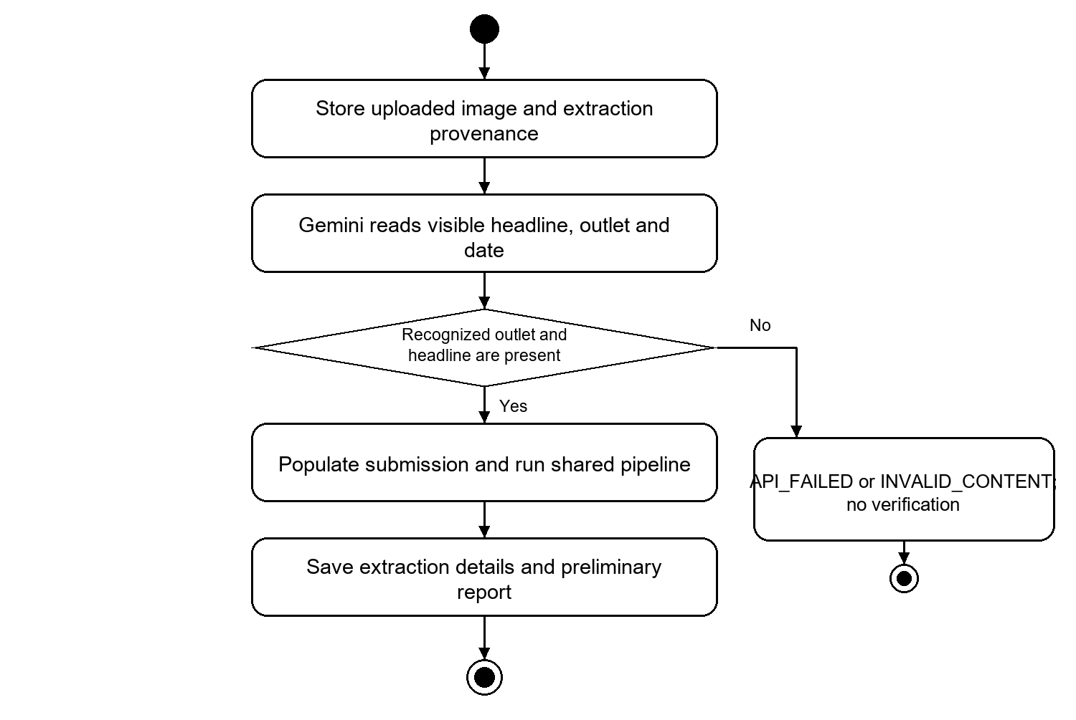
Figure 5.3: Current photocard extraction and verification pipeline
The input is the image alone. Gemini reads the headline as printed, recognizes the outlet from the active verified-source registry using visible name/logo/alias evidence, and returns a complete printed publication date when present. The service validates the response. No missing outlet or date is guessed. A missing headline or unrecognized outlet prevents verification.
The default request policy has at most nine extraction requests in three batches of three, separated by ten-second pauses. Failed attempts and model identity are retained. On success, the extracted headline, source and date become the submission fields and its scope is HEADLINE_ONLY. The uploaded image and extraction provenance are retained in photocard_extractions.

5.2 Model Selection
Table 5.4: Current model and service roles
Model or service | Role and implementation
BanglaBERT | Text feature backbone for multimodal inference; csebuetnlp/banglabert is the configured default.
EfficientNet-B4 | Image features for multimodal inference; feature dimension 1,792.
LaBSE | Sentence embeddings for retrieval, correspondence, headline semantics and body similarity.
mMARCO MiniLM cross-encoder | cross-encoder/mmarco-mMiniLMv2-L12-H384-v1 reranks surviving evidence candidates when there are more than three.
Multilingual NLI | MoritzLaurer/mDeBERTa-v3-base-mnli-xnli is the configured default for entailment and contradiction analysis.
BanglaTag NER | arafatfahim/BanglaTag is the configured BanglaBERT-based NER checkpoint; trained entity labels support entity comparison.
Gemini image extraction | External image-reading service for photocards. Model identity and request outcomes are recorded; it does not supply the final editorial verdict.
The current NLI default is a multilingual mDeBERTa checkpoint, replacing the English-oriented small DeBERTa description in the earlier design. A base language model is not assumed to be a trained NER model. Runtime availability and actual model identity should be recorded when executing deployment validation.

5.3 Recorded Multimodal Evaluation
Table 5.5: Saved notebook test results
Metric | Recorded value
Test examples | 960
Accuracy | 0.8000 (80.00%)
Weighted precision | 0.8001
Weighted recall | 0.8000
Weighted F1 | 0.8000
These values are stored notebook outputs, not a newly reproduced experiment or a production guarantee. They evaluate the binary text-image model, not source retrieval, Gemini extraction or human voting. A release evaluation must verify dataset separation, exported weight identity and performance on representative current claims.

5.4 Expert Consensus and Result Reuse
Experts make an independent overall editorial judgment using four categories: Real, Fake, Misleading and Altered. Source, headline and date votes are supplementary. The finalization service does not add the automated model result or supplementary dimensions to the overall tally.
For each candidate verdict v, let S(v) be the sum of saved vote weights supporting v. A claim finalizes when there is a unique leading verdict, the number of expert votes is at least M, the leading S(v) is at least T, and the difference from the runner-up is at least the configured lead margin. An exact tie never finalizes, even when a zero margin is configured.
An expert uses weight 1 before completing N reviews. Later weight resolution uses the configured active tier for completed-review accuracy. The applied weight and tier are stored with each vote. On finalization, agreement with the final overall verdict updates the expert profile. This credibility measures agreement with platform decisions, not independently established real-world accuracy.
If consensus is not reached, either a configured maximum vote count or maximum time since submission can escalate the claim. A background sweep applies time-based limits without requiring a new vote or page visit. Null limits impose no cap. An administrator resolves the escalated overall verdict and the decision is recorded separately from ordinary expert votes.

Reuse and compatibility
Text and photocard reuse use normalized claim identity, source/date information, claim scope and pipeline version. A headline-only submission cannot silently receive body scores from a different claim scope. A compatible saved result can be reused while it remains available. A new submission retains its submitter and a link to the original result so personal delivery and effective final status remain meaningful.
Multimodal duplicate detection compares text, image and combined embeddings among stored candidates. The configuration defaults are 0.92 text cosine, 0.85 image cosine and 0.90 combined cosine, with a candidate limit of 100 recent predictions. These are similarity thresholds, not measured classification accuracy. Approximate duplicate matching should be evaluated separately for false matches.

6. Test Plan and Verification Status

6.1 Testing Objectives
The test plan verifies input handling, role boundaries, pipeline semantics, persistence, human decision logic and user-visible behavior. Tests shall distinguish an incomplete operation from a negative finding and protect the separation between automated output and the final human verdict. The repository includes backend unit/integration tests, Angular tests and extension tests; their existence does not imply that every test has passed in the current deployment.

6.2 Features to be Tested
Table 6.1: Test scope and evidence
Area | Acceptance focus
Authentication | Regular registration, active-role login, refresh, logout, password-reset expiry and expert/admin access rejection.
Verification | All three input contracts, source registry handling, headline-only scope and correctly qualified missing evidence.
Evidence interpretation | Exact/semantic headline display, material differences, unavailable models, body metric nulls and date provenance.
Voting | Weight activation, snapshots, unique leader, score and margin gates, edit rules and limit-based escalation.
Persistence and reuse | Durable acceptance, stale job recovery, compatibility/version checks, duplicate links and personal ownership.
Notifications | Stage-level in-app delivery, queued final email, retry state and extension preference/account isolation.
Clients | Method-aware report routes, public filtering, profile behavior, capture permissions, drafts and status continuity.
Operations | Migration compatibility, model availability, storage failure, external search failure and measured load behavior.

6.3 Test Cases
The following scenarios are acceptance specifications. They should be executed against a controlled environment and recorded with build identifier, test data, expected result, actual result and pass/fail evidence. Live source retrieval, SMTP and installed-Chrome behavior require integration validation beyond model or browser-API fakes.

6.3 Test Cases continued

Test Case T1 Authentication and role-based access
Requirements: FR-01 to FR-04.
Scenario: Register a normal account, log in with valid/invalid credentials, refresh and revoke a session; call an expert/admin endpoint as a regular user.
Expected outcome: Valid sessions succeed. Invalid or inactive credentials and privileged requests fail. Registration cannot self-assign expert or admin. An expert cannot modify self-service profile fields.

Test Case T2 Multimodal verification
Requirements: FR-07, FR-08.
Scenario: Submit valid headline/body/image; repeat with short body, missing headline, unsupported type and unavailable model.
Expected outcome: Valid input receives a preliminary NON_FAKE/FAKE prediction. Invalid requests fail validation. Model unavailability is not reported as Fake. The expert overall verdict remains separate.

Test Case T3 Text verification and source findings
Requirements: FR-05, FR-09, FR-15.
Scenario: Check claims against verified news sources with matching evidence, an adequate empty search and total provider failure.
Expected outcome: Source output is respectively CONFIRMED, NOT_FOUND or INCOMPLETE; an empty or failed lookup never fabricates an overall verdict.

6.3 Test Cases continued

Test Case T4 Photo card extraction
Requirements: FR-06, FR-13.
Scenario: Upload a readable card, a card without a date, one without a recognized outlet and one whose extraction requests all fail.
Expected outcome: Valid content enters headline-only verification. A missing date remains absent. Invalid content and API failure produce distinct extraction reasons and no verification.

Test Case T5 Duplicate and compatible-result reuse
Requirements: FR-18.
Scenario: Repeat an identical text/photocard claim; change scope, body or pipeline identity. Check multimodal duplicate thresholds and a second submitter.
Expected outcome: Compatible results are reused with provenance. Incompatible scopes do not share body measurements. The new submitter retains a personal submission link and later effective final status.

Test Case T6 Expert consensus and credibility
Requirements: FR-10, FR-21.
Scenario: Exercise below-N experts, weighted tiers, vote edits, exact ties, insufficient M/T/margin and successful consensus.
Expected outcome: Only overall expert votes count. Each gate is enforced. Weights are snapshotted and completed-review statistics update on final decision.

6.3 Test Cases continued

Test Case T7 Fact Explorer and reports
Requirements: FR-11, FR-22.
Scenario: Filter by keyword, method, findings and review state; open each result method from the same detail route.
Expected outcome: Results satisfy filters and pagination. Preliminary reports are distinguishable from final ones. The correct method-specific report loads without treating absent fields as false.

Test Case T8 Browser extension workflow
Requirements: FR-19, FR-20.
Scenario: Import headline/body text, capture a selected region, crop/upload and submit all modes. Switch accounts and turn tracking OFF/ON.
Expected outcome: Only the selected image is retained/uploaded. Drafts and activity remain account-separated. OFF pauses new extension actions and alerts, not accepted backend work.

Test Case T9 Personal notifications and email
Requirements: FR-16.
Scenario: Complete and finalize submissions by different users; repeat reconciliation and simulate SMTP failure/restart.
Expected outcome: Only the relevant account receives its in-app updates. Final email stays queued or retries. Logical result stages are not duplicated; at-least-once SMTP behavior is accounted for.

6.3 Test Cases continued

Test Case T10 Administration
Requirements: FR-12, FR-14.
Scenario: Create/deactivate an expert, edit source activation/configuration and modify tiers/limits using authorized and unauthorized clients.
Expected outcome: Only administrators can perform these operations. New source selection reflects active entries; existing records retain valid references according to service and database rules.

Test Case T11 Data integrity
Requirements: NFR-02.
Scenario: Insert duplicate one-to-one analysis rows, remove referenced parents in an isolated database and inspect result-delivery composite keys.
Expected outcome: Unique constraints, cascades and SET NULL actions match the declared schema; historical references are not assumed to be universally protected from deletion.

Test Case T12 Headline alteration and body scores
Requirements: FR-15, FR-22.
Scenario: Compare exact titles, semantic paraphrases, changed quantities/negation/entities, missing titles and missing body/model data.
Expected outcome: Exact and meaning-preserved matches are distinguishable. Material alterations are explained. Null verdicts expose status. Body metrics remain measurements and absent scores remain null.

6.3 Test Cases continued

Test Case T13 Date verification
Requirements: FR-09, FR-15.
Scenario: Use matching dates, different dates, missing datePublished, dateModified-only metadata and timezone-boundary timestamps.
Expected outcome: Publication provenance and Asia/Dhaka day conversion are respected. Missing/ambiguous dates do not become mismatches. Date findings do not determine headline truth.

Test Case T14 Job durability and recovery
Requirements: FR-08, FR-17.
Scenario: Accept a job, close its client, restart the server and simulate an abandoned heartbeat or processing failure.
Expected outcome: Accepted work remains stored, is reclaimable and exposes a terminal outcome or recoverable processing state. No completion depends on an open page.

Test Case T15 Escalation and administrative decision
Requirements: FR-10, FR-21.
Scenario: Reach either configured review limit without consensus; exercise time sweep without page visits and resolve as admin.
Expected outcome: The claim becomes ESCALATED, ordinary voting stops, and only the authorized administrative decision establishes its final overall outcome.

6.3 Test Cases continued

Test Case T16 Session and connection boundaries
Requirements: FR-03, FR-20.
Scenario: Trigger concurrent token refresh and temporary network loss. Attempt extension connection changes as guest/user and as a revalidated admin.
Expected outcome: Transient network errors do not automatically clear the web session. Connection edits require current admin authorization. Website and extension sessions remain independent.

6.4 Requirements Traceability and Test Evidence
Table 6.2: Requirement to acceptance-test mapping
Requirements | Tests | Relevant implementation
FR-01–04 | T1, T16 | auth services/security; users router; web guards and session interceptor
FR-05, 09, 15, 22 | T3, T12, T13 | verification pipeline, analysis and presenter; shared report UI
FR-06, 13 | T4 | photocard router, service, Gemini extraction and stored provenance
FR-07 | T2 | multimodal router, inference engine and classifier
FR-08, 17, 18 | T5, T14 | verification jobs, claim hashing/reuse and multimodal duplicate service
FR-10, 21 | T6, T15 | expert review service, voting config and escalation worker
FR-11 | T7 | dashboard API and public dashboard/detail route
FR-12, 14 | T10 | admin/source services and expert/source management pages
FR-16 | T9 | result delivery worker, notification API and email service
FR-19, 20 | T8, T16 | extension side panel, background worker and local storage
NFR-01–12 | T1–T16 plus operational tests | database migrations, services, configured deployment and clients
Existing backend test areas include verification pipeline, multimodal/photocard background work, extraction failures, headline comparisons, body scores, voting, delivery and data access. Client tests cover result presentation, sessions and extension behavior using controlled dependencies. No new full application test run is asserted by this document revision.

6.5 Remaining Validation
Before release, run the full suites in a configured environment; verify current migration state, actual model weights and credentials; perform live source/Gemini checks; confirm installed-Chrome capture and desktop notifications; test SMTP delivery/retries; and measure end-to-end latency, concurrent load and recovery. The saved 80% notebook accuracy is a historical experiment result and must not substitute for this acceptance evidence.

7. Timeline and Current Implementation Status
The earlier report was submitted on 2 August 2026. This revision records the implementation baseline available on 7 October 2026. The timeline below shows repository milestones rather than a new estimated completion schedule; migration dates identify schema changes and are not proof of production deployment.
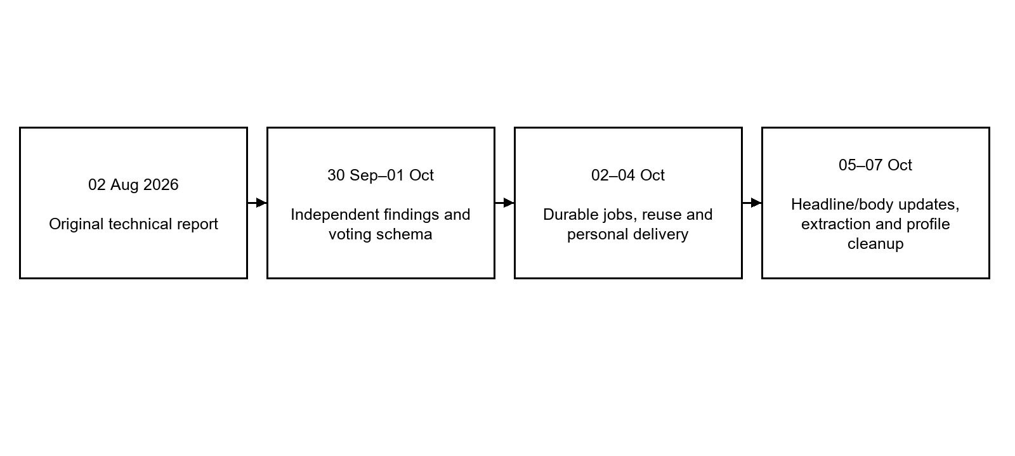
Figure 7.1: Report and implementation milestones
Table 7.1: Current status and follow-up
Area | Current baseline | Follow-up
Core clients | Website and extension code support all three methods. | Deployment and installed-browser acceptance.
Evidence checks | Shared 13-stage pipeline and structured reports. | Representative retrieval and semantic evaluation.
Photo card | Gemini image-only extraction and provenance. | Live API reliability and difficult-card evaluation.
Human review | Weighted overall voting, limits and admin resolution. | Scenario testing and operational review staffing.
Persistence/delivery | Durable jobs, compatible reuse, personal notifications and email queue. | Restart, recovery, SMTP and backup validation.
Multimodal model | Notebook and inference implementation; saved test accuracy 80%. | Verify release weights and reproduce evaluation.

8. Conclusion
BanglaFactGuard now has an implemented web application, backend and Chrome extension for submitting Bangla news claims through text, photocards and text-image pairs. The evidence-based workflows check against verified news sources and preserve separate source, headline, body-similarity and date findings. Gemini supports photocard extraction, while BanglaBERT and EfficientNet-B4 provide preliminary multimodal classification.
Human review remains the basis of the final editorial verdict. Expert overall votes use configurable credibility weights and consensus requirements; undecided claims can be escalated for an administrator to resolve. These decisions remain distinguishable from automated measurements and model predictions.
The current implementation also supports persistent jobs, scope-aware result reuse, public fact exploration, personal history and result delivery. The revised requirements, diagrams, schema dictionary and test plan provide a consistent basis for further development and assessment. Remaining work centers on live integration validation, release-model verification, representative evaluation and operational readiness rather than the earlier assumption that the browser extension and voting features were still entirely unimplemented.

9. References
Research references retained from the original report provide background; the implementation records below define the current software behavior.
[1] F. T. J. Faria et al., “MultiBanFakeDetect: Integrating advanced fusion techniques for multimodal detection of Bangla fake news in under-resourced contexts,” International Journal of Information Management Data Insights, vol. 5, article 100347, 2025.
[2] R. Panchendrarajan and A. Zubiaga, “Claim detection for automated fact-checking: A survey on monolingual, multilingual and cross-lingual research,” Natural Language Processing Journal, vol. 7, article 100066, 2024.
[3] A. Bhattacharjee et al., “BanglaBERT: Language Model Pretraining and Benchmarks for Low-Resource Language Understanding Evaluation in Bangla,” Findings of NAACL, pp. 1318–1327, 2022.
[4] M. Tan and Q. V. Le, “EfficientNet: Rethinking Model Scaling for Convolutional Neural Networks,” Proceedings of ICML, pp. 6105–6114, 2019.
[5] F. Feng et al., “Language-agnostic BERT Sentence Embedding,” Proceedings of ACL, pp. 878–891, 2022.

9. References continued
[6] L. Bonifacio et al., “mMARCO: A Multilingual Version of the MS MARCO Passage Ranking Dataset,” arXiv:2108.13897, 2021.
[7] P. He, J. Gao and W. Chen, “DeBERTaV3: Improving DeBERTa using ELECTRA-Style Pre-Training with Gradient-Disentangled Embedding Sharing,” arXiv:2111.09543, 2021.
[8] Md. Abul Kalam Azad, BanglaFactGuard Technical Report, BSSE-1425, Institute of Information Technology, University of Dhaka, 2 August 2026.
[9] BanglaFactGuard repository, current application source and schema models inspected for the 7 October 2026 revision.
[10] MultiBanFake_BanglaBERT_EfficientNetB4.ipynb, saved dataset-loading and test-evaluation outputs, project repository.

9.1 Implementation Reference Index
Table 9.1: Implementation evidence for this revision
Area | Repository-relative source
Pipeline and semantics | backend/app/core/constants.py; features/verification/pipeline/factory.py; features/verification/analysis/; features/verification/schemas.py
Photocard contract | backend/app/features/photocard/router.py, schemas.py, service.py and gemini_image_extractor.py
Multimodal inference | backend/app/features/multimodal/pipeline/model_architecture.py and inference_engine.py; backend/app/core/config.py
Voting and escalation | backend/app/features/expert_review/service.py, models.py and escalation.py
Data dictionary | backend/app/features/{auth,sources,submissions,verification,multimodal,expert_review,notifications}/models.py
User access and public views | backend/app/features/submissions/access.py; users/router.py; dashboard/router.py; frontend/src/app/routes/app.routes.ts
Delivery and extension | backend/app/features/notifications/delivery.py; extension/src/; extension/README.md and TESTING.md
Paths in this index are repository-relative implementation references. Configuration defaults can be overridden by deployment settings. Old design notes and compatibility enum values are not treated as current user-facing requirements when newer code specifies different behavior.

