BanglaFactGuard
A Multimodal Bangla Fact-Checking System
Final Report
SE 801: Software Project Lab III
Supervised by:
Toukir Ahammed
Lecturer
Institute of Information Technology
University of Dhaka

Submitted by:
Md. Abul Kalam Azad
Roll: BSSE-1425
Institute of Information Technology
University of Dhaka

Submitted to:
SPL-03 Program Committee
Submission Date: 11 October 2026
Institute of Information Technology
University of Dhaka

Letter of Transmittal
11 October 2026
BSSE 4th Year Exam Committee
Institute of Information Technology
University of Dhaka

Subject: Final Report Submission, BanglaFactGuard: A Multimodal Bangla Fact Checking System.
Dear Sir,
I am pleased to submit the final report for my Software Project Lab III project, BanglaFactGuard: A Multimodal Bangla Fact-Checking System. The report covers the project from the requirements and the analysis models to the component-level design, the interface design, the implementation and the testing of the finished system. It closes with a user manual, installation steps and the address of the public repository.
I have tried my best to present the technical details of the project clearly and accurately. However, the work may still lack perfection in places. I would therefore be grateful if you would kindly accept my report and provide any feedback that could help me improve it further.
Thank you for your consideration.
Sincerely,
Md. Abul Kalam Azad
Roll: BSSE-1425
Institute of Information Technology
University of Dhaka

__________________
Supervisor's Signature
Toukir Ahammed

Acknowledgement
I am sincerely grateful to the Institute of Information Technology, University of Dhaka, for giving me the opportunity to carry out my Software Project Lab III on the project titled “BanglaFactGuard: A Multimodal Bangla Fact-Checking System”. This project gave me the chance to apply software engineering, natural language processing, computer vision and information retrieval to a practical and socially relevant problem.
I would like to express my heartfelt gratitude to my respected supervisor, Toukir Ahammed, Lecturer, Institute of Information Technology, University of Dhaka, for his continuous guidance, constructive criticism and encouragement throughout every phase of this work. His insights shaped the direction, design and scope of this system.
I am also thankful to my other teachers and classmates for their cooperation, helpful discussions and suggestions during different phases of the project. Finally, I acknowledge the resources and academic environment provided by the Institute of Information Technology, which made the progress of this project possible.

Abstract
BanglaFactGuard is an AI-assisted platform that helps people check Bangla news claims, changed headlines and news photocards. It has three parts: an Angular website, a FastAPI backend and a Chrome browser extension. Users can check a claim in three ways. Text & source verification looks for the story on the news outlet that the claim names and reports three separate findings: whether a matching report was found, whether the headline was altered and whether the publication date matches. When article text is given, it also shows four body-similarity scores. Photo card verification reads the headline, outlet and printed date from an uploaded card with Gemini and then runs the same source check. Text & image verification uses a BanglaBERT and EfficientNet-B4 model to give a preliminary Likely Real or Likely Fake prediction.
All automated findings are shown as preliminary. Human experts then review each claim and give a final verdict (Fake, Real, Misleading or Altered) through credibility-weighted voting; claims without agreement are escalated to an administrator. Missing or incomplete evidence is shown honestly and is never treated as proof that a claim is false. The platform also offers a public Fact Explorer, submission history, in-app and email notifications and administration of experts, news sources and voting rules. PostgreSQL, Redis and MinIO store data, cached results and images and a durable job queue runs long checks in the background.
This report presents the requirements, activity diagrams, data and class models, AI engineering design, component-level design, interface design, implementation, testing, user manual and installation of the system.
Table of Contents
Letter of Transmittal 2
Acknowledgement 3
Abstract 4
List of Figures 8
List of Tables 10
1. Introduction 11
1.1 Problem Statement 11
1.2 Objectives 11
1.3 Scope 12
1.3.1 In Scope 12
1.3.2 Out of Scope 12
1.4 Deliverables 12
1.5 Functional and Non-Functional Requirements 13
1.5.1 Functional Requirements 13
1.5.2 Non-Functional Requirements 14
2. Activity Diagrams 15
2.1 Authentication and Registration 15
2.2 Text & Source Verification 16
2.3 Photo Card Verification 17
2.4 Text & Image (Multimodal) Verification 18
2.5 Expert Review and Voting 19
2.6 Browser Extension 20
2.7 Fact Explorer 21
3. Data-Based Modeling and Dataset Description 22
3.1 Entity-Relationship Diagram 22
3.2 Main Entities and Relationships 22
3.3 Dataset Description 24
4. Class-Based Modeling 25
5. AI Engineering Design 27
5.1 Multimodal Verification Model 27
5.1.1 Model Architecture 27
5.1.2 Recorded Evaluation 28
5.1.3 Duplicate Detection 28
5.2 Source-Based Verification Pipeline 28
5.3 Model Selection 30
5.4 Responsible Use of AI 30
6. Component-Level Design 32
6.1 Component Diagram 32
6.1.1 Information Flow 33
6.2 Design Classes 34
6.3 Persistent Data Sources 36
6.4 Behavioural Design 38
6.4.1 Submission Lifecycle 38
6.4.2 Sequence of a Text & Source Check 39
6.4.3 Voting Rules 39
6.5 Deployment Design 41
6.6 Design Alternatives Considered 42
7. Interface Design 43
7.1 User Interface Objects and Actions 43
7.2 Navigation 44
7.3 UI Events and State Transitions 45
7.3.1 Verify Facts Page 45
7.3.2 Expert and Administrator Review 46
7.3.3 Browser Extension Side Panel 47
7.4 Interface States as Seen by the User 47
8. Implementation 54
8.1 Technology Stack 54
8.2 Code Organisation 54
8.3 Key Implementation Details 54
8.3.1 Authentication and Roles 54
8.3.2 Background Jobs and Reuse 54
8.3.3 Photo Card Reading 55
8.3.4 Voting, Escalation and Notifications 55
8.3.5 Browser Extension 55
8.4 Main API Routes 55
9. Testing 56
9.1 Testing Approach and Strategy 56
9.2 Test Environment and Tools 56
9.3 Item Pass/Fail Criteria 56
9.4 Summary of Executed Test Runs 57
9.5 Test Cases with Detailed Outcomes 57
9.5.1 Authentication and Sessions 57
9.5.2 Text & Source Verification 58
9.5.3 Photo Card and Text & Image Verification 59
9.5.4 Expert Review, Voting and Escalation 59
9.5.5 Notifications, Fact Explorer and Extension 60
9.6 Observed Performance and Model Results 60
9.7 Tests Not Executed or Not Verified 60
9.8 Risks and Contingencies 61
10. User Manual 62
10.1 Getting Started 62
10.2 Creating an Account and Signing In 62
10.3 Checking a Claim 63
10.3.1 Text & Source (News story against claimed source) 63
10.3.2 Photo Card (Photocard against claimed source) 63
10.3.3 Text & Image (News story against an image) 64
10.4 Reading a Result 65
10.5 Fact Explorer 68
10.6 My Submissions, Notifications and Settings 68
10.7 Using the Browser Extension 70
10.8 Expert Tasks 70
10.9 Administrator Tasks 72
10.10 Troubleshooting 76
11. Repository Installation and Deployment 77
11.1 Repository 77
11.2 Prerequisites 77
11.3 Backend Setup 77
11.4 Services, Database and Sources 78
11.5 Website 78
11.6 Browser Extension (Installation) 78
11.7 Running the Tests 79
11.8 Deployment Status 79
12. Conclusion 80
13. References 81

List of Figures
Figure 2.1: Activity Diagram — Authentication and Registration 15
Figure 2.2: Activity Diagram — Text & Source Verification 16
Figure 2.3: Activity Diagram — Photo Card Verification 17
Figure 2.4: Activity Diagram — Text & Image Verification 18
Figure 2.5: Activity Diagram — Expert Review and Voting 19
Figure 2.6: Activity Diagram — Browser Extension 20
Figure 2.7: Activity Diagram — Fact Explorer 21
Figure 3.1: Entity-Relationship Diagram — BanglaFactGuard 22
Figure 4.1: Analysis Class Diagram (CRC View) 25
Figure 5.1: Multimodal Verification Architecture — Text and Image Fusion 27
Figure 5.2: Source-Based Verification Pipeline — Stages S01 to S13 29
Figure 6.1: Component Diagram of BanglaFactGuard 32
Figure 6.2: Design Class Diagram 34
Figure 6.3: Persistent Data Sources and Their Classes 36
Figure 6.4: State Diagram of a Submission 38
Figure 6.5: Sequence Diagram — Text & Source Claim (rotated to fit the page) 40
Figure 6.6: Deployment Diagram 41
Figure 7.1: Website Navigation by User Role 44
Figure 7.2: State Diagram of the Verify Facts Interface 45
Figure 7.3: State Diagram of the Review Interface 46
Figure 7.4: State Diagram of the Extension Side Panel 47
Figure 7.5: EDITING State — Text & Source Claim Form 48
Figure 7.6: IN PROGRESS State — Claim Received 49
Figure 7.7: PRELIMINARY RESULT State — Final Decision Under Review 50
Figure 7.8: FINAL DECISION State — Administrator Decision on a Photo Card 51
Figure 7.9: CHECK FAILED State — Photo Card Could Not Be Read 52
Figure 7.10: Extension States — Signed In, Checking Your Claim and Result Ready 52
Figure 7.11: VOTE FORM State — Expert Review Page 53
Figure 10.1: Home Page 62
Figure 10.2: Create Account Page 63
Figure 10.3: Photo Card Form with Preview 64
Figure 10.4: Text & Image Result with a Reused Assessment 65
Figure 10.5: Headline Comparison Showing an Altered Headline 66
Figure 10.6: Body Similarity Scores 66
Figure 10.7: Result When the Claimed Source Has No Matching Report 67
Figure 10.8: Fact Explorer 68
Figure 10.9: My Submissions 69
Figure 10.10: Notifications 69
Figure 10.11: Extension Verify Tab — Text & Source, Photo Card and Text & Image 70
Figure 10.12: Expert Review Queue 71
Figure 10.13: Administrator Dashboard 72
Figure 10.14: Expert Management 73
Figure 10.15: Verified Sources 73
Figure 10.16: Voting Configuration and Credibility Weight Tiers 74
Figure 10.17: Final Decision with Voting Details After an Administrator Decision 75

List of Tables
Table 1.1: Functional Requirements 13
Table 1.2: Non-Functional Requirements 14
Table 3.1: Main Entities and Their Key Attributes 23
Table 3.2: Dataset Split Summary (Text–Image Pairs) 24
Table 4.1: Class Responsibilities and Collaborators 26
Table 5.1: Multimodal Model Configuration 28
Table 5.2: Recorded Test Results of the Multimodal Model (960 test items) 28
Table 5.3: Source-Based Verification Pipeline — Stage Reference 29
Table 5.4: AI Model Selection Summary 30
Table 6.1: Main Components and Their Responsibilities 32
Table 6.2: Design Classes and Domain Concepts 35
Table 6.3: Persistent Data Sources 37
Table 6.4: Submission States 39
Table 6.5: Deployment Nodes 41
Table 6.6: Design Alternatives and Decisions 42
Table 7.1: User Interface Objects and Actions 43
Table 7.2: Events and State Transitions on the Verify Facts Page 46
Table 8.1: Technology Stack 54
Table 8.2: Main API Routes (prefix /api/v1) 55
Table 9.1: Test Environment 56
Table 9.2: Executed Automated Test Runs (8 October 2026) 57
Table 9.3: Test Cases — Authentication and Sessions 57
Table 9.4: Test Cases — Text & Source Verification 58
Table 9.5: Test Cases — Photo Card and Text & Image 59
Table 9.6: Test Cases — Expert Review and Voting 59
Table 9.7: Test Cases — Notifications, Fact Explorer and Extension 60
Table 9.8: Tests Not Executed in This Run 60
Table 9.9: Testing Risks and Contingencies 61
Table 10.1: Common Problems and Solutions 76
Table 11.1: Prerequisites 77
Table 11.2: Main Configuration Settings (backend/.env) 78

Project Title: BanglaFactGuard: A Multimodal Bangla Fact-Checking System
GitHub Repository: https://github.com/abulkalamazad1425/BanglaFactGuard

1. Introduction
Fake and misleading news spreads very quickly on social media. In Bangladesh, much of this content is shared in Bangla, often as a changed headline or as a “photocard”, which is an image that looks like a news outlet's post. Most automated fact-checking tools are built for English, so Bangla readers have few tools that can check such claims quickly.
BanglaFactGuard is a full-stack fact-checking platform for Bangla news. A user submits a claim on the website or from the browser extension. The system first produces quick automated findings, which are always labelled as preliminary. Human experts then examine the claim and its evidence and vote on a final verdict. Every reviewed claim, with its evidence and verdict, can be searched in the public Fact Explorer.

1.1 Problem Statement
At present, Bangla-speaking users do not have a single place where they can check a news claim, a headline or a photocard. Manual fact-checking by journalists is accurate but slow and it cannot handle the volume of claims shared every day. Automated models are fast, but their output is not reliable enough to be the final word and a missing search result can easily be misread as proof that a story is fake.
The problem this project addresses is therefore to build one platform that (1) accepts Bangla claims in the forms in which they are actually shared, (2) gives fast, clearly preliminary evidence-based findings, (3) keeps the final decision with human experts and (4) makes the results easy to find and reuse.

1.2 Objectives
The objectives of BanglaFactGuard are:
- To let users check Bangla news claims in three ways: Text & source, Photo card and Text & image.
- To compare a claim with the report published by the claimed news outlet and give separate findings for source, headline and publication date.
- To give a quick preliminary prediction for a news text and image pair using a multimodal model.
- To keep every final verdict with human experts through credibility-weighted voting, with administrator decisions for escalated claims.
- To reuse saved results for claims that were already checked, instead of repeating the work.
- To provide a public Fact Explorer, personal submission history and result notifications.
- To provide a browser extension so users can check a claim from the page they are reading.
- To give administrators tools to manage experts, verified news sources and voting rules.

1.3 Scope

1.3.1 In Scope
- A website with four kinds of users: anonymous visitor, registered user, expert and administrator.
- Three verification methods: Text & source, Photo card (read by Gemini) and Text & image (BanglaBERT + EfficientNet-B4).
- Separate automated findings for source correspondence, headline alteration and date, plus four body-similarity scores when a body is given.
- Background processing through a durable job queue, with reuse of saved results.
- Expert review, credibility-weighted voting, escalation and administrator decisions.
- Public Fact Explorer with search, filters and statistics.
- In-app notifications for signed-in submitters and queued final-result emails.
- A Chrome (Manifest V3) extension with a side panel, selected-text import, image upload, screenshot-area capture, cropping, activity tracking and desktop alerts.
- Administration of experts, verified news sources, credibility tiers and voting configuration.

1.3.2 Out of Scope
- Checking claims in languages other than Bangla.
- Native mobile applications; the system is a website and a desktop Chrome extension.
- Video verification.
- Fully automated final verdicts; every final verdict comes from experts or an administrator.
- Automatic crawling of social media; only submitted claims are checked.
- Removing content or taking legal action against publishers.

1.4 Deliverables
- The BanglaFactGuard website (Angular), backend API (FastAPI) and Chrome extension.
- The trained multimodal model files used by the Text & image method.
- The database design and migrations and the verified-source seeding script.
- Automated test suites for the backend, the website and the extension.
- This final report, with design, implementation, testing, a user manual and installation steps.
- A public Git repository: https://github.com/abulkalamazad1425/BanglaFactGuard.

1.5 Functional and Non-Functional Requirements

1.5.1 Functional Requirements
Table 1.1 lists the functional requirements of the final system. They are taken from the earlier SRS and updated to match what is implemented.
Table 1.1: Functional Requirements
ID | Requirement | Users
FR-1 | Register with name, email and password; sign in and sign out; reset a forgotten password with a time-limited emailed code (OTP). | All signed-in roles
FR-2 | Submit a Text & source claim with a headline and claimed outlet and an optional body and claimed date. | All users
FR-3 | Submit a Photo card image; read its headline, outlet and printed date; explain the reason when the card cannot be read. | All users
FR-4 | Submit a Text & image claim (headline, article text and image) and receive a preliminary Likely Real or Likely Fake prediction. | All users
FR-5 | Report source correspondence (Found, Not Found or Incomplete), headline alteration (Exact Matched, Meaning Preserved or Altered) and date (Matched or Mismatched) separately. | All users
FR-6 | Show four body-similarity scores when article text is supplied. | All users
FR-7 | Reuse a saved result for an identical claim and say that it was reused. | All users
FR-8 | Run checks in the background and show progress; let the user leave the page safely. | All users
FR-9 | Show an expert review queue; let experts inspect evidence and vote with a written justification (at least 50 characters). | Expert
FR-10 | Finalize a verdict by credibility-weighted voting or escalate to an administrator when the review limits are reached without agreement. | Expert, Administrator
FR-11 | Let an administrator decide escalated claims; other claims stay view-only. | Administrator
FR-12 | Provide a public Fact Explorer with search, filters and statistics. | All users
FR-13 | Show each signed-in user's submissions and notifications; queue final-result emails. | Registered user
FR-14 | Manage expert accounts, verified sources, credibility tiers and voting configuration. | Administrator
FR-15 | Offer all three methods in the browser extension, with selected-text import, screenshot capture, cropping, activity and alerts. | All users

1.5.2 Non-Functional Requirements
Table 1.2 lists the main non-functional requirements and how the final system meets them.
Table 1.2: Non-Functional Requirements
ID | Category | Requirement and how it is met
NFR-1 | Performance | Long checks run in the background; the website and extension stay usable and show the current status.
NFR-2 | Efficiency | Saved results are reused and search, embedding and claim data are cached in Redis.
NFR-3 | Security | Passwords are hashed; access uses short-lived JWT tokens with rotating refresh tokens; OTP codes are single-use and expire.
NFR-4 | Security | Role checks protect expert and admin functions; private records check ownership; experts cannot vote on their own claims.
NFR-5 | Usability | Bangla input is supported; findings use plain labels and short explanations; a public FAQ explains the terms.
NFR-6 | Reliability | Accepted jobs survive restarts; stalled jobs are re-claimed; failures are saved with a readable reason.
NFR-7 | Data integrity | A submission and its job are saved in one transaction; persistence is idempotent; the weight of every vote is stored.
NFR-8 | Correctness and transparency | Automated findings never set the final verdict; a missing source is never shown as Fake.
NFR-9 | Maintainability | Features are separate modules; pipeline stages share one interface; voting rules and sources are changed without code changes.
NFR-10 | Compatibility | The extension uses Chrome Manifest V3 and the same accounts as the website, with a separate login session.

2. Activity Diagrams
This chapter shows the activity diagrams for the most important workflows of BanglaFactGuard. They were drawn for the SRS and updated to match the final system. Less important flows, such as profile management, notifications and source management, are left out to save space; their behaviour is covered in Chapters 7 and 10.

2.1 Authentication and Registration
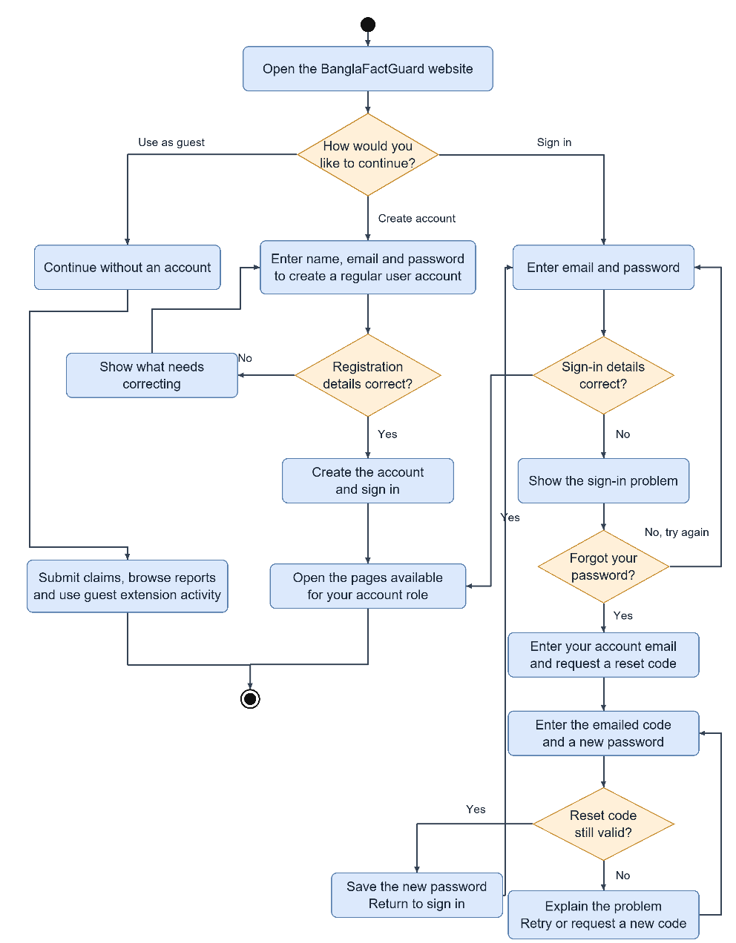
Figure 2.1: Activity Diagram — Authentication and Registration
A visitor can continue as a guest, create an account or sign in. Registration checks the details and signs the new user in. A failed sign-in shows the problem. A user who forgot the password asks for a reset code by email, enters the code with a new password and returns to sign in. After sign-in, the user sees the pages allowed for his or her role.

2.2 Text & Source Verification
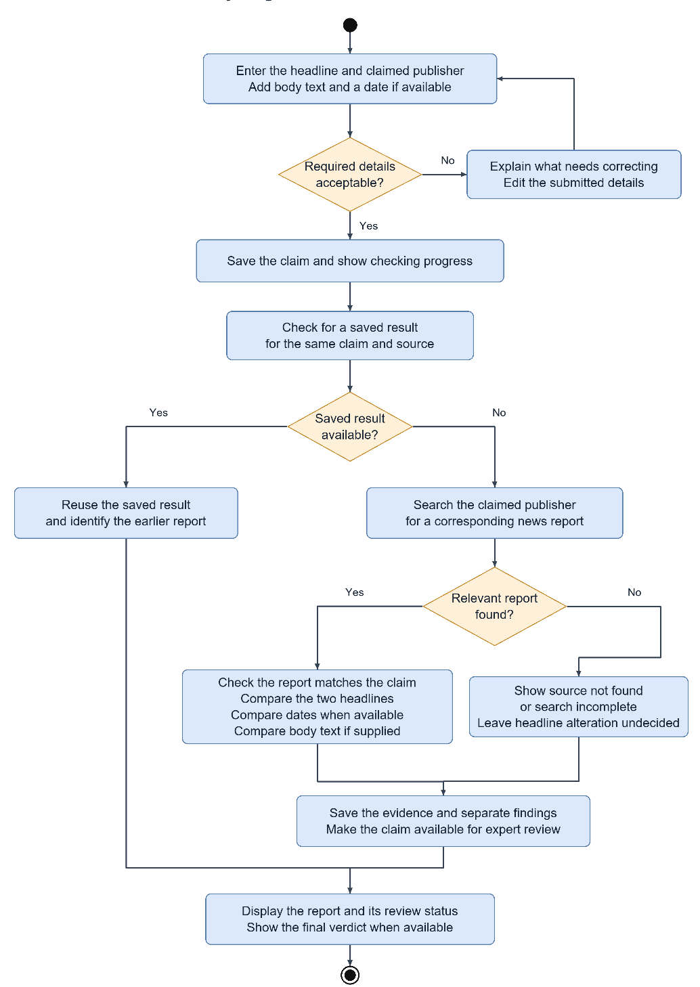
Figure 2.2: Activity Diagram — Text & Source Verification
The user enters the headline and claimed outlet and optionally the body and date. If a saved result for the same claim exists, it is reused. Otherwise the system searches the claimed outlet. When a relevant report is found, the headline, date and body are compared; when it is not found, the result says Not Found or Incomplete and the headline check stays undecided. The findings are saved and the claim goes to expert review.

2.3 Photo Card Verification
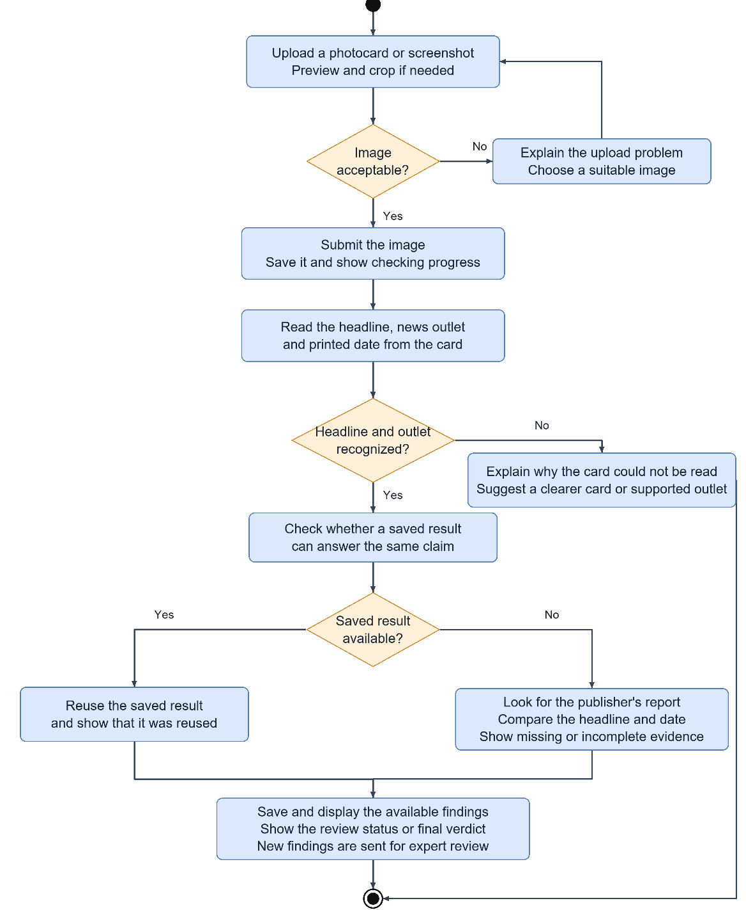
Figure 2.3: Activity Diagram — Photo Card Verification
The user uploads only the card image. The system reads the headline, the outlet and the printed date from the card. If the headline or a known outlet cannot be recognised, the user is told why. Otherwise the card is checked in the same way as a text claim and the findings go to expert review.

2.4 Text & Image (Multimodal) Verification
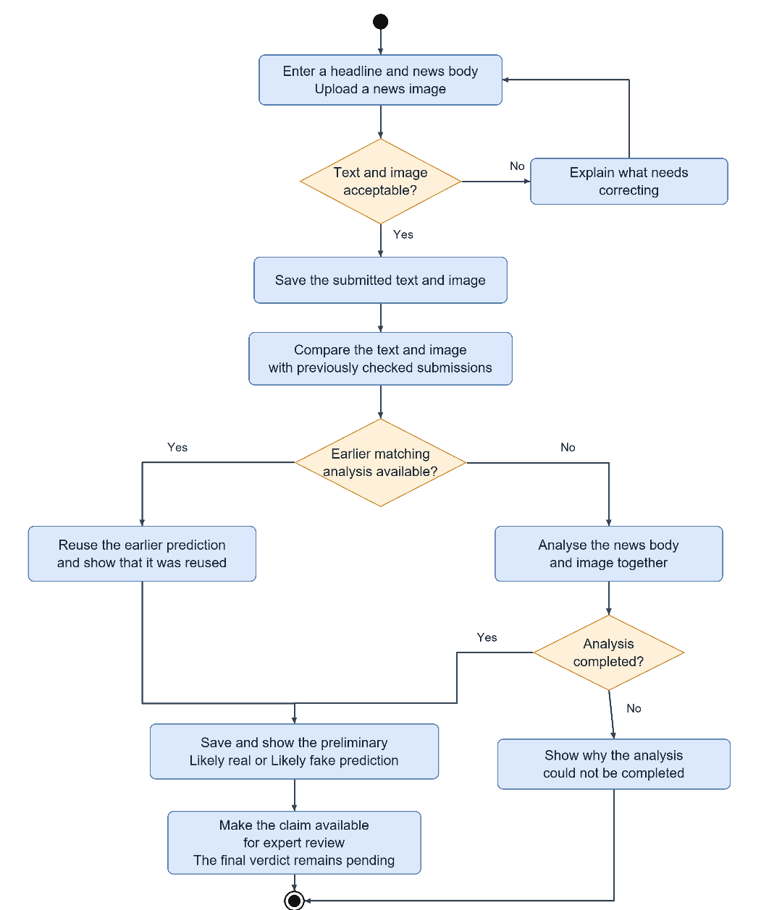
Figure 2.4: Activity Diagram — Text & Image Verification
The user enters a headline and the news text and uploads the news image. The system first compares the text and image with earlier submissions. A close match reuses the earlier prediction. Otherwise the model analyses the text and image together and saves a preliminary Likely Real or Likely Fake prediction. The claim then waits for expert review.

2.5 Expert Review and Voting
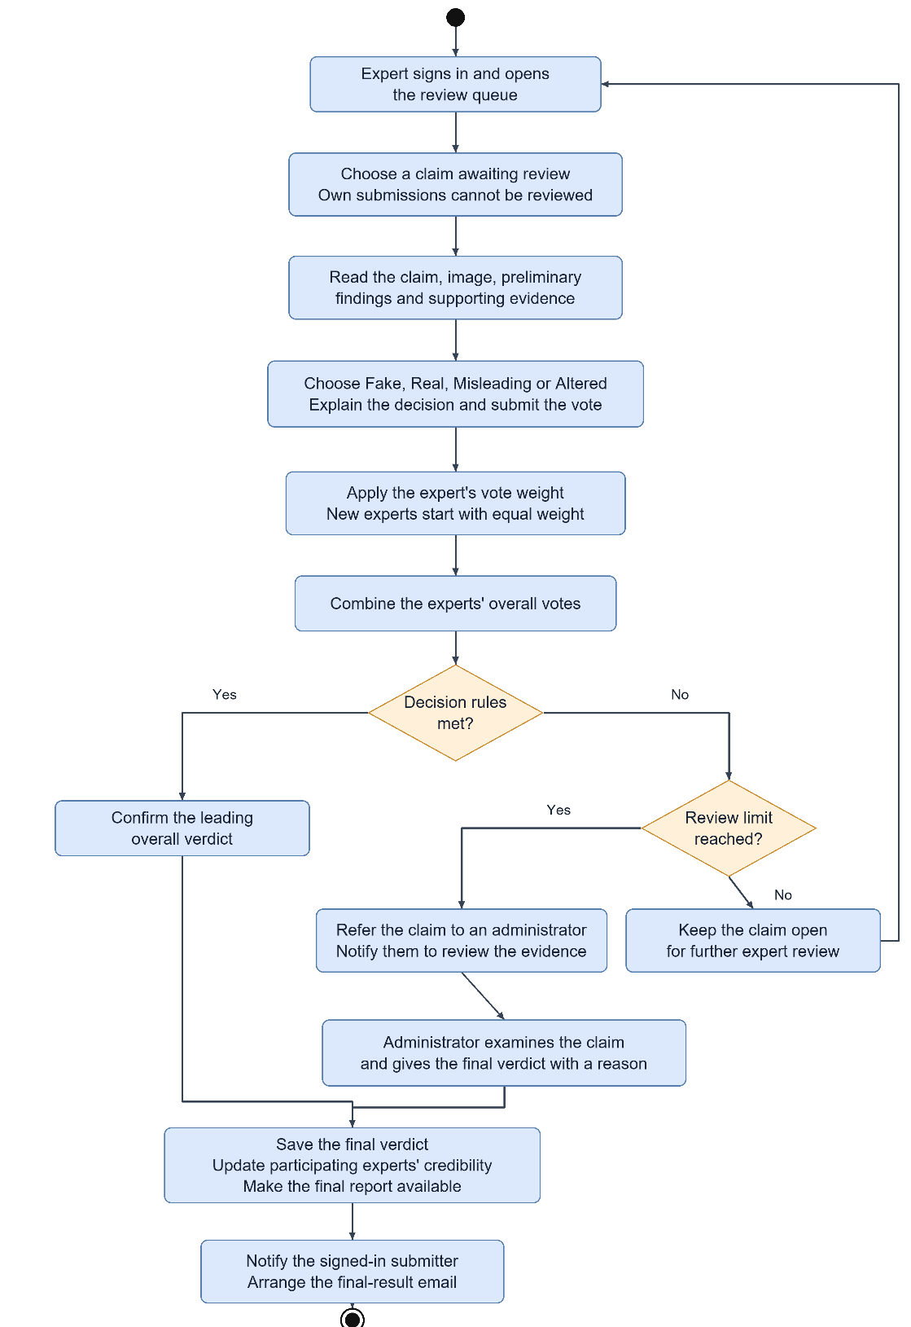
Figure 2.5: Activity Diagram — Expert Review and Voting
An expert opens the queue, chooses a claim (never his or her own), reads the evidence and votes Fake, Real, Misleading or Altered with a justification. The system applies the expert's vote weight and combines the votes. If the decision rules are met, the leading verdict becomes final. If a review limit is reached without agreement, an administrator decides. The final verdict is saved, expert credibility is updated and the submitter is notified.

2.6 Browser Extension
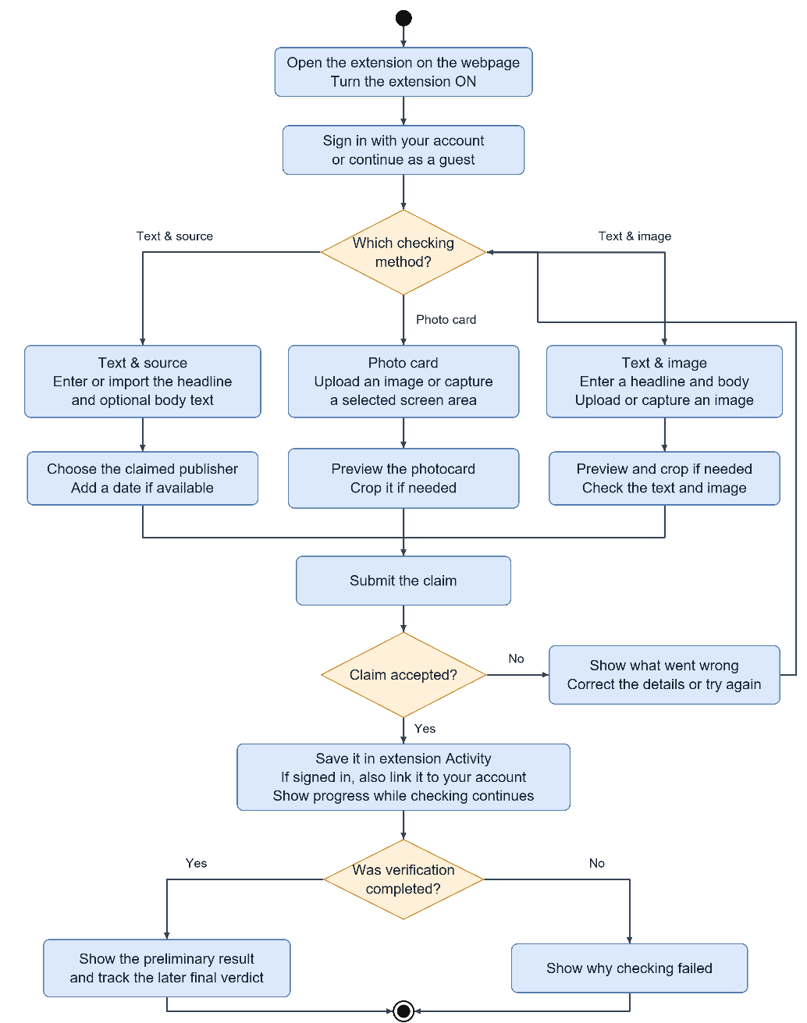
Figure 2.6: Activity Diagram — Browser Extension
The user opens the side panel, signs in or continues as a guest and chooses a method. Text can be typed or imported from the page; images can be uploaded or captured from a selected screen area and cropped. After submission the claim is saved in Activity and the panel shows progress, the preliminary result and, later, the final verdict or the reason the check failed.

2.7 Fact Explorer
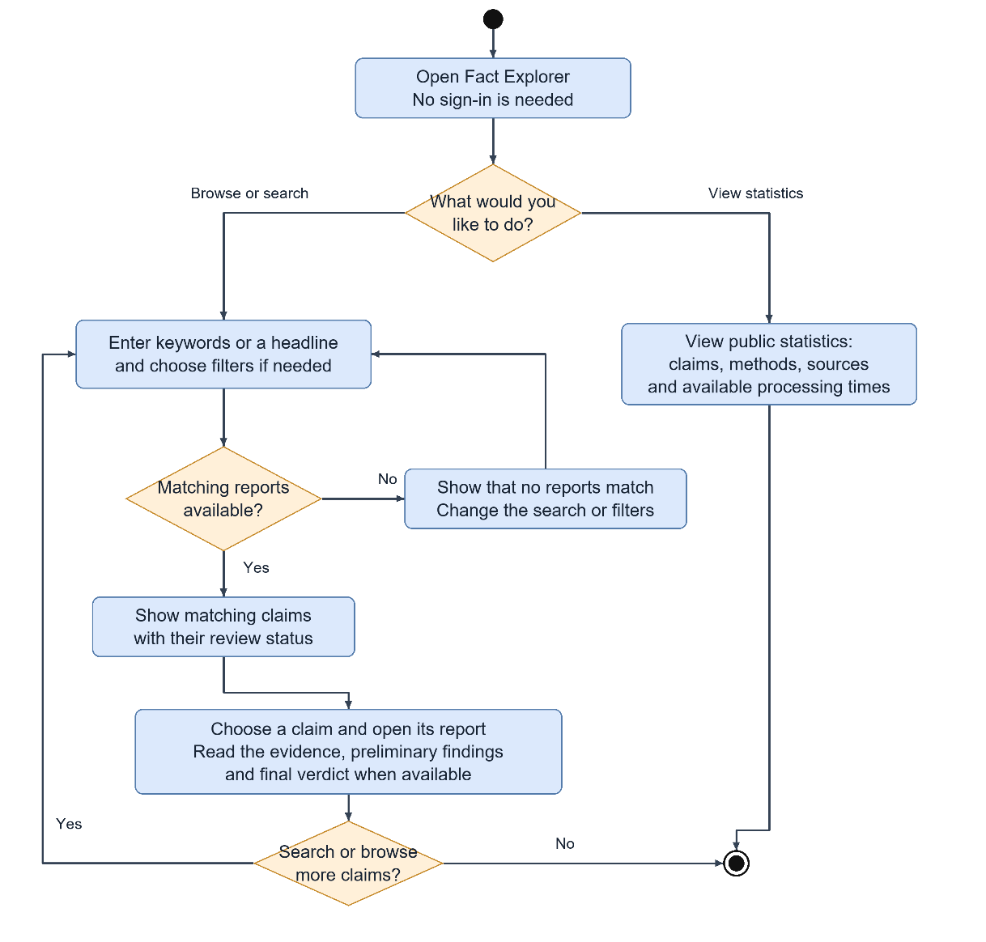
Figure 2.7: Activity Diagram — Fact Explorer
Anyone can open the Fact Explorer without signing in. The user searches by keyword or headline and applies filters or views the public statistics. Matching claims are shown with their review status and the user can open a full report to read the evidence and the final verdict when available.

3. Data-Based Modeling and Dataset Description

3.1 Entity-Relationship Diagram
The ER diagram in Figure 3.1 shows the core entities of BanglaFactGuard and how they are related. User is specialised into RegisteredUser, Expert and Administrator. Submission is the centre of the model; every check, its evidence, its result and its expert reviews belong to one submission.
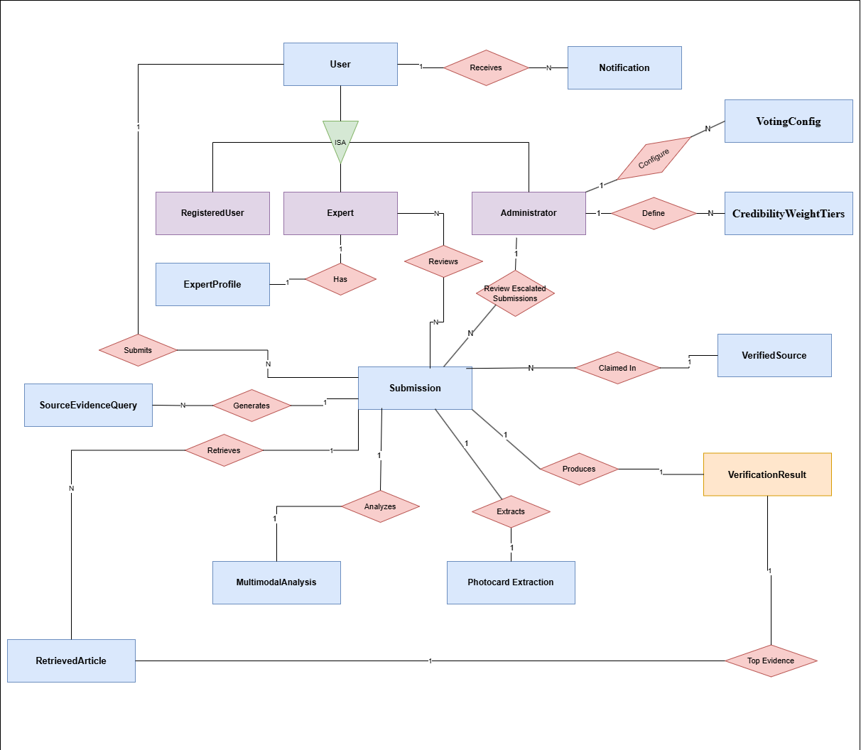
Figure 3.1: Entity-Relationship Diagram — BanglaFactGuard

3.2 Main Entities and Relationships
The main relationships are:
- A User submits many Submissions and receives many Notifications (1:N).
- An Expert has one ExpertProfile (1:1) and reviews many Submissions; a Submission is reviewed by many Experts (M:N, stored as ExpertReview records).
- An Administrator configures the VotingConfig, defines CredibilityWeightTiers and reviews escalated Submissions.
- Each Submission claims one VerifiedSource; one source can be claimed by many Submissions (N:1).
- A Submission generates many SourceEvidenceQueries and retrieves many RetrievedArticles (1:N).
- A Submission has at most one MultimodalAnalysis, one PhotocardExtraction and one VerificationResult (1:1); a VerificationResult points to one RetrievedArticle as its top evidence.
Table 3.1 summarises the main tables that implement these entities. The system also uses supporting tables for tokens, the job queue and result delivery (Section 6.3).
Table 3.1: Main Entities and Their Key Attributes
Entity (table) | Purpose | Key attributes
User (users) | Account of every signed-in person | email, hashed_password, full_name, role, is_active, total_submissions
ExpertProfile (expert_profiles) | Expert details and accuracy record | user_id, area_of_expertise, credential_notes, credibility_score, total_votes, correct_votes, completed_reviews_count, is_active
VerifiedSource (verified_sources) | Registered Bangla news outlet | canonical_name, display_name, display_name_en, aliases, base_url, rss_url, language, search_language, internal_search_url, body_selectors, title_selectors, date_selectors, article_url_patterns, js_rendered, description, is_active
Submission (submissions) | One submitted claim | submitter_id, submission_type, headline, body_text, claimed_source_text, claimed_source_id, published_date, content_hash, duplicate_of_submission_id, status, processing_phase, failure_reason, is_published, view_count, escalated_at
RetrievedArticle (retrieved_articles) | Article fetched as evidence | submission_id, url, url_hash, title, body, author, published_date, extraction_method, extraction_success, rank_score, retrieved_at
SourceEvidenceQuery (source_evidence_queries) | Search query that was run | submission_id, query_type, query_text, search_provider, results_count, executed_at
VerificationResult (verification_results) | Automated findings and final verdict | submission_id, source_status, content_status, date_status, headline_check_status, headline_exact_match, body_comparison_status, top_article_id, headline_similarity, headline_keyword_coverage, passage_keyword_coverage, claim_scope, pipeline_version, analysis_details, overall_verdict, finalized_at, reused_from_submission_id
PhotocardExtraction (photocard_extractions) | What Gemini read from a card | submission_id, image_object_key, status, failure_code, model_version, attempts, extraction_details
MultimodalAnalysis (multimodal_analysis) | Text & image prediction | submission_id, image_object_key, prediction, confidence_fake, confidence_real, text_embedding, image_embedding, combined_embedding, model_version, expert_overall_verdict, finalized_at,
ExpertReview (expert_reviews) | One expert or admin vote | submission_id, reviewer_id, ai_overall_verdict, ai_source_status, ai_content_status, ai_date_status, vote_overall_verdict, vote_source_status, vote_content_status, vote_date_status, justification, credibility_weight, applied_weight_tier_id, status, is_admin_decision
VotingConfig | Voting rules set by the admin | min_expert_votes, activation_threshold_votes, verified_threshold, lead_margin, max_review_votes, max_review_hours
CredibilityWeightTier | Experts Credibility weight tier | label, min_accuracy_pct, max_accuracy_pct, weight, is_active
Notification (notifications) | In-app message or Gmail | user_id, title, body, notification_type, link_url, is_read

3.3 Dataset Description
The AI model is trained on MultiBanFakeDetect, a Bangla multimodal fake-news dataset [1]. Each instance pairs a news headline and description with an image and a label: non-fake or one of three fake types (misinformation, rumor or clickbait). The news comes from online forums, news websites and social media and covers topics such as politics, sports, technology, national news, entertainment, education, international news, crime and business.
The dataset is balanced between fake and non-fake items and is split by stratified sampling into training, validation and test sets in an 80/10/10 ratio. Several trained annotators labelled each item and agreement was checked with Cohen's and Fleiss' Kappa. BanglaFactGuard uses the two-class form of the labels (Real = 0, Fake = 1).
Table 3.2: Dataset Split Summary (Text–Image Pairs)
Subset | Instances | Class balance
Training | 7,680 | Stratified across the label classes
Validation | 960 | Stratified across the label classes
Testing | 960 | 480 Real and 480 Fake (as recorded in the evaluation run)
Total | 9,600 | 4,800 fake and 4,800 non-fake

The Text & source and Photo card methods do not use a training dataset. They use pretrained language models and live articles from the registered Bangla news outlets (ten active outlets in the demonstration database).

4. Class-Based Modeling
Class-based modeling identifies the main analysis classes of the problem domain, their responsibilities and the classes they work with. Figure 4.1 shows these classes with their main attributes and operations and Table 4.1 gives their responsibilities and collaborators in CRC form. Chapter 6 refines these analysis classes into design classes.
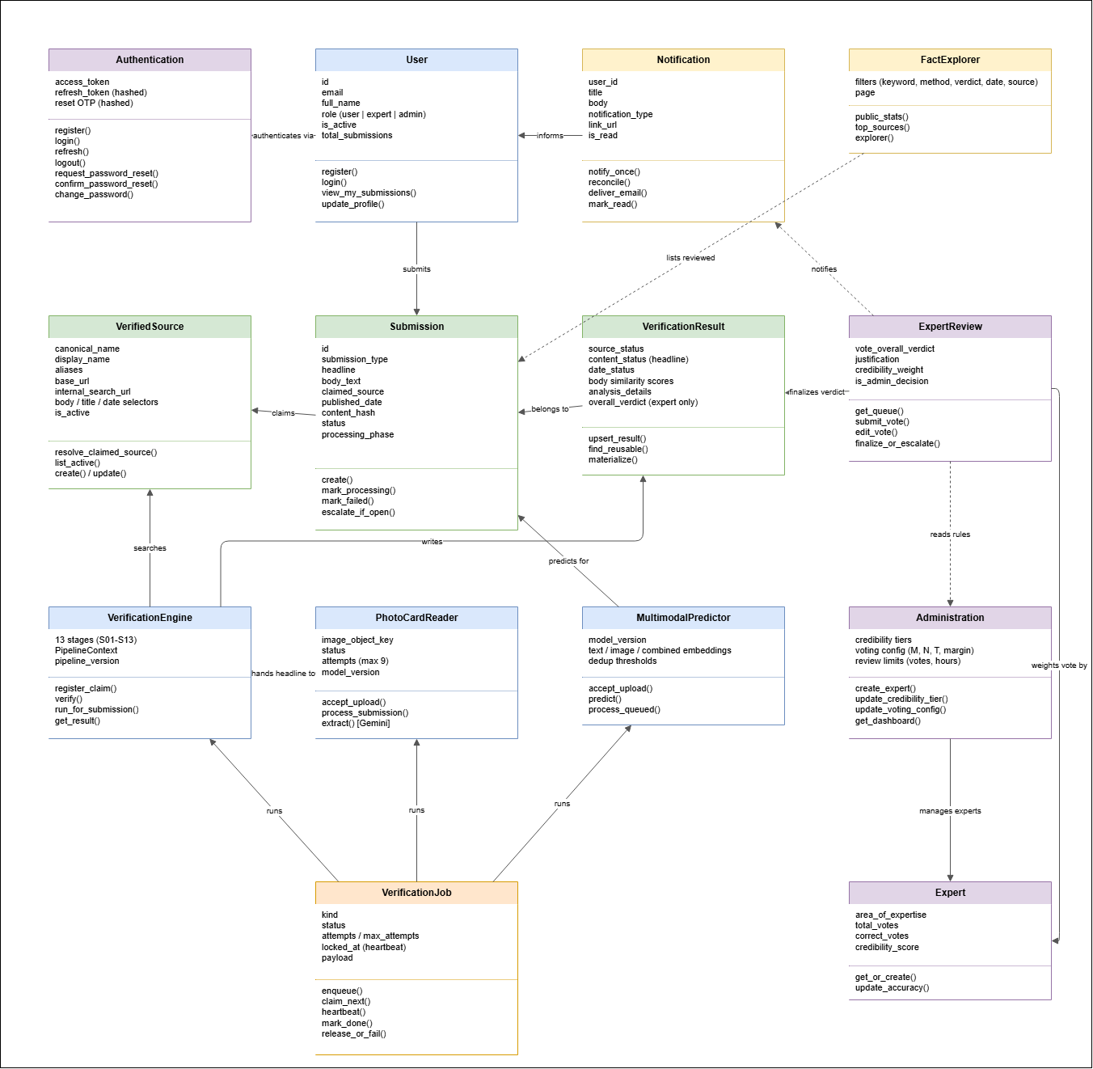
Figure 4.1: Analysis Class Diagram (CRC View)
Table 4.1: Class Responsibilities and Collaborators
Class | Responsibilities | Collaborators
User | Registers, signs in, views own submissions, updates profile | Authentication, Submission, Notification
Authentication | Issues and refreshes tokens, signs out, resets passwords with OTP | User
Submission | Holds a claim and its status and phase; marks processing, failure and escalation | VerifiedSource, VerificationResult, ExpertReview
VerifiedSource | Resolves a claimed outlet and lists active sources | Submission, VerificationEngine
VerificationEngine | Runs the 13-stage source check and returns findings | Submission, VerifiedSource, VerificationResult
PhotoCardReader | Accepts a card, reads it with Gemini and hands the headline to the engine | VerificationEngine, Submission
MultimodalPredictor | Accepts a text and image, predicts, detects duplicates | Submission
VerificationJob | Queues, claims, heartbeats, completes or fails background work | VerificationEngine, PhotoCardReader, MultimodalPredictor
VerificationResult | Stores findings; finds and copies reusable results | Submission, ExpertReview
ExpertReview | Builds the queue, records votes, finalizes or escalates | Expert, Administration, Notification
Expert | Keeps accuracy and credibility | ExpertReview, Administration
Administration | Manages experts, tiers, voting rules and the dashboard | Expert, ExpertReview
Notification | Sends each notification once, delivers email, marks read | User, ExpertReview
FactExplorer | Lists reviewed claims, statistics and top sources | Submission

5. AI Engineering Design
BanglaFactGuard uses AI in two places described in this chapter: the multimodal model behind Text & image verification and the source-based verification pipeline behind Text & source verification. Both give preliminary findings only; the final verdict always comes from human reviewers.

5.1 Multimodal Verification Model

5.1.1 Model Architecture
Figure 5.1 shows the multimodal design from the SRS. The news text is encoded by BanglaBERT and the news image by EfficientNet-B4. The two feature vectors are joined (early fusion) and passed through fully connected layers that output Real or Fake.
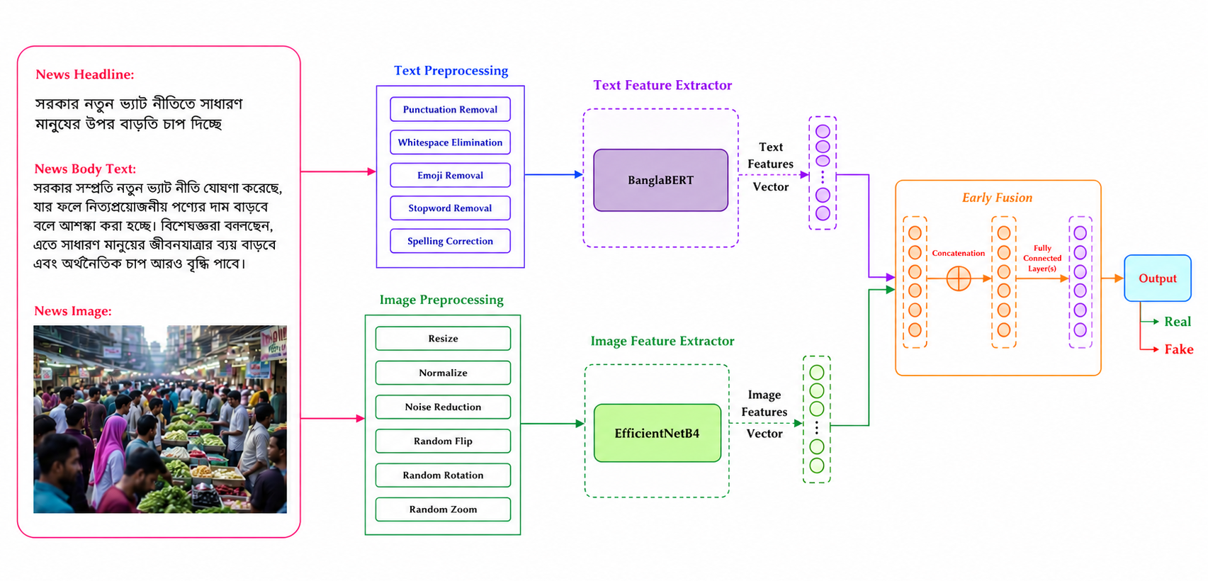
Figure 5.1: Multimodal Verification Architecture — Text and Image Fusion
In the implemented model (MultiFusionFake), BanglaBERT gives the 768-value [CLS] vector of the body text (up to 128 tokens) and EfficientNet-B4 gives a 1,792-value image vector (images resized to 380 × 380 and normalised). The joined 2,560-value vector is normalised and passed through two hidden layers (1,024 and 512 units, GELU, dropout 0.4) to two outputs. The figure also shows the cleaning and augmentation steps of the design; at prediction time the service applies tokenisation, resizing and normalisation. The headline is stored for display, while the body text is the model's text input.
Table 5.1: Multimodal Model Configuration
Item | Value
Text encoder | csebuetnlp/banglabert, [CLS] vector (768)
Image encoder | EfficientNet-B4 (timm), average pooled (1,792)
Fusion and classifier | Concatenation (2,560) → LayerNorm → 1,024 → 512 → 2
Training | 35 epochs, learning rate 2e-4, weight decay 0.01, batch size 6, label smoothing 0.1, 3 warm-up epochs
Output | FAKE or NON_FAKE with confidence values, shown as Likely Fake or Likely Real

5.1.2 Recorded Evaluation
The training notebook records the results in Table 5.2. The best validation accuracy during training was 82.92%.
Table 5.2: Recorded Test Results of the Multimodal Model (960 test items)
Class | Precision | Recall | F1-score | Support
Real (0) | 0.79 | 0.81 | 0.80 | 480
Fake (1) | 0.81 | 0.79 | 0.80 | 480
Weighted average | 0.80 | 0.80 | 0.80 | 960
Accuracy |  |  | 0.80 | 960

5.2 Source-Based Verification Pipeline
Text and verified sources based verification runs a 13-stage pipeline (S01–S13), shown in Figure 5.2. A single context object is passed through every stage.
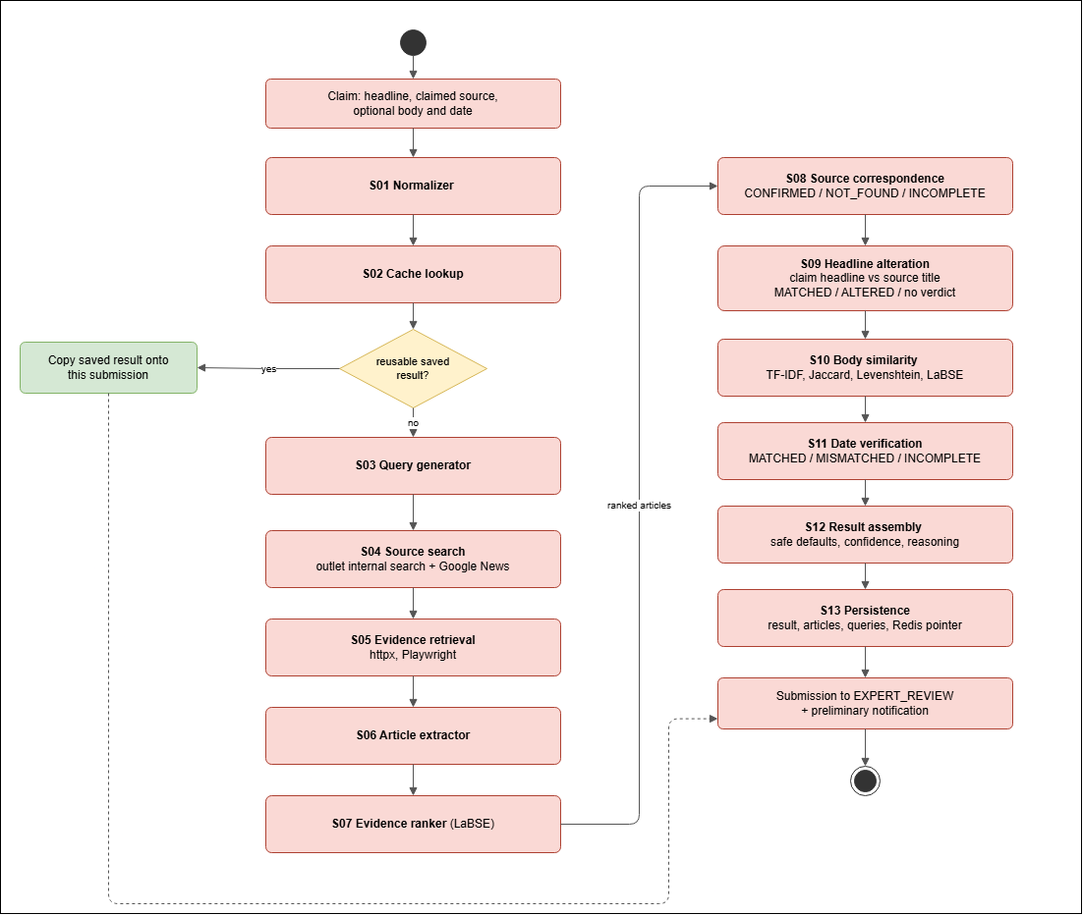
Figure 5.2: Source-Based Verification Pipeline — Stages S01 to S13
Table 5.3: Source-Based Verification Pipeline — Stage Reference
Stage | What it does
S01 Normalizer | Cleans the Bangla text, resolves the claimed outlet and builds the claim identity (hash).
S02 Cache lookup | Reuses a complete saved result for the same claim and pipeline version.
S03 Query generator | Builds up to six outlet-restricted queries from the headline and its keywords (dated variants when a date is given).
S04 Source search | Runs the outlet's own site search and Google News and rejects off-source results.
S05 Evidence retrieval | Fetches pages with httpx and uses Playwright for JavaScript pages.
S06 Article extractor | Extracts title, body and date with outlet selectors and general extractors.
S07 Evidence ranker | Ranks candidates with LaBSE similarity and keyword, date and domain signals; re-ranks with a cross-encoder when more than three remain.
S08 Source correspondence | Decides Confirmed, Not Found or Incomplete and selects the source article.
S09 Headline alteration | Compares the claim headline with the source title only: exact match, rule checks and NLI + LaBSE; Matched, Altered or no verdict.
S10 Body similarity | TF-IDF cosine, Jaccard, normalised Levenshtein and LaBSE cosine (only when a body is given).
S11 Date verification | Compares the claimed date with the article's date (Asia/Dhaka calendar).
S12 Result assembly | Builds the result, reasoning and analysis details; never an overall verdict.
S13 Persistence | Saves the result, articles and queries, sets the Redis pointer and notifies the submitter once.

Headline alteration uses deterministic rules for material changes, such as different numbers, dates, negation, attribution, subject–object roles and named entities. A rule-detected change gives Altered. A Matched result needs positive evidence that the meaning is the same; when neither can be shown, the result gives no verdict and states the reason. The body-similarity scores are measurements only and are never used as a verdict.

5.3 Model Selection
Table 5.4 lists the models used and why each was chosen. Cheap, cacheable models are used widely and the more expensive cross-encoders run only on a few selected pairs.
Table 5.4: AI Model Selection Summary
Model | Used in | Reason
BanglaBERT | Text & image (text encoder) | Pretrained on Bangla; understands Bangla vocabulary and grammar.
EfficientNet-B4 | Text & image (image encoder) | Good accuracy for its computing cost.
LaBSE (sentence-transformers) | S07–S10 | Multilingual sentence embeddings that cover Bangla; embeddings are cached by text hash.
mMARCO MiniLM cross-encoder | S07 re-ranking | More precise ranking of claim–article pairs; used only when more than three candidates remain.
mDeBERTa-v3 NLI (MNLI/XNLI) | S09 | Detects entailment and contradiction between the headline and the source title in both directions.
BanglaTag NER | S09 entity checks | Bangla named-entity model used to spot changed persons, places and organisations.

5.4 Responsible Use of AI
- Automated output is always labelled preliminary; the overall verdict field stays empty until experts or an administrator finalize it.
- A source that was not found is not evidence of fake news and an incomplete search is never shown as a confident negative.
- Model limits are stated openly: the NLI model was not trained on Bangla, the NER model passed only a label and smoke check and the similarity thresholds are hand-set without a labelled Bangla benchmark. The pipeline tests use deterministic fakes and prove the logic, not model accuracy.

6. Component-Level Design
This chapter refines the analysis models into components, design classes, data stores, behaviour and deployment. Every name used here exists in the source code.

6.1 Component Diagram
Figure 6.1 shows the main components. Two clients, the Angular website and the extension, call one FastAPI backend. Inside the backend, feature modules handle requests, background workers run long work and shared services wrap the models, storage and cache. PostgreSQL, Redis and MinIO hold the data.
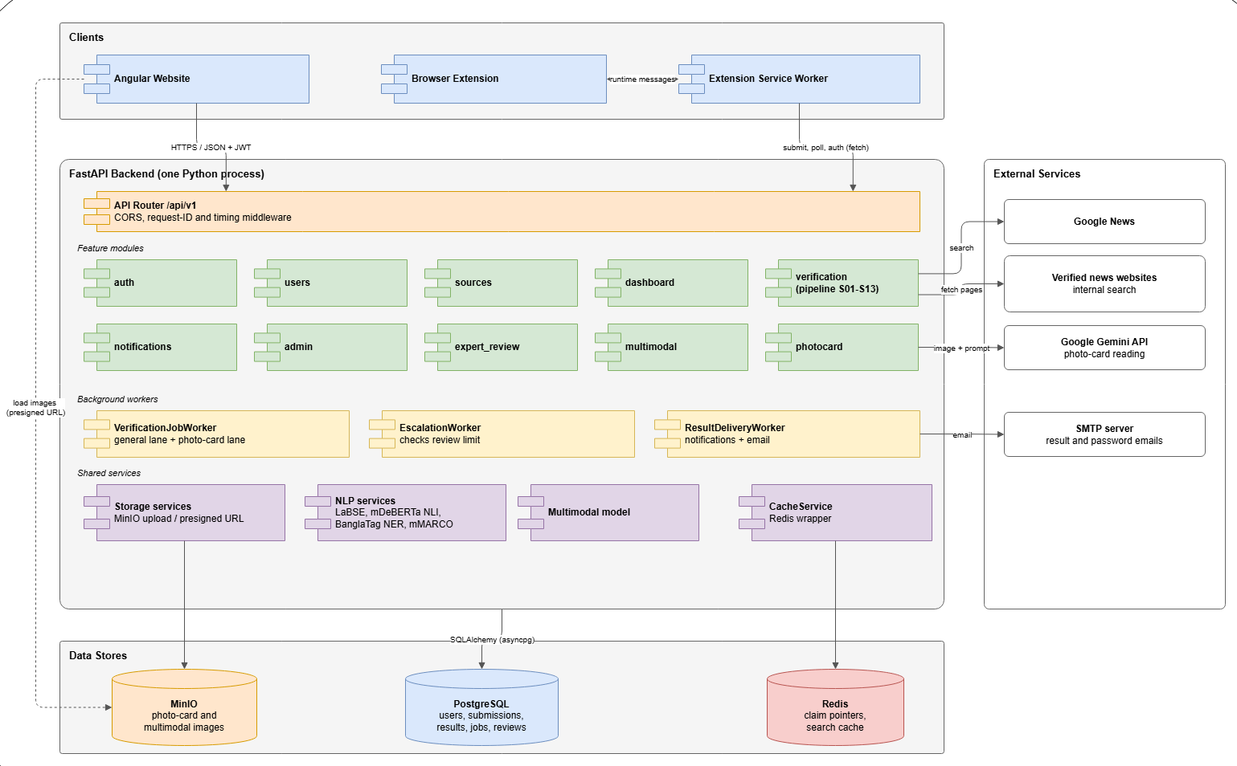
Figure 6.1: Component Diagram of BanglaFactGuard
Table 6.1: Main Components and Their Responsibilities
Component | Responsibility
Angular website | Public pages, claim forms, result reports, history, notifications, expert and admin workspaces.
Browser extension + service worker | Side panel for submission; the worker submits, polls, stores activity and raises alerts.
API router (/api/v1) | Routes requests; adds CORS, request ID and timing middleware.
auth, users | Registration, login, token refresh, OTP reset, profile and own submissions.
verification | Text & source claims and the S01–S13 pipeline.
photocard | Accepts card images, reads them with Gemini and runs the pipeline.
multimodal | Accepts text and image, detects duplicates and predicts.
expert_review | Queue, votes, weighted tally, finalization and escalation.
admin, sources | Experts, verified sources, tiers, voting configuration and dashboard.
dashboard, notifications | Fact Explorer data and statistics; in-app notifications.
VerificationJobWorker | Drains the durable job queue in two lanes (general and photo card).
EscalationWorker | Every 60 s, escalates claims that reached a review limit.
ResultDeliveryWorker | Every 15 s, delivers result notifications and final-result emails.
Shared services | MinIO storage, NLP services, multimodal model and Redis CacheService.

6.1.1 Information Flow
A Text & source claim moves through the components as follows:
- The website sends POST /verify/async with the claim and a JWT token (if signed in).
- The verification module resolves the outlet and saves the Submission (PENDING) and its job in one transaction, then returns 202 Accepted with the submission ID.
- The website polls GET /verify/{id}/status every 4 seconds while it stays open.
- VerificationJobWorker claims the job with FOR UPDATE SKIP LOCKED and runs the pipeline.
- The pipeline searches the outlet and Google News, fetches and ranks articles and decides each finding with the NLP services.
- S13 saves the result, sets the status to EXPERT_REVIEW and creates a preliminary notification.
- Experts vote through the expert_review module; when the rules pass, the verdict is saved and ResultDeliveryWorker notifies and emails the submitter.

6.2 Design Classes
Figure 6.2 shows the design classes that implement the problem domain and Table 6.2 maps each domain concept to its class.
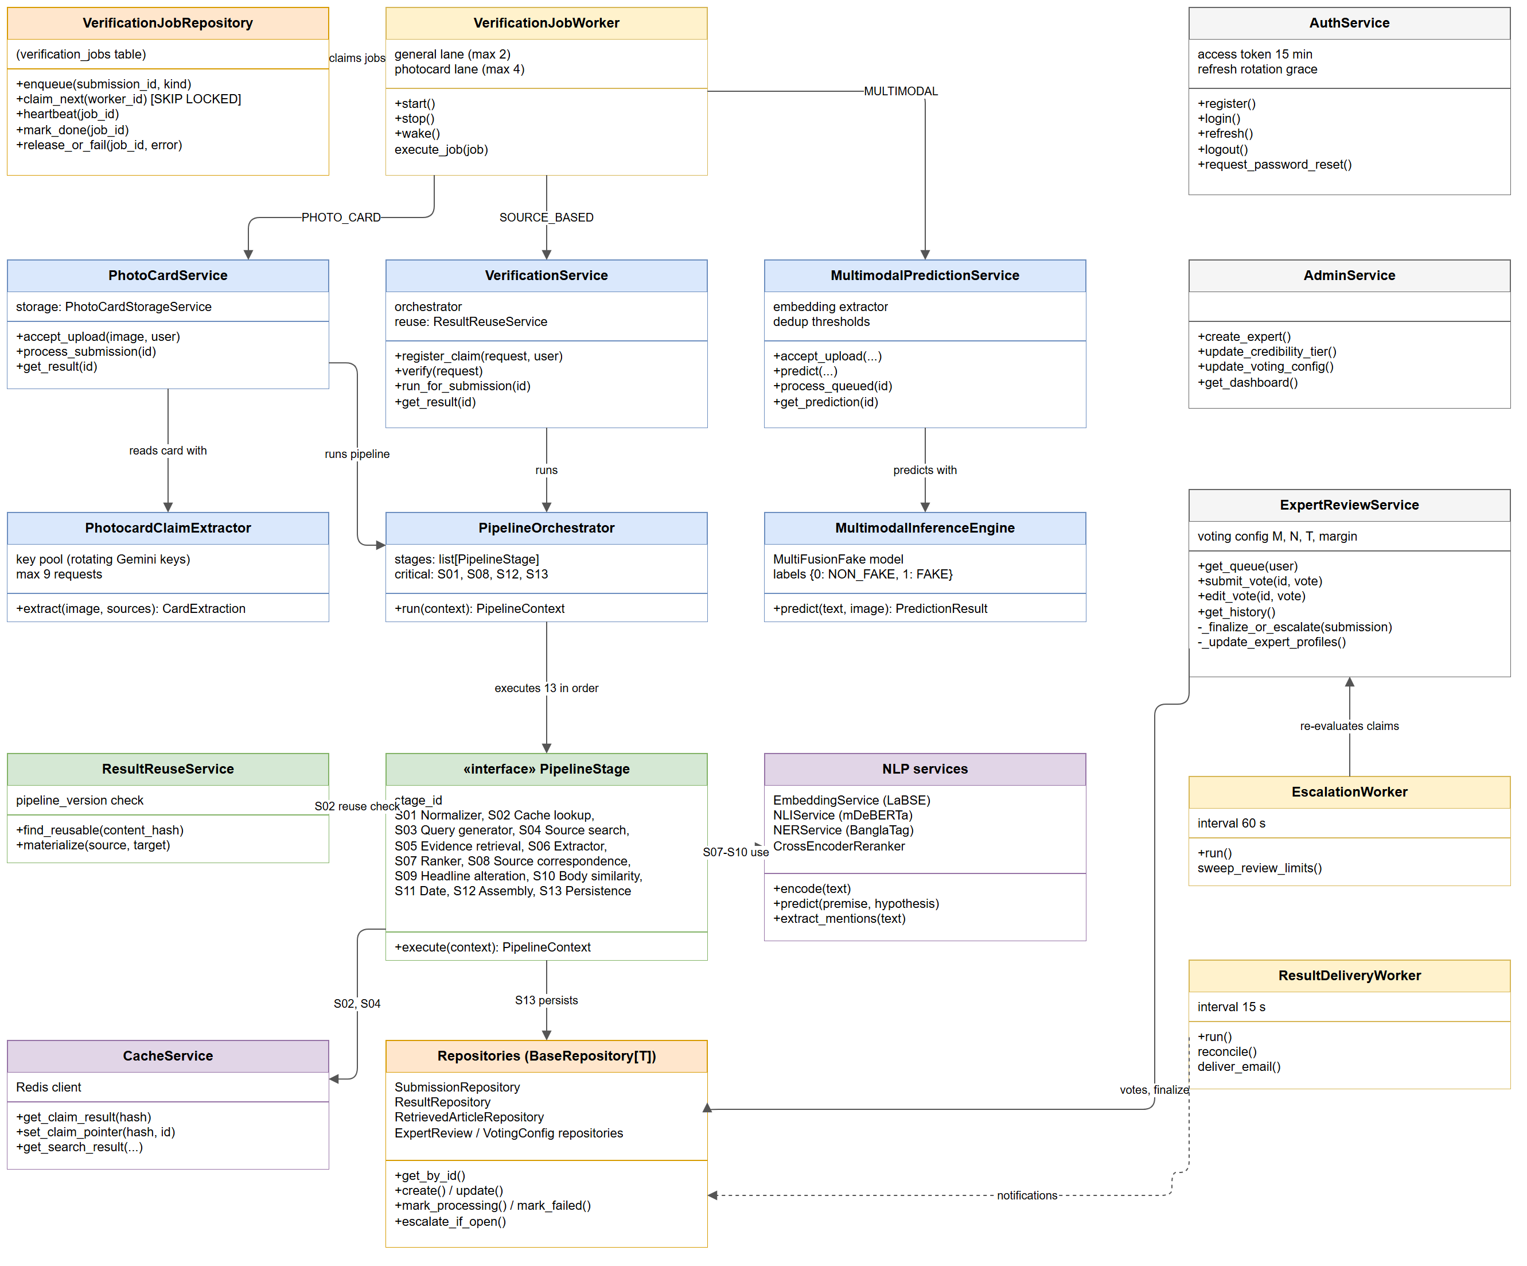
Figure 6.2: Design Class Diagram
Table 6.2: Design Classes and Domain Concepts
Domain concept | Design class | Main operations
Claim checking | VerificationService, PipelineOrchestrator, PipelineStage (S01–S13) | register_claim(), run_for_submission(), run(context), execute(context)
Photo card | PhotoCardService, PhotocardClaimExtractor | accept_upload(), process_submission(), extract(image, sources)
Text & image | MultimodalPredictionService, MultimodalInferenceEngine | accept_upload(), predict(text, image)
Background work | VerificationJobRepository, VerificationJobWorker | enqueue(), claim_next(), heartbeat(), mark_done()
Result reuse | ResultReuseService, CacheService | find_reusable(), materialize(), get_claim_result()
Expert voting | ExpertReviewService, EscalationWorker | submit_vote(), _finalize_or_escalate(), sweep_review_limits()
Accounts and admin | AuthService, AdminService | login(), refresh(), create_expert(), update_voting_config()
Notifications | notify_once(), ResultDeliveryWorker | reconcile(), deliver_email()
Data access | BaseRepository[T] and repositories | get_by_id(), create(), update(), mark_failed(), escalate_if_open()

6.3 Persistent Data Sources
Figure 6.3 shows which backend classes write to which data store and Table 6.3 describes each store.
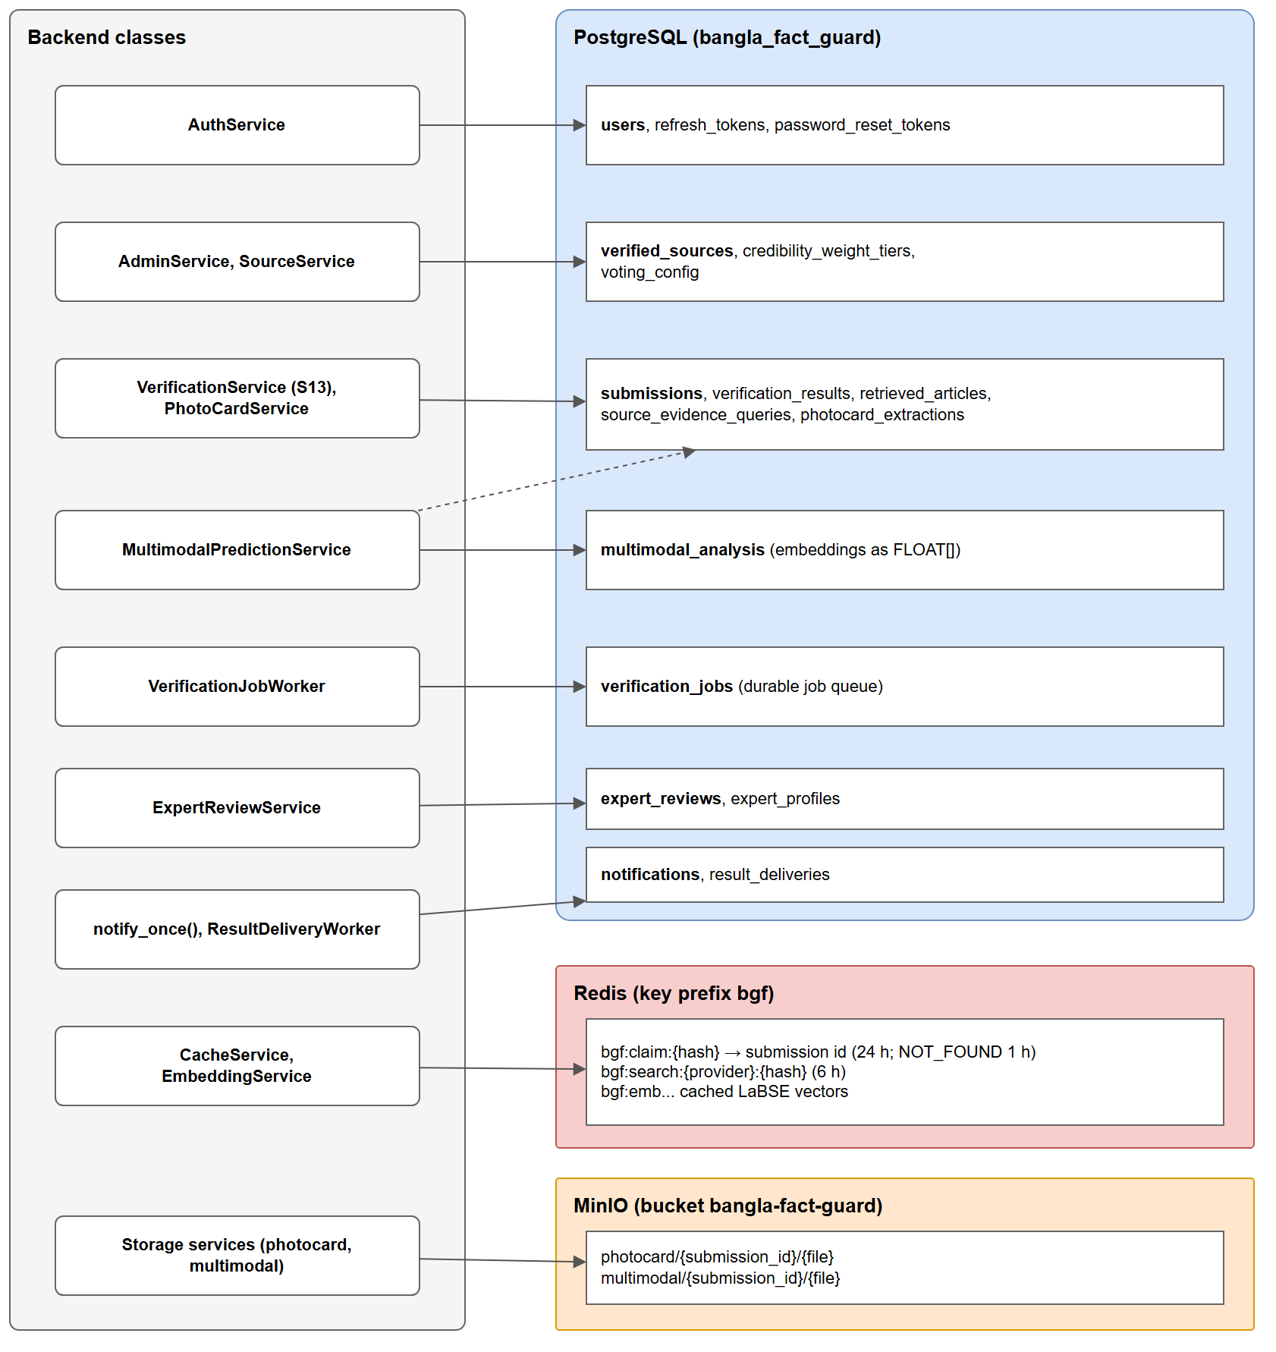
Figure 6.3: Persistent Data Sources and Their Classes
Table 6.3: Persistent Data Sources
Data store | What is stored | Lifetime
PostgreSQL (bangla_fact_guard) | Users, tokens, sources, submissions, results, articles, queries, extractions, analyses, reviews, notifications, the job queue (verification_jobs) and result deliveries | Permanent; migrations managed by Alembic
Redis (key prefix bgf) | Claim pointers to the submission holding a result, search results and LaBSE embeddings | Claim pointer 24 h (Not Found 1 h); search 6 h
MinIO (bucket bangla-fact-guard) | Photo card and multimodal images, served by presigned URLs | Permanent
Browser storage (extension) | Settings, tokens, drafts and account-separated activity | Until cleared or signed out

6.4 Behavioural Design

6.4.1 Submission Lifecycle
Every submission follows the state machine in Figure 6.4. The status is stored in the submissions table and the processing phase shows finer progress.
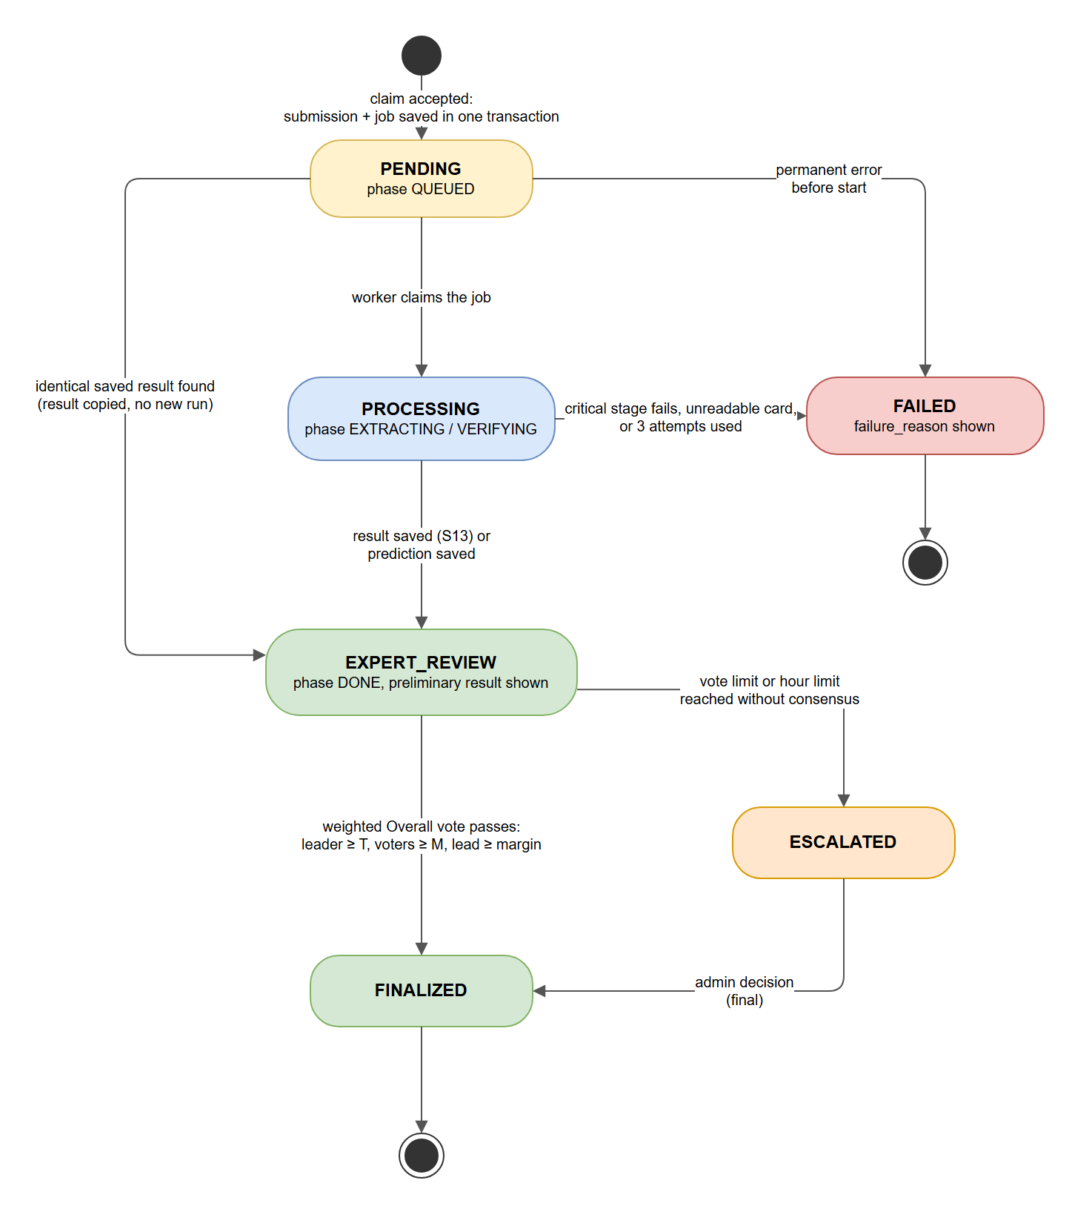
Figure 6.4: State Diagram of a Submission
Table 6.4: Submission States
State | Meaning | Leaves when
PENDING | Claim accepted; job queued (phase QUEUED) | A worker claims the job, a saved result is copied or a permanent error occurs
PROCESSING | Phase EXTRACTING or VERIFYING | The result or prediction is saved or a critical stage fails after up to 3 attempts
EXPERT_REVIEW | Preliminary result shown (phase DONE) | The weighted vote passes or a vote or time limit is reached
ESCALATED | Waiting for an administrator | The administrator submits the final decision
FINALIZED | Final verdict published | End state
FAILED | failure_reason shown to the user | End state

6.4.2 Sequence of a Text & Source Check
Figure 6.5 shows the full sequence from submission to expert vote, including the 4-second polling loop, the worker, the pipeline and the later final notification.

6.4.3 Voting Rules
Each vote is weighted. A new expert's vote has weight 1 until the expert has N completed reviews (the activation threshold); after that the weight comes from the accuracy tier set by the administrator (for example Novice 0.5, Competent 1, Expert 1.5 and Master 2 in the demonstration setup). A claim is finalized only when all of the following hold: there is one clear leading verdict, its weight is at least T, at least M experts voted and it leads the runner-up by the margin. A tie never finalizes. If the maximum number of votes or hours is reached first, the claim is escalated and the administrator's decision is final.

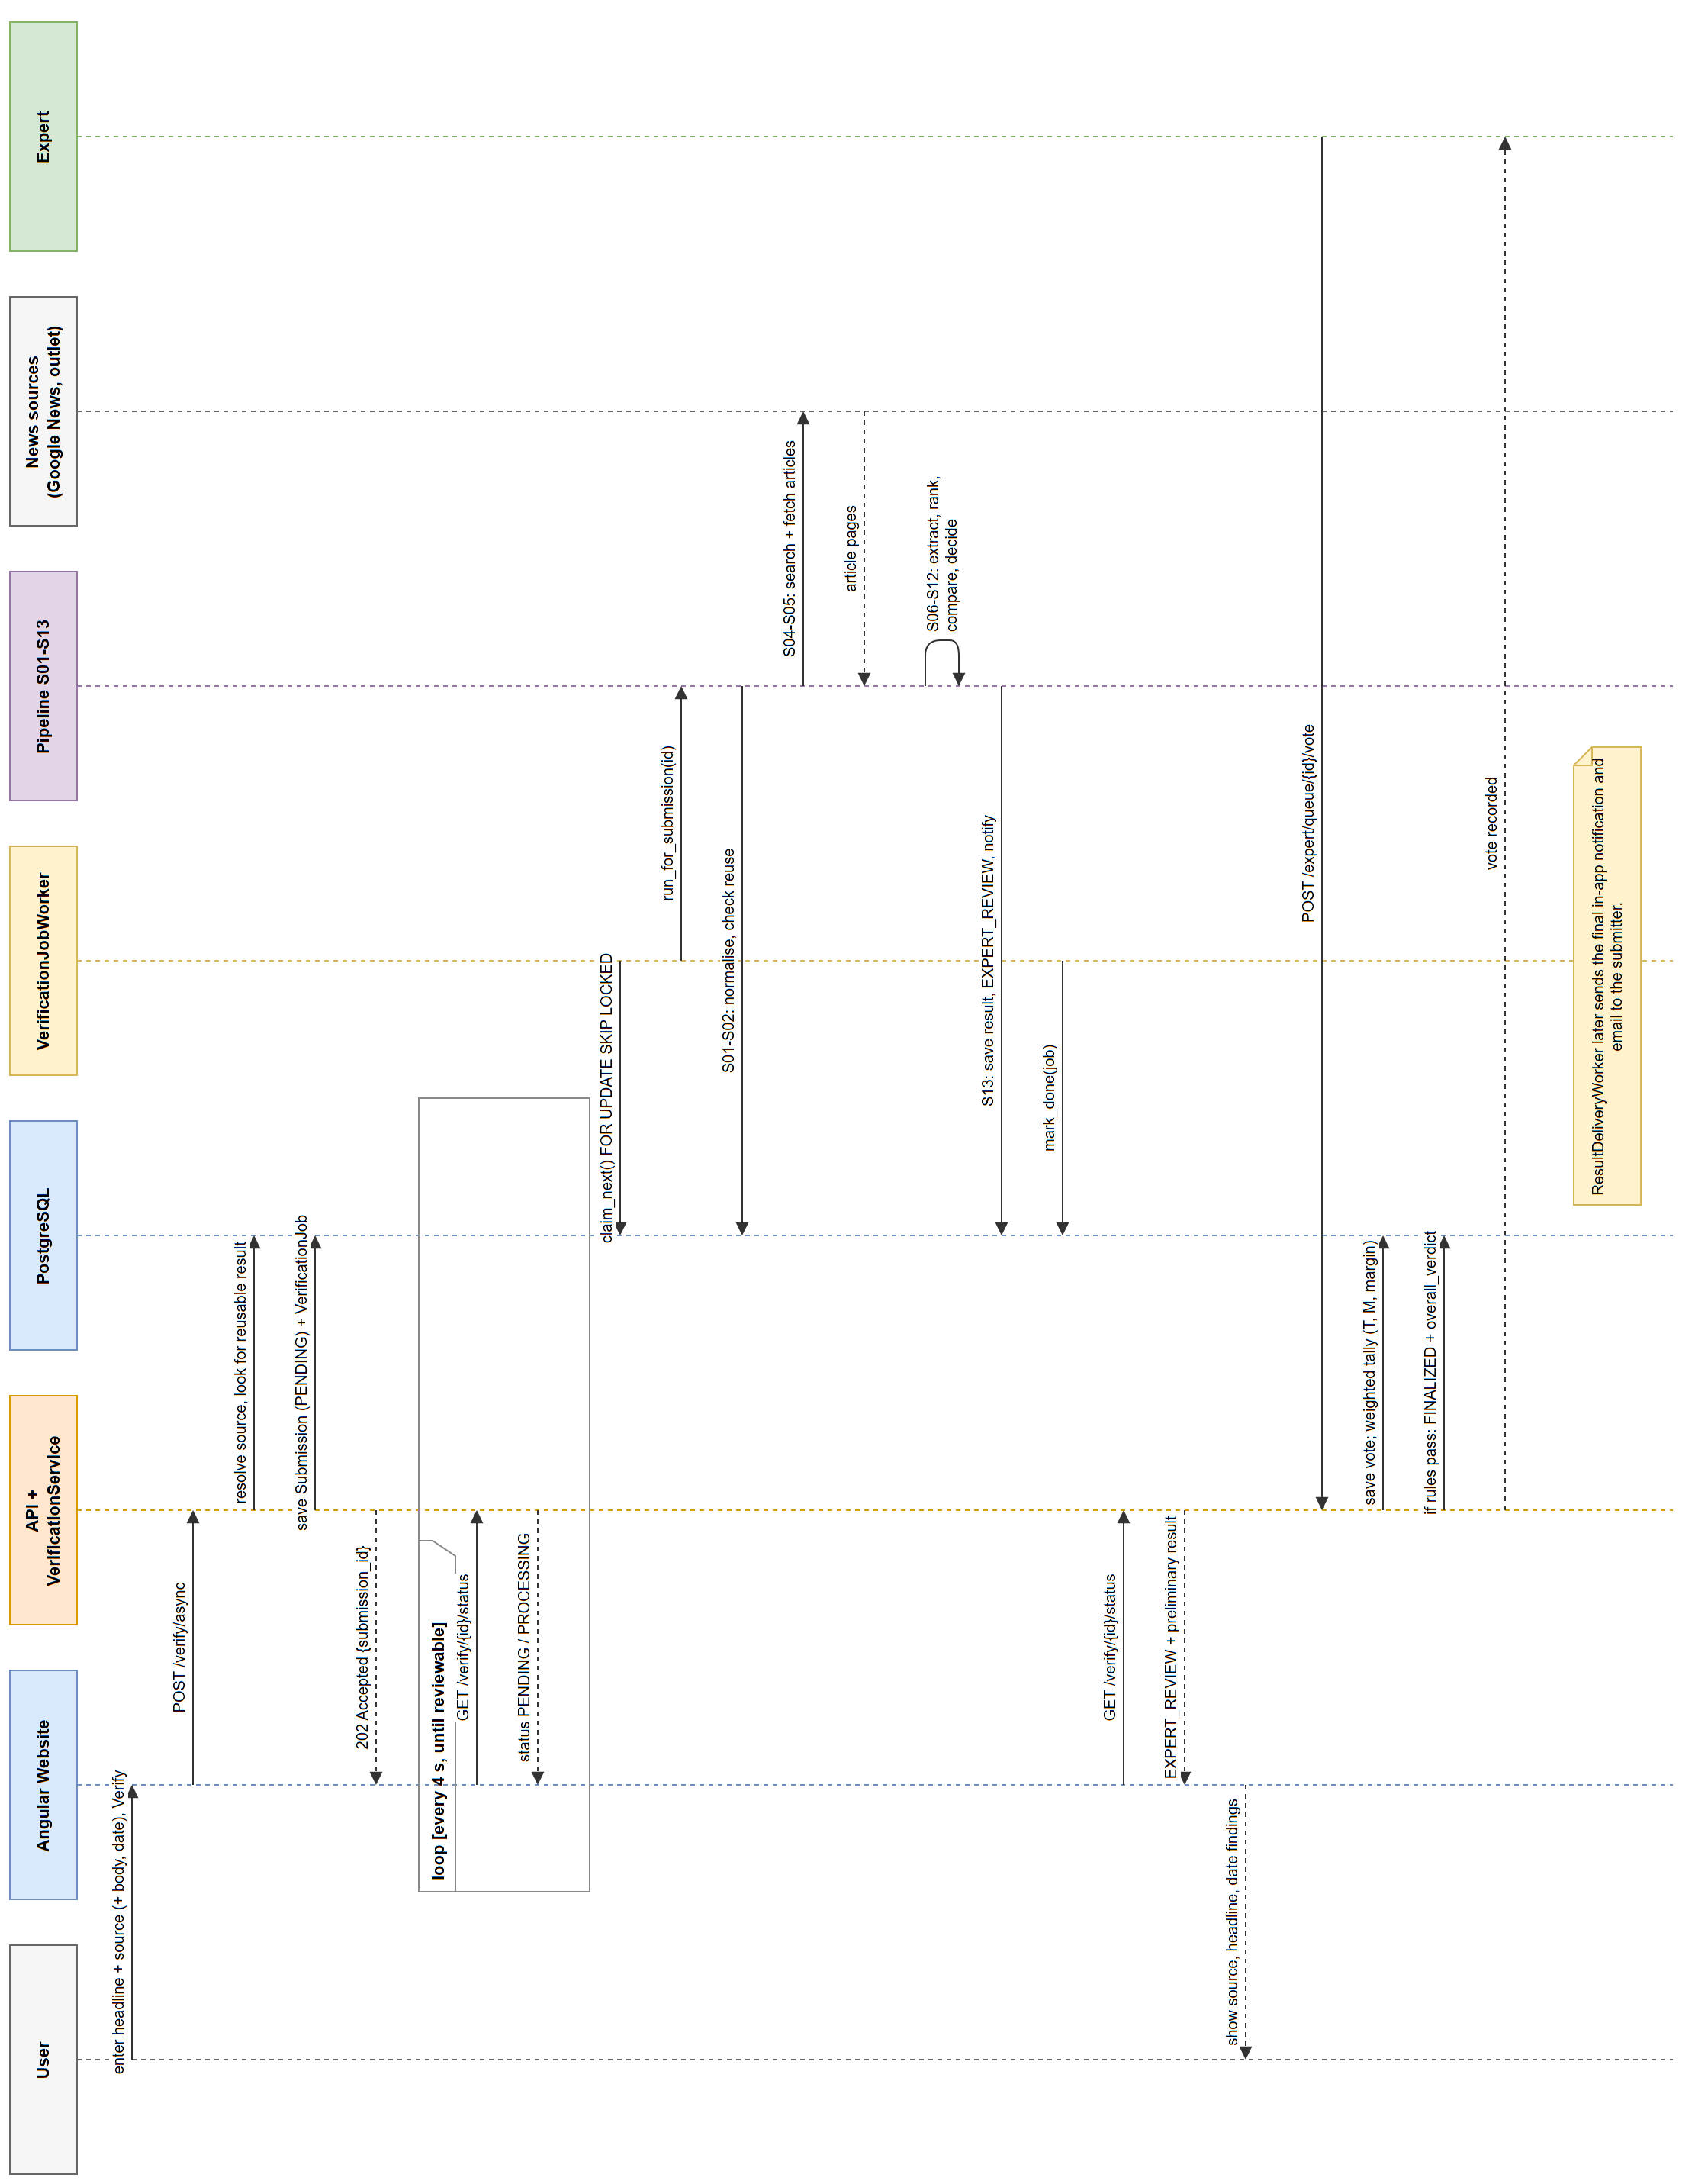
Figure 6.5: Sequence Diagram — Text & Source Claim (rotated to fit the page)

6.5 Deployment Design
Figure 6.6 shows the deployment used for development and the demonstration. The browser loads the website from the Angular development server and calls the FastAPI server. PostgreSQL 17 runs on the host, while Redis and MinIO run in Docker Compose.
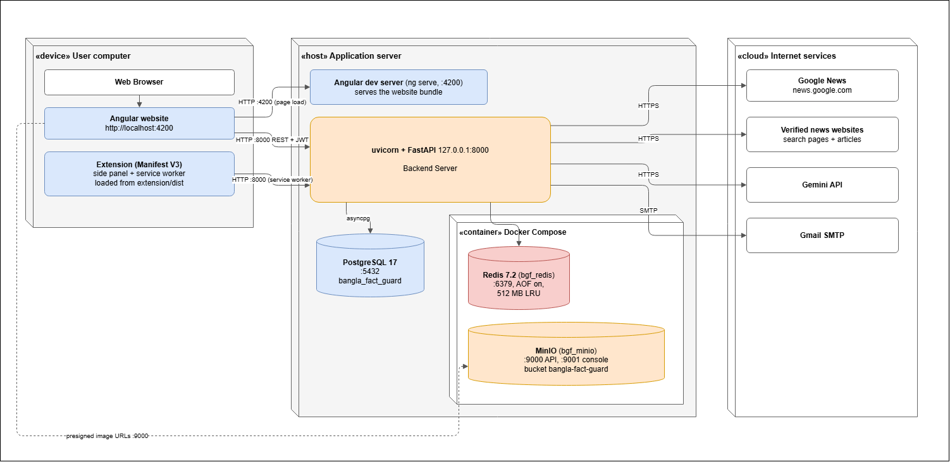
Figure 6.6: Deployment Diagram
Table 6.5: Deployment Nodes
Node | Contents | Notes
User computer | Chrome with the website and the unpacked extension (extension/dist) | Extension calls the API on port 8000
Application server | Angular dev server (:4200); uvicorn + FastAPI (127.0.0.1:8000) with the job, escalation and delivery workers | Workers run inside the API process
PostgreSQL 17 | Database bangla_fact_guard (:5432) | Installed on the host, not in Compose
Docker Compose | Redis 7.2 (:6379, AOF, 512 MB LRU) and MinIO (:9000 API, :9001 console) | Started with docker compose up -d
Internet services | Google News, verified news websites, Gemini API, Gmail SMTP | Reached over HTTPS / SMTP

6.6 Design Alternatives Considered
Each component design was reviewed and refactored during development. The main alternatives and the reasons for the final choices are listed below.
Table 6.6: Design Alternatives and Decisions
Decision | Alternative considered | Reason for the choice
Durable job table in PostgreSQL | Separate broker (Celery with Redis) | Jobs are saved in the same transaction as the submission and survive restarts without another service.
Separate Source, Headline and Date findings | One automated True/False/Partially True label | A single label hid why a claim failed and mixed missing evidence with falsehood.
Headline compared with the source title only | Headline compared with the whole article body | Body text often repeats or rephrases facts and gave misleading matches.
Gemini reading of photocards | Tesseract OCR with manual correction | OCR could not reliably read stylised Bangla cards or identify the outlet logo.
Redis stores only a pointer; the database is authoritative | Cache full results in Redis | Prevents stale or incompatible cached scores from overriding saved results.
In-process workers | Separate worker processes | Simpler deployment for the project; the queue still allows more workers later.

7. Interface Design
BanglaFactGuard has two user interfaces: the website, used by all four roles and the extension side panel, used to submit and track claims while browsing. This chapter defines the interface objects and actions, the navigation, the events that change the interface state and how each state looks to the user.

7.1 User Interface Objects and Actions
Table 7.1: User Interface Objects and Actions
Interface | UI object | Actions
Header | Navigation links, bell icon, user menu | Open Verify facts, Fact Explorer, My Submissions, Expert Queue, Administration; open notifications; sign out
Verify facts | Method cards | Choose News story against an image, News story against claimed source or Photocard against claimed source
Verify facts | Claim form | Type or paste headline and text; choose outlet and date; upload image; Verify
Verification result | Report sections | Read claim, final decision, preliminary result, article, headline comparison, body scores and date; open the original source; copy the report link
Fact Explorer | Statistics, tabs, search and filters | Switch Final decisions / Under review; search; filter by decision, type, date and outlet; page through results
My Submissions, Notifications | Lists | View details; mark as read; mark all as read
Expert workspace | Queue, review page, vote form | Search; Review & vote; choose verdict; add optional supplementary findings; write justification; Submit vote
Administration | Dashboard, tables and forms | Create, edit, deactivate experts and reset passwords; register, edit, disable and delete sources; edit tiers and voting rules; decide escalated claims
Extension | ON/OFF switch, Verify, Activity and Account tabs | Use selected text; upload image; select screenshot area; crop; submit; refresh; mark read; view details; sign in/out

7.2 Navigation
Figure 7.1 shows how the website screens are connected for each role. Every role reaches the same verification result page, which is the shared report for all three methods.
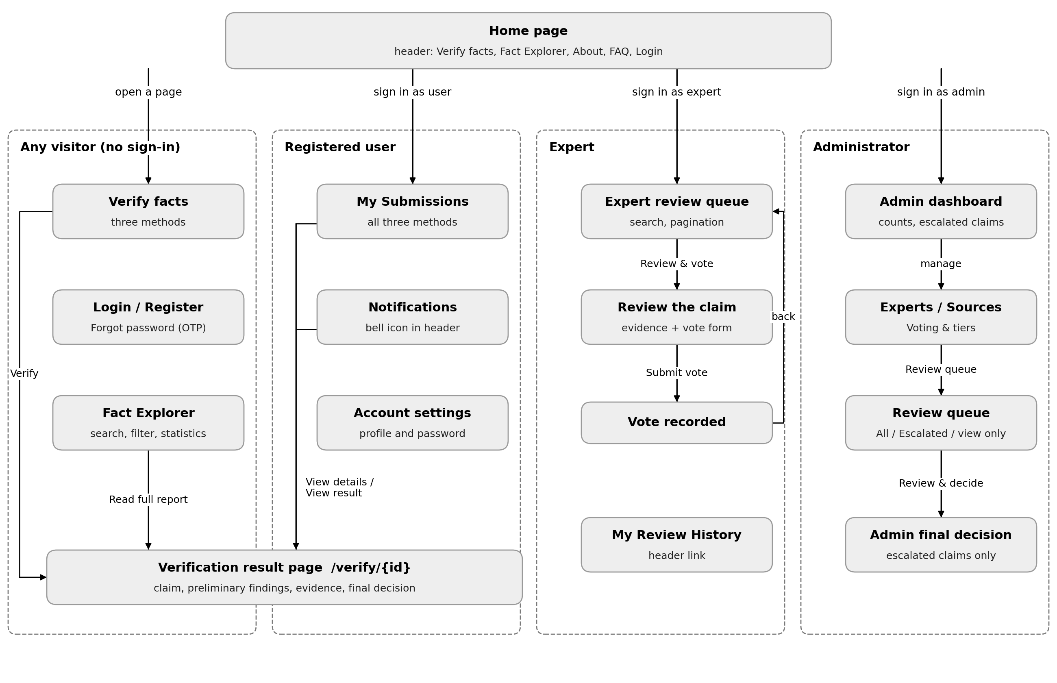
Figure 7.1: Website Navigation by User Role

7.3 UI Events and State Transitions

7.3.1 Verify Facts Page
Figure 7.2 shows the states of the Verify facts page and Table 7.2 lists the user events that cause each change.
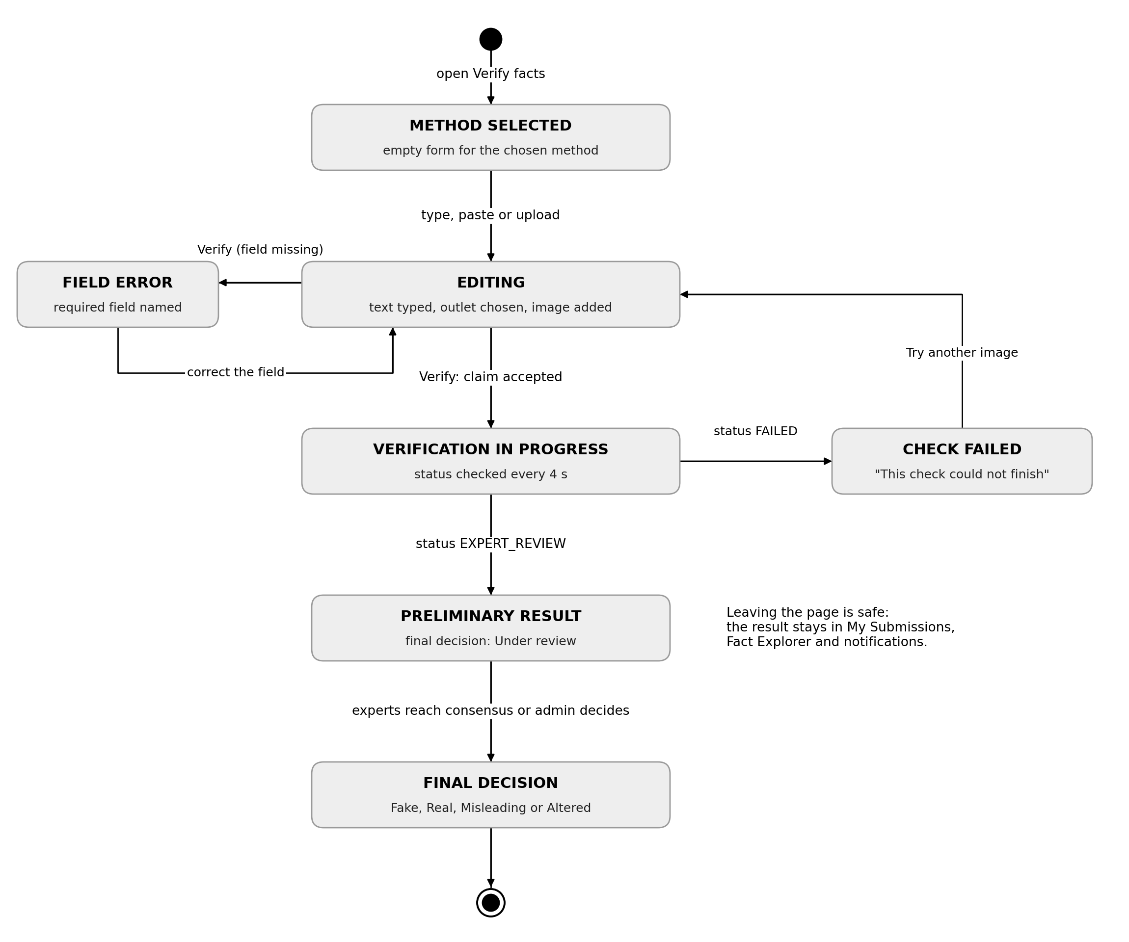
Figure 7.2: State Diagram of the Verify Facts Interface
Table 7.2: Events and State Transitions on the Verify Facts Page
User or system event | From state | To state | What the user sees
Choose a method card | none | METHOD SELECTED | The matching form and a preview panel
Type, paste or upload | METHOD SELECTED | EDITING | Live preview of the claim or image
Click Verify with a required field empty | EDITING | FIELD ERROR | The field is named and the inputs are kept
Click Verify with valid input | EDITING | IN PROGRESS | “Verification in progress” with View progress and My Submissions
Status poll returns EXPERT_REVIEW | IN PROGRESS | PRELIMINARY RESULT | Findings with Final decision: Under review
Status poll returns FAILED | IN PROGRESS | CHECK FAILED | “This check could not finish” with the reason
Experts or admin finalize | PRELIMINARY RESULT | FINAL DECISION | Final decision badge and Voting Details

7.3.2 Expert and Administrator Review
Figure 7.3 shows the review interface. The vote form keeps the user on the same state until the justification has at least 50 characters. An escalated claim appears on the administrator dashboard and only the administrator can decide it.
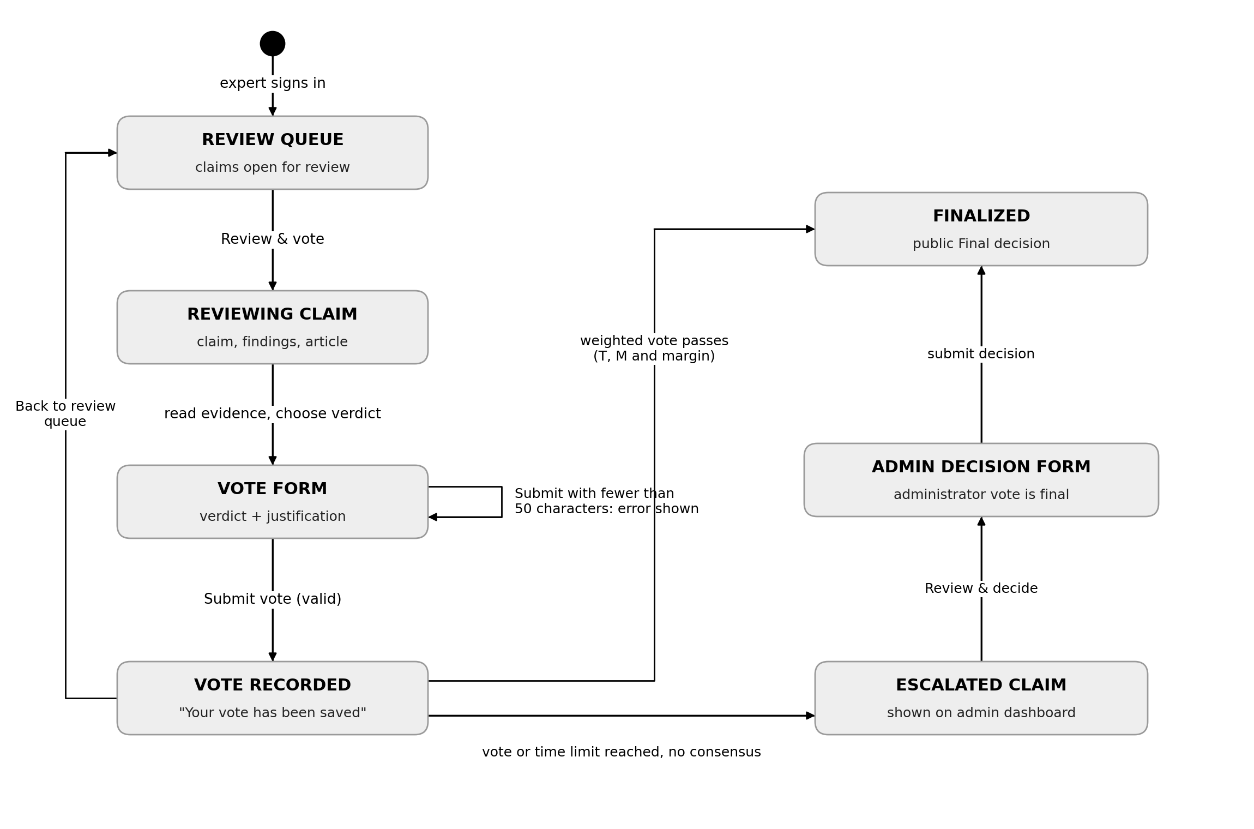
Figure 7.3: State Diagram of the Review Interface

7.3.3 Browser Extension Side Panel
Figure 7.4 shows the side panel states. Switching the extension OFF stops new submissions and alerts, but jobs already accepted by the server continue. The Account tab changes between guest and signed-in states independently of the Verify flow.
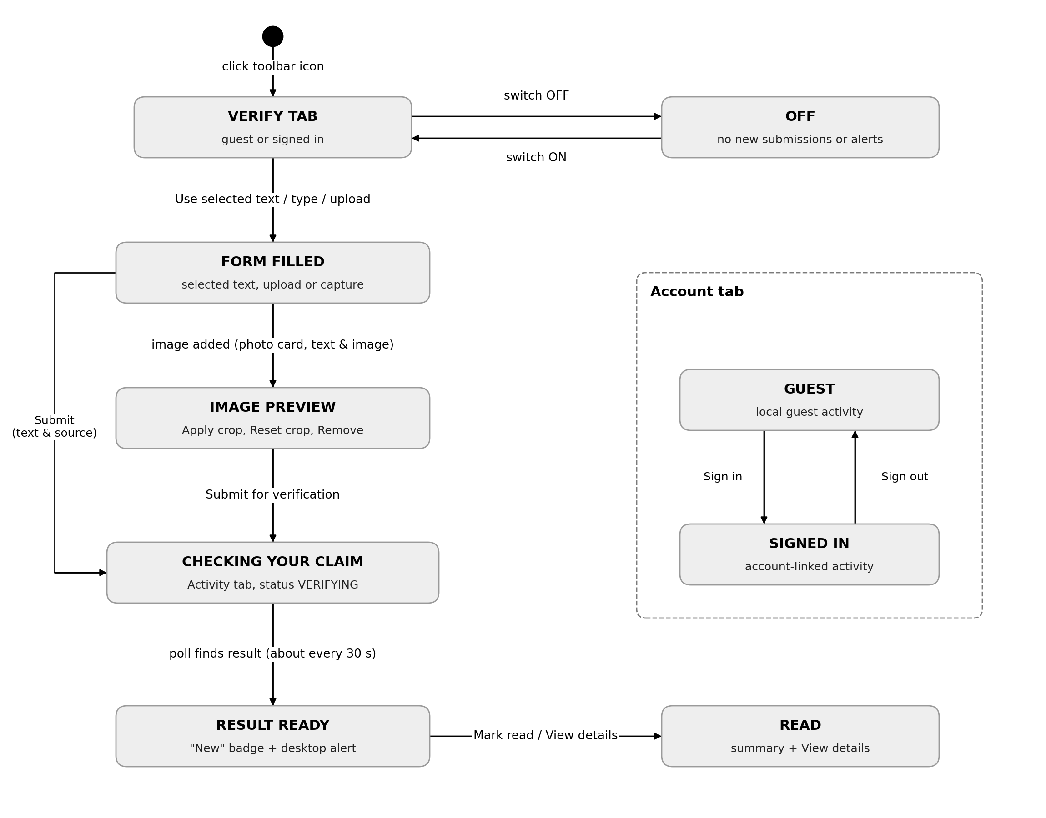
Figure 7.4: State Diagram of the Extension Side Panel

7.4 Interface States as Seen by the User
The figures below show the main interface states as they appear in the running system. Each screenshot is cropped to the part of the page that shows the state.
Figure 7.5 shows the EDITING state of a Text & source claim: the selected method card is highlighted, the form holds the headline, outlet and date and the preview on the right updates as the user types. After Verify news is clicked, the page changes to the IN PROGRESS state in Figure 7.6.
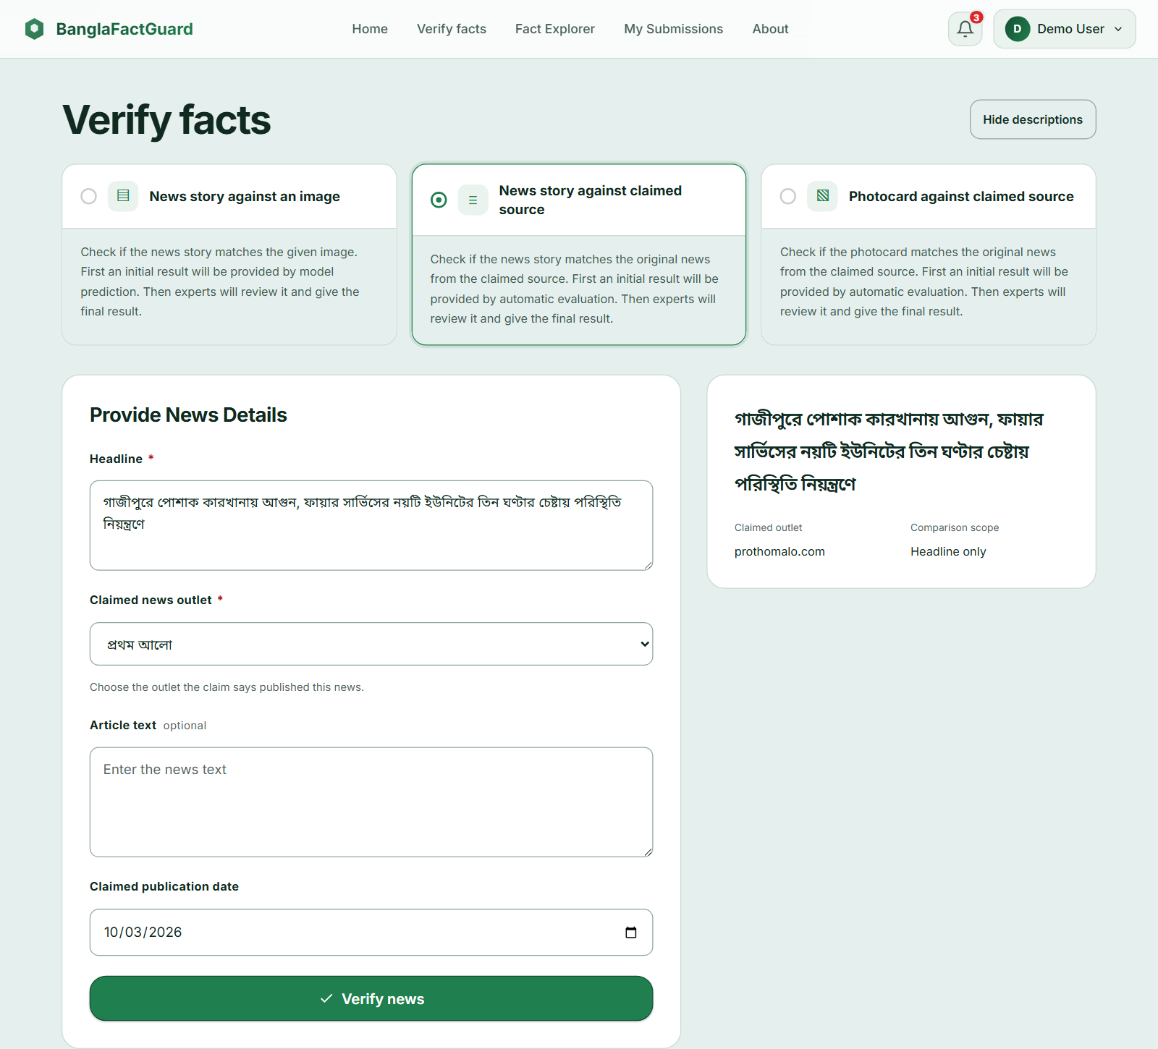
Figure 7.5: EDITING State — Text & Source Claim Form
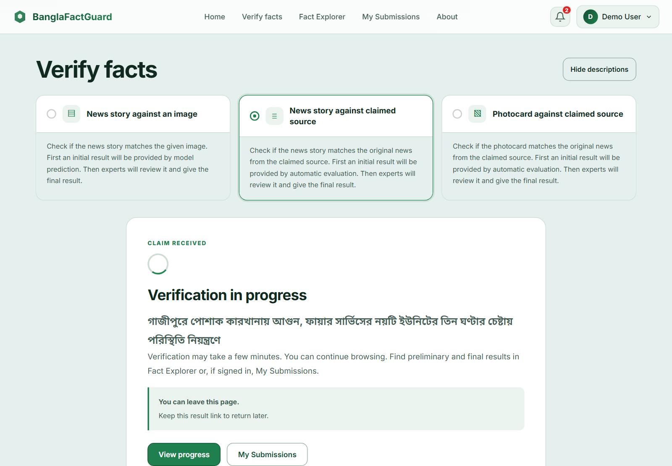
Figure 7.6: IN PROGRESS State — Claim Received
When the automated check is finished, the report page shows the PRELIMINARY RESULT state (Figure 7.7). The dashed Final decision box says Under review. After expert review, the same box becomes the FINAL DECISION state with a verdict badge and Voting Details (Figure 7.8).
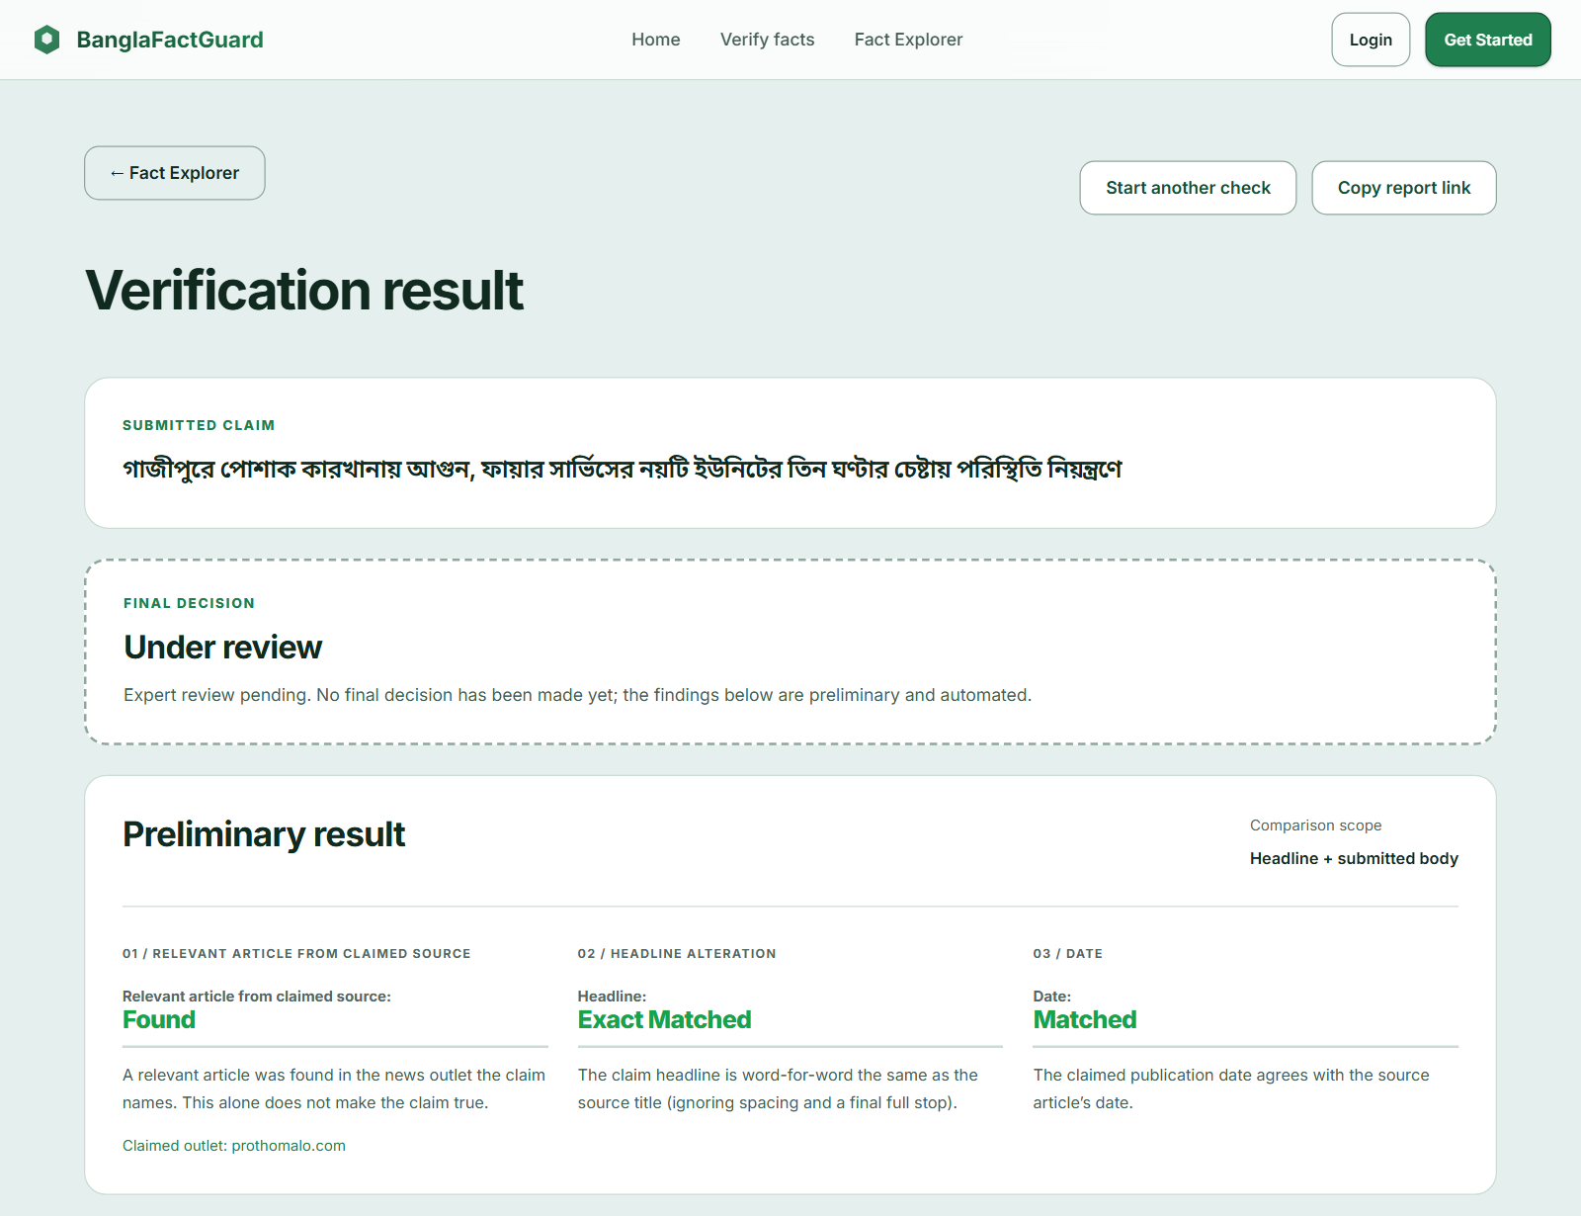
Figure 7.7: PRELIMINARY RESULT State — Final Decision Under Review
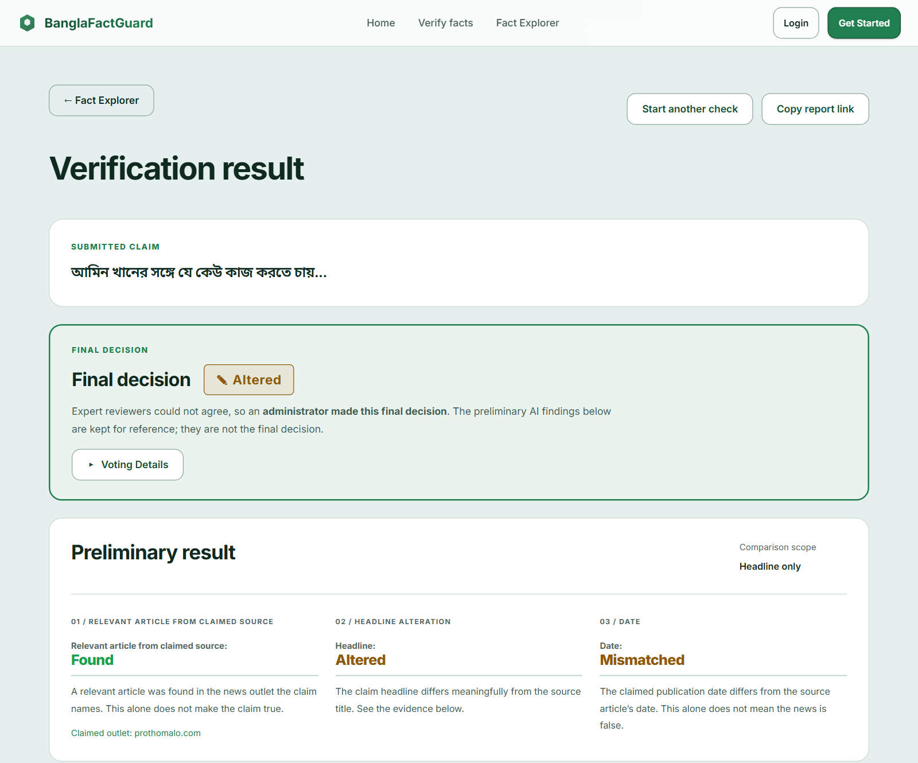
Figure 7.8: FINAL DECISION State — Administrator Decision on a Photo Card
If a check cannot finish, the CHECK FAILED state explains the reason and offers a recovery action instead of a verdict (Figure 7.9). The extension shows the same life cycle in its Activity tab (Figure 7.10).
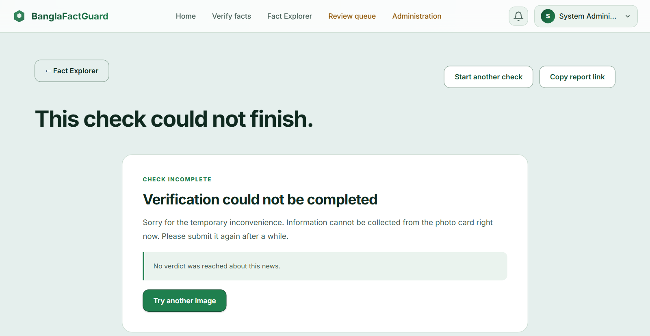
Figure 7.9: CHECK FAILED State — Photo Card Could Not Be Read
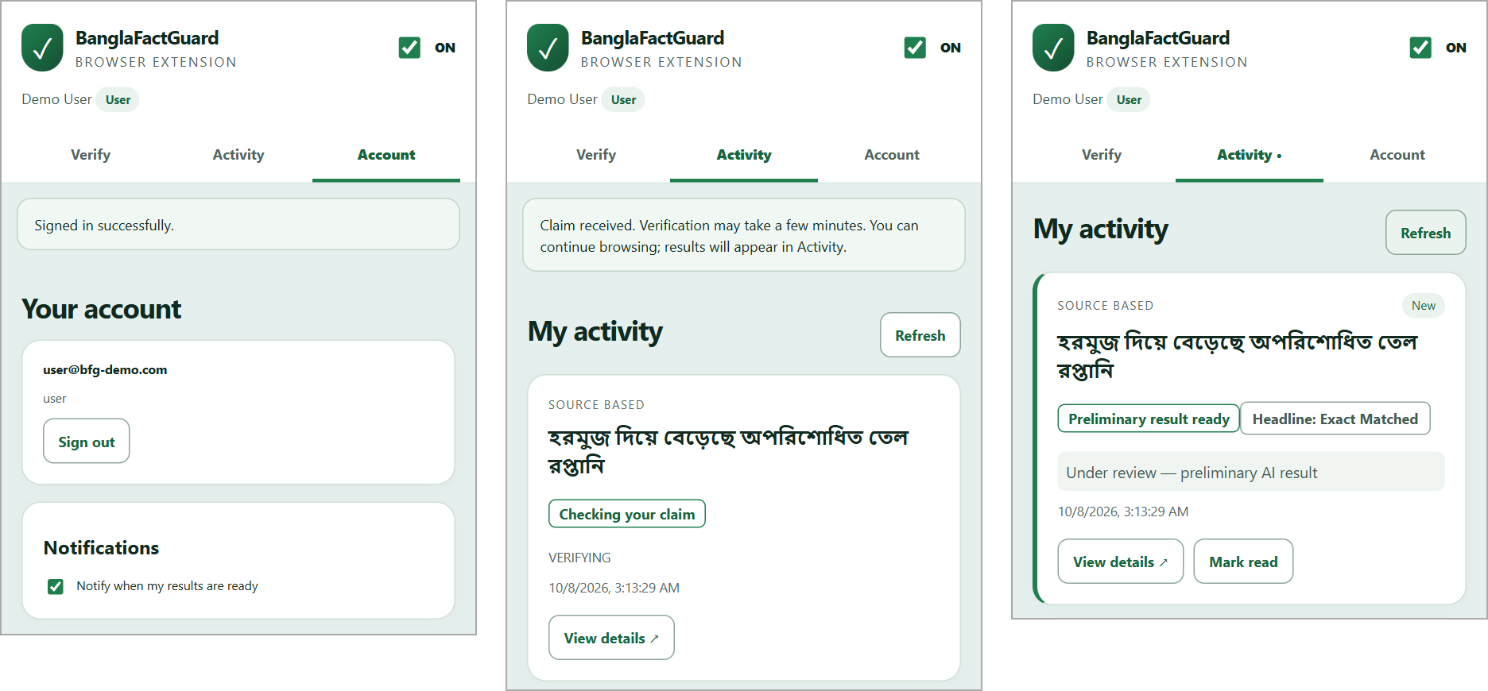
Figure 7.10: Extension States — Signed In, Checking Your Claim and Result Ready
Figure 7.11 shows the VOTE FORM state of the expert review page. The left column repeats the claim, the preliminary findings and the article; the right column holds the decision guidance and the vote form with the justification counter.
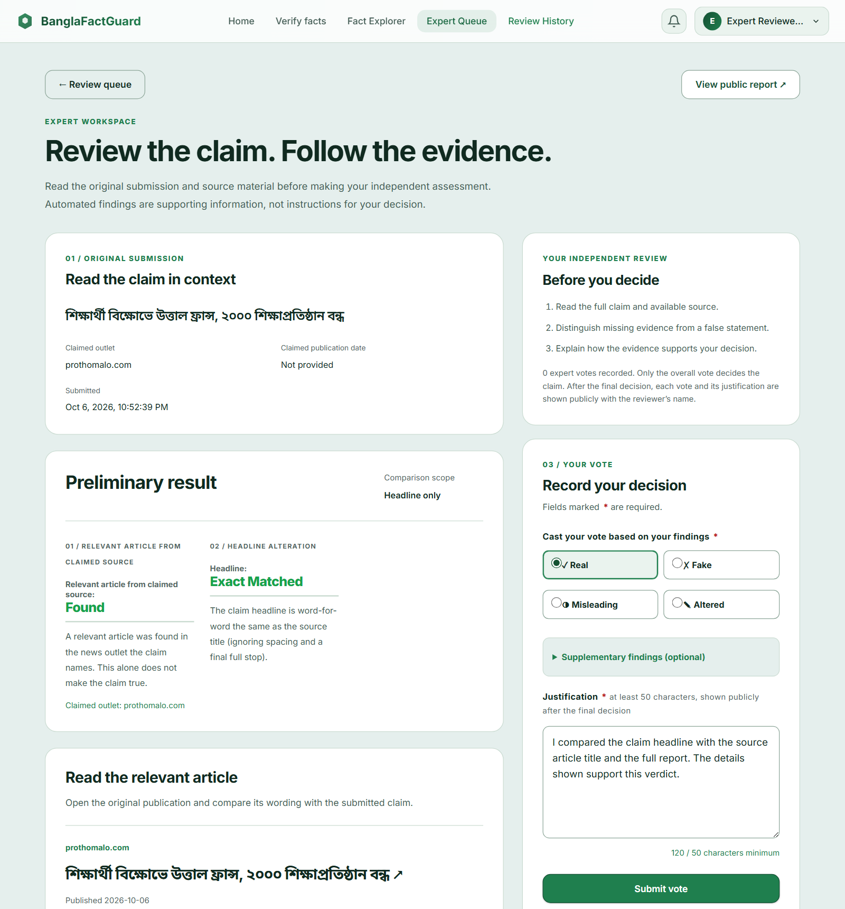
Figure 7.11: VOTE FORM State — Expert Review Page

8. Implementation

8.1 Technology Stack
Table 8.1: Technology Stack
Part | Technology
Website | Angular 19, TypeScript, SCSS, Angular Material/CDK
Backend | Python (3.11 or newer; 3.13.5 in the test environment), FastAPI, SQLAlchemy 2 (async, asyncpg), Alembic, Pydantic settings, structlog
AI and NLP | PyTorch, timm, Hugging Face Transformers, sentence-transformers, Google Gemini API (photo cards)
Retrieval | httpx, Playwright (headless Chromium), trafilatura, readability, BeautifulSoup, pygooglenews
Data | PostgreSQL 17, Redis 7.2, MinIO
Extension | Preact, Vite 6, Chrome Manifest V3 (side panel and service worker)
Testing | pytest 9 with SQLite helpers and fakes; Karma/Jasmine with headless Chrome; node:test with happy-dom and fake-indexeddb

8.2 Code Organisation
The repository has three applications. The backend (backend/app) is organised by feature: auth, users, submissions, verification (with pipeline/stages s01–s13), photocard, multimodal, expert_review, admin, sources, dashboard, notifications, search, nlp and cache. The website (frontend/src/app) has feature folders for home, verification, dashboard (Fact Explorer), history, notifications, settings, expert, admin, auth, about and faq. The extension (extension/src) contains the panel, the background worker, capture and shared helpers.

8.3 Key Implementation Details

8.3.1 Authentication and Roles
Passwords are hashed and access tokens are short-lived (15 minutes). The website refreshes the token before it expires and shares one refresh between parallel requests; a temporary network failure does not sign the user out. Password reset uses a 6-digit code that expires after 10 minutes. Role checks protect the expert and admin routes.

8.3.2 Background Jobs and Reuse
Every accepted claim is saved with a row in verification_jobs. The in-process worker claims jobs with FOR UPDATE SKIP LOCKED, sends a heartbeat every 30 seconds and re-claims jobs whose heartbeat is older than 120 seconds. Photo card jobs have their own lane (up to 4 at once) so that waiting for Gemini never blocks text jobs (up to 2 at once). A failed job is retried up to three times; permanent errors fail at once with a readable reason. A claim that was already checked gets a copy of the saved result on its own submission and the copy follows the original's final verdict.

8.3.3 Photo Card Reading
Gemini reads the headline exactly as printed, chooses the outlet only from the active verified sources and reads the printed date without guessing. At most nine requests are made (three batches of three, 10 seconds apart). If none succeeds or no headline or known outlet is found, the submission fails with a message that tells the user what to do.

8.3.4 Voting, Escalation and Notifications
ExpertReviewService locks the submission row before saving a vote, rejects a second vote by the same expert and blocks experts from reviewing their own claims. The weighted tally ignores the AI output. EscalationWorker checks the review limits every minute. notify_once() avoids duplicate notifications and ResultDeliveryWorker sends final-result emails with retry and backoff when SMTP is configured.

8.3.5 Browser Extension
The side panel stores drafts and activity per account. The service worker submits through the asynchronous endpoints, checks pending results about every 30 seconds (with backoff after network errors), shows desktop alerts and an unread badge and forgets a claim only when the server says that this submission no longer exists. Screenshot capture takes the visible tab and immediately crops it to the selected area. Only an administrator can change the API and website addresses.

8.4 Main API Routes
Table 8.2: Main API Routes (prefix /api/v1)
Operation | Route
Register, login, refresh, logout, profile | POST /auth/register, /auth/login, /auth/refresh, /auth/logout; GET /auth/me
Active verified sources | GET /sources
Queue a text claim; status and result | POST /verify/async; GET /verify/{id}/status, /verify/{id}
Queue a photo card; status and result | POST /photocard/verify/async; GET /photocard/{id}
Queue a text & image claim; result | POST /multimodal/predict/async; GET /multimodal/by-submission/{id}
Submission lookup; own submissions | GET /submissions/{id}; GET /users/me/submissions
Fact Explorer | GET /dashboard/explorer and statistics routes
Expert queue and vote | GET /expert/queue; POST /expert/queue/{id}/vote
Notifications | GET /notifications

9. Testing

9.1 Testing Approach and Strategy
Testing was done at three levels. Unit and component tests check each backend stage, service and rule with deterministic fakes for the models, search and storage. Integration-style tests run real database code on SQLite (only the needed tables are created) and run whole pipelines, the job worker and the voting service end to end with fakes for external services. Client tests check the website components and the extension panel and service worker with simulated browser APIs. Finally, the full system was used manually with real services to capture the screenshots in this report.
The strategy covers valid input, invalid input and failure situations for every main workflow: missing fields, wrong file types, an unknown outlet, failed searches, unreadable photo cards, ties and limits in voting, expired tokens and network failures.

9.2 Test Environment and Tools
Table 9.1: Test Environment
Item | Value
Execution date | 8 October 2026
Machine | Windows 11 Home (10.0.26100)
Backend | Python 3.13.5, pytest 9.1.1; command: python -m pytest tests/unit -q --no-cov
Website | Node 22.17, Angular 19, Karma with Chrome Headless 154; command: ng test --watch=false --browsers=ChromeHeadless
Extension | Node 22.17, node:test with happy-dom and fake-indexeddb; command: npm test

9.3 Item Pass/Fail Criteria
- Pass: the test runs and every assertion holds (expected status, fields, saved state and messages).
- Fail: any assertion does not hold or the code raises an unexpected error.
- Skipped / not executed: the test needs a resource that was not enabled in the run (for example real model weights). It counts as neither pass nor fail.
- A release is acceptable when all executed automated tests pass. Model accuracy is reported separately and is not a pass/fail criterion of the software tests.

9.4 Summary of Executed Test Runs
Table 9.2 gives the results of the three suites run for this report.
Table 9.2: Executed Automated Test Runs (8 October 2026)
Suite | Tests | Passed | Failed | Skipped | Time
Backend unit tests (44 files) | 426 | 424 | 0 | 2 | 20.4 s
Website (16 spec files) | 93 | 93 | 0 | 0 | 1.8 s
Extension (3 test files) | 33 | 33 | 0 | 0 | 2.7 s
Total | 552 | 550 | 0 | 2

The two skipped backend tests run only with real local model weights (BFG_REAL_MODEL_TESTS=1); they were not enabled in this run. Error lines that appear in the backend log come from tests that deliberately simulate failures and are expected.

9.5 Test Cases with Detailed Outcomes
The tables below list the important test cases. Cases without a mark are automated: they were run on 8 October 2026 and the actual result is the outcome of that run. Cases marked (M) are manual: they were carried out in the running system and their evidence is the screenshot named in the table.

9.5.1 Authentication and Sessions
Table 9.3: Test Cases — Authentication and Sessions
ID | Scenario | Input / steps | Expected result | Actual result | Status
TC-01 | Refresh access token | Expired access token, valid refresh token | New token issued; user stays signed in | As expected | Pass
TC-02 | Lost refresh response | Refresh succeeds but the reply is lost | User is not logged out within the grace window | As expected | Pass
TC-03 | Logout | Sign out, then use the old refresh token | Token revoked immediately | As expected | Pass
TC-04 | Parallel 401s on website | Several requests fail with 401 together | One shared refresh, then all requests retried | As expected | Pass
TC-05 | Temporary refresh failure | Network error during refresh | Session is kept; sign-in required only when refresh is rejected | As expected | Pass
TC-06 (M) | Register form validation | Password shorter than 8 characters | Inline message “At least 8 characters” | Message shown (Figure 10.2) | Pass

9.5.2 Text & Source Verification
Table 9.4: Test Cases — Text & Source Verification
ID | Scenario | Input / steps | Expected result | Actual result | Status
TC-07 | Matching claim end to end | Headline that the outlet published | Source Confirmed, headline Matched, everything saved | As expected | Pass
TC-08 | Wrong claimed date | Correct headline, wrong date | Headline Matched, date Mismatched | As expected | Pass
TC-09 | Changed number | Headline with an altered number | Headline Altered | As expected | Pass
TC-10 | All search providers fail | Search clients raise errors | Source Incomplete, not Not Found | As expected | Pass
TC-11 | Unknown outlet | Outlet that cannot be resolved (fallback disabled) | Rejected before a submission is created | As expected | Pass
TC-12 | Identical claim again | Same claim submitted twice | Saved result reused on the new user's own submission | As expected | Pass
TC-13 | Incomplete result not reused | Earlier result was Incomplete | Claim is re-queued, not served from cache | As expected (9 tests) | Pass
TC-14 | Body similarity display | Claim with body text | Four scores; an unavailable score is never shown as 0 | As expected; see Figure 10.6 | Pass
TC-15 (M) | Source not found in UI | Claim the outlet did not publish | Not Found, no Fake verdict, other checks hidden | As expected (Figure 10.7) | Pass

9.5.3 Photo Card and Text & Image Verification
Table 9.5: Test Cases — Photo Card and Text & Image
ID | Scenario | Input / steps | Expected result | Actual result | Status
TC-16 | Fast acceptance | Upload a card | 202 returned before slow extraction; job finishes without the client | As expected | Pass
TC-17 | Gemini unavailable | All Gemini requests fail | Submission fails with the temporary-inconvenience message; no verdict | As expected; also seen in Figure 7.9 | Pass
TC-18 | No headline or outlet | Card without a readable headline or known outlet | Fails with the “valid headline or recognized outlet” message | As expected | Pass
TC-19 | Crash recovery | Worker stops during a job | A fresh worker re-claims the job; Gemini is not called again | As expected | Pass
TC-20 | Invalid file type | PDF uploaded as image | Rejected with HTTP 415 before acceptance | As expected | Pass
TC-21 | Empty article text | Whitespace body with an image | Rejected with HTTP 422 | As expected | Pass
TC-22 | Duplicate text and image | Same text and image again | Model not run; earlier prediction reused with similarity scores | As expected | Pass
TC-23 | Different image | Same text, different image | Not treated as a duplicate | As expected | Pass

9.5.4 Expert Review, Voting and Escalation
Table 9.6: Test Cases — Expert Review and Voting
ID | Scenario | Input / steps | Expected result | Actual result | Status
TC-24 | All rules met | Leader ≥ T, voters ≥ M, lead ≥ margin | Claim finalized | As expected | Pass
TC-25 | Threshold, voters or margin missing | One rule not met | Claim stays open | As expected (3 tests) | Pass
TC-26 | Tie | Equal top weights | Never finalizes; escalates at the vote limit | As expected | Pass
TC-27 | New expert weight | Expert below N completed reviews | Neutral weight 1 | As expected | Pass
TC-28 | Own claim and double vote | Expert votes on own claim; votes twice | Both rejected | As expected | Pass
TC-29 | Time limit | max_review_hours passed with no votes | Escalated; admin notified once | As expected | Pass
TC-30 | Admin rights | Admin opens escalated and normal claims | Decides escalated; view-only otherwise; decision is final | As expected | Pass
TC-31 | Short justification | Fewer than 50 characters | Error next to the field; vote not sent | As expected | Pass
TC-32 (M) | Escalated claim end to end | Three split votes, admin decides Real | Final decision Real with Voting Details | As shown in Figure 10.17 | Pass

9.5.5 Notifications, Fact Explorer and Extension
Table 9.7: Test Cases — Notifications, Fact Explorer and Extension
ID | Scenario | Input / steps | Expected result | Actual result | Status
TC-33 | Personal notifications | Each method × user, expert, admin | Preliminary and final notifications once each | As expected (9 cases) | Pass
TC-34 | Guest submitter | Claim without an account | No account notification or email | As expected | Pass
TC-35 | SMTP failure | Mail server error | Retry without duplicate notifications | As expected | Pass
TC-36 | Explorer filters | Reversed date range | Rejected without sending a search | As expected | Pass
TC-37 | Explorer service failure | API error | Error kept separate from “no results”, with retry | As expected | Pass
TC-38 | Extension OFF/ON | Turn OFF, then ON | Polling and submissions blocked, then resumed | As expected | Pass
TC-39 | Account isolation | Switch accounts in the extension | Other account's activity not shown | As expected | Pass
TC-40 | Connection settings | Guest, user and expert try to change URLs | Refused; only a server-confirmed admin can save | As expected | Pass
TC-41 | Restricted page | Capture on a Chrome internal page | Selection cannot start; clear message | As expected | Pass

9.6 Observed Performance and Model Results
No load test or formal performance benchmark was run. The backend keeps the measured run time of completed checks. A read-only report from 4 October 2026 (docs1/recent-verification-timings.md) lists eight Text & source checks on earlier pipeline versions (v3.1 and v3.2): their pipeline time ranged from 82 to 153 seconds. These are observations of a few checks, not a benchmark. The recorded accuracy of the multimodal model is given in Section 5.1.2.

9.7 Tests Not Executed or Not Verified
Table 9.8: Tests Not Executed in This Run
Item | Reason | Status
Backend integration tests (tests/integration) | Need a PostgreSQL test fixture; the shared client fixture uses an httpx API removed in httpx 0.28 | Not executed
Real-model tests (2) | Require BFG_REAL_MODEL_TESTS=1 and local weights | Skipped
Installed-Chrome checks (live capture, OS notifications, browser restart) | Automated extension tests use simulated Chrome APIs | Manual checklist in extension/TESTING.md; not formally recorded
Accuracy of the source pipeline (NLI, NER, thresholds) | No labelled Bangla evaluation set | Not measured
Load and stress testing | Not planned in this project phase | Not executed

9.8 Risks and Contingencies
Table 9.9: Testing Risks and Contingencies
Risk | Contingency
Gemini quota or network errors stop photo card checks | Retries in batches; clear failure message; no false verdict
A news outlet blocks requests or changes its layout | Playwright fallback, several extractors and Incomplete status instead of Not Found
Model behaviour differs from tests that use fakes | Real-model opt-in tests and the expert review step
Data loss on restart | Durable job queue, heartbeats and idempotent persistence
Too few experts to reach agreement | Configurable limits and administrator escalation

10. User Manual
This chapter explains how to use BanglaFactGuard. Sections 10.1 to 10.7 are for every user, Section 10.8 is for experts and Section 10.9 is for administrators. The website is in English and accepts Bangla text.

10.1 Getting Started
Open the website (for a local setup, http://localhost:4200). The home page in Figure 10.1 explains the three ways to check a claim. You can use every verification method without an account. Sign in if you want your claims saved in My Submissions and to receive notifications.
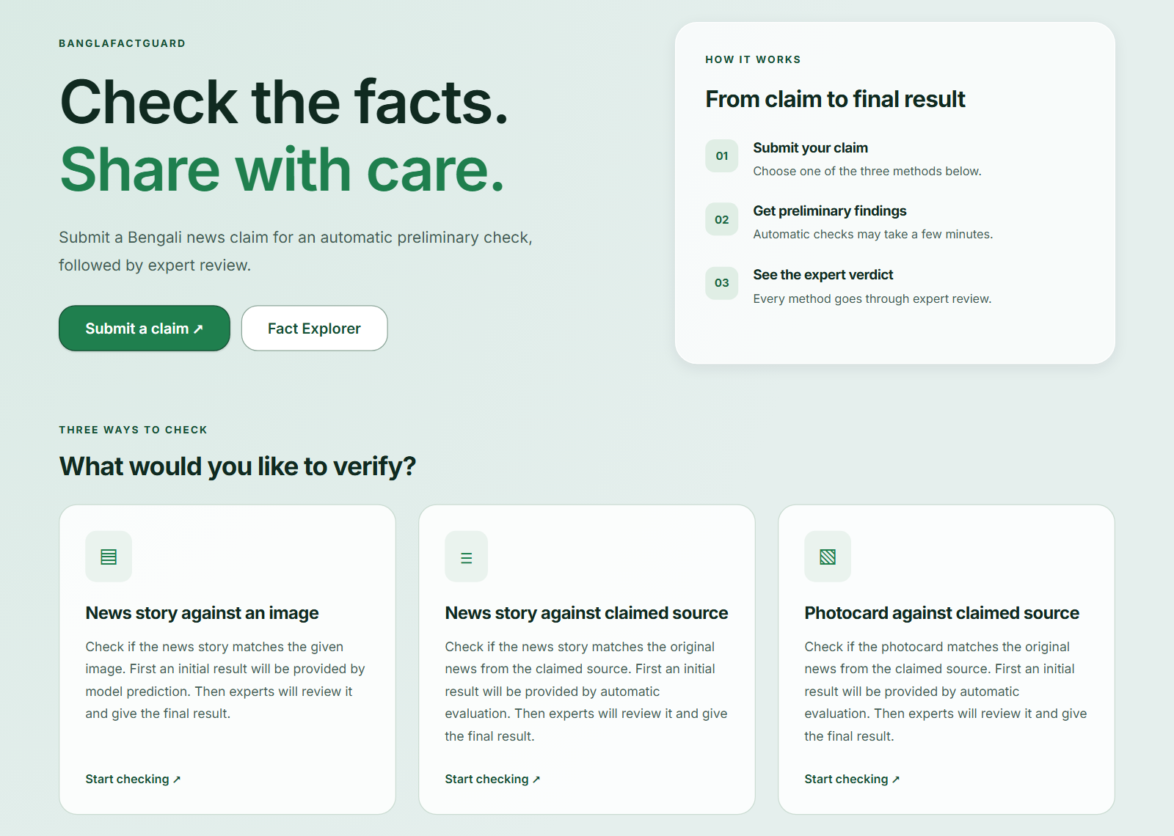
Figure 10.1: Home Page

10.2 Creating an Account and Signing In
- Click Get Started (or Login, then Create one).
- Enter your full name, email and a password of at least 8 characters with an uppercase letter and a number. Confirm the password and click Create Account (Figure 10.2).
- To sign in later, click Login, enter your email and password and click Sign In.
- If you forget your password, click Forgot password?, enter your email, then type the code sent to your email and a new password.
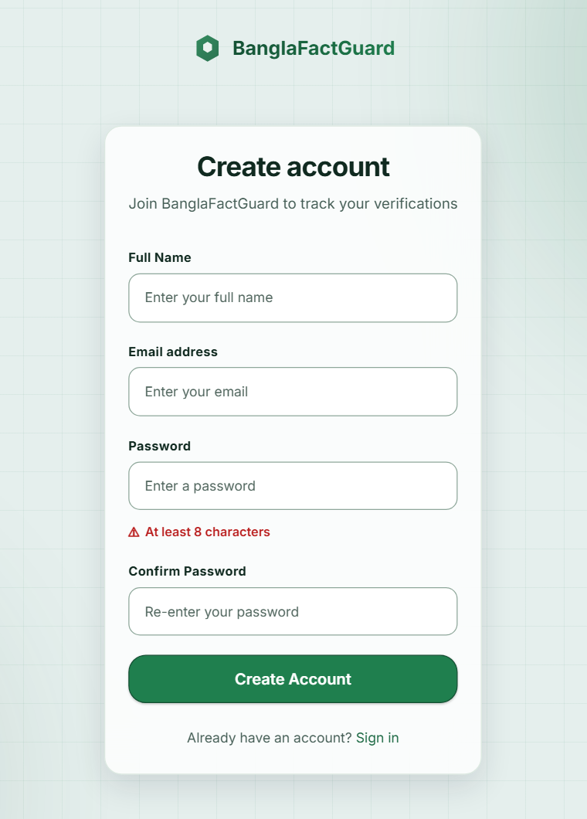
Figure 10.2: Create Account Page

10.3 Checking a Claim
Click Verify facts and choose a method card. You can hide the card descriptions with Hide descriptions.

10.3.1 Text & Source (News story against claimed source)
- Type or paste the Bangla headline.
- Choose the Claimed news outlet: the publisher named in the claim, not necessarily the site where you saw it.
- Optionally paste the article text and choose the claimed publication date.
- Click Verify news. The page shows “Verification in progress” (Figure 7.6). You may leave the page; the check continues.
The form is shown in Figure 7.5. A check usually takes one to two minutes.

10.3.2 Photo Card (Photocard against claimed source)
- Click the upload box and choose the card image (JPEG, PNG, WebP or GIF, up to 10 MB).
- Check the preview, then click Verify photo card.
- The system reads the headline, outlet and date from the card. If the card cannot be read, the result page explains why and offers Try another image (Figure 7.9).
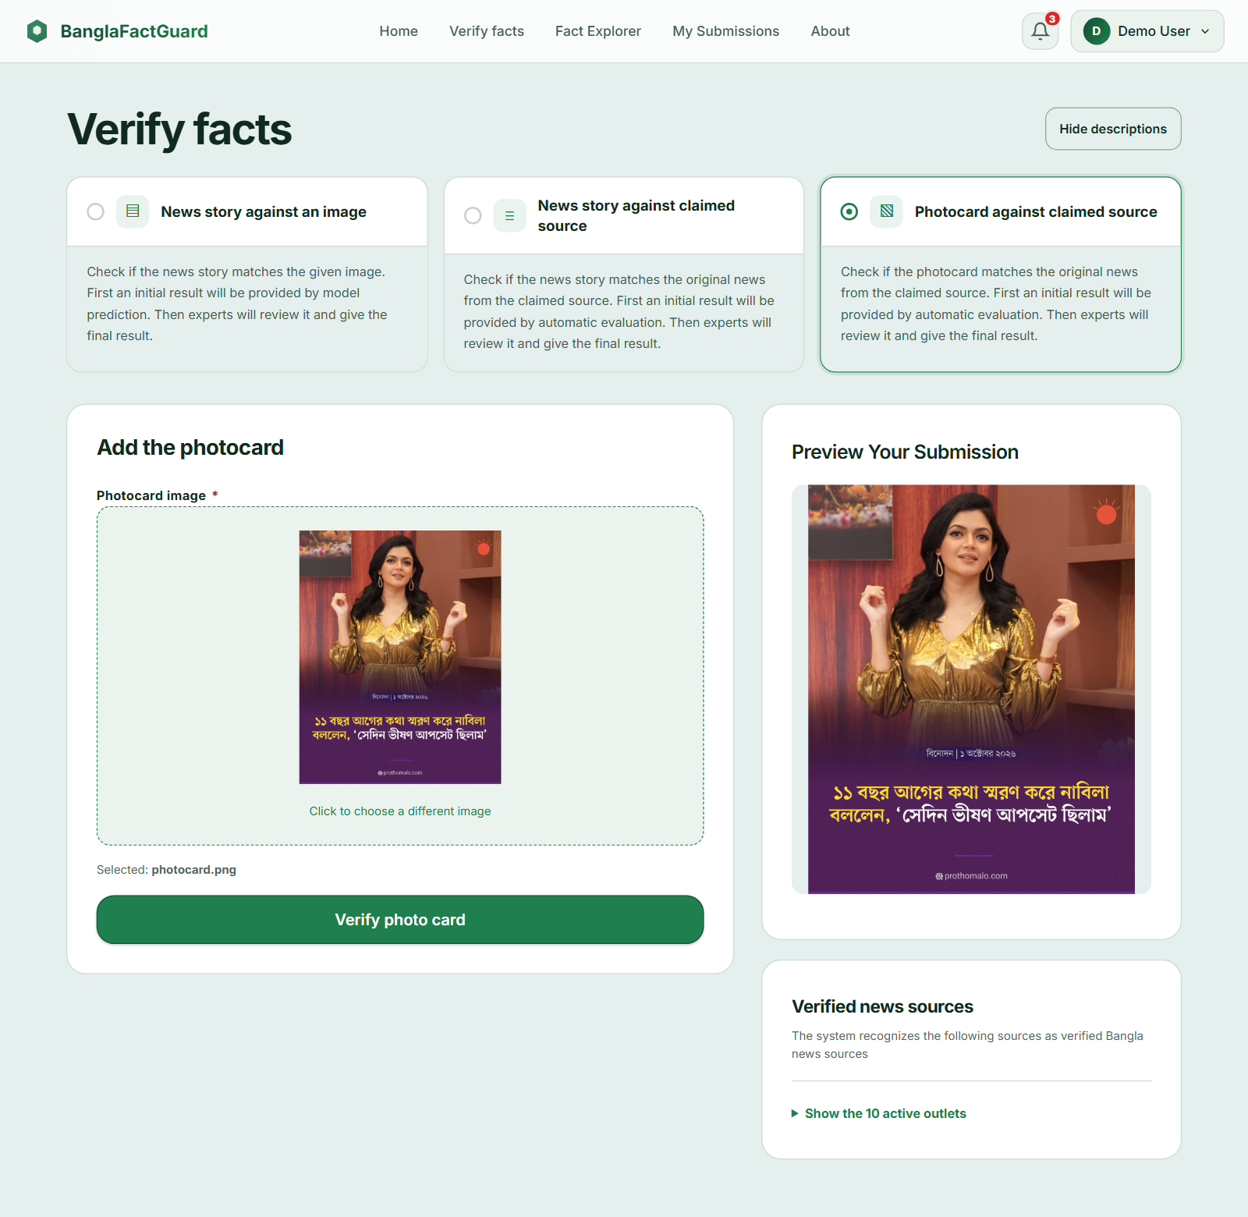
Figure 10.3: Photo Card Form with Preview

10.3.3 Text & Image (News story against an image)
- Enter the headline and the article text.
- Upload the news image and check the preview.
- Click Check text and image. The result shows AI decision: Likely Real or Likely Fake, which is a preliminary estimate only.
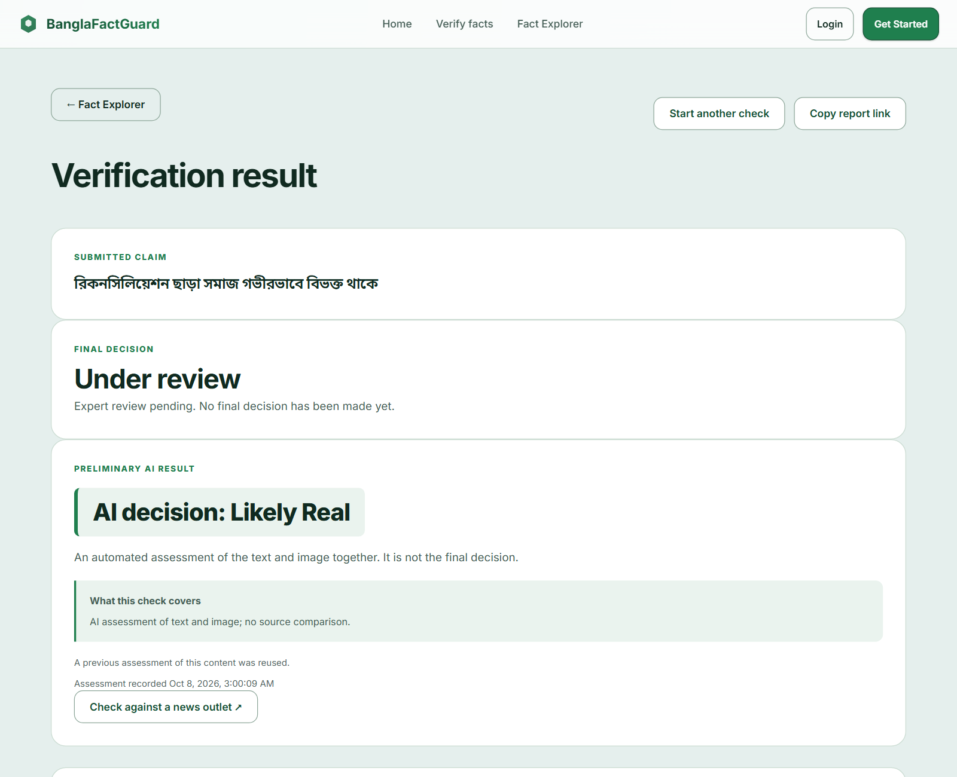
Figure 10.4: Text & Image Result with a Reused Assessment

10.4 Reading a Result
Every result page has the same order: the submitted claim, the Final decision box, the Preliminary result, the relevant article and the detailed comparisons. While experts are reviewing, the final decision says Under review. When a final decision exists, it is shown with Voting Details.
- Relevant article from claimed source: Found, Not Found or Incomplete. Not Found alone does not mean the news is false.
- Headline: Exact Matched, Meaning Preserved or Altered. Altered lists each meaningful difference with the claim text and the source text.
- Date: Matched or Mismatched, shown only when you gave a date.
- Body similarity: four percentages shown only when you gave article text. They describe overlap, not truth.
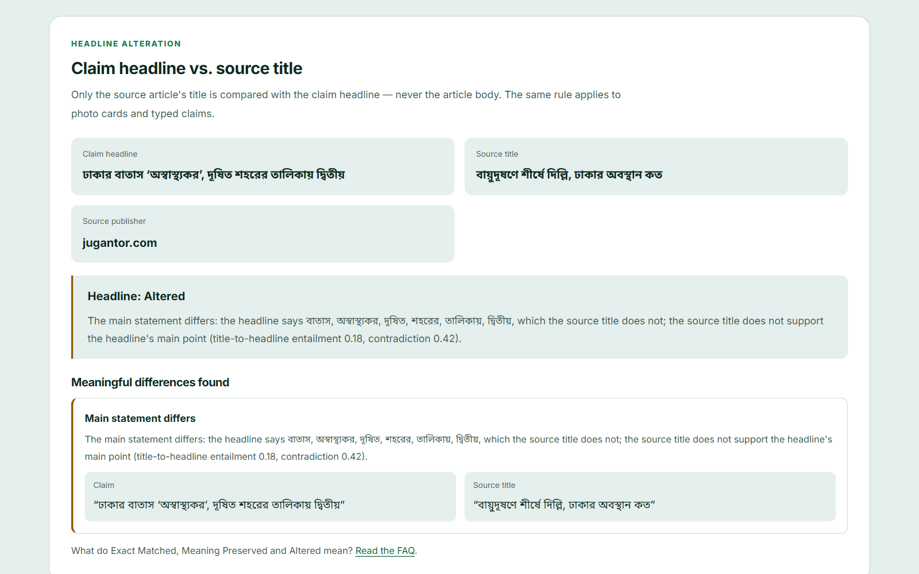
Figure 10.5: Headline Comparison Showing an Altered Headline
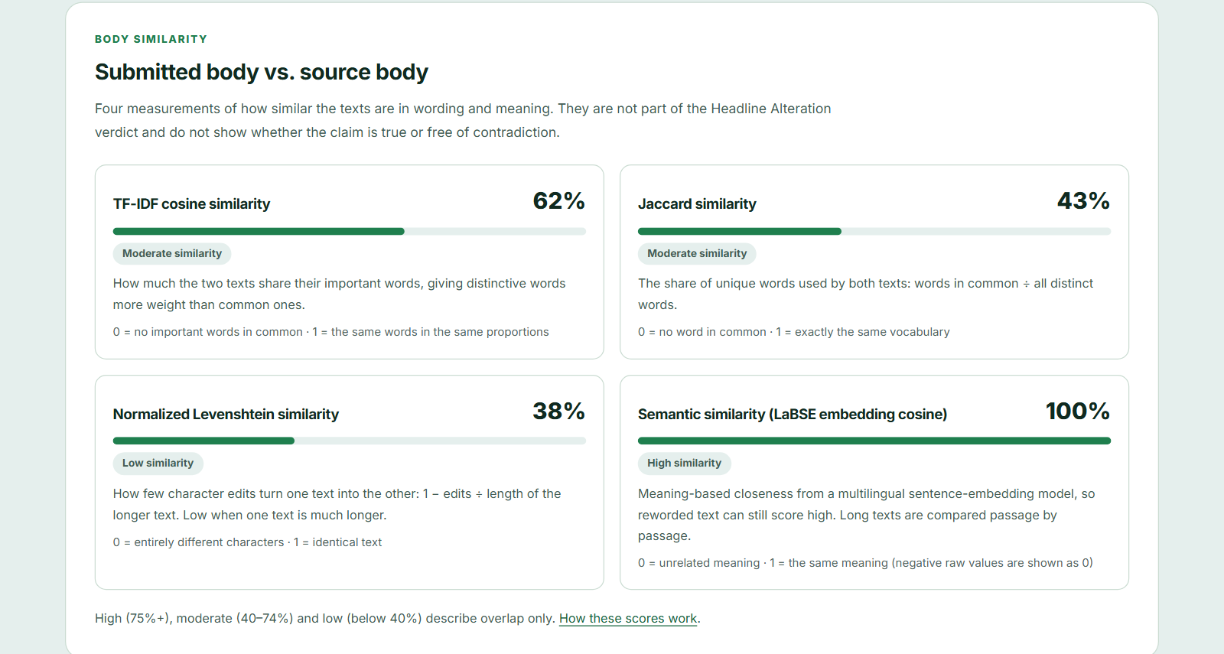
Figure 10.6: Body Similarity Scores
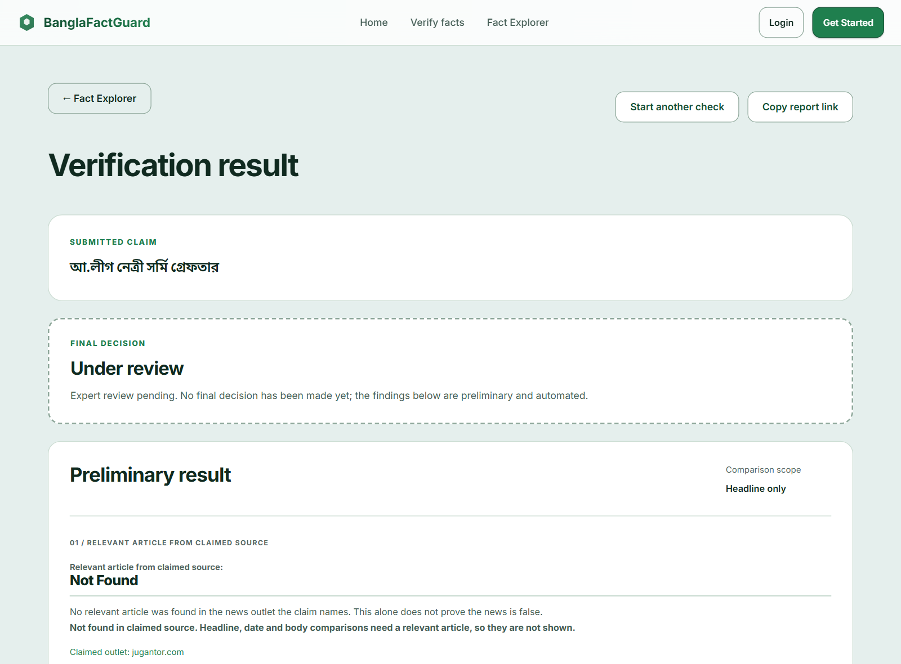
Figure 10.7: Result When the Claimed Source Has No Matching Report
Use Copy report link to share a result and Start another check to begin again.

10.5 Fact Explorer
Click Fact Explorer to search previous claims (Figure 10.8). The top shows archive counts. Choose Final decisions or Under review, type a keyword, choose a decision and content type and click Search. More filters adds date and outlet filters. Click Read full report to open a claim.
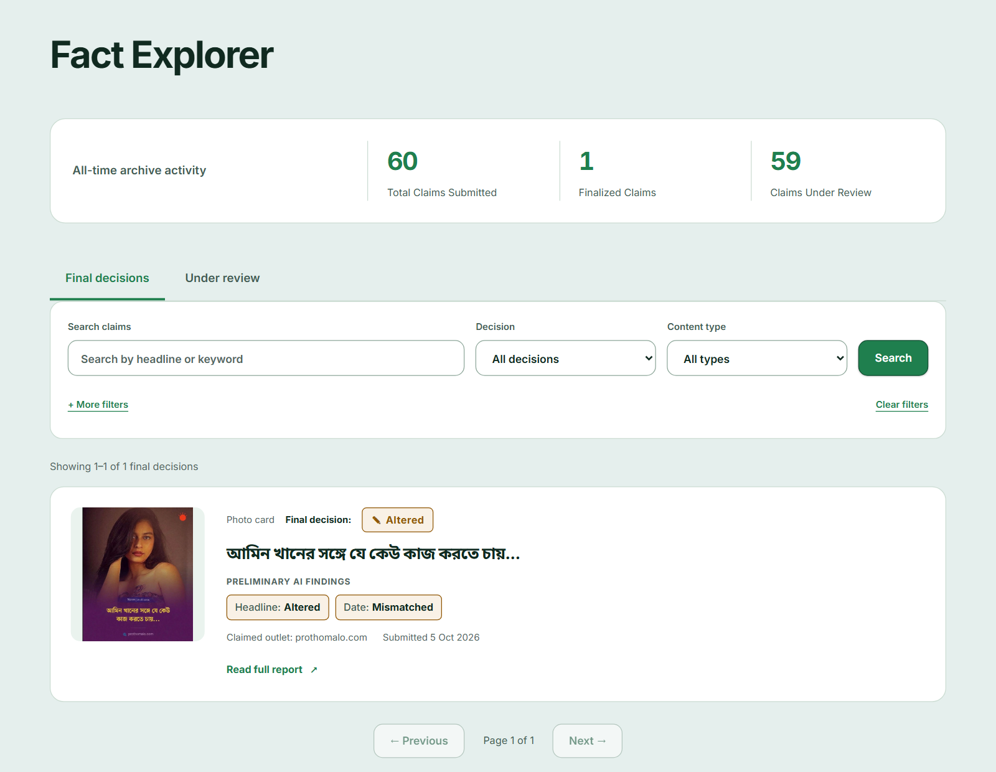
Figure 10.8: Fact Explorer

10.6 My Submissions, Notifications and Settings
Signed-in users can open My Submissions to see every claim they submitted, with its method, preliminary findings and review status (Figure 10.9). The bell icon opens Notifications (Figure 10.10). Each notification has View result and Mark as read; Mark all as read clears the list. Final results are also sent by email when email is configured. Account settings (user menu) changes your name and password.
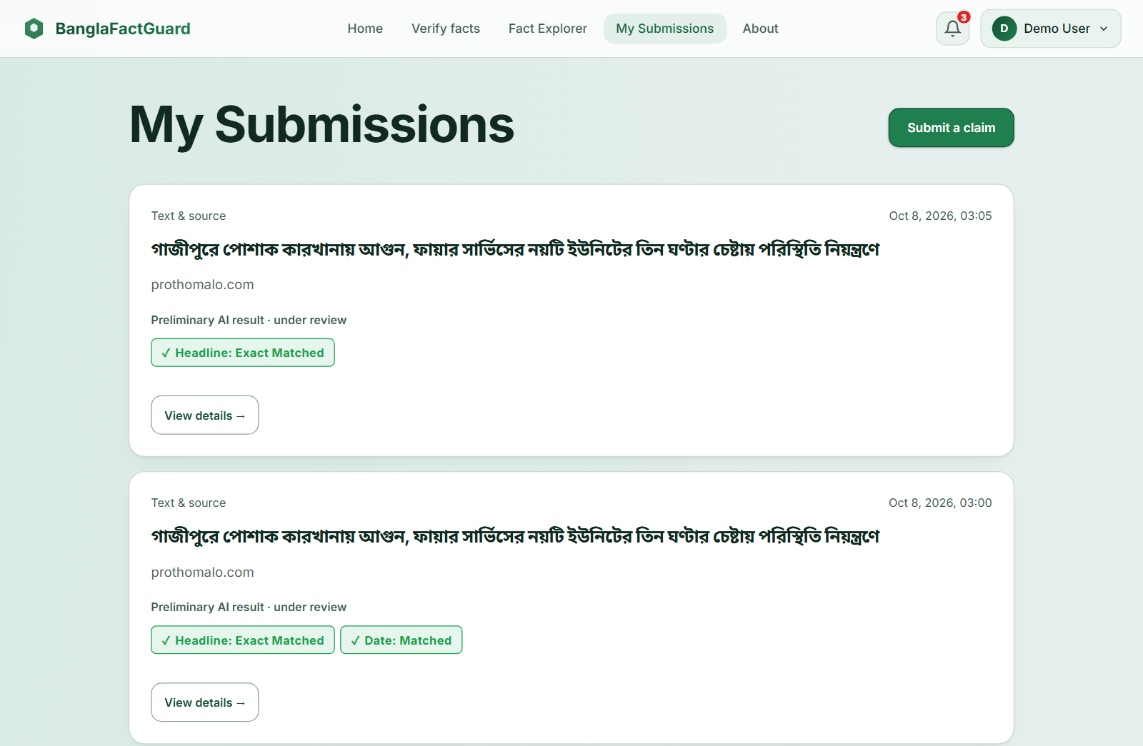
Figure 10.9: My Submissions
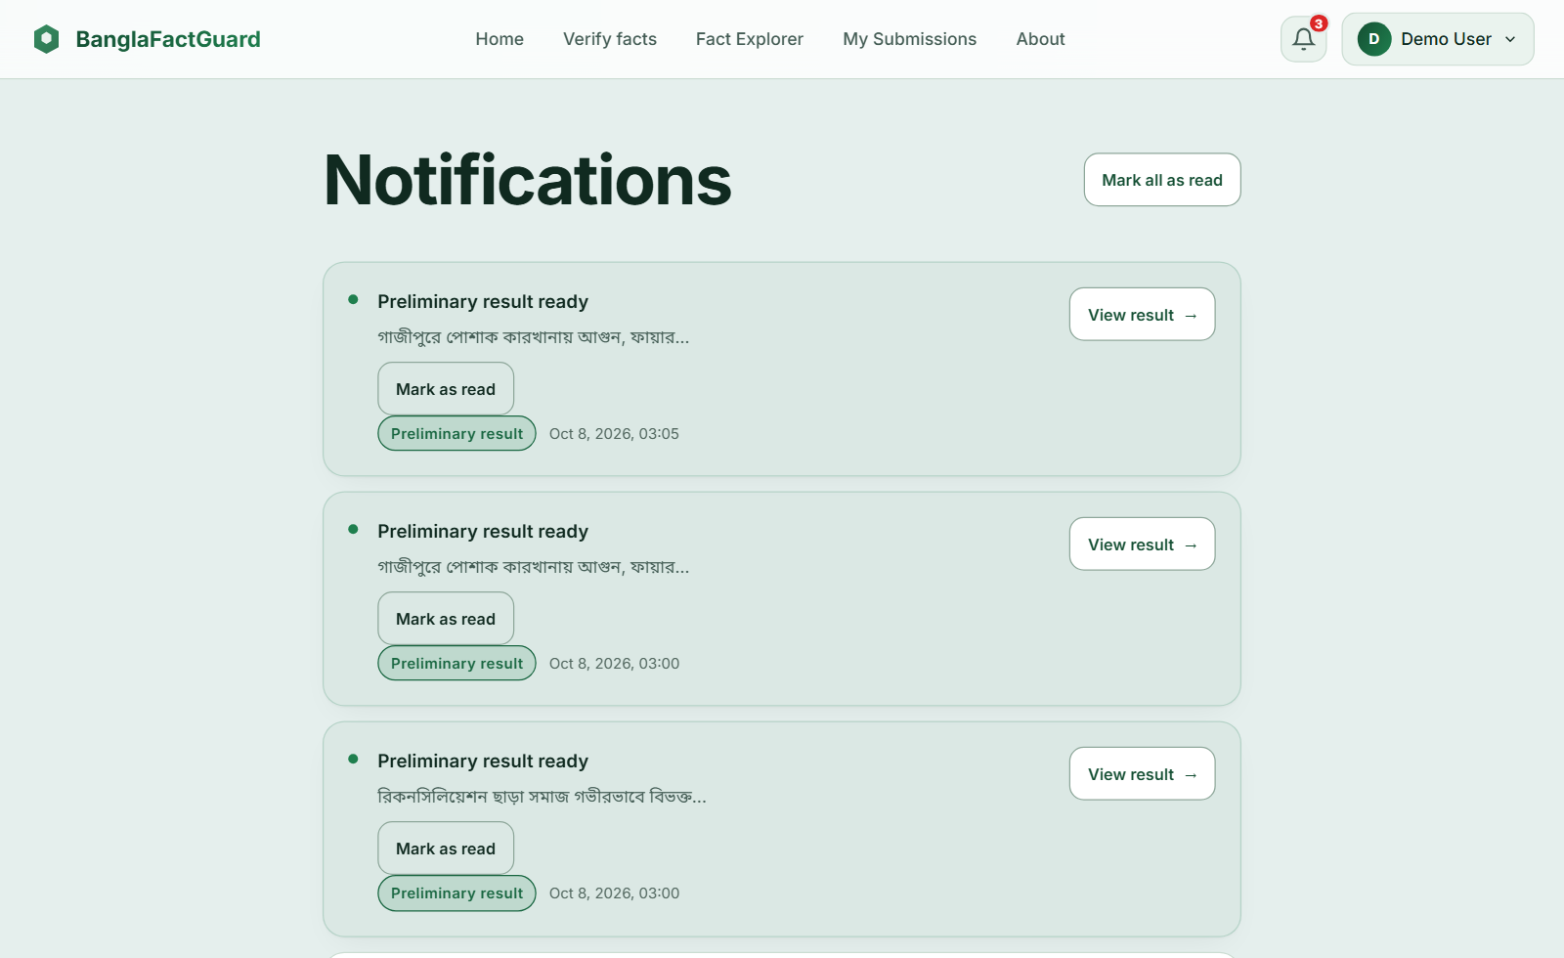
Figure 10.10: Notifications

10.7 Using the Browser Extension
- Pin BanglaFactGuard — Browser Extension in Chrome and click its toolbar icon on the news page. The side panel opens.
- Choose Text & source, Photo card or Text & image.
- Select text on the page and click Use selected text or type it. For images, click Upload image or Select screenshot area and drag over the part of the page you want.
- Adjust the image with Apply crop, Reset crop or Remove.
- Click Submit for verification. The Activity tab shows “Checking your claim” and later “Preliminary result ready” with a desktop alert. Click View details to open the full report on the website.
- Use the Account tab to sign in with your website account and the ON switch to pause the extension.
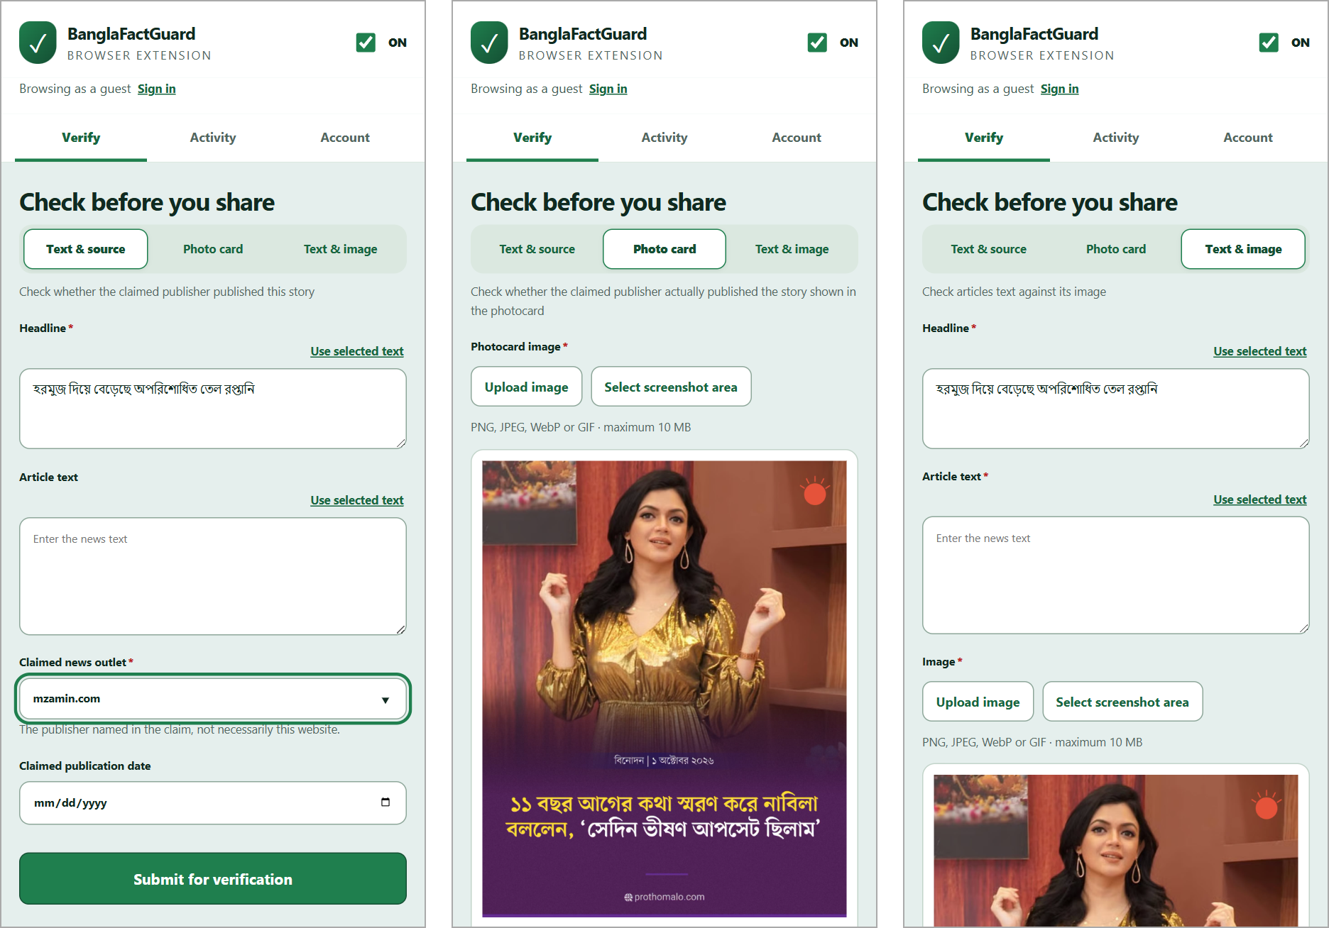
Figure 10.11: Extension Verify Tab — Text & Source, Photo Card and Text & Image
The account and activity screens are shown in Figure 7.10.

10.8 Expert Tasks
- Sign in with the account created by the administrator. Open Expert Queue (Figure 10.12).
- Search if needed and click Review & vote on a claim.
- Read the claim, the preliminary findings and the article (Figure 7.11). Remember that automated findings are supporting information, not instructions.
- Choose Real, Fake, Misleading or Altered, optionally add supplementary findings, write a justification of at least 50 characters and click Submit vote.
- Open Review History to see your votes and the final decisions. Account settings shows your number of reviews; credibility weight activates after the required number of reviews.
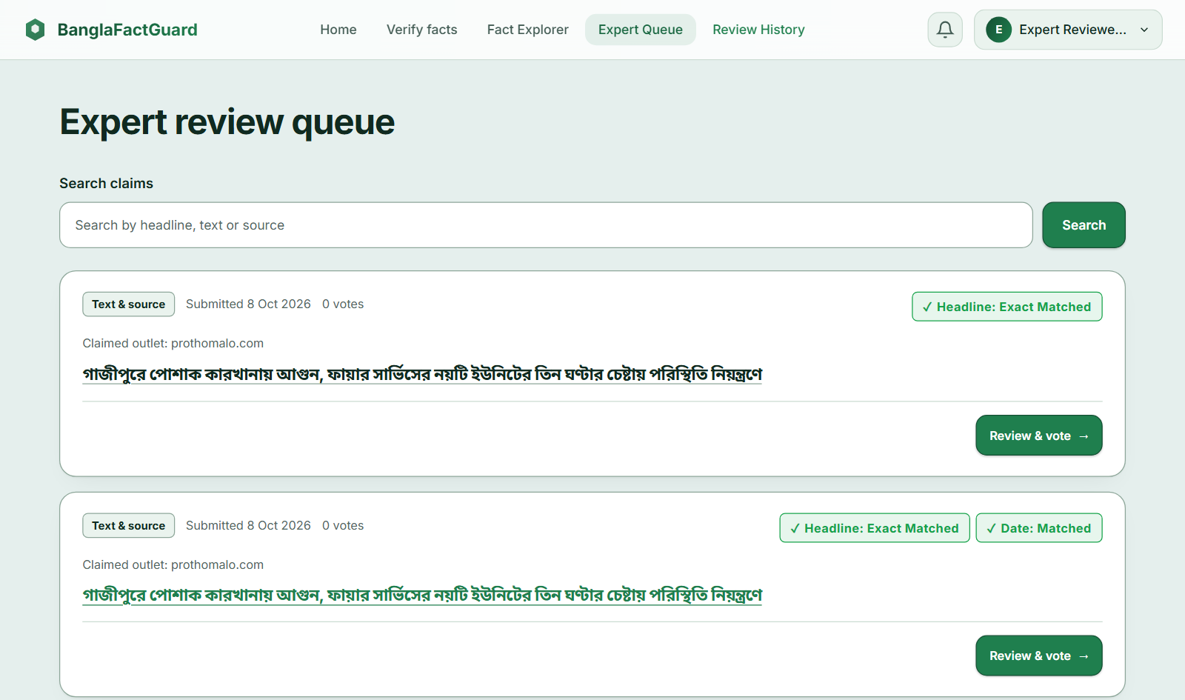
Figure 10.12: Expert Review Queue

10.9 Administrator Tasks
The Admin dashboard (Figure 10.13) shows escalated claims that need your decision, activity counts, claims waiting longest and recent decisions. Use the Experts, Sources and Voting & tiers buttons to manage the system.
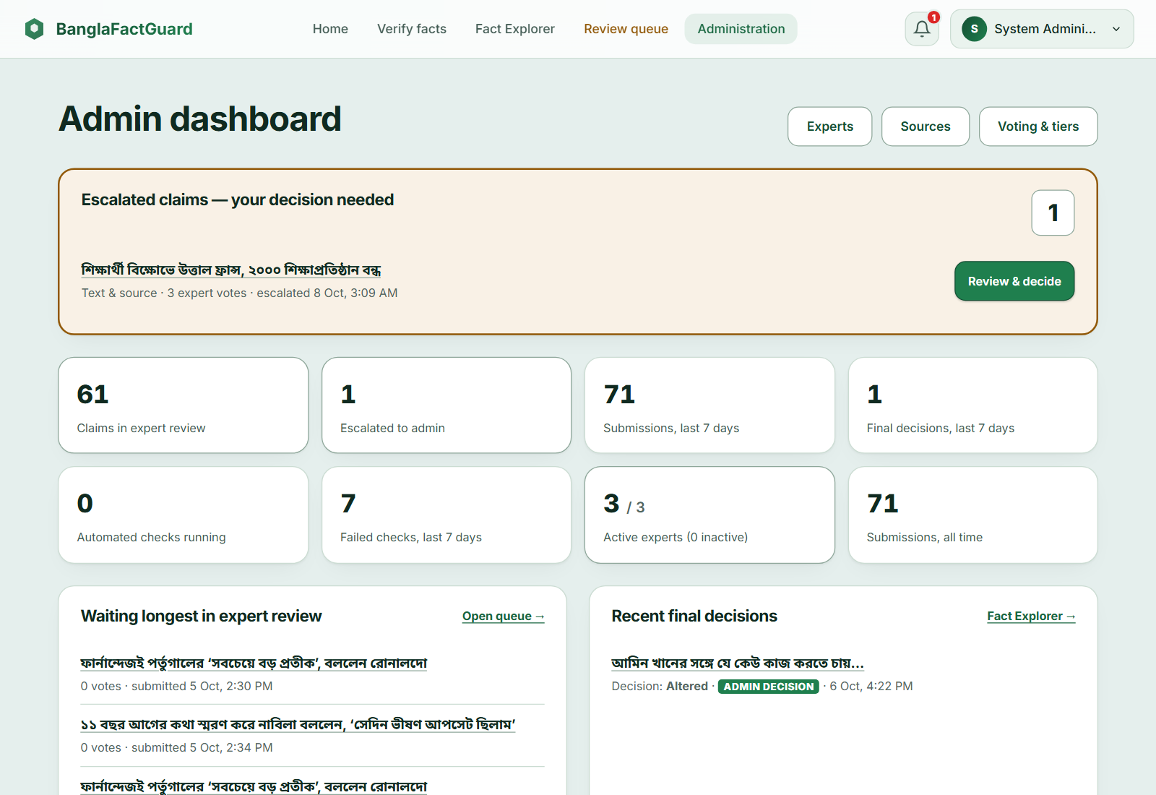
Figure 10.13: Administrator Dashboard
- Experts: click Create expert, enter name, email, password and expertise area and click Create Expert Account. Use Edit, Deactivate and Reset password in the table (Figure 10.14).
- Sources: click Register New Source to add an outlet or use Edit, Disable and Delete on a card (Figure 10.15). Only active sources are used for verification.
- Voting & tiers: set Min voters (M), Verified threshold (T), Lead margin, Activation threshold (N), Max review votes and Max review hours, then Save Configuration. Add or edit tiers with their accuracy range and weight (Figure 10.16).
- Escalated claims: in Review queue, choose Escalated — needs your decision, click Review & decide, choose the verdict, explain it and submit. Your decision is final; the public result then shows it with Voting Details (Figure 10.17). Claims that are not escalated are view-only.
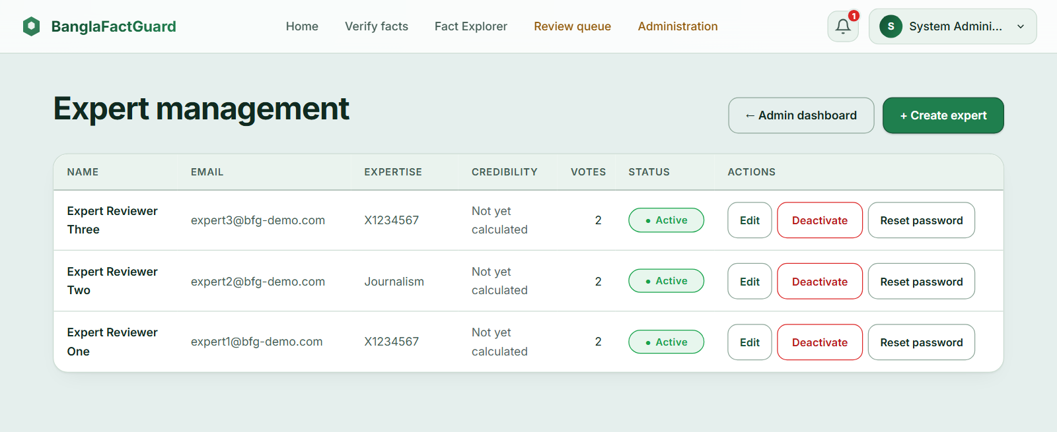
Figure 10.14: Expert Management
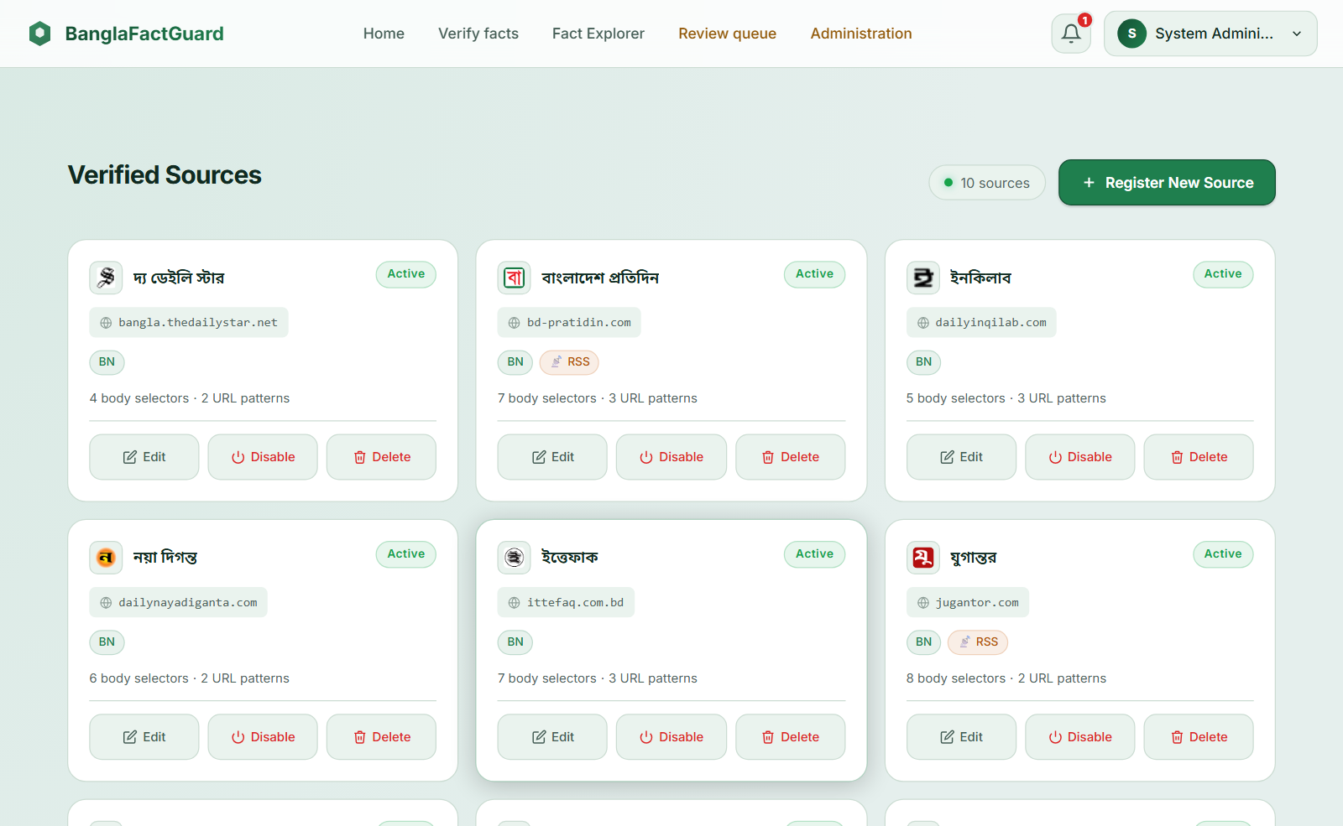
Figure 10.15: Verified Sources
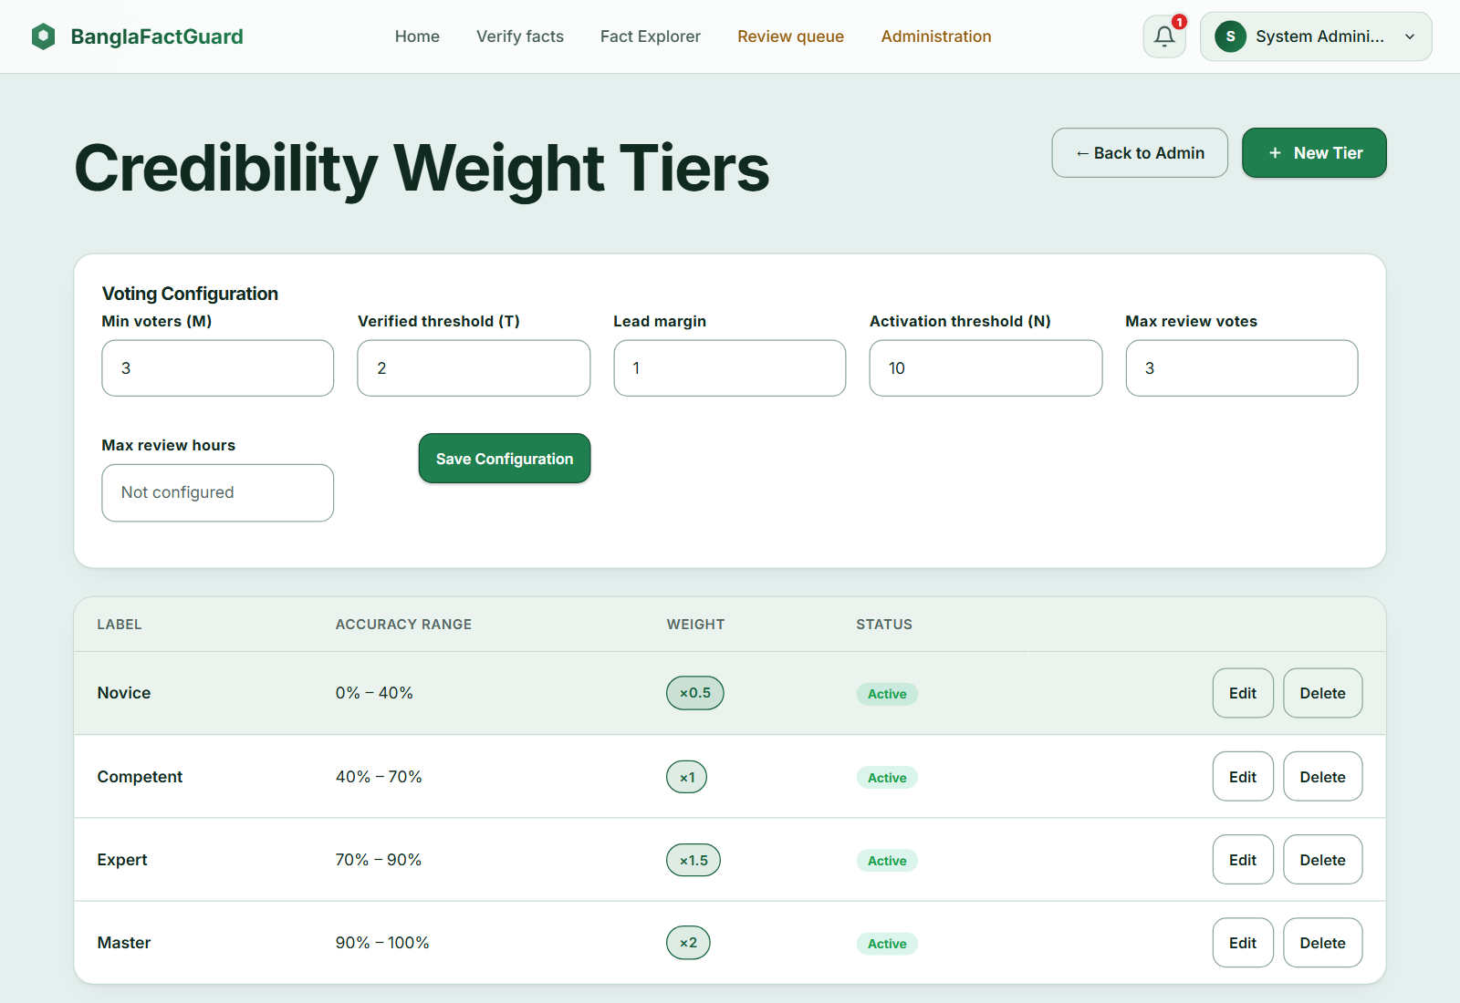
Figure 10.16: Voting Configuration and Credibility Weight Tiers
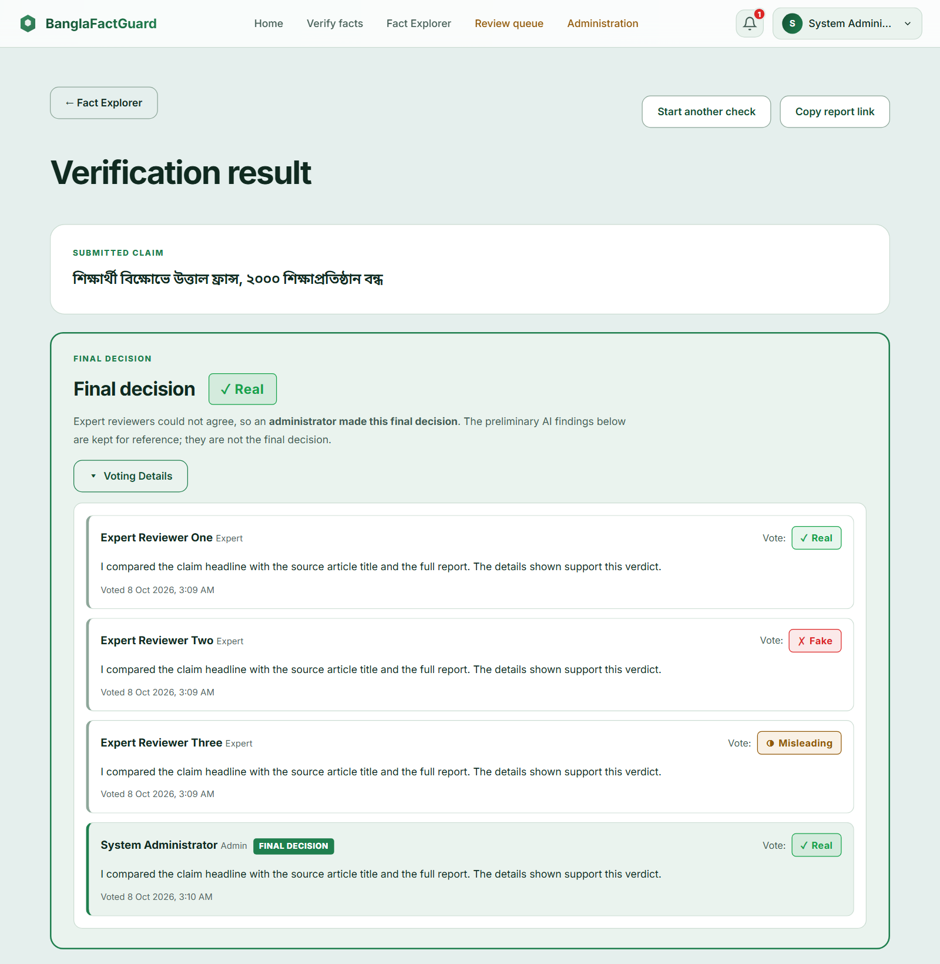
Figure 10.17: Final Decision with Voting Details After an Administrator Decision

10.10 Troubleshooting
Table 10.1: Common Problems and Solutions
Problem | What to do
“Unknown claimed source” or the outlet is missing | Choose the publisher named in the claim; ask an administrator to register or activate the outlet.
The claim stays “in progress” for a long time | Checks may take a few minutes. The backend must be running with background jobs enabled.
Photo card “temporarily unavailable” | Gemini could not be reached; submit again later.
Photo card has no valid headline or outlet | Use a clearer card that shows the headline and the outlet's name or logo.
Extension cannot capture a page | Click the pinned toolbar icon on that page first; Chrome internal pages cannot be captured, so upload an image instead.
No desktop alert | Check that the extension is ON, notifications are enabled in the Account tab and Chrome may show notifications; Activity still shows the result.

11. Repository Installation and Deployment

11.1 Repository
The source code is publicly available at https://github.com/abulkalamazad1425/BanglaFactGuard. Clone it with:
git clone https://github.com/abulkalamazad1425/BanglaFactGuard.git
cd BanglaFactGuard

11.2 Prerequisites
Table 11.1: Prerequisites
Software | Version / note
Python | 3.11 or newer, with PyTorch and model dependencies
Node.js and npm | Node 22 for the website and the extension
PostgreSQL | A database and user for the project (PostgreSQL 13+; 17 used in development)
Docker Compose | For the included Redis and MinIO services
Google Chrome | Desktop Chrome 120 or newer for the extension
Gemini API key | Needed for photo card reading
Multimodal model files | img_backbone.pt, text_backbone.pt, classifier.pt and tokenizer/ in MULTIMODAL_MODEL_DIR

11.3 Backend Setup
Run these PowerShell commands from the repository root:
cd backend
python -m venv .venv
.\.venv\Scripts\python.exe -m pip install --upgrade pip
.\.venv\Scripts\python.exe -m pip install -r requirements.txt
.\.venv\Scripts\python.exe -m playwright install chromium
Copy-Item .env.example .env
Edit backend/.env with your own values (Table 11.2). Generate a secret key with python -c "import secrets; print(secrets.token_urlsafe(48))". Never commit the .env file.
Table 11.2: Main Configuration Settings (backend/.env)
Setting | Purpose
DB_HOST, DB_PORT, DB_NAME, DB_USER, DB_PASSWORD | PostgreSQL connection
REDIS_HOST, REDIS_PORT | Redis connection
MINIO_* | Image storage endpoint, credentials and bucket
AUTH_SECRET_KEY | Required JWT signing key (at least 32 characters)
ML_* | LaBSE, NLI and NER model names (ML_NER_MODEL_NAME=arafatfahim/BanglaTag)
GEMINI_API_KEY, GEMINI_* | Photo card reading and request batches
MULTIMODAL_MODEL_DIR, MULTIMODAL_LOAD_ON_STARTUP | Text & image model files and loading
JOBS_ENABLED, JOBS_* | Background worker and recovery
EMAIL_SMTP_*, EMAIL_FROM_ADDRESS, EMAIL_WEBSITE_URL | OTP and final-result emails

11.4 Services, Database and Sources
Create the PostgreSQL database named in DB_NAME. Then, from backend/, start Redis and MinIO, apply the migrations, seed the verified sources and start the API:
docker compose up -d
.\.venv\Scripts\python.exe -m alembic upgrade head
.\.venv\Scripts\python.exe scripts/seed_verified_sources.py
.\.venv\Scripts\python.exe run.py
The API runs at http://localhost:8000 and its interactive documentation at http://localhost:8000/docs. The migrations include an initial administrator account; experts are created by the administrator.

11.5 Website
cd frontend
npm ci
npm start
Open http://localhost:4200. The development API address is set in frontend/src/environments/environment.ts (default http://localhost:8000/api/v1). A production build is made with npm run build and needs a web server that forwards /api/v1 to FastAPI.

11.6 Browser Extension (Installation)
cd extension
npm ci
npm run build
- Open chrome://extensions and turn on Developer mode.
- Click Load unpacked and select the extension/dist folder.
- Pin BanglaFactGuard — Browser Extension and click its icon on a news page.

11.7 Running the Tests
cd backend; .\.venv\Scripts\python.exe -m pytest tests/unit -q --no-cov
cd frontend; npx ng test --watch=false --browsers=ChromeHeadless
cd extension; npm test

11.8 Deployment Status
- Verified: the local deployment in Figure 6.6 (Angular dev server, uvicorn API, PostgreSQL 17 on the host, Redis and MinIO in Docker, unpacked extension) was used for the demonstration and the screenshots in this report.
- Documented but not verified: a production deployment with the built website behind a web server that proxies /api/v1. No public hosting was set up in this project.

12. Conclusion
This report presented BanglaFactGuard, a multimodal fact-checking system for Bangla news. The final system lets anyone check a claim in three ways from the website or the browser extension: against the claimed news outlet, from a photocard or as a text and image pair. Automated findings are fast and always marked as preliminary, while the final verdict comes from credibility-weighted expert voting, with administrator decisions when experts do not agree.
Compared with the SRS, several designs changed during implementation. The single automated True/False/Partially True label was replaced by separate Source, Headline and Date findings; OCR was replaced by Gemini reading of photocards; and background jobs were moved to a durable database queue. These changes make the results easier to understand and the system more reliable. All 550 executed automated tests passed.
The system still has limitations. The NLI and NER models have not been evaluated on labelled Bangla data, the multimodal model reached 80% recorded test accuracy, photocard reading depends on the Gemini service and the integration tests and a production deployment were not completed. Future work includes a labelled Bangla evaluation set, more verified outlets, load testing, a public deployment and support for video claims.

13. References
[1] F. T. J. Faria, M. B. Moin, Z. Hasan, Md. A. A. Khandaker, N. Islam, K. M. Hasib and M. F. Mridha, “MultiBanFakeDetect: Integrating advanced fusion techniques for multimodal detection of Bangla fake news in under-resourced contexts,” International Journal of Information Management Data Insights, vol. 5, Art. no. 100347, 2025.
[2] A. Bhattacharjee, T. Hasan, W. U. Ahmad, K. S. Mubasshir, M. S. Islam, A. Iqbal, M. S. Rahman and R. Shahriyar, “BanglaBERT: Language Model Pretraining and Benchmarks for Low-Resource Language Understanding Evaluation in Bangla,” in Findings of the Association for Computational Linguistics: NAACL 2022, 2022, pp. 1318–1327.
[3] M. Tan and Q. V. Le, “EfficientNet: Rethinking Model Scaling for Convolutional Neural Networks,” in Proc. 36th International Conference on Machine Learning (ICML), 2019, pp. 6105–6114.
[4] F. Feng, Y. Yang, D. Cer, N. Arivazhagan and W. Wang, “Language-agnostic BERT Sentence Embedding,” in Proc. 60th Annual Meeting of the Association for Computational Linguistics, 2022, pp. 878–891.
[5] L. Bonifacio, V. Jeronymo, H. Q. Abonizio, I. Campiotti, M. Fadaee, R. Lotufo and R. Nogueira, “mMARCO: A Multilingual Version of the MS MARCO Passage Ranking Dataset,” arXiv:2108.13897, 2021.
[6] P. He, J. Gao and W. Chen, “DeBERTaV3: Improving DeBERTa using ELECTRA-Style Pre-Training with Gradient-Disentangled Embedding Sharing,” arXiv:2111.09543, 2021.
[7] R. Panchendrarajan and A. Zubiaga, “Claim detection for automated fact-checking: A survey on monolingual, multilingual and cross-lingual research,” Natural Language Processing Journal, vol. 7, Art. no. 100066, 2024.
[8] R. S. Pressman and B. R. Maxim, Software Engineering: A Practitioner's Approach, 9th ed. New York: McGraw-Hill, 2020.

