BanglaFactGuard
A Multimodal Bangla Fact-Checking System
Final Report
SE 801: Software Project Lab III
Supervised by:
Toukir Ahammed
Lecturer
Institute of Information Technology
University of Dhaka

Submitted by:
Md. Abul Kalam Azad
Roll: BSSE-1425
Institute of Information Technology
University of Dhaka

Submitted to:
SPL-03 Program Committee
Submission Date: 11 October 2026
Institute of Information Technology
University of Dhaka

Letter of Transmittal
11 October 2026
BSSE 4th Year Exam Committee
Institute of Information Technology
University of Dhaka

Subject: Submission of the BanglaFactGuard final report
Dear Sir,
I am submitting the final report for BanglaFactGuard, my Software Project Lab III project. The report explains the requirements, system design, implementation and testing. It also includes a user manual and instructions for setting up the project.
The report describes the work completed and the limitations that remain. I have included the design diagrams, interface screenshots and recorded test results to support the discussion. I would appreciate your feedback on the project and this report.
Thank you for your consideration.
Sincerely,
Md. Abul Kalam Azad
Roll: BSSE-1425
Institute of Information Technology
University of Dhaka

_____
Supervisor's Signature
Toukir Ahammed

Acknowledgement
I thank the Institute of Information Technology, University of Dhaka, for the opportunity to complete BanglaFactGuard as part of Software Project Lab III. The project allowed me to apply software engineering, language processing and image analysis to Bangla news verification.
I am grateful to my supervisor, Toukir Ahammed, Lecturer at the Institute of Information Technology, University of Dhaka, for his guidance and feedback throughout the project. His suggestions helped me define the scope and improve the design.
I also thank my teachers and classmates for their discussions and suggestions. The resources and academic support provided by the institute helped me complete the work.

Abstract
BanglaFactGuard helps users examine Bangla news claims through a website and a Chrome extension. It supports three methods: Text & source, Photo card, and Text & image. The source check looks for relevant news reports and compares the headline and publication date. It also measures text similarity when an article body is supplied. The photo card method reads a claim from an uploaded image before checking it against news reports. The text and image method produces a preliminary classification from the two inputs.
Automated findings remain separate from the final decision. Experts review the available evidence and vote Real, Fake, Misleading or Altered. Votes are weighted according to the configured credibility rules. Claims that reach a review limit without agreement go to an administrator. Users can follow their submissions, receive result notifications and search earlier claims in Fact Explorer. Checks run in the background, and suitable saved results can be reused.
This report describes the requirements, design, implementation, testing and use of the system. The recorded multimodal evaluation achieved 80% accuracy on 960 test items. The software test record lists 550 passing tests and two skipped tests. These results describe the recorded evaluation and test runs; they do not establish the accuracy of every verification method or performance under production load.
Table of Contents
Letter of Transmittal 2
Acknowledgement 3
Abstract 4
List of Figures 8
List of Tables 9
1. Introduction 10
1.1 Problem Statement 10
1.2 Objectives 10
1.3 Scope 10
1.3.1 In Scope 10
1.3.2 Out of Scope 11
1.4 Deliverables 11
1.5 Functional and Non-Functional Requirements 12
1.5.1 Functional Requirements 12
1.5.2 Non-Functional Requirements 13
2. Activity Diagrams 14
2.1 Authentication and Registration 14
2.2 Text & Source Verification 15
2.3 Photo Card Verification 16
2.4 Text & Image (Multimodal) Verification 17
2.5 Expert Review and Voting 18
2.6 Browser Extension 19
2.7 Fact Explorer 20
3. Data-Based Modeling and Dataset Description 21
3.1 Entity-Relationship Diagram 21
3.2 Main Entities and Relationships 21
3.3 Dataset Description 23
4. Class-Based Modeling 24
5. AI Engineering Design 26
5.1 Multimodal Verification Model 26
5.1.1 Model Architecture 26
5.1.2 Recorded Evaluation 27
5.1.3 Duplicate Detection 27
5.2 Source-Based Verification Pipeline 28
5.3 Model Selection 29
5.4 Responsible Use of AI 29
6. Component-Level Design 30
6.1 Component Diagram 30
6.1.1 Information Flow 31
6.2 Design Classes 32
6.3 Persistent Data Sources 34
6.4 Behavioural Design 36
6.4.1 Submission Lifecycle 36
6.4.2 Sequence of a Text & Source Check 37
6.4.3 Voting Rules 37
6.5 Deployment Design 39
6.6 Design Alternatives Considered 40
7. Interface Design 41
7.1 User Interface Objects and Actions 41
7.2 Navigation 42
7.3 UI Events and State Transitions 43
7.3.1 Verify Facts Page 43
7.3.2 Expert and Administrator Review 44
7.3.3 Browser Extension Side Panel 45
7.4 Interface States as Seen by the User 45
8. Implementation 52
8.1 Technology Stack 52
8.2 Code Organisation 52
8.3 Key Implementation Details 52
8.3.1 Authentication and Roles 52
8.3.2 Background Jobs and Reuse 52
8.3.3 Photo Card Reading 52
8.3.4 Voting, Escalation and Notifications 53
8.3.5 Browser Extension 53
8.4 Main API Routes 53
9. Testing 54
9.1 Testing Approach and Strategy 54
9.2 Test Environment and Tools 54
9.3 Item Pass/Fail Criteria 54
9.4 Summary of Executed Test Runs 54
9.5 Test Cases with Detailed Outcomes 55
9.5.1 Authentication and Sessions 55
9.5.2 Text & Source Verification 56
9.5.3 Photo Card and Text & Image Verification 57
9.5.4 Expert Review, Voting and Escalation 58
9.5.5 Notifications, Fact Explorer and Extension 59
9.6 Observed Performance and Model Results 59
9.7 Tests Not Executed or Not Verified 59
9.8 Risks and Contingencies 60
10. User Manual 61
10.1 Getting Started 61
10.2 Creating an Account and Signing In 61
10.3 Checking a Claim 62
10.3.1 Text & Source (News story against claimed source) 62
10.3.2 Photo Card (Photocard against claimed source) 62
10.3.3 Text & Image (News story against an image) 63
10.4 Reading a Result 64
10.5 Fact Explorer 67
10.6 My Submissions, Notifications and Settings 68
10.7 Using the Browser Extension 69
10.8 Expert Tasks 71
10.9 Administrator Tasks 72
10.10 Troubleshooting 76
11. Repository Installation and Deployment 77
11.1 Repository 77
11.2 Prerequisites 77
11.3 Backend Setup 77
11.4 Services, Database and Sources 78
11.5 Website 78
11.6 Browser Extension (Installation) 78
11.7 Running the Tests 79
11.8 Deployment Status 79
12. Conclusion 80
13. References 81

List of Figures
Figure 2.1: Activity Diagram — Authentication and Registration 14
Figure 2.2: Activity Diagram — Text & Source Verification 15
Figure 2.3: Activity Diagram — Photo Card Verification 16
Figure 2.4: Activity Diagram — Text & Image Verification 17
Figure 2.5: Activity Diagram — Expert Review and Voting 18
Figure 2.6: Activity Diagram — Browser Extension 19
Figure 2.7: Activity Diagram — Fact Explorer 20
Figure 3.1: Entity-Relationship Diagram — BanglaFactGuard 21
Figure 4.1: Analysis Class Diagram (CRC View) 24
Figure 5.1: Multimodal Verification Architecture — Text and Image Fusion 26
Figure 5.2: Source-Based Verification Pipeline — Stages S01 to S13 28
Figure 6.1: Component Diagram of BanglaFactGuard 30
Figure 6.2: Design Class Diagram 32
Figure 6.3: Persistent Data Sources and Their Classes 34
Figure 6.4: State Diagram of a Submission 36
Figure 6.5: Sequence Diagram — Text & Source Claim (rotated to fit the page) 38
Figure 6.6: Deployment Diagram 39
Figure 7.1: Website Navigation by User Role 42
Figure 7.2: State Diagram of the Verify Facts Interface 43
Figure 7.3: State Diagram of the Review Interface 44
Figure 7.4: State Diagram of the Extension Side Panel 45
Figure 7.5: EDITING State — Text & Source Claim Form 46
Figure 7.6: IN PROGRESS State — Claim Received 47
Figure 7.7: PRELIMINARY RESULT State — Final Decision Under Review 48
Figure 7.8: FINAL DECISION State — Administrator Decision on a Photo Card 49
Figure 7.9: CHECK FAILED State — Photo Card Could Not Be Read 50
Figure 7.10: Extension States — Signed In, Checking Your Claim and Result Ready 50
Figure 7.11: VOTE FORM State — Expert Review Page 51
Figure 10.1: Home Page 61
Figure 10.2: Create Account Page 62
Figure 10.3: Photo Card Form with Preview 63
Figure 10.4: Text & Image Result with a Reused Assessment 64
Figure 10.5: Headline Comparison Showing an Altered Headline 65
Figure 10.6: Body Similarity Scores 65
Figure 10.7: Result When the Claimed Source Has No Matching Report 66
Figure 10.8: Fact Explorer 67
Figure 10.9: My Submissions 68
Figure 10.10: Notifications 69
Figure 10.11: Extension Verify Tab — Text & Source, Photo Card and Text & Image 70
Figure 10.12: Expert Review Queue 71
Figure 10.13: Administrator Dashboard 72
Figure 10.14: Expert Management 73
Figure 10.15: Verified Sources 73
Figure 10.16: Voting Configuration and Credibility Weight Tiers 74
Figure 10.17: Final Decision with Voting Details After an Administrator Decision 75

List of Tables
Table 1.1: Functional Requirements 12
Table 1.2: Non-Functional Requirements 13
Table 3.1: Main Entities and Their Key Attributes 22
Table 3.2: Dataset Split Summary (Text–Image Pairs) 23
Table 4.1: Class Responsibilities and Collaborators 25
Table 5.1: Multimodal Model Configuration 26
Table 5.2: Recorded Test Results of the Multimodal Model (960 test items) 27
Table 5.3: Source-Based Verification Pipeline — Stage Reference 28
Table 5.4: AI Model Selection Summary 29
Table 6.1: Main Components and Their Responsibilities 30
Table 6.2: Design Classes and Domain Concepts 33
Table 6.3: Persistent Data Sources 35
Table 6.4: Submission States 37
Table 6.5: Deployment Nodes 39
Table 6.6: Design Alternatives and Decisions 40
Table 7.1: User Interface Objects and Actions 41
Table 7.2: Events and State Transitions on the Verify Facts Page 44
Table 8.1: Technology Stack 52
Table 8.2: Main API Routes (prefix /api/v1) 53
Table 9.1: Test Environment 54
Table 9.2: Executed Automated Test Runs (8 October 2026) 54
Table 9.3: Test Cases — Authentication and Sessions 55
Table 9.4: Test Cases — Text & Source Verification 56
Table 9.5: Test Cases — Photo Card and Text & Image 57
Table 9.6: Test Cases — Expert Review and Voting 58
Table 9.7: Test Cases — Notifications, Fact Explorer and Extension 59
Table 9.8: Tests Not Executed in This Run 59
Table 9.9: Testing Risks and Contingencies 60
Table 10.1: Common Problems and Solutions 76
Table 11.1: Prerequisites 77
Table 11.2: Main Configuration Settings (backend/.env) 78

Project Title: BanglaFactGuard: A Multimodal Bangla Fact-Checking System
GitHub Repository: https://github.com/abulkalamazad1425/BanglaFactGuard

1. Introduction
Bangla news is shared as articles, short headlines and photo cards. A photo card is an image containing a news headline, often with a publisher name or logo. When this content is copied or edited, readers may need to find the original report before judging the claim.
BanglaFactGuard brings claim submission, evidence checking and expert review into one system. Users submit content through the website or Chrome extension. The system provides preliminary findings, and human reviewers decide the final verdict. Fact Explorer provides access to available claims and their review status.

1.1 Problem Statement
Checking a shared claim can require several steps: identifying the publisher, finding the original article and comparing its wording and date. A photo card adds another difficulty because the claim must first be read from an image. Automated predictions can assist this work, but a prediction or an unsuccessful search is not enough to establish whether a claim is true.
The project addresses this problem by combining evidence retrieval with human review. It accepts common forms of Bangla news, explains the available automated findings and keeps the final decision with experts or an administrator.

1.2 Objectives
The objectives of BanglaFactGuard are:
- To let users check Bangla news claims in three ways: Text & source, Photo card, and Text & image.
- To compare claims with relevant news reports and present separate findings for the source, headline and publication date.
- To provide a preliminary prediction for news submitted as text and an image.
- To support expert voting and administrator decisions for claims that cannot be resolved within the review limits.
- To reuse suitable results from earlier checks and identify when a result has been reused.
- To provide a public Fact Explorer, personal submission history and result notifications.
- To provide a browser extension so users can check a claim from the page they are reading.
- To provide tools for managing experts, registered news sources and voting rules.

1.3 Scope

1.3.1 In Scope
- A website that supports guests, registered users, experts and administrators.
- Three verification methods: Text & source, Photo card, and Text & image.
- Separate source, headline and date findings, with four similarity measures when article text is supplied.
- Background processing, progress updates and reuse of compatible saved results.
- Expert review, credibility-weighted voting, escalation and administrator decisions.
- Public Fact Explorer with search, filters and statistics.
- In-app notifications for signed-in submitters and queued final-result emails.
- A Chrome extension with text import, image upload, selected-area capture, cropping, activity history and alerts.
- Administration of experts, verified news sources, credibility tiers and voting configuration.

1.3.2 Out of Scope
- Checking claims in languages other than Bangla.
- Native mobile applications; the system is a website and a desktop Chrome extension.
- Video verification.
- Fully automated final verdicts; every final verdict comes from experts or an administrator.
- Automatic crawling of social media; only submitted claims are checked.
- Removing content or taking legal action against publishers.

1.4 Deliverables
- The BanglaFactGuard website, backend service and Chrome extension.
- The training notebook and the trained model files required for text and image prediction.
- The database design, database update scripts and source registration setup.
- Automated test suites for the backend, the website and the extension.
- This final report, with design, implementation, testing, a user manual and installation steps.
- A public Git repository: https://github.com/abulkalamazad1425/BanglaFactGuard.
- The extension is installed from its build folder as an unpacked Chrome extension. Section 11.6 gives the installation steps.

1.5 Functional and Non-Functional Requirements

1.5.1 Functional Requirements
Table 1.1 summarises the main functions supported by the system.
Table 1.1: Functional Requirements
ID | Requirement | Users
FR-1 | Create an account, sign in and out, and reset a forgotten password using an emailed verification code. | Visitors and account holders
FR-2 | Submit a Bangla headline, with an optional news outlet, article body and claimed date. Use registered sources when no active outlet is identified. | All users
FR-3 | Read a headline and any visible outlet or date from a photo card. Explain when the image cannot be processed. | All users
FR-4 | Submit a headline, article text and image to receive a preliminary Likely Real or Likely Fake prediction. | All users
FR-5 | Present source, headline and date findings separately. Explain when a comparison is unavailable or incomplete. | All users
FR-6 | Show four body-similarity scores when article text is supplied. | All users
FR-7 | Reuse a compatible completed result and tell the user when this occurs. | All users
FR-8 | Process accepted claims in the background and display their progress. | All users
FR-9 | Allow experts to inspect claims and evidence, then submit a verdict with a justification of at least 50 characters. | Expert
FR-10 | Apply the configured voting rules and send unresolved claims to an administrator when a review limit is reached. | Expert, Administrator
FR-11 | Allow administrators to decide escalated claims and inspect other claims without changing their verdicts. | Administrator
FR-12 | Provide a public Fact Explorer with search, filters and statistics. | All users
FR-13 | Provide personal submission history and notifications, with final-result email delivery when configured. | Account holders
FR-14 | Manage expert accounts, verified sources, credibility tiers and voting configuration. | Administrator
FR-15 | Offer all three methods in the browser extension, with selected-text import, screenshot capture, cropping, activity and alerts. | All users

1.5.2 Non-Functional Requirements
Table 1.2 describes the main quality requirements and the mechanisms used to address them. Performance and accuracy limits are discussed in Chapter 9.
Table 1.2: Non-Functional Requirements
ID | Category | Requirement and supporting mechanism
NFR-1 | Performance | Long checks run in the background; the website and extension stay usable and show the current status.
NFR-2 | Efficiency | Reuse compatible results and cache search data and text representations to reduce repeated processing.
NFR-3 | Security | Store hashed passwords and use expiring access tokens. Password reset codes expire and can be used only once.
NFR-4 | Security | Restrict expert and administrator actions by role, protect personal records and prevent experts from reviewing their own claims.
NFR-5 | Usability | Accept Bangla content and explain findings through readable labels, result details and a public FAQ.
NFR-6 | Reliability | Keep accepted jobs in the database, recover abandoned work and show a reason when processing fails.
NFR-7 | Data integrity | Save a submission and its job together, avoid repeated result records and retain the weight applied to each vote.
NFR-8 | Correctness and transparency | Keep automated findings separate from final verdicts. Do not label a claim Fake solely because no source report was found.
NFR-9 | Maintainability | Separate features into modules and allow administrators to update sources and voting rules through the interface.
NFR-10 | Compatibility | Support the Chrome extension and website with the same accounts while keeping their login sessions separate.

2. Activity Diagrams
The activity diagrams describe the main user workflows, from submitting a claim to receiving a reviewed result. Each explanation identifies the input, the main decision points and the outcome. Account settings, notifications and source management are covered in Chapters 7 and 10.

2.1 Authentication and Registration
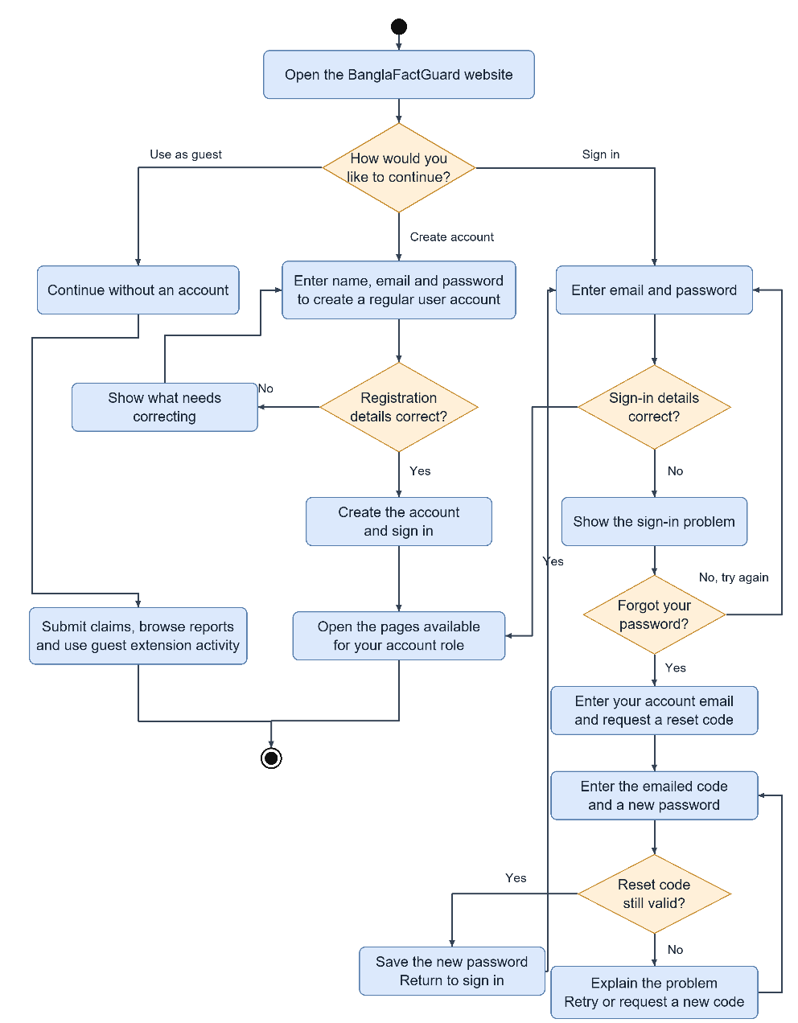
Figure 2.1: Activity Diagram — Authentication and Registration
Visitors can continue as guests, register or sign in. Registration checks the submitted details before creating an account. If sign-in fails, the form displays an error. Password recovery uses an emailed code and a new password. After sign-in, the available pages depend on the account role.

2.2 Text & Source Verification
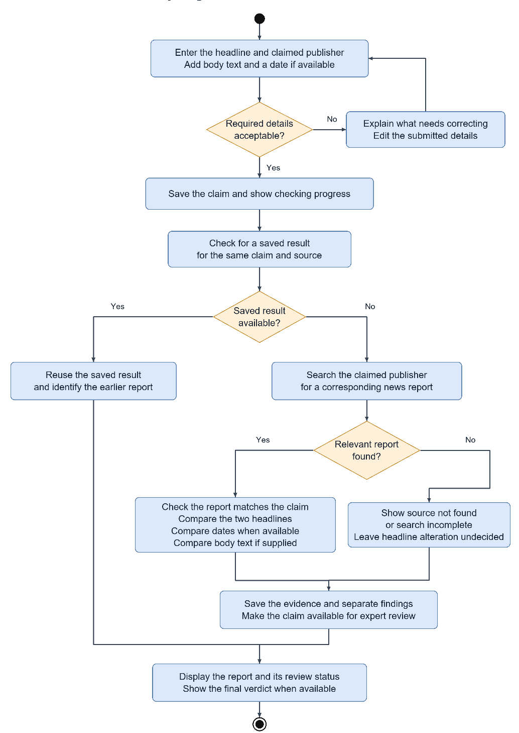
Figure 2.2: Activity Diagram — Text & Source Verification
The user submits a headline and may add the outlet, article text and date. The system reuses a compatible result or searches for relevant reports. A recognised outlet limits the search to that publisher; otherwise, the current system can search active registered sources. It then reports the available comparisons and sends the claim for expert review. An unsuccessful or incomplete search does not produce a Fake verdict.

2.3 Photo Card Verification
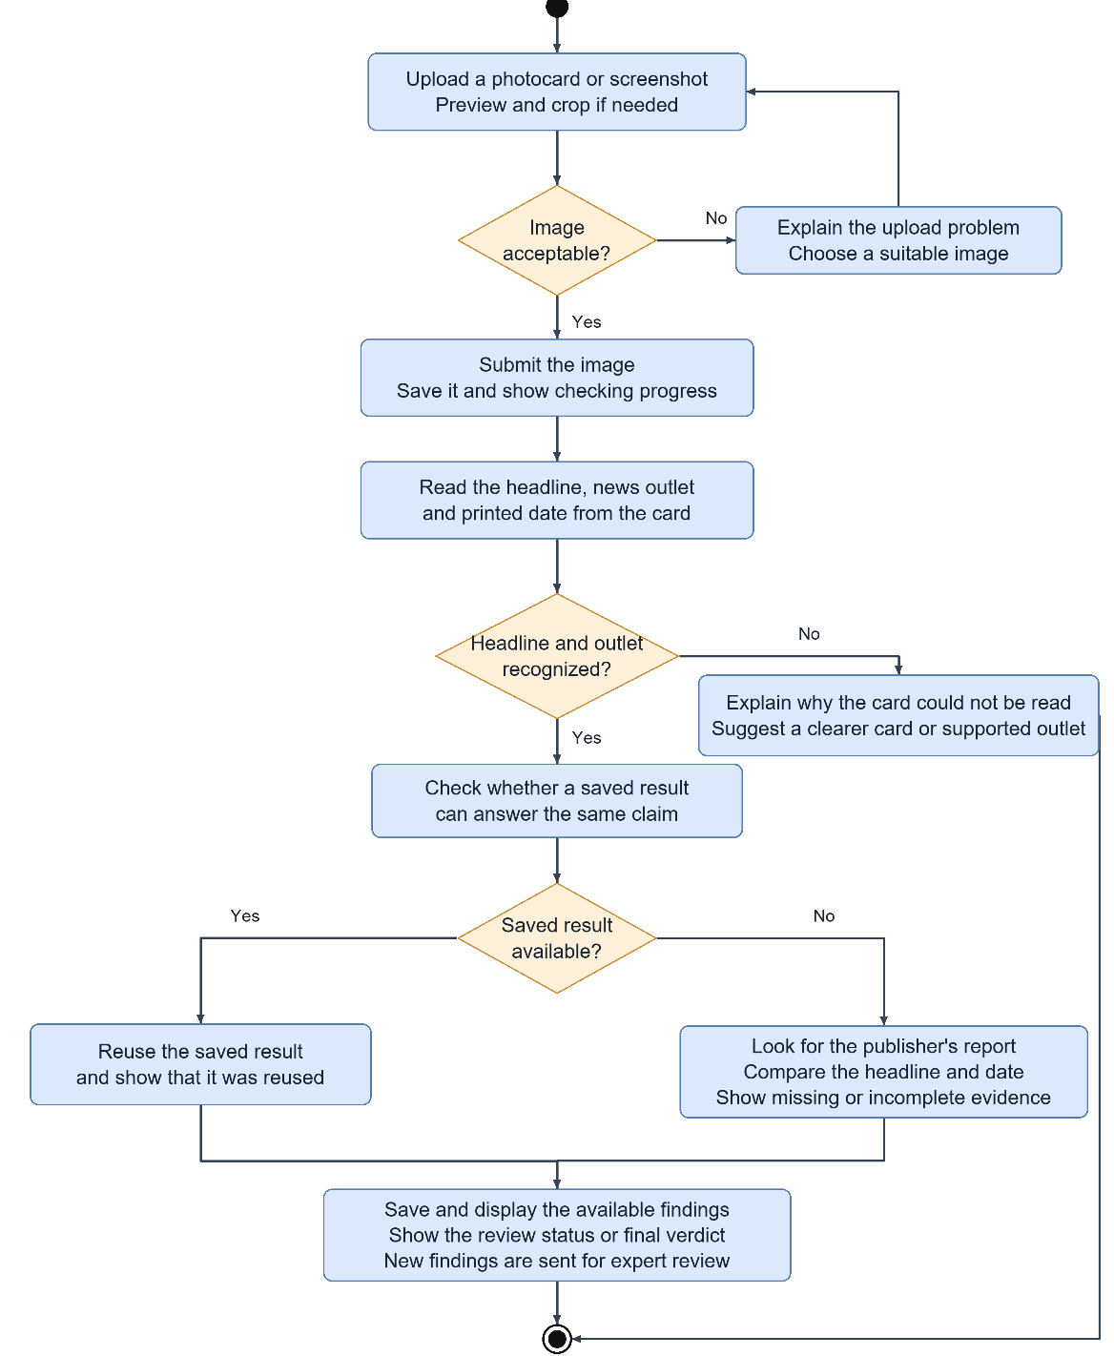
Figure 2.3: Activity Diagram — Photo Card Verification
The user uploads a photo card. The system reads its headline and any visible outlet and date, then checks the extracted claim against news reports. A recognised outlet defines the search scope. If the outlet is missing or unrecognised, the current system can search active registered sources. An unreadable headline or a failed image-reading service prevents the check and produces an explanation.

2.4 Text & Image (Multimodal) Verification
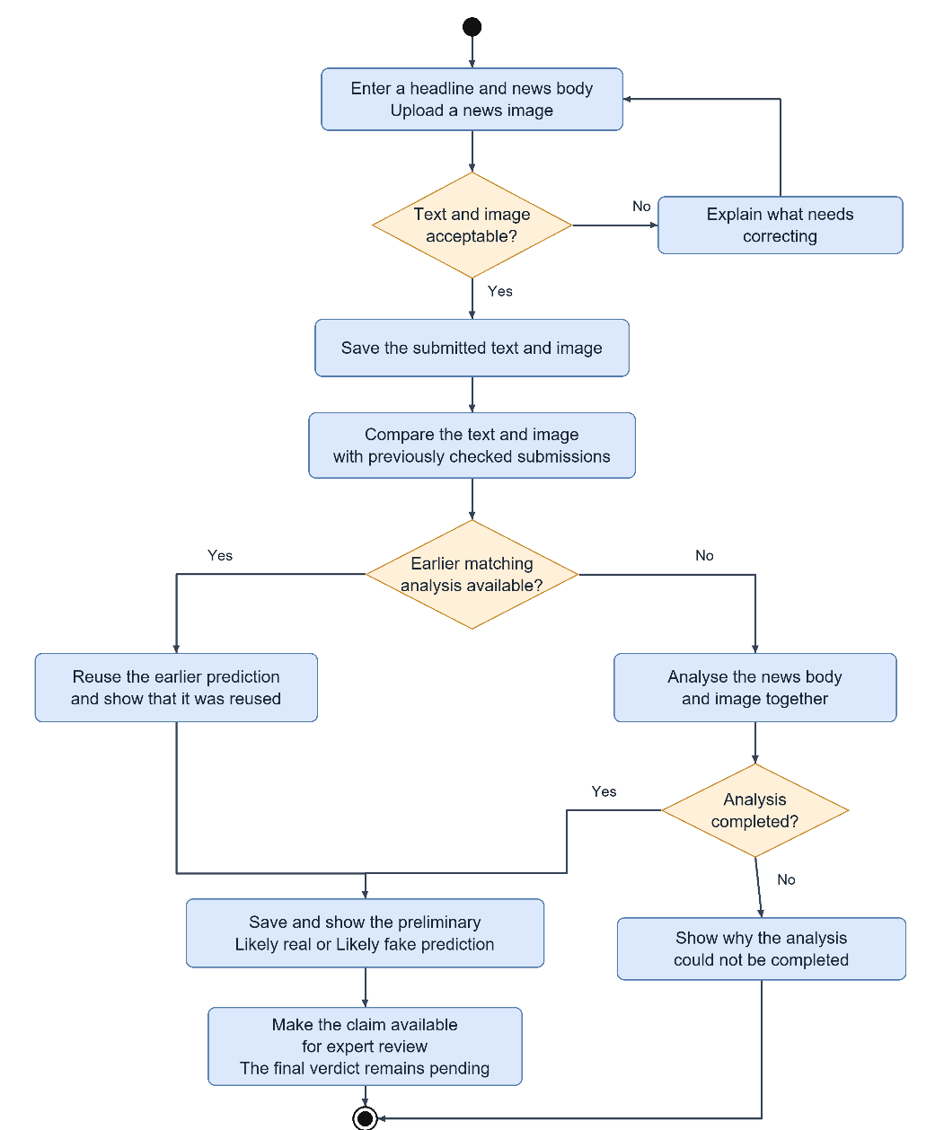
Figure 2.4: Activity Diagram — Text & Image Verification
The user submits a headline, article text and image. The system compares the text and image with earlier analyses. A sufficiently close match can reuse a saved prediction. Otherwise, it analyses the article text and image together and returns Likely Real or Likely Fake. This prediction remains preliminary while the claim awaits expert review.

2.5 Expert Review and Voting
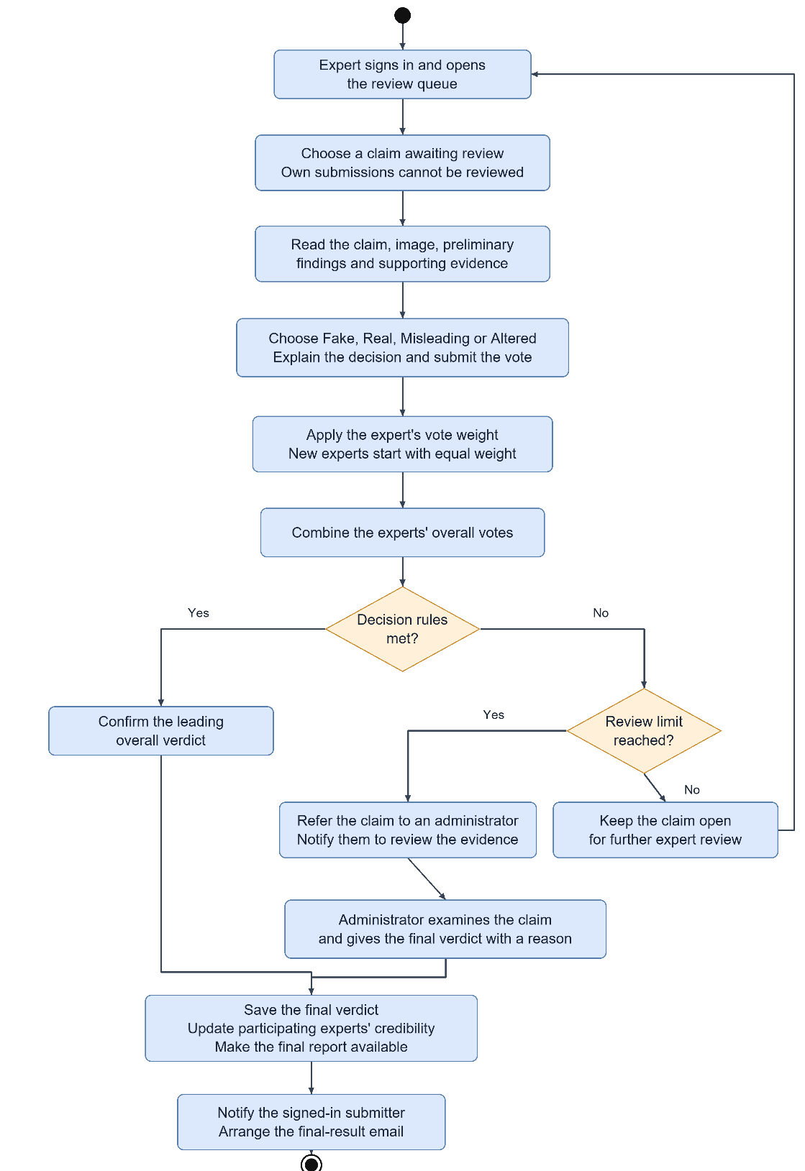
Figure 2.5: Activity Diagram — Expert Review and Voting
An expert selects a claim, reads the evidence and submits a verdict with a written explanation. Experts cannot review their own submissions. The system combines the weighted votes and checks the decision rules. A claim becomes final when those rules are met, or goes to an administrator if a review limit is reached first. The final decision is saved and result delivery is scheduled.

2.6 Browser Extension
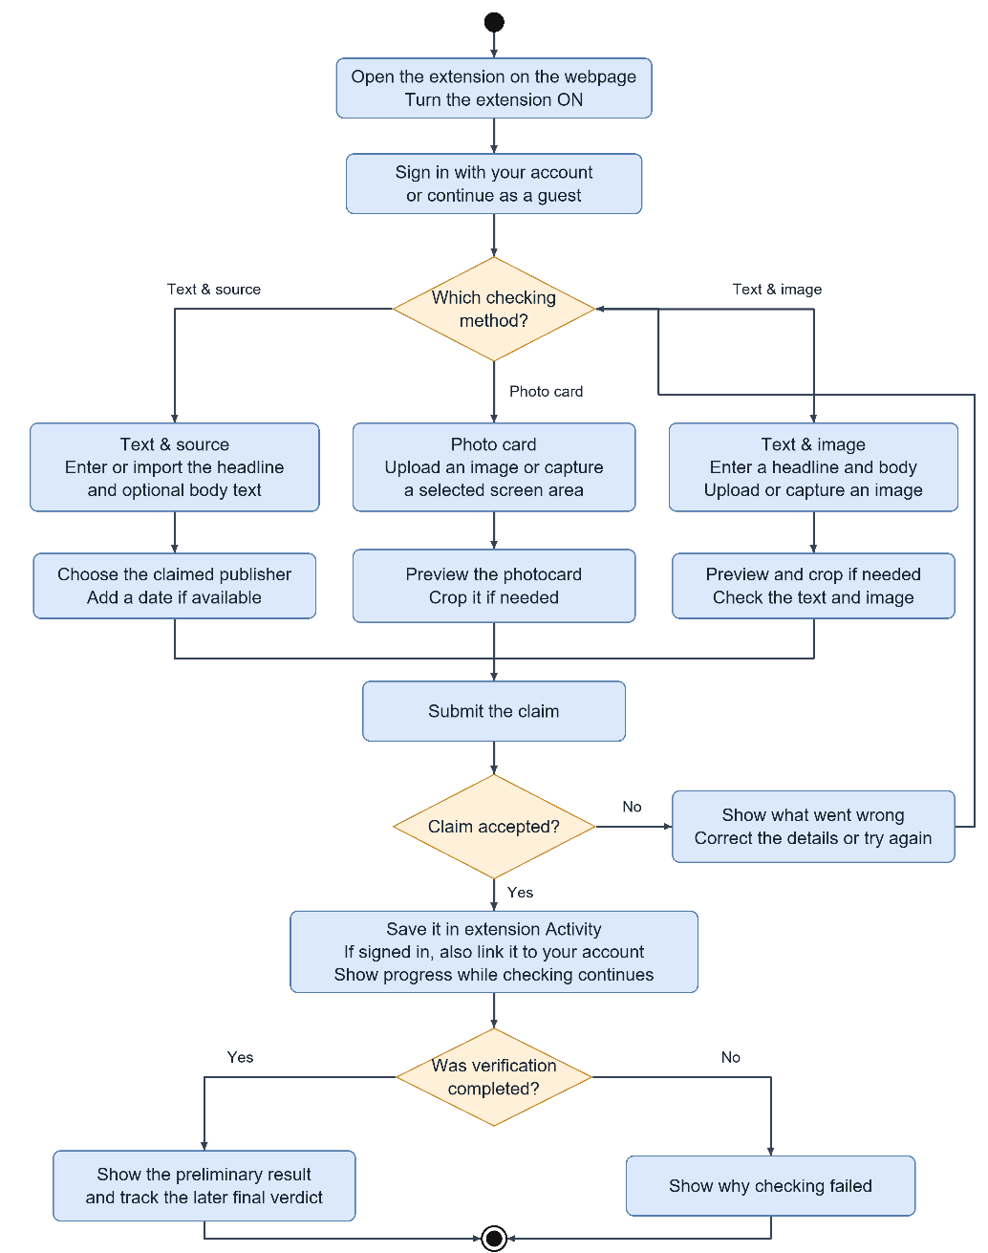
Figure 2.6: Activity Diagram — Browser Extension
The extension lets users submit and follow claims beside the page they are reading. They can type or import text, upload an image, or capture and crop a selected area. Activity shows the progress, available findings and final decision. Failed checks show a reason.

2.7 Fact Explorer
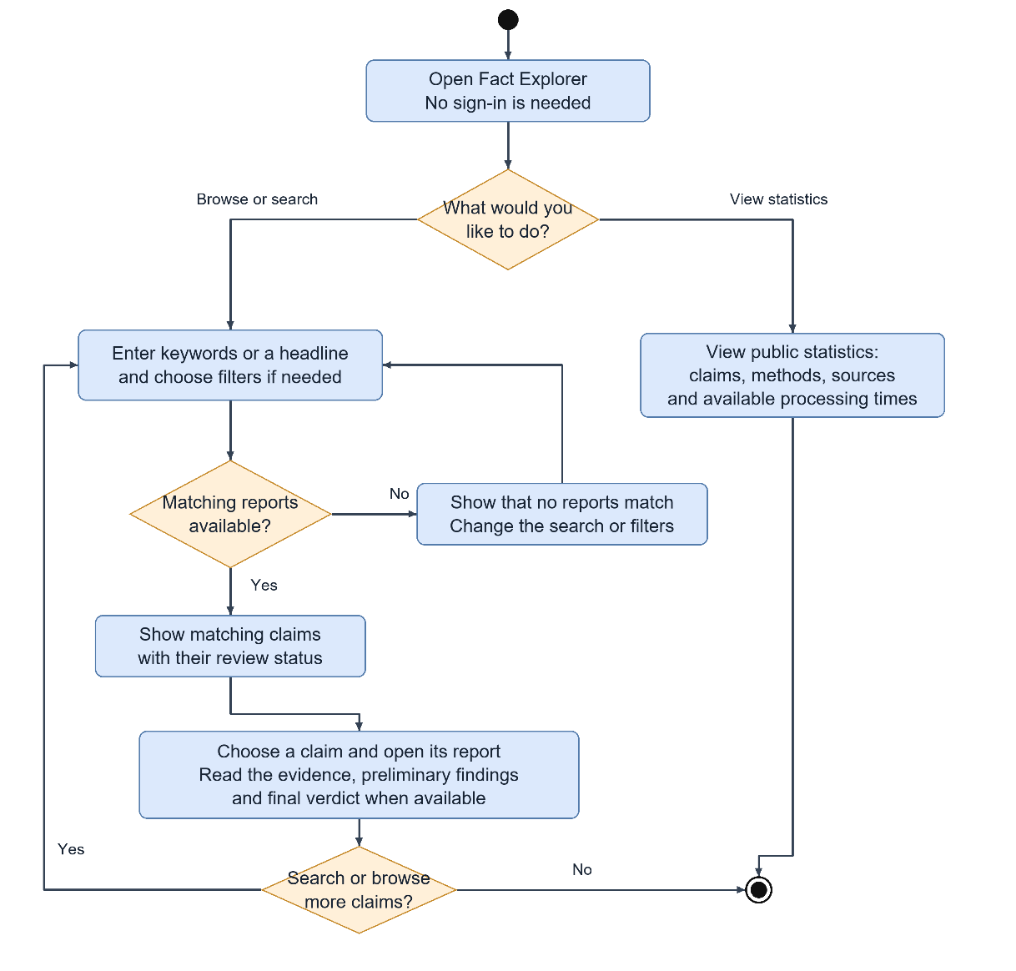
Figure 2.7: Activity Diagram — Fact Explorer
Fact Explorer is available without sign-in. Users can search claims, apply filters and view archive statistics. Each available report shows its evidence and review status, including the final verdict when one has been published.

3. Data-Based Modeling and Dataset Description

3.1 Entity-Relationship Diagram
Figure 3.1 presents the main data entities and their relationships. A submission connects the claim to its evidence, automated findings and reviews. The diagram distinguishes user roles at a conceptual level; the database stores account roles in one user table and keeps additional expert information in a separate profile.
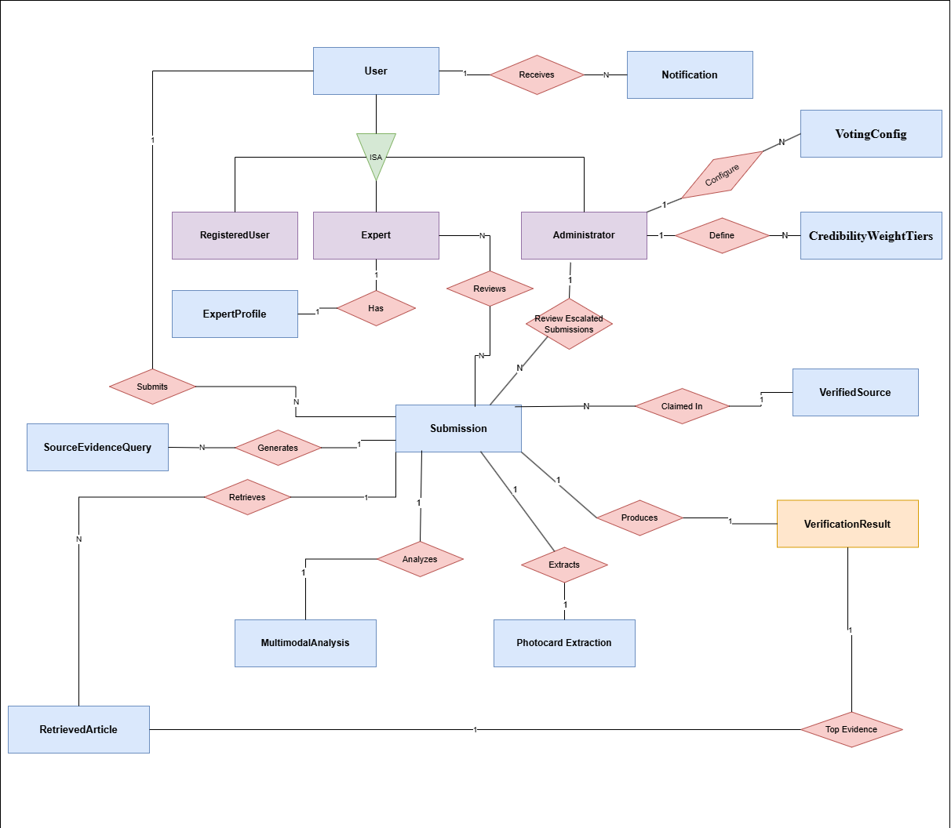
Figure 3.1: Entity-Relationship Diagram — BanglaFactGuard

3.2 Main Entities and Relationships
The main relationships are:
- One account can have many submissions and notifications. Guest submissions do not require an account.
- An expert account can have one expert profile. Each expert can review several submissions, and each submission can receive reviews from several experts.
- Administrators manage voting rules and credibility tiers and provide final decisions for escalated submissions.
- A submission can refer to one claimed news source. This relationship is optional for text and image checks and for searches across registered sources.
- A submission can have several search queries and retrieved articles as its evidence record.
- Depending on the verification method, a submission can have a photo card extraction, a multimodal analysis and a verification result. A source-based result can identify a selected evidence article when one is available.
Table 3.1 summarises the main entities and their stored information. Supporting records handle sessions, background jobs and result delivery, as discussed in Section 6.3.
Table 3.1: Main Entities and Their Key Attributes
Entity | Purpose | Main information
User account | Identity and access details | Name, email, password hash, role and account status
Expert profile | Expertise and review record | Expertise area, completed reviews, agreement with final decisions and credibility score
News source | Registered news publisher | Publisher name, aliases, website, search and extraction settings, and active status
Submission | Claim and processing record | Method, headline, article text, claimed outlet and date, submitter, status and failure reason
Evidence article | Retrieved news report | Article address, title, text, publication date and relevance score
Evidence search | Record of an article search | Search text, query type, search provider and number of results
Verification result | Findings and reviewed decision | Source, headline and date findings, comparison details, selected article and final verdict
Photo card extraction | Information read from a card | Image reference, extracted content, reading status, attempts and failure details
Text and image analysis | Preliminary model assessment | Prediction, class confidence scores, text and image representations, and model version
Expert review | Reviewer decision and explanation | Reviewer, submission, verdict, justification, vote weight and administrator decision indicator
Voting rules and credibility tiers | Decision settings | Minimum voters, required vote weight, lead margin, review limits and accuracy-based weight ranges
Notification | Personal result update | Recipient, title, message, type, result link and read status

3.3 Dataset Description
The text and image model uses the MultiBanFakeDetect dataset [1]. Each item combines news text with an image. The project uses two labels, Real and Fake, to train and evaluate the classifier.
The training notebook contains 7,680 training items, 960 validation items and 960 test items, giving an 80/10/10 split. The training set contains 3,840 items per class, and the test set contains 480 items per class. Table 3.2 summarises the dataset sizes recorded in the notebook.
Table 3.2: Dataset Split Summary (Text–Image Pairs)
Subset | Instances | Share of dataset
Training | 7,680 | 80%
Validation | 960 | 10%
Testing | 960 | 10%
Total | 9,600 | 100%

The source and photo card methods use retrieved news articles and pretrained language models. Their evidence depends on the active source list and the reports available when a check runs. These methods were not evaluated using the multimodal test set.

4. Class-Based Modeling
Class-based modelling groups the main responsibilities of the system. Figure 4.1 shows the analysis classes and how they work together. Table 4.1 summarises their responsibilities and collaborators. Chapter 6 describes their implementation as service components.
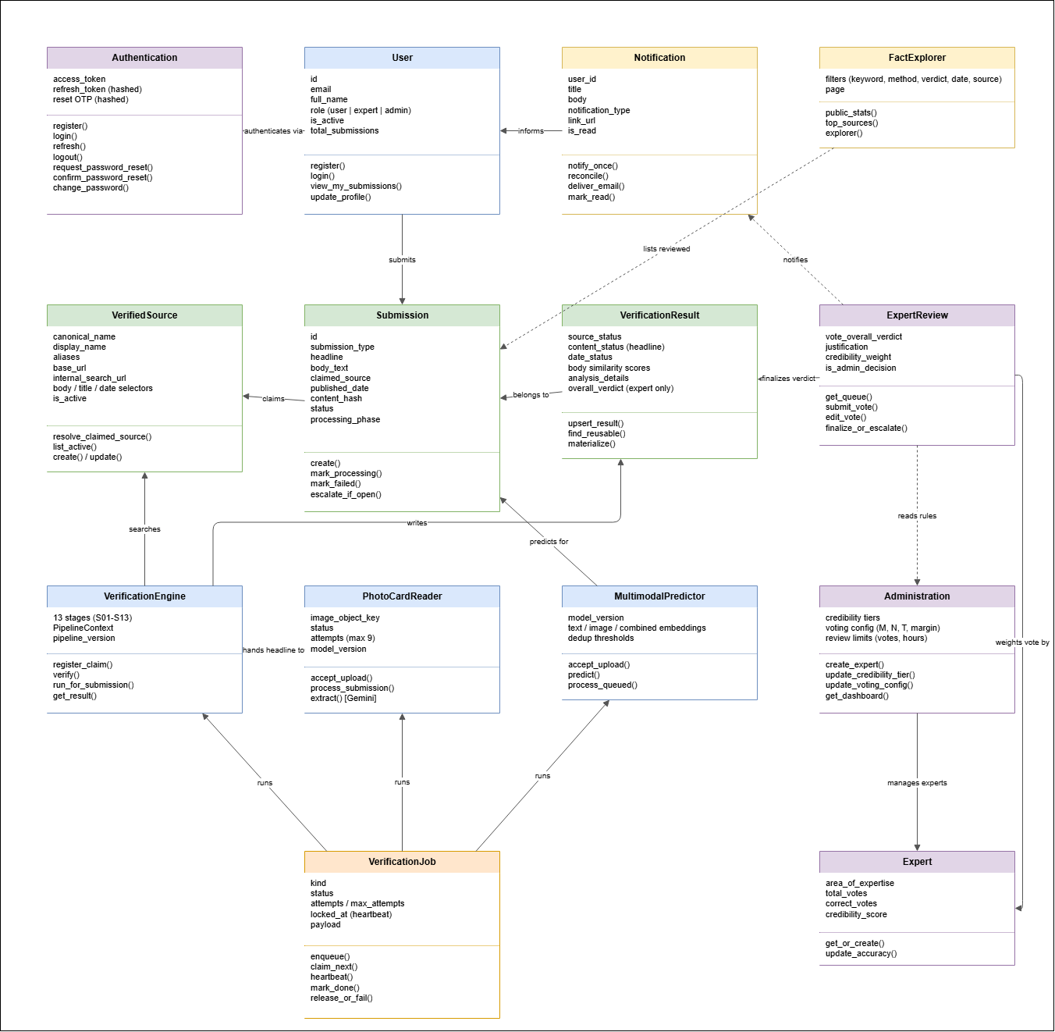
Figure 4.1: Analysis Class Diagram (CRC View)
Table 4.1: Class Responsibilities and Collaborators
Class | Responsibilities | Collaborators
User | Creates an account, signs in and manages personal submissions and settings | Authentication, Submission, Notification
Authentication | Controls sign-in, session renewal, sign-out and password recovery | User
Submission | Stores the claim and tracks its progress and review status | News source, Verification result, Expert review
News source | Identifies registered publishers and their search settings | Submission, Verification engine
Verification engine | Retrieves evidence and prepares source, headline and date findings | Submission, News source, Verification result
Photo card reader | Reads a claim from an image and passes it to the verification engine | Verification engine, Submission
Text and image predictor | Produces preliminary predictions and identifies reusable analyses | Submission
Verification job | Tracks queued work, progress, completion and recovery | Verification engine, Photo card reader, Text and image predictor
Verification result | Stores findings and supports reuse of compatible results | Submission, Expert review
Expert review | Records votes and supports final decisions or escalation | Expert, Administration, Notification
Expert | Maintains an expertise profile and a record of completed reviews | Expert review, Administration
Administration | Manages experts, tiers, voting rules and the dashboard | Expert, Expert review
Notification | Records personal updates and tracks final-result email delivery | User, Expert review
Fact Explorer | Provides access to available claims, filters and archive statistics | Submission

5. AI Engineering Design
AI supports two main tasks: assessing text and images together, and comparing a claim with retrieved news reports. This chapter explains the models used for those tasks and the limits of their output. Photo card reading supplies the claim text for the source check; its processing is described in Section 8.3.3.

5.1 Multimodal Verification Model

5.1.1 Model Architecture
Figure 5.1 shows how the model combines text and image features. BanglaBERT represents the article text [2], while EfficientNet-B4 represents the image [3]. A classifier combines these representations to produce scores for Real and Fake.
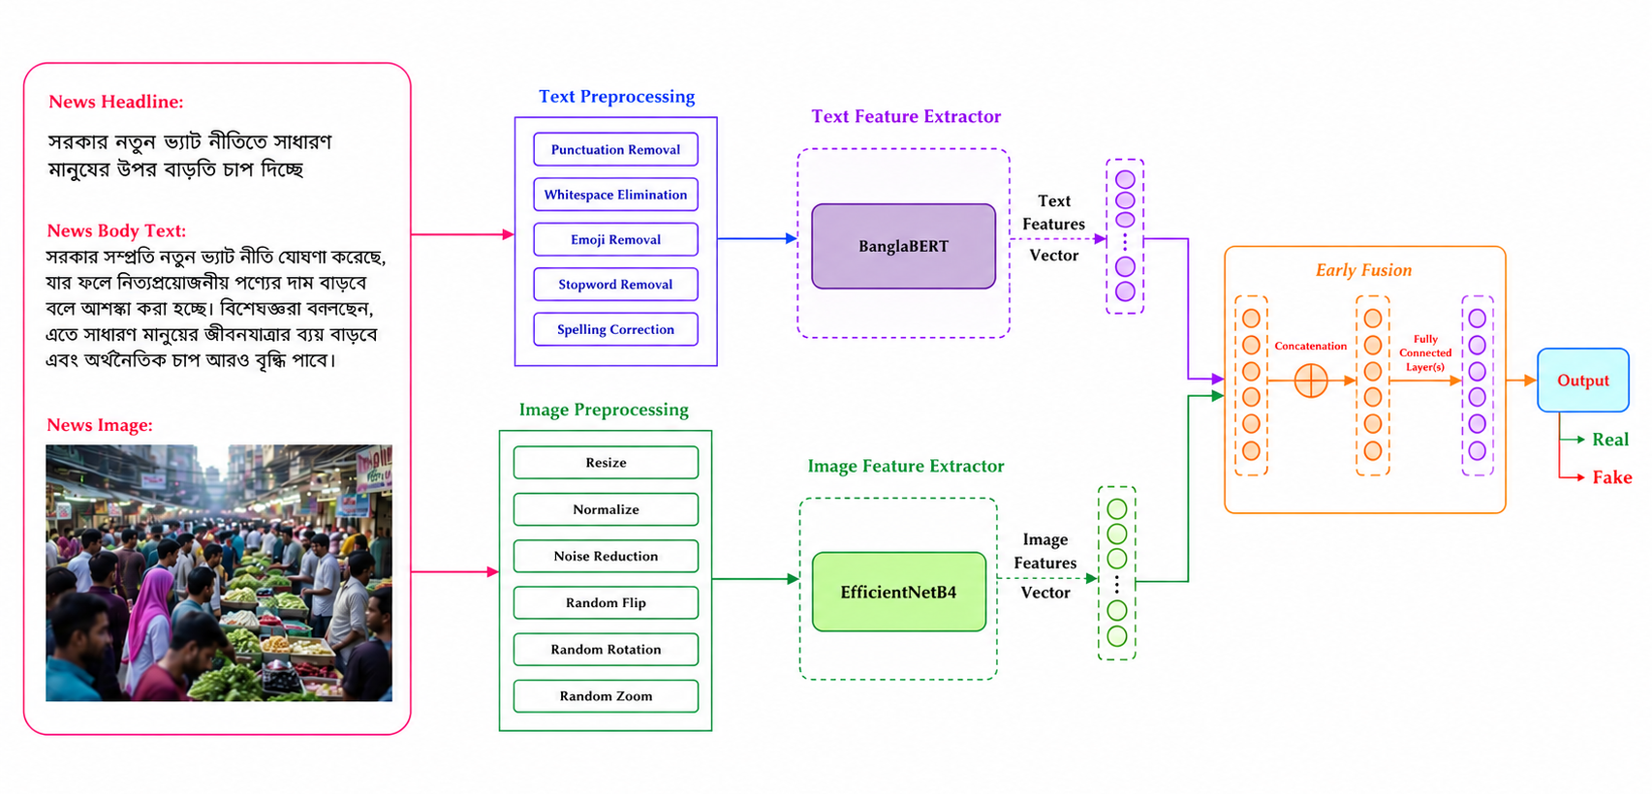
Figure 5.1: Multimodal Verification Architecture — Text and Image Fusion
The model combines 768 text features and 1,792 image features before classification. It uses up to 128 body-text tokens and resizes images to 380 × 380 pixels. The headline is retained for display. Table 5.1 gives the model settings.
Table 5.1: Multimodal Model Configuration
Item | Value
Text encoder | BanglaBERT; 768 text features
Image encoder | EfficientNet-B4; 1,792 image features
Fusion and classifier | 2,560 combined features; hidden layers of 1,024 and 512 units; two output classes
Training | 35 epochs, learning rate 2e-4, weight decay 0.01, batch size 6, label smoothing 0.1, 3 warm-up epochs
Output | Two class scores, displayed as Likely Real or Likely Fake

5.1.2 Recorded Evaluation
Table 5.2 reports the evaluation saved in the project training notebook. The model achieved 80% accuracy on 960 test items. This result applies to the recorded dataset and evaluation setup; accuracy on other Bangla news requires separate testing.
Table 5.2: Recorded Test Results of the Multimodal Model (960 test items)
Class | Precision | Recall | F1-score | Support
Real (0) | 0.79 | 0.81 | 0.80 | 480
Fake (1) | 0.81 | 0.79 | 0.80 | 480
Weighted average | 0.80 | 0.80 | 0.80 | 960
Accuracy |  |  | 0.80 | 960

5.1.3 Duplicate Detection
Before a new prediction, the system compares the text and image representations with recent saved analyses. Reuse requires a close match in the text, the image and their combined representation. Checking all three helps distinguish the same article paired with a different image. The result page identifies a reused assessment.

5.2 Source-Based Verification Pipeline
The 13 stages in Figure 5.2 prepare the claim, retrieve relevant articles and produce separate comparisons. Searches remain within the permitted news sources. The report distinguishes incomplete processing from a completed search with no relevant result.
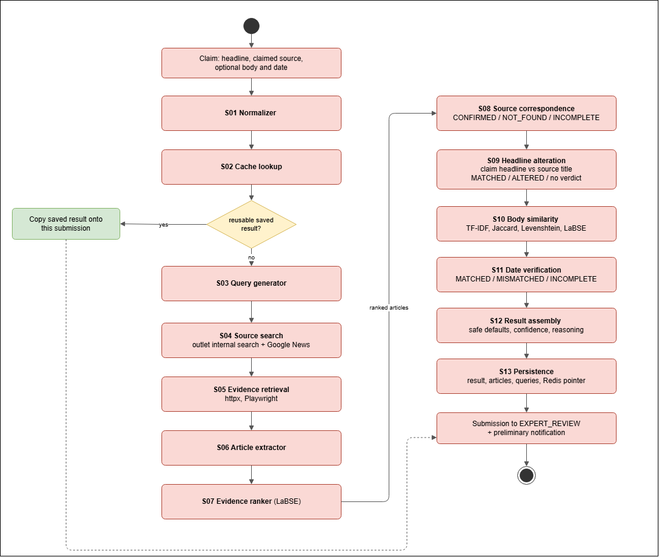
Figure 5.2: Source-Based Verification Pipeline — Stages S01 to S13
Table 5.3: Source-Based Verification Pipeline — Stage Reference
Stage | What it does
S01 Normalizer | Prepares the text and identifies the search scope.
S02 Cache lookup | Checks for a compatible completed result that can be reused.
S03 Query generator | Creates search phrases from the headline, keywords and date.
S04 Source search | Searches permitted publishers and rejects off-source results.
S05 Evidence retrieval | Loads article pages, using browser rendering when needed.
S06 Article extractor | Reads the article title, body and publication date from each page.
S07 Evidence ranker | Ranks articles by their relevance to the claim.
S08 Source correspondence | Selects relevant evidence and records the source finding.
S09 Headline alteration | Compares the headline with the selected source title.
S10 Body similarity | Measures body-text similarity when article text is supplied.
S11 Date verification | Compares available claimed and source publication dates.
S12 Result assembly | Prepares the preliminary findings and explanations.
S13 Persistence | Saves the result and schedules any personal notification.

Headline comparison considers changes such as numbers, dates, negation and named people or organisations. It uses language models alongside these checks to assess whether the meaning is preserved. When the evidence is insufficient, the report leaves the comparison undecided and explains why. Body similarity scores describe overlap between texts; they do not determine whether a claim is true.

5.3 Model Selection
Table 5.4 identifies each model and its role. These are the components selected for the implementation, not the outcome of a comparative model benchmark. The recorded evaluation covers the combined text and image classifier.
Table 5.4: AI Model Selection Summary
Model | Used in | Role in the system
BanglaBERT | Text & image (text encoder) | Provides a representation of Bangla article text for classification.
EfficientNet-B4 | Text & image (image encoder) | Extracts visual features from the submitted image.
LaBSE (sentence-transformers) | S07–S10 | Represents sentence meaning for article ranking and text comparison [4].
mMARCO MiniLM cross-encoder | S07 re-ranking | Refines the order of shortlisted claim–article pairs [5].
mDeBERTa-v3 NLI (MNLI/XNLI) | S09 | Assesses support or contradiction between the claim headline and source title.
BanglaTag NER | S09 entity checks | Identifies people, places and organisations for headline comparison.

5.4 Responsible Use of AI
- Automated findings are presented as preliminary. A final verdict is published only after the expert voting rules are met or an administrator decides an escalated claim.
- A missing source report does not establish that a claim is false. An incomplete search and an unavailable model score are shown as limitations of the check.
- The source-checking models and thresholds need evaluation on labelled Bangla claims. Tests with simulated responses check software behaviour, not model accuracy. Expert review remains part of the decision process.

6. Component-Level Design
This chapter explains how the interfaces, verification services and data stores work together. It also describes the submission lifecycle, voting rules and local deployment.

6.1 Component Diagram
The website and Chrome extension use the same backend service. The backend handles accounts, verification, expert review and administration. Background workers process accepted jobs and deliver results. PostgreSQL stores application records, Redis caches reusable data, and MinIO stores uploaded images.
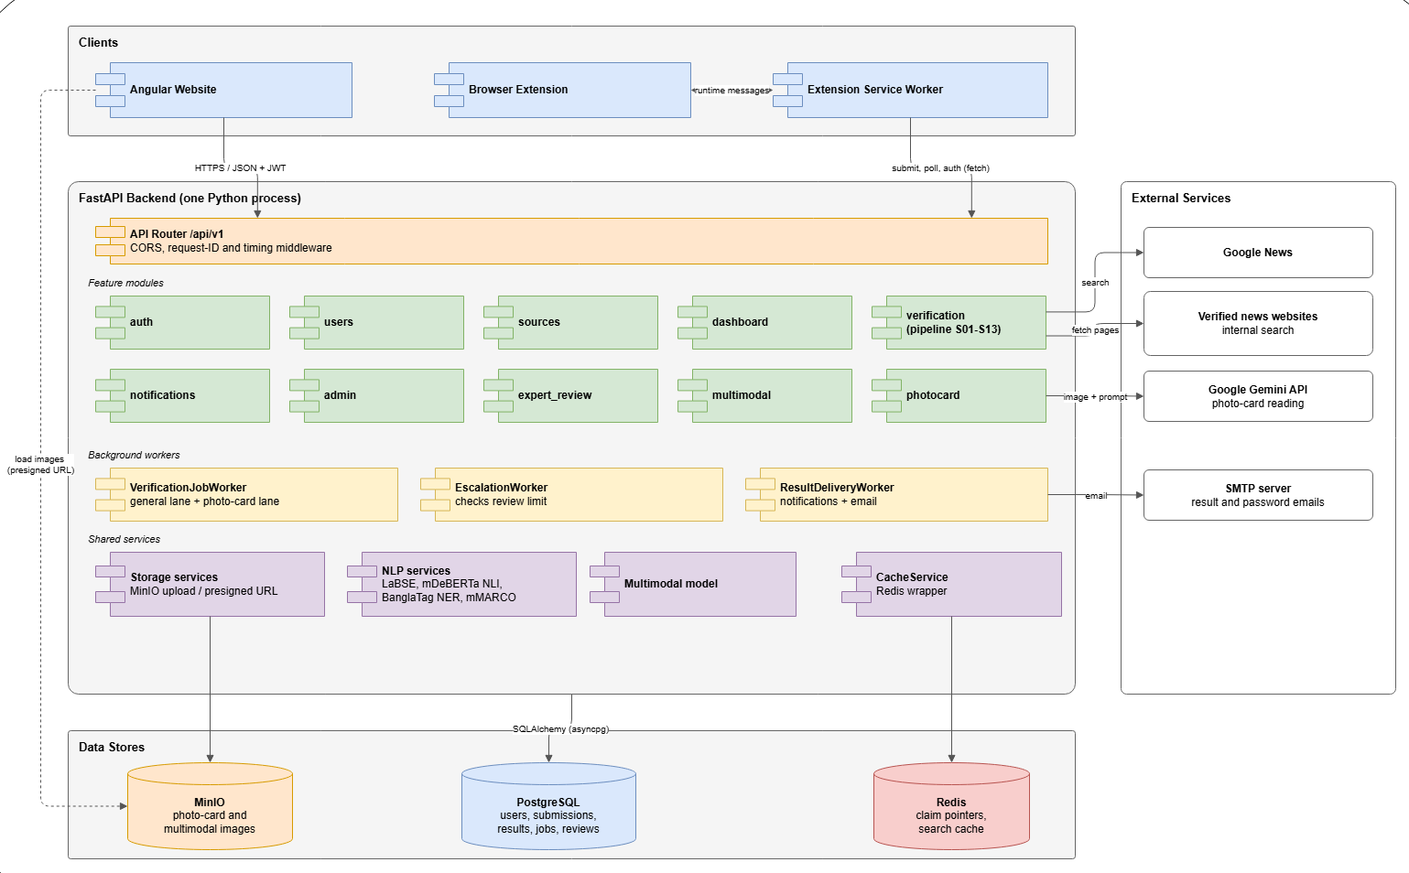
Figure 6.1: Component Diagram of BanglaFactGuard
Table 6.1: Main Components and Their Responsibilities
Component | Responsibility
Angular website | Public pages, claim forms, result reports, history, notifications, expert and admin workspaces.
Browser extension | Accepts claims, tracks progress and displays activity and result alerts.
API layer | Receives client requests and directs them to the appropriate service.
Account management | Handles registration, sign-in, password recovery, profiles and personal history.
Source verification | Retrieves evidence and compares the submitted claim with relevant reports.
Photo card processing | Reads a claim from an uploaded card and sends it for source verification.
Text and image analysis | Checks for reusable analyses and produces preliminary predictions.
Expert review | Manages the review queue, votes, final decisions and escalation.
Administration and sources | Manages experts, publishers, credibility tiers and voting rules.
Public archive and notifications | Provides claim search and statistics and records personal updates.
Job processing | Runs saved verification jobs, with separate capacity for photo card processing.
Review monitoring | Checks review limits and escalates unresolved claims.
Result delivery | Sends personal result notifications and final-result emails.
Shared services | Provides image storage, language analysis, model inference and caching.

6.1.1 Information Flow
A Text & source claim moves through the components as follows:
- The user submits a claim from the website. A signed-in submission is linked to that account.
- The backend validates the input, determines the search scope and saves the claim with its background job.
- The website receives a submission reference and checks its status while the result page is open.
- A background worker takes the queued job and starts verification.
- The verification service retrieves relevant news articles and compares the available evidence with the claim.
- The findings are saved, the claim enters expert review and a personal update is created for a signed-in submitter.
- Experts review the claim. After finalisation, the result is updated and final-result delivery is scheduled.

6.2 Design Classes
Figure 6.2 shows the design classes. Table 6.2 summarises their service responsibilities and main operations.
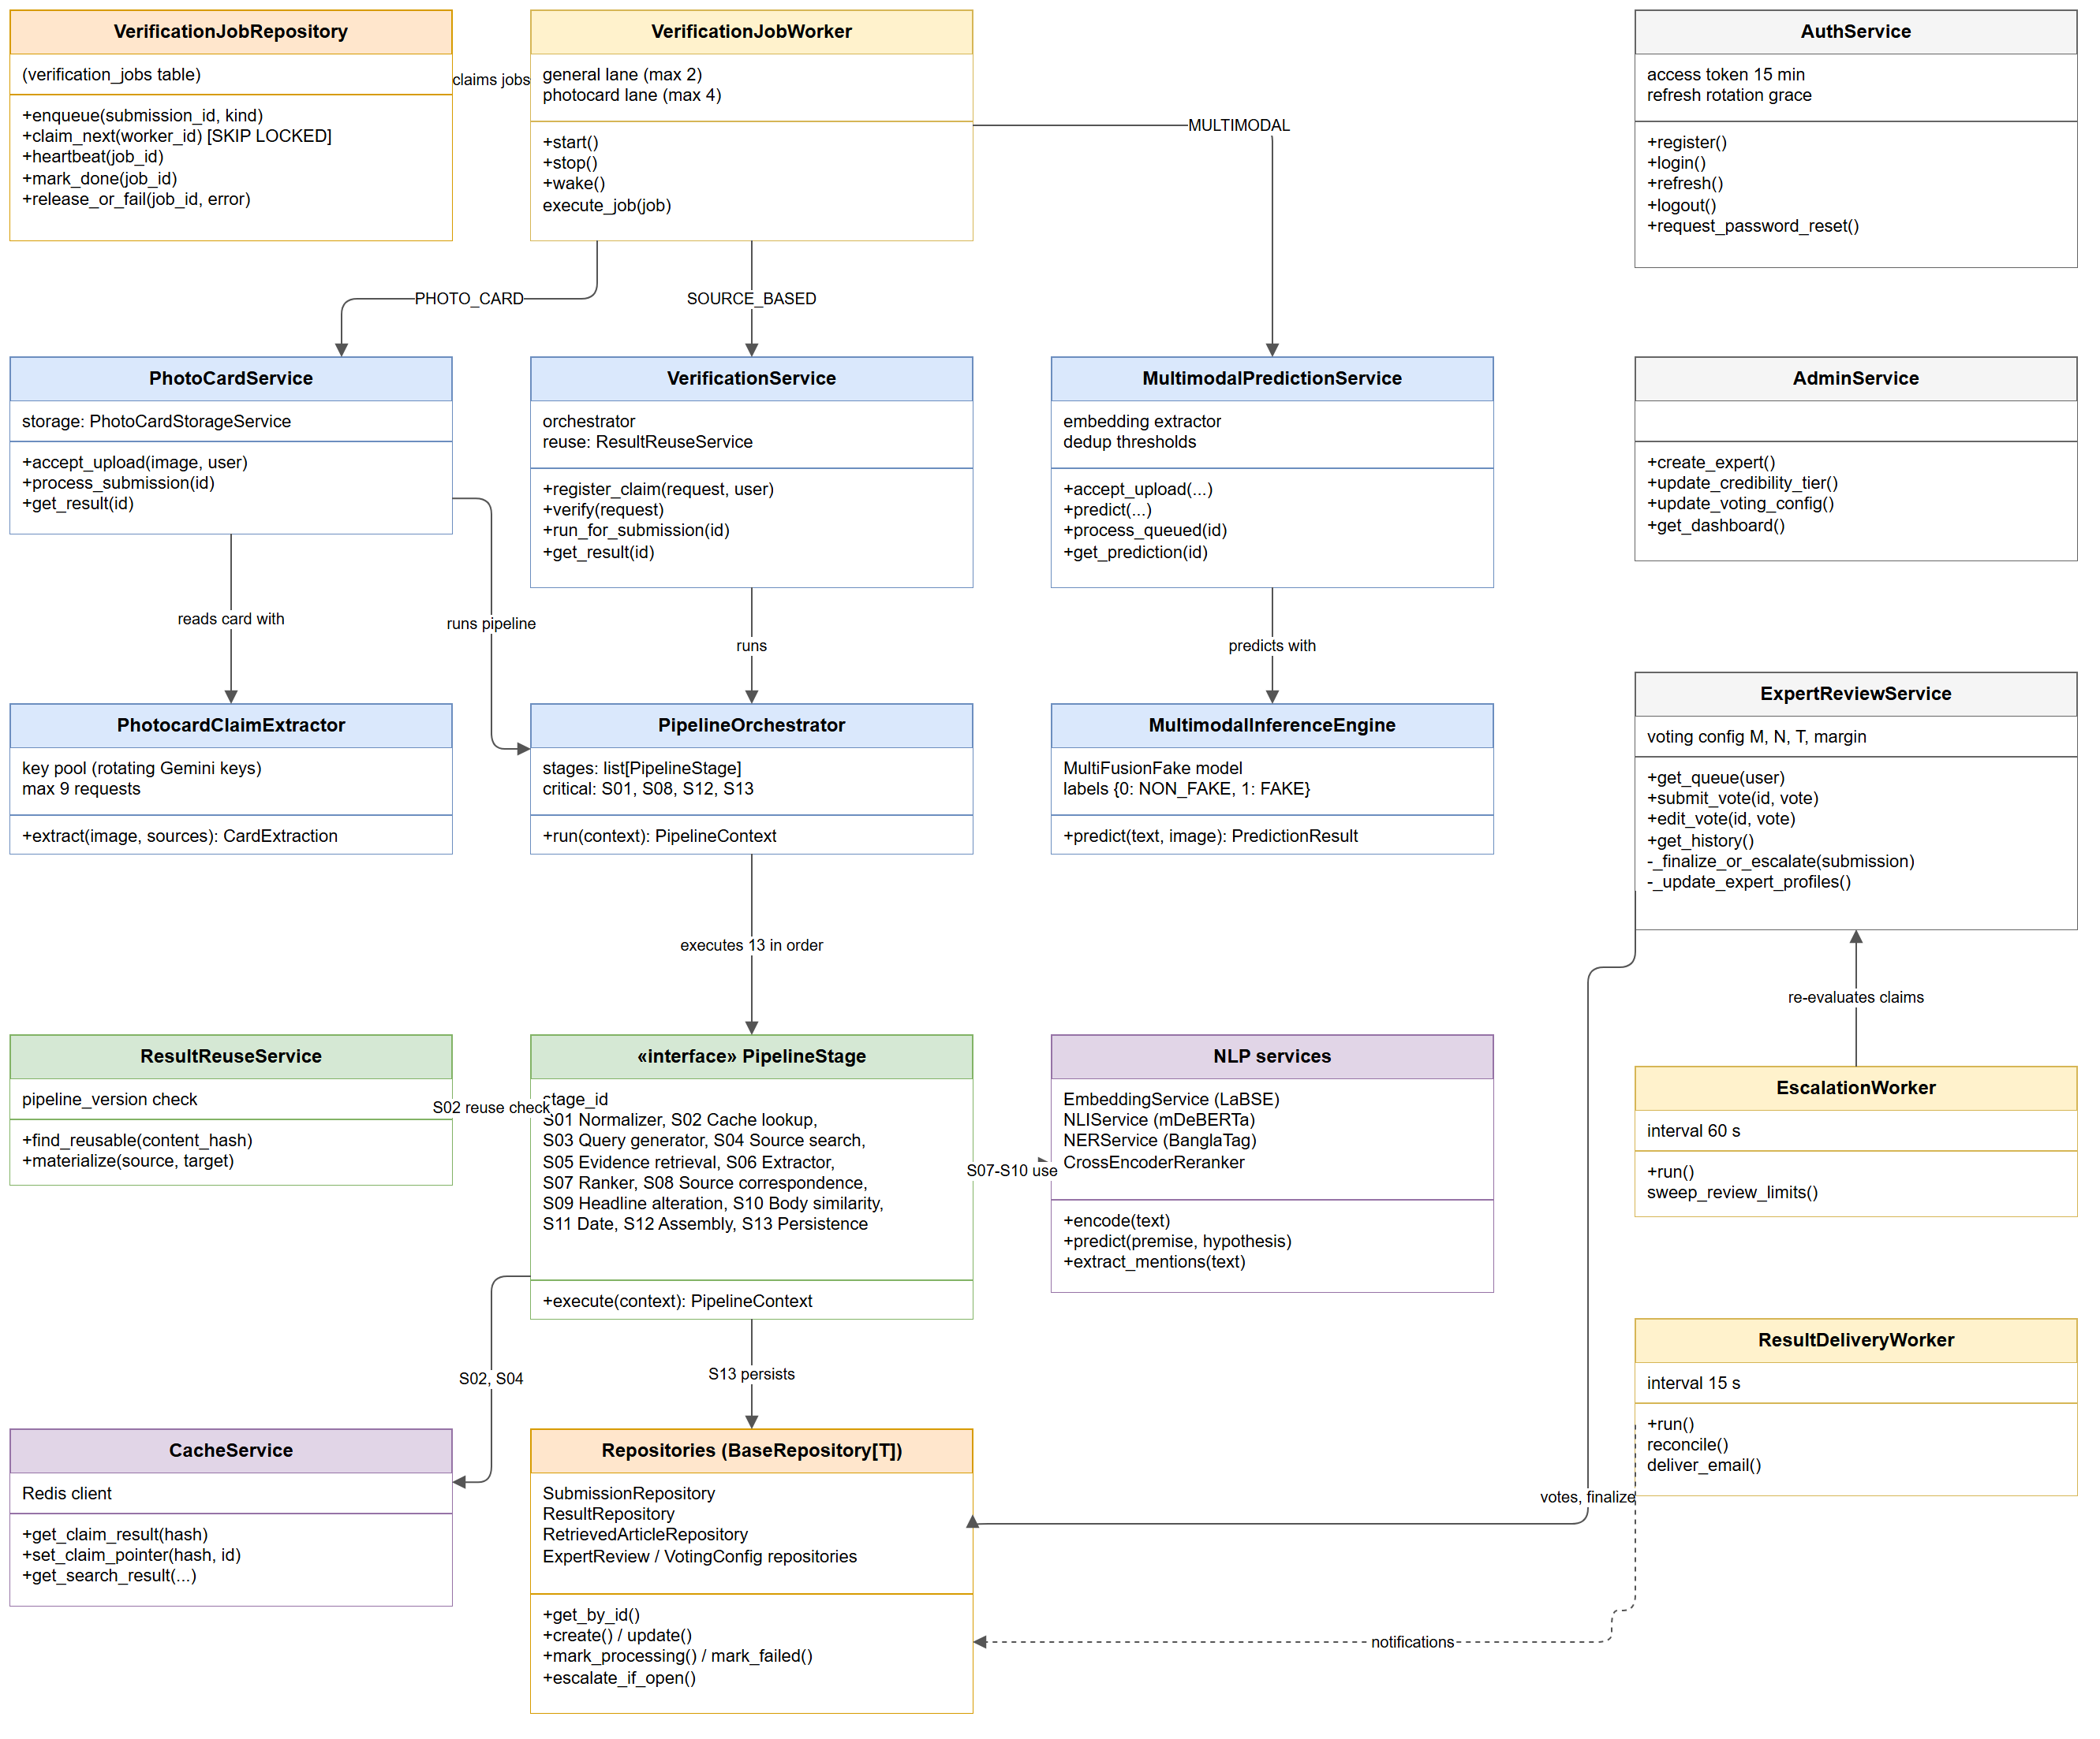
Figure 6.2: Design Class Diagram
Table 6.2: Design Classes and Domain Concepts
Domain concept | Service responsibility | Main actions
Claim checking | Verification service and processing stages | Accept claims, run the evidence check and assemble findings
Photo card | Photo card service and claim reader | Store the image, extract the claim and start verification
Text & image | Prediction service and inference engine | Accept text and images and produce preliminary predictions
Background work | Job queue and worker | Queue work, claim jobs, track progress and recover interrupted processing
Result reuse | Result reuse and cache services | Find compatible results and attach reusable findings to a submission
Expert voting | Review service and review monitor | Record votes, apply decision rules and escalate unresolved claims
Accounts and admin | Authentication and administration services | Manage sessions, expert accounts, sources and voting settings
Notifications | Notification and delivery services | Record personal updates and send final-result emails
Data access | Data repositories | Read and update application records through a common data-access layer

6.3 Persistent Data Sources
Figure 6.3 shows the data stores used by the backend. Table 6.3 distinguishes durable application records from temporary cached data and browser storage.
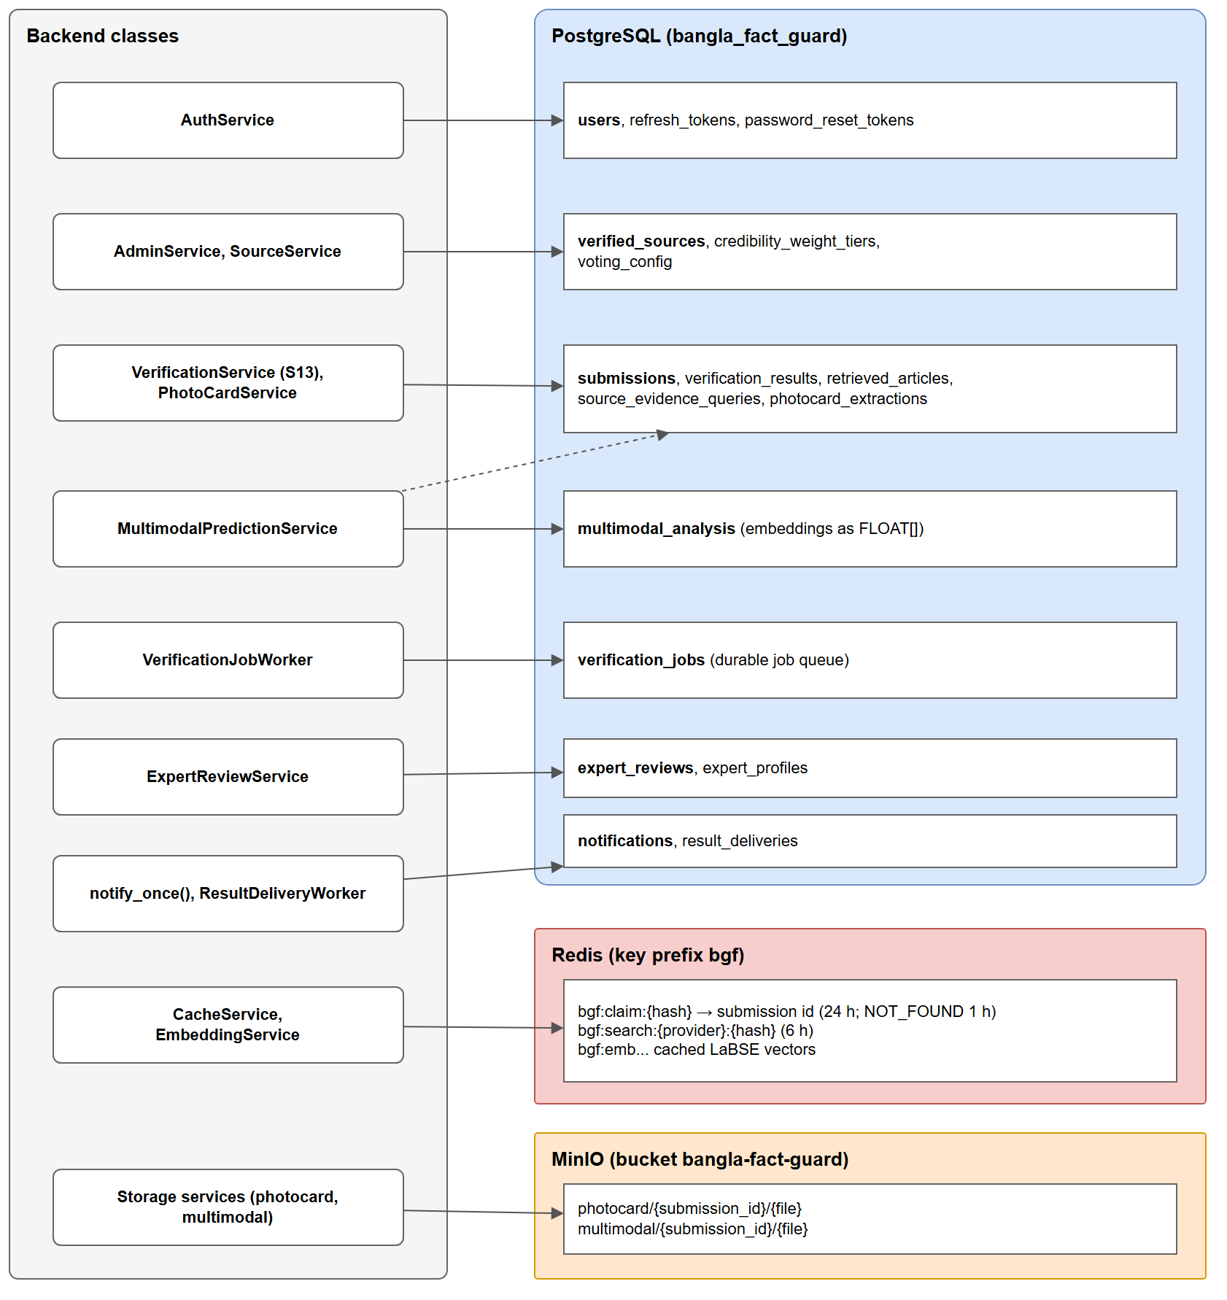
Figure 6.3: Persistent Data Sources and Their Classes
Table 6.3: Persistent Data Sources
Data store | What is stored | Lifetime
PostgreSQL database | Accounts, sources, claims, evidence, results, reviews, notifications, background jobs and delivery records | Retained until removed through database or application maintenance
Redis cache | Search results, text representations and references to reusable verification results | Temporary; entries expire according to the cache settings
MinIO image storage | Uploaded photo cards and news images, accessed through temporary signed links | Objects remain until deleted; access links expire
Extension browser storage | Preferences, sessions, drafts and account-separated activity | Depends on the record type and account or browser cleanup

6.4 Behavioural Design

6.4.1 Submission Lifecycle
Figure 6.4 shows the main submission states. The system also records the current processing step so that users can distinguish queued work from image reading and verification.
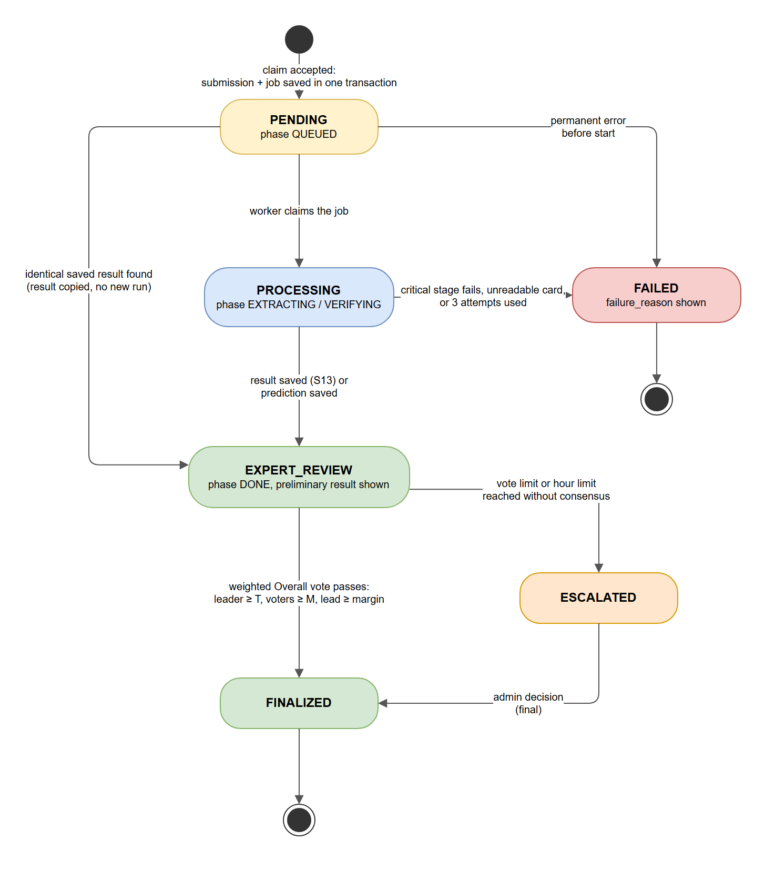
Figure 6.4: State Diagram of a Submission
Table 6.4: Submission States
State | Meaning | Leaves when
PENDING | The claim has been accepted and is waiting for processing | Processing starts, a saved result is reused or the request fails
PROCESSING | The claim is being read or verified | A preliminary result is saved or processing fails
EXPERT_REVIEW | Preliminary findings are available for human review | The voting rules are met or a review limit is reached
ESCALATED | Waiting for an administrator | The administrator submits the final decision
FINALIZED | Final verdict published | End state
FAILED | Processing has stopped and a reason is available | End state

6.4.2 Sequence of a Text & Source Check
Figure 6.5 follows a source-based claim from submission to review. It shows the status checks made by the website, the background verification work and the later delivery of a final decision.

6.4.3 Voting Rules
Each expert vote has a stored weight. New experts use weight 1 until they reach the configured number of completed reviews. Later votes use the credibility tier assigned from their review record. A final decision requires a clear leading verdict, enough voters, sufficient total weight and the required lead over the next verdict. A tie remains unresolved. Claims that reach the vote or time limit go to an administrator for a final decision.

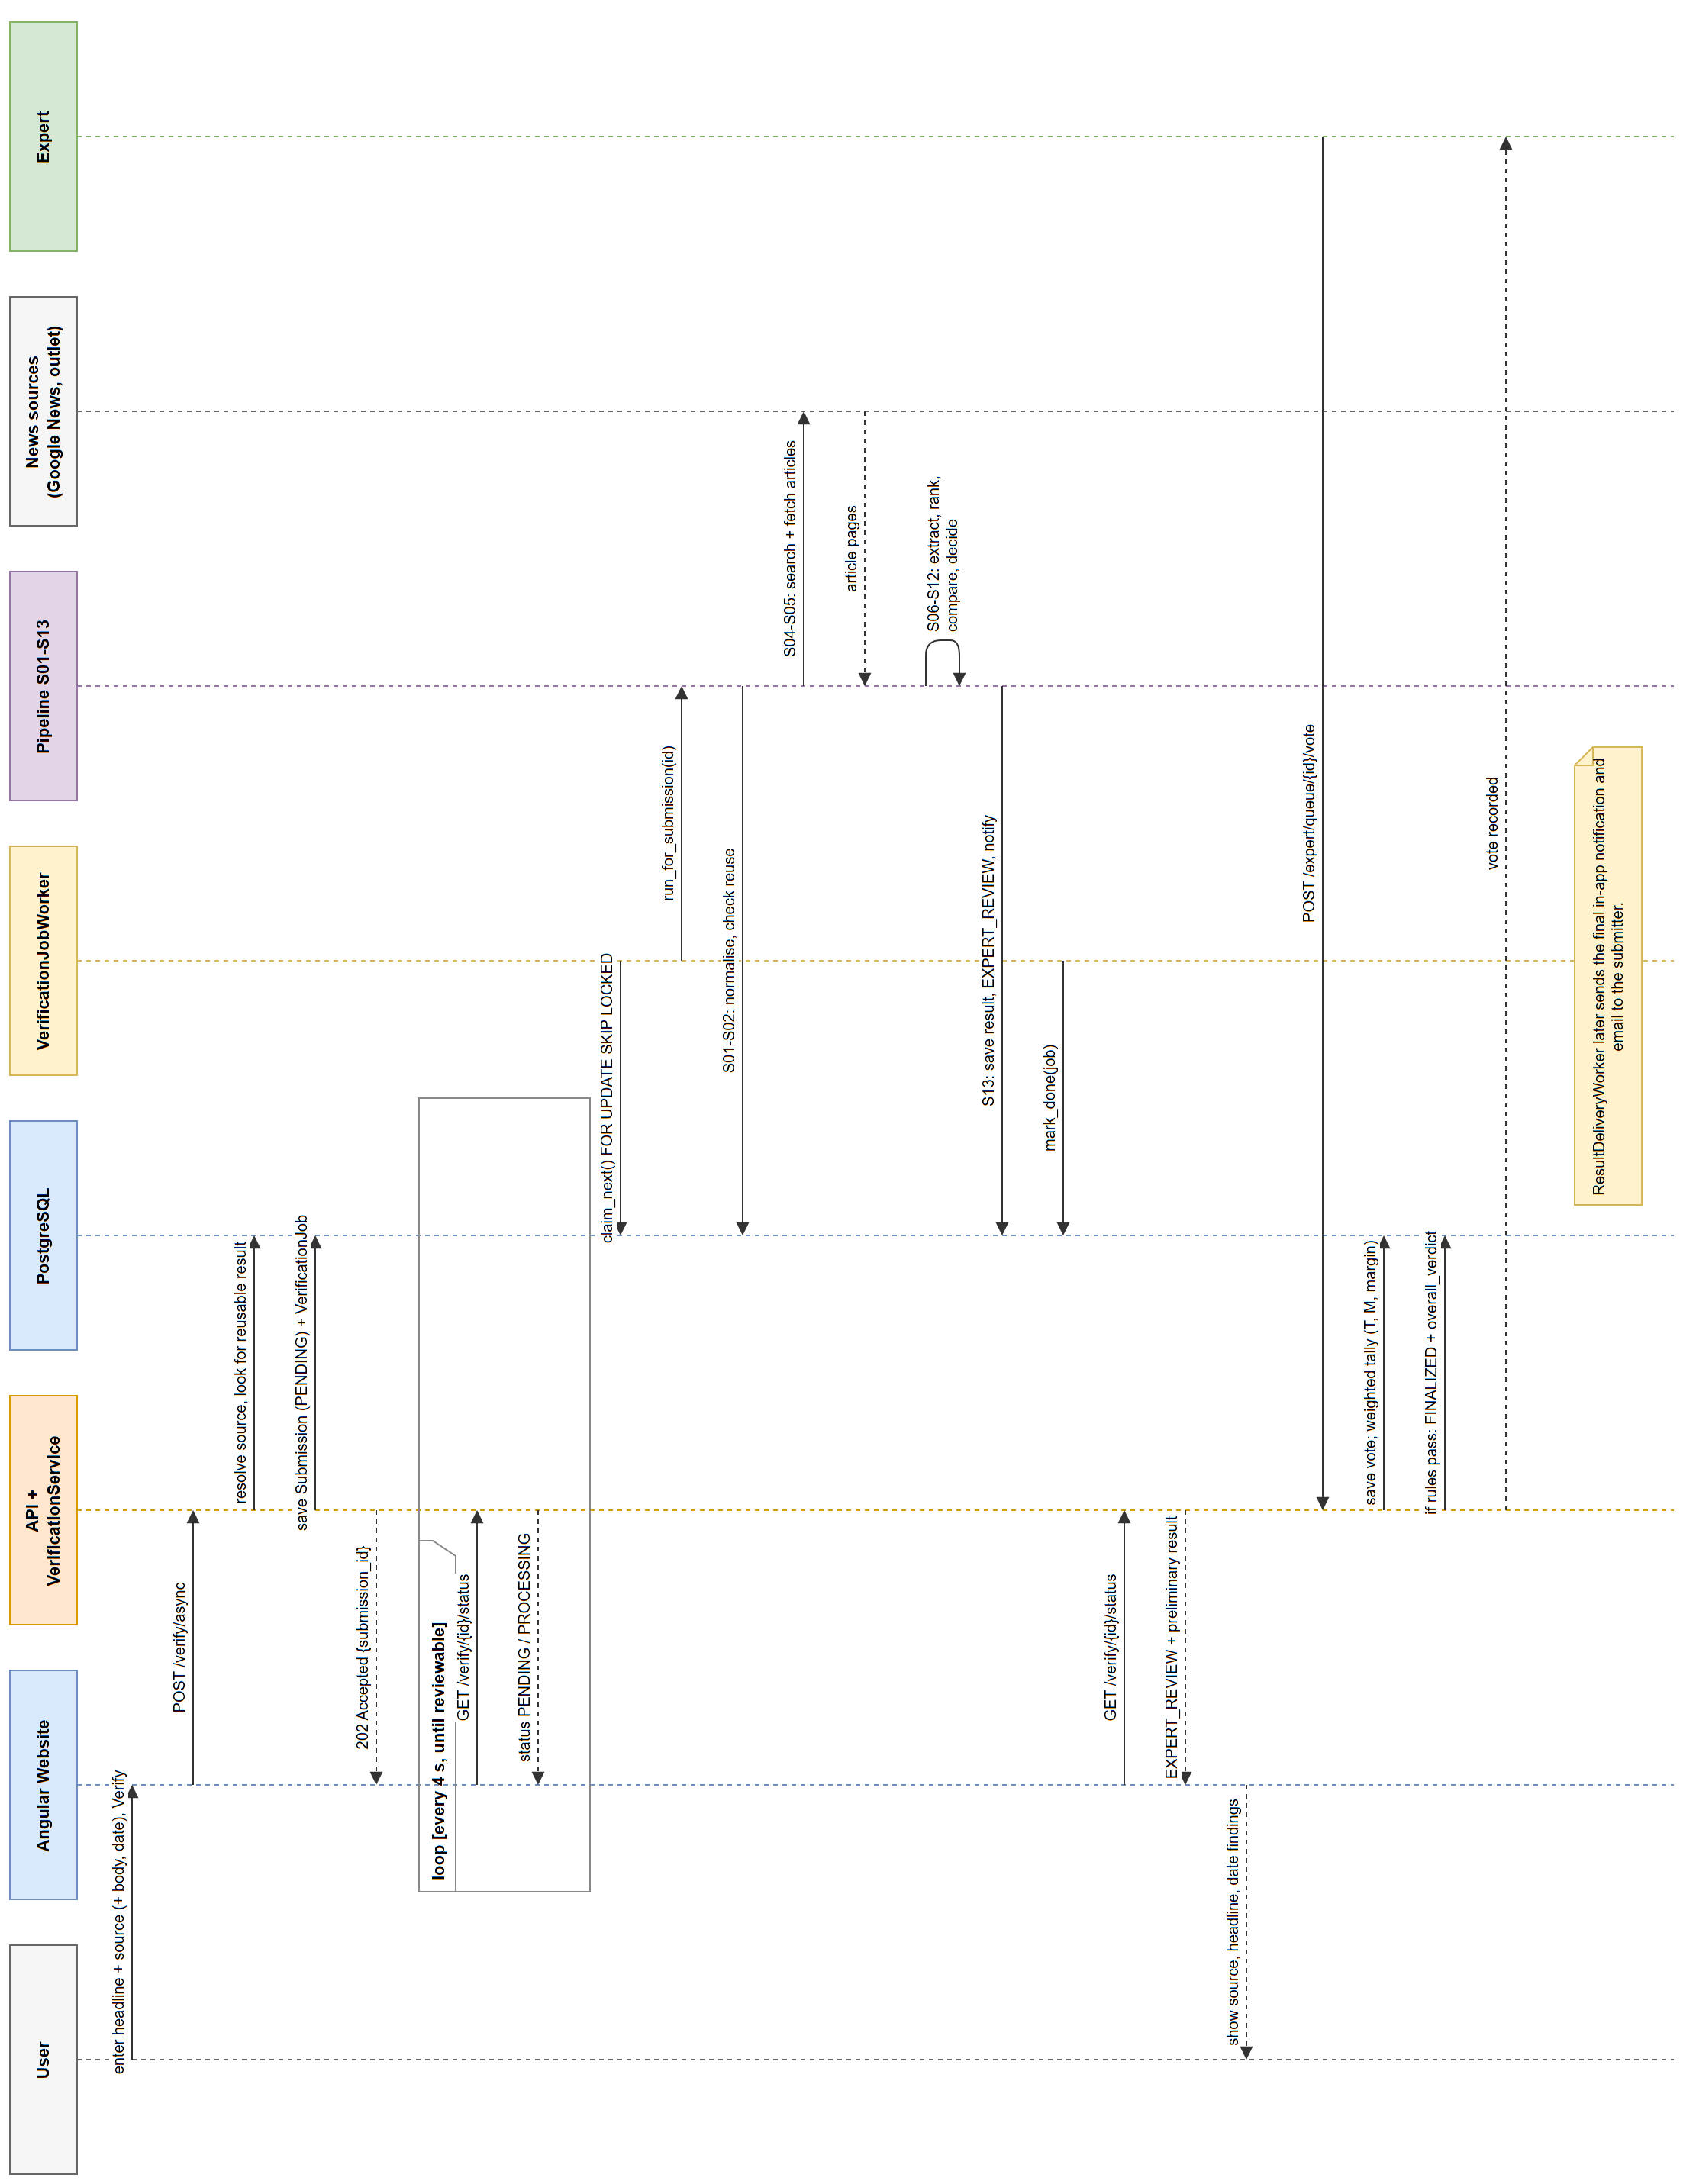
Figure 6.5: Sequence Diagram — Text & Source Claim (rotated to fit the page)

6.5 Deployment Design
Figure 6.6 shows the local development setup used for the report. The browser loads the website and communicates with the backend. PostgreSQL runs on the host, while Docker Compose provides Redis and MinIO. This setup demonstrates the application locally; it is not evidence of a public production deployment.
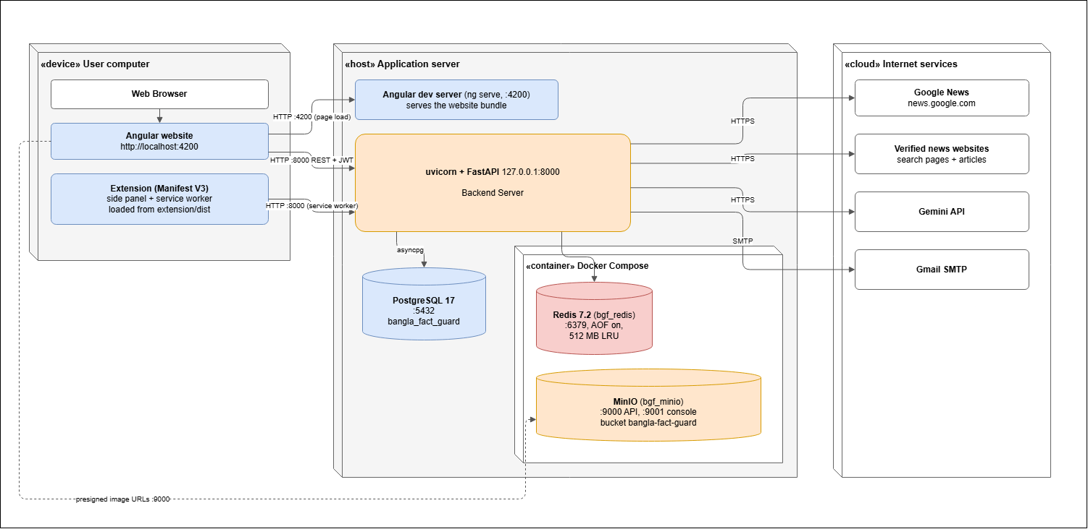
Figure 6.6: Deployment Diagram
Table 6.5: Deployment Nodes
Node | Contents | Notes
User computer | Chrome, the website and the unpacked extension | Connects to the local application services
Application server | Website development server and backend with background workers | Workers run within the backend application process
PostgreSQL 17 | Project database on the host | Installed on the host, not in Compose
Docker Compose | Redis cache and MinIO image storage | Managed by the project Compose configuration
Internet services | News search, registered publishers, image-reading service and email server | Require network access and any necessary credentials

6.6 Design Alternatives Considered
Table 6.6 compares the main design choices with possible alternatives and explains the reasons for the current approach.
Table 6.6: Design Alternatives and Decisions
Decision | Alternative considered | Reason for the choice
Durable job table in PostgreSQL | Separate broker (Celery with Redis) | Keeps accepted jobs with the submission records and supports recovery without a separate task broker.
Separate Source, Headline and Date findings | One automated True/False/Partially True label | Shows what was checked and separates missing evidence from a judgement that a claim is false.
Headline compared with the source title only | Headline compared with the whole article body | Compares equivalent parts of the claim and report and keeps body similarity as a separate measurement.
Gemini reading of photocards | Tesseract OCR with manual correction | Reads the headline, outlet and date together from the card. No comparative OCR accuracy result is reported.
Redis stores only a pointer; the database is authoritative | Cache full results in Redis | Keeps the saved database result as the authoritative record.
In-process workers | Separate worker processes | Keeps the local setup smaller while retaining a persistent job queue.

7. Interface Design
The website supports claim checking, results, personal records and review work. The extension supports submission and tracking while browsing. This chapter describes the main controls, navigation and visible states of both interfaces.

7.1 User Interface Objects and Actions
Table 7.1: User Interface Objects and Actions
Interface | UI object | Actions
Header | Navigation links, bell icon, user menu | Open Verify facts, Fact Explorer, My Submissions, Expert Queue, Administration; open notifications; sign out
Verify facts | Method cards | Choose News story against an image, News story against claimed source, or Photocard against claimed source
Verify facts | Claim form | Type or paste headline and text; choose outlet and date; upload image; Verify
Verification result | Report sections | Read claim, final decision, preliminary result, article, headline comparison, body scores and date; open the original source; copy the report link
Fact Explorer | Statistics, tabs, search and filters | Switch Final decisions / Under review; search; filter by decision, type, date and outlet; page through results
My Submissions, Notifications | Lists | View details; mark as read; mark all as read
Expert workspace | Queue, review page, vote form | Search; Review & vote; choose verdict; add optional supplementary findings; write justification; Submit vote
Administration | Dashboard, tables and forms | Create, edit, deactivate experts and reset passwords; register, edit, disable and delete sources; edit tiers and voting rules; decide escalated claims
Extension | ON/OFF switch, Verify, Activity and Account tabs | Use selected text; upload image; select screenshot area; crop; submit; refresh; mark read; view details; sign in/out

7.2 Navigation
Figure 7.1 shows the pages available to each role. All three verification methods open a shared report page, with details suited to the selected method.
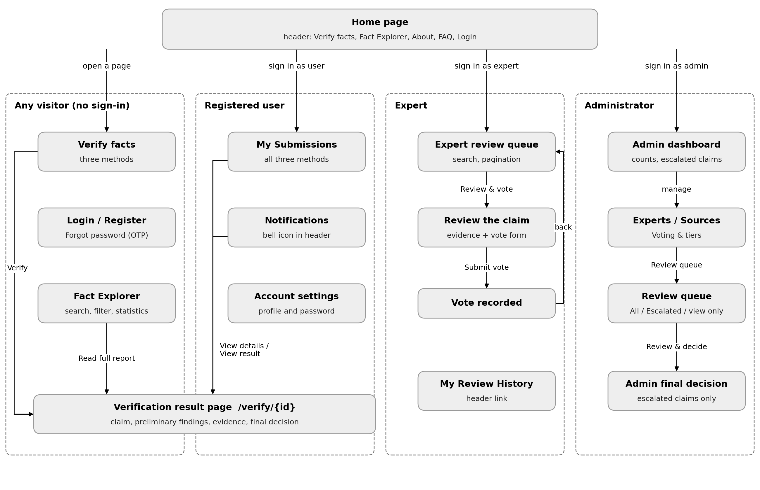
Figure 7.1: Website Navigation by User Role

7.3 UI Events and State Transitions

7.3.1 Verify Facts Page
Figure 7.2 shows the verification page states. Table 7.2 links common user actions and system responses to the state shown on screen.
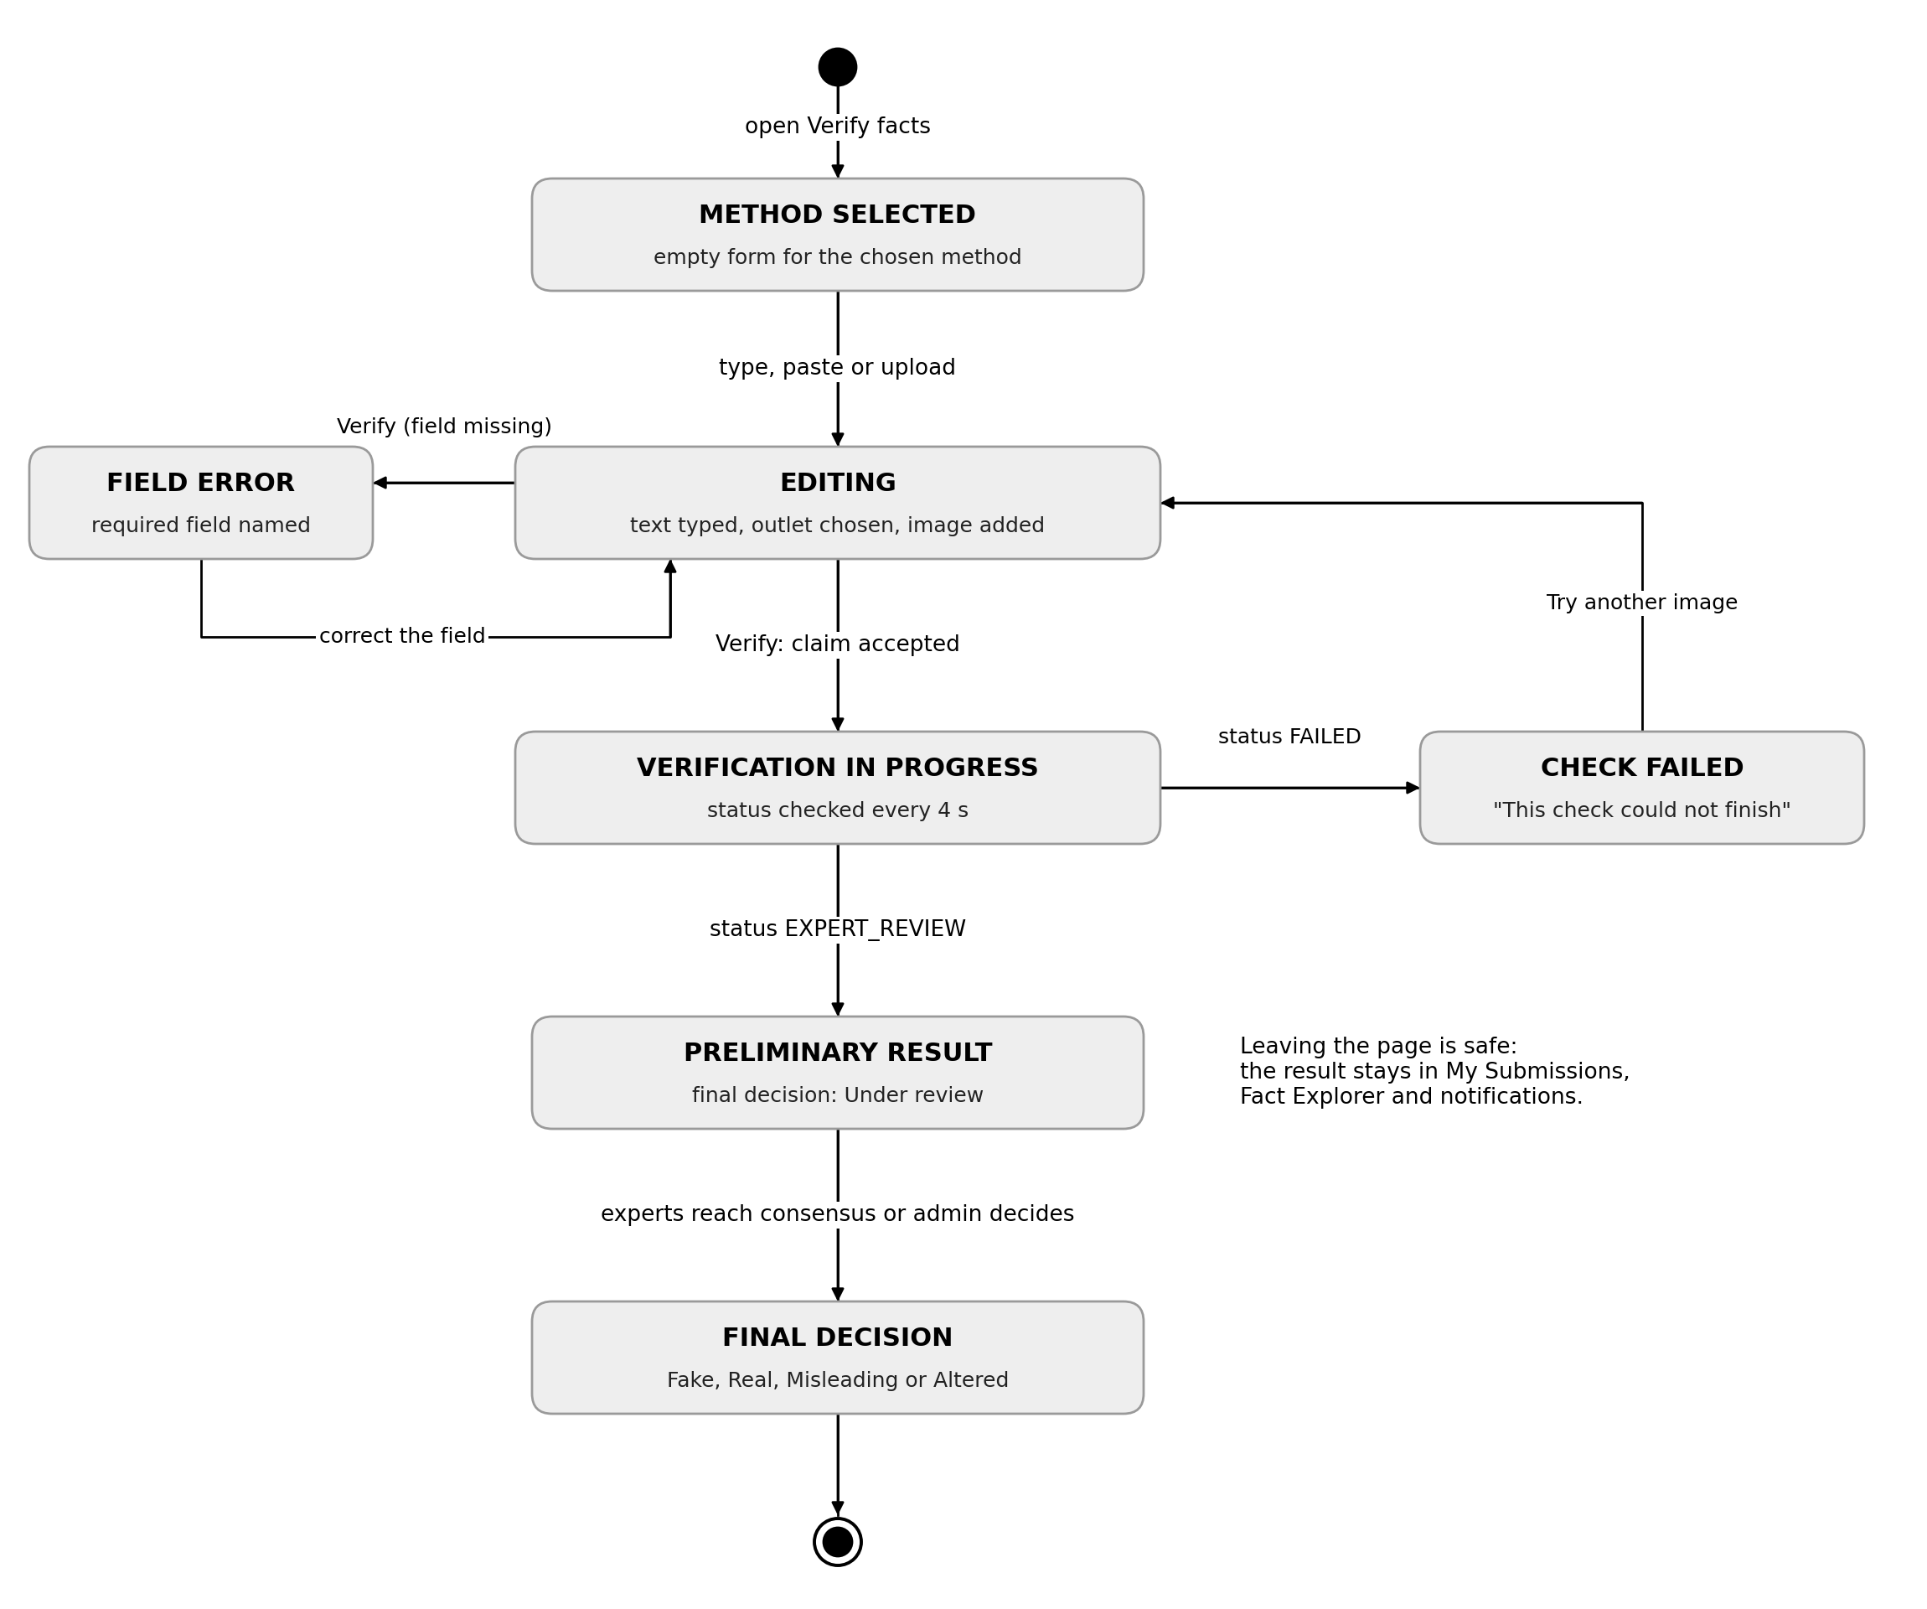
Figure 7.2: State Diagram of the Verify Facts Interface
Table 7.2: Events and State Transitions on the Verify Facts Page
User or system event | From state | To state | What the user sees
Choose a method card | none | METHOD SELECTED | The matching form and a preview panel
Type, paste or upload | METHOD SELECTED | EDITING | Live preview of the claim or image
Click Verify with a required field empty | EDITING | FIELD ERROR | The field is named and the inputs are kept
Click Verify with valid input | EDITING | IN PROGRESS | “Verification in progress” with View progress and My Submissions
Preliminary findings become available | IN PROGRESS | PRELIMINARY RESULT | Findings with Final decision: Under review
Processing fails | IN PROGRESS | CHECK FAILED | “This check could not finish” with the reason
Experts or admin finalize | PRELIMINARY RESULT | FINAL DECISION | Final decision badge and Voting Details

7.3.2 Expert and Administrator Review
The review page lets an expert inspect the claim and submit a verdict. A justification must contain at least 50 characters before submission. Escalated claims appear in the administrator review queue and require an administrator decision.
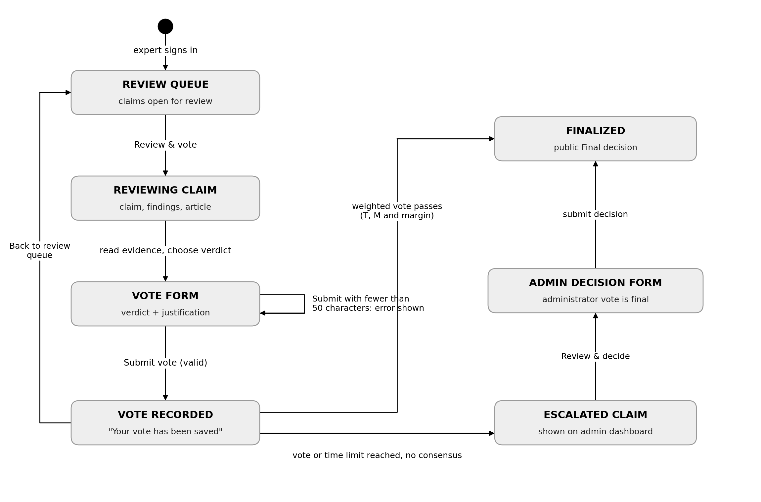
Figure 7.3: State Diagram of the Review Interface

7.3.3 Browser Extension Side Panel
The extension shows separate states for editing, processing and reading results. Switching it off pauses new extension activity and alerts; accepted server jobs continue. The Account tab controls the extension session independently of the claim form.
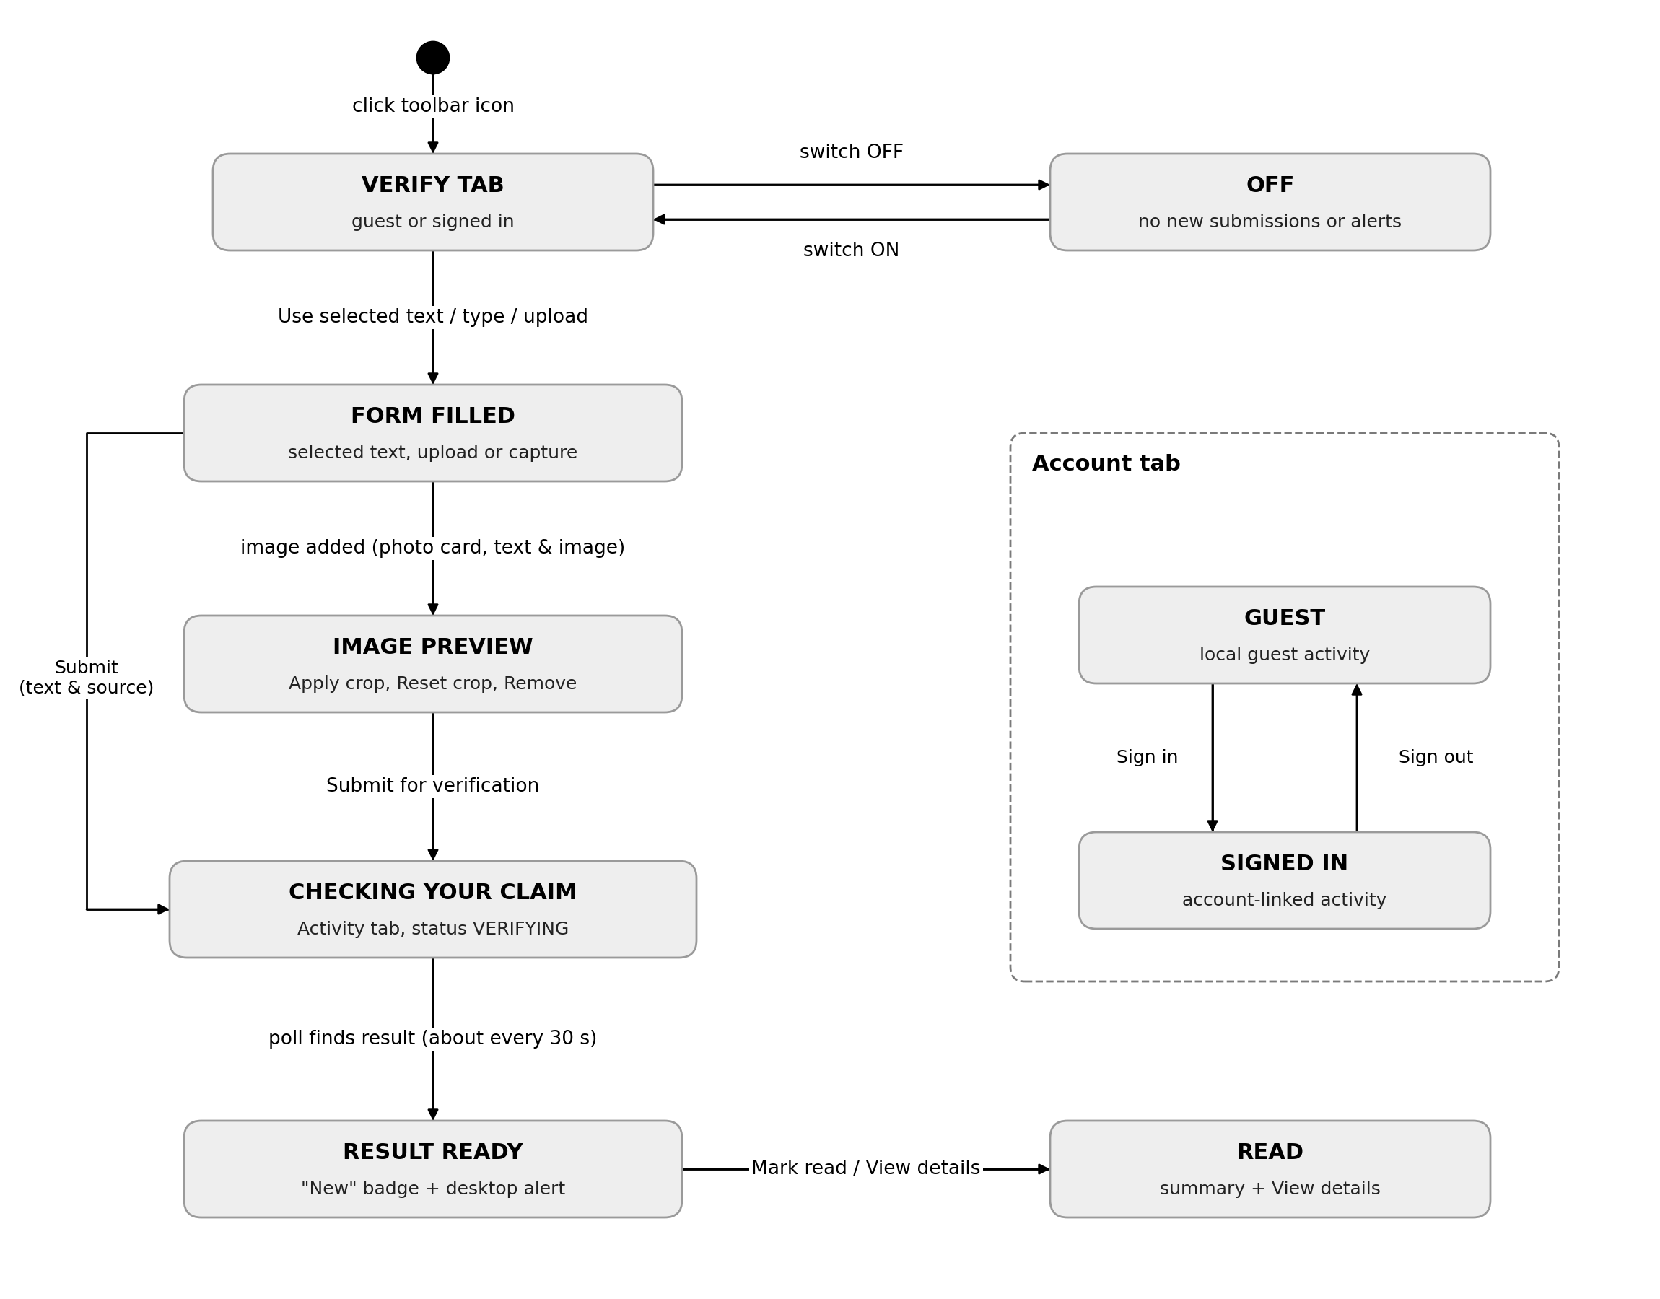
Figure 7.4: State Diagram of the Extension Side Panel

7.4 Interface States as Seen by the User
The screenshots below show the main interface states. They illustrate the forms, progress messages, findings and review controls discussed in this chapter.
Figure 7.5 shows a text and source claim being edited. The preview reflects the entered information. After submission, the page confirms that verification is in progress, as shown in Figure 7.6.
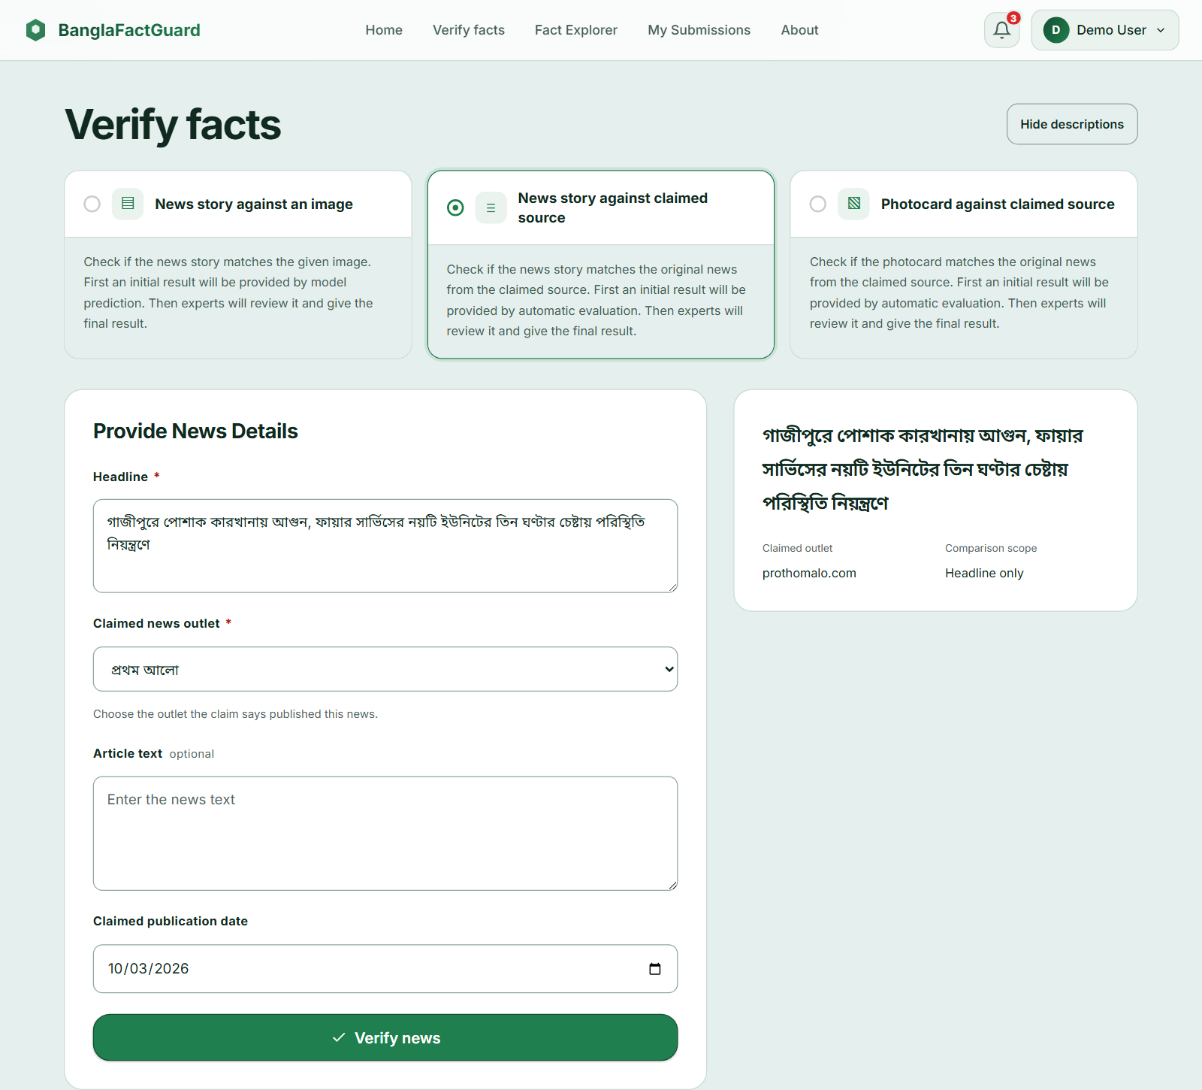
Figure 7.5: EDITING State — Text & Source Claim Form
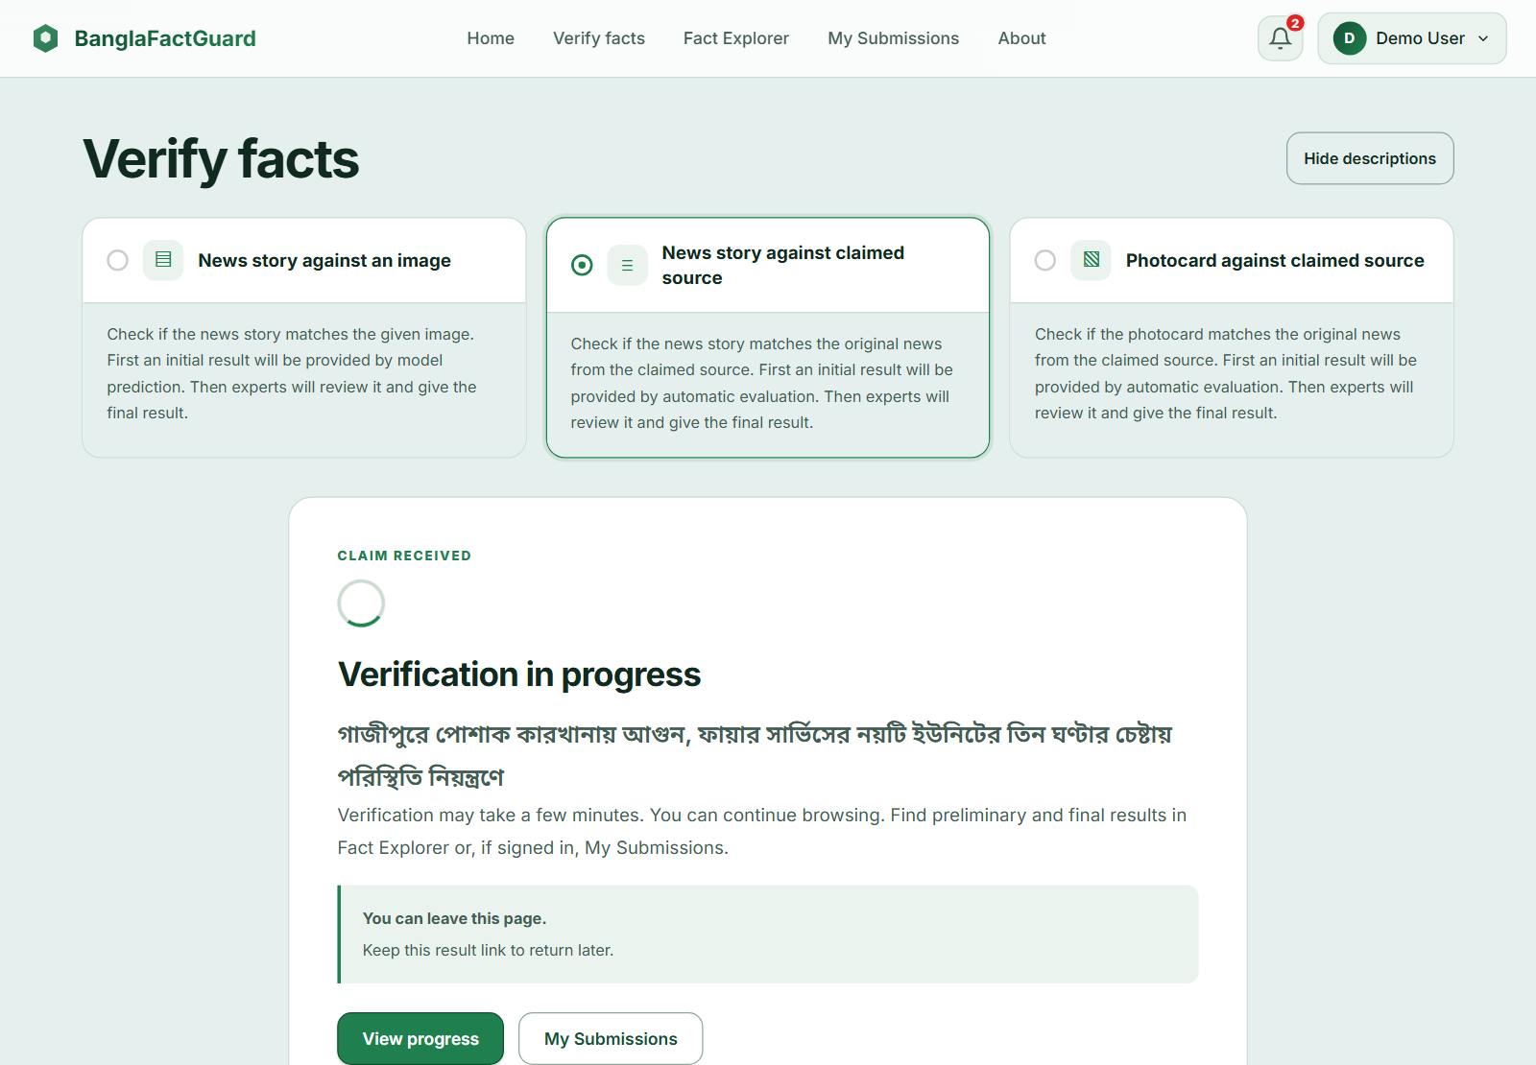
Figure 7.6: IN PROGRESS State — Claim Received
After the automated check, the report displays preliminary findings and shows the final decision as Under review (Figure 7.7). Once review is complete, it displays the verdict and voting details. Figure 7.8 shows a photo card decided by an administrator.
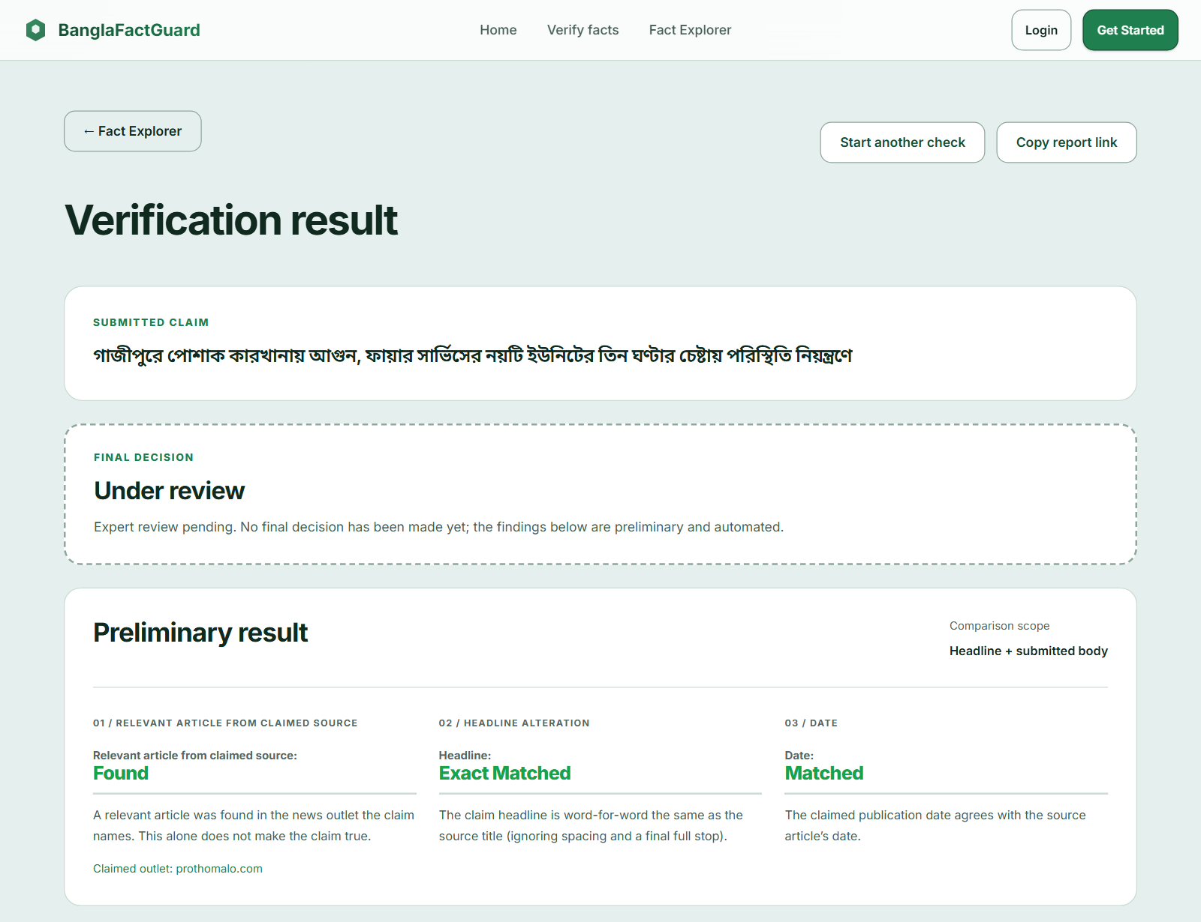
Figure 7.7: PRELIMINARY RESULT State — Final Decision Under Review
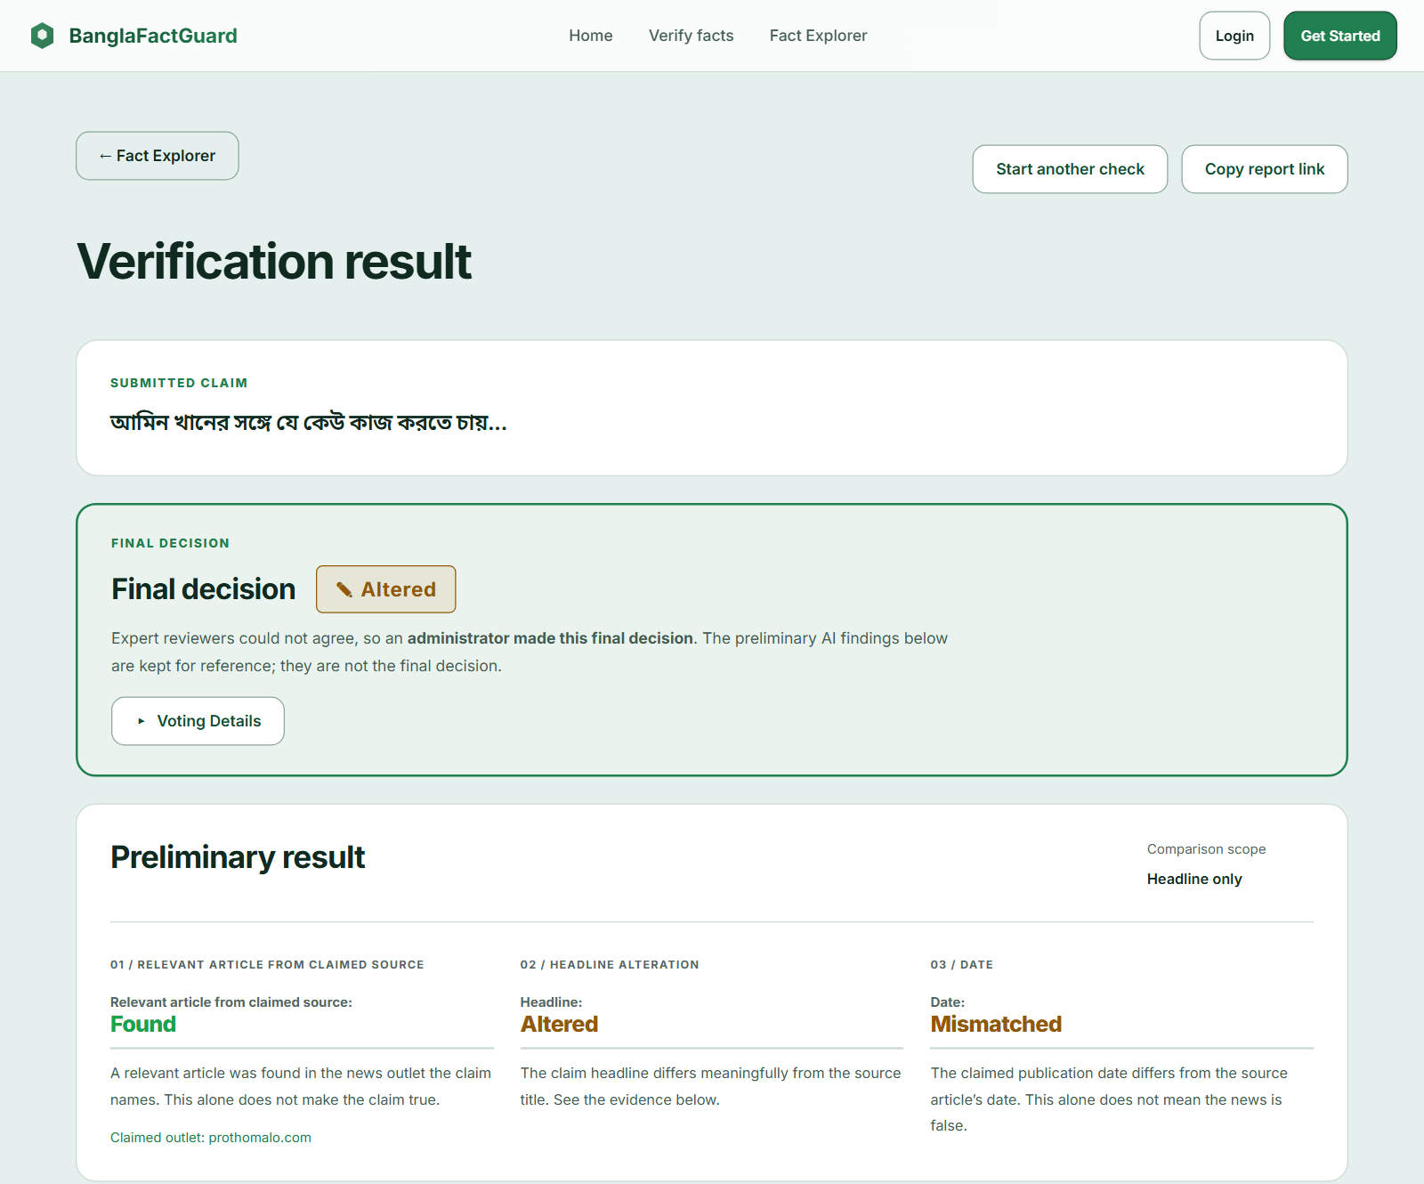
Figure 7.8: FINAL DECISION State — Administrator Decision on a Photo Card
A failed check displays its reason and an available recovery action (Figure 7.9). The extension Activity view also distinguishes claims being processed from results that are ready (Figure 7.10).
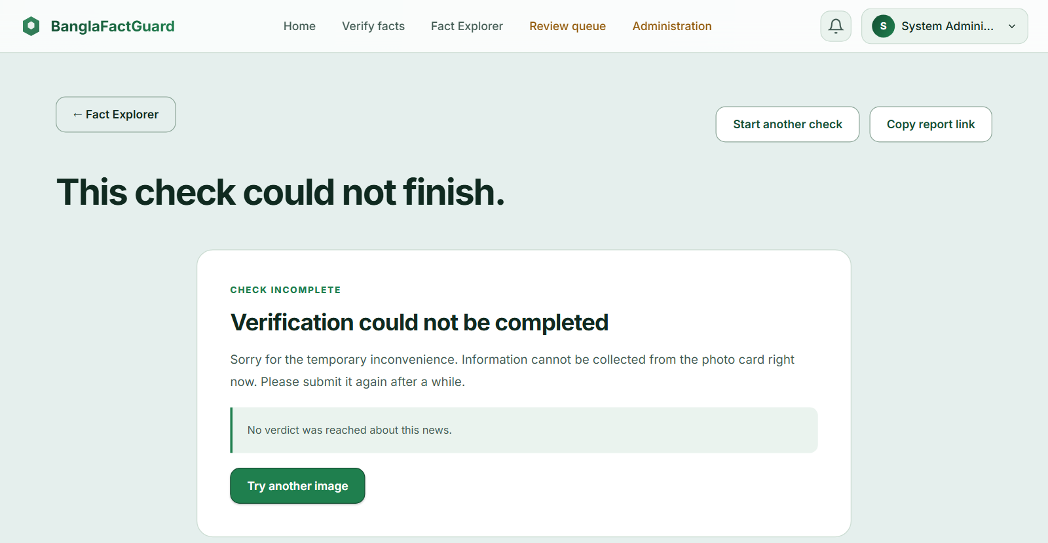
Figure 7.9: CHECK FAILED State — Photo Card Could Not Be Read
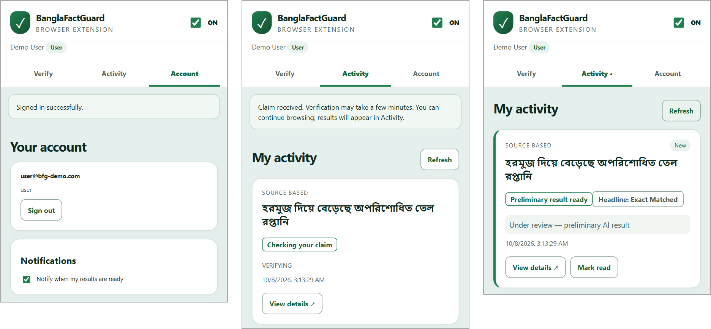
Figure 7.10: Extension States — Signed In, Checking Your Claim and Result Ready
Figure 7.11 shows the expert review form beside the claim and its evidence. The form includes the verdict options and a justification field with a character counter.
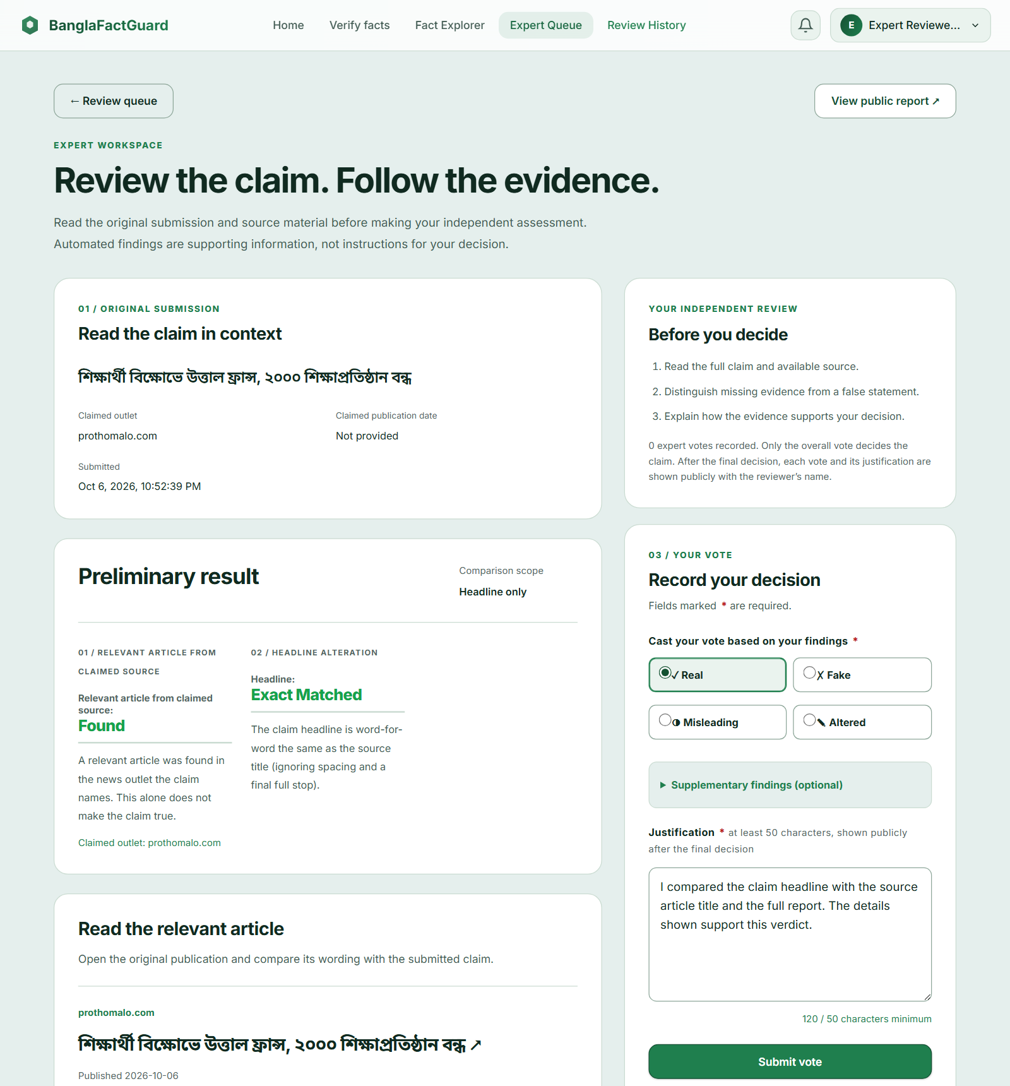
Figure 7.11: VOTE FORM State — Expert Review Page

8. Implementation

8.1 Technology Stack
Table 8.1: Technology Stack
Part | Technology
Website | Angular 19, TypeScript, SCSS, Angular Material/CDK
Backend | Python, FastAPI, SQLAlchemy, Alembic and Pydantic
AI and NLP | PyTorch, timm, Hugging Face Transformers, sentence-transformers, Google Gemini API (photo cards)
Retrieval | HTTP retrieval, browser rendering and article text extraction tools
Data | PostgreSQL 17, Redis 7.2, MinIO
Extension | Preact, Vite 6, Chrome Manifest V3 (side panel and service worker)
Testing | pytest; Karma and Jasmine; Node test runner with simulated browser services

8.2 Code Organisation
The repository separates the backend, website and extension. The backend groups related work into features such as accounts, submissions, verification and expert review. The website follows the main user functions, while shared components provide common forms and result displays. The extension contains the side panel, background processing and page-capture features.

8.3 Key Implementation Details

8.3.1 Authentication and Roles
The system stores password hashes and checks the account role before allowing restricted actions. Expiring access tokens are renewed through a refresh session. The website coordinates simultaneous refresh requests and keeps the session during a temporary network failure. Password recovery uses an emailed code that expires after ten minutes.

8.3.2 Background Jobs and Reuse
Accepted claims and their jobs are saved together. Background workers track progress and recover work abandoned after a restart. Photo card jobs have separate processing capacity because image reading may involve longer waits. Temporary failures can be retried, while permanent failures return an explanation. Compatible saved results can be reused without repeating the full check.

8.3.3 Photo Card Reading
The image-reading service extracts the printed headline, any recognised publisher and any readable date. It does not invent missing values. The extracted claim is checked against the identified outlet, or active registered sources when no outlet is identified and broader checking is enabled. An unreadable headline or repeated service failure stops the check with an explanation.

8.3.4 Voting, Escalation and Notifications
The review service prevents repeated votes by the same expert and blocks reviews of the expert’s own claims. Automated predictions do not count as expert votes. Unresolved claims are monitored against the configured review limits. Personal notifications are recorded, and final-result emails are queued and retried when email delivery is configured.

8.3.5 Browser Extension
The extension stores drafts and activity separately for each account. Its background process submits claims, checks their status and displays available alerts. For screenshots, it crops the captured viewport to the selected area before saving or uploading it. Only an administrator can change the website and service addresses.

8.4 Main API Routes
Table 8.2: Main API Routes (prefix /api/v1)
Operation | Route
Register, login, refresh, logout, profile | POST /auth/register, /auth/login, /auth/refresh, /auth/logout; GET /auth/me
Active verified sources | GET /sources
Queue a text claim; status and result | POST /verify/async; GET /verify/{id}/status, /verify/{id}
Queue a photo card; status and result | POST /photocard/verify/async; GET /photocard/{id}
Queue a text & image claim; result | POST /multimodal/predict/async; GET /multimodal/by-submission/{id}
Submission lookup; own submissions | GET /submissions/{id}; GET /users/me/submissions
Fact Explorer | GET /dashboard/explorer and statistics routes
Expert queue and vote | GET /expert/queue; POST /expert/queue/{id}/vote
Notifications | GET /notifications

9. Testing

9.1 Testing Approach and Strategy
The recorded tests cover backend services, website components and extension behaviour. External models, search services and browser features are simulated in many tests so that expected outcomes can be checked consistently. Some backend tests exercise database operations and complete workflows with a local test database. The screenshots provide examples from the running application; they do not replace systematic live integration testing.
The test cases cover valid submissions, invalid input and failure handling. They include unavailable search services, unreadable images, session expiry, repeated submissions, voting ties and network errors. Tests of software rules are reported separately from model evaluation.

9.2 Test Environment and Tools
Table 9.1: Test Environment
Item | Value
Execution date | 8 October 2026
Machine | Windows 11 Home (10.0.26100)
Backend | Python 3.13.5, pytest 9.1.1; command: python -m pytest tests/unit -q --no-cov
Website | Node 22.17, Angular 19, Karma with Chrome Headless 154; command: ng test --watch=false --browsers=ChromeHeadless
Extension | Node 22.17, node:test with happy-dom and fake-indexeddb; command: npm test

9.3 Item Pass/Fail Criteria
- Pass: the test runs and every assertion holds (expected status, fields, saved state and messages).
- Fail: any assertion does not hold, or the code raises an unexpected error.
- Skipped / not executed: the test needs a resource that was not enabled in the run (for example real model weights). It counts as neither pass nor fail.
- The test summary records whether the executed cases passed. Passing these cases does not establish model accuracy, live-service reliability or production readiness.

9.4 Summary of Executed Test Runs
Table 9.2 summarises the recorded test run of 8 October 2026. The counts and durations apply to that run and should be read alongside the untested areas in Section 9.7.
Table 9.2: Executed Automated Test Runs (8 October 2026)
Suite | Tests | Passed | Failed | Skipped | Time
Backend unit tests (44 files) | 426 | 424 | 0 | 2 | 20.4 s
Website (16 spec files) | 93 | 93 | 0 | 0 | 1.8 s
Extension (3 test files) | 33 | 33 | 0 | 0 | 2.7 s
Total | 552 | 550 | 0 | 2

The two skipped backend tests require local model weights and an explicitly enabled real-model test setting. The recorded run did not enable them. They are excluded from the passing-test total.

9.5 Test Cases with Detailed Outcomes
The following tables summarise the recorded cases and outcomes. Cases marked (M) refer to manual observations illustrated by the cited screenshots. Other cases refer to the automated run summarised in Table 9.2.

9.5.1 Authentication and Sessions
Table 9.3: Test Cases — Authentication and Sessions
ID | Scenario | Input / steps | Expected result | Actual result | Status
TC-01 | Refresh access token | Expired access token, valid refresh token | New token issued; user stays signed in | As expected | Pass
TC-02 | Lost refresh response | Refresh succeeds but the reply is lost | User is not logged out within the grace window | As expected | Pass
TC-03 | Logout | Sign out, then use the old refresh token | Token revoked immediately | As expected | Pass
TC-04 | Simultaneous session expiry responses | Several requests require session renewal together | One shared refresh, then all requests retried | As expected | Pass
TC-05 | Temporary refresh failure | Network error during refresh | Session is kept; sign-in required only when refresh is rejected | As expected | Pass
TC-06 (M) | Register form validation | Password shorter than 8 characters | Inline message “At least 8 characters” | Message shown (Figure 10.2) | Pass

9.5.2 Text & Source Verification
Table 9.4: Test Cases — Text & Source Verification
ID | Scenario | Input / steps | Expected result | Actual result | Status
TC-07 | Matching claim through the full workflow | Test claim with a corresponding source article | Source and headline match; evidence and findings are saved | As expected | Pass
TC-08 | Wrong claimed date | Correct headline, wrong date | Headline Matched, date Mismatched | As expected | Pass
TC-09 | Changed number | Headline with an altered number | Headline Altered | As expected | Pass
TC-10 | All search providers fail | Search clients raise errors | Search is reported as Incomplete | As expected | Pass
TC-11 | Unknown outlet with broader checking disabled | Submit an unrecognised outlet with the fallback option disabled | Rejected before a submission is created | As expected | Pass
TC-12 | Repeated claim | Same claim submitted twice | A compatible saved result is reused for the submission | As expected | Pass
TC-13 | Incomplete result not reused | Earlier result was Incomplete | Claim is re-queued, not served from cache | As expected (9 tests) | Pass
TC-14 | Body similarity display | Claim with body text | Four scores; an unavailable score is never shown as 0 | As expected; see Figure 10.6 | Pass
TC-15 (M) | Source not found in UI | Search completes without a relevant source report | Not Found is shown without an automated Fake verdict | As expected (Figure 10.7) | Pass

9.5.3 Photo Card and Text & Image Verification
Table 9.5: Test Cases — Photo Card and Text & Image
ID | Scenario | Input / steps | Expected result | Actual result | Status
TC-16 | Acceptance before processing finishes | Upload a card | The request is accepted before image reading finishes; processing continues after the client leaves | As expected | Pass
TC-17 | Image-reading service unavailable | All image-reading requests fail | Failure message shown without a verdict | As expected; also seen in Figure 7.9 | Pass
TC-18 | Unreadable claim or unrecognised outlet | Missing headline, or missing recognised outlet with broader checking disabled | A readable validation message explains why processing cannot continue | As expected | Pass
TC-19 | Crash recovery | Worker stops after the extracted claim has been saved | A new worker resumes from the saved extraction | As expected | Pass
TC-20 | Invalid file type | PDF uploaded as image | Rejected with HTTP 415 before acceptance | As expected | Pass
TC-21 | Empty article text | Whitespace body with an image | Rejected with HTTP 422 | As expected | Pass
TC-22 | Duplicate text and image | Same text and image again | A compatible earlier prediction is reused after the similarity check | As expected | Pass
TC-23 | Different image | Same text, different image | Not treated as a duplicate | As expected | Pass

9.5.4 Expert Review, Voting and Escalation
Table 9.6: Test Cases — Expert Review and Voting
ID | Scenario | Input / steps | Expected result | Actual result | Status
TC-24 | All rules met | Required voters, leading weight and lead margin are all satisfied | Claim finalized | As expected | Pass
TC-25 | Threshold, voters or margin missing | One rule not met | Claim stays open | As expected (3 tests) | Pass
TC-26 | Tie | Equal top weights | Never finalizes; escalates at the vote limit | As expected | Pass
TC-27 | New expert weight | Expert has fewer completed reviews than the configured requirement | Neutral weight 1 | As expected | Pass
TC-28 | Own claim and double vote | Expert votes on own claim; votes twice | Both rejected | As expected | Pass
TC-29 | Time limit | The configured review time passes without a decision | Escalated; admin notified once | As expected | Pass
TC-30 | Admin rights | Admin opens escalated and normal claims | Decides escalated; view-only otherwise; decision is final | As expected | Pass
TC-31 | Short justification | Fewer than 50 characters | Error next to the field; vote not sent | As expected | Pass
TC-32 (M) | Escalated claim end to end | Three split votes, admin decides Real | Final decision Real with Voting Details | As shown in Figure 10.17 | Pass

9.5.5 Notifications, Fact Explorer and Extension
Table 9.7: Test Cases — Notifications, Fact Explorer and Extension
ID | Scenario | Input / steps | Expected result | Actual result | Status
TC-33 | Personal notifications | Check each method for signed-in users, experts and administrators | Each preliminary and final in-app update is recorded once | As expected (9 cases) | Pass
TC-34 | Guest submitter | Claim without an account | No account notification or email | As expected | Pass
TC-35 | SMTP failure | Mail server error | Email is retried without creating another in-app notification | As expected | Pass
TC-36 | Explorer filters | Reversed date range | Rejected without sending a search | As expected | Pass
TC-37 | Explorer service failure | API error | Error kept separate from “no results”, with retry | As expected | Pass
TC-38 | Extension OFF/ON | Turn OFF, then ON | Polling and submissions blocked, then resumed | As expected | Pass
TC-39 | Account isolation | Switch accounts in the extension | Other account's activity not shown | As expected | Pass
TC-40 | Connection settings | Guest, user and expert try to change URLs | Refused; only a server-confirmed admin can save | As expected | Pass
TC-41 | Restricted page | Capture on a Chrome internal page | Selection cannot start; clear message | As expected | Pass

9.6 Observed Performance and Model Results
No formal load or stress test is recorded. The timing log from 4 October 2026 contains eight source checks from earlier versions, with processing times of about 82–153 seconds. These timings cover pipeline work rather than the full wait for expert review. They are observations from a small set of checks, not a general response-time guarantee. Section 5.1.2 gives the separate model evaluation.

9.7 Tests Not Executed or Not Verified
Table 9.8: Tests Not Executed in This Run
Item | Reason | Status
Separate backend integration suite | Requires a working database test setup and a compatible HTTP test client | Not executed
Real-model tests (2) | Require local model weights and explicit activation | Skipped
Installed-Chrome checks (live capture, OS notifications, browser restart) | Automated extension tests use simulated Chrome APIs | A manual checklist exists; a complete formal result is not recorded
Accuracy of source verification | No labelled Bangla evaluation set | Not measured
Load and stress testing | No load-test result is available | Not executed

9.8 Risks and Contingencies
Table 9.9: Testing Risks and Contingencies
Risk | Contingency
Gemini quota or network errors stop photo card checks | Retry temporary failures and explain when image reading remains unavailable
A news outlet blocks requests or changes its layout | Use available retrieval methods and report incomplete evidence when access fails
Model behaviour differs from tests that use fakes | Evaluate with real models and labelled data; retain expert review
Processing interrupted by a restart | Retain accepted jobs and resume recoverable work from saved state
Too few experts to reach agreement | Configurable limits and administrator escalation

10. User Manual
This chapter explains how to submit a claim, read a result and manage account activity. It also covers expert and administrator tasks. The interface uses English, while the verification forms accept Bangla content.

10.1 Getting Started
Open the website. For the local setup, use http://localhost:4200. The home page introduces the three verification methods (Figure 10.1). Guests can submit claims; signing in links submissions to an account and enables personal notifications.
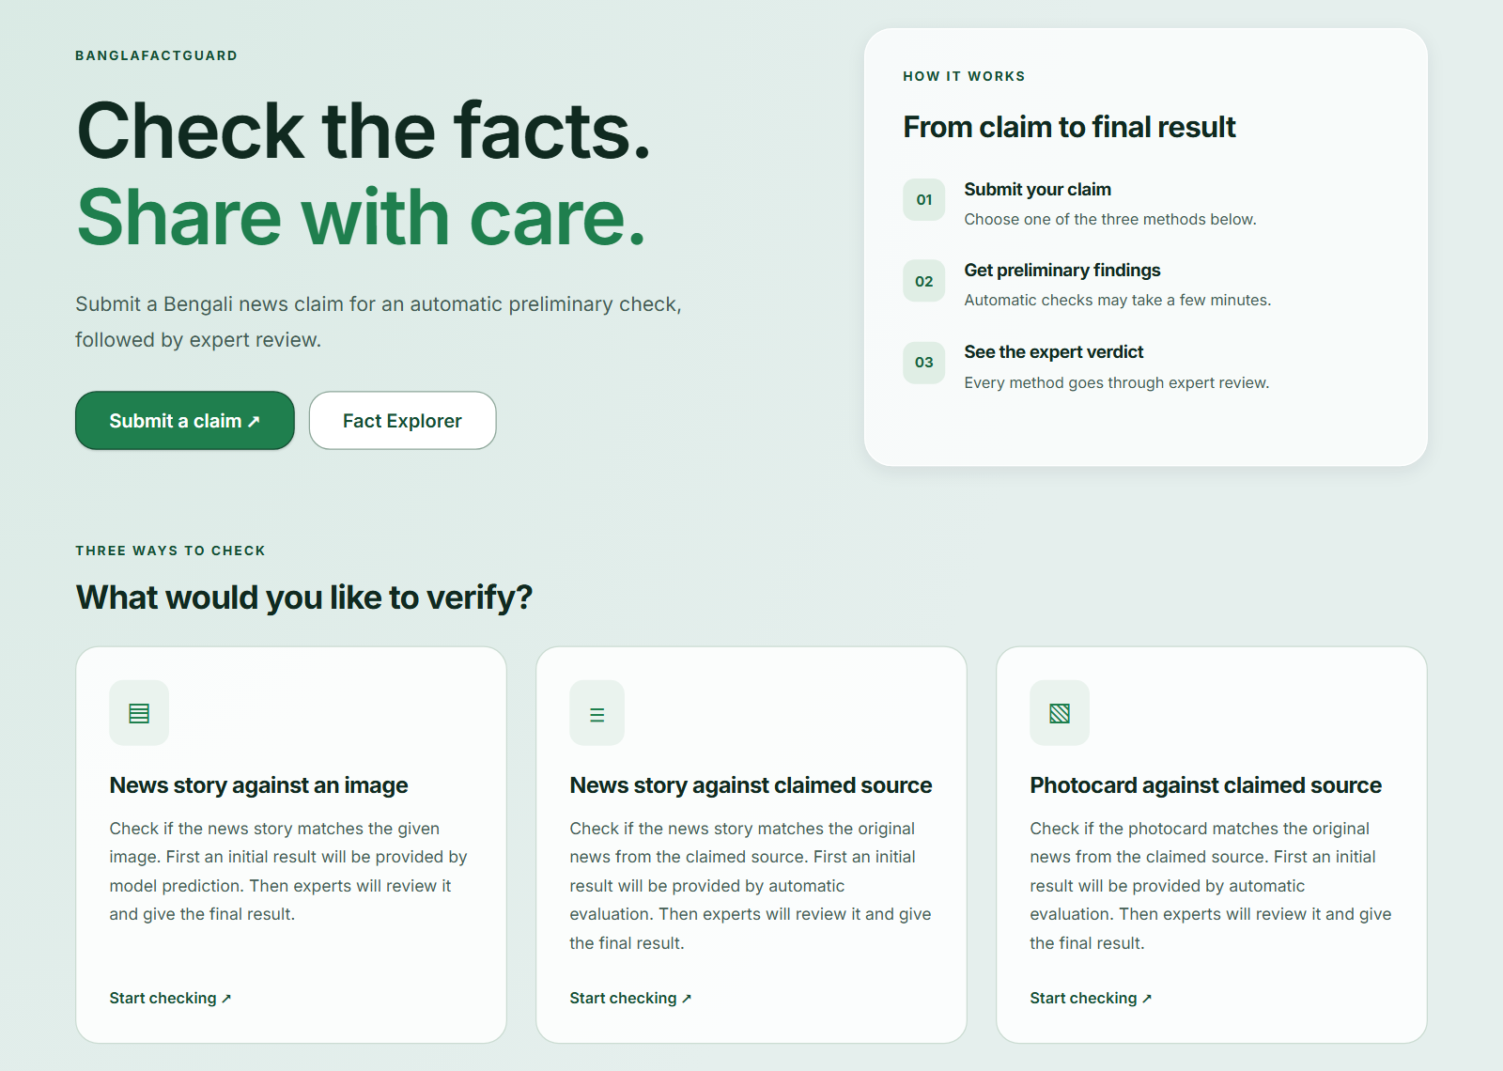
Figure 10.1: Home Page

10.2 Creating an Account and Signing In
- Click Get Started (or Login, then Create one).
- Enter your full name, email and a password of at least 8 characters with an uppercase letter and a number. Confirm the password and click Create Account (Figure 10.2).
- To sign in later, click Login, enter your email and password and click Sign In.
- If you forget your password, click Forgot password?, enter your email, then type the code sent to your email and a new password.
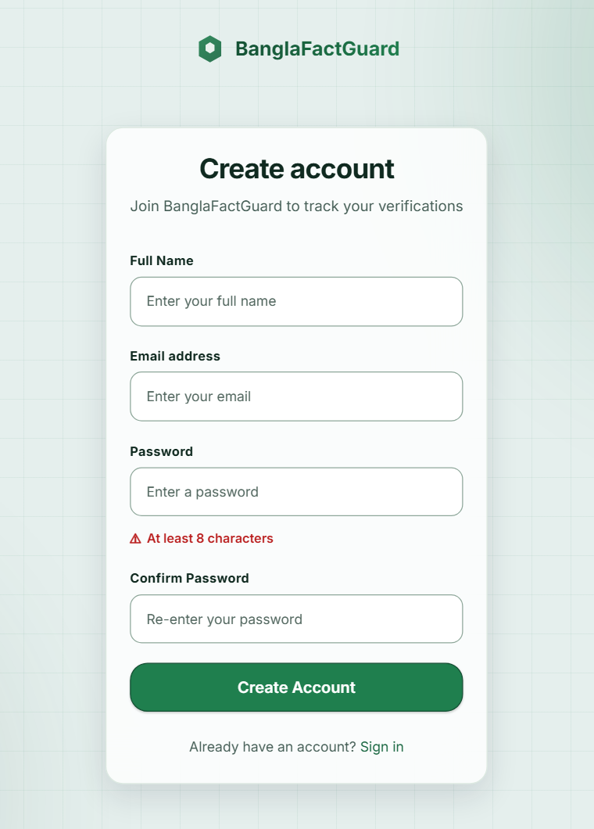
Figure 10.2: Create Account Page

10.3 Checking a Claim
Click Verify facts and choose a method card. You can hide the card descriptions with Hide descriptions.

10.3.1 Text & Source (News story against claimed source)
- Type or paste the Bangla headline.
- Choose the publisher named in the claim when it is known. If no active publisher is identified, the current system can search across registered sources.
- Optionally paste the article text and choose the claimed publication date.
- Click Verify news. The page shows “Verification in progress” (Figure 7.6). You may leave the page; the check continues.
Figure 7.5 shows the form. Completion time varies with evidence retrieval, model processing and server load.

10.3.2 Photo Card (Photocard against claimed source)
- Click the upload box and choose the card image (JPEG, PNG, WebP or GIF, up to 10 MB).
- Check the preview, then click Verify photo card.
- The system reads the headline and any visible outlet and date. It then searches the identified outlet or the active registered sources. If the headline cannot be read or the service fails, the result explains the problem and offers another image upload (Figure 7.9).
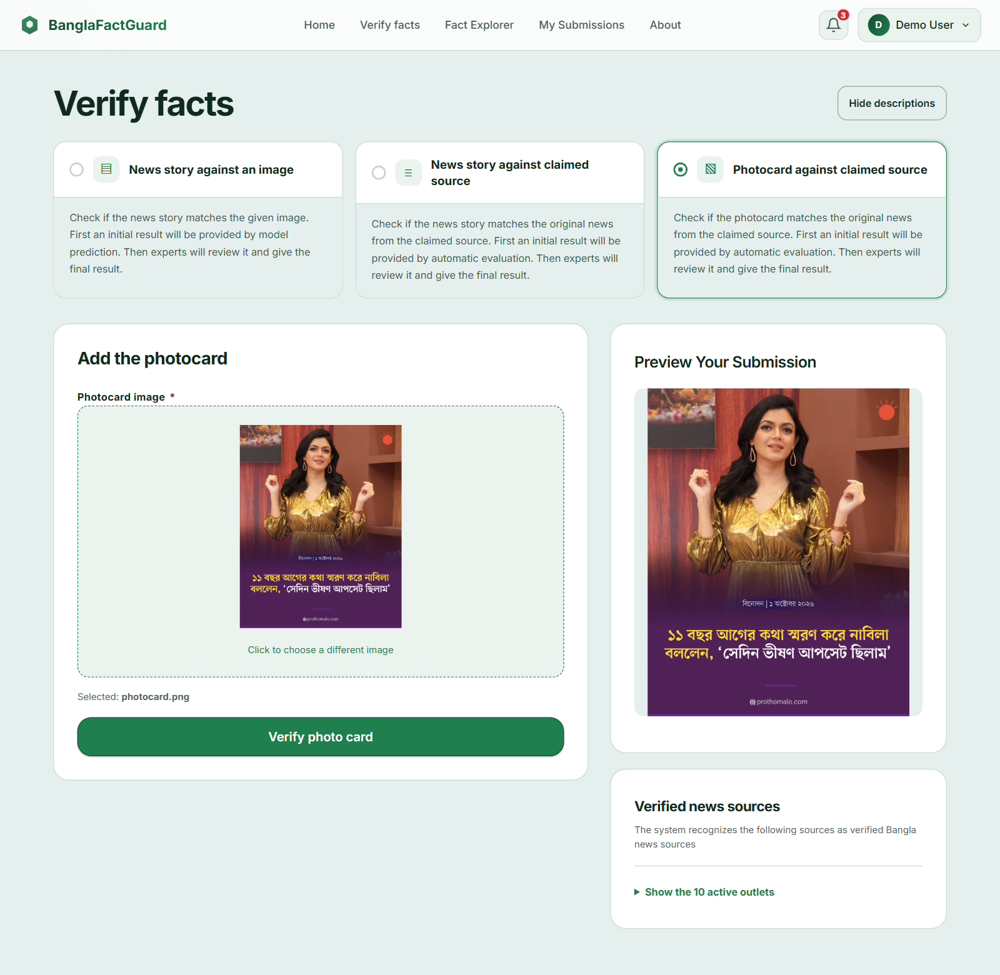
Figure 10.3: Photo Card Form with Preview

10.3.3 Text & Image (News story against an image)
- Enter the headline and the article text.
- Upload the news image and check the preview.
- Click Check text and image. The result shows AI decision: Likely Real or Likely Fake, which is a preliminary estimate only.
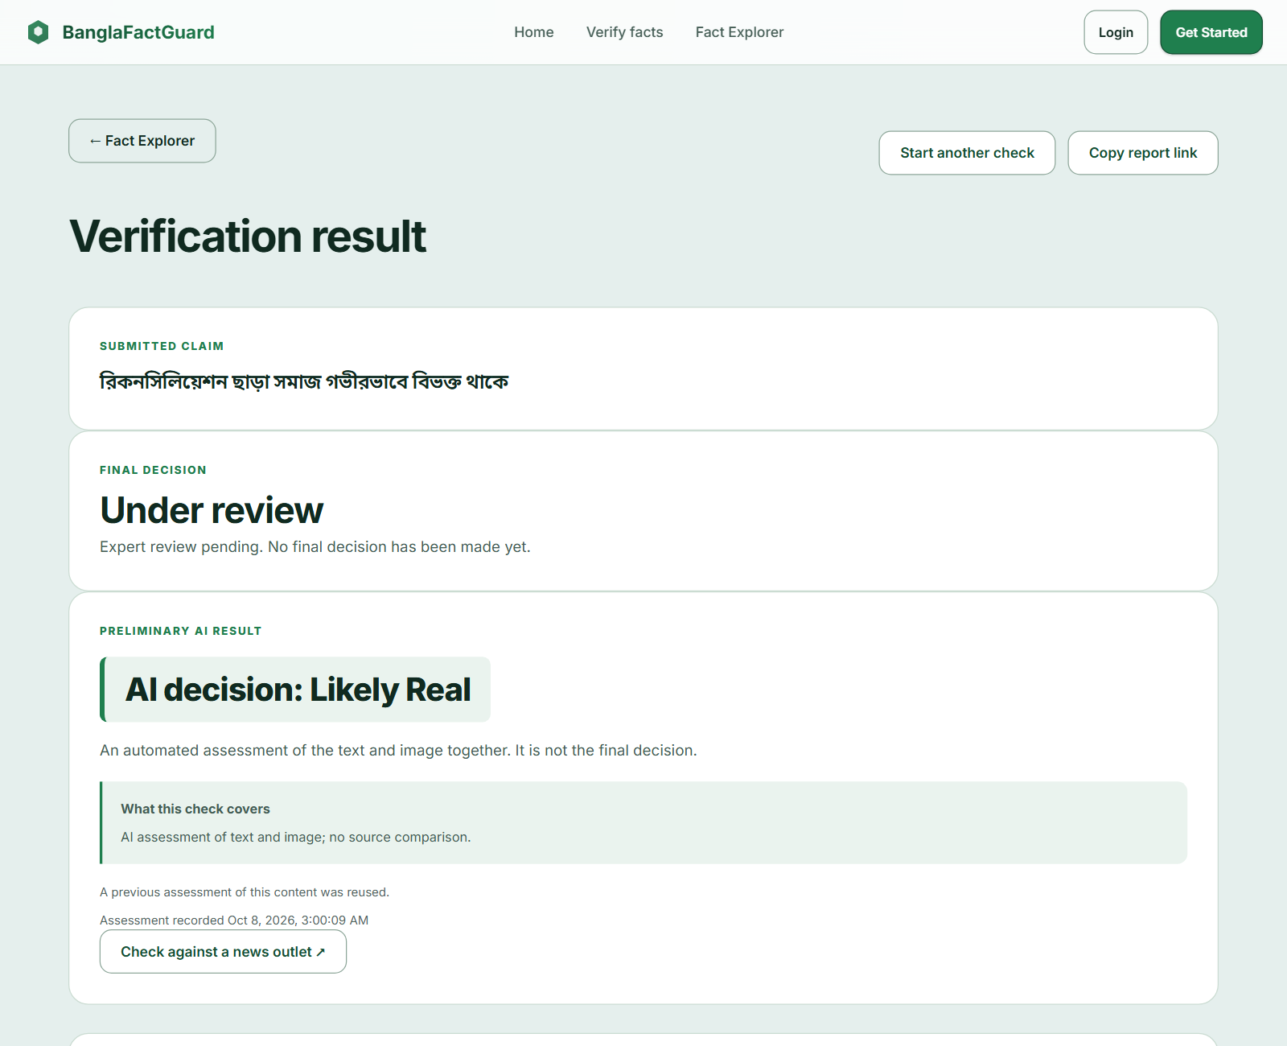
Figure 10.4: Text & Image Result with a Reused Assessment

10.4 Reading a Result
The report shows the claim, the review status and the available preliminary findings. Source-based checks also show relevant articles and comparisons when available. Under review means that no final verdict has been published. A completed review adds the final decision and voting details.
- Source findings show whether a relevant article was found within the stated search scope. Not Found does not mean the claim is false, and Incomplete means the check could not reach a conclusion.
- Headline findings show an exact match, preserved meaning or an alteration when a comparison is possible. Meaningful differences are listed beside the claim and source wording.
- Date findings compare a supplied or extracted date with the article date. If either is unavailable, a definite match or mismatch cannot be shown.
- Body similarity scores appear when article text is supplied. They measure text overlap and meaning similarity, not the probability that a claim is true.
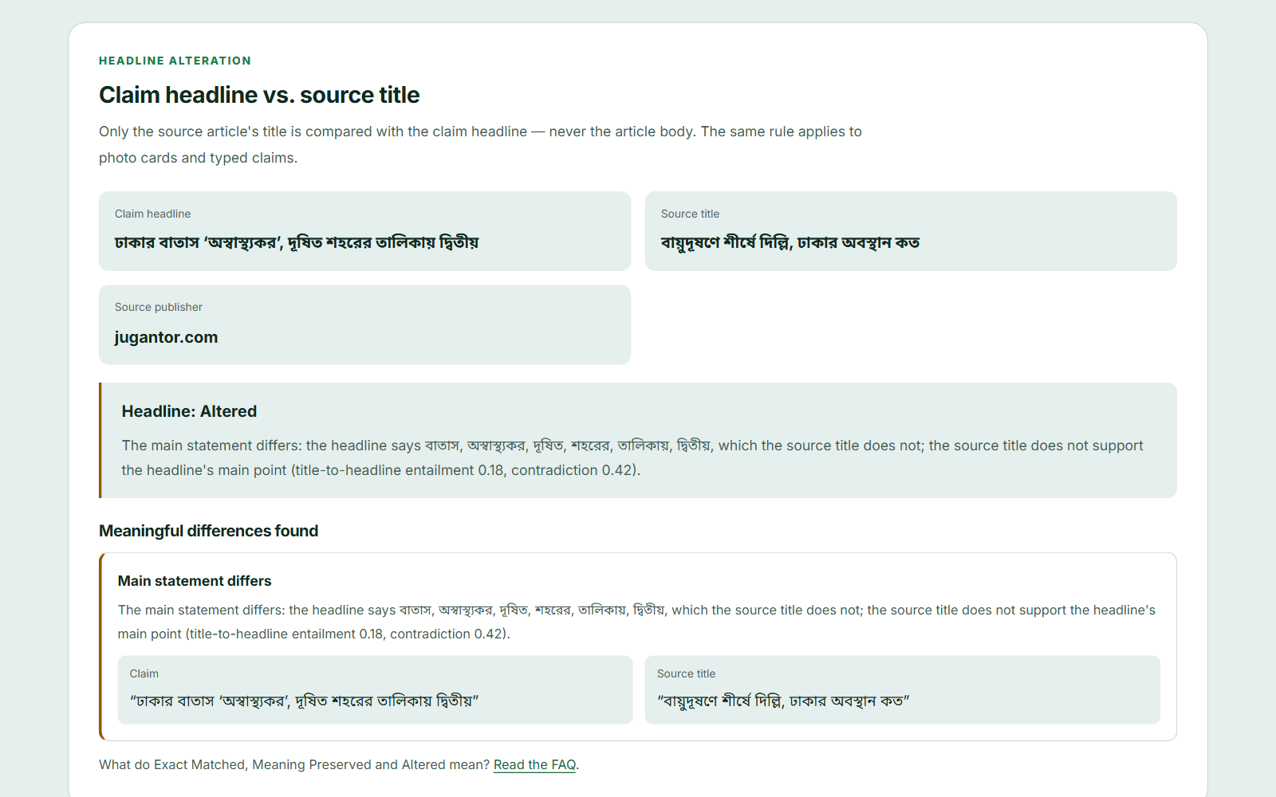
Figure 10.5: Headline Comparison Showing an Altered Headline
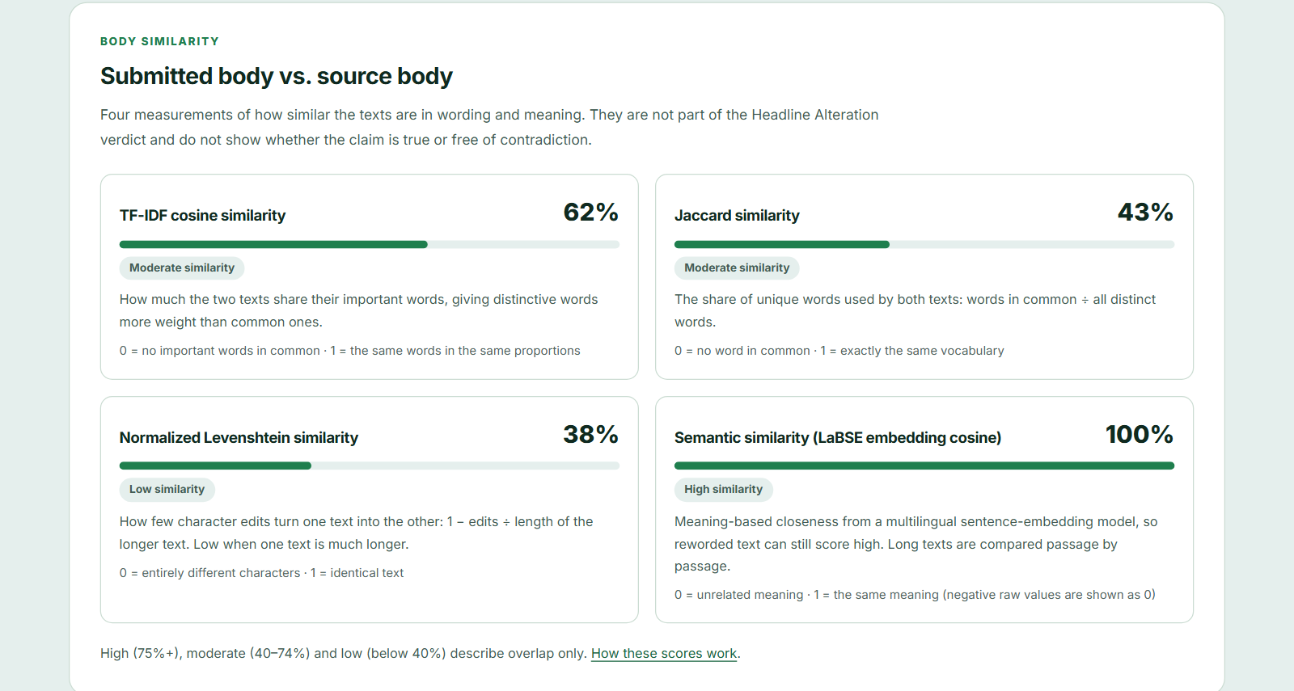
Figure 10.6: Body Similarity Scores
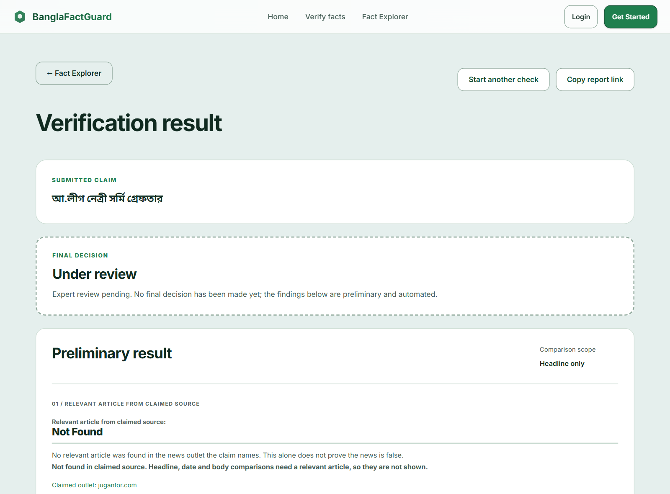
Figure 10.7: Result When the Claimed Source Has No Matching Report
Use Copy report link to share a result and Start another check to begin again.

10.5 Fact Explorer
Click Fact Explorer to search previous claims (Figure 10.8). The top shows archive counts. Choose Final decisions or Under review, type a keyword, choose a decision and content type, and click Search. More filters adds date and outlet filters. Click Read full report to open a claim.
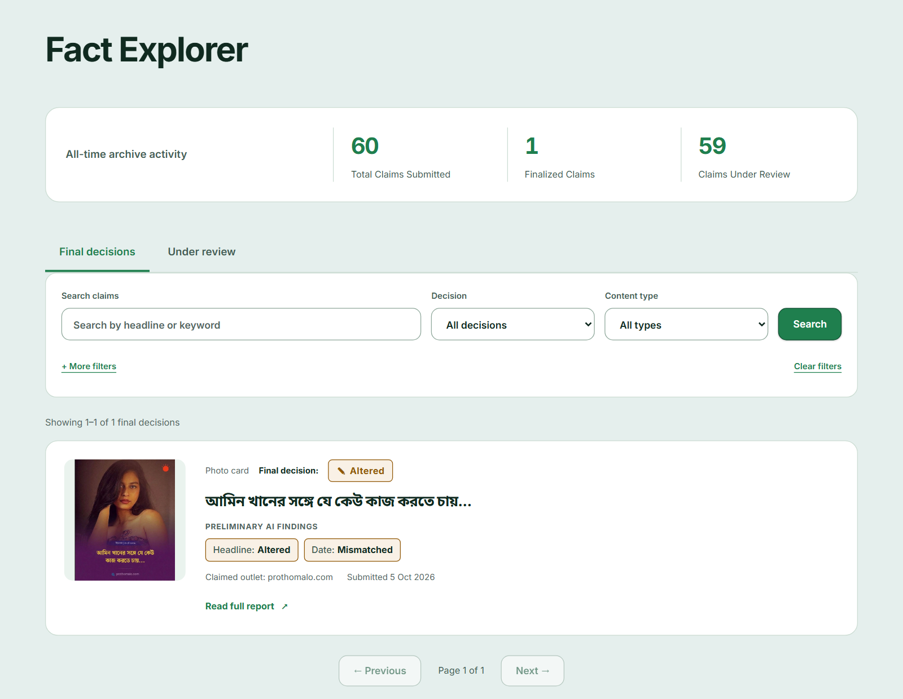
Figure 10.8: Fact Explorer

10.6 My Submissions, Notifications and Settings
My Submissions lists your claims (Figure 10.9). The bell opens result notifications (Figure 10.10); marking them as read keeps them in the list. Final results are emailed when delivery is configured. Account settings lets you change your name and password.
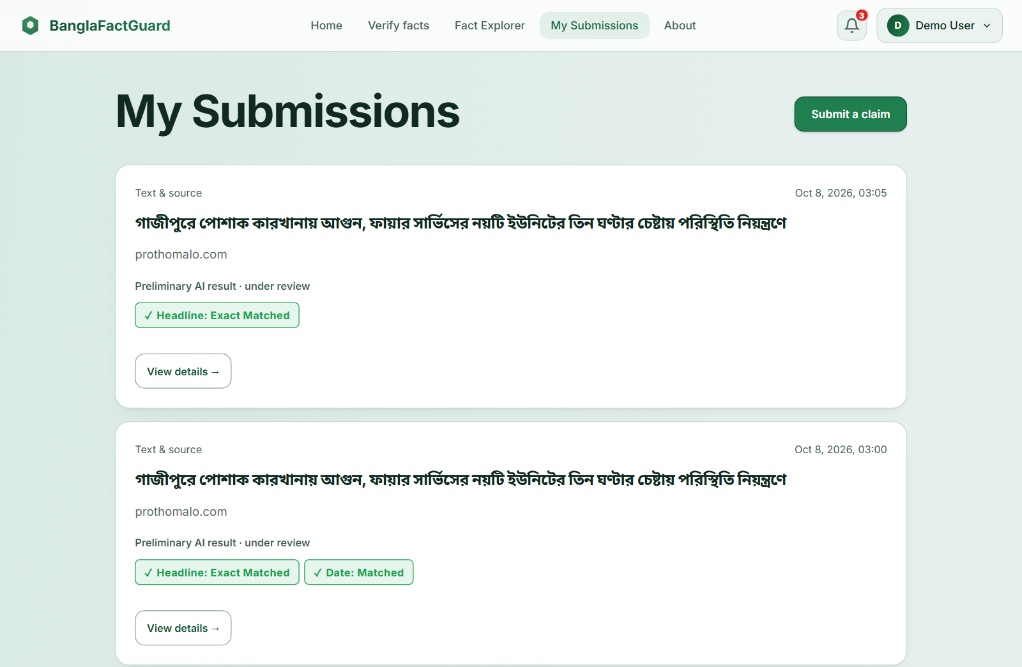
Figure 10.9: My Submissions
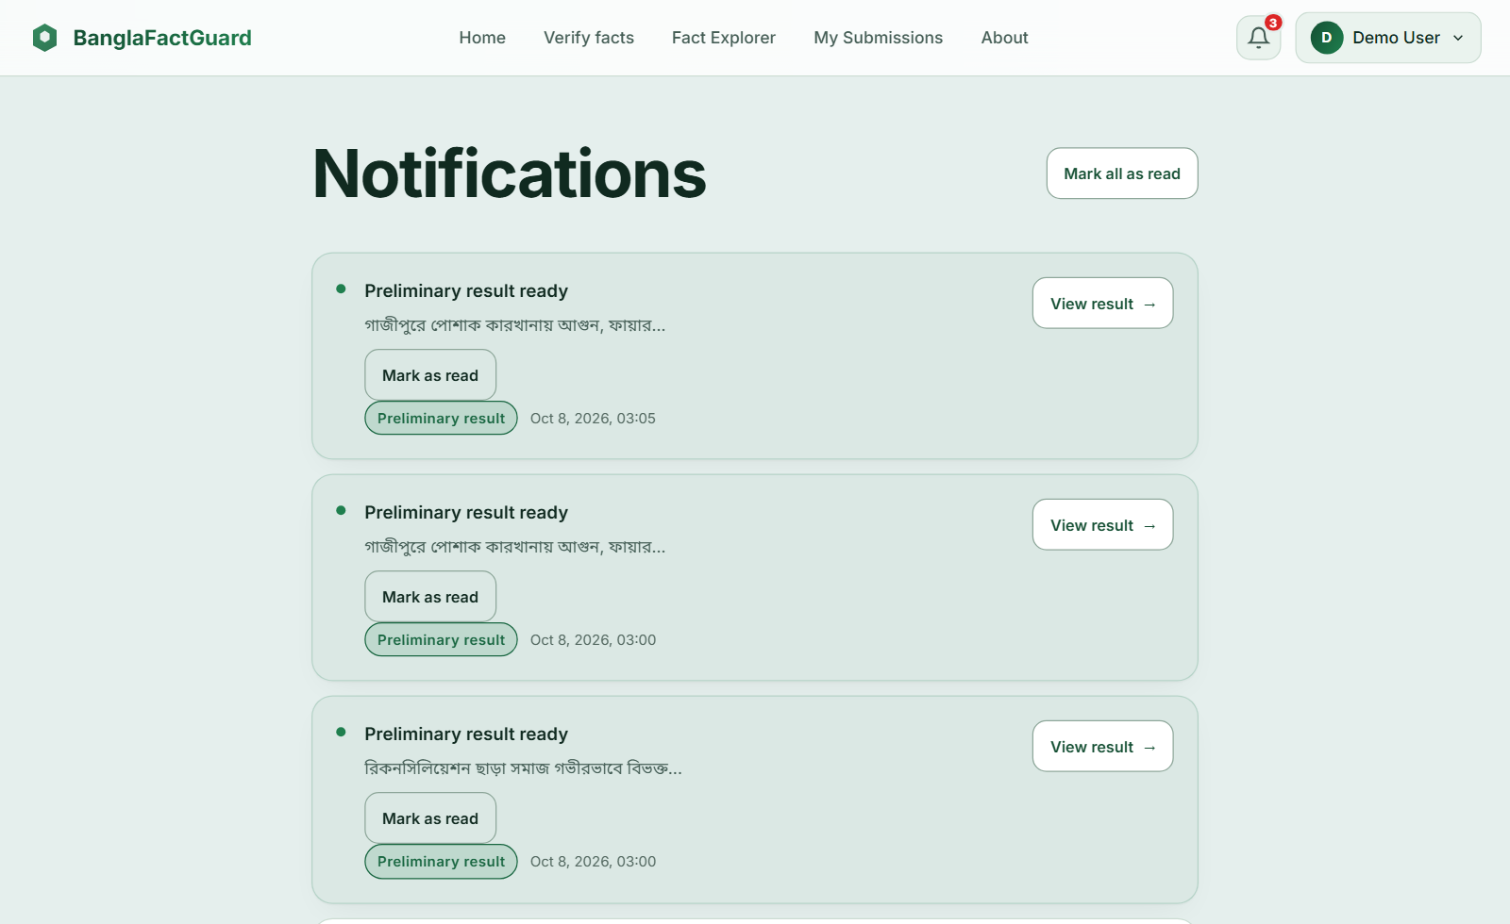
Figure 10.10: Notifications

10.7 Using the Browser Extension
- Pin BanglaFactGuard — Browser Extension in Chrome and click its toolbar icon on the news page. The side panel opens.
- Choose Text & source, Photo card or Text & image.
- Select text on the page and click Use selected text, or type it. For images, click Upload image or Select screenshot area and drag over the part of the page you want.
- Adjust the image with Apply crop, Reset crop or Remove.
- Click Submit for verification. Activity first shows the claim being checked and then the available result. Desktop alerts depend on browser and notification settings. Use View details to open the full website report.
- Sign in separately through the Account tab using your website account. Switch the extension off to pause new activity and alerts; accepted checks continue on the server.
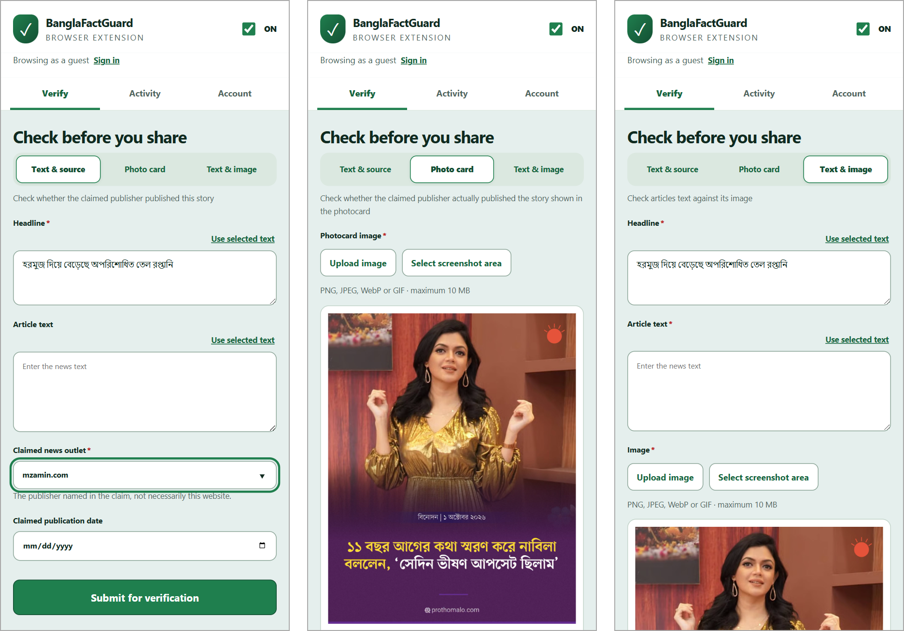
Figure 10.11: Extension Verify Tab — Text & Source, Photo Card and Text & Image
The account and activity screens are shown in Figure 7.10.

10.8 Expert Tasks
- Sign in with the account created by the administrator. Open Expert Queue (Figure 10.12).
- Search if needed, and click Review & vote on a claim.
- Read the claim, the preliminary findings and the article (Figure 7.11). Remember that automated findings are supporting information, not instructions.
- Choose Real, Fake, Misleading or Altered, optionally add supplementary findings, write a justification of at least 50 characters and click Submit vote.
- Open Review History to see your votes and available final decisions. Account settings shows your review record. New experts use the default vote weight until they reach the required number of completed reviews.
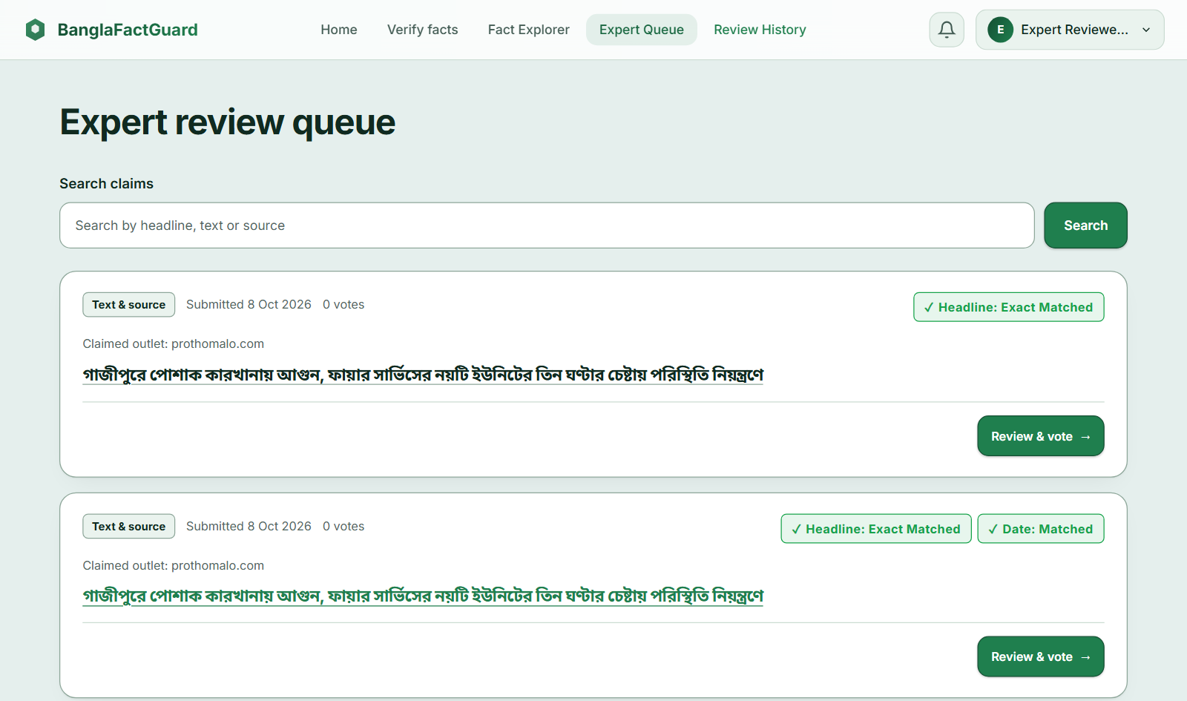
Figure 10.12: Expert Review Queue

10.9 Administrator Tasks
The Admin dashboard (Figure 10.13) shows escalated claims that need your decision, activity counts, claims waiting longest and recent decisions. Use the Experts, Sources and Voting & tiers buttons to manage the system.
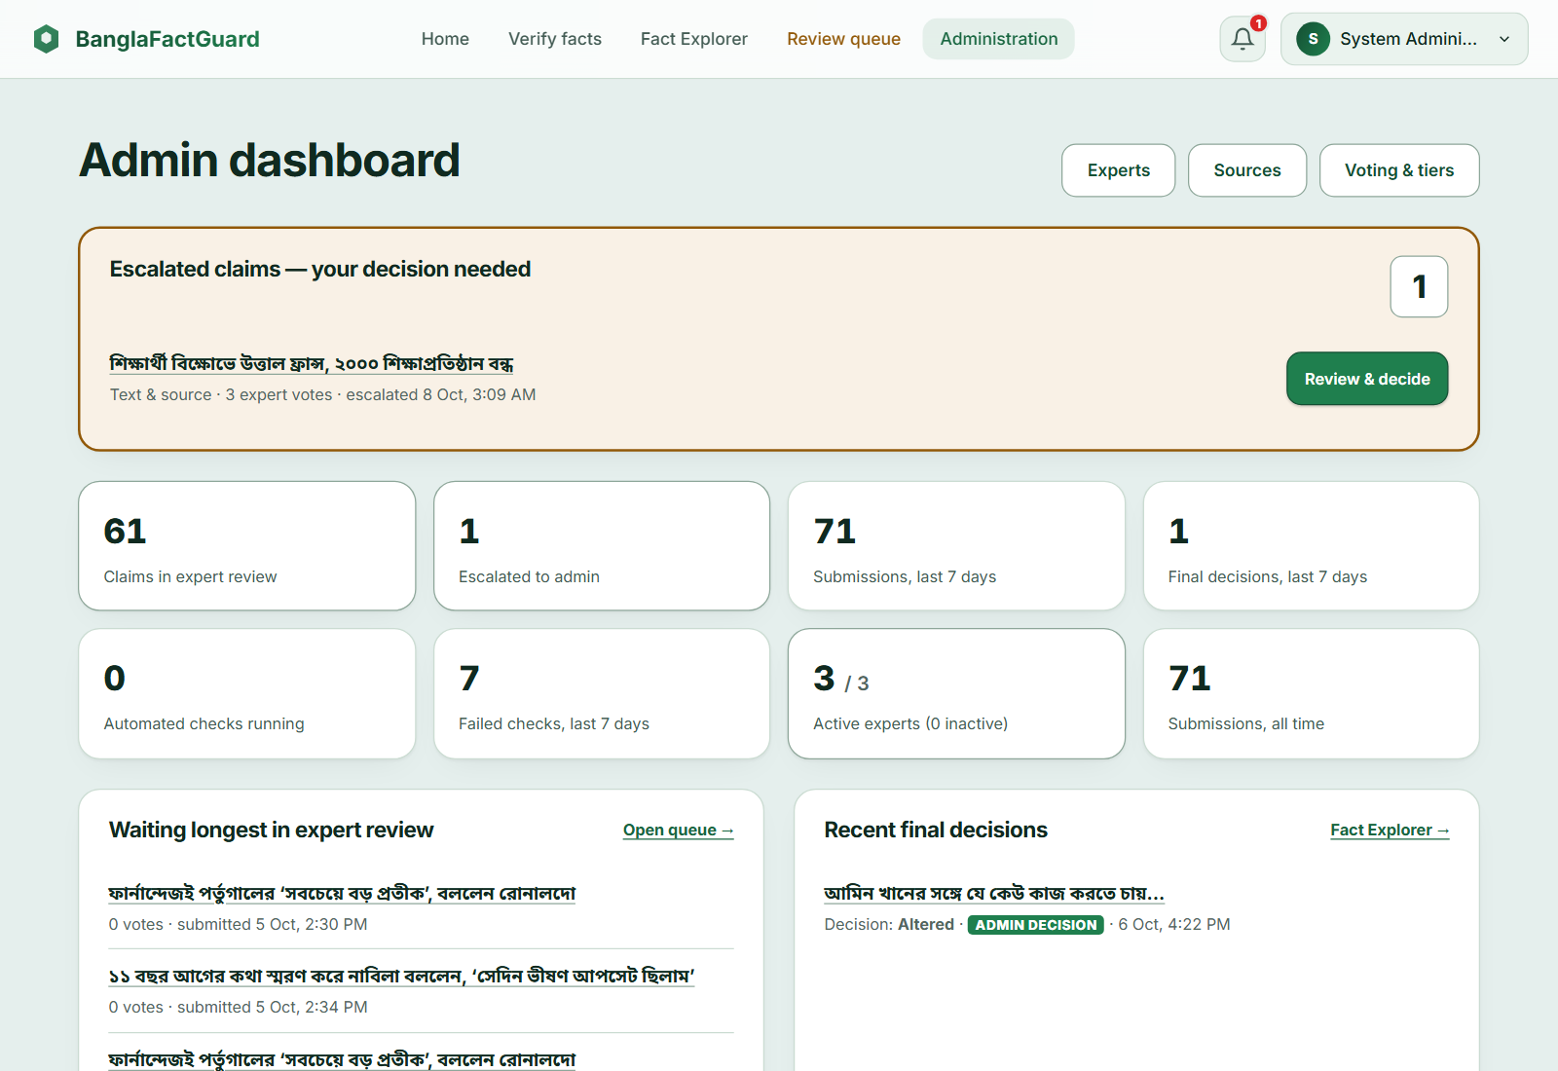
Figure 10.13: Administrator Dashboard
- Experts: click Create expert, enter name, email, password and expertise area, and click Create Expert Account. Use Edit, Deactivate and Reset password in the table (Figure 10.14).
- Sources: click Register New Source to add an outlet, or use Edit, Disable and Delete on a card (Figure 10.15). Only active sources are used for verification.
- Voting & tiers: set Min voters (M), Verified threshold (T), Lead margin, Activation threshold (N), Max review votes and Max review hours, then Save Configuration. Add or edit tiers with their accuracy range and weight (Figure 10.16).
- Escalated claims: in Review queue, choose Escalated — needs your decision, click Review & decide, choose the verdict, explain it and submit. Your decision is final; the public result then shows it with Voting Details (Figure 10.17). Claims that are not escalated are view-only.
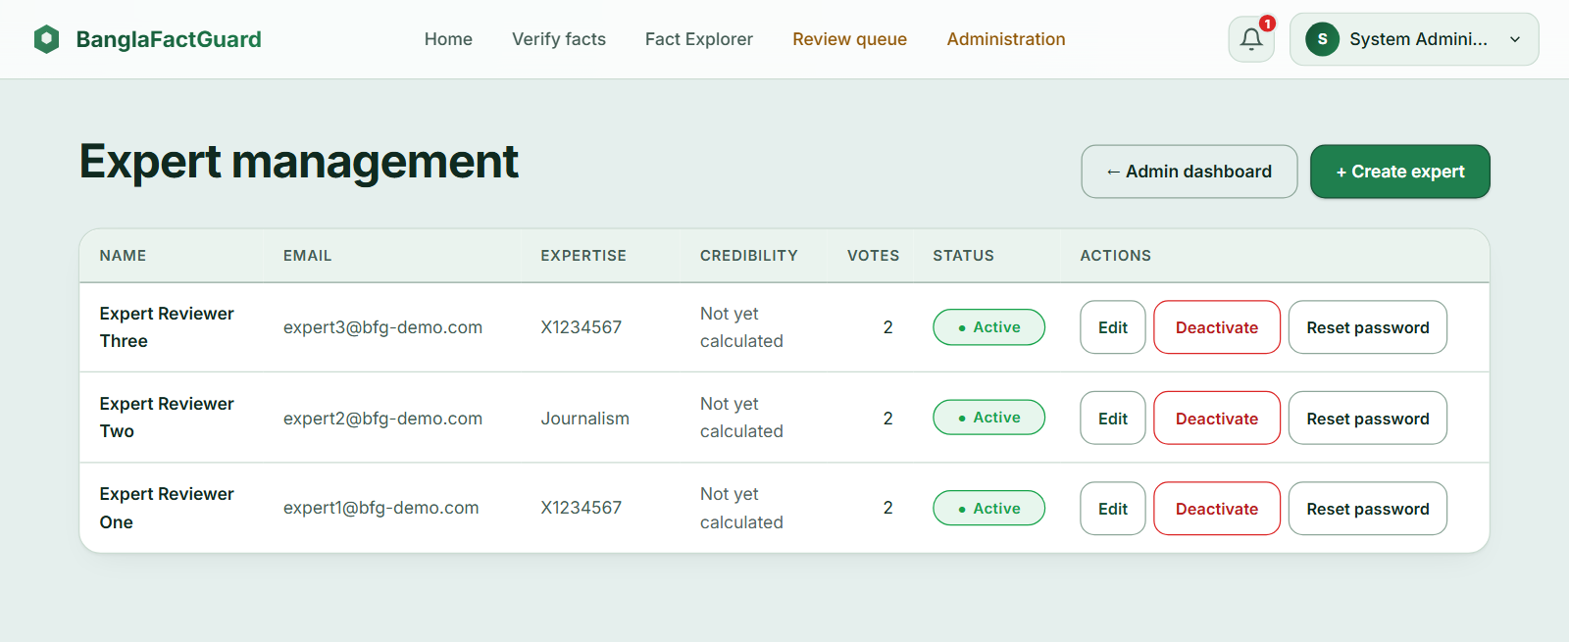
Figure 10.14: Expert Management
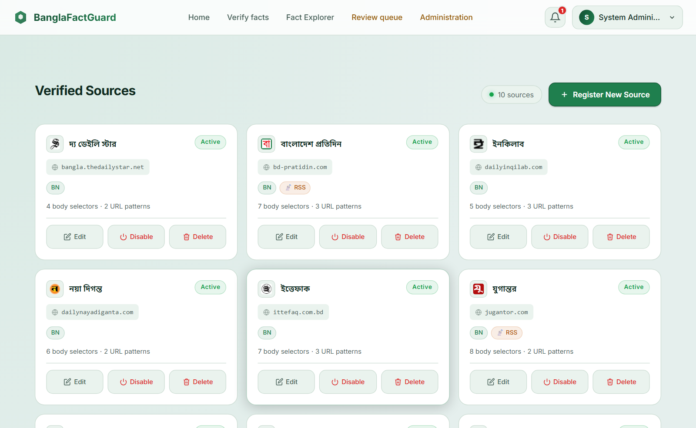
Figure 10.15: Verified Sources
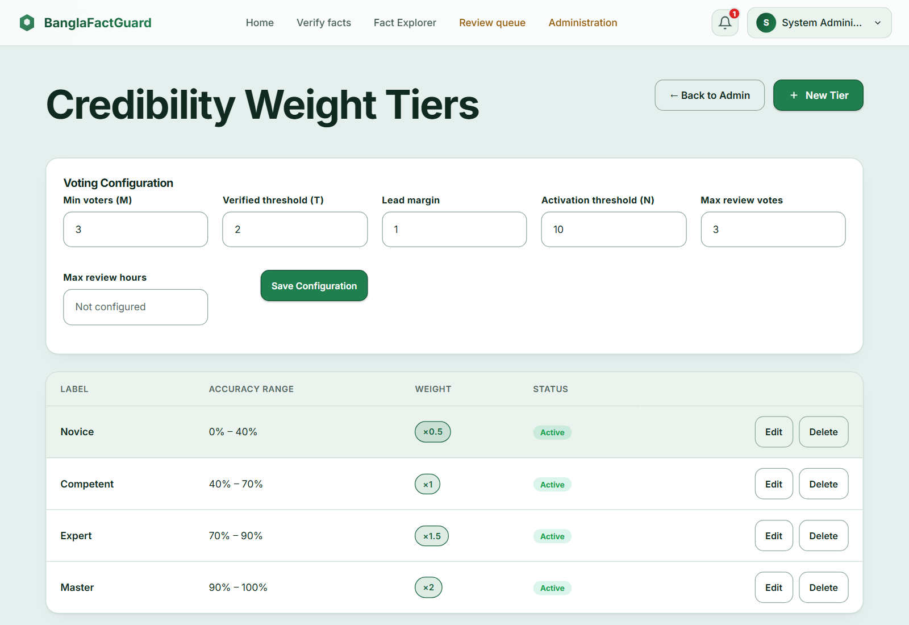
Figure 10.16: Voting Configuration and Credibility Weight Tiers
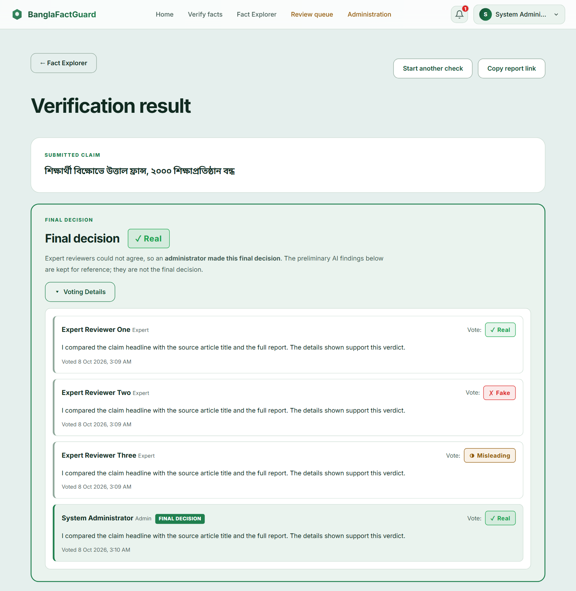
Figure 10.17: Final Decision with Voting Details After an Administrator Decision

10.10 Troubleshooting
Table 10.1: Common Problems and Solutions
Problem | What to do
A publisher is unavailable or unrecognised | Use the registered-source check when available. Ask an administrator to review a publisher that needs registration or activation.
The claim stays “in progress” for a long time | Checks may take a few minutes. The backend must be running with background jobs enabled.
Photo card “temporarily unavailable” | The image-reading service did not return a usable response. Try again later.
The card has no readable headline | Upload a clearer image with the full headline visible. Include the publisher name or logo if available.
Extension cannot capture a page | Click the pinned toolbar icon on that page first; Chrome internal pages cannot be captured, so upload an image instead.
No desktop alert | Check that the extension is ON, notifications are enabled in the Account tab, and Chrome may show notifications; Activity still shows the result.

11. Repository Installation and Deployment

11.1 Repository
The project repository is https://github.com/abulkalamazad1425/BanglaFactGuard. Use the following commands to obtain a local copy:
git clone https://github.com/abulkalamazad1425/BanglaFactGuard.git
cd BanglaFactGuard

11.2 Prerequisites
Table 11.1: Prerequisites
Software | Version / note
Python | 3.11 or newer, with PyTorch and model dependencies
Node.js and npm | Node 22 for the website and the extension
PostgreSQL | PostgreSQL database and account; version 17 is listed in the development setup
Docker Compose | For the included Redis and MinIO services
Google Chrome | Desktop Chrome 120 or newer for the extension
Gemini API key | Needed for photo card reading
Multimodal model files | img_backbone.pt, text_backbone.pt, classifier.pt and tokenizer/ in MULTIMODAL_MODEL_DIR

11.3 Backend Setup
Run these PowerShell commands from the repository root:
cd backend
python -m venv .venv
.\.venv\Scripts\python.exe -m pip install --upgrade pip
.\.venv\Scripts\python.exe -m pip install -r requirements.txt
.\.venv\Scripts\python.exe -m playwright install chromium
if (!(Test-Path .env)) { Copy-Item .env.example .env }
Configure backend/.env for your database, storage and external services (Table 11.2). Keep an existing configuration when updating the project. Use a generated signing secret and keep credentials outside version control.
Table 11.2: Main Configuration Settings (backend/.env)
Setting | Purpose
DB_HOST, DB_PORT, DB_NAME, DB_USER, DB_PASSWORD | PostgreSQL connection
REDIS_HOST, REDIS_PORT | Redis connection
MINIO_* | Image storage endpoint, credentials and bucket
AUTH_SECRET_KEY | Required JWT signing key (at least 32 characters)
ML_* | Language-model configuration for article and headline comparison
GEMINI_API_KEY, GEMINI_* | Photo card reading and request batches
MULTIMODAL_MODEL_DIR, MULTIMODAL_LOAD_ON_STARTUP | Text & image model files and loading
JOBS_ENABLED, JOBS_* | Background worker and recovery
EMAIL_SMTP_*, EMAIL_FROM_ADDRESS, EMAIL_WEBSITE_URL | OTP and final-result emails

11.4 Services, Database and Sources
Create the PostgreSQL database named in DB_NAME. Then, from backend/, start Redis and MinIO, apply the migrations, seed the verified sources and start the API:
docker compose up -d
.\.venv\Scripts\python.exe -m alembic upgrade head
.\.venv\Scripts\python.exe scripts/seed_verified_sources.py
.\.venv\Scripts\python.exe run.py
The local API is available at http://localhost:8000, with interactive documentation at http://localhost:8000/docs. The migrations include an initial administrator account. Use an appropriately configured administrator account to create expert accounts.

11.5 Website
cd frontend
npm ci
npm start
Open http://localhost:4200. The development API address is set in frontend/src/environments/environment.ts (default http://localhost:8000/api/v1). A production build is made with npm run build and needs a web server that forwards /api/v1 to FastAPI.

11.6 Browser Extension (Installation)
cd extension
npm ci
npm run build
- Open chrome://extensions and turn on Developer mode.
- Click Load unpacked and select the extension/dist folder.
- Pin BanglaFactGuard — Browser Extension and click its icon on a news page.

11.7 Running the Tests
cd backend; .\.venv\Scripts\python.exe -m pytest tests/unit -q --no-cov
cd frontend; npx ng test --watch=false --browsers=ChromeHeadless
cd extension; npm test

11.8 Deployment Status
- The report documents a local setup with the website, backend, PostgreSQL, Redis, MinIO and an unpacked Chrome extension. The included screenshots illustrate this setup.
- A public production deployment is not documented as completed. Production use would require a configured web server, service addresses, credentials and validation in that environment.

12. Conclusion
BanglaFactGuard combines automated checks with human review for Bangla news. Users can submit a headline and source, a photo card, or text with an image through the website and Chrome extension. The system presents preliminary findings, while experts or an administrator provide the final verdict.
The implementation separates source, headline and date findings so that users can see what each check establishes. Background processing supports longer checks, and result reuse avoids repeating compatible completed work. The recorded software run lists 550 passing tests. The separate multimodal evaluation records 80% test accuracy.
Further evaluation is needed before making broader claims about reliability. Priorities include a labelled Bangla benchmark for source verification, live integration checks, load testing and a validated production deployment. Photo card reading also depends on an external service. These limits remain relevant even when the automated software tests pass.

13. References
[1] F. T. J. Faria, M. B. Moin, Z. Hasan, Md. A. A. Khandaker, N. Islam, K. M. Hasib and M. F. Mridha, “MultiBanFakeDetect: Integrating advanced fusion techniques for multimodal detection of Bangla fake news in under-resourced contexts,” International Journal of Information Management Data Insights, vol. 5, Art. no. 100347, 2025.
[2] A. Bhattacharjee, T. Hasan, W. U. Ahmad, K. S. Mubasshir, M. S. Islam, A. Iqbal, M. S. Rahman and R. Shahriyar, “BanglaBERT: Language Model Pretraining and Benchmarks for Low-Resource Language Understanding Evaluation in Bangla,” in Findings of the Association for Computational Linguistics: NAACL 2022, 2022, pp. 1318–1327.
[3] M. Tan and Q. V. Le, “EfficientNet: Rethinking Model Scaling for Convolutional Neural Networks,” in Proc. 36th International Conference on Machine Learning (ICML), 2019, pp. 6105–6114.
[4] F. Feng, Y. Yang, D. Cer, N. Arivazhagan and W. Wang, “Language-agnostic BERT Sentence Embedding,” in Proc. 60th Annual Meeting of the Association for Computational Linguistics, 2022, pp. 878–891.
[5] L. Bonifacio, V. Jeronymo, H. Q. Abonizio, I. Campiotti, M. Fadaee, R. Lotufo and R. Nogueira, “mMARCO: A Multilingual Version of the MS MARCO Passage Ranking Dataset,” arXiv:2108.13897, 2021.
[6] P. He, J. Gao and W. Chen, “DeBERTaV3: Improving DeBERTa using ELECTRA-Style Pre-Training with Gradient-Disentangled Embedding Sharing,” arXiv:2111.09543, 2021.
[7] R. Panchendrarajan and A. Zubiaga, “Claim detection for automated fact-checking: A survey on monolingual, multilingual and cross-lingual research,” Natural Language Processing Journal, vol. 7, Art. no. 100066, 2024.
[8] R. S. Pressman and B. R. Maxim, Software Engineering: A Practitioner's Approach, 9th ed. New York: McGraw-Hill, 2020.

