**Md. Abul Khair**

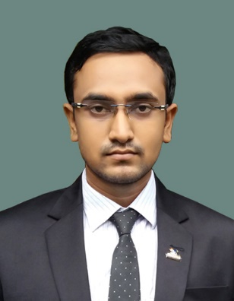 Photo

E-mail: [abulkhairsohag@gmail.com](mailto:abulkhairsohag@gmail.com)

LinkedIn: Abul Khair Sohag

Contact Number: 01753474401

**OBJECTIVE:**

To pursue a highly challenging career in the IT industry and work closely with a team of highly experienced professionals where my creative initiative, ideas and a genuine enthusiasm would allow me to progress.

**PROJECT :**

1. Online Vehicle Management System.
2. Online Tenant Management System .

**EDUCATION DETAILS:**

B.Sc. Engineering in Information and Communication Engineering

Rajshahi University, Bangladesh.

|  |  |  |  |  |  |
| --- | --- | --- | --- | --- | --- |
| Degree | Institution | **Board/University** | **Group/ Dept.** | Passing year | **GPA obtained** |
| B.Sc. Engineering | Rajshahi University | Rajshahi University | I.C.E | 2017 | 3.19 (scale of 4.00) |
| H.S.C | Rajshahi Govt. City College | Rajshahi | Science | 2012 | 5.00 (scale of 5.00) |
| S.S.C | Matikata High School | Rajshahi | Science | 2010 | 5.00 (scale of 5.00) |

**Programming Languages:**

C, Java, HTML, CSS, jQuery, PHP, MySQL

**Trainings:**

Top-up IT Training On Android Under Leveraging ICT.

**LANGUAGE SKILLS:**

Good fluency in both Bengali and English writing, listening and speaking.

**EXTRA CURRICULAR ACTIVITIES:**

* President-1 at BADHAN, Shaheed suhrawardy Hall unit (a voluntary blood donor’s organization).
* Donated blood 4 times.
* Organizer of Public University Student`s Association, Godagari.
* Member of Programming Club, Dept. of ICE, RU.
* Participated in the workshop on 3D Printing Technology.
* Attended in Android App Camp organized by Rajshahi University IT Society.

**PERSONAL INFORMATION:**

Father’s Name : Md. Salah Uddin

Mother’s Name : Most. Khairun Nesa

Permanent Address : Village: Uzanpara, PO: Matikata, PS: Godagari, District: Rajshahi

Date of Birth : 17th March 1994

Sex : Male

Nationality : Bangladeshi

Nationl ID : 19948113457000337

**REFERENCE:**

Name : Dr. Firoz Ahmed

Designation : Associate Professor

Address : Rajshahi University

Phone No. : 017711065595

Email ID : [fahmed@ru.ac.bd](mailto:fahmed@ru.ac.bd)

I authorized the signature below and clarify that above information in my curriculum vitae is accurate.

**Signature:**

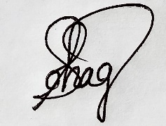

**Date: 28.03.2019**