**BUG 1:**

**Source Day 1/Two_Wire_SPI**

Looking at pictures of bug 1 when the bottom half of getting errors generating bitstream error is “[Synth 8-27] else clause after check for clock not supported”

The code was fixed by removing the elseif clause and replacing it with an if. This didn’t break simulation and can now generate bitstream 😊

**BUG 2:**

**Source Day 1/LED Control**

This code is suppose to use the two_wire_spi source to send some pixel data. It should be sending “00000000” for the first 4 transmissions but this doesn’t work. The outputs are just U I suspect this is due to the actual two_wire_spi code. You can see here we are waiting for ready_for_data to be high before sending anything. I think that the code is not initializing the o_ready_for_data from the two_wire_spi source to be 1 initially. The testbench is shown below for led_control.

Below is the testbench of the two_wire_spi source which verifies my suspicions.

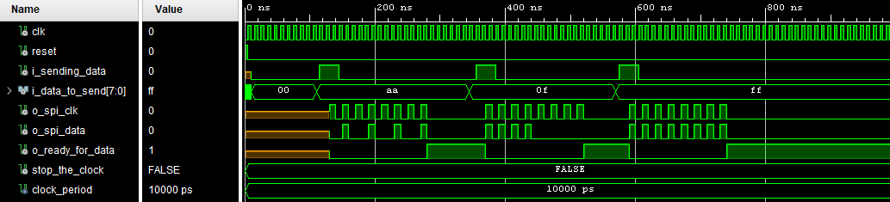

Below is the test bench for two_wire_spi fixed

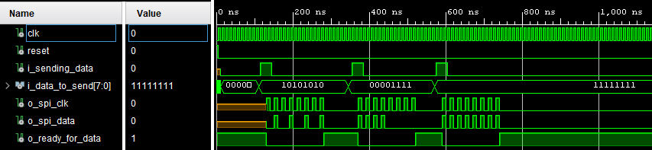

Retesting the led_control reveals a successful testbench now I just need to complete the code

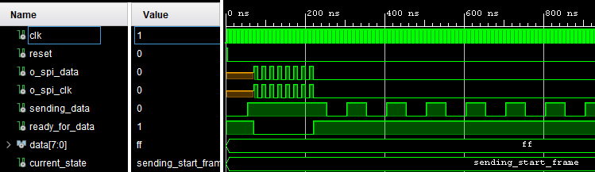

**BUG 3:**

**Source Day 1/Two Wire Spi**

??

**Bug 4:**

**Source Day 2/Addresable_Strips**

I decided to completely rewrite all the code I made and although I lost some time I managed to do everything eventually simulation below for just the start frame and the first two leds.

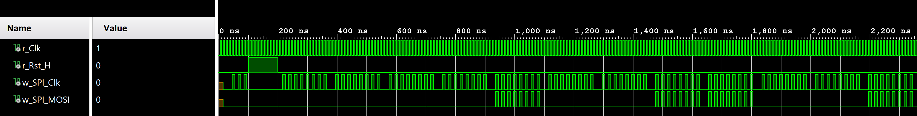

However even though I have no errors in the code and the simulation nworks fine now I can’t generate bitstream because of this error….

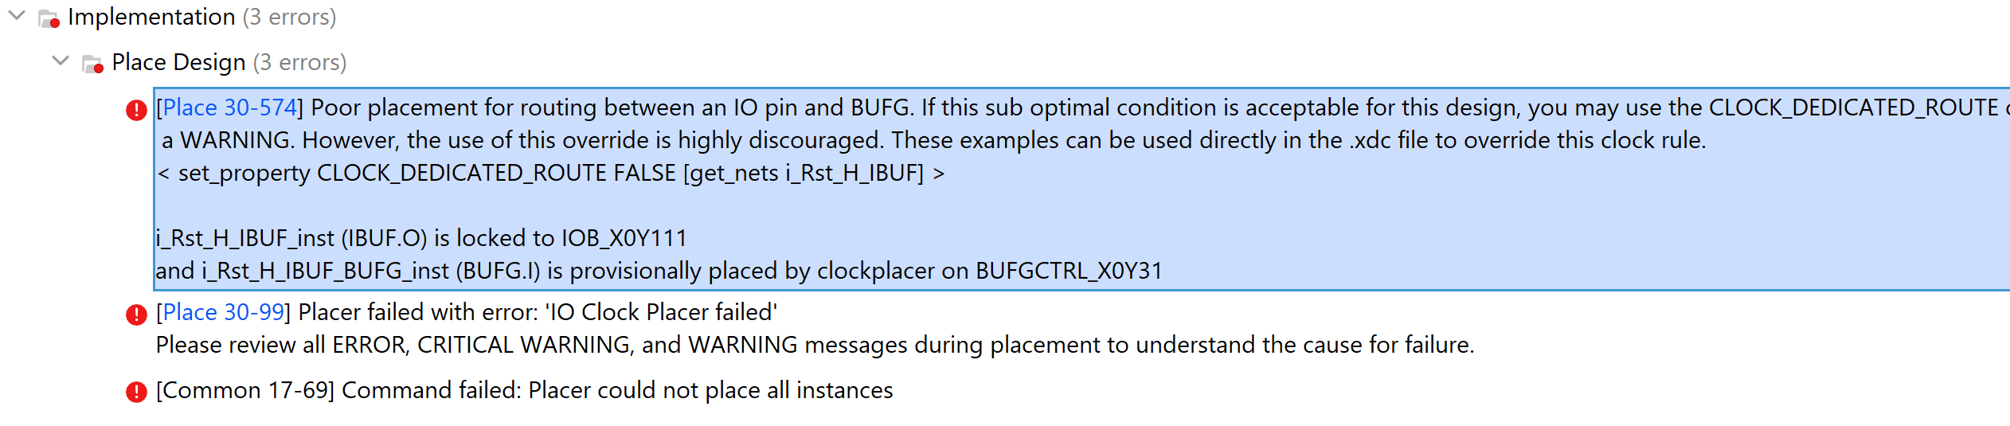

After like 2 hours of debugging I found the issue……. The highlighted line when uncommented caused the error. I have no idea why this isn’t a clock.

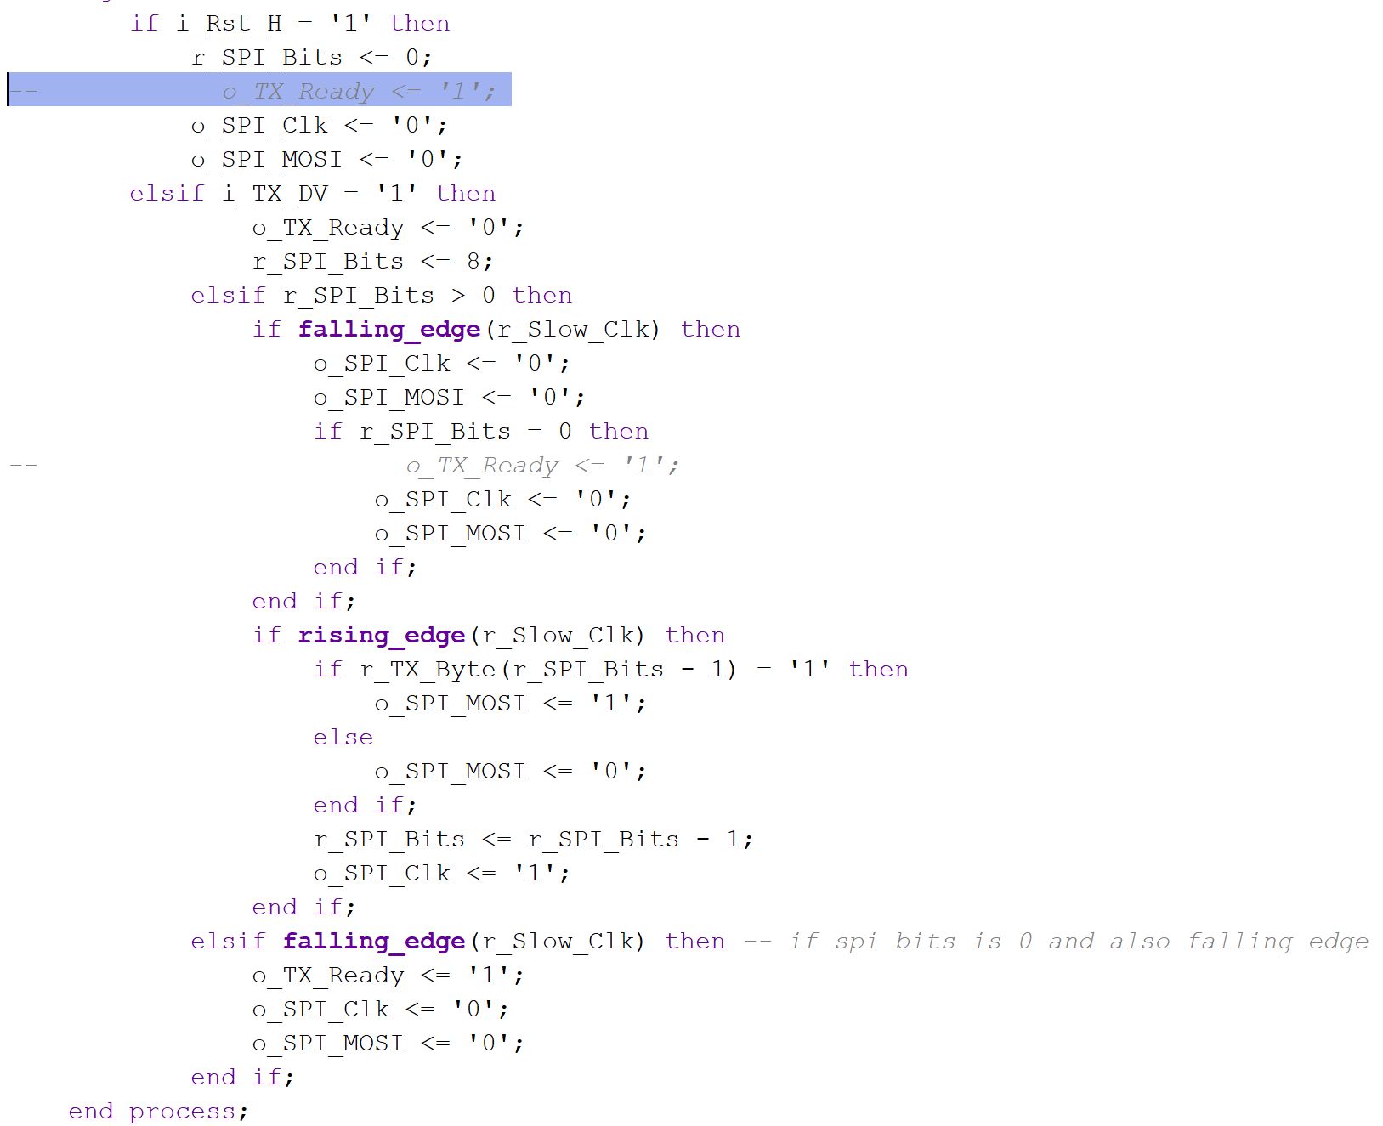

**Bug 5: Day 3**

No pictures for this but even though my simulation is working every time I upload my code nothing is coming up on the FPGA when I probe with my logic analyser. I have confirmed that it’s not the issue with the logic analyser as I have tested other codes on the same pins and they worked. I even drove the spi pins with a clock directly and that worked but when I try to display the spi output it just stays low. I am pretty sure the spi code needs to be improved so I guess I’m going to rewrite it for the third time.

I fixed the problem with no output showing I suspect its to do with the fact that I was doing stuff on rising and falling edges before. Now I only do stuff on rising edges

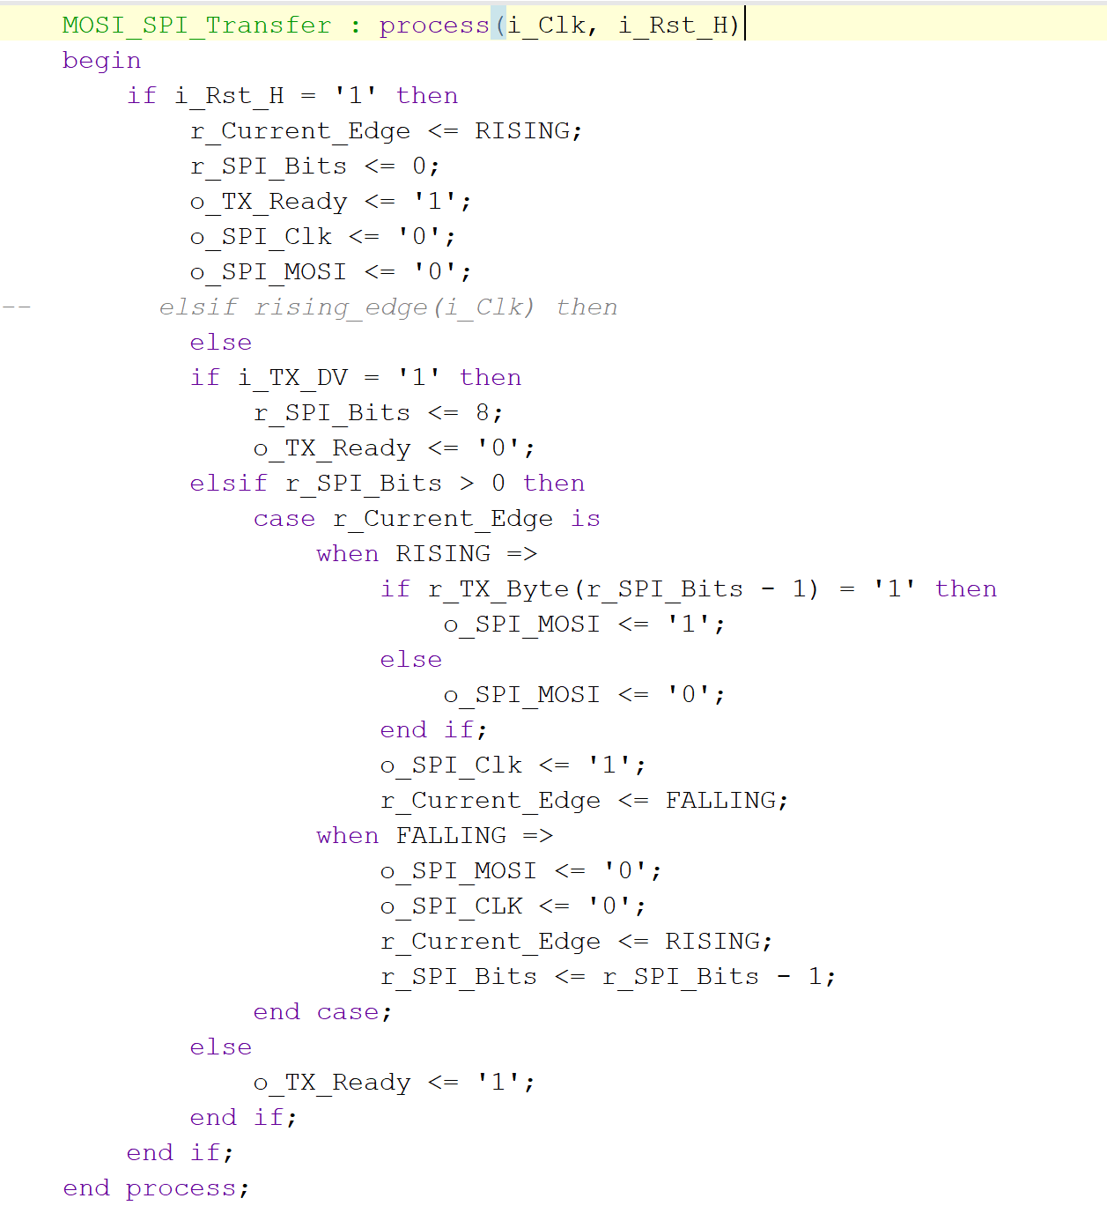



Success!! I just have an issue where the o_tx_ready which signifies that the spi bus is no longer busy is hanging for too long which accepts multiple spi transactions while actually only proessing one.