Assignment 1-2: Revised Interest Areas

I would like to work on:

Medication non-adherence in chronic diseases
Around 50% of people who suffer from chronic diseases (Diabetes, Cardiovascular-hypertension, Asthma, COPD etc.) stop following their treatment plan for various reasons, most of which are highly related to their experience of perceiving their illness and failure of changing their behavior accordingly. Here are some snapshots from a quick research:

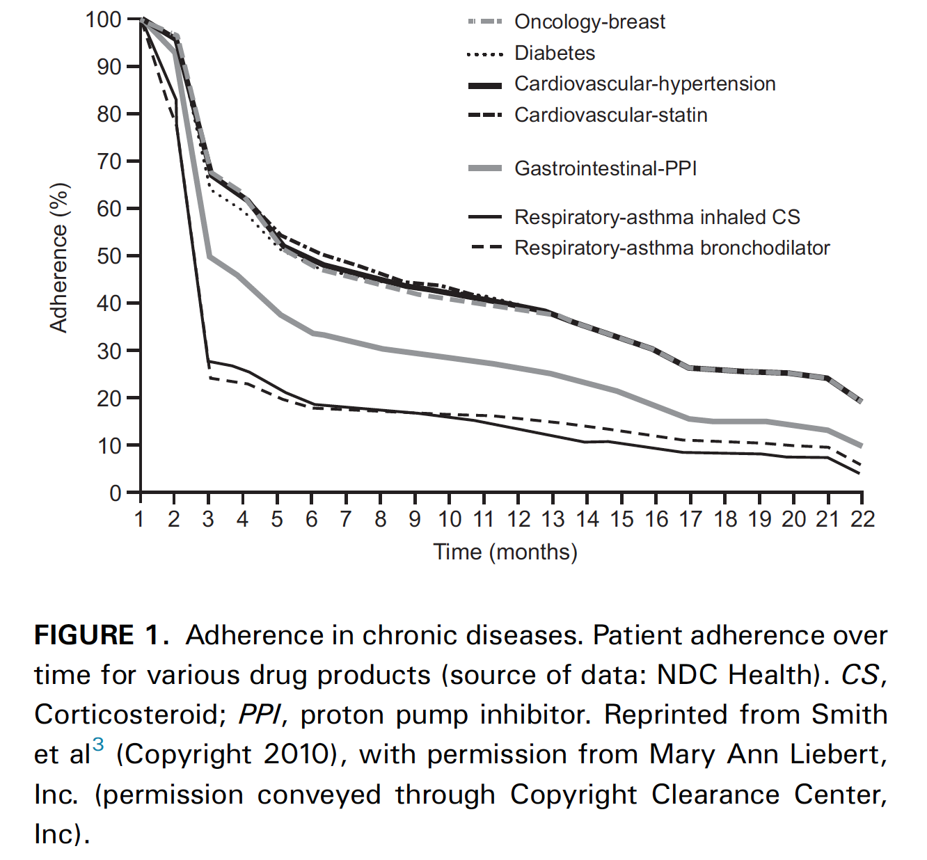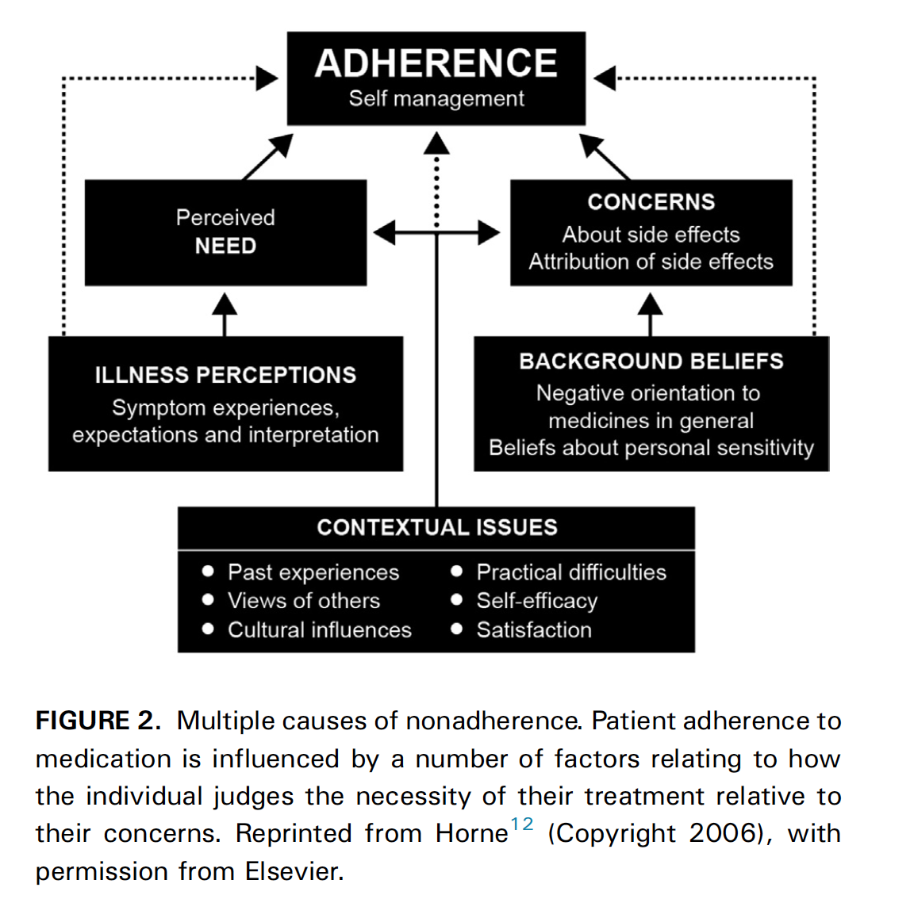

Dekhuijzen, R., Lavorini, F., Usmani, O. S., & van Boven, J. F. M. (2018). Addressing the Impact and Unmet Needs of Nonadherence in Asthma and Chronic Obstructive Pulmonary Disease: Where Do We Go From Here? The Journal of Allergy and Clinical Immunology: In Practice, 6(3), 785–793. https://doi.org/10.1016/j.jaip.2017.11.027

I am interested in conducting research on this topic to create a model of patients’ experiences living with a chronic disease.

