Assignment 1: Interest Areas

I am interested in these three topics:

- Experience of using asthma and COPD inhalers correctly and on time
Around %50 of asthma and COPD patients stop using their medication in 3 months. And around 70% of the ones who continue to use their medication, fail to use them correctly. Which means only about 15% of the patients follow their treatment plan. The reasons are highly related to their experience of perceiving their illness and failure of changing their behavior accordingly.

- Medication non-adherence in chronic diseases
This is a more generalized topic not only just focusing on respiratory diseases but all chronic diseases. (However, if you look at below graph, you can see the results are drastically worse for respiratory patients because respiratory patients have to use inhalers (usually badly designed products) which adds more complexity to the problem). Again, I believe and researches show that the reasons are highly related to failing to change patient’s behavior. Here are some snapshots from a quick research:

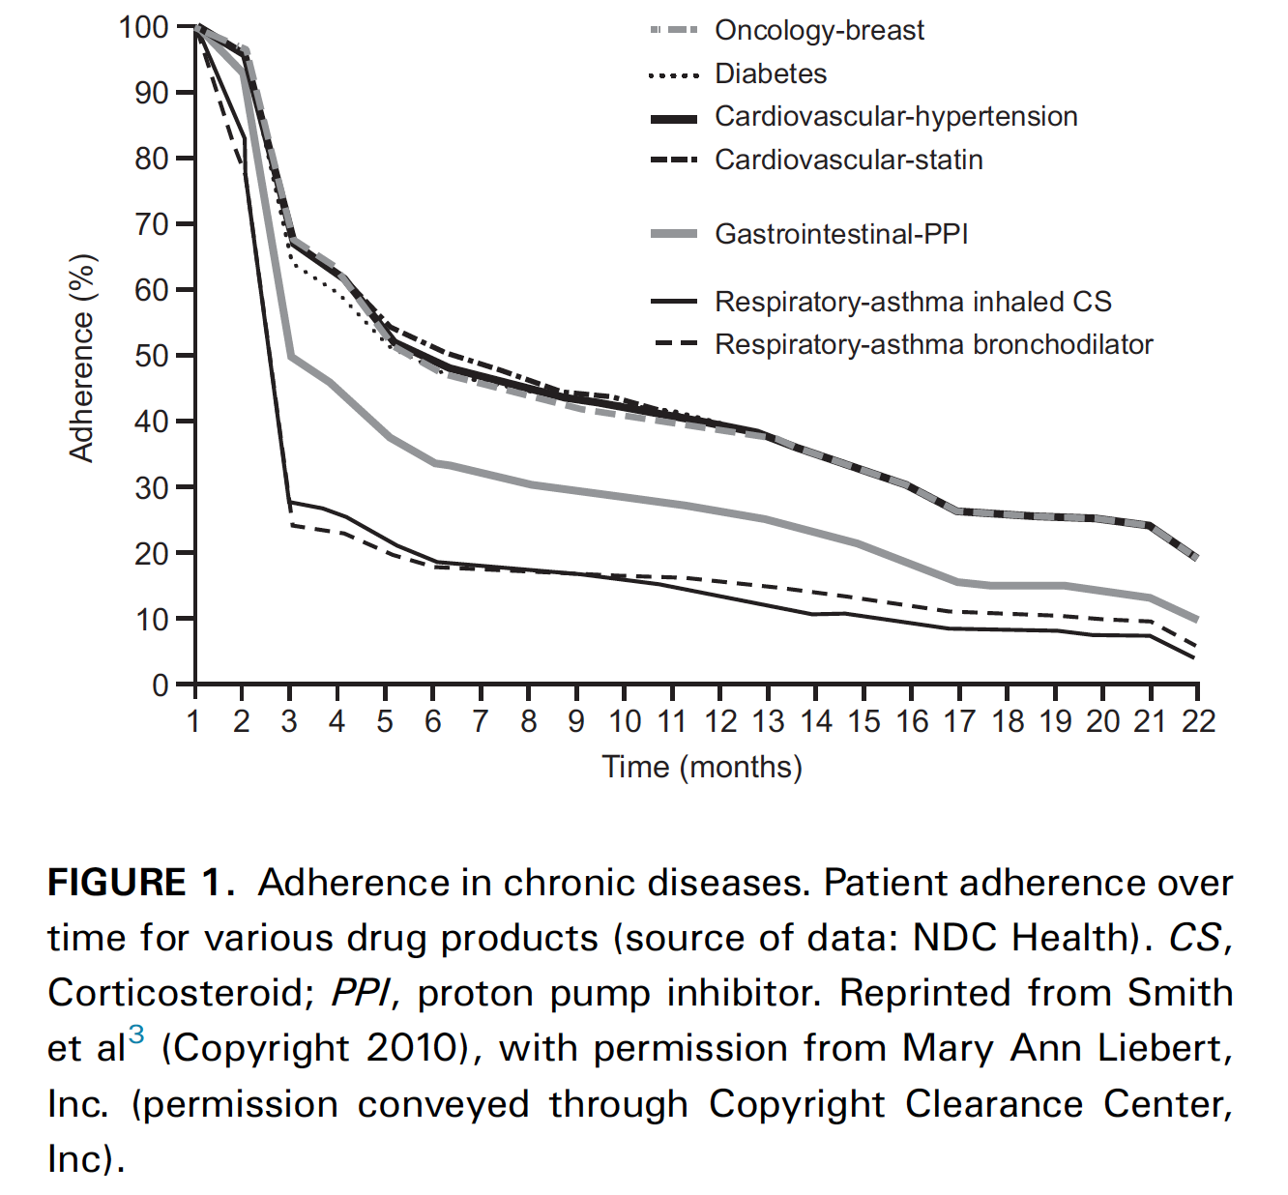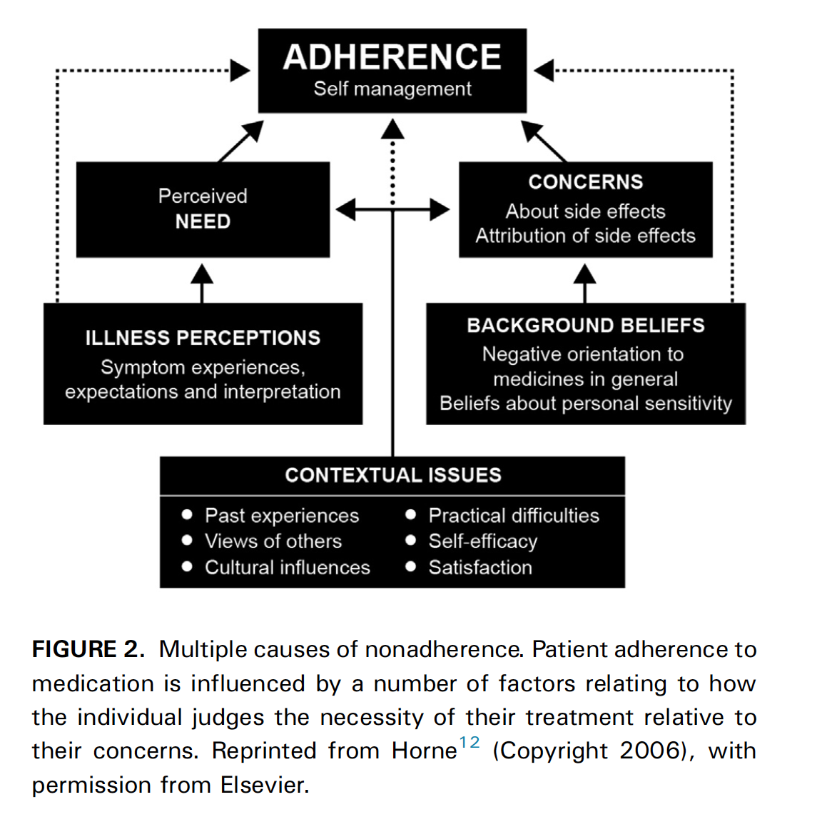

Dekhuijzen, R., Lavorini, F., Usmani, O. S., & van Boven, J. F. M. (2018). Addressing the Impact and Unmet Needs of Nonadherence in Asthma and Chronic Obstructive Pulmonary Disease: Where Do We Go From Here? The Journal of Allergy and Clinical Immunology: In Practice, 6(3), 785–793. https://doi.org/10.1016/j.jaip.2017.11.027

- Experience of donating blood in Turkey
In Turkey, 95% of active blood donors needed blood for themselves in the past (Karacan et al., 2013). Exploring the experience of donating blood, or being a regular donor might be an interesting topic.

Karacan, E., Seval, G. C., Aktan, Z., Ayli, M., & Palabiyikoglu, R. (2013). Blood donors and factors impacting the blood donation decision: Motives for donating blood in Turkish sample. Transfusion and Apheresis Science,49(3), 468-473. doi:10.1016/j.transci.2013.04.044

